ACADEMIC
AND
EMPLOYABILITY
SKILLS

ASSIGNMENT 1
CLASS: BMSW4001

ACCADEMIC ESSAY

STUDENT NAME: GIUSEPPE COGONI
LECTURE:MR HOPKINS

Table of contents

1. Introduction

2. Employability skills
2.1 Hard skills description
2.2 Soft skills description
2.3.1 Communication
2.3.2 The ability to give instructions
2.3.3 Time management
2.3.4 Working with a team

3. Academic skills
3.1 Research note-take ddddddd d d3.2 Referencing and avoid plagiarism gggggggggggg3.3Paraphrasing and summarising4.

4. Methodology4.4
.4.44
5. Findings result
cccccccccccccc5.1 Swot analysis
hhhhhhhhhhh5.2 The Conclusion
6. Discussion
7. Conclusion
8. Reference
9. Appendices

Academic and employability skills – a reflective report

Summary: The global jobs requires determinate skills to process your career and development plan. Some important skills will be a priority for your employer, however analysing the reflection of my workplace I can assume the fact that academic skills are the base of career management success.

1. introduction

Any organization is built of people and its success depends basically on the capability’s skills of the human resources and of hard work, communication and commitment they are able to establish. Human skills are fundament component for any enterprise and the quality of it deeply affects the results that the company need to reach.
Below I’m going to analyse most important academic skills you need in order to be successful in your career development and how academic skills can improve your general knowledge and abilities when searching a job.

2.1 employability skills

Each workplace requires different abilities and knowledge.
What is important is to be able to choose the ones that are useful on a daily basis. Employability skills are the key and attribute in nearly every job. General skills which we will mention shorty, makes the applicant desirable to a business organisation.
The significance of skills When it comes to skills in employment, is typically towards abilities, training and knowledge of specific skills sets. These are referred to as hard skills.
Soft skills are often overlooked, but they also play an important role in day-to-day operations.
When I Discussing about “workplace “I can take as example my job as host reservation in a 5 star hotel environment ,where you may use abilities learnt during your studies , however team work , communication and the way how I interact with guests are the basics to success in my role as reservation team and especially for the business requirements .
We organise training sessions by breaking employees’ sessions with different skills and knowledge, to reach your goals, set it for a period time.
I assume the fact that also Learning digital skills at school ,are essentials when comes the time to work in a different department in hotel such as food beverage coordinator, office manager or concierge or in my case at the restaurant desk with reservation most commune platforms. Once we learned capacity to use academic skills at school and be able to deliver at work, I can move on setting my goals. (Frost, 2019)
Employability skills are definite as transferable skills you need to be successful in your job research.
The employers are looking to hire people with some particular skills and graduation, it depends what a workplace requires.
Skills such as communication are the base of global jobs, to deliver and understand information.
While I’m setting “smart goals in a based managed time I will figure out what are my strengths and weakness and what ambitions.

2.2 Hard skills

The hard skills are usually referred to a technology knowledge such as computer programming, writing, law, and mathematics. They are gain by studies, trainings and programming. Hard skills and soft skills are the combination of success when an organisation is hiring.
Hard skills can be explicitly proven, whereas soft skills are harder to prove.

2.3 Soft skills:

Soft skills enable you to be successful in the workplace, allowing you to work as a team with others, delivering your knowledge to solve problems. (Doyle, 2019)
The hire manager most of the time is looking for an applicant with those skills mentioned above, as often hospitality and tourism will invest in people with empathy and emotional intelligence, capable also to use digital and academic resources. (Iulm, 2016)
A summary of soft skills are languages, positive attitude, engagement with customers in this case essential in my work place as time management.

2.3.1 Communication

The ability to communicate effectively with colleagues, managers, staff and customers is essential, no matter what industry you work in.
We are in a technological age and people must know how to deliver and receive a message using phone, email or social media.
Communicate include also, writing and speaking the use of verbal and no verbal communication, however every person has a different way of communication and culture. I would say that Everyone can build his personally skills throughout their life. Effectively communication skill is the power of a manager development ,in order to progress necessity a good basic time management taking as example solving out daily problems in hotel in a short time ,prioritising the most important daily task to deliver an efficient customer service .Customers are the business priority ,in fact they pay our salaries, and a professional service, good communication will make them come back in the future.
I think that Communication skills are important to impress as first stage of recruitment, the ability to show the employee your knowledge, but also interpersonal communication and personal presentation are part of the contest.

2.3.2The ability to give instructions

This type of skills is a particular skill that often reflect to a management team or team leader. In a workplace could be a Good challenge, it does not matter of which environment you work for, giving instructions to other team member is essential to achieve business goals.
In some busy workplaces such as hospitality, a team leader must have the capacity to be multitasking and communicate with members and senior managers managing their time, whereas in a less busy place the instructions and tasks might be settled without any pressure.

2.3.3 Time management

Time management is the ability to use your time, productively and efficiently. An efficient time management need a process of your plans and exercises with conscious of a good time some list of activities, tasks, meetings, daily routine.

2.3.4 Working with a team

Teamwork is basically the right mix of people with different skills in a
workplace, with some particular tasks designed and processes, in
command of positive behaviour and dynamic attitude. (Mortensen, 2016)
Haas, Mark Mortensen). The key of teamwork in hospitality, is a
Leader who can face fact and complicated situations to solve out
in that particular moment following standards and communicate to
team members, management etc. Members of team work together in
determinate circumstance and busy time service during daily
shifts. Most important is daily collaboration to success even if your job
description does not mention particular tasks.

3. Academic skills

We define academic skills the use of skills related to a workplace, done
in the Schools, colleges, and universities, usually a work which includes
studying and reasoning rather than a practical or technical skill.

3.1 Research and note taking

These particular skills are very important in your way to approach the
University. Note taking in the class using other academic skills such as
Paraphrase, summering using class words, or synonyms which I will
Mention below. This process is useful to take researchers on articles, journals, etc.

3.2 Referencing and avoid plagiarism

Referencing is a very important task in academic writing, the use of References, accrued while analysing of articles, online libraries and books permit to avoid plagiarism. The use of References gives support of arguments and opinions.

3.3 Paraphrasing and summarising

The paraphrasing is a process of written ideas of another person in own
Words, changing the words from the original source, but without
changing the meaning. we use different techniques to paraphrase But
The main subject or source which showed to the reader, must be always
Clear and efficient to be understood.
The way is used to summarising in shorter sentence to highlight the main
points are useful to take notes, in any environment.

4. Methodology

This report has been created throughout researchers of my in-class work exercises across employability and academic skills course: such as writing skills included note taking, Paraphrasing, summarising, time management Swot analysis, in class exercises, work activities.
The reflection of my performance, throughout online findings sources.
5. Findings and results
This report has showed which employability academic skills are important, how to use them in a workplace and what employee is looking for when hire. Research found out that academic skills are a good base for career progress.
5.1 Swot analysis
The swot analysis is a technique used for assessing business development and stands for strengths, weakness, opportunities and threats. The process of swot analysis determinates advantages for my workplace, understanding which my lacks are, find the solution and progression in hotel as management team or office collaboration.
Strength | Weakness | Opportunities | Threats
Team work | Communication under the pressure | Management career | Training IT programmes
Multitasking | IT knowledge procedure | Office career | University studies
Empathy with customers | Listening Work in different environment | Focus on company standards

Personal swot analysis
5.2 The Conclusion
This swot analysis made me understand what my strengths and weakness are to be improved, and I’m aware that my next step will be the learning progression on its computers, technology to reach a management level in the future after my studies.

6. Discussion
I mention above about workplace skills finalizing a question and answer regarding me
researchers. how we could have a career progress during our studies?
To find an answer we can definitively say that found by researches, employability skills
could help me to complete some particular tasks at work that before I was not able to do it.

7. Conclusion And recommendation
Employability skills are essential, are the key of success in your job search or practical in a
work place such as hotel environment, each person goes through a career with particular
skills that an enterprise is looking for. The academic skills above named, reflected my job
tasks and what I Need to step up as manager level, improving my weakness and academic
skills for the future ahead.

8. Reference

Doyle, A. (2019, June 15). https://www.thebalancecareers.com. Retrieved 04 05, 2020, from thebalancecareers.com: https://www.thebalancecareers.com/employability-skills-list-and-examples-4143571
Frost, S. (2019, February 05). https://smallbusiness.chron.com. Retrieved 04 05, 2020, from smallbusiness.cron.com: https://smallbusiness.chron.com/importance-training-development-workplace-10321.html
Iulm. (2016, October 20). https://www.topuniversities.com. Retrieved from topuniversities.com: https://www.topuniversities.com/student-info/careers-advice/5-essential-soft-skills-careers-hospitality-tourism
Mortensen, M. H. (2016, June n/a). https://hbr.org. Retrieved 05 04, 2020, from hbr.org: https://hbr.org/2016/06/the-secrets-of-great-teamwork

9. Appendices
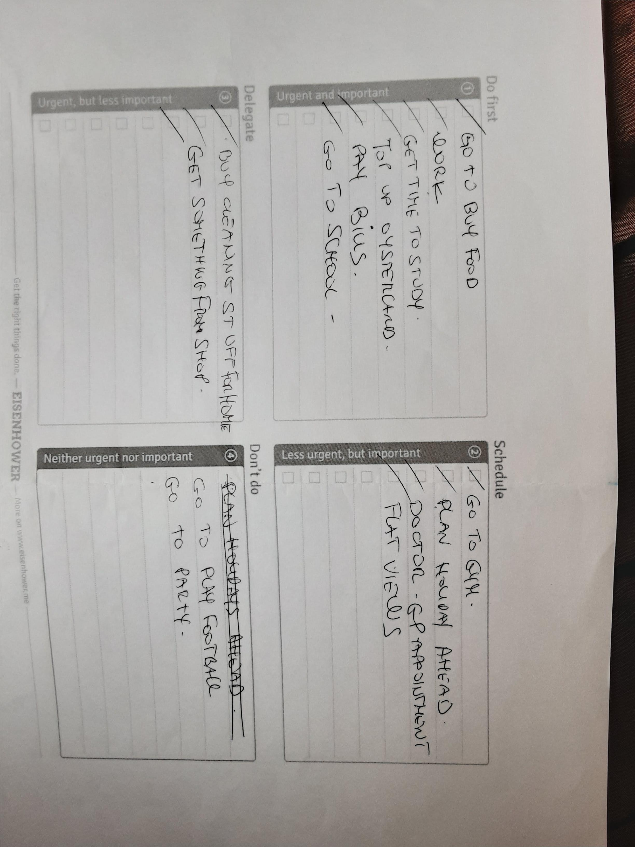
Below I have attached in class exercises q


