

Problem statement for homeless people analyse the impact OF SOCIAL factors

NAME: mihaela geanina oneamoise
student NUMBER: 2232227
module: integrating project [ACHA-4008]
‘This project is submitted in partial fulfilment of the requirements for the Certificate of Higher Education: CertHE Courses (Digital Skills, Skills for Electronics, Skills for Engineering, Professional Skills for Construction), University of Wales Trinity Saint David’.

Declaration
I have read and understood the University Regulations concerning plagiarism and I undertake:
- That all material presented for examination is my own work and has not been written for me, in whole or in part by any other person(s).
- That any quotation or paraphrase from the published or unpublished work of another person has been duly acknowledged in the project [Mihaela Geanina Oneamoise-2232227]

FORM OF CONSENT
I Mihaela Geanina Oneamoise hereby consent that my Project, submitted in candidature for the Certificate of Higher Education: CertHE Digital Skills degree, if successful, may be made available for inter-library loan or photocopying (subject to the law of copyright), and that the title and abstract may be made available to outside organizations.

Acknowledgements
I would like to thank my wonderful family, also a big thank you for my lecturers who have assisted me on this module, and I will say thank you as well for my references, for all their help that has made my research possible.

Table of contents:
- Abstract
- Chapter One: The Problem /Introduction
- Chapter Two: Review of Related Literature
- Chapter Three: Design & Implementation
- Chapter Four: Presentation and Analysis of Results (with screen dumps)
- Chapter Five: Conclusions and Recommendations
- References

abstract
Homelessness is becoming more prevalent in all countries, including the United Kingdom. Although numerous programmes focus on assisting in the resolution of this huge issue today, nations frequently lack the resources required to assist each homeless individual. Homelessness remains one of the world's most pressing social challenges, affecting both men and women, adults and children, single people, and families. [1]
Homelessness is a complicated societal condition characterised by several underlying economic and social factors, including poverty, a lack of affordable housing, unreliable bodily and mental health, addictions, and community and family collapse. These factors, in various combinations, influence the length, frequency, and kind of homelessness. [1] To be completely homeless means to be without shelter; nevertheless, many people suffer partial homelessness, which might involve uncertain, temporary, or inadequate shelter. [1]

Chapter one
Introduction

It is important to begin this project with an understanding of what homelessness is and is not. According to the Canadian Definition of Homelessness:
Homelessness describes the situation of an individual or family without stable, permanent, appropriate housing, or the immediate prospect, means and ability of acquiring it. It is the result of systemic or societal barriers, a lack of affordable and appropriate housing, the individual/household’s financial, mental, cognitive, behavioural, or physical challenges, and/or racism and discrimination. [2] Most people do not choose to be homeless, and the experience is generally negative, unpleasant, stressful, and distressing (CHRN, 2012, Canadian Definition of Homelessness). [2]
Most homeless persons wander through a variety of transient and insecure living conditions, making producing income, preserving health, staying safe, fostering healthy relationships, and getting permanent housing exceedingly difficult. [1]
Homelessness is more than just not having a fixed address. It is a condition that affects a vast and growing number of people in the United States and, most likely, the rest of the world. It involves being cut off from families, social groups, and community organisations, as well as feeling disconnected from society (Brown Casey, 2014). [2]
Homelessness is a long-standing and persistent societal issue in the United States. Health care is a concern for homeless people, who often struggle to receive even the most basic care. Attempts to provide proper care for the homeless under the current healthcare system are frustrating for both patients and providers. [2]

Chapter Two- Review of Related Literature
What exactly is homelessness? This is an essential question to think about. Many of us are quick to judge homeless persons for their own failings and weaknesses. Some of us still feel that people choose to be homeless and like the 'vagrant' lifestyle. [3] However, the feeling of chronic hunger, the increased danger of disease or injury, and the persistent threat of violence casts doubt on these beliefs. Any attempt to solve the issue of homelessness necessitates an understanding of what it is. [3]
Homelessness is both complicated and simple to define. On the one hand, the term "homelessness" refers to a wide range of social and economic issues that contribute to poverty and unstable housing, such as a lack of affordable housing, tenant insecurity, insufficient income, individual crises, health problems, mental health challenges, addictions, trauma, veteran’s issues, child abuse, and involvement with the justice system. [3]
When people lose their homes, they frequently move in with friends or relatives, a practise known as "couch surfing." [3] Many people will stay in temporary emergency shelters or become completely homeless if the option of moving in with friends and/or family is not (or is no longer) available due to a lack of social capital or a lack of consistent income. Emergency shelters are available in medium- and large-sized cities, but not in rural areas or small villages. [3]
Many individuals may argue that homelessness has always existed and that the issue is not new. [3] While it is undeniably true that there have been homeless people throughout history and in many communities, this does not imply that homelessness has always existed. A lot of researchers now agree that our current homelessness problem intensified in the latter half of the twentieth century, and this was not due to an increase in the number of homeless persons. [1] It was a direct effect of rising poverty because of our economy's reorganisation and substantial changes in government policies. As a result, an increasing number of people are finding up on the streets or in emergency shelters due to a lack of safe, affordable accommodation. [3]

Education
Having a good education is essential to understanding the issue of homelessness. This is because individuals with lower levels of education are more likely to face unemployment, underemployment, or poverty according to research [4]. The impact that youth homelessness can have on academic performance and completion also highlights the importance of having access to quality education for this group. In some cases, young people may be forced out of school due their situation as homeless while others were already at risk before becoming unhoused; regardless, being removed from one's community increases the likelihood that they will leave school prematurely [4].
Keeping their children in school is often a challenge for families who are homeless. [3] Such families frequently must move into family shelters that may be far from their original neighbourhoods, forcing the children to enrol in new schools. Furthermore, these families struggle financially, and this puts them at a disadvantage when it comes to accessing quality education. Despite being widely accepted as something all youth should receive, homelessness and poverty make providing an appropriate education arduous or unfeasible. [4]
Among the obstacles encountered in education are:
-Instability in housing
-Reworded: Change in position or movement.
-Inadequate parental assistance and unfavourable family connections.
-The act of family or household members inflicting physical, mental, emotional, sexual abuse on one another is referred to as domestic violence.
-Policies regarding school enrolment
-Insufficient nourishment.
-Discrimination

Planning
Creating a plan assists communities in setting goals and conceptualising what they should prioritise. [5]A plan can include objectives, a procedure and schedule for achieving those objectives, and tools for measuring progress. Planning also brings together providers, government officials, Continuum of Care leads, and funders to discuss topics such as identifying population needs, deciding on the structure of coordinated assessment, integrating prevention and shelter diversion resources, mapping out existing assessment and intake processes, and sketching out preliminary needs assessment and screening tools. [5]

Chapter three - Design & Implementation

The Homelessness Reduction Act
In decades, there hasn't been a more significant alteration in the law concerning homelessness than The Homelessness Reduction Act.
According to gov.uk citation [6], there has been a notable change in strategy that emphasizes early prevention and helping more people. Additionally, local government housing professionals are encouraged to adopt an approachable and friendly demeanour.
In April 2018, most additional duties were enforced by The Act on local governments and other public bodies in England:
- All eligible applicants must receive assessments and personalised housing plans (PHPs) from local authorities as a mandatory requirement.
- A longer-lasting obligation to prevent homelessness mandates that local authorities must take practical measures to avoid homelessness for claimants at risk of becoming homeless within 56 days irrespective of intent, priority status, or their connection with the locality.
- Local authorities have a responsibility to aid with homeless applicants in securing suitable accommodation within 56 days, irrespective of their intentionality or priority need. This obligation is deemed reasonable and necessary under relief duty provisions.
- The authorities in the local area are obligated to furnish information and guidance regarding homelessness to all individuals residing in their locality, irrespective of whether they have a prevention or relief responsibility towards them.
To effectively address homelessness, a comprehensive approach is needed that encompasses various initiatives including affordable housing options, mental health care assistance, vocational training schemes and fostering community involvement. [4]
For prosperous execution, it is crucial to have cooperation between the administration and neighbouring societies . [6]
What are my personal options? I can aid the homeless by devoting time to volunteer at shelters, give donations to local charities, supply necessary items like clothes and food or endorse organisations that concentrate on developing long-term solutions such as job training and housing assistance. Encouraging awareness regarding homelessness while advocating for supportive policies will also result in a beneficial impact.

Chapter Four: Presentation and Analysis of Results
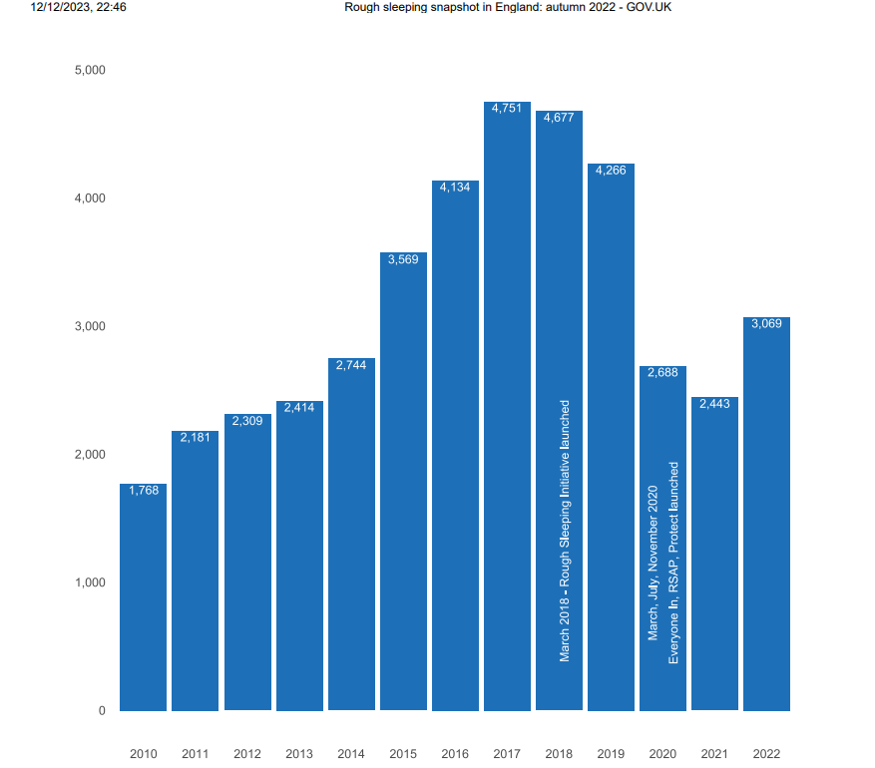
- This article contains estimates of the number of persons sleeping rough on a single night between 1 October and 30 November 2022, as well as some basic demographic information (age, gender, and nationality). [7]These figures can be used to estimate the number of individuals sleeping rough across England on a single night in fall, as well as to track changes over time. The rate of people sleeping rough on a single night in England in 2022 was 5.4 people per 100,000. [7] This has increased since 2021 (4.3 per 100,000) though is lower than in 2017 (8.5 per 100,000) .

Chapter Five: Conclusions and Recommendations
The multifaceted issue of homelessness demands a diverse approach that encompasses more than simply offering temporary relief via shelters and aid initiatives. Addressing this problem requires tackling underlying concerns such as affordable housing, career opportunities and mental health support. It is imperative for those in charge- including lawmakers and disaster response officials -to prioritize efforts aimed at averting additional homeless situations following calamities while simultaneously devising feasible solutions to provide permanent accommodation for the previously displaced populations. Fundamentally speaking, shelters should aim to meet basic requirements of privacy, safety assurances with emphasis on keeping families united whilst ensuring access to hygiene facilities alongside comfort accommodations with minimal constraint possible. [8]

Recommendations:
- Solutions that are comprehensive and address all aspects of a problem or situation.
-Introduce all-encompassing measures to cater to the varied requirements of homeless people such as shelter, medical aid and assistance with job opportunities.
- Long-Term support
-focus on providing long-term support and sustainability solutions
- Community Engagement
-encourage participation in the community through campaigns aimed at raising awareness, educational programs, and initiatives that aim to decrease negative perceptions related to homelessness.

References

[1]F. C. M. approach, “Analyzing the impact of social factors on homelessnes,” [Online]. Available: https://www.ncbi.nlm.nih.gov/pmc/articles/PMC3766254/#:~:text=Social%20forces%20such%20as%20addictions,homelessness%20through%20their%20dynamic%20relations.. [Accessed 12 12 2023]. Analyzing the impact of social factors on homelessness: a Fuzzy Cognitive Map approach - PMC (nih.gov)
[2]gov.uk, “gov.uk,” [Online]. Available: https://www.local.gov.uk/sites/default/files/documents/22.7%20HEALTH%20AND%20HOMELESSNESS_v08_WEB_0.PDF. [Accessed 12 12 2023]. 22.7 HEALTH AND HOMELESSNESS_v08_WEB_0.PDF (local.gov.uk)
[3]“homeless hub,” [Online]. Available: https://www.homelesshub.ca/resource/what-homelessness#:~:text=Most%20people%20who%20are%20homeless,obtaining%20permanent%20housing%20extremely%20challenging.. [Accessed 10 12 2023]. What is Homelessness? | The Homeless Hub
[4]“homeless hub,” [Online]. Available: https://www.homelesshub.ca/about-homelessness/education-training-employment/education. [Accessed 10 12 2023]. Education | The Homeless Hub
[5]“National alliance,” [Online]. Available: https://endhomelessness.org/ending-homelessness/solutions/creating-systems-that-work/. [Accessed 12 12 2023]. Creating Systems That Work - National Alliance to End Homelessness
[6]“gov.uk media,” [Online]. Available: https://assets.publishing.service.gov.uk/media/5f68c436d3bf7f723618781c/Evaluation_of_the_Implementation_of_the_Homelessness_Reduction_Act_Final_Report.pdf. [Accessed 12 12 2023]. Evaluation of the Implementation of the Homelessness Reduction Act: Final Report (publishing.service.gov.uk)
[7]“gov.uk 3,” [Online]. Available: https://assets.publishing.service.gov.uk/media/5f68c436d3bf7f723618781c/Evaluation_of_the_Implementation_of_the_Homelessness_Reduction_Act_Final_Report.pdf. [Accessed 10 12 2023]. Rough sleeping snapshot in England: autumn 2022 - GOV.UK (www.gov.uk)
[8]“hudexchange,” [Online]. Available: https://files.hudexchange.info/resources/documents/ESG-Emergency-Shelter-and-Permanent-Housing-Standards.pdf. [Accessed 13 12 2023]. ESG Emergency Shelter and Permanent Housing Standards (hudexchange.info)

