Context and Historical Background
I chose to analyse Llandaff Cathedral and City Hall, Cardiff, due to visiting these buildings as I was growing up. My junior and high schools were linked with the cathedral and I attended there for services on many occasions.
Llandaff Cathedral is approximately 2 miles from the city centre (Jenkins, 2008). The exact date of starting construction of Llandaff Cathedral is unknown, however Hilling (1975) suggests that parts of the cathedral started to be built around 1120. It can be difficult to identify one particular architectural style as many parts of the cathedral have been reconstructed and developed upon (Thurlby, 2006). Earlier parts of the cathedral are Norman Romanesque, e.g. the rounded Norman arch which separates the Nave from the Lady Chapel (Jenkins, 2008). Also, the cathedral shows many Early English features from the Gothic period such as the pointed arches and lancet windows (Jenkins, 2008).
City Hall is located within the Civic Centre in Cathays Park, Cardiff (Jenkins, 2008). It was designed in 1901 by Lancaster, Stewart and Richards (Hilling, 1975). The architectural style is Edwardian Baroque; however, it also incorporates French Baroque, e.g. the large dome and the asymmetry of the clock tower to the west (Hilling, 2016). These architectural styles are not the preferred Neo-Classical style of the time.
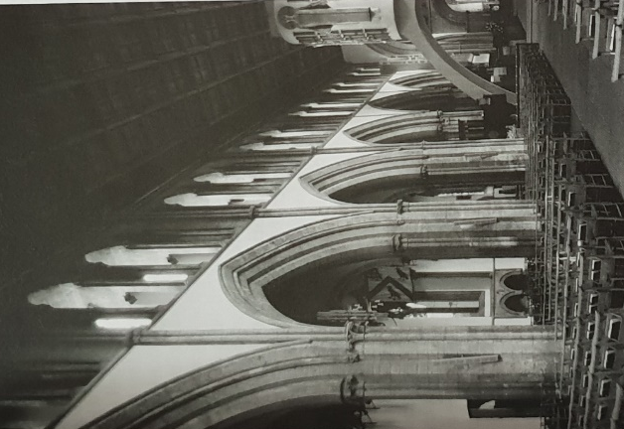
Plan and Sections
Figure 1: Llandaff Cathedral North Elevation (Thurlby, 2006)

The Nave is separated from the side bays by large Gothic arches (Figure 1). I think this allows for ease of movement of the congregation during services.
Llandaff Cathedral is situated at the bottom of a steep hill, at a very low level within the surrounding area. This is unlike many other cathedrals, as it cannot be seen from afar, apart from its south-west tower, which was added in 1859 by John Pritchard (Thurlby, 2006; Jenkins, 2008).
Figures 2, 3 and 4 - Llandaff Cathedral within its surroundings.
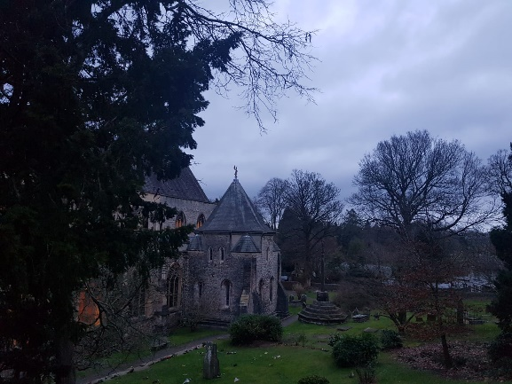
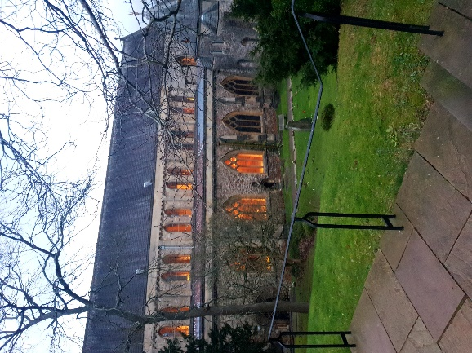
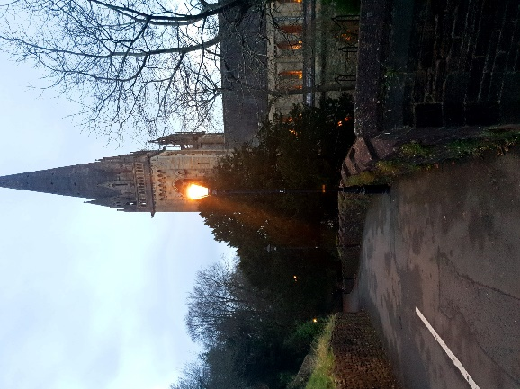
Figure 2 Figure 3 Figure 4

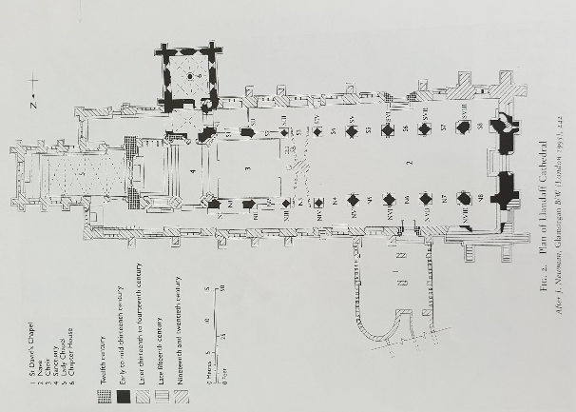
As shown in Figure 5, the cathedral is not cruciform (cross-shaped in plan), which is unlike many churches and cathedrals of its time (Wilson, 1990). Furthermore, the cathedral provides separate areas, e.g. The Lady Chapel and St. Davids Chapel, which can provide quieter zones for members of the community to use if they wish to be away from the noisier and busier Nave (main area).
Figure 5: Llandaff Cathedral Plan (thurlby, 2006)

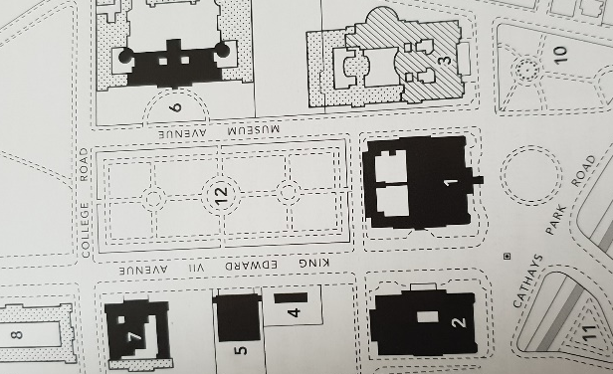

City Hall is sited between the National Museum of Wales and Cardiff Crown Court (Figure 6). This central positioning of City Hall shows its importance within the city and highlights its Baroque architectural style (Hilling, 2016). Furthermore, City Hall faces the city centre and in my opinion acts as a focal point.
Figure 6: City Hall Plan (Hilling, 2016)

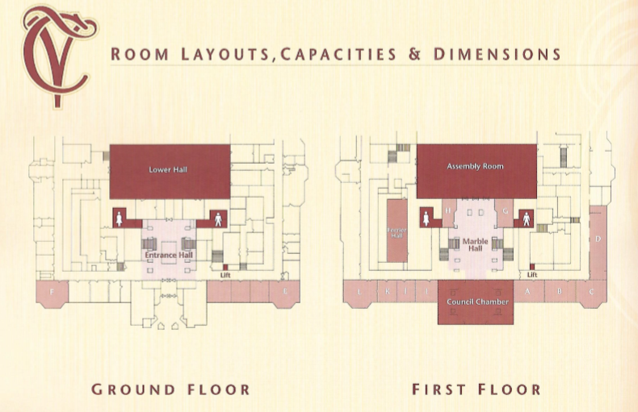
Figure 7: City Hall Interior Plan (Cardiff Council, 2003)

The first-floor plan (Figure 7) shows the Council Chambers and Marble Hall. The Marble Hall can be used for exhibitions, events and a meeting space for the public. It exhibits statues and the walls are lined with Doric columns. In addition, the building has many other function rooms, that are highly decorated and have intricate detailing to the ceilings and walls (Hilling, 2016). Another successful part of the design is the Council Chambers with seating arranged in a circular shape, these seats are arranged to fit the room and incorporate the dome into the interior space.
Materials and Light
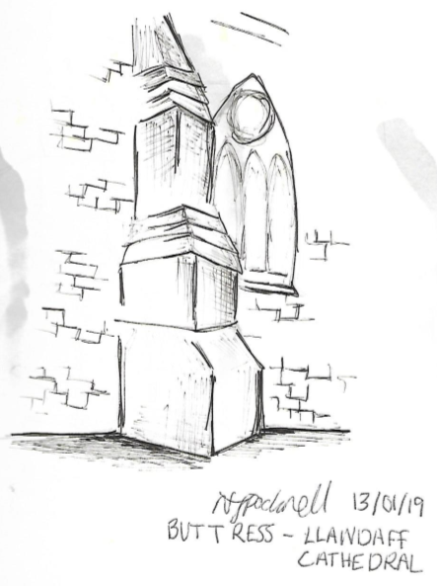
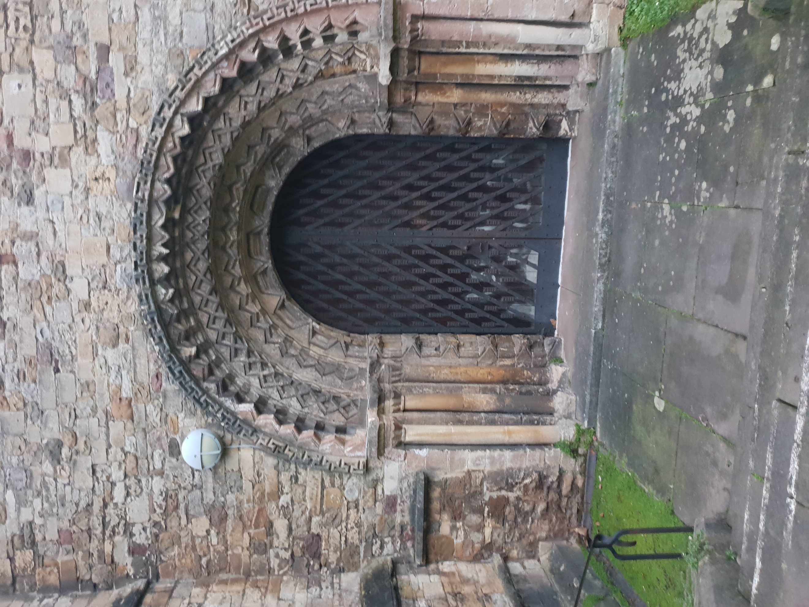
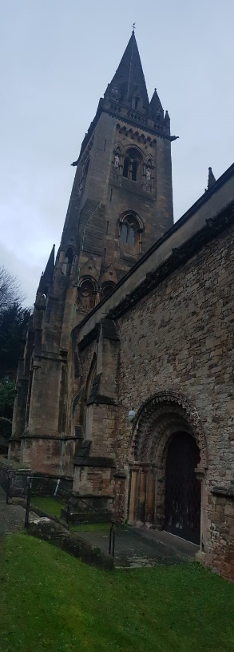
The oldest parts of Llandaff Cathedral are made from Dundry stone from Somerset (Thurlby, 2006). The Romanesque arches are highly decorated and detailed, e.g. the south doorway is formed from four arches with zigzag detailing (Figures 8 and 9).
Figure 10
Figure 8
Figure 9

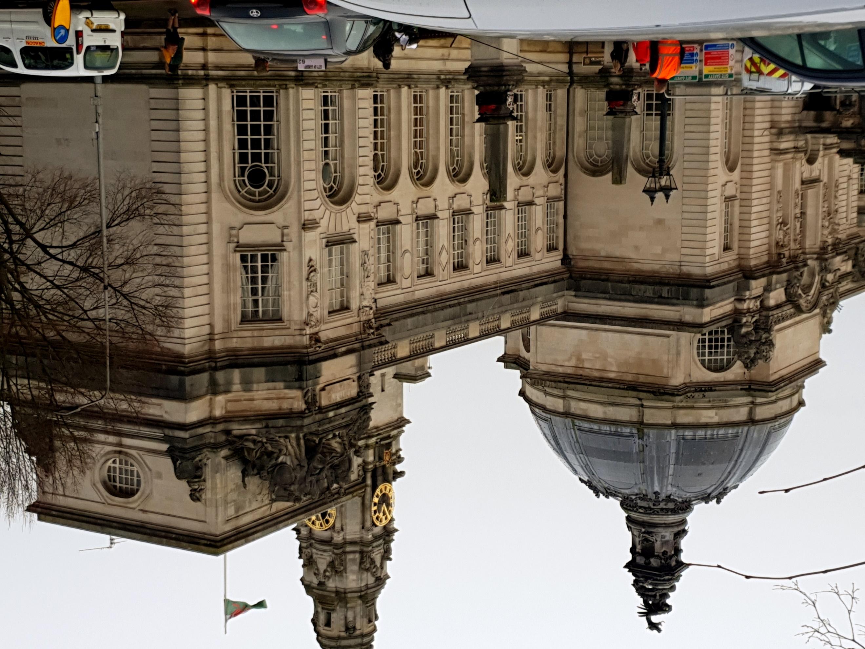
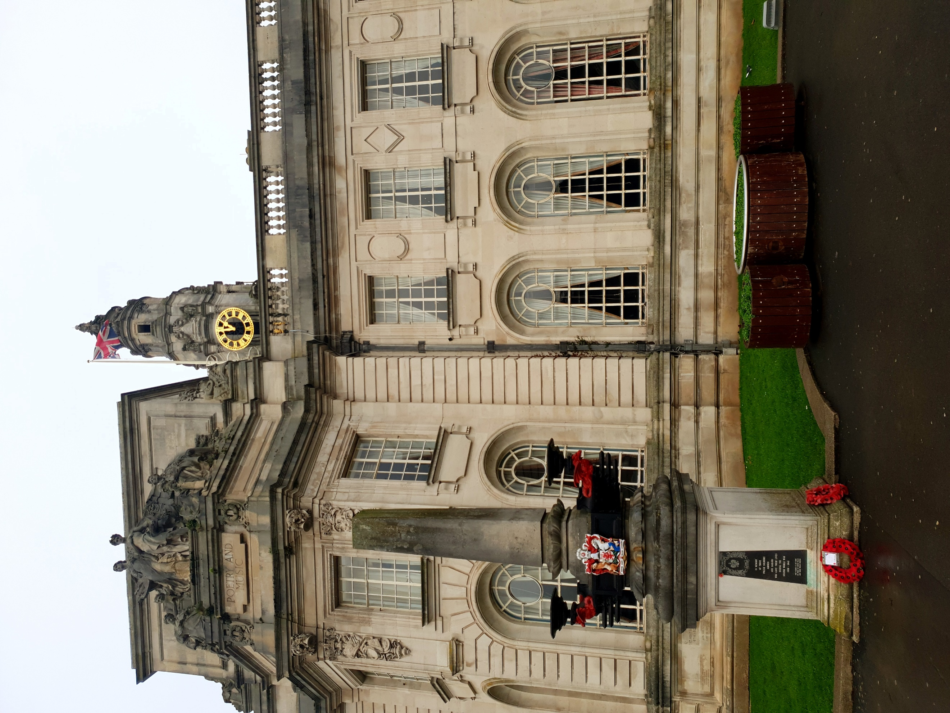
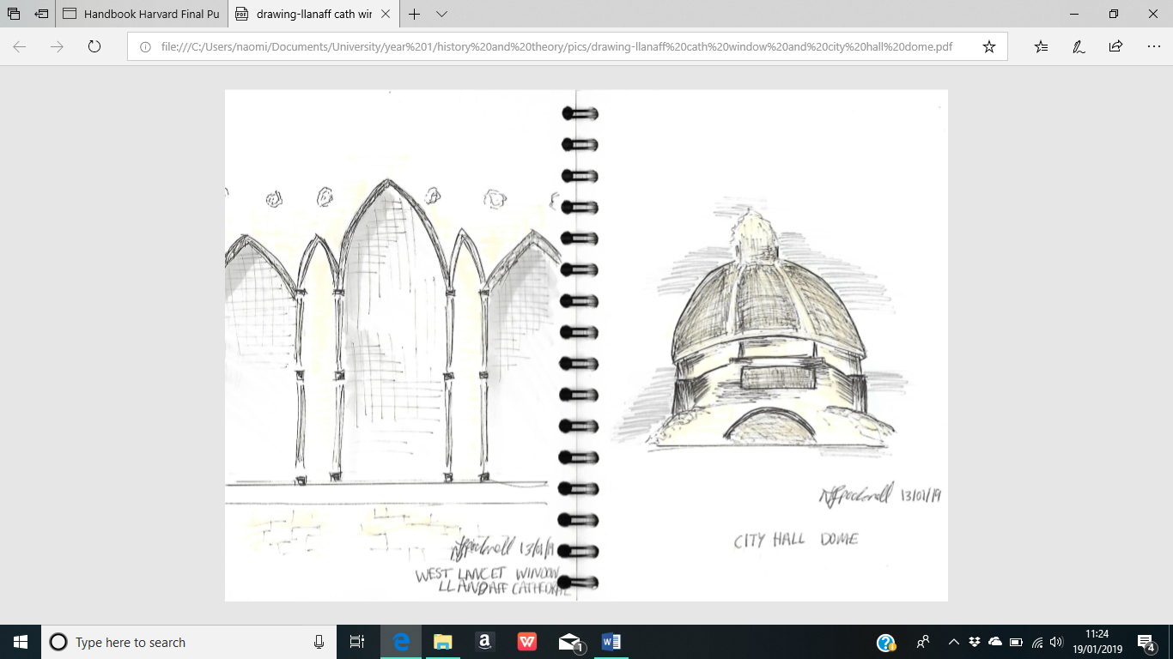
A newer section of the cathedral is the large concrete interior arches which hold the oval organ case. To the west of these arches is Epstein’s ‘Majestas’. However, this feature blocks the view of the original Norman arch and Lady Chapel. It separates the cathedral, which makes it look smaller.
Figure 12
Figure 11
Figure 14
Figure 13
To the west side of the cathedral are three lancet windows (Figure 11) which elongates the Nave. It allows natural sunlight into the interior.
City hall is a two storey, rectangular building made from Portland stone; which gives the building its white colour and smooth texture (Hilling, 2016). It has a large dome in the centre which is highly decorated e.g. intricate stone shell detail with a bronze dragon placed on a plinth (Figures 13 and 14). The windows of the building differ in shape, the ground floor windows are rounded whereas the first-floor windows are rectangular (Figures 12 and 13). Less natural light enters the rooms at City Hall due to the smaller windows, which is in comparison to Llandaff Cathedral which has the larger lancet windows. At each end of City Hall there are Baroque style door frames and the Assembly room is lined with Doric columns and has a barrel-vaulted ceiling (Jenkins, 2008).
Use
Llandaff Cathedral is used by the public as a place of worship. The Nave is the busiest area of the cathedral and is where services are held. As seen in Figure 5 (page 2) the cathedral consists of two side bays, here there is more seating however this area is quieter and allows people to move freely around the cathedral even during a service. To the east of the cathedral is the Lady Chapel which is also a quieter area and seats a lot less people than in the Nave. The main movement of people through the cathedral is from the main entrance (west) into the Nave and surrounding the cathedral is a small open green space which can be used by the public.
City Hall, similarly to Llandaff cathedral, is a public space, however the use of the two buildings is different. City Hall can be used for large events and exhibitions such as weddings and conferences. The spaces work well in City Hall as there is a range of smaller and larger function rooms. Furthermore, to the exterior there is a large open, green space in front of the building which is intended to show the history of Wales through statues and sculptures. This provides additional space as the outside park area can also be used during events which are being held at City Hall.
To conclude, by analysing these two buildings I was able to contrast details such as the architectural styles, materials used and the shape of windows. Although I have visited both buildings on numerous occasions, I had not examined them to this scale and I was able to appreciate them in more detail.

Word Count – 1099

References

Cardiff Council. (2003) City Hall. 2nd edn. Cardiff.
Figure 2- Personal Image (2019).
Figure 3- Personal Image (2019).
Figure 4- Personal Image (2019).
Figure 8- Personal Image (2019).
Figure 9- Personal Image (2019).
Figure 10- Personal Drawing (2019).
Figure 11- Personal Drawing (2019).
Figure 12- Personal Image (2019).
Figure 13- Personal Image (2019).
Figure 14- Personal Drawing (2019).
Hilling, J. (1973) Cardiff and the Valleys. London: Lund Humphries Publishers Limited.
Hilling, J. (1976) The Historic Architecture of Wales. Cardiff: University of Wales Press.
Hilling, J. (2016). The History and Architecture of Cardiff Civic Centre. Cardiff: University of Wales Press.
Jenkins, S. (2008) Wales Churches, Houses, Castles. London: Penguin Books Ltd.
Thurlby, M. (2006) ‘The Early Gothic Fabric of Llandaff Cathedral and its Place in the West Country School of Masons’, in Kenyon J. and Williams, D. (ed.) Cardiff Architecture and Archaeology in the Medieval Diocese of Llandaff. Leeds: British Archaeology Association and Maney Publishing.
Wilson, C. (1990) The Gothic Cathedral. London: Thames & Hudson Ltd.

