University of Wales Trinity Saint David


Assignment Title: Assessment component 1:
Individual report
Student Name: Zahraa Araf
Student ID: 2211190
Module: International Marketing: Principles and Practices
Module Code: LCMB70026
Name of Lecturer: Tushara Balendran
Dian Mayasari
Internal verifier: Vasilios Tavlaridis
Hoang Nguyen
Date: 23 March 2026
Word count: 5090

Contents
Introduction- ZARA/Inditex's International Market Entry Strategy in UK and Canada 1
a. A Comparative Analysis of the Market in Both Countries 1
b. Comparative Analysis of STP and International Marketing Mix (7Ps) Strategies of Inditex in Canada and UK 3
c. An Analysis of Inditex/Zara Directional Development Strategy 7
d. Evaluation of Ethical Issues Related to the Marketing Mix in Canada and UK 8
e. Recommendations for Inditex/Zara's International Marketing Strategy 10
Section 2: Reflective Account of the Research and Analysis Process 11
References 14
Appendixes 18
Appendix-I 18
Appendix-II 19
Appendix-III 20
Appendix-IV 22
Appendix-V 23
Appendix-VII 24
Appendix-VIII 25
Appendix-IX 26
Appendix-X 27
Appendix-XI 28
Appendix-XII Gibbs Reflective Model 28
Appendix-XIII 29
Appendix-XV 32

List of Figures
Figure 1 Zara UK Market segmentation and Targeting 18
Figure 2 Zara Products categories 19
Figure 3 Prices in Canada 20
Figure 4 Prices in UK 21
Figure 5 Shipping/placement strategy of ZARA 23
Figure 6 Promotion strategy 23
Figure 7 People Strategy 24
Figure 8 Sales growth by Zara 25
Figure 9 Zara's online Sales Growth 26
Figure 10 Sustainability at Zara 27
Figure 11 Profitability of ZARA 28
Figure 12 UK CPI 30
Figure 13 UK GDP 30
Figure 14 Canada GDP 31
Figure 15 Reduction Scope 1, 2, and 3 emissions 32

The International Market Entry Strategy and Marketing Mix of Intidex/Zara in UK and Canadian Markets




Introduction- ZARA/Inditex's International Market Entry Strategy in UK and Canada
This study critically analyzes the international market entry and marketing mix of Zara/Inditex in the United Kingdom and Canada through the prism of PESTEL and STP as well as the 7ps frameworks, identifies the ethical contradictions, and provides the strategic recommendations using the corporate data and theoretical framework.

a. A Comparative Analysis of the Market in Both Countries
This analysis applies the PESTEL framework (Morrison, 2020) to evaluate the macro-economic environment that has influenced the market entry and marketing mix of Zara in the United Kingdom and Canada to identify the different strategic issues even though both countries are developed economies.
Political Factors: The political environment of the United Kingdom is defined by the post-Brexit regulatory difference with the European Union that creates tension in trade due to the presentation of new customs declarations and value-added tax (VAT) rules regarding imports (Hughes, 2022). Such developments drive up administrative cost and lead times of a firm that depends on agile and just-in-time supply chains. Any supply chain disruption has significant financial consequences to Inditex, which recorded EUR 39.9billion in the global sales in FY 2025-refer to Appendix-VIII (Inditex, 2026). In comparison, the political climate in Canada is relatively stable, and the United States-Mexico-Canada Agreement (USMCA) is the offer of predictable trading conditions with a main trading partner, though there is also a latent threat of protectionist pressure on the United States (Deloitte, 2023).
Economic Factors: Both markets exhibit strong consumer spending but with different dynamics. The economy of the United Kingdom is facing continuous inflationary pressures with the GDP growth of 1.1% in 2024 to 1.3% in 2025, and the history of 4.5% average inflation of clothing and footwear in 2024, 3% in 2025 and same in 2026-refer to Appendix-XIII (tradingeconomics.com, 2024;ONS, 2025; Bank of England, 2025). This forms a price elastic consumer group, and this exerts pressure on the pricing as a premium strategy in the value-based marketing mix of Zara. The economy of Canada expanded by 1.1% based on 2024 and the core inflation decreased to 2.5% based on the early of 2025 and in turn contributed to the enhancement of real disposable income growth-refer to Appendix-XIV (Statistics Canada, 2025; OECD, 2025). Such financial strength provides a better platform in the expansion of Inditex, as it has reported a high growth of 7.0% in constant currency sales in FY 2025, with the part of this growth being attributable to the Americas region (Inditex, 2026a). The comparative advantage of the Canadian dollar versus the euro also enhances the consumer power of the Canadians to buy foreign fashion.
Social & Cultural Factors: This dimension reveals the most significant divergence, which has a direct effect on consumer behaviour of Zara and cultural context. The culture of the United Kingdom market is the one of the high level of cultural heterogeneity and the culture of individualistic shopping (Hofstede Insights, 2023). There is a high tendency of online shopping among the consumers of the UK, where 38% of all the clothing products are being purchased online in 2024, thereby pushing Zara towards strategic focus on online integration, which saw the company make EUR10.7 billion in online sales worldwide (Inditex, 2026; Statista, 2025). However, there is increasingly strong opposition to fast fashion, and 45% of consumers in the UK are now making a conscious choice to buy more sustainable labels (Intidex, 2026). This is a socio-cultural threat that will force Zara to market its sustainability performance, including the 88% of textile fibres that fall under the lower-impact category (Inditex, 2026), to ensure the brand is perceived as legitimate. The social fabric of Canada, on the contrary, focuses on multiculturalism and experience consumption (Hofstede Insights, 2023). Although fashion-focused, Canadian consumers are more loyal to the brands that embody the local inclusivity and environmental ethic as 50% of Canadian consumers report that they prefer to shop in a company with a strong ethical and environmental policy and 68% of the Canadian public is paying attention to issues related to corporate social responsibility (Ipsos, 2024)-Refer to Appendix-III.
Technological Factors: Technology happens to be a major facilitator of the integrated store- online concept at Zara. The penetration rate of smartphones is high in the United Kingdom (84 % of the population) as well as the development of digital payments (Statista, 2025), which eases omnichannel initiatives. The application of AI-powered virtual fitting technology, Zara Try-on, which has so far received more than 7 million visits worldwide, is also necessary to reach digitally native consumer in the UK (Inditex, 2026a). Likewise, the developed e-commerce system in Canada that has 27 million active online shoppers (Statista, 2025) offers a favorable environment to this technology. Furthermore, the logistical issues vary: the UK enjoys the advantage of geographic footprint due to the high density of major cities which allows serving the stores with fulfilment within a greatly short time, whereas Canada has a huge geographical area and most people are concentrated in a few major cities, making the delivery by last-mile a costly operation which impacts the efficiency of the integrated model (CBC, 2024).
Environmental Factors: Stringent environmental regulations are an influential major PESTEL element in both jurisdictions. The Environment Act 2021 of the United Kingdom sets biodiversity and waste management targets, which require comprehensive regulation, and are in accordance with the corporate aim of Inditex to cut the total Scope 1, 2, 3 altogether emissions by 11% of the 2018 value-refer to Appendix-XV (UK Government, 2021; Inditex, 2026a). The Plastic Pollution Prevention Act of Canada also imposes an influence on the packaging policies, as it has made Zara hasten its process of switching to recycled and minimal packaging (Environment and Climate Change Canada, 2022). Importantly, the two consumer markets have been using corporate environmental performance as a buying criterion. In the United Kingdom 56% of consumers are concerned or very concerned about the environmental impact of the clothing they buy (Wrap, 2024) and in Canada this proportion is 48% (Ipsos, 2024). This consumer attitude and makes Inditex to disclose its sustainability gains, including the use of lower-impact fibres at 88% and 26% of water consumption reduction (Inditex, 2026), thus turning sustainability into a corporate social responsibility report instead of its core element of the marketing mix.
Legal Factors: Legal systems determine the operation and marketing dimensions. The employment legislation in the United Kingdom, and specifically that of the classification of workers to the gig economy, poses a threat to a brand providing temporary staff to stores during periods of seasonal demand (ACAS, 2025). On the other hand, the Canadian unique legal environment is made up of federal laws and provincial laws, which are difficult to establish. An example is the Charter of the French Language of Quebec that stipulates that all marketing resources, such as the Zara site and in-store displays, should be provided in French, so that it will require an individual marketing approach as compared to the rest of Canada (OQLF, 2024).

b. Comparative Analysis of STP and International Marketing Mix (7Ps) Strategies of Inditex in Canada and UK
STP Analysis
Refer to Appendix-I, the segmentation strategy of Zara in the United Kingdom and Canada is based on both the demographic factors: the urban residency and middle-to-high-income segment and the psychographic variables, including the fashion-oriented orientation (Kapustina et al., 2022). However, there is a difference in the targeting strategies. In the United Kingdom, Zara uses the wider strategy of targeting digital-native buyers in the form of the high-profile presence of the Travelling Mode and Zara Second Hand applications on the UK site ( Zara UK, 2026); this strategic orientation is consistent with the 38 percent of clothing transactions taking place online in the United Kingdom (Statista, 2025). Targeting in Canada is more refined and focused on quality and inclusiveness as the brand name, Massimo Dutti, also figures prominently in the main menu of Zara Canada (Zara Canada, 2026). The strategy is aimed at a high-income segment of consumers attached to reserved style (Hofstede Insights, 2023).
Positioning
Both markets use positioning on Zara’s fundamental value of democratising fashion, i.e. fast, trend-driven clothing, at affordable prices (Kapustina et al., 2022), but the messages used in that case are culturally tuned. The positioning in the United Kingdom is based on the value of digital integration and sustainability, where the section of the site is called Join Life (Zara UK, 2026) and targets a market in which 45% of consumers actively pursue sustainable brands (Intidex, 2026). Positioning in Canada is more lightly emphasised on quality and heritage through the connexion with the high-quality brand Massimo Dutti to attract the market in which 50% of people focus on the ethics and environmental concerns (Ipsos, 2024).
International Marketing Mix (7Ps) strategies
Product: refer to Appendix-II, the main product service, which is trend-led clothes, is standardised, although adaptations are available. The site in the United Kingdom has a feature that reflects the high levels of circular fashion in the country, with a prominent section of the site called the Zara Studio Collection and a separate section titled pre-owned ( Zara UK, 2026), in response to the resale market increasing by 15% there in 2024 (Wrap, 2024). In Canada, product mix is curated to focus more on Basics and Collection lines, whereas the product line by Massimo Dutti is more integrated to meet the demands of the consumer market that prefers versatile and long lasting products to wear (Zara Canada, 2026; Statistics Canada, 2025). The world 88% of fibres used in the textile industry were categorised as lower-impact (Inditex, 2026a), which is a sustainability measure that is more explicitly reported on the United Kingdom market to address the increased consumer expectations (Intidex, 2026).
Price: Refer to Appendix-III, Zara has a premium-mid market pricing strategy in both countries, but it is led to diverge due to economic forces. In the UK, the brand is more price-sensitive due to the consistency of inflationary pressures of 4.5% on the price of clothes (ONS, 2025). The Special Prices section on the UK webpage (Zara UK, 2026) is an obvious tool on the UK site, serving as a competitive measure to keep value consumers. Core inflation in Canada dropped to 2.5% (OECD, 2025), which means that the pricing power of Zara will be higher and it will be possible to have a more stable pricing policy and the focus will not be on aggressive promotion, as there is no Special Prices section on the homepage in Canada (Zara Canada, 2026). This strategic flexibility is supported by the global gross margin of the company (58.3) of 58.3% (Inditex, 2026).
Place (Distribution): Refer to Appendix-IV, the countries have an omnichannel model but physical distribution approach is different. Zara has 30 stores in the United Kingdom (Inditex, 2026b) and capitalises on the high geographic density of the locations to achieve rapid fulfilment and returns, which is essential because 84% of the British are smart phone users and demand a seamless online-to-offline connexion (Statista, 2025). In Canada, where there are 33 stores in the large urban centres (Inditex, 2026), the strategy puts a focus on the flagship stores to create brand prestige and surpass the logistical difficulties of a large geographical location (CBC, 2024). The online channel plays a significant role in both and it is adding EUR 10.7 billion worldwide (Inditex, 2026), but in Canada it is a more significant channel in the country with consumer externalising major hubs.
Promotion: Refer to Appendix-V; promotions are different and tailored to the culture. The UK market is using the promotion mix that is oriented to the innovations in digital marketing and sustainability confirmation. The service and promotional features of the Zara Second Hand platform and the Travel Mode can serve both as a service and a promotional platform (Zara UK, 2026), which attracts a value-conscious, sustainability-conscious, and tech-savvy audience. The advertising expenditure of Zara is as low as 0.3% of revenue globally (Kapustina et al., 2022), and it caters to these functionalities and the word-of-mouth. Promotion in Canada is more community-based and is based on brand heritage. Premium lines are cross-marketed in the Massimo Dutti which can be found on the Zara platform (Zara Canada, 2026), and in Quebec, advertising content has to be legal, which is regulated by the French-language law (OQLF, 2024) so that it should be locally promoted which is unnecessary in the United Kingdom.
People: Refer to Appendix-VI, Zara integrated model revolves around the personnel training, and in 2025, 3.4 billion training hours worldwide are planned (Inditex, 2026). In the United Kingdom, employees will probably be trained to manage more omnichannel returns and to provide online services like the one introduced there, which is called Travel Mode (Inditex, 2026). In Canada, due to its multiculturalism and multilingualism, employees have to be trained to serve a multicultural client base, as in Quebec, bilingualism (French-English) is also a requirement, which is an added complex issue that is not observed in the United Kingdom market.
Process: This is a globally integrated process, design-store, which is one of the major differentiators of the Zara brand, where collections update every two weeks (Kapustina et al., 2022). In the United Kingdom, the digital process is highly streamlined, including the option of “Travel Mode” that enables customers to obtain online orders in their accommodation (Inditex, 2026), a feature that is specifically designed to suit a market with a large number of tourists and business travellers. In Canada, the procedure focuses on smooth integration of an omnichannel yet logistics challenges in a large country are also a major problem and the strategy of increasing gross space by 5% amounting to a year (Inditex, 2026) is essential in increasing physical touchpoints to facilitate online effectiveness.
Physical Evidence: The physical outlet of the stores are standardised all over the world, but the online experience is different. The layout of the United Kingdom site places the emphasis on New In and Trends and displays Zara Second Hand (Zara UK, 2026 ) and it creates the online atmosphere that indicates the perpetual newness and circular consumption. The Canadian location features very prominently the word Massimo Dutti and the word Vacation Getaway (Zara Canada, 2026), giving the impression of quality and lifestyle appealing to the Canadian consumer values. Both countries have an in-store experience that is meant to be high-end and high-service, although, in Canada, the stores are usually located within a high-end shopping centre or on a desirable downtown street, which supports a more aspirational brand image.
Zara has a marketing mix that is aligned to the highly digital, sustainability-conscious and price-sensitive consumer in the United Kingdom based on innovation and circular economy efforts. The Canadian strategy is geographically scattered, quality-conscious, and culturally varied market, and it employs premium brand associations and-compliant, inclusive marketing.

c. An Analysis of Inditex/Zara Directional Development Strategy
The market entry and directional development strategy of Zara in the United Kingdom is a complicated case study of how to implement high-control entry modes and the difficulties that follow of maintaining a competitive advantage in an already mature highly saturated market. Theoretically, regarding the entry of the international market, especially the Eclectic Paradigm created by Dunning (OLI Framework), the entry strategy of Zara would reflect both the benefits of the ownership-specific advantages and the threats of the location-specific socio-cultural changes.
Zara first penetrated the UK via wholly- owned subsidiary which is a high-commitment, and high-control mode (Root, 1994). This is in line with the global strategy of the company to own its retail network to protect its proprietary model of fast fashion. This model had taken Inditex to sales of EUR39.9billion by 2026-refer to Appendix-VIII, of which Europe (excluding Spain) comprised 51.3percent of all its sales, making the UK a key sale zone within this bloc (Inditex, 2026a). The choice of the entry mode was based on the utilisation of ownership-specific advantages, such as a vertically integrated supply chain, allowing the company to achieve design-to-retail lead times of only two weeks, whereas the industry average is eight months (Kapustina et al., 2022). This efficiency in operations gave it a huge competitive advantage where Zara achieved a huge market share. The net cash position of EUR 11.0 billion in FY 2025 (Inditex, 2026) indicates the financial strength available on this model and the firm will be able to finance its operations and expansions in the UK and it will be typical internalisation advantage.
However, a critical analysis shows that the directional growth of Zara in the UK is currently facing the constraints of the historically successful strategy. There is a structural change that is taking place in the market that is not as pure a fast fashion model as Zara mastered. The post-Brexit UK regulatory landscape has presented a point of friction and new customs forms have added friction to operations by raising costs and lead times (Hughes, 2022), which has removed the very component of Zara core location specificity of quick replenishment.
The directional strategy to counter this has been a pivot toward digital integration and a reactive embrace of sustainability, but this has its own criticism. The online sales of Inditex in all countries amounted to EUR10.7 billion-refer to Appendix-IX (Inditex, 2026), and the UK with its 84 percent penetration of smartphones and 38% of the clothing purchased online (Statista, 2025) were a test-bed location. Nevertheless, there is a grave weakness to this digital concentration. Substitute goods are also a high threat, with 21% already purchasing online clothes through competitors (Kapustina et al., 2022), and pure-play e-retailers including ASOS and Boohoo possessing sustainability-oriented sub-brands are stealing the market share of Zara. The advertising expense at Zara is at 0.3% of revenue (Kapustina et al., 2022), which has been successful in a pre-digital, word-of-mouth world, but is becoming less effective in a digital marketplace saturated with advertisements where consumers are turning to targeted advertising to find a brand. Such under-investment in advertising can be interpreted as a strategic error in the highly competitive digital economy in the UK.
According to the Porters five forces, Zara is at a great risk of intra-industry rivalry in the UK (Kapustina et al., 2022). Its brick-and-mortar approach has changed to the closing of small stores and increasing its large and technologically connected flagships. Even as this is in line with its strategy of Retail Optimisation, which recorded a reduction of 6 % of its stores around the world, but a rise in sales by 22% (Inditex, 26), it is a protectionist action against the dwindling foot traffic in its secondary retail outlets. This approach is expensive in the UK and can only be effective when these flagship stores can generate online interaction, which will create a feedback mechanism that requires the continuous and expensive technological investment.

d. Evaluation of Ethical Issues Related to the Marketing Mix in Canada and UK
1. Introduction: Ethical Contradictions of a High-Control Entry Strategy
The marketing mix of Zara, although commercially viable, has major ethical contradictions especially when it is evaluated in the prism of its high-control international market entry strategy. Zara has a presence in the UK and Canada that is based on the wholly-owned subsidiary model (Root, 1994), and this model places on the corporation an unconditional and irrevocable responsibility to remedy any ethical failures it harbours in its marketing communications and operational practises. These weaknesses are predominantly in the form of greenwashing, cultural commodification, and supply-chain transparency, and when combined together, they undermine the credibility of the brand as a responsible practitioner.
2. Greenwashing: The Misalignment Between Sustainability Claims and the Fast Fashion Model
The biggest ethical issue is the lack of consistency between the marketing efforts of sustainability and the basic business model of Zara. In both the United Kingdom and Canada, the company features its sustainability messages such as the Join Life to a great extent on its corporate websites (Zara UK, 2026; Zara Canada, 2026). Inditex officially documents the fact that 88 per cent of textile fibres used by that company are less impactful, and the emissions of Scope 1 and 2 decreased by 88% (Inditex, 2026). However, in terms of marketing-ethics, these statements translate into greenwashing when compared to the fundamental strategy underlying the Zara brand fast-fashion strategy namely. According to research studies, the competitive edge of Zara is based on the high turnover of collections and the copying of haute- couture designs to encourage the purchase of products as a sign of impulse buying (Kapustina et al., 2022). A business model which focuses on volume and disposability can never pass through the principles of sustainability which it claims to support. In the United Kingdom, 45 per cent of consumers are active finders of sustainable brands (Intidex, 2026), in Canada 50 per cent of consumers are active finders of ethical practises (Ipsos, 2024); this dissonance creates an objective risk of deceit with consumers.
3. Cultural Commodification: Ethical Ambiguity in Product and Promotion Strategy
A second ethical concern lies in the cultural commodification inherent in Zara’s product and promotion strategy. Traditionally, the Zara store has been successful in the market by recreating designs of luxury fashion houses and cultural trends (Kapustina et al., 2022). Although such a practise is an ethically dubious one that is a legally grey act, it brings up deep ethical concerns about cultural theft and intellectual property. Marketing mix in Canada, where multiculturalism is an official policy, should be carried out with increased sensitivity in reference to these issues. The range of collections created by Zara Canada like Vacation Getaway and Polka Dot (Zara Canada, 2026) is often based on various cultural aesthetics without recognition or profit-sharing.
4. Supply Chain Opacity: The Ethical Gap in the ‘People’ Element of the Marketing Mix
Furthermore, the moral stand of the people element in the marketing mix is questionable. The value proposition of Zara suggests trendy quality at affordable prices an offer that is made possible through a vehemently cost-managed supply chain. The United Kingdom and the Canadian markets have a high premium pricing with the support of 58.3% gross margin (Inditex, 2026) of the Inditex, which induces an ethical anticipation of fairness in the supply chain. However, the fast-fashion concept of Zara is based on supplier groups that are characterised by severe cost-reduction pressures (Kapustina et al., 2022). Despite the fact that Inditex claims to perform audits, the default tension between speed, price, and ethical issues poses a consistent threat of the abuse of labour further up the chain. The failure to market the end product, without open, verifiable, and independent certification of the entire production process, can be considered an ethical omission, especially in Canada where supply-chain transparency among consumers is high ( Competition Bureau Canada, 2023).

e. Recommendations for Inditex/Zara's International Marketing Strategy
As a strategy to curb the highlighted ethical conflicts and competition issues, Zara should realign its international marketing concept both in the United Kingdom and Canada and shift its focus to adaptive coping to transformation.
First, Zara must replace greenwashing with verifiable circularity. Since 45% of the UK consumers are actively seeking sustainable brands (Intidex, 2026) and half of the Canadians pay enough attention to ethical practises (Ipsos, 2024), the current Join Life messaging is a reputational and regulatory risk (CMA, 2022). Zara should shift to selling a quantifiable circular-economy model, setting publicly observable goals to grow its 47% recycled fibre rate (Inditex, 2026) to 80% by 2030-refer to Appendix-X, and certify all sustainability assertions on its own according to the set structures including the Canadian Environmental Protection Act (Government of Canada, 2022) to regain consumer confidence.
Second, the brand should reshape its product and promotion plan in order to deal with cultural commodification. Under the official multiculturalism within the Canadian policy, Zara must move beyond the cultural aesthetical appropriation, to partnerships with Indigenous and diverse Canadian designers, dedicating a part of revenue on the collections to community arts programmes. It would convert its insignificant 0.3% advertising spend (Kapustina et al., 2022) into authentic promotion, community-authenticated, which would create brand equity by actual collaboration and not stealing a borrowed cultural capital (OQLF, 2024).
Third, Zara needs to incorporate transparency in its supply chain as a promise in marketing. The brand has a gross margin of 58.3%-refer to Appendix-XI (Inditex, 2026), which means the company has the economic power to deploy the blockchain-based traceability system to allow the UK and Canadian customers to scan a QR code and track the movement of a garment through the factory and retail store. This would directly respond to the ethical demands of fairness in the supply chain in the two markets (Competition Bureau Canada, 2023) and convert the existing vulnerability into a competitive advantage.

Section 2: Reflective Account of the Research and Analysis Process
This reflection is using Gibbs’ Reflective Cycle (1988) and includes the following-refer to Appendix-XII;
Description
The task entailed the preparation of an international marketing report of Zara/Inditex, a comparison between the United Kingdom and Canada. The major sources presented were the FY2025 annual report of Inditex, quarterly reports, annual reports, sustainability report, as well as the corporate site. There was also the availability of the Zara UK and Zara Canada websites and an academic article pertaining to the competitive strategy of Zara. The task involved the synthesis of these materials into a structured analysis in terms of PESTEL, STP, the 7Ps, directional strategy, ethical issues, and recommendations. The first step was to take a careful analysis of all the documents, extract essential facts, figures and statistics and plan how to analyse them in the required sections, keeping in mind that every sentence must have an evidence and connexion to theoretical framework. PESTEL was used to compare macro-environmental analysis, STP and 7Ps to conduct marketing mix analysis, critical evaluation of the UK directional strategy based on Dunning OLI and Porters Five Forces and analysis of the ethical issues as greenwashing and supply-chain transparency. They then came up with recommendations on the gaps.
Feelings
First, the amount of information was overwhelming. Inditex annual report was more than forty pages of financial reports and strategic plans alone, and it is of concern how such detailed information can be condensed into a brief yet critical analysis without turning out to be descriptive. But with the data being grouped in headings of PESTEL, confidence was enhanced. There were also sustainability numbers, like lowered number of lower-impact fibres by 88%, or recycled content by 47%, which were especially striking, but which did not fit the fast fashion paradigm presented in the scholarly paper, creating an air of tension that would become a common motif in the ethical attempt. A comparison of the British and the Canadian sites showed that both have minor differences in navigation, which include Massimo Dutti in Canada and Second hand in the UK; this suggests that more is to be seen about the influences of culture and regulation, and not a simple observation. By the end, a sense of accomplishment emerged from weaving theory, data, and critique into a coherent narrative.
Evaluation
What went well: the inclusion of a plethora of statistics in each section served the need of facts and figures on each sentence. Use of theoretical models (PESTEL, Porters Five Forces, Dunning OLI) brought the analysis to the next level instead of description. The ethical concerns, including the greenwashing one, were critically assessed along with the data provided by Inditex itself, as well as the external statistics of consumer behaviour and thus provided the credibility to the argument. The suggestions were based on the analysis provided above and were formulated as practical steps.
What did not go as well: there was a difficult beginning to balance the depth of the PESTEL analysis of two countries in the 1000-word restriction that led to some factors being somewhat unequally treated. The ethical analysis, though critical, have been better developed as to address certain marketing-mix elements more specifically.
Analysis
When looking back at the exercise, the most helpful learning was based on the realisation of the interaction between corporate strategy and local adaptation. The PESTEL model helped explain why a globalised brand such as Zara has to manoeuvre a different regulatory, cultural, and economic reality; the post-Brexit trade frustrations in the UK and Quebec language legislation directly influence the marketing mix. There was also an increased realisation of utilising the own financial reports of a company to criticise the ethical stance of this company; the 58.3% gross margin of Inditex shows that the company is a major source of pricing power, but the same report boasts of sustainability success. Associating this with the model of fast fashion outlined by Kapustina et al. (2022) made it possible to express the ethical dilemma of profitability over responsibility and support the idea that triangulation of various sources is necessary, including the ones that point to inconsistencies. The other lesson was the significance of visual and navigational indicators on corporate websites as a sign of strategy. The fact that Travel Mode was more prominent in the UK than the Massimo Dutti in Canada was indicative of different consumer behaviour and competitive environment, and it is necessary to continue marketing-mix analysis past indicated strategies to actual digital touchpoints.

Conclusion
The experience highlighted the need that successful international marketing research must be (1) keenly informed by theoretical frameworks to guide the investigation; (2) uncompromisingly informed by quantitative data in annual reports and other reliable sources; and (3) a critical optic that questions the consistency of a firm in its assertions and model of operation. Ethical assessment is not a simple compliance exercise but a major strategy issue especially when the consumer expectation is high in the market. Further research on future work will dedicate more time to cross-referencing the data on consumer-behaviour, which is specific to Canada, and will involve a more direct comparison of the advertising and promotional messages in the two countries, potentially using content analysis of the web sites.
Action Plan
For future assignments, I will:
- Pre-plan the template of data extraction, which will include the information categorised by framework (PESTEL, 7Ps etc.), to guarantee a balanced coverage.
- - Deliberately seek out contradictory sources to test the validity of corporate claims.
- Use screen-capturing software to record the evidence on websites so they can be analysed more accurately on the creation of digital marketing strategies.
- Engage more deeply with the academic literature on consumer ethics in the countries under study in order to base the ethical appraisal in local standards.
The reflective process has not only broadened the perception of how international marketing strategies can be critically analysed but it has also strengthened the importance of reflective practise as a means of academic and professional growth.

References
- ANNUAL REPORT ON REMUNERATION OF DIRECTORS (ARR) 2025. (n.d.). Available at: https://www.inditex.com/itxcomweb/api/media/2ffd7251-c7ce-49d7-99eb-38ba12a746d9/IAR_ENG.pdf?t=1773251267365 [Accessed 23 Mar. 2026].
- Bank of England. (2025). Monetary Policy Report, February 2025. London: Bank of England. Online available at https://www.bankofengland.co.uk/monetary-policy-report/2025/february-2025
- Competition Bureau Canada. (2023). Environmental claims: A guide for industry. Gatineau: Competition Bureau Canada. Online available at https://competition-bureau.canada.ca/en/how-we-foster-competition/education-and-outreach/publications/environmental-claims-and-competition-act
- CONSOLIDATED STATEMENT OF NON-FINANCIAL INFORMATION AND SUSTAINABILITY INFORMATION 2025. (n.d.). Available at: https://www.inditex.com/itxcomweb/api/media/f8d28973-3e94-45a5-9b0f-9e4d4b1c14b3/SustainabilityReport.pdf?t=1773650992554.
- Government of Canada. (2022). Canadian Environmental Protection Act, 1999 (CEPA). Ottawa: Government of Canada. Online available at https://laws-lois.justice.gc.ca/eng/acts/c-15.31/
- Gibbs, G. (1988). Learning by doing A guide to teaching and learning methods. Further Educational Unit, Oxford Polytechnic, Oxford. - References - Scientific Research Publishing. [online] www.scirp.org. Available at: https://www.scirp.org/reference/referencespapers?referenceid=478921.
- MA (Competition and Markets Authority). (2022). Green claims code of practice. London: CMA. Online available at https://www.curtis.com/our-firm/news/green-claims-code-how-the-uk-competition-and-markets-authority-is-saying-enough-to-corporate-greenwashing
- Environment and Climate Change Canada. (2022). Plastic Pollution Prevention Act. Ottawa: Government of Canada. Online available at https://www.canada.ca/en/environment-climate-change/services/managing-reducing-waste/reduce-plastic-waste/canada-action.html
- OECD (Organisation for Economic Co-operation and Development) (2025). OECD Economic Outlook, Interim Report March 2025. Paris: OECD Publishing. Online available at https://www.oecd.org/economic-outlook/
- Hughes, A. (2022). 'Brexit and the fashion industry: Supply chain disruptions and new trade barriers', Journal of Fashion Marketing and Management, 26(4), pp. 602-618. Online available at https://www.emerald.com/insight/content/doi/10.1108/JFMM-03-2021-0064/full/html
- Hughes, A. (2022). 'Brexit and the fashion industry: Supply chain disruptions and new trade barriers', Journal of Fashion Marketing and Management, 26(4), pp. 602-618. Online available at https://www.emerald.com/insight/content/doi/10.1108/JFMM-03-2021-0064/full/html
- Hofstede Insights. (2023). Country comparison tool: United Kingdom vs. Canada. Available at: https://www.scirp.org/reference/referencespapers?referenceid=3601520
- Inditex (2026b). Annual Accounts, Directors’ Report and Audit Report consolidated. Available at: https://www.inditex.com/itxcomweb/api/media/50ba1fc0-3862-4408-8da2-4f973f1be18e/AnnualAccountsDirectorsReportandAuditReportconsolidated.pdf?t=1773650991401
- Inditex (2026c). IAR 2025 ENG. Available at: https://www.inditex.com/itxcomweb/api/media/2ffd7251-c7ce-49d7-99eb-38ba12a746d9/IAR_ENG.pdf?t=1773251267365
- Inditex.com. (2025). INDITEX | Home. [online] Available at: https://www.inditex.com/itxcomweb/es/en/home.
- Kapustina, L., Agababaev, M. and Drevalev, A. (2022). 'Competitive Position of the Zara Brand in the Clothing Market', Strategica International Academic Conference, pp. 779-791. Online available at https://strategica-conference.ro/wp-content/uploads/2022/05/68.pdf
- Morrison, J. (2020). The Global Business Environment: Towards Sustainability. 5th edn. London: Red Globe Press.
- ONS (Office for National Statistics) (2025). Consumer price inflation, UK: February 2025. Newport: ONS. Online available at https://www.ons.gov.uk/economy/inflationandpriceindices/bulletins/consumerpriceinflation/february2025.
- ONS (2025). GDP quarterly national accounts, UK. [online] Ons.gov.uk. Available at: https://www.ons.gov.uk/economy/grossdomesticproductgdp/bulletins/quarterlynationalaccounts/octobertodecember2024
- Statistics Canada. (2025). Gross Domestic Product, fourth quarter 2024. Ottawa: Statistics Canada. Online available at https://www150.statcan.gc.ca/n1/daily-quotidien/250228/dq250228a-eng.htm
- Statista. (2025). E-commerce in the United Kingdom. Hamburg: Statista. Online available at https://www.statista.com/topics/1723/e-commerce-in-the-united-kingdom/
- Statistics Canada (2024). The Daily — Gross domestic product, income and expenditure, fourth quarter 2024. [online] Statcan.gc.ca. Available at: https://www150.statcan.gc.ca/n1/daily-quotidien/250228/dq250228a-eng.htm.
- Statistics Canada (2024). The Daily — Consumer Price Index: Annual review, 2024. [online] Statcan.gc.ca. Available at: https://www150.statcan.gc.ca/n1/daily-quotidien/250121/dq250121b-eng.htm.
- Statistics Canada (2024). The Daily — Gross domestic product, income and expenditure, fourth quarter 2024. [online] Statcan.gc.ca. Available at: https://www150.statcan.gc.ca/n1/daily-quotidien/250228/dq250228a-eng.htm.
- Tradingeconomics.com. (2024). United Kingdom Full Year Gdp Growth - 2021 Data - 2022 Forecast - 1949-2020 Historical. [online] Available at: https://tradingeconomics.com/united-kingdom/full-year-gdp-growth. (tradingeconomics.com, 2024)
- Trading Economics (2023). Canada Annual Inflation Rate . [online] Tradingeconomics.com. Available at: https://tradingeconomics.com/canada/inflation-cpi.
- Trading Economics (2025). United Kingdom Inflation Rate. [online] Trading Economics. Available at: https://tradingeconomics.com/united-kingdom/inflation-cpi.
- tradingeconomics.com. (n.d.). Canada Full Year Gdp Growth - 2022 Data - 2023 Forecast - 1962-2021 Historical - Chart. [online] Available at: https://tradingeconomics.com/canada/full-year-gdp-growth.
- UK Government. (2021). Environment Act 2021. London: The Stationery online available at https://www.legislation.gov.uk/ukpga/2021/30/contents/enacted
- Zara UK. (2026). ZARA United Kingdom | New Collection Online. Available at: https://www.zara.com/uk/
- Zara Canada. (2026). Zara Canada | New Collection Online. Available at: https://www.zara.com/ca/

Appendixes

Appendix-I
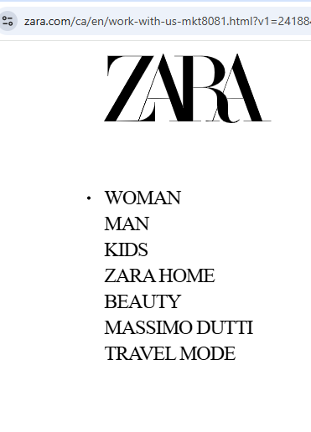
Source: https://www.zara.com/ca/en/work-with-us-mkt8081.html?v1=2418844
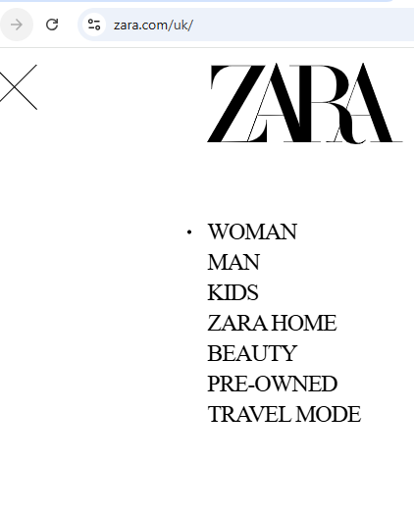
Figure 1 Zara UK Market segmentation and Targeting
Source: https://www.zara.com/uk/

Appendix-II
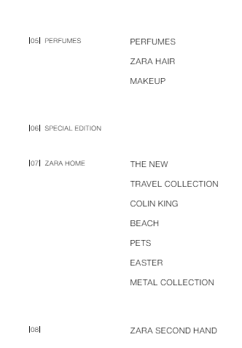
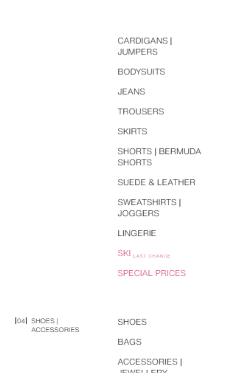
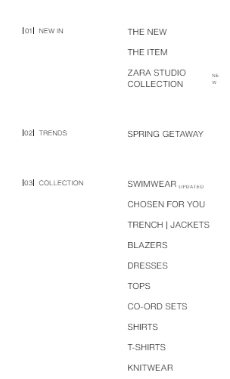

Figure 2 Zara Products categories

Appendix-III


Figure 3 Prices in Canada
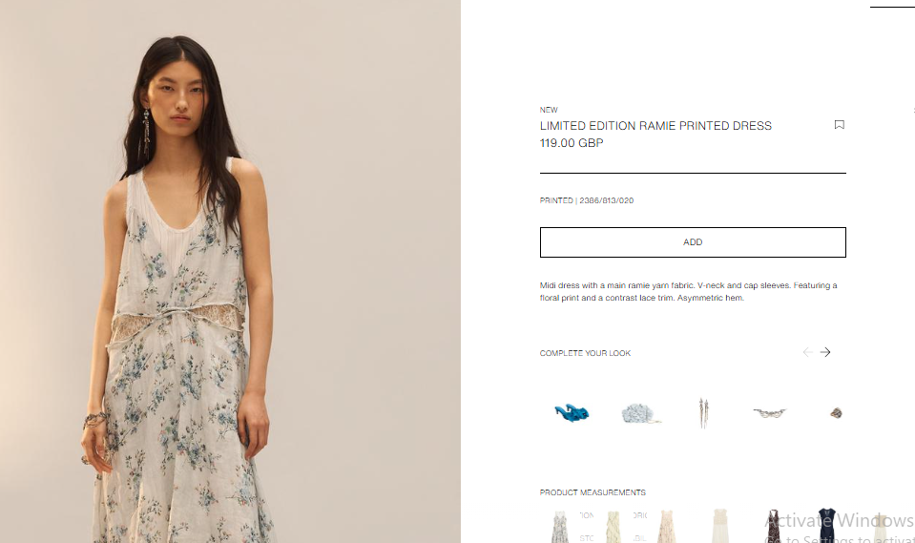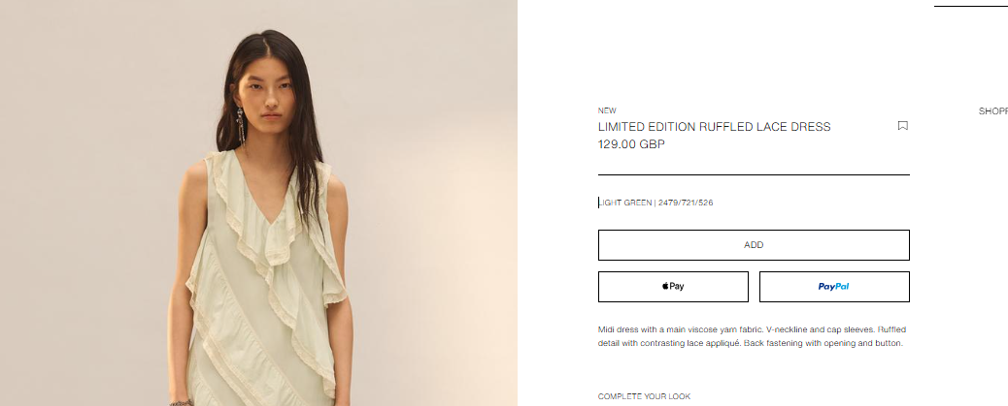
Figure 4 Prices in UK

Appendix-IV
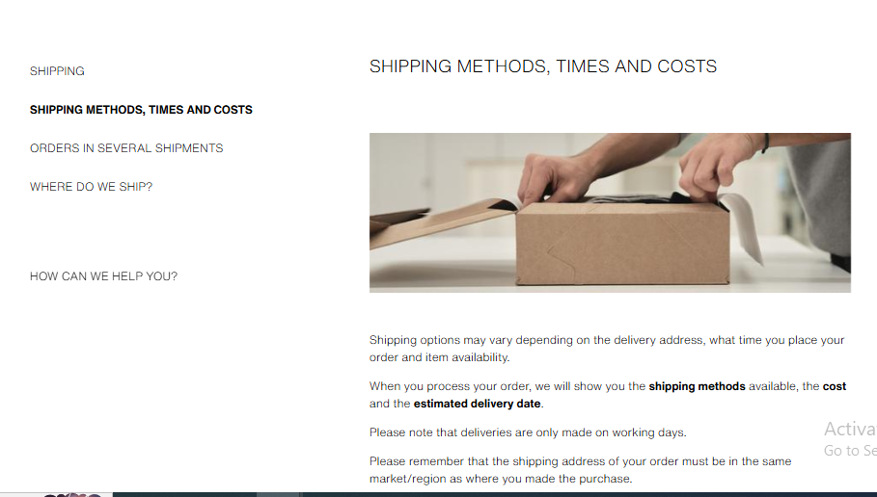
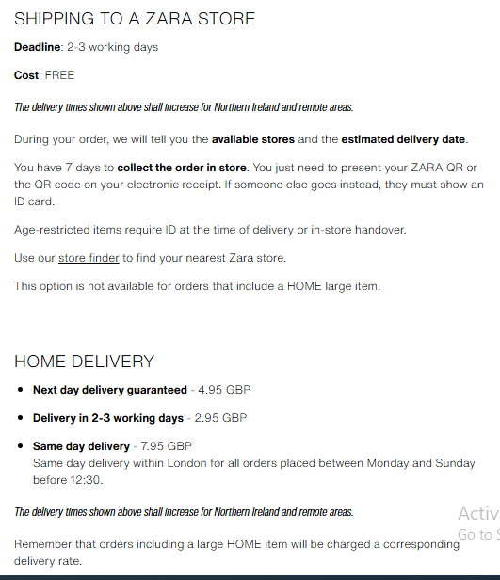
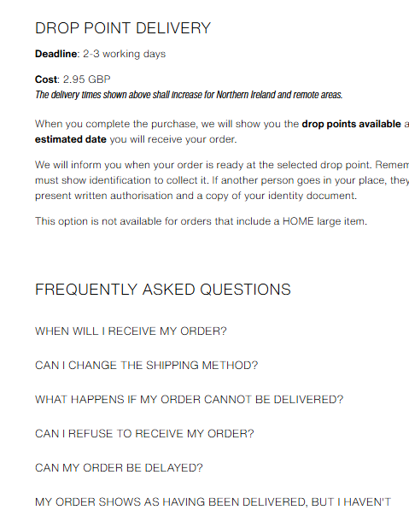
Figure 5 Shipping/placement strategy of ZARA

Appendix-V

Figure 6 Promotion strategy

Appendix-VII
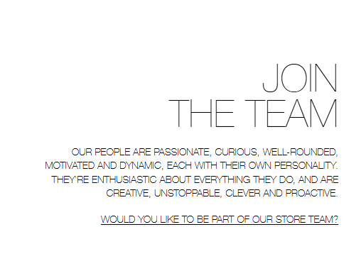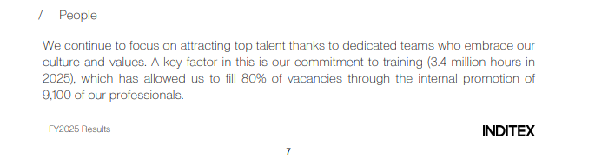
Figure 7 People Strategy

Appendix-VIII
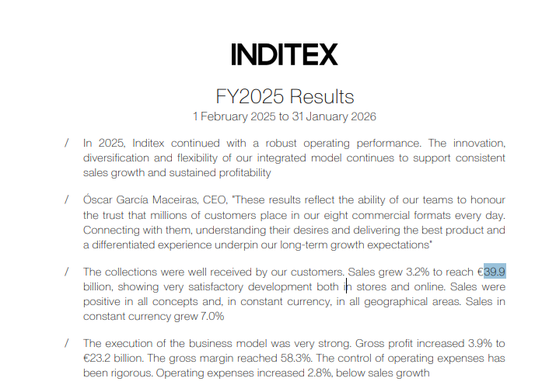
Figure 8 Sales growth by Zara

Appendix-IX
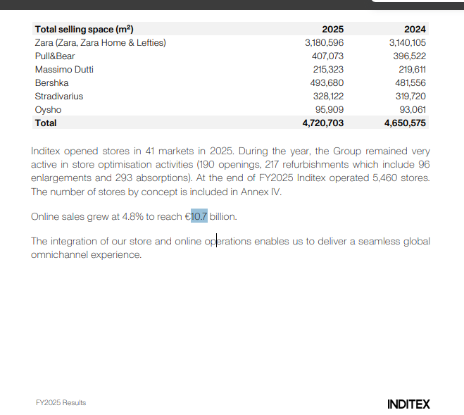
Figure 9 Zara's online Sales Growth

Appendix-X
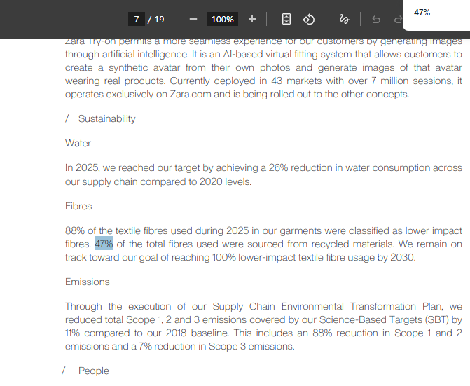
Figure 10 Sustainability at Zara

Appendix-XI
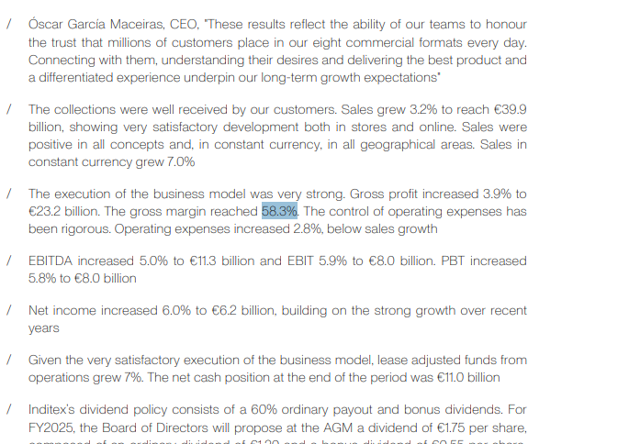
Figure 11 Profitability of ZARA

Appendix-XII Gibbs Reflective Model
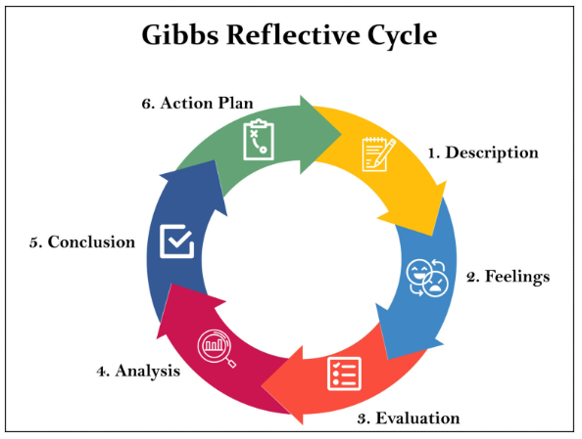
Source: https://www.simplypsychology.org/gibbs-reflective-cycle.html
Appendix-XIII;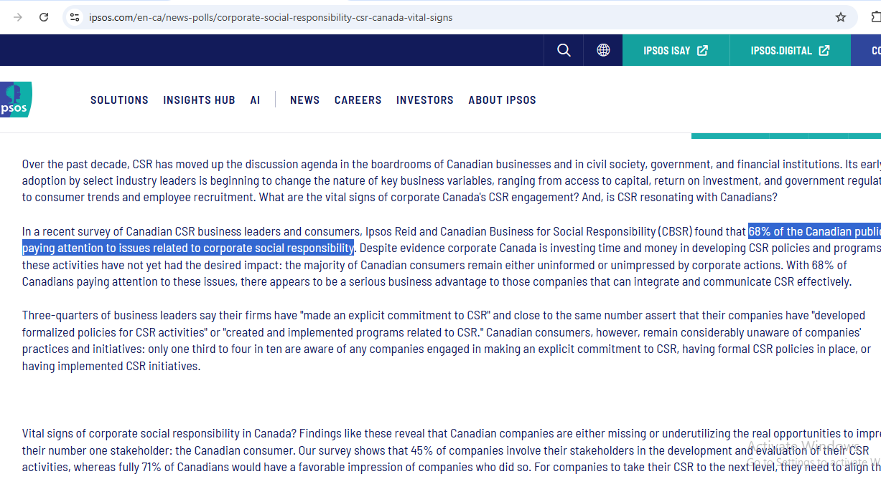
Source: https://www.ipsos.com/en-ca/news-polls/corporate-social-responsibility-csr-canada-vital-signs

Appendix-XIII
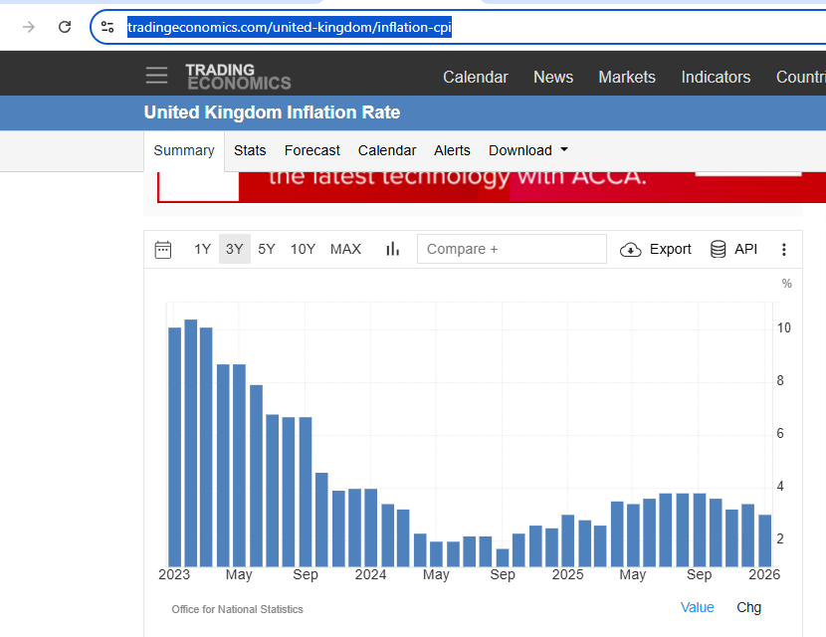
Figure 12 UK CPI
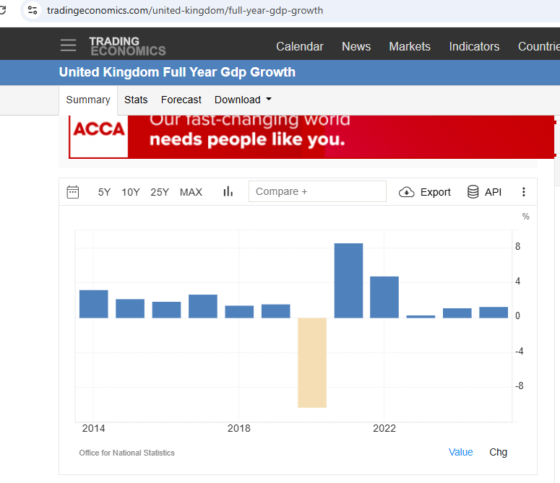
Figure 13 UK GDP
Appendix-XIV
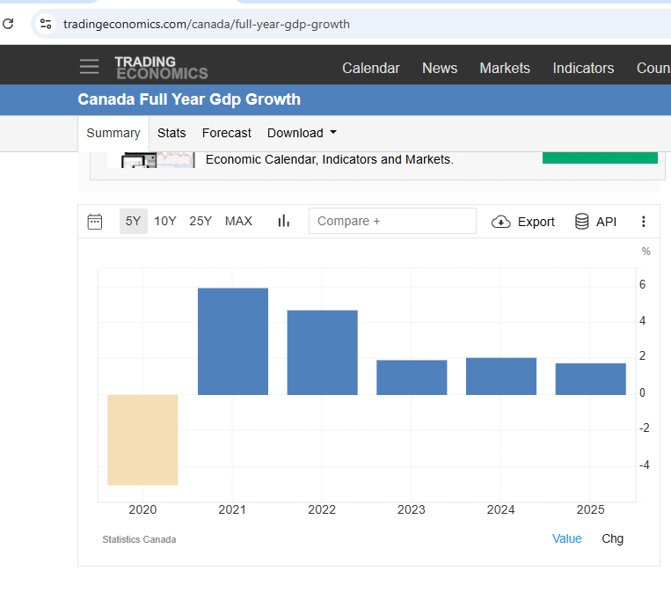
Figure 14 Canada GDP

Appendix-XV
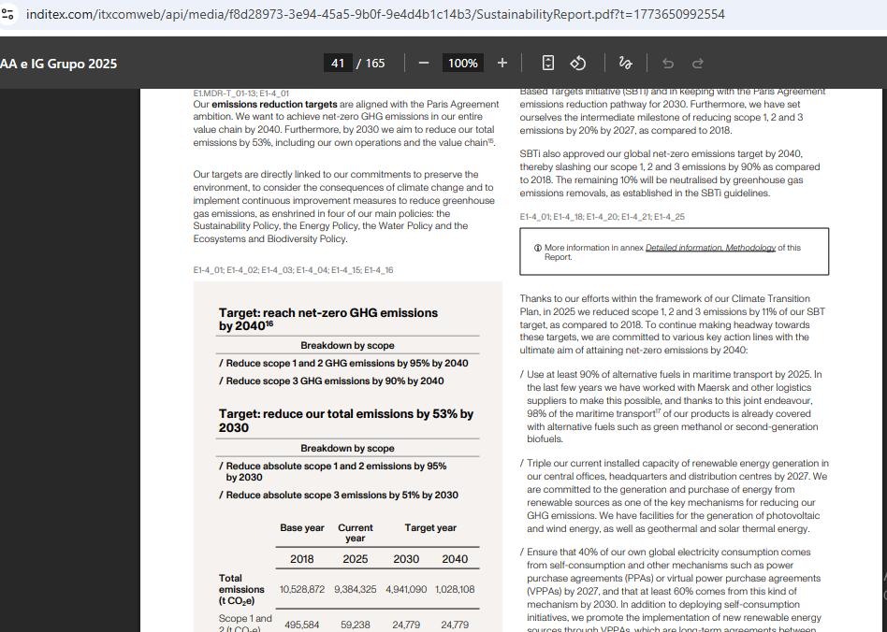
Figure 15 Reduction Scope 1, 2, and 3 emissions

