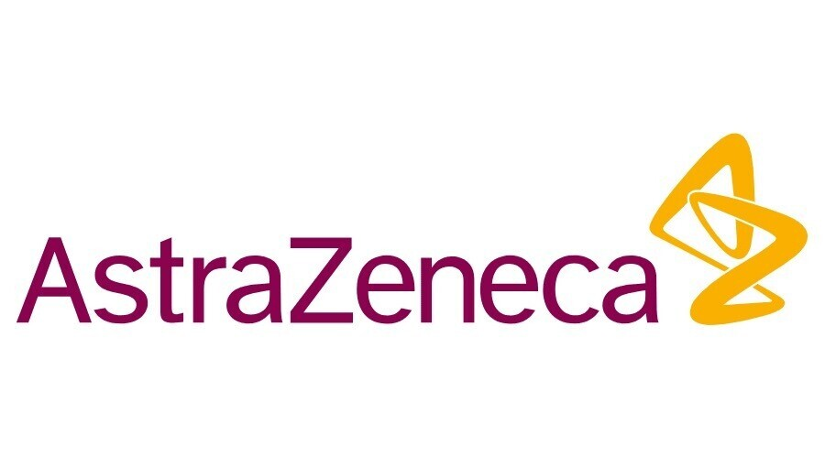
Strategic Management of AstraZeneca

Institution: Trinity Saint David
Programme: BA Business Management
Module: Strategic Management and Sustainability(LCBB6004)
Professor’s Name: Riaz Bhatti
Student Name: Darinka Corman (2029004)



Table of Contents
Introduction 3
Company Background 3
Key Business and Corporate Strategies 4
Ansoff Matrix 5
Porter's Generic Strategies 7
Resources and Capabilities Analysis 9
Porter’s Value Chain Analysis 9
VRIO Analysis 11
Business and Corporate Strategies Implementation 12
Environmental Sustainability 13
Future Strategic Direction and Sustainability Practices 14
Conclusion 15
Bibliography 16

Introduction
The stiff competition pressure in the globalised business environment necessitates the implementation of effective strategies to promote business success. Successful companies implement creative and unique strategies in achieving market dominance, market share growth, and profit optimisation objectives. The outcome implies that the strategic management process plays a crucial role in the survival and success of modern business organisations. Strategic management refers to the ongoing evaluation, monitoring, planning, and implementation of procedures and activities that facilitate the accomplishment of corporate objectives and goals (Lynch, 2015). The procedure enables management teams to understand their current situations, formulate and implement strategies, and assess implemented strategies' effectiveness in improving organisational performance. AstraZeneca relies on proper strategic management approaches in maintaining dominance within the global healthcare and pharmaceutical industry.

Company Background
AstraZeneca is a UK-based multinational pharmaceutical that emerged in 1999 through the Zeneca Group and the Astra AB. The multinational company develops, discovers, produces, and sells prescription drugs for diverse therapy areas, including respiratory, inflammation, neuroscience, metabolism, oncology, renal, vaccines, autoimmune, rare diseases, and cardiovascular diseases (Al Ghanem et al., 2021; GlobalData, 2023). AstraZeneca markets its pharmaceutical products under brand names like Iressa, Casodex, Onglyza, Diprivan, Zoladex, Accolate, Lynparza, Nexium, Tagrisso, Faslodex, Byetta, Symbicort, and Pulmicort. Today, AstraZeneca generates around $4.7 billion and $44.4 billion in annual profits and revenues, respectively (GlobalData, 2023). The company employs approximately 83,500 people, owns $96.7 billion in assets, boasts $199.2 billion in market capitalisation, and operates in over 100 nations globally (Yahoo Finance, 2023). The UK-based company serves speciality care and primary care physicians through its representatives and distributors in different nations internationally. The pharmaceutical company relies on innovation, effective marketing strategies, and a superior R&D program in maintaining competitiveness in different continents.
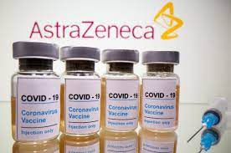
AstraZeneca Covid-19 Vaccine (Reuters, 2021)

Key Business and Corporate Strategies
Planning is an essential strategic management procedure that revolves around the identification of resources and time required in accomplishing organisational goals. Strategic planning operation entails reviewing, establishing, and transforming strategic priorities into actionable and quantitative plans. Notably, strategic planning requires managers to make proper strategic choices regarding operational areas and tactics for long-term goals and milestones achievements (Hanson et al., 2016). The decision-making process enables individuals to choose the right business-level and corporate-level strategies for their businesses. The corporate-level strategy entails making strategic choices regarding the general scope and direction of a company (Seifzadeh & Rowe, 2019). The decision-making procedure revolves around strategic organisational procedures like downsizing, vertical integration, joint ventures, divestments, acquisitions and mergers, expansion, and diversification. On the contrary, the business-level strategy focuses on tactics for improving the competitiveness of individual product lines/business units (Hill et al., 2017). Crucial business-level strategies for modern businesses include marketing campaigns, competitive pricing, and differentiation. In this scenario, the Ansoff Matrix and Porter's generic strategies provide details about corporate-level and business-level strategies for AstraZeneca, respectively.

Ansoff Matrix
The Ansoff matrix supports businesses in generating evidence that guides them in selecting appropriate corporate-level strategies. The strategic planning tool offers businesses four strategic choices for growth, including product development, diversification, market development, and market penetration. Diversification refers to a crucial business growth strategy that entails new product introduction under existing product lines. The corporate-level strategy supports AstraZeneca in maintaining competitiveness, innovation, and competence in the pharmaceutical market (Furrer, 2016). The pharmaceutical company utilises diversification strategies like vertical diversification, acquisitions and mergers, and horizontal diversification in achieving continuous growth objectives. Product development is also an essential corporate-level strategy that supports business expansion within an existing market (Johnson et al., 2017). AstraZeneca relies on its strong R&D (research and development) program in discovering new pharmaceutical products for existing markets. The multinational company utilises different strategies in supporting its product development initiatives such as R&D, new product launches, product modification, strategic partnership, and product quality improvement. Updates and modifications of existing pharmaceutical products enable the company to improve care provider satisfaction and patients’ welfare.
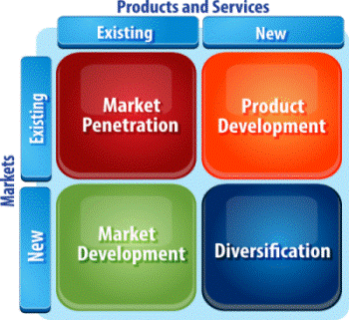
Ansoff Matrix (MSG, 2023)
Market penetration refers to the corporate-level strategy that enables existing products to grow within existing markets. Specifically, the strategy supports AstraZeneca in expanding its loyal customer base within its existing markets. The multinational company utilises market penetration strategies like reduced operational costs, enhanced distribution, improved marketing strategy, optimised production capacity, competitive pricing, competitor acquisition, and strategic partnerships. For example, strategic partnerships and improved distribution enable the company to access new customers within existing markets. Competitive pricing and improved marketing strategies enable the company to attract new clients within its existing markets globally. Finally, market development refers to the business growth strategy that revolves around existing products launched in new markets. The corporate-level strategy features activities like regional expansion, brand awareness creation, R&D, international expansion, and customer education (Morgan et al., 2018). The company depends on its R&D program in identifying potential clients and new markets for its pharmaceutical products. Notably, the product development approach enables AstraZeneca to pursue its internationalisation and market share growth objective.

Porter's Generic Strategies
Porter's generic strategies enable managers to assess and choose business-level strategies that improve their competitiveness within a specific industry. The strategy supports businesses in choosing tactics that help them in positioning themselves effectively within specific industries. Every generic strategy supports companies in maintaining focus on specific business-level strategies to ensure proper differentiation in their industries. AstraZeneca utilises three key generic business-level strategies in improving its competitiveness within the pharmaceutical industry, namely the focus strategy, differentiation, and cost leadership (Islami et al., 2020). Differentiation refers to a generic strategy that entails distinguishing brands and products to improve organisational competitiveness (Ali & Anwar, 2021). The pharmaceutical company combines scientific research and innovation in developing unique and high-quality products. The investment in innovative technology helps in addressing dynamic consumer interests and overcoming stiff competition pressure from other brands. The business-level strategy further improves the firm’s capacity to seize existing opportunities in the international pharmaceutical industry. The product/brand differentiation procedure further involves increasing investment and focusing on advanced marketing strategies like social bookmarking, social media marketing, and influencer marketing.
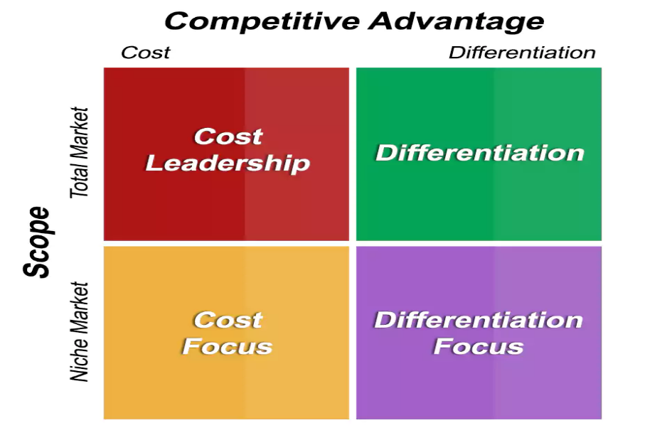
Porter's Generic Strategies (Shyamadanthi, 2023)
Focus strategy and cost leadership are business-level strategies that improve resource-use efficiency in improving organisational competitiveness within its specific industry. For instance, the cost leadership strategy features operational cost reduction procedures aimed at addressing competitive pressure in specific industries. AstraZeneca relies on the cost leadership tactic in supporting its competitive pricing strategy based on its desire to attract middle-class consumers (Barney & Hesterly, 2015). The strategy aligns with the company’s focus on making its products easily accessible and affordable for middle-income earners. The business-level strategy is associated with benefits like sales optimisation, customer base expansion, increased consumption, and quick brand recognition. The focus generic strategy motivates businesses to concentrate the required resources for business expansion. AstraZeneca capitalises on this business-level strategy providing the best value at low operational cost to create a balance between balance corporate interests and consumer needs. The value focus tactic entails stressing product design, size, and taste that suit clients’ requirements and needs.

Resources and Capabilities Analysis
Resources and capabilities serve as foundational elements for strategy creation and implementation in business organisations. The strongly interconnected foundational elements support firms in implementing their business-level and corporate-level strategies. Resources that facilitate strategy creation and adoption are broadly categorised into intangible and tangible resources. Tangible resources that support value-added processes in businesses include equipment, cash, building, plant, and raw materials. On the contrary, intangible organisational resources with beneficial impact on organisational processes include technology, intellectual property, organisational culture, skills and knowledge, and brand name. The resource-based theory describes capabilities as an organisation’s ability to perform tasks and achieve specific goals. Organisational capabilities comprise routines, skills, and knowledge that support resource sharing and deployment based on the need to accomplish certain goals. In this scenario, VRIO analysis and Porter’s value chain analysis frameworks illustrate resources and capabilities for AstraZeneca.

Porter’s Value Chain Analysis
Porter’s value chain serves as an important strategic management tool that helps in determining value creation in business organisations. The strategic management tool performs this function through the breakdown of organisational activities into relevant fragments. Specifically, Porter’s value chain categorises organisational activities into primary and supportive groups (Fearne et al., 2012). Primary organisational activities represent operations that facilitate the production, maintenance, and sale of products to targeted clients. Primary activities for AstraZeneca are categorized into service, inbound logistics, sales and marketing, outbound logistics, and operations. Regarding inbound logistics, AstraZeneca maintains strong relationships with suppliers to ensure timely access to high-quality raw materials. Various operational activities that enable the company to transform acquired raw materials into finished pharmaceutical products are testing, processing, machining, and packing. The outbound logistics element comprises activities like order processing, product distribution, warehousing, and collection. The company focuses on providing high-quality services to clients to improve their gratification and well-being. The process involves implementing an effective sales and marketing program to popularise brands and products among target consumers.
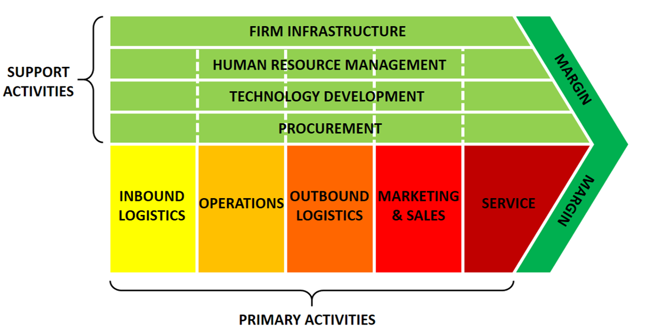
Porter’s Value Chain Analysis (de Bruin, 2018)
Support/secondary activities help in facilitating, reinforcing, and coordinating core/primary activities in the organisational value chain. Support activities for AstraZeneca are technology development, human resource management, procurement, and firm infrastructure. Firm infrastructure represents activities that strengthen the value chain, including legal matters handling, planning, quality management, and financing. The firm’s management understands that these activities can improve its competitiveness, which explains why they are not underestimated. Human resource management allows the company to capitalise on workforce skills, capabilities, and values in facilitating its core activities. AstraZeneca relies on its talented employees in supporting operational activities, sales and marketing, and service delivery processes. Similarly, technological development is an essential supportive activity for marketing, logistics management, and operational processes. For instance, advanced technology enables the management team to improve value chain activities without increasing operational costs. Finally, procurement ensures that acquired raw materials, equipment, and machinery meet the expected safety and quality standards.

VRIO Analysis
The VRIO test analyses resources to determine their capacity to offer organisations a competitive advantage in their markets. The assessment tool considers that organisational resources that give an organization a competitive advantage in the market are properly organised, inimitable, rare, and valuable (Knott, 2015). The analysis indicates that AstraZeneca maintains valuable resources like patents, financial capital, a talented workforce, advanced technology, and a marketing program to improve its competitiveness in the pharmaceutical industry. For example, adequate financial resources and a talented workforce allow AstraZeneca to develop high-quality, innovative, and safe products for its clients. The UK-based company depends on its rare financial capabilities, workforce, and products in differentiating itself within the global market. The fact that few pharmaceutical firms possess adequate financial capital implies that AstraZeneca is a dominant company in the industry. The company further provides pharmaceutical products that are difficult and costly to replicate. Finally, the company depends on its well-organised distribution networks and financial resources in maintaining a competitive advantage in the market.

Business and Corporate Strategies Implementation
Business organisations should utilise appropriate tools to ensure that selected strategies are implemented effectively in promoting objectives and goals accomplishment. Notably, the SAF (Suitability, Acceptability and Feasibility) framework serves as an effective tool for assessing business-level and corporate-level strategies implementation in business organisations. The assessment tool facilitates the assessment of the strategy implementation process based on criteria like feasibility, acceptability, and suitability. Suitability provides details regarding organisational strategy’s alignment with long-term goals. Acceptability demonstrates the effectiveness of an organisational strategy in satisfying stakeholders’ needs (Zolfani et al., 2021). The feasibility supports an individual in assessing the practicality of a specific corporate-level and business-level strategy. The company has implemented different strategies in optimising its competitiveness in the international pharmaceutical industry, namely diversification, differentiation, and competitive pricing. Table 1 below demonstrates the company’s success in implementing these corporate and business strategies in creating a competitive advantage over its rivals in the global pharmaceutical industry.
The SAF Model
Strategy | Suitability | Acceptability | Feasibility | Accept/Reject
Differentiation | The differentiation strategy aligns with AstraZeneca competitiveness optimisation goal. | The differentiation strategy addresses specific needs of different stakeholders, the company and its clients. | AstraZeneca relies on its financial resources, skilled employees, and advanced technology in facilitating the development of diversified products. | Accept
Diversification | Product diversification aligns with the company’s goal of continuous expansion and increased competitiveness. | Diversification focuses on satisfying diverse needs and taste of clients in the global pharmaceutical industry. | AstraZeneca has financial capability, infrastructure, and human capital to ensure effective implementation of its diversification agenda. | Accept
Competitive pricing | The competitive pricing technique aligns with the company’s need to maintain competitive advantage in the global pharmaceutical industry. | Competitive pricing enables AstraZeneca to promote product accessibility and affordability among middle income earners in the market. | Economies of scale allows the company to reduce operational cost and implement competitive pricing strategy without reducing its profit margins. | Accept

Environmental Sustainability
AstraZeneca has invested in an environmental sustainability program to promote environmental protection and conservation. The company’s environmental sustainability program features initiatives like net-zero healthcare and biodiversity protection (Fogel, 2016). For instance, the pharmaceutical firm has invested in renewable energy sources to minimise dependence on non-renewable energy sources, which has reduced its carbon footprint. Investment in renewable energy sources and energy-efficient equipment has enabled the company to reduce electricity consumption. The company has invested $400 million in a tree-planting program to expand the carbon sink (Carbon Credits, 2023). Investment in renewable energy sources has enabled the company to accomplish a 59.3% reduction in GHG generation since 2015 (AstraZeneca, 2022). The sustainability program has enabled the company to reduce waste production and water consumption by 18.6% and 18.7%, respectively, since 2015 (AstraZeneca, 2022). The sustainability initiative is expected to support the company in preventing environmental pollution and mitigating climate change.

Future Strategic Direction and Sustainability Practices
AstraZeneca can utilise different strategies in enhancing its competitiveness and promote its sustainability in the future. For instance, the company can increase financial allocation to its R&D program to strengthen its diversification and differentiation strategies. Notably, the program can enable the company to develop high-quality products and implement innovative strategies. AstraZeneca can rely on the R&D program to address dynamics in consumer demands, technologies, and regulatory policies. The focus on strategic partnerships can support the pharmaceutical company in minimising risks associated with new market entry. The tactic can allow the company to maintain strong supply chains by maintaining strong relationships with suppliers and distributors. Additionally, AstraZeneca should strengthen its environmental sustainability program to create higher energy efficiency and protect essential resources. Future sustainability programs for the company should address areas like 100% renewable energy usage, energy-efficient solutions, water conservation, and eco-friendly materials usage.

Conclusion
AstraZeneca depends on effective strategic management approaches in maintaining competitiveness in the international pharmaceutical market. Specifically, the UK-based company utilises business-level and corporate-level strategies to maintain its huge market share in the pharmaceutical industry. The business-level strategy for this multinational company comprises initiatives like focus strategy, differentiation, and cost leadership. The company also utilises a corporate-level strategy that features initiatives like market development, diversification, product development, and market penetration. AstraZeneca uses its resources and capabilities in supporting its business-level and corporate-level strategies. Properly organised, inimitable, rare, and valuable support the company in maintaining resilience to competitive pressure from dominant firms and new entrants in the pharmaceutical industry. The SAF model proves that this company has effectively implemented differentiation, diversification, and competitive pricing strategies in maintaining dominance in the market. AstraZeneca has strengthened its environmental sustainability program to improve stakeholders’ welfare and gain a competitive advantage.

Bibliography
Al Ghanem, K., Al Qubaisi, N., Al Zaabi, H., Al Dhahmani, L., Al Naqbi, A., Al Dhanhani, H., ...
& Nobanee, H. (2021). Financial Analysis of AstraZeneca. Available at SSRN 3895292.
Ali, BJ, & Anwar, G.(2021). Porter’s Generic Competitive Strategies and its influence on the
Competitive Advantage. International Journal of Advanced Engineering, Management and Science, 7(6), 42-51.
AstraZeneca. (2022). Environmental protection: Our approach to Environmental protection.
https://www.astrazeneca.com/sustainability/environmental-protection.html
AstraZeneca. (2022). Sustainability at AstraZeneca.
https://www.astrazeneca.com/sustainability.html
Barney, J. B. & Hesterly, W. S. (2015). Strategic management and competitive advantage:
Concepts and Cases. 5 ed. Essex: Pearson Education Limited.
Carbon Credits. (2023). Pharma’s AstraZeneca invests $400 million to plant 200 million trees.
Carbon Credits. https://carboncredits.com/astrazeneca-reforestation-initiative-carbon-credits/
Fearne, A., Martinez, M. G., & Dent, B. (2012). Dimensions of sustainable value chains:
implications for value chain analysis. Supply Chain Management: An International Journal, 17(6), 575-581.
Fogel, D. S. (2016). Strategic Sustainability: A Natural Environmental Lens on Organizations
and Management. 1 ed. New York: Routledge.
Furrer, O. (2016). Corporate level strategy: Theory and applications. Abingdon: Routledge.
GlobalData. (2023). AstraZeneca: Company profile. GlobalData.
https://www.globaldata.com/store/report/astrazeneca-plc/
GlobalData. (2023). AstraZeneca Plc: Company Profile. GlobalData.
https://www.globaldata.com/company-profile/astrazeneca-plc/
Hanson, D., Hitt, M. A., Ireland, R. D., & Hoskisson, R. E. (2016). Strategic management:
Competitiveness and globalisation. Melbourne: Cengage AU.
Hill, C. W. L., Schilling, M. A. & Jones, G. R. (2017). Strategic management theory. 12 ed.
Boston: Cengage Learning.
Islami, X., Mustafa, N., & Topuzovska Latkovikj, M. (2020). Linking Porter’s generic strategies
to firm performance. Future Business Journal, 6, 1-15.
Johnson, G. et al. (2017). Exploring Corporate: Text and Cases. 11 ed. Harlow: Pearson
Education Limited.
Knott, P. J. (2015). Does VRIO help managers evaluate a firm’s resources?. Management
Decision, 53(8), 1806-1822.
Lynch, R. (2015). Strategic management. 7 ed. Harlow: Pearson Education Limited.
Morgan, P., Brown, D. G., Lennard, S., Anderton, M. J., Barrett, J. C., Eriksson, U., ... & Pangalos, M. N. (2018). Impact of a five-dimensional framework on R&D productivity at
AstraZeneca. Nature Reviews Drug Discovery, 17(3), 167-181.
Seifzadeh, P., & Rowe, W. G. (2019). The role of corporate controls and business-level strategy
in business unit performance. Journal of Strategy and Management, 12(3), 364-381.
Yahoo Finance. (2023). AstraZeneca PLC (AZN).
https://finance.yahoo.com/quote/AZN/?guccounter=1&guce_referrer=aHR0cHM6Ly93d3cuZ29vZ2xlLmNvbS8&guce_referrer_sig=AQAAACMKIUld8ZQe6AzqTeHi5OBwlL-Ra7D5tXpyzNzI7AvzTWsaAinlZzlgF21GfFvTSPOsYmnAnyMxQOmAtS4l7pDUz8yW0QWxJcBXJnMwYKnx3tyEae_eFIlWWJ_9b6rbcdLBFwYxY2hBZh97q8Iym17dnZgHuNPUJmmQ5yHks0nC
Zolfani, S. H., Bazrafshan, R., Akaberi, P., Yazdani, M., & Ecer, F. (2021). Combining the
suitability-feasibility-acceptability (SFA) strategy with the MCDM approach. Facta Universitatis, Series: Mechanical Engineering, 19(3), 579-600.

