

Assessment 1 – Reading Task Template
PART 1: Upload your photo of your A3 in-class notes here:
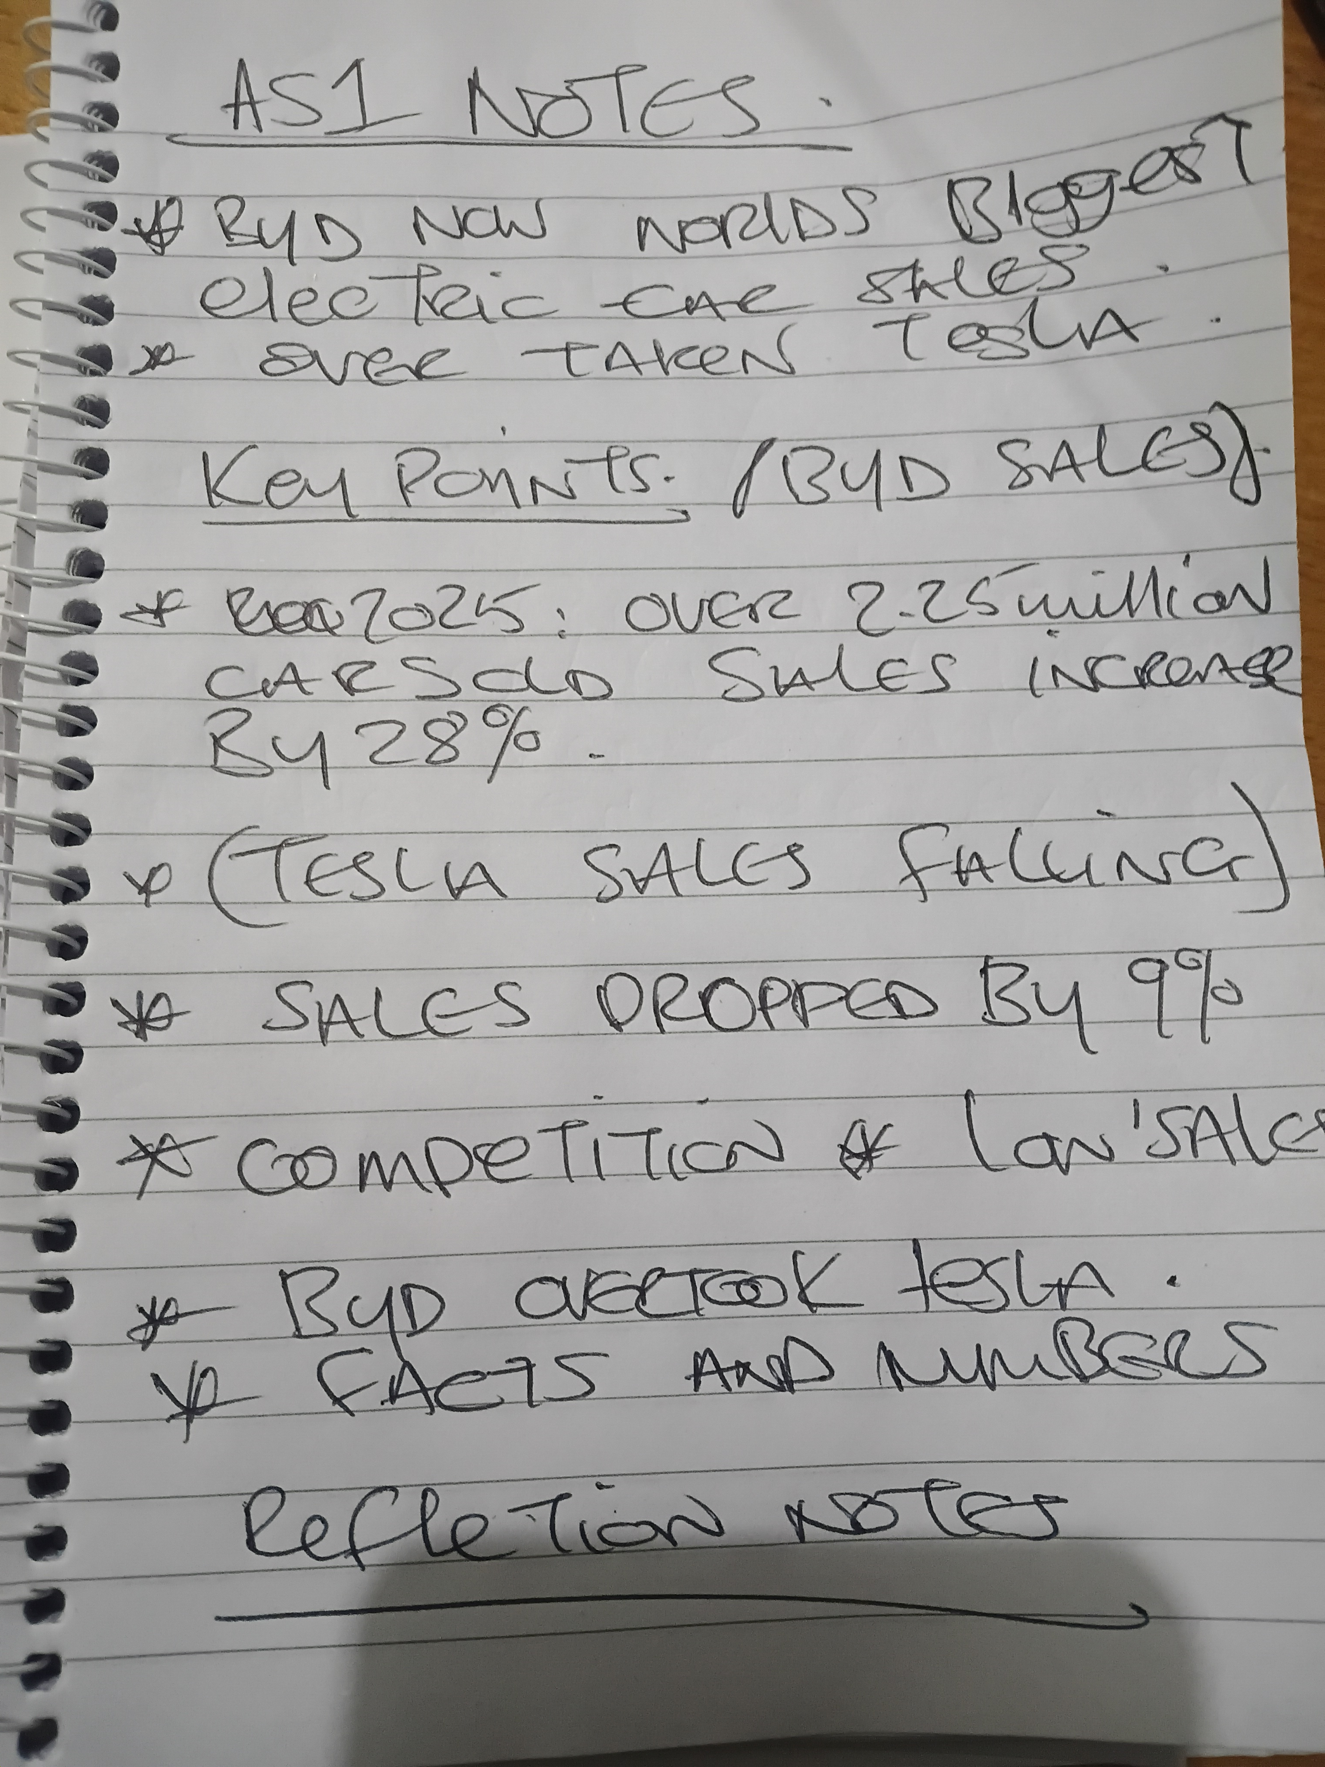

PART 2:
- Answer every question below in 1-3 full sentences.
- Use your own words. Do not use generative AI to answer these questions.
- Include a specific detail from the text when asked.
REMINDER
- The main idea is the overall message of the whole text.
- A key point helps to explain the main idea.
- A specific detail or example from the text shows that the key point is true.

- What is the main idea of the whole text?
The main idea of the text is BYD has become the biggest seller of electric cars. The text explains how tesla sales have gone down.

- What is one key point that supports the main idea, and which specific example from the text shows this?
One key point is the BYD is selling more cars then tesla. The evidence shows BYD have moved ahead of tesla in sales.

- What is a different key point that supports the main idea, and which specific example from the text shows this?
The text shows BYD sales have increased by 25% while tesla have dropped 9%. In 2025. This shows BYD is growing in the electrical market ahead of tesla.

- Which part of the text do you think is most important, and why?
The most important text is the comparison in sales
I think the most important part is the comparison in sales. This is important because of the evidence shown in the context.

Reflection:
- What did you find difficult in this task (including in-class components), and why was it difficult?
The most difficult part was the repeated context and the difference between them. The mind map also helped me to understand. The sales information also helped me to understand the main idea behind this task.

- What helped you with this difficulty, and how did it help you?
Reading the text repeatedly helped me to understand and memorise the main idea. The mind map also helped me a lot. The examples and sales figures helped me helped and a lot and made it easier to understand

