Sophie Evans (2108843)

Globally Responsible Business (BMS6001)

A debate for and against Voluntary CSR

Contents
Executive Summary 2
Introduction 2
Business puporse 2
Business Ethics 3
Corporate Social Responsibility 4
Position For Voluntary Reporting 5
Environment 6
Education 6
Employee Satisfaction 7
Position against voluntary reporting 8
Environment 9
Health 12
Ethics 13
Discussion 14
Conclusion 15
References 16

Executive Summary
The paper will analyse whether corporate social responsibility (CSR) should be mandatory or voluntary. It will also provide contemporary business practices that illustrate many viewpoints on the topic and provide an answer for whether CSR should be mandatory or voluntary.

Introduction
This essay will debate John Mackey noition that “Business social responsibility should not be coerced; it is a voluntary decicion that the entreperneurial leadership of every company must make on its own.” The paper will provide an overview of business, ethics, and corporate social responsibility (CSR). It will also present arguments for and against John Mackey's notion, citing important theorists and current business perspectives on both sides of the debate to reach a conclusion about whether or not Mackey's point of view is plausible.

Business puporse
The purposes of business have always been perceived to increase their revenue, according to CFI Team (n.d.) theorist Friedman states that “an entity’s greatest responsibility lies in the satisfaction of the shareholders.” As a result, the company should always aim to maximise its profits in order to raise shareholder returns. CEO`s of The Business Roundtable (n.d.) supported Friedmans notion that stated that maximising shareholder profit should be a corporation's primary goal, but this notion was overturned in 2019 and replaced with a new statement of purpose which stated that businesses should support their local communities, deal fairly with suppliers, deliver value to customers, and invest in employees in addition to serving shareholders. Drucker (2001) stated that businesses are part of society, as are organisations that provide public services. They exist to serve a certain social function and to meet the needs of a community, a society, or individual people rather than for their own sake. Yohn (2018) mentions that Mackey`s states that the purpose of business is to “create sustainable value for all stakeholders.” According to Shaywitz (2013) Mackey & Sisodias view is that the objective of business is to pursue a greater cause and to influence the world.

Business Ethics
Business ethics are according to Twin (2024) the moral principles, policies, and values that drive the way businesses and people participate in business activity. Svensson & Wood (2007) state that the three main elements of the business ethics model are expectations, perceptions, and evaluations. These are related by five smaller elements, which are: society expects; organizational values, norms and beliefs; outcomes; society evaluates; and reconnection. Having strong ethics within an organisation can according to Marquette University (2023) are essential to the long-term prosperity of a business. A corporation may build a solid reputation and foster brand loyalty by upholding high ethical standards. More and more stakeholders and customers demand that businesses uphold high moral standards. Whereas unethical behaviours can affect the reputation of a business and lead to consequences such as according to Duncan (2023) Insufficient connections with investors, stakeholders, suppliers, and consumers which reduce opportunities and profit, as well as a negative impact on the company's image and positioning, which could culminate in a decline in clientele and eventual closure. Employee morale and efficiency among workers would decline quickly. It is reasonable to anticipate financial fines and legal action would be actioned.

Corporate Social Responsibility
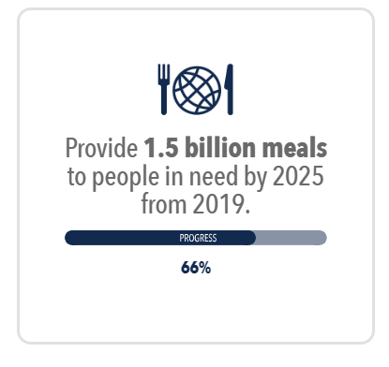
Corporate Social Responsibility (CSR) is according to Fernando (2024) enables a firm to be socially responsible to the public, its stakeholders, and itself. Companies that engage in CSR are conscious of their effects on the social, economic, and environmental facets of society. A corporation that practices corporate social responsibility (CSR) improves society and the environment rather than harming them. Gozdan & Sudolska (2019) mentions that companies that engage in corporate social responsibility (CSR) seek to offset the negative impacts of their activities because they care about the future well-being of future generations. However, they also want to establish their brands as being involved in specific environmental programmes and aiding local communities. Philanthropy is a part of CSR, according to the Odyssey Teams (2023) Kraft Heinz started the internet charity project Huddle to Fight Hunger in 2011. For every Facebook "like," a meal's worth of food was donated to food banks. This campaign combined name recognition, social media advertising, and philanthropic giving. According to Kraft Heinz (n.d.) currently they are committed to achieving their target of 1.5 billion meals for the underprivileged by 2025. They gave almost 334 million meals to those in need alone in 2022.
Fig 1 – Kraft Heinz (n.d)
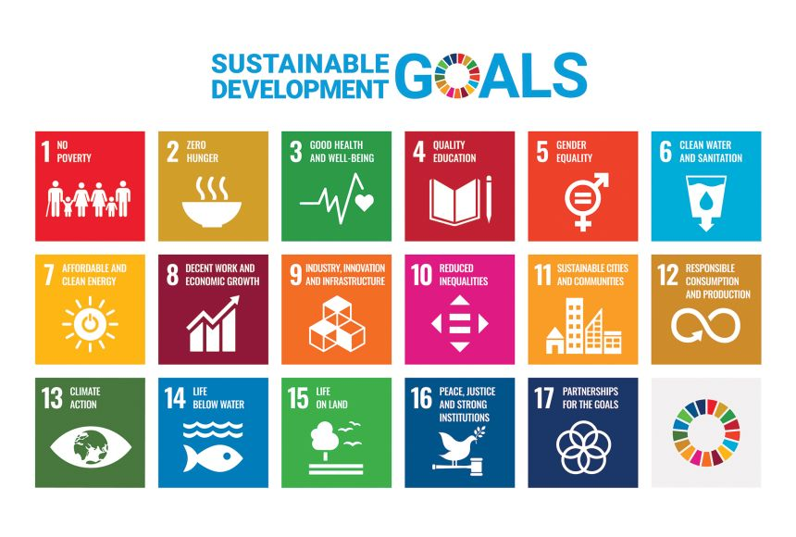
With an organisation such as Kraft Heinz working to alleviate global hunger, supports goal 2 – Zero Hunger of the 17 sustainable development goals.
Fig 2 - (National Geographic, n.d.)

Bcorp (n.d.) is a movement that was founded on the belief that a new, stakeholder-driven economic model could be led by business and that it was not only feasible but also essential. B Lab gained notoriety for accrediting B Corporations, businesses that adhere to strict criteria for accountability, transparency, and social and environmental performance.
With its 5 impact areas being Governance, Workers, Customers, Environment and Community.

Position For Voluntary Reporting
According to Gattie et al., (2018) the voluntary component is driven by the idea that, when management customises corporate social responsibility (CSR) to the unique needs of the sector or company, individual businesses are better equipped to adopt CSR and lower their social costs.

Environment
According to Friske et al., (2022) the growing number of organisations adopting the Global Reporting Initiative (GRI) standards or other comparable reporting frameworks over the past years is conclusive evidence that voluntary sustainability reporting is becoming more prevalent.
Corporations such as Uniliever (n.d.) are transitioning its business to utilise only renewable energy sources. They are innovating to identify new lower carbon components and reformulating their goods to provide plant-based alternatives and cleaning solutions that don't use fossil fuels, all while working directly with their suppliers. In order to improve the climate, Uniliever is also acting to stop deforestation in their supply chain and promote the growth of nature.
Unilever aims to achieve net zero emissions throughout its value chain by 2039 and a reduction of carbon emissions from its activities by 2030. Warnick (2020) mentions that Starbucks goal is “giving more than we take from the planet.” By storing more carbon than they produce, removing waste, and generating cleaner freshwater than they use, Starbucks hopes to achieve resource positivity. Due to a larger shift towards a circular economy, Starbucks plans to reduce carbon emissions by 50% by 2030. The company will also conserve or replenish 50% of the water currently used for direct operations and coffee production, as well as reduce waste sent to landfills from stores and manufacturing by 50%.

Education
A company that supports voluntary education is Lego and according to Kazachiner et al., (2023) a brand-new educational idea for teaching braille via play in an engaging and inclusive approach is Lego Braille Bricks, activities using LEGO Braille Bricks help blind adolescents gain specialised visual impairment abilities as well as academic skills that are routinely utilised in the classroom. Lego (2023) states that educational toolkits for Lego Braille Bricks are provided free of charge to certain organisations, educational institutions, and agencies that support the education of children with visual impairments. This innovative approach is remarkable as it enables learning via play, encourages braille learning among adolescents and offers inclusive education and opportunities for the visual impaired. Gadiraju et al., (2020) states that many blind children today grow up not knowing Braille because of the decline in Braille literacy in recent years. Learning Braille, however, can boost career prospects and develop comprehension skills. The use of Lego Braille Bricks has the potential to increase braille literacy.
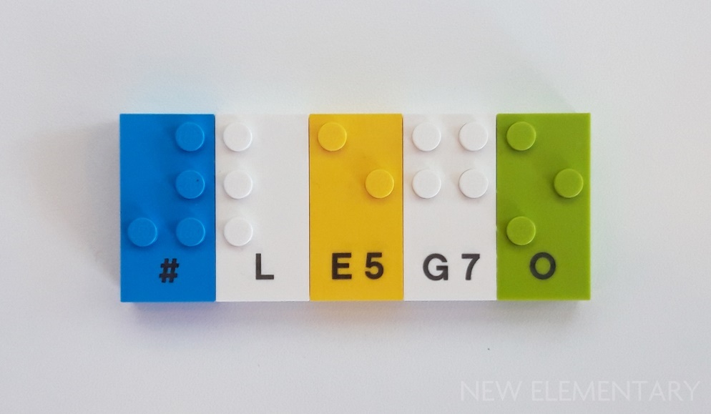

Fig 3 – Image of Lego Braile Bricks (New Elementry, 2020)

Employee Satisfaction
According to Hilton (n.d.) Hilton's Team Member Value Proposition is Thrive at Hilton. It provides perks, recognition, and assistance to satisfy professional needs that lead the industry, all of which contribute to the well-being and productivity of their team members. The characteristics that Hilton employees feel make the company a great place to work are expressed in Fig. 4 below.

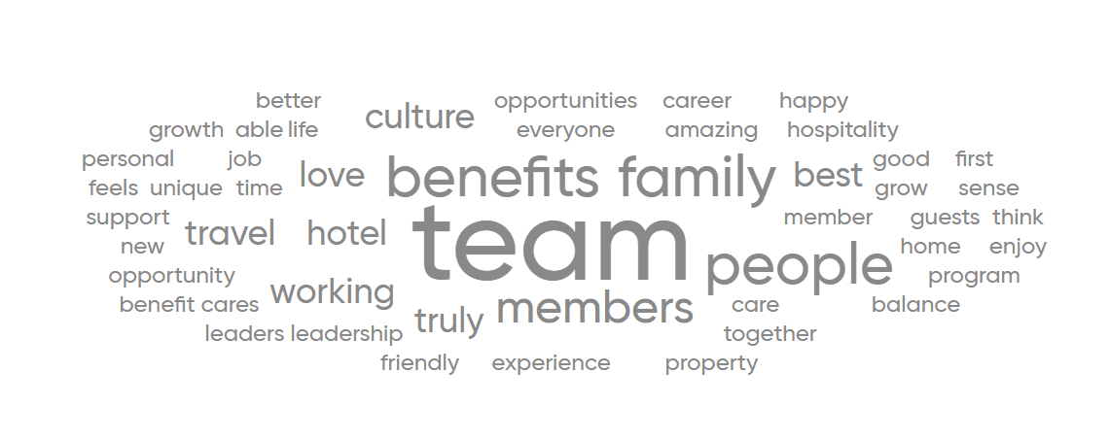
Fig 4 – Great Place to Work (2023)

According to Kim (2020) a company's voluntary CSR initiatives can provide employees a sense of accomplishment and pride. The growing needs of workers' quality of working life (QWL) can be positively impacted by voluntary CSR.

Position against voluntary reporting
Gattie et al., (2018) states that positive effects are produced by government action when corporate social responsibility is mandated. Particularly, making CSR mandatory increases awareness and can make it a legitimate governmental goal. The construction of regulated and comparable CSR metrics that eventually benefit the entire country may be facilitated by switching from a voluntary to a mandatory approach.
Not all business are concerned over the prospects of sustainability and society and focus on their prime goal which are profits.

Environment
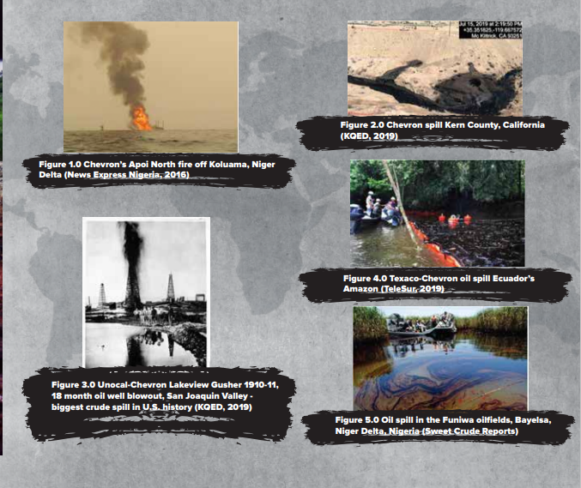
Howell (2023) Nearly 250,000 barrels of crude oil are produced daily by Chevron who are in the oil and gas industry. The court determined that Chevron purposefully disposed of billions of gallons of hazardous oil waste in the Amazonian provinces of Sucumbíos and Orellana, the firm was forced to pay $9.5 billion to rectify the social and environmental harm. Figs 5 & 6 represent what 1 companies’ actions can do to the environment, thus posing harm to the planet and society.
Fig 5 – Chevrons Global Destruction (Greer, 2021)
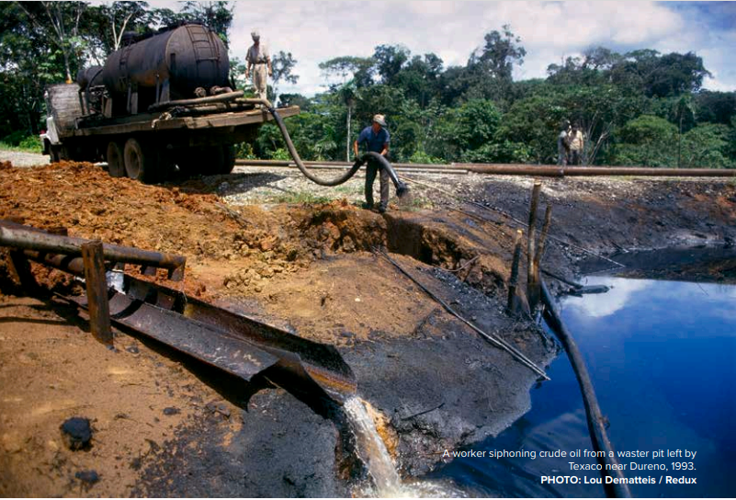
Fig 6 - (Greer, 2021)
These images demonstrate that Chevron engaged in unethical behaviour (deontological) and failed to evaluate the consequences of these actions. Whereas the repercussions of these activities include environmental and societal harm, as well as a significant penalties levied on Chevron.
Plastic is another issue causing environmental concerns, Geitmann -Mugge (2021) states that transnational firms such as Coca-Cola and PepsiCo are frequently held accountable for the worldwide plastic pollution issue since the majority of their goods are marketed in plastic. According to Moore (2020) 200,000 tonnes of plastic pollution, or around 8 billion bottles, are burned or disposed of by Coca-Cola annually in developing nations, Pepsi Co. contributes 137,000 tonnes of plastic pollution annually. According to Phelan et al., (2022) oceans, wildlife, public health, and economic activity are all under risk due to the hundreds of millions of plastic particles that are present in the environment. Fig 7 demonstrates companies progress and commitments on reducing or recycling plastic.

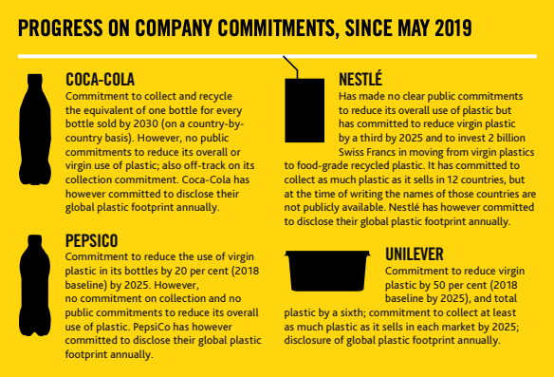
Fig 7 – (Moore 2020)
Businesses still need to explore for better solutions and take the circular economy into consideration since, despite their efforts, the amount of plastic that is disposed of into the environment on a daily basis still has detrimental effects.

Health
Every stakeholder values health, but do companies value it as much? Profit-driven companies that sell tobacco products, alcohol, unhealthy food, liquids even fossil fuel industries all have hidden costs to society; yet, by participating in voluntary CSR these companies just need to set the minimum standards for its social accountability. According to Rwafa (2023) tobacco products cause cancer, sugar-filled beverages that lead to obesity and coal generates carbon dioxide emissions. All of this is a result of standard corporate procedures that put profit ahead of health.
According to Hall et al., (2020) one of the main causes of the obesity pandemic in both children and adults is the intake of sugar-sweetened beverages (SSBs). GOV.UK (2020) states that one of the most significant health concerns the nation is facing is obesity. In England, one in three children leave primary school overweight or obese, while over two thirds (63%) of adults are overweight or suffer from obesity. The (NHS) spends £6 billion annually on obesity-related disorders. According to GOV.UK (2020) UK Governments have imposed restrictions on unhealthy foods in 2022 for medium and large business such as deals on unhealthy foods, such as "buy one, get one free," will be prohibited. In the restaurant industry, unlimited refills of sugar-filled soft drinks will also be forbidden. This is intended to encourage people across the country to make healthier decisions. Even with Governments implementing restrictions on unhealthy products, is that enough can more be done. According to Rossiter (2022) warning labels on beverages—whether text-only or text accompanied by graphic images of damaged human organs—are prohibited in the United States, the United Kingdom, and Australia.
Tissaoui et al., (2023) states that through societal and multisectoral initiatives, corporate social responsibility has the ability to improve population health and health inequalities. Research demonstrates that self-regulatory commitments as well as corporate social responsibility activities do not significantly enhance public health.
Voluntary CSR does not address the issue of health for society. Governments in the UK promote health alternatives by imposing restrictions, but mandated CSR might do more to assist society's overall health.

Ethics
Siano (2017) sates that in the context of marketing and corporate communication tactics, deceptive communication—also known as "greenwashing"—has become a common technique with the goal of concealing the most contentious parts of corporate sustainability. As consumer awareness increases and they desire to purchase eco-friendly products or services that support the environment, businesses take advantage of this and employ unethical market approaches such as greenwashing to deceive consumers.

Pellegrino (2023) states that McDonald's launched a programme in 2019 to cut down on the amount of single-use plastics used in their establishments. The primary goal was to switch out all plastic straws in its UK restaurants with paper straws that could be recycled. However, the company's new paper straws, were not recyclable. Even though McDonald's was aware of the environmental impact of their single-use plastic straws, their alternate choice was inadequate because it could not be recycled, increasing waste.
According to Kell (2022) Volkswagen was accused by the US Environmental Protection Agency in September 2015 of placing software in its diesel-powered vehicles to enable the cars to falsify emissions testing for the EPA. The actual Nitrogen Oxide (NOX) emissions from the automobiles were forty times greater than what was allowed by US regulations.

These unethical practices of greenwashing are deceiving, considering CSR imposed by businesses are meant to be transparent to its stakeholders.
Gatti et al., (2019) states that Combining voluntary and mandatory elements might improve the prevention of "greenwashing."

Discussion
Research indicates that while many organisations report voluntarily and make a conscious choice to operate responsibly in order to support society and the environment, there are still other organisations that do not adhere to these same values and should be held accountable for the adverse effects that their actions cause.

Companies that engage in voluntary CSR reporting are enhancing their value and demonstrating transparency to their stakeholders, while also employing new strategies for improvement of the environment and society. Implementing mandatory CSR could cause ramifications for firms that are already actively engaged in beneficial work, whilst being penalised for the actions of other companies.
However, there are many difficulties facing the world today, and they must be addressed rather than ignored if we are to prosper both socially and economically. Mandatory CSR may help society move towards a more optimistic and environmentally friendly future. Enforcing mandatory (CSR) through collaborative approaches between governments and cooperations could guarantee that all organisations are positively impacting the environment and society. Businesses may help achieve initiatives like the Paris Climate Agreement, the Future Generations Act, and the 17 Sustainable Goals through the implementation of mandatory CSR. Each organisation has a responsibility to the environment, society, and the next generation.

Conclusion

In order to generate opinions on both sides of the controversy, this paper has included evidence for and against voluntary CSR, along with examples from contemporary business practices.

Although several firms have implemented CSR initiatives to promote environmental and societal well-being, persistent difficulties persist among profit-driven companies that prioritise financial gains over the interests of stakeholders, resulting in detrimental effects on society and the world.

Contrary to John Mackey's argument that CSR should be voluntary, the implementation of mandatory CSR reporting is necessary as we must take immediate action and make the best decisions for the environment and society. Whilst also taking into consideration about the next generation and make sure that the earth is still a prosperous and thriving ecosystem for them to live in. A prosperous future may be achieved by businesses collaborating with other agencies to support all of the objectives that are enforced, such as the Paris Climate Agreement and the Sustainable Development Goals.

References
Alfanso Siano, A. V. (2017, February). "More than words" : Expanding the taxonomy of greenwashing after the Volkswagen scandal. Journal of Business Reserch, 71, 27-32. Retrieved from https://www.sciencedirect.com/science/article/pii/S0148296316306154?casa_token=mu-56Xav0xUAAAAA:2MnznRfZVPcsgQQFwcE3jXNoh59ZX9LvhXb_XqjT82SofU7cz95Nt-dZN-BBSABAgXr8nWoU
Anna (Anya) Phelan, K. M. (2022, January). Plastic pollution and packaging: Corporate commitments and actions from the food and beverage sector. Journal of Cleaner Production, 331. Retrieved from https://www.sciencedirect.com/science/article/pii/S0959652621040014?casa_token=QuDA_HfmqKYAAAAA:-zeLol8J5TvPzDNISIhc-0pvEuH6TIqoo-0lkU6JA38uy3yR5F4XIICWzEw2RFgWw45Bu195
Business Roundtable. (n.d.). Business Roundtable. Retrieved March 2024, from One Year Later: Purpose of a Corporation: https://purpose.businessroundtable.org/
CFI Team. (n.d.). CFI. Retrieved from Friedman Doctrine: https://corporatefinanceinstitute.com/resources/equities/friedman-doctrine/
Corp, B. (n.d.). About B Lab. Retrieved from B Lab is the nonprofit network transforming the global economy to benefit all people, communities, and the planet.: https://www.bcorporation.net/en-us/movement/about-b-lab/
Drucker, P. F. (2001). The Dimensions of Management. In P. F. Drucker, The Essential Drucker. Retrieved from https://www.taylorfrancis.com/chapters/mono/10.4324/9780080939322-2/dimensions-management-peter-drucker
Duncan, S. (2023, March). Real Business. Retrieved from Unethical Business Practices: https://realbusiness.co.uk/unethical-practices-in-business
Fernando, J. (2024, March 6). Investopedia. Retrieved March 9, 2024, from What Is CSR? Corporate Social Responsibility Explained: https://www.investopedia.com/terms/c/corp-social-responsibility.asp
Geitmann-Mugge, L. (2021, May). Reserch Gate. Retrieved from Plastic Pollution - Crisis, Problem, or Business Opportunity?: https://www.researchgate.net/profile/Luisa-Geitmann-Muegge/publication/353604782_Plastic_Pollution_-_Crisis_Problem_or_Business_Opportunity_A_deconstructive_analysis_of_Coca-Cola's_sustainability_communication_as_organisational_crisis_response/links/6208e
GOV.UK. (2020, December). GOV.UK. Retrieved from Promotions of unhealthy foods restricted from April 2022: https://www.gov.uk/government/news/promotions-of-unhealthy-foods-restricted-from-april-2022
Greer, D. N. (2021). Retrieved from CHEVRON’S Global Destruction Ecocide, Genocide and Corruption: http://www.letsbeatchevron.org/assets/files/chevrons_global_destruction_report.pdf
Hilton. (n.d.). Hilton. Retrieved from BENEFITS INNOVATIVE PROGRAMS AND PERKS FROM ​A GLOBAL LEADER: https://jobs.hilton.com/us/en/benefits#:~:text=Our%20approach%20to%20recognition%20is,Warmth%20Award%20our%20highest%20honor.
Howell, B. (2023, October). The Eco Experts. Retrieved from The top 14 most polluting companies: https://www.theecoexperts.co.uk/blog/most-polluting-companies
Hyelin Kim (Lina), Y. R. (2020, May). Why hotel employees care about Corporate Social Responsibility (CSR): Using need satisfaction theory. International Journal of Hospitality Management, 87. Retrieved from https://www.sciencedirect.com/science/article/pii/S0278431920300578?casa_token=rJ8Ks6r-a4QAAAAA:bFPiBq5xmuw2uVjUGdqyqC-GT0KYnQZW6WLDbSJIT-QsAa1xDA1yxauYVKoLqiLPL9JnhiPd
Kazachiner O.S, B. Y. (2023). DSpace. Retrieved from Learning through play with lego Braille Brick: https://dspace.hnpu.edu.ua/items/12c9650c-0c14-4012-9c3c-41addf2b7048
Kell, G. (2022, December). Forbes. Retrieved from From Emissions Cheater To Climate Leader: VW’s Journey From Dieselgate To Embracing E-Mobility: https://www.forbes.com/sites/georgkell/2022/12/05/from-emissions-cheater-to-climate-leader-vws-journey-from-dieselgate-to-embracing-e-mobility/
Kraft Heinz. (n.d.). Kraft Heinz. Retrieved March 2024, from Working to alleviate global hunger: https://www.kraftheinzcompany.com/esg/food-security.html
Lego. (2023, August). Lego. Retrieved from Bringing Braille Fun Home: LEGO® Braille Bricks on Sale for the First Time: https://www.lego.com/en-gb/aboutus/news/2023/august/lego-braille-bricks-play-with-braille-
Lucia Gatti, B. V. (2018). Are We Moving Beyond Voluntary CSR? Exploring Theoretical and Managerial Implications of Mandatory CSR Resulting from the New Indian Companies Act. Journal of Business Ethics, 160, 961-972. Retrieved from https://link.springer.com/article/10.1007/s10551-018-3783-8
Lucia Gatti, P. S. (2019). Grey Zone in - greenwash out. A review of greenwashing reserch and implications for the voluntary - mandatory transition of CSR. IOnternational Journal of Corporate Social Responsibility, 4. Retrieved from https://link.springer.com/article/10.1186/s40991-019-0044-9
Marissa G. Hall, A. J. (2020, March). Science Direct. Retrieved from The impact of front-of-package claims, fruit images, and health warnings on consumers' perceptions of sugar-sweetened fruit drinks: Three randomized experiments: https://www.sciencedirect.com/science/article/pii/S0091743520300220?casa_token=pVtXprzhZXYAAAAA:J4uZ08gLkBy_2JNBpksDshloCJcxy96RjB7pa2-PJ8xUYp5dA9vu80jEVq-wT0vxbFthXTJ8
Marquette University. (2023, July). Marquette University Business. Retrieved from Why are ethics important in business?: https://online.marquette.edu/business/blog/why-are-ethics-important-in-business#:~:text=Business%20ethics%20play%20a%20vital,corporations%20to%20have%20strong%20values.
Moore, D. (2020, March). Circular. Retrieved from Eight billion Coca-Cola bottles burnt or dumped each year, study finds: https://www.circularonline.co.uk/news/eight-billion-coca-cola-bottles-burnt-or-dumped-each-year-study-finds/?gad_source=1&gclid=CjwKCAjw17qvBhBrEiwA1rU9w0ayQlokchQUUAjc7ZHJlgrVpOwpTr-Vt-aCYUKLUpgeE0NtInNhwhoCT4gQAvD_BwE
National Geographic. (n.d.). National Geographic. Retrieved from Sustainable Development Goals: https://education.nationalgeographic.org/resource/sustainable-development-goals/
New Elementry. (2020, August). New Elementry. Retrieved from Free LEGO® Braille bricks released by The LEGO Foundation [IMAGE]: https://www.newelementary.com/2020/08/free-lego-braille-bricks-released-by.html
Odyssey Teams. (2023, February). Odyssey Teams. Retrieved from 20 Inspiring Corporate Philanthropy Examples: https://odysseyteams.com/corporate-philanthropy-examples/
Pellegrino, S. (2023). Capital Mentor. Retrieved from Explainer: Household brands accused of greenwashing: https://capitalmonitor.ai/sector/consumer/explainer-household-brands-accused-of-greenwashing/
Rossiter, J. R. (2022, July). Wiley Online Library. Retrieved from “Sugary drinks” and graphic warning labels: Critique of a recent U.S. study of parents' beverage choices for their children: https://onlinelibrary.wiley.com/doi/full/10.1002/cb.2092#:~:text=2.3%20Illegal%20and%20deceptive%20sugar,by%20Hall%20et%20al.
Rwafa, T. (2023, March). The Conversation. Retrieved from Profit versus health: 4 ways big global industries make people sick: https://theconversation.com/profit-versus-health-4-ways-big-global-industries-make-people-sick-202368
Shaywitz, D. (2013, February). Forbes. Retrieved from Five Take-Aways From Whole Foods CEO John Mackey's Surprising New Book: https://www.forbes.com/sites/davidshaywitz/2013/02/16/five-take-aways-from-whole-foods-ceo-john-mackeys-surprising-new-book/
Sudolska, E. G. (2019). Exploring Company’s Activities in the Field of CSR: The Case of Starbucks. Journal of Corporate responsibility and leadership, 6(2), 29. Retrieved from https://apcz.umk.pl/JCRL/article/view/JCRL.2019.006/28397
Takwa Tissaoui, T. D. (2023, December). National Library of Medicine . Retrieved from Health policy implications of corporate social responsibility provisions in international investment agreements: https://www.ncbi.nlm.nih.gov/pmc/articles/PMC10835630/#R1
Twin, A. (2024, January). Investopedia. Retrieved from What Is Business Ethics? Definition, Principles, and Importance: https://www.investopedia.com/terms/b/business-ethics.asp
Unilever. (n.d.). Unilever. Retrieved from Climate Action Taking a Stand: https://www.unilever.com/planet-and-society/climate-action/taking-a-stand/
Vinitha Gadiraju, A. M. (2020, April). ACM Digital Library. Retrieved from Braille Blocks: Computational Braille Toys for collabirative learning: https://dl.acm.org/doi/abs/10.1145/3313831.3376295
Warnick, J. (2020, January). Starbucks Stories & News. Retrieved from 5 things to know about Starbucks new environmental sustainability commitment: https://stories.starbucks.com/stories/2020/5-things-to-know-about-starbucks-new-environmental-sustainability-commitment/
Wesley Friske, S. A. (2022, June). The impact of voluntary sustainability reporting on firm value: Insights from signaling theory. Journal of the Academy of Marketing Scirence, 51, 372-392. Retrieved from https://link.springer.com/article/10.1007/s11747-022-00879-2
Wood, G. S. (2007, March). A Model of Business Ethics. Journal of Business Ethics. Retrieved March 2024, from A Model of Business Ethics: https://link.springer.com/article/10.1007/s10551-007-9351-2
Work, G. P. (2023). Great Placer to work. Retrieved from Hilton: https://www.greatplacetowork.com/certified-company/1000367
Yohn, D. (2018, February). Linkedin. Retrieved from What Is the Purpose of Business?: https://www.linkedin.com/pulse/what-purpose-business-denise-yohn#:~:text=Free%20enterprise%20capitalism%20has%20been,humanity%20upward%20for%20continuous%20improvement.%E2%80%9D

