Destination Management: Venice



Name: Sophie Edmunds
Student Number: 2100303
Module Title: Sustainable Hospitality & Tourism Management
Module Number: BMIH5006
Lecturer’s Name: Ruth Taylor-Davies

Word Count: 2,051

Table of Contents
Executive Summary 3
Introduction 4
Principles of Sustainable Tourism: An Evaluation of Venice 4
The Travel Aspect of the Tourism Industry 6
Recommendations 7
Conclusion 9
Appendices 10
References 12

Executive Summary
In this report, an analysis of Venice’s Destination Management Plan has been reviewed. It has discovered that Venice has been declared a ‘sinking city’ and requires urgent action to repair the damage that will become irreversible. The City has already begun taking action to tackle over tourism and global warming, from the promotion of sustainable marketing around the city to encourage visitors and residents to respect the environment, culture, architecture, and heritage and has acted towards these changes by charging tourist taxes, banning cruise ships, and imposing tighter restrictions on short-term rental properties to address the housing crisis Venice is currently facing.
Furthermore, an evaluation of the technological advances having an impact on tourism has shown that social media sites such as Instagram and cheap airline flights have contributed towards the influx of visitors. An application of Doxey’s Irridex Model of 1975 and Butler’s Life Cycle Model of 1980 has been applied and analysed in comparison to Venice and has implied the stages where it finds the city.
There have been recommendations discussed based on the information gathered, written alongside the case study of the DMP that closely connects with the actions Venice is taking to confront the changes it urgently needs to make its journey towards a sustainable future, and suggestions upon how it can undertake the issue of flooding.
A conclusion follows thereafter which summarises the findings. Appendices and references can be located to examine references that link to the main body of discussion throughout the report.

Introduction
A destination that is deemed by Maddy (2023) as the “City of Water” famous for its picturesque scenery, elegant bridges, gondolas, and romantic canals, the impact tourism has had upon Venice, Italy has been major (Simmons, 2023), (Eaglescliffe, 2023). The city has become overrun with crowds. On average, 20 million people visit the destination each year (Simmons, 2023). It is home to just 641,000 residents (PopulationStat, 2023). Tourists who have visited famous landmarks are contributing to infrastructure damage, and fragile buildings and inhibit local people from their daily lives making the experience in Venice rather worn and run down (Simmons, 2023). Furthermore, Hardy (2019) states that Venice is on the concourse of becoming “a sinking city”. Hardy (2019) continues to say Venice has seen a “50cm rise in sea levels and could see the city vanish beneath the waves.”
This report will evaluate the tourism of Venice, Italy, and the principles of sustainable tourism, looking at the three pillars of sustainability and development. Also, practices will be identified of organisations responsible for implementation and analysis of the travelling aspect of the industry, with reference to academic theories, a case study and the use of data and statistics. There will then be recommendations for the future development of Venice with sustainability as the priority of the subject and the use of Venice’s Destination Management Plan (DMP) will be used as the case study of this report (Citta’ Di Venezia, 2017).

Principles of Sustainable Tourism: An Evaluation of Venice
At the outset, destination management after the Covid-19 Pandemic has encouraged innovative solutions and requirements to understand the nature of the impact it had on tourism from mass unemployment to economic loss and uncertainty (Gowreesunkar, et al. 2021, pg. 1-2). Moreover, in an article by Milo (2022), the issue of sustainability has become imperative with the ominous threat of climate change, rising temperatures, and resource waste, with Booking.com’s Sustainable Travel Report (2022) stating that “81% of global travellers said that travelling sustainably is important to them.” Together with the Paris Agreement of 2015, whereby every country worldwide must find their own solutions to become net zero and follow the seventeen Sustainable Development Goals* (SDGs) by as soon as 2030 (*Refer to Appendix 1), (UN, 2023), (UNFCC, 2023) It can be possible for a city like Venice to reach its targets.
Therefore, principles of sustainable tourism must be closely analysed to connect with Venice and how these are affecting the development of the city. Ecobnb (2022) says “Sustainable tourism is a matter of principle, separates itself from mass tourism.” Here, the three pillars of sustainability: economic, socio-cultural, and environmental can be analysed in relation to Venice (UN, 2023).
With information from Citta’ Di’ Venezia (2017), Venice has been working on aiming to tackle the threat of irreversible damage to the community of Venice, its heritage, and its environmental impact. Their Destination Management Plan is inspired by three principles: “innovation, sustainability and the promotion of what the Venetian territory has to offer culturally.”
According to the UNWTO (2023), sustainable tourism should make “optimal use of environmental resources” which means to conserve and respect “natural heritage and biodiversity.” An example of how Venice is addressing this issue is by encouraging the community and visitors to get involved, such as by travelling to and around Venice using public transportation, to consider the choices of transport to get to Venice that are responsible and use fewer carbon emissions, respecting common spaces by not leaving rubbish in the areas tourists visit and not to waste food, avoid using plastic bottles and to make use of their ‘wastebaskets’ and restrooms around the city, avoiding the wastage of water (La Biennale Di Venezia, 2023).
Additionally, the UNWTO (2023) article defines the sociocultural principle by respecting the “authenticity of host communities, conserving their built and living cultural heritage”. Venice recognises that the city shares the status of a World Heritage Site, and the root of Venice’s tourism boom can be linked to the technological and digital evolution that has been inadequately controlled (Citta Di’ Venezia, 2017, pg. 7-8). To respect and conserve the natural environment of Venice, recently according to Reid (2022), the destination is now introducing an entry fee for day-trippers. Moreover, Reid continues, saying that “cruise ships have been banned to prevent and deter day-trippers from filling up the narrow streets” to encourage improvement in “the quality of tourism and overall experience.”
Another way Venice is attempting to tackle some of the socio-cultural issues in the area is what Caradonio (2021) says is “imposing tighter restrictions on the thousands of short-term rentals contributing to the cities' housing crisis.” To monitor the headcount of visitors and preserve the culture of the city.
Furthermore, the DMP report by Citta Di’ Venezia (2017, pg. 16) states that “foreigners make up 85% of the entire tourist market” which is ideal economically but is not sustainable, as the Covid-19 Pandemic proved to damage the economy of these destinations that relied heavily on tourism (Momigliano, 2021). The UNWTO (2023) refers to being sustainably economically long-term is to provide “socio-economic benefits to all stakeholders that are fairly distributed.” The article continues by saying this involves “stable employment and income-earning opportunities and social services in host communities.” One way Venice is attempting to address this issue is by encouraging ‘Detourism’ which promotes slow and sustainable tourism, encouraging visitors to explore further than the popular landmarks to spread out the volume of people in one area and spend time and money in other parts of the lagoon islands and mainland Venice (Venezia Unica, 2023).
These regulations implemented in Venice have been overseen by the Deputy Mayor of Venice for Tourism, Simone Venturini. Domus Forum (2023), state he is the body that “cooperates between public and private organisations to develop quality tourism” that is aligned with the city’s shared views and goals of over-tourism.

The Travel Aspect of the Tourism Industry
The transport industry has globalised countries by providing reliable transportation to connect destinations to trade, and travel and has been heavily revolutionised by technology (PIIE, 2022), (Weebly, 2023).
As a result of this, Venice has seen rapid growth in tourism year on year with a decline in 2020-21 due to the Covid-19 Pandemic** which has bounced back in 2022-23 once travel restrictions were eased (Williams, 2023), (**Refer to Appendix 2).
It can be suggested that the population of Venice are frustrated with over-tourism, and this can be closely linked to Doxey’s Irridex Model*** (1975). This model explained the progress of tourism from a positive in the beginning, to a negative perspective that affects the residents of the host destination (Uğur and Murat, 2018, pg. 1-2). To begin with, tourism was widely accepted by the population of Venice because it brought in revenue and boosted the economy of the city, as technological changes occurred with influences from social media sites like Instagram, it has reinvented its tourist appeal and with the combination of cheaper flights from companies like Ryanair, the city of Venice is the second most visited destination in Italy (Francis, 2020), (Doleman, 2019), (Basarangil, et al. 2022, pg. 92), (***Refer to Appendix 3). The city of Venice can be placed on the model within the Irritation to Antagonism stage where residents are now showing retaliation against the tourism industry due to infrastructure issues and increasing numbers, even now there are protestors verbally and physically expressing tourists are a problem, residents not being able to find housing, to pushing the authorities to reject cruise ships and reduce the number of tourists it allows into the city at one time (Calienno, 2022), (Carr, 2020), (Dr Stainton, 2023).
The next theory that can be applied to Venice is Butler’s life cycle model of 1980****, which goes through six stages from Exploration to Decline or rejuvenation. It can be conveyed from the information gathered that Venice has reached the stage of Stagnation where the volume of tourists has now peaked and is causing damage to the environment, the infrastructure and are becoming a hindrance for the residents of Venice. With Venice’s plans of ‘Detourism’ it could be argued that the stage of decline is what Venice seeks to slow down tourism, on the other hand, it could be implied that the city of Venice is attempting to rejuvenate the way it operates its tourism appeal such as taxing tourists to reinvest into the city to improve the maintenance of its infrastructure to reduce flooding of seawater and improve the aesthetic of the City (Dr Stainton, 2023), (**** Refer to Appendix 4).

Recommendations
Although science predicts that Venice could become an underwater city as soon as 2100, if actions are taken to tackle climate change, the acceleration of global warming may reduce the probability of that happening (Varley, 2022), (Robbins, 2021). With information from Venice’s DMP (2017, pg. 45-46), a strategic plan of development is required to act now to take control of the tourist influx and make it sustainable. The macro-objectives set by Venice’s DMP (2017, pg. 45-46) include “safeguarding the residential nature”, “budgeting for extra costs to be used for the development of the City” and “introducing innovations in information dissemination and marketing” Which will promote “responsible and sustainable tourism.”
Venice still requires tourism to contribute to the local economy, therefore the city is planning on developing a modern management system that will be able to profile a tourist as a day-tripper or staying overnight. It will be able to offer the tourist an appropriate variety of targeted advertising and to monitor the volume of tourists in one area depending upon their characteristics on the purpose of their visit (Citta Di’ Venezia, 2017, pg. 51).
Another solution Venice can take to reduce the over-tourism in its City is optimising the flow of traffic on land and on the water with improved video surveillance systems, telecameras and telecommunications that can be controlled in one place. They could also achieve this by using data from telephone network operators in the area to detect movement and monitor the flow of pedestrians and cars from mobile devices, as well as being able to monitor and safeguard citizens, tourists, and green areas (Citta Di’ Venezia, 2017, pg. 55-56)
In an article by Phelan (2022), they state that “water damage has affected 60% of the Venetian Buildings along the grand canal”. Consequently, Venice could tackle its flooding issue by introducing what Phelan (2022) suggests is introducing “a huge flood management system” which consists of dams, dikes, barriers, and sluices like what the Netherlands introduced in 1997. However, the project that was carried out in the Netherlands took 50 years to complete and cost around £6.2bn so it will not be a solution that would align with the 2015 Paris Agreement goals by 2030, though, it can be reviewed and monitored if the project proves to be supporting the city from sinking.
To improve ecological footprints, Venice should continue to charge tourists fees to help fund improvements for developments within the city, encourage tourists to respect the destination with sustainable marketing and education to residents and tourists, and reduce plastic waste which can reduce costs and increase access to fresh water that builds foundations for meaningful economic, social and ecological change for marine and land life which contributes positive change that aligns with at least 8 of the UN’s SDGs* (Costa, 2022), (*Refer to Appendix 1).

Conclusion
To conclude, it can be agreed that the city of Venice is taking action to tackle climate change and its severe issue of flooding within the city from charging tourist fees and banning cruise ships. It is certain that the protesting residents of Venice are frustrated and want to reduce over tourism significantly. It urgently requires finding a solution to address the city that is sinking from the lagoon infrastructure foundations becoming weaker and is on a predestined journey to see the city of Venice disappear beneath the water, unless action is taken critically to prevent further damage and repair the foundations of current infrastructure now. Sustainability is at the heart of Venice’s Destination Management Plan and aims to actively seek ways to continually develop the City and incorporate the cooperation of residents and visitors to create the beginning of a sustainable future for Venice to preserve and protect its cultural heritage, environment, and citizens (Citta Di’ Venezia, 2017, pg. 155-158).

Appendices
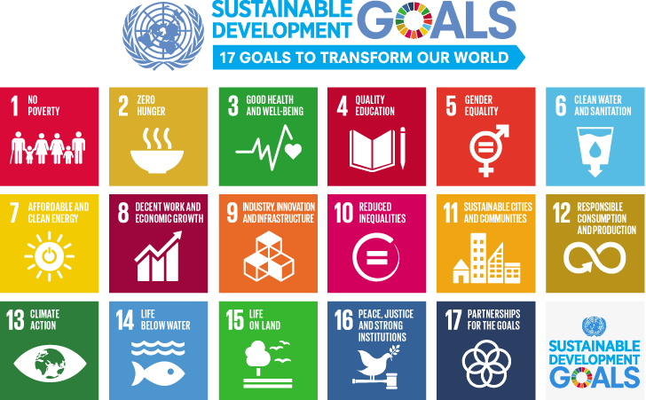
Appendix 1. Image from the United Nations (2015). Available at: [https://www.un.org/sustainabledevelopment/blog/2015/12/sustainable-development-goals-kick-off-with-start-of-new-year/]
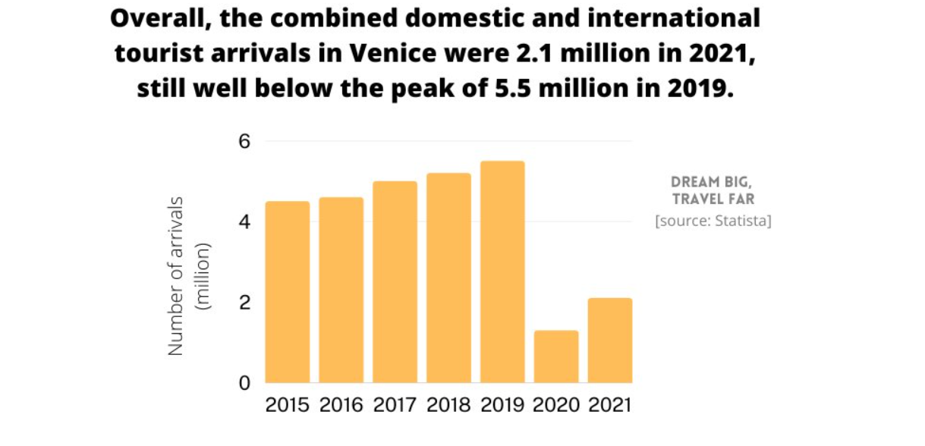

Appendix 2. Image from Williams (2023). Available at: [https://www.dreambigtravelfarblog.com/blog/venice-travel-tourism-statistics] (Accessed on: 12/06/2023).

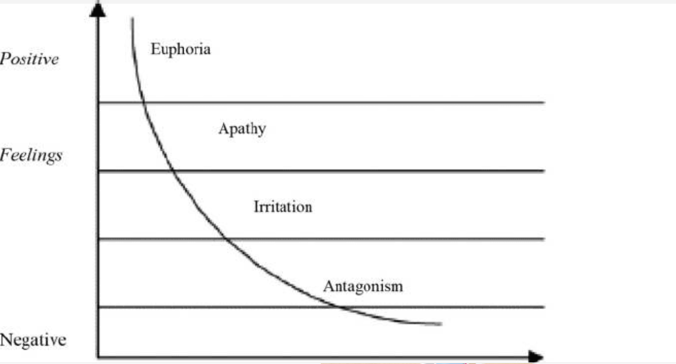
Appendix 3: Doxey’s Irridex Model of 1975. Available at: [https://tourismteacher.com/doxeys-irritation-index/] (Accessed on: 12/06/2023).

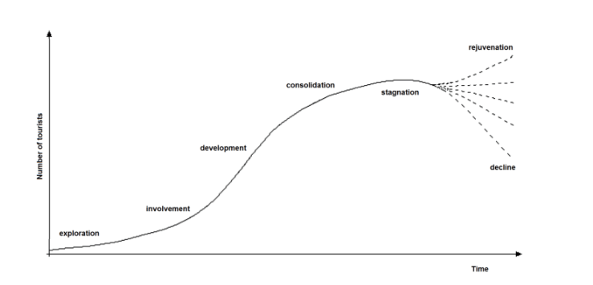
Appendix 4: Prof. Richard Butler’s Tourism Area Life Cycle Model of 1980. Available at: [https://tourismteacher.com/butlers-tourism-area-life-cycle-model/] (Accessed on: 12/06/2023).

References
Basarangil, I., Ozturk, A and Hancer, M. (2022) Digital Marketing and Social Media Strategies for Tourism and Hospitality Organizations. Goodfellow Publishers Limited: Florida.
Booking.com (2022) Sustainable Travel Report. Available at: [https://globalnews.booking.com/download/1161485/booking.comsustainabletravelreport2022final.pdf] (Accessed on: 05/06/2023).
Butler, R. (2006) The Tourism Area Life Cycle. Volume 2. Channel View Publications: United Kingdom.
Calienno, V. (2022) The Other Face of Tourism: the De-Population of Venice. Campaign For A Living Venice. Available at: [https://campaignforalivingvenice.org/2022/08/13/the-other-face-of-tourism-the-de-population-of-venice/] (Accessed on: 12/06/2023).
Caradonio (2021) How Venice Is Retackling Overtourism After a Year Without Visitors. Conde Nast Traveler. Available at: [https://www.cntraveler.com/story/how-venice-is-retackling-overtourism-after-a-year-without-visitors] (Accessed on: 01/06/2023)
Citta’ Di Venezia (2017) Project of territorial governance of tourism in Venice. Available at: [https://www.comune.venezia.it/sites/comune.venezia.it/files/documenti/documenti/territorial%20governance%202017.pdf] (Accessed on: 01/06/2023).
Costa, E. (2022) How Venice is Reimagining Tourism Towards a Sustainable Future. Medium. Available at: [https://medium.datadriveninvestor.com/how-venice-is-reimagining-tourism-towards-a-sustainable-future-e23c3b9a7ac6] (Accessed on: 13/06/2023).
Doleman, A (2019) INSTAGRAM VERSUS THE REALITY OF OVERTOURISM. We are social. Available at: [https://wearesocial.com/uk/blog/2019/10/instagram-versus-the-reality-of-overtourism/] (Accessed on: 12/06/2023).
Domus Forum (2023) Simone Venturini. Available at : [https://www.domusweb.it/en/events/forum/speakers/simone-venturini.html] (Accessed on: 12/06/2023).
Easglescliffe, B. (2023) Venice, Italy, Is Being Destroyed by Tourism and Flooding. Wander Wisdom. Available at: [https://wanderwisdom.com/travel-destinations/Venice-Tourism-Sinking] (Accessed on: 04/06/2023).
Francis, J. (2020) Flights have to get more expensive for the sake of the environment. INews. Available at: [https://inews.co.uk/inews-lifestyle/travel/problems-overtourism-revealed-85705] (Accessed on: 12/06/2023).
Hardy, P (2019) Sinking city: how Venice is managing Europe's worst tourism crisis. Available at: [https://www.theguardian.com/cities/2019/apr/30/sinking-city-how-venice-is-managing-europes-worst-tourism-crisis] (Accessed on: 01/06/2023).

Gowreesunkar, V.G. et al. (2021) ‘Introduction: Destination Management Solutions Post Pandemic: A Need of the Hour’, in Tourism Destination Management in a Post-Pandemic Context. United Kingdom: Emerald Publishing Limited, pp. 1–7. Available at: [https://doi.org/10.1108/978-1-80071-511-020211002].
La Biennale Di Venezia (2023) Environmental Sustainability, Good Practices Recommended to the Public of La Biennale Di Venezia. Available at: [https://www.labiennale.org/en/environmental-sustainability] (Accessed on: 05/06/2023).
Maddy (2023) What is Venice Known For? Available at: [https://www.venicetraveltips.com/what-is-venice-famous-for/#:~:text=to%20visiting%20Venice.-,Why%20is%20Venice%20popular%20with%20tourists%3F,the%20'City%20of%20Canals'.] (Accessed on: 04/06/2023).
Milo, S. (2022) Implementing Sustainability Into The Hospitality Industry. Forbes. Available at: [https://www.forbes.com/sites/forbesbusinesscouncil/2022/09/29/implementing-sustainability-into-the-hospitality-industry/?sh=d39ded76c302] (Accessed on: 05/06/2023).
Momigliano, A. (2021) Venice Tourism May Never Be the Same. It Could Be Better. New York Times. Available at: [https://www.nytimes.com/2020/07/02/travel/venice-coronavirus-tourism.html] (Accessed on: 05/06/2023).
Peterson Institute for International Economies (2022) What is Globalization? And How Has the Global Economy Shaped the United States. Available at: [https://www.piie.com/microsites/globalization/what-is-globalization] (Accessed on: 12/06/2023).
Phelan, J. (2022) Venice is at risk of succumbing to its sinking foundations and rising sea levels. To avert disaster, the city is making changes. Future Planet. Available at: [https://www.bbc.com/future/article/20220927-italys-plan-to-save-venice-from-sinking] (Accessed on: 13/06/2023).
PopulationStat (2023) Venice, Italy Population. Available at: [https://populationstat.com/italy/venice] (Accessed on: 06/06/2023).
Reid, J. (2022) Venice to introduce entry fee for day-trippers to tackle overtourism. Wanderlust. Available at: [https://www.wanderlust.co.uk/content/venice-italy-to-charge-tourists-to-tackle-overtourism/] (Accessed on: 01/06/2023).
Robbins, N. (2021) Venice: A Future for a Dying City. Oxford Urbanists. Available at: [https://www.oxfordurbanists.com/magazine/2021/12/22/venice-a-future-for-a-dying-city] (Accessed on: 13/06/2023).
Dr Stainton, H. (2023) What is Doxey’s Irritation Index and how does it work? Tourism Teacher. Available at: [https://tourismteacher.com/doxeys-irritation-index/] (Accessed on: 12/06/2023).
Dr Stainston, H. (2023) Butler’s Tourism Area Life Cycle Model: A simple explanation. Available at: [https://tourismteacher.com/butlers-tourism-area-life-cycle-model/] (Accessed on: 12/06/2023).
Simmons, J. (2023) OVERTOURISM IN VENICE, Responsible Travel. Available at: [https://www.responsibletravel.com/copy/overtourism-in-venice] (Accessed on: 01/06/2023)
Uğur, A., and Murat, Ö. (2018) Examining the Impacts of Tourism on Gumushane Residents According to the Doxey Index. Tourism Academic Journal: Gumushane University, Tourism Faculty. Available at: [https://dergipark.org.tr/tr/download/article-file/599129#:~:text=2018)%2033%2D45-,Doxey%20Irritation%20Index,and%20negative%20aspects%20of%20tourism.] (Accessed on: 12/06/2023).
UNFCC (2023) The Paris Agreement. Available at: [https://unfccc.int/process-and-meetings/the-paris-agreement] (Accessed on: 05/06/2023).
United Nations, (2023) The 17 Goals. Available at: [https://sdgs.un.org/goals] (Accessed on: 05/06/2023).
United Nations (2023) Sustainable Development. Available at: [https://www.un.org/ecosoc/en/sustainable-development#:~:text=ECOSOC%20operates%20at%20the%20centre,%E2%80%94economic%2C%20social%20and%20environmental.] (Accessed on: 05/06/2023).
UNWTO (2023) Sustainable Development, Available at: [https://www.unwto.org/sustainable-development] (Accessed on: 05/06/2023).
Varley, R. (2022) Science Says This Is When Venice Will Become an Underwater City. Culture Trip. Available at: [https://theculturetrip.com/europe/italy/articles/science-says-this-is-when-venice-will-become-an-underwater-city/] (Accessed on: 13/06/2023).
Venezia Unica (2023) Detourism: travel Venice like a local. Citta’ Di Venezia. Available at: [https://www.veneziaunica.it/en/content/detourism-venezia] (Accessed on: 05/06/2023).
Weebly (2023) A-Level Geography Revision: Edexcel. Available at: [https://geographyrevisionalevel.weebly.com/31b-transport-technology-and-globalisation.html] (Accessed on: 12/06/2023).

