Student name: Bethan Morris
Student number: 2103899
Programme of study: Research in Context (ADAD5003)

Total word count: 2484

Can graphic design really save your life?

The c-word. Cancer. One of the world’s biggest killers. According to Prevent, breast cancer is the most common form of cancer in women in the UK. Over 55,900 women are diagnosed with breast cancer a year which is equivalent to 153 women a day. Sadly, we lose over 11,500 women a year to this ‘deadly disease’ (Cancer, 2022).
Breast cancer is a taboo subject that no one wants to willingly talk about. More often than not, images of breasts online are censored as they are seen as a sexual object. But how are we able to learn and educate ourselves about breast cancer if an image of a breast offends someone? I believe that graphic design is how and within this essay, I will be exploring how graphic design could indirectly save a life. I will be researching how graphic design can promote awareness of breast cancer, how visual design is being used to help find early detection of breast cancer, how design is used to show young women how to check their breasts and how information is delivered effectively.
In the first part of this essay, I will be exploring three sources that promote breast cancer awareness. I will be analysing each source to identify how graphic design could indirectly save a life.
Secondly, I will be researching the story behind the pink ribbon and how a small graphic ribbon has such a huge role in raising awareness for breast cancer and how it is being used in this present day. I will also be looking at Macmillan and how their brand relaunch in 2006 has made a significance difference to breast cancer awareness and whether a successful campaign identity would influence the increase in donations and awareness for breast cancer.
Thirdly, I will be exploring how graphic design can be used in medical infographics regarding breast cancer. I will be looking at cancer pathway diagrams and an article from ACTA Scientific Medical Sciences; ‘Utilization of Infographics for Breast Cancer Awareness: Another Look’ which discusses how the evolution of infographics has improved the way we deliver and communicate vital information visually.

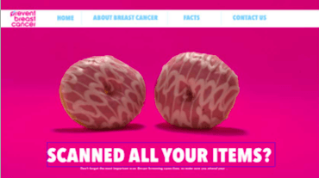
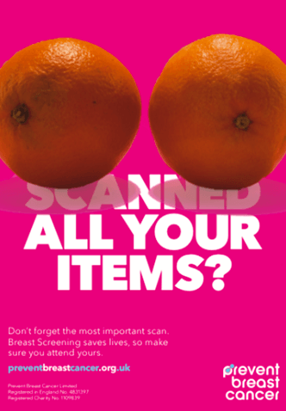

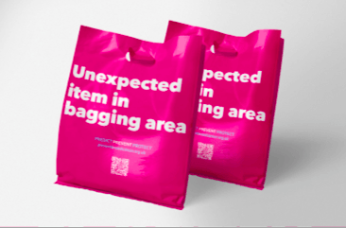

Figure 1: Oktawia Andrys and Ya’qub Mir response to the creative brief by Prevent Breast Cancer (Allison, 2019)

Prevent Breast Cancer is a UK based charity that creates funding for the research to prevent breast cancer for the future generations (Cancer, 2016). For the fourth year running, Prevent Breast Cancer uses Graphic Design students from Bolton University to answer a creative brief set by the charity. The most recent brief was to encourage older women to attend their breast cancer screening appointments (Allison, 2019).
The idea of breasts in Figure 1 if conveyed through the visuals of food. They have used the idea of food throughout the campaign and turned it into a playful more positive way to address breast cancer screening. The iconic pink colour represents breast cancer awareness and reflects the pink ribbon. The idea of food shopping and ‘scanning’ your items is a visual metaphor of breast screening. I personally believe this is an effective campaign and the idea of using round foods avoids censor issues online as well as audiences recognising that the two, round, symmetrical objects were conveying the idea of breasts.

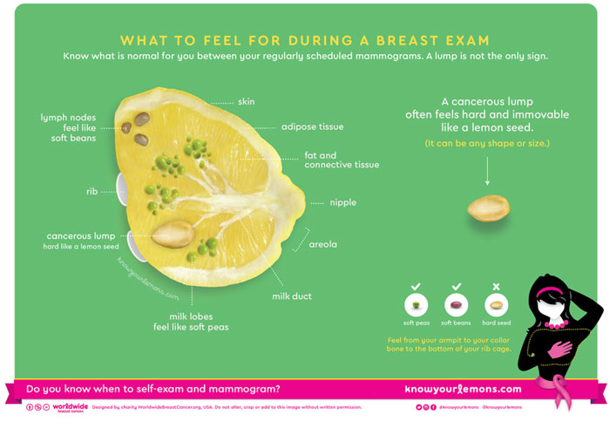

Figure 2: Know Your Lemons self-examination guide (DesignCurial, 2017)

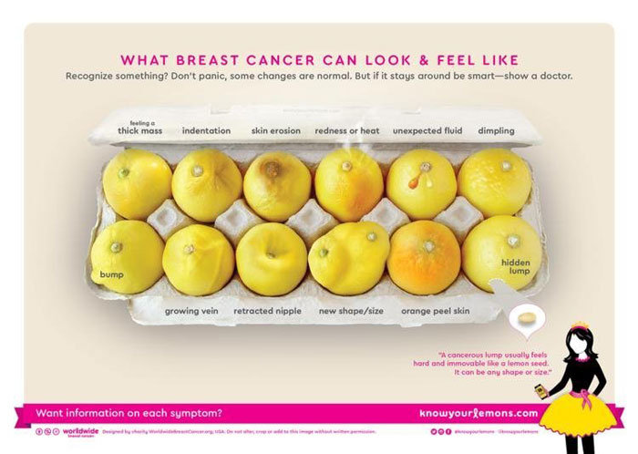

Figure 3: Know Your Lemons visual guide to symptoms (DesignCurial, 2017)

Corrine Beaumont, a professional graphic designer, is well known for her breast cancer campaign ‘Know Your Lemons’. Her self-examination infographic guide targets women and delivers information visually discussing what is normal when checking your breasts. She uses a graphic of a lemon sliced in half, figure 2, to demonstrate what you should be checking and a graphic of a woman and where they should be checking. Beaumont says, ‘a lot of the design was quite standard for the medical industry’ and the medical information is ‘often not communicated through visuals, but instead uses words and fancy terminology’. Beaumont claimed that medical infographics were used as ‘scare tactics and commonly censored visual images of breasts. Her idea of using a playful, vibrant way to highlight the symptoms that can occur with breast cancer helps audiences become more open to learning about breast cancer.
The idea of using a lemon as a metaphor to represent a breast is genius. ‘A lemon doesn’t have an age, or gender or an ethnicity so it can represent anyone’ (Lemons, 2014). By creating this campaign, Beaumont has visually educated the world on how to check your breasts, what to look out for, figure 3, and if something is not right to seek immediate medical attention. This light-hearted campaign has become a charity as well as being turned into an app that is being used across the world (Lemons, 2014). The app encourages women to start checking their breast from a young age and is now used as a platform in schools across the world. An article claimed that the app had educated 200 million people (Burnett, 2017), never mind the amount of lives it has possibly saved.
Beaumont’s self-examining campaign could save a life as the visually appealing infographic is promoting self-examination in young women. It Is promoting what to look for, what is normal, how you should check and what to do if you have concerns about your breasts. This campaign could help someone find breast cancer early, indirectly reducing the mortality rate.

Macmillan is a clear example of how a strong brand identity is a requirement for a charitable campaign. Macmillan is a charity that raises awareness and funding to support those with cancer and educates those who don’t of the key symptoms. In January 2019 the UK’s leading cancer charity launched their new branding advertising campaign (Dragonrouge, 2019) and was known as ‘simple, yet powerful and influential’.
Before the most recent relaunch, Macmillan had its most successful launch in 2006. In 2005, Macmillan struggled with spreading their message about their campaign and who they were aiming it at. Many misconceptions meant that Macmillan were aiming the charity to those who were dying of cancer and to the end-of-life nurses. The 2006 rebrand allowed the charity to define their services as well as giving their campaign a new and iconic look (Sanders, 2015). The BBC claimed that Macmillan saw its brand recognition after its rebranding in 2006 due the rapid increase in statistics. ‘Awareness among its core audiences of people diagnosed with cancer and their families and friends rose from 41% and 38% respectively to 65% and 66% between 2006 and 2011’. The charity had seen a huge financial surge of £44million of donations due to the new face of Macmillan (Hope, 2013).
It is clear from my research that the face of a charity is a crucial aspect to make a campaign successful. A clear, successful brand identity is needed to ensure people understand the purpose of the brand. By rebranding the Macmillan charity, more people were educated about cancer, and fundraising had seen a large increase. The money raised for a success rebrand contributed to cancer research and provided hope for those suffering with cancer.
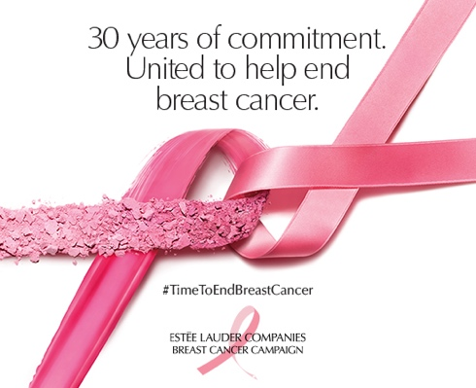

Figure 4: The Pink Ribbon; Estee Lauder Breast Cancer Campaign (EsteeLauder, 2022)
The pink ribbon symbolizes breast cancer awareness. The idea of the pink ribbon stemmed from Susan G. Komen from the Cure. She combined the yellow ribbon from the AID’s activists in 1979 has used the iconic colour of pink since 1982. ‘The birth of the pink ribbon’ started in 1991 where pink ribbons were given to all the breast cancer survivors (Komen, Unknown).
However, the pink ribbon did not stem from there. Charlotte Hayey, a breast cancer survivor, came up with the idea of a peach-coloured ribbon to support breast cancer awareness. In the 1990’s, Hayey started making handmade ribbons from home and distributed them to supermarkets with messages regarding the amount of funding that contributed to cancer, awareness, and cures. Estee Lauder and Self Magazine wanted to get involved in this movement and created the pink ribbon. They chose the colour pink as it is a ‘soothing, comforting and healing’ colour which is the opposite of what breast cancer is.

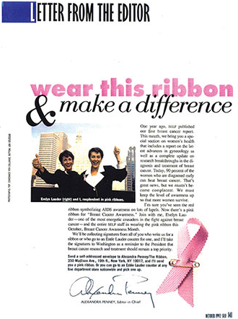

Figure 5: Self Magazines editors’ letter at the beginning of the campaign in 1993, the start of the pink ribbon (EsteeLauder 2022).
The pink ribbon was first seen in Self’s Magazine in the editors letter in 1993 (figure 5) and since then the pink ribbon is known worldwide as the breast cancer awareness ribbon (Barnes, 2017).
‘October is breast cancer month’ (Macmillan, 2022) and every year, the month of October is filled with the colour pink. The use of graphic design and the pink ribbon influences communication of breast cancer and creates a talking point, making people aware of the taboo subject.

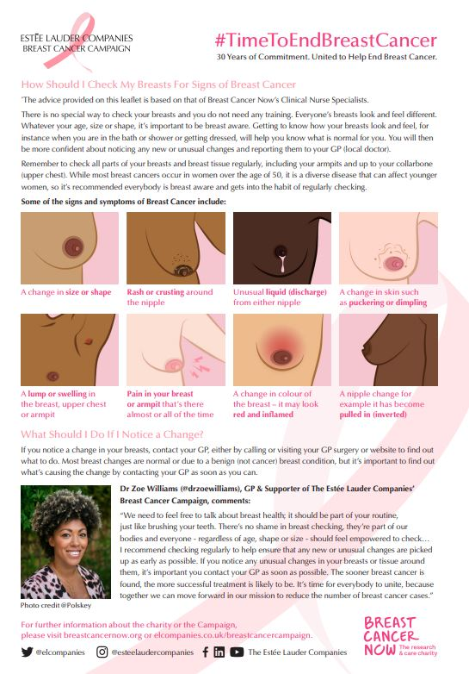

Figure 6: 30th Anniversary of Estee Lauder’s Breast Cancer Campaign (EsteeLauder, 2022)
Estee Lauder and Dr Zoe Williams, a supporter of the Estee Lauder Breast Cancer Campaign, have used graphic design in an infographic in their 30th year anniversary of their campaign. They have used digital illustrations of breasts, which is not very common, and displayed some of the signs and symptoms of breast cancer. The campaign is culturally diverse and uses various skin types within the advert. They also use various shapes and sizes to communicate that breast cancer can occur in anyone. Visually, the campaign is clear and direct which emphasises the importance of self-checking regularly and the use of graphic design to show breast cancer symptoms which could potentially save a life and help women to detect breast cancer early.
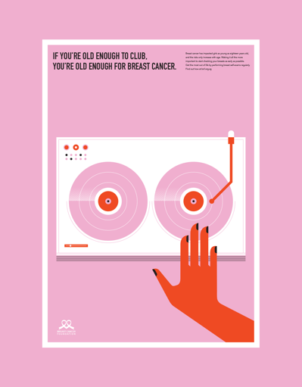
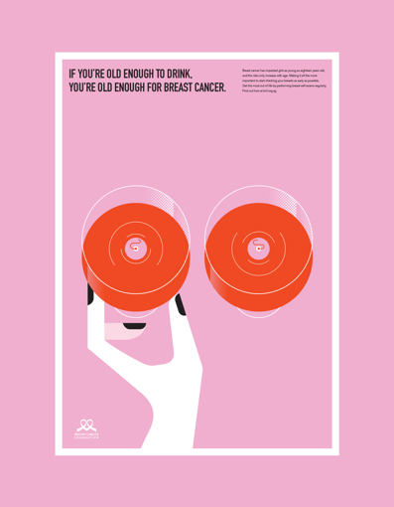

Figure 7: Coming Of Age Breast Cancer Campaign by Elen Winata (Winata, 2018)
Coming of age is a series of posters for Breast Cancer Foundation created by Elen Winata. Winata uses graphic design to convey the ideas of age and ‘the danger of breast cancer among young women’ (Winata, 2018). In each poster there is a different illustration that corresponds to the title of the poster. Winata is emphasising that breast cancer can develop at any age, as young as 18 years old, and you’re more at risk the older you are. The posters are urging women to self-check more regularly to catch it early. They bold quirky posters are eye catching. She uses rounded images such as two wine glasses or two dec tapes (figure 7) to resemble breasts which works effectively as they cannot get censored, and it is a creative approach for a taboo subject. I really like the way Winata has used two wine glasses and a DJ set in her campaign. The idea of being young and going out is also a scary reminder that breast cancer can affect anyone. Breast cancer is not discussed enough to understand that it can affect girls as young as eighteen years old (Winata, 2018).

Finally, I will be discussing infographics used in diagrams, how they are used to deliver information and how they may be used by medical professionals in the industry.
Infographics is another way graphic design could indirectly save a life. It is another way to communicate facts and figures and make people aware of statistics of those suffering with breast cancer. Graphic design can light heartedly share information using illustrations and positive colour palettes, however, it can also communicate more serious information in ways such as graphs.
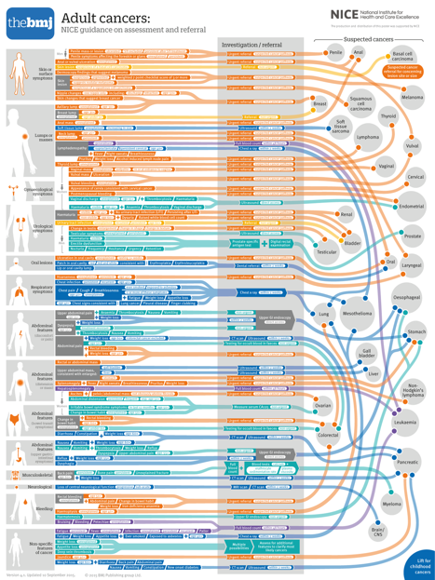

Figure 8: Cancer Pathway Diagram by Will Stahl-Timmins (Harikrishnan, 2018).
Will Stahl-Timmins designed a ‘cancer pathway graphic design’ to ‘expedite the intervention and referrals for potential cancer patients for BMJ’. The purpose of the poster allows general practitioners in the UK choose the best method to treat their cancer patients. To simplify this diagram, it is essentially an advance mind map. On the left there are illustrations of a body with areas that are affected highlighted. The next column is specifying the issue in that area. That stems to another column which discusses investigation or referral where it proceeds to the fourth column which looks at the type of cancer their patient might or currently has (Harikrishnan, 2018). This visual design is indirectly combating cancer as the design allows GP’s to quickly choose the next appropriate step or course of treatment for their patient.

An article from ACTA Scientific Medical Sciences discussed that through their experimental studies, they found that infographics draw in the consumers attention and helps them take in the information easier. ACTA also confirmed that infographics ‘improve data visualisation education and evaluation’ which emphasises that important information can be understood by a person easier when it is designed visually rather than reading it as a piece of text. This also refers to Corrine Beaumont and what she had learnt when creating her campaign, Know Your Lemons! Beaumont discussed that breast cancer was commonly censored and not many people knew how to approach the topic and make people aware of it and its symptoms. Beaumont used design as a way of communicating the symptoms and how to check yourself.
ACTA also discussed how infographics not only helps someone to understand the information, but it can also ‘improve their capacity to remember and retrieve the message’. Therefore, health boards across the world are now distributing visually appealing infographics to share important information (Asefeh Kardgar, 2022).

In conclusion, I agree that graphic design could save your life. From my research, I have found that infographics are now being used to distribute important information about breast cancer and when and how to check yourself, what to look out for and what you should do if you find something you’re unsure of. Without out using images of breasts and the risk of being censored, we as graphic designers can communicate the idea of breasts through design. Round, symmetrical objects are used to visually communicate lifesaving information.
I have also discovered that graphic design is being used to break down barriers about the taboo subject. Visual design is a talking point and can help young women feel more open to talk about their breasts and what is normal and what is not. Quirky designs such as Beaumont’s Know Your Lemon’s campaign helps women remember important information. An effective design is memorable and will stand out from other typical adverts. Therefore, when talking about an important topic such as breast cancer, visual design is the most effective way to raise awareness.
I also learnt while researching breast cancer and how graphic design is used to combat the disease, is that there are very few campaigns target men. Breast cancer does not only effect women, in the US, 1 in 100 men are diagnosed with cancer (Prevention, 2022). Breast cancer is a taboo subject for women; however, visual communications have evolved and enabled communities to come together and fund raise and make people known about the disease. I believe visual design can also do the same for men and allow men to openly talk and learn about breast cancer in men.

Bibliography
Allison, C., 2019. Students From The BA (Hons) Graphic Design Programme Once Again Work With Prevent Breast Cancer UK. [Online]
Available at: https://www.bolton.ac.uk/blogs/students-from-the-ba-hons-graphic-design-programme-once-again-work-with-prevent-breast-cancer-uk/
[Accessed 26 November 2022].

Asefeh Kardgar, R. S., 2022. Utilization of Infographics for Breast Cancer Awareness: Another Look. Acta Scientific Medical Sciences, 6(6), pp. 32-43.
Barnes, K., 2017. The Story Behind The Pink Ribbon. [Online]
Available at: https://www.komen.org/uploadedFiles/Content_Binaries/The_Pink_Ribbon_Story.pdf
[Accessed 27 November 2022].

Burnett, J., 2017. Worldwide Breast Cancer - Know Your Lemons campaign. [Online]
Available at: https://sofii.org/case-study/worldwide-breast-cancer-know-your-lemons-campaign
[Accessed 26 November 2022].

Cancer, P. B., 2016. Breast Cancer Prevention Charity UK. [Online]
Available at: https://preventbreastcancer.org.uk
[Accessed 26 November 2022].

Cancer, P. B., 2022. About Us. [Online]
Available at: https://preventbreastcancer.org.uk/about-us/
[Accessed 27 November 2022].

DesignCurial, 2017. Profile - Corrine Beaumont. [Online]
Available at: https://www.designcurial.com/news/profile---corrine-beaumont-5859154/
[Accessed 27 November 2022].

Dragonrouge, 2019. Macmillan. [Online]
Available at: https://www.dragonrouge.com/work/macmillan-cancer-support/
[Accessed 27 November 2022].

EsteeLauder, 2022. The Breast Cancer Campaign. [Online]
Available at: https://www.elcompanies.co.uk/en-gb/our-commitments/the-breast-cancer-campaign
[Accessed 3 December 2022].

Harikrishnan, H., 2018. How an Intelligent Visual Design is Combating Cancer. [Online]
Available at: https://medium.com/cerebrus/how-an-intelligent-visual-design-is-combating-cancer-c74d53c3f2fd
[Accessed 30 November 2022].

Hope, K., 2013. Why image is crucial for a charity to secure donations. [Online]
Available at: https://www.bbc.co.uk/news/business-23948572
[Accessed 27 November 2022].

Komen, S. G., Unknown. The Pink Ribbon Story. [Online]
Available at: https://www.komen.org/uploadedFiles/Content_Binaries/The_Pink_Ribbon_Story.pdf
[Accessed 26 November 2022].

Lemons, K. Y., 2014. The Story Behind Know Your Lemons Foundation. [Online]
Available at: https://www.knowyourlemons.org/blog/the-story-behind-know-your-lemons-foundation
[Accessed 26 November 2022].

Macmillan, 2022. Breast Cancer Awareness Month 2022. [Online]
Available at: https://www.macmillan.org.uk/cancer-awareness/breast-cancer-awareness-month
[Accessed 27 November 2022].

Prevention, C. f. D. C. a., 2022. Breast Cancer in Men. [Online]
Available at: https://www.cdc.gov/cancer/breast/men/index.htm
[Accessed 4 December 2022].

Sanders, A., 2015. Macmillan's Brand Journey. [Online]
Available at: https://www.charitycomms.org.uk/macmillan-s-brand-journey
[Accessed 27 November 2022].

Winata, E., 2018. Breast Cancer Foundation: Coming of Age. [Online]
Available at: https://www.behance.net/gallery/65680425/Breast-Cancer-Foundation-Coming-of-Age
[Accessed 27 November 2022].

