
Past Peoples, Present Societies

The fabric of daily life: sensory experiences of textile production in Classical Greece

6th December, Wednesday, 5pm (GMT) online
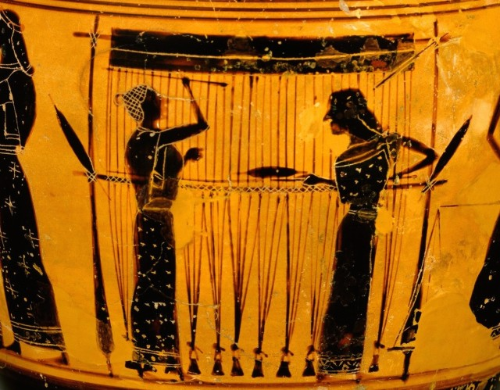

A talk presented by Jane Lawrence, Durham University
Fabric production formed a significant part of women’s domestic life in ancient Greece. In addition to the considerable amount of time involved, it also required highly developed skills; contributed to the economic well-being of the household and was an expression of gender, identity and status. Much textile research has focused on Northern European contexts. My research aims to address two gaps in scholarship: on the one hand textile production in Classical Greece and on the other hand developing and testing a methodology for collecting and presenting sensory experience.
My research seeks to identify the range of sensory experiences which spinning and weaving afforded in Classical Greece, encompassing an understanding of the senses which were of particular importance in producing textiles, responses to the materials and tools used, and the physical, mental and emotional demands which spinning and weaving make on the individual practitioner. In my presentation I will discuss my overall approach; the evidence which survives from ancient Greece; report on findings from initial experiential workshops and evaluate the effectiveness of my approach to date.

Tickets and links available on Eventbrite (Past Peoples, Present Societies) or through email to 1811607@student.uwtsd.ac.uk (Please use Subject: TICKETS PPPS)

