Liam Gardiners Movement and performance process workbook

Beginning our movement class, the first two weeks with Stirling, prior to Easter holls it was refreshing to start up doing contact improv with each other, an abstract and sporadic meeting with some of the practitioners. Some of the 3rd year dancers came into the lesson they moved, and it reminded me of some fine-tuned cats who were comfortable moving with their bodies and together very fluid this inspired me more from the dancer’s technique of non-verbal expression as the body has its own language often more powerful than superfluous words.
this gave an interesting mix and nice energy to the room going straight into some blind folded individual and dual dancing with one another holding ones hand up and being guided into the inner performance space when the urge to move struck, quite brief yet a prolific experience and very necessary after prolonged quiet times and limited human touch.

and the group was exciting and refreshing to get back into the body and practicing with our physicality and. I decided upon movement for this reason of using the body in new ways of movement unconventional/ fitness broadening my acting expressing My feelings and connecting to others in different ways also. My journey of movement has come a long way a summary would be that I felt a disconnect from my head to my body emotionally quite early when I had limited recall for physiological sequences and choreographed moves. This was at the start although working hard in the group and letting go of any dead energy or negativity from all of the yoga warmups the light music floor rolling and contact improv, I found connected my mind body and soul.
This was one of the self-nurturing techniques, having the hand on the abdomen, (Mei practitioner 2022) other palm on the heart, moving the upper hand up to the forehead and the lower up to the heart and then back down after counting to 3 this simple little warm up allowed me to envision a heat wave above a sunrise whilst on holiday, or a mist or seeing warmth radiating from something like a hot drink but allowing positive thoughts and feeling to enter my head, heart and core.

These light works mixed with and some H.I.T exercises really allowed the endorphins to flow and shaking off any stagnant energy with the soft music and upbeat sounds.

Our final performance piece after cutting out some of the remarkable choreographed sequences really came together. “Art is never finished, only abandoned', attributed to Leonardo Da Vinci” as Mei was finding new ways and opportunities to improve our cohesiveness as a unit by individually noting sticking points for improvement in each of us, expressing, and delivering the movement piece. We got as close to a finished piece as we possibly could, the day before the final performance as we all kept on pushing right to the last minute to get the sequence down correctly with feeling and in good order.
Leaving bits out, where one door closes another open and anything abandoned, discovery will not be far behind and the primal jungle circling or the crossings we did using each other without touching the floor some incredible feats of human body like all things cyclical it left a strong memory for our imaginations, for us to be seriously inspired, to pick up on them in the very near future on individual /group projects. It was necessary to the final piece, and I was impressed by The practitioner Mei’s creative vision with unwavering decision of what he wanted to feel and see in the end.
Reflection
We managed to choreograph the circle piece after much difficulty, working together and finding the key points and numbering them within the song to understand when we all must turn and go the same way. This was a crucial part that we nailed together.
For instance, whilst rehearsing our circle sequence, our set points for each of us to change direction or movement was not clear. We had to compartmentalize for all to understand the crescendo when we break out the center circle to the outer bigger running and skipping circle. We spoke through the points of the song after numbering each part 1 to 8 within the circle movement. We had to get together and explain the key points in the song i.e., sun and gun the critical point to switch direction and all go the correct way and synchronize in order between the other performers. This last push to get the piece right made the difference of doing something or doing it well.
projection
What it means to me to be able to work as one unit circling individually but as a collective was something we all felt a sense of achievement when we overcame our difficult spot of breaking out the circle. The describing and explanatory part of it was not for everyone however, some of us had to join heads and find the logic within this piece. “They say rational thought can solve all the issues in the world”. On the other hand, the rationality and logic sometimes find itself as there is a certain logic within the feeling of any of our movement works. I have found immense joy and alignment within myself, from physicalizing the music piece and expressing myself as an actor in a nonverbal way through the body. I feel we reached a certain sense togetherness at times (this was after previous close contact improv, hugging, partner work) and we at the same time held our own unique sense of individuality.
(The performance)
The final piece started with an abstract walk out to slowly starting to clap, the rest followed suit then Nat set the second clap, we all progressively build up the tension and intension of the tap to all over until it was frantic and then Harley said Found them. We all clapped immediately. Then slowly turned to the audience and just as curious we touched our hands together like for the first time, we visited the audience for with a certain curiosity and cheekiness without fully accepting nor rejecting them upon arrival greeting in some usual or abstract manner almost slithering smooth curious animal like Meer cats or an animal in the mirror but not guilt or shame or anything heavy just simplest form of curiosity to see and almost touch with a new greet.
Many instincts were to retract with speed or mild disgust although the vision from Mei was to be extra smooth so no need to be reactive, to practice not seeing things as they are and using abstract thinking Grotowski mentions lazy thinking in his carnal prayer as it seems a human tendency fo the brain to go down familiar routes. (SALATA, 2021) touching this new alien’s hand just unsure. Essentially delving into the unknown and all that it brings. These were big learning steps not only for me but others around because we were essentially embracing the weird and the words, we made up like social norms etc naturally many went for strong fist bumps and well-known gestures although the vision was to go towards the unknown which I felt opened new ways of thinking to be open minded in how we interact and how we act. I felt this helped me tremendously as an actor to get out of any cognitive biases and always if not embrace consider the new as we get older, we get more stuck in our ways and routines are just as important although keeping things fresh sand always reevaluate the way we move interact and go towards tension (Chamberlain, 2008) Laban mentions this is something gone by the wayside. What we all do together and essentially how much of we do when interacting is essentially autonomous from what is considered normal and how we as humans follow like this naturally. I felt was a beautiful thing. As one thing I never thought of looking at it that way.
One of our main concept and title piece was Unite and we had recurrent themes of yogurt and like in science and how we are all bacteria some good bacteria some bad and we thought of what it’s like to be a living organism themes of atoms while we were circling, and we all contributed to the living organism that worked together synergically like a living cell.
My evaluation of the final performance
What
I felt the performance went very well. I felt that I did all the sequence and I felt fully engaged as soon as I stepped into the area to the moment I stepped off. I think putting the performance piece outside was a good call from Mei as the S4c did not want us to go up to 11. The piece arguable any needed for us to give it our all for instance in the laughing part and the doing it outside on the hot day allowed us to do this.
So, What
this movement piece was executed well although a little hiccup on the circle crescendo we did nail it previously but nothing to hang up on.
Now what
Bringing with me in my arsenal of knowledge in body warmups softening techniques interacting and communicating through touch and generally a firmer body language and control over slow and subtle nuances within human interaction. Especially helpful for me doing body work putting energy into the body and not over intellectualize things stepping more into the feelings and the core.

Appendix 1(The performance cont.)
We stepped back from the greet to the line to complete stillness continuing the theme of neutrality just as we didn’t accept or reject this alien creature new person or new thing if it’s a clap one hand meets another or one new greet almost meets someone but using neutrality is also a main overriding theme for this stage because it helps to keep the intention of it backing up into the line and we stoon with a neutral face in our pose but beginning to smile to the point our faces would want to jump off or skulls. This was literally expressing to the max. holding this awkward tension on the face feeling it allowing others to feel the awkwardness and holding the pressure at 20 smile scream rage face until someone buckles creases themselves laughing and we all go like dominoes almost instantly laugh complete pressure relief the whole like in hysterics. Laughing and not having any difficulty in just laughing easier to just laugh than to try to laugh at a bad joke than just to belt out for no reason at all makes perfect sense ironically, it’s the natural thing, too much absurdism doesn’t suit everyone although I found it the most fun doing the unknown but the environment and people in it called for laughter and it suited the moment so laugh, we did. We went to the evolution phase after laughter then tapping and random clapping and expanding to big smile for a while until the music came on for our circle piece.
The circle piece was all of us going round in a circle in our certain order and some breaking off to the inner progressively and again, other rings go opposite direction and at the peak everyone turns to go the correct way together at our chosen time place of the song. This was confirmed and we all deployed out correctly to our aligned slot in the circle between the choses persons once we reached the outer circle, we had all completed the cycle and mitosis and meiosis had essentially just happened in human display form. The final part was the clumping off circle group this and that way and I was in the tall guy corner circling faster and faster until we circled into the bigger circle and skipped hand grabbed passed each other and did a complete revolution. We jogged on the spot to a central cheer then ran in a zig zag around the round to our spot to chill then rock out to the song then fall to the floor whilst rocking. Then after lying on the floor all in our positions breathing heavily tired but then staring the final 28. We finished the 28 in a mesmerized and return to ourselves and regain our ability to feel and walk so tapping gently whilst recognizing our friends made on the way tapping gently the abdomen and heart softly but alert walking off the stage.
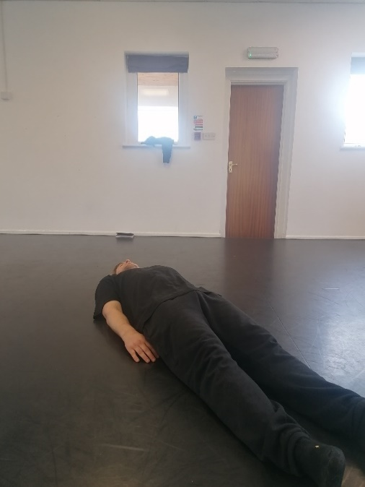
1 - Asleep

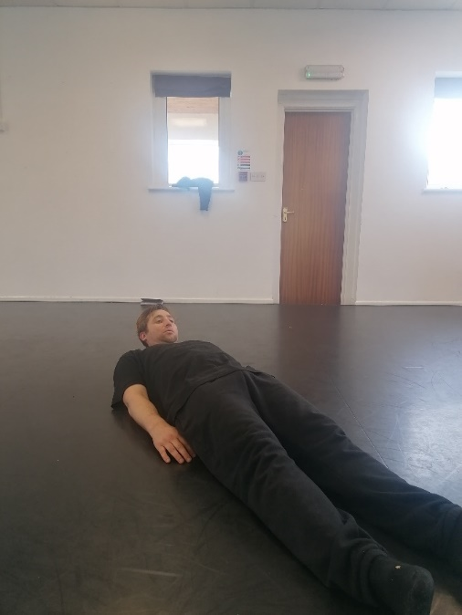
2 – head up

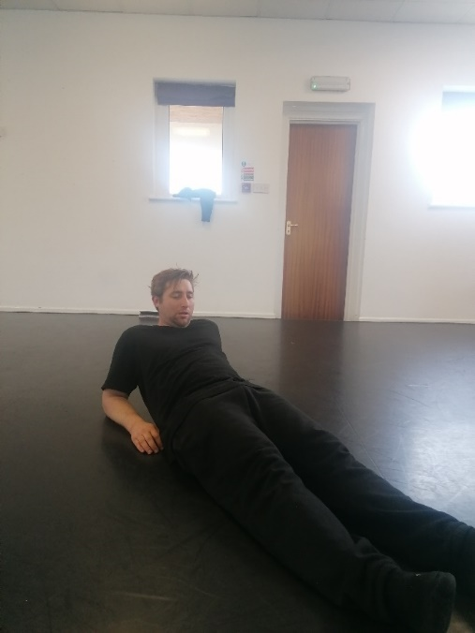

3 – elbows back

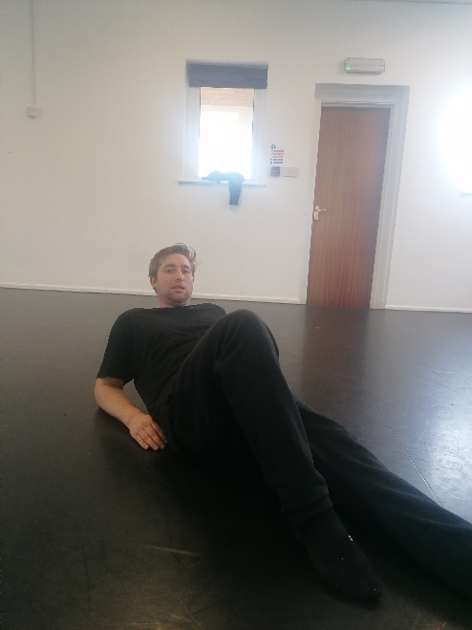
4 - right leg up

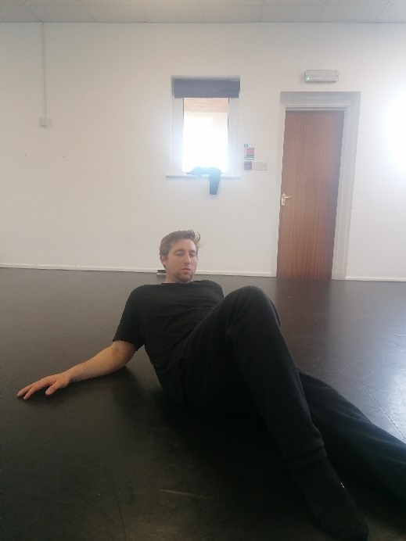

5 – hand move get a drink

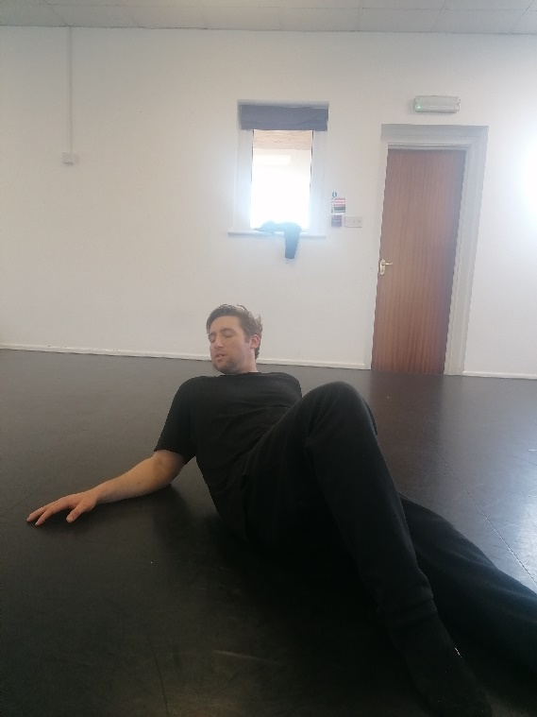

6 – Cd cover (head turn knee & arm)

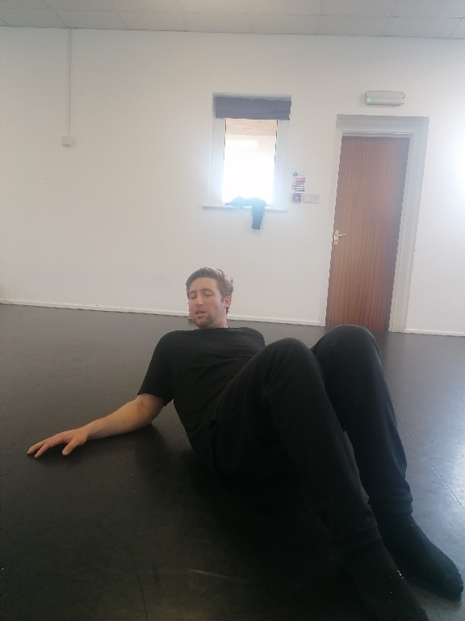
7 knees up (out the bed)

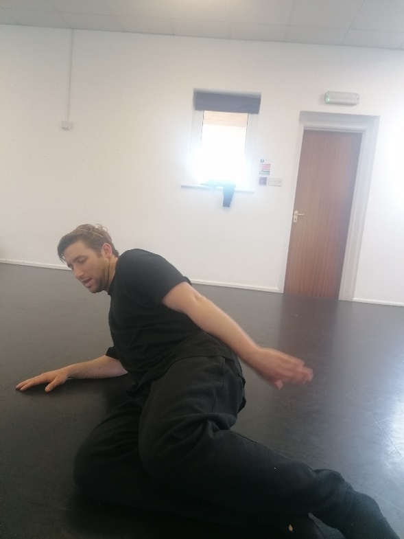

8 – Murmaid

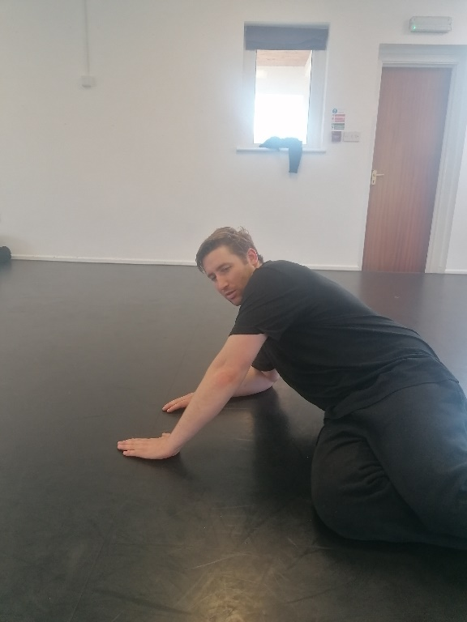

9 hand over (Beethoven)

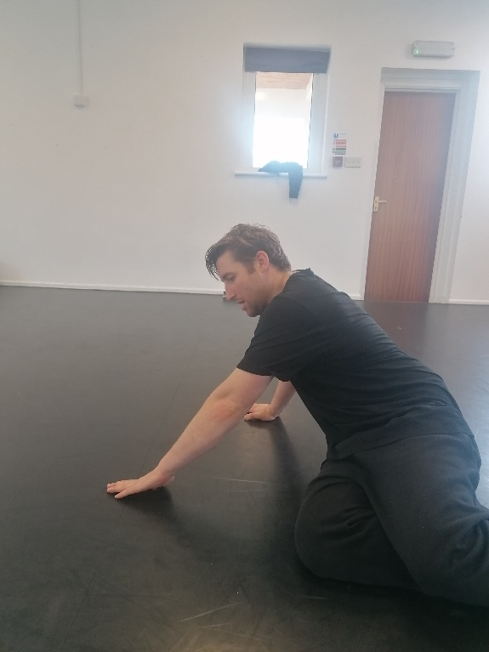
10 – other hand (covers)

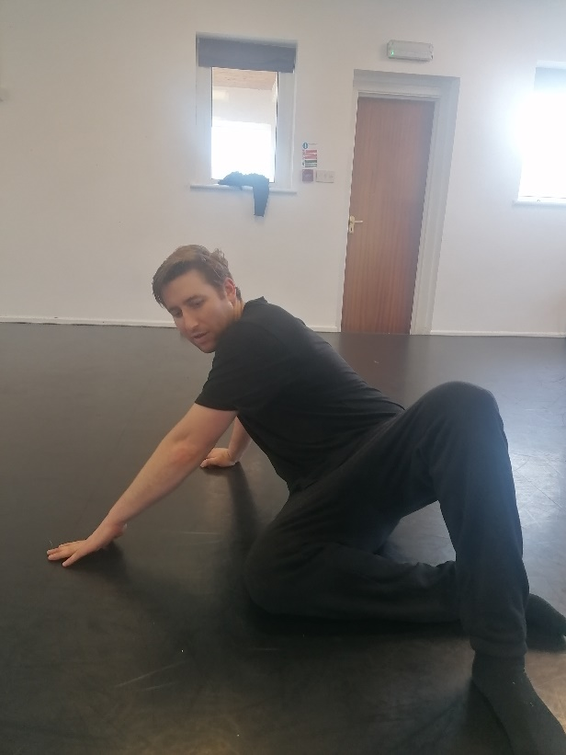

11 – left foot (zig zag)

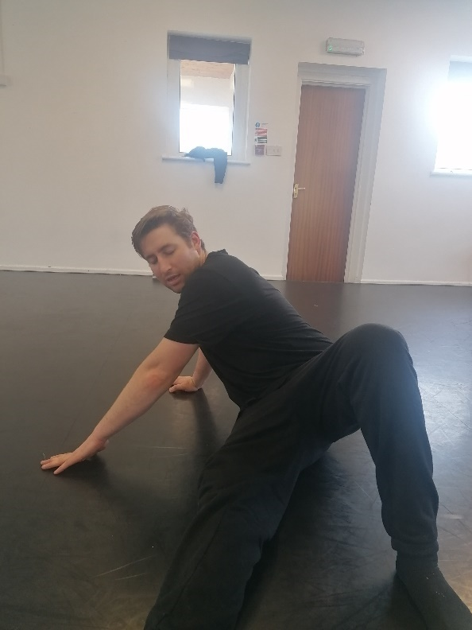

12 – right leg flex (birds of a feather)

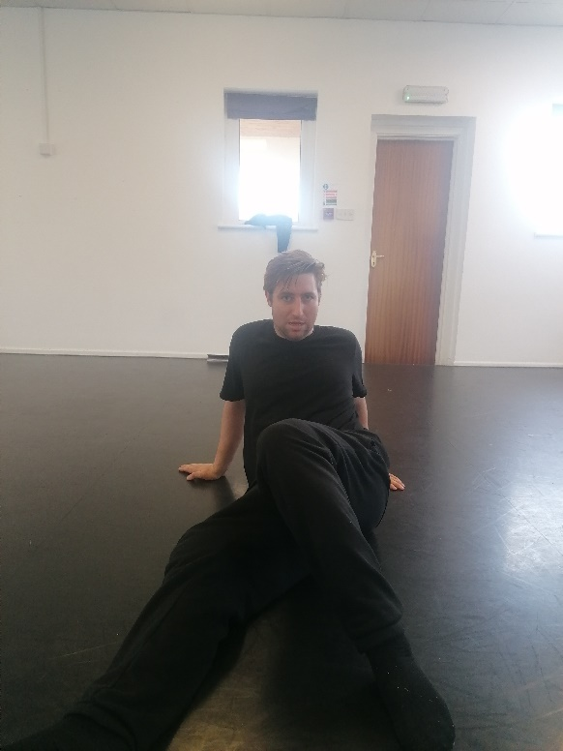
13 – left hand back (back in bed)

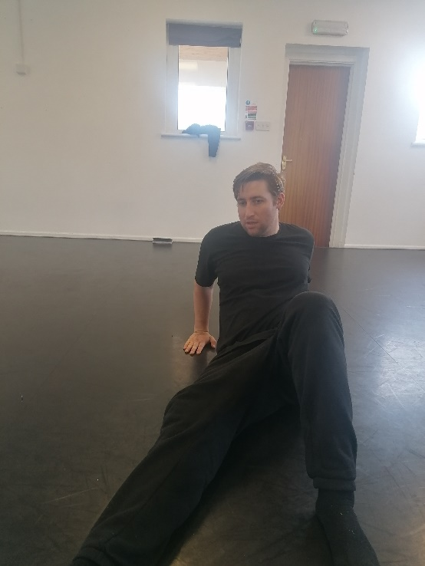

14 – readjusting right hand (achilleas wrist)

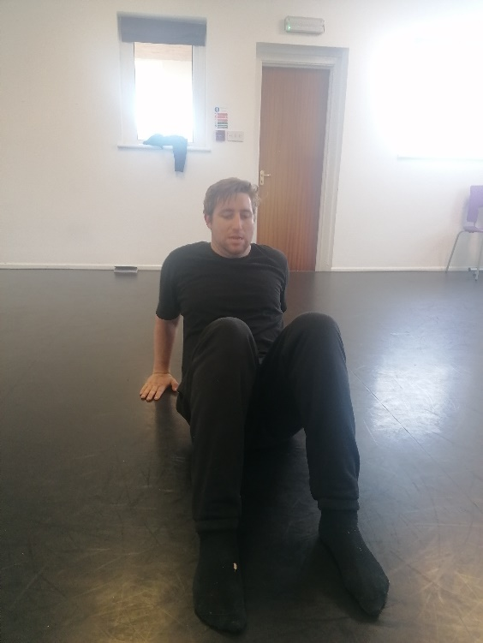

15 – leg in (pre-table)
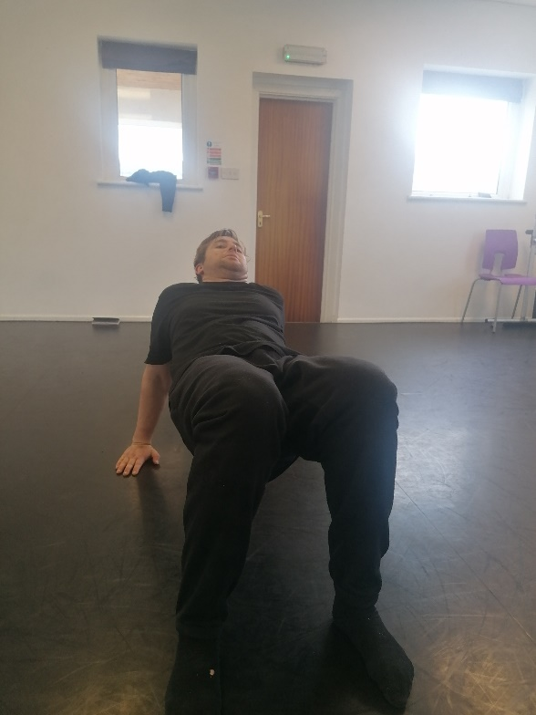

16 – table

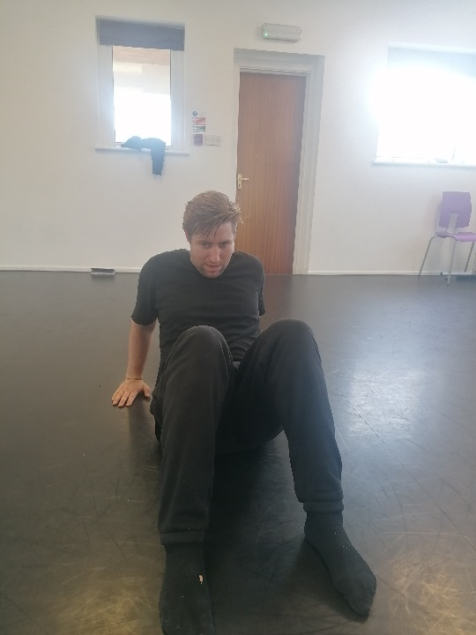

17 – table down

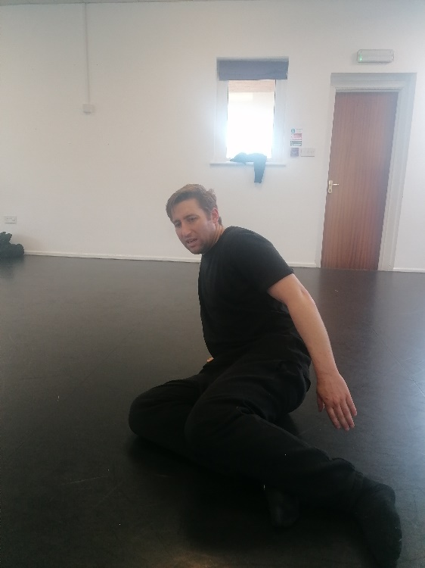

18 - right leg legs down pre sphinx

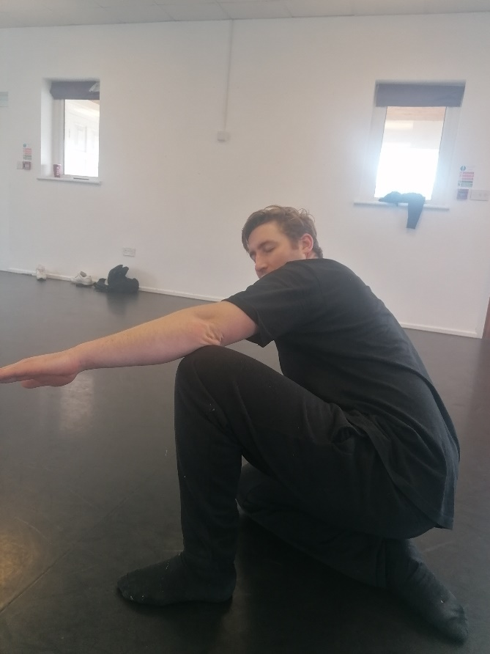

19 - sphinx

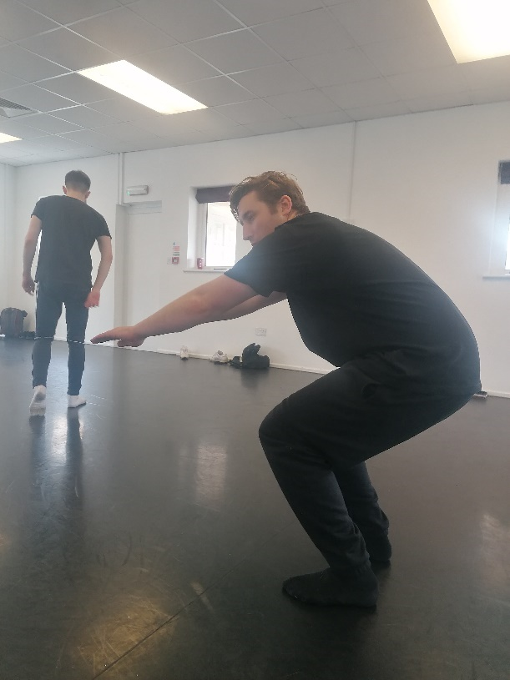

20 low squat

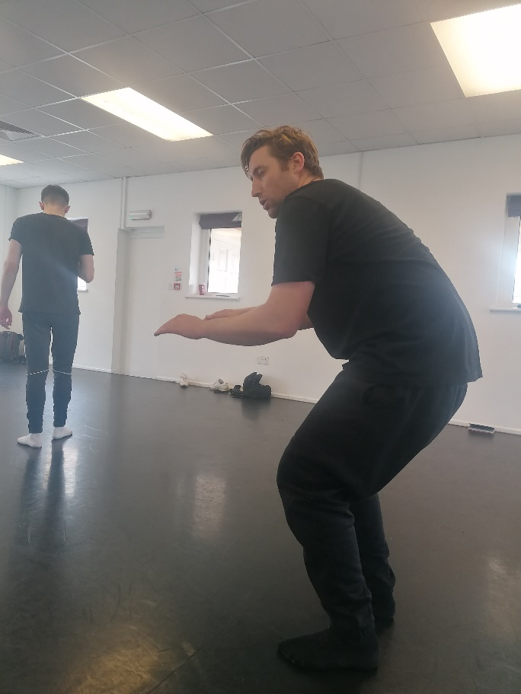
21 high squat (thriller)
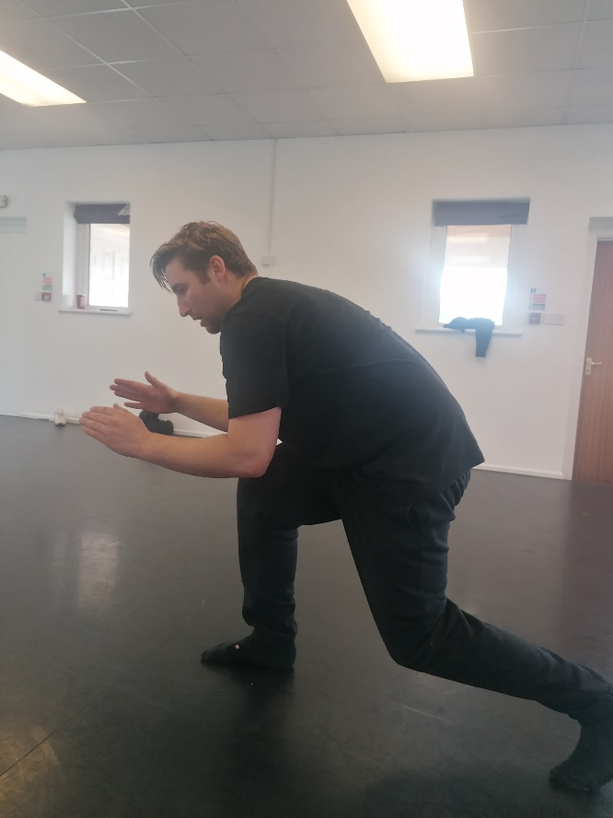
22 – ready steady

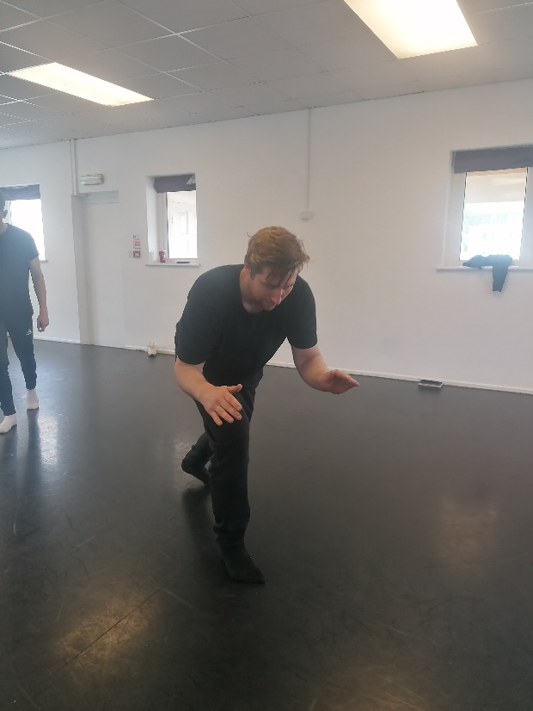
23 – turn ready steady

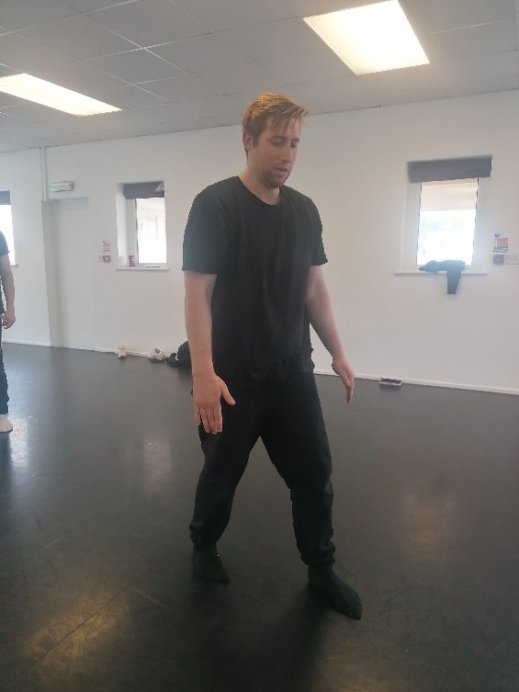

24 – walk

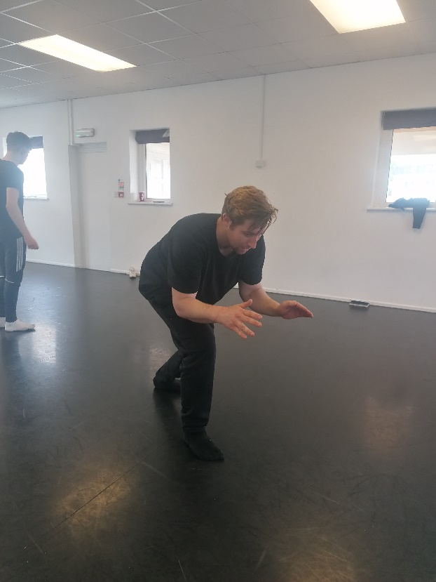
26 – ready steady
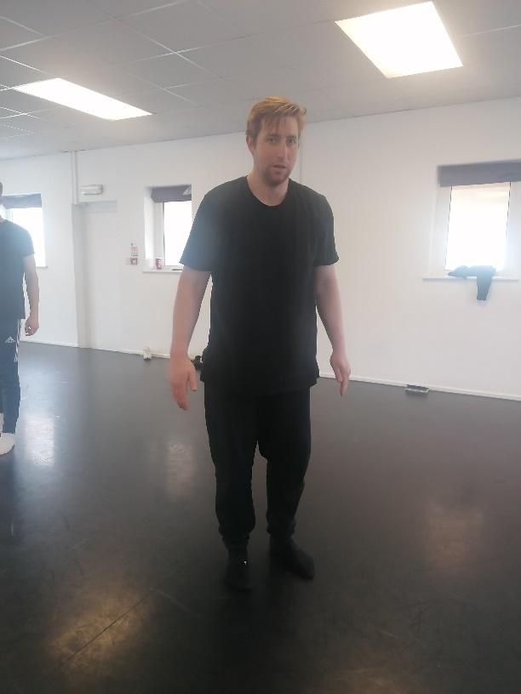

27 neutral stand

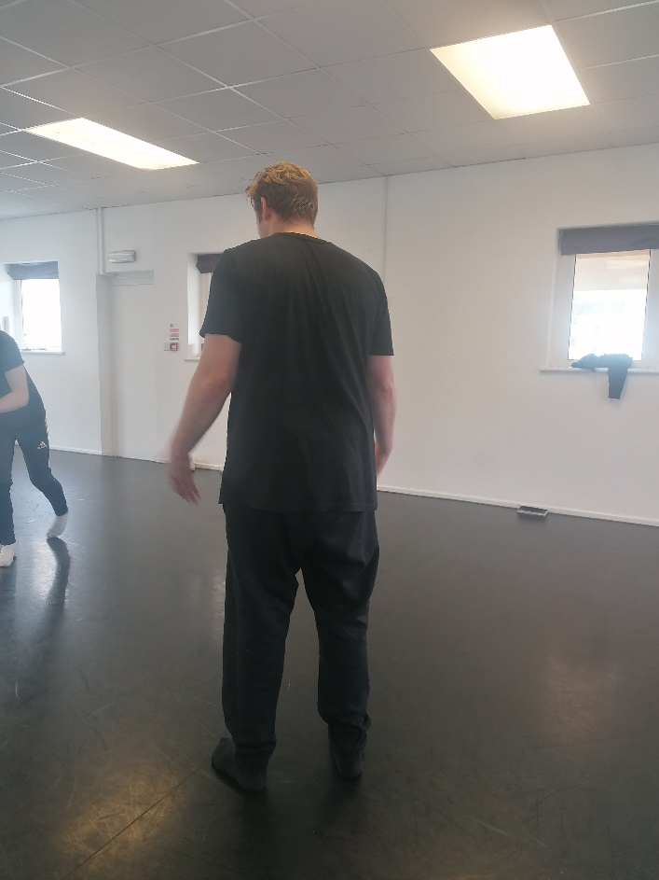
28 – 180

My songs to accompany were inspired by the environment recently

Ann Peebles - I Can't Stand the Rain

Dario G - Sunchine
https://www.youtube.com/watch?v=yFKhgF_vkgs
Purple rain – Prince

Simba – Lion king

Rise above it – cool Runnings

Foxy lady – Jimmy Hendrix
Random memorable words
Culture, connections, yogurt!

Bibliography
Chamberlain F. (2008) Rudolf Laban. Routledge Performance Practitioners. Taylor & Francis, pp.86,88,89.
SALATA, K., (2021) ACTING AFTER GROTOWSKI. [S.l.]: ROUTLEDGE, pp.61-100.

