Programme: BA (Hons) Leadership and Management Skills in the Workplace
Module: Project Planning and Management in workplace
Module code: BMSW5104
Lecturer: Paul Ranson
Assignment Title: Project Planning and
Management in the workplace/Report
Student Name: Ameera Khan
Student Number: 1810760

Executive Summary
This report is being addressed to the course lecturer. The purpose of this report is to convey the approach taken as a project manager to develop a project for the Vintner family. This report will analyse factors which pose a risk to the success of a project. The report will consider professional techniques and tools used to reduce potential risk factors. The project will be managed using the waterfall approach.

Contents
Executive Summary 1
List of Figures 3
The Vintner Family 4
The Vintner Family Project 4
Risks Associated with the Project Development 4
Project Management Tools and Techniques 4
Risk of Family Run Businesses 4
Roberts Steering Group 4
Dennis Vintner 5
Doreen Vintner 6
Shuha Madani 6
Omar King 6
Project Planning 6
User Stories 6
Trello 6
Risk of Project Change 10
The Iron Triangle 10
Project Schedule 11
Communication 12
Personal Reflections 12
References 13

List of Figures
Figure 1. Vintner Family Steering Group...............................................Page 5
Figure 2. Vintner Family Trello ‘User Story’ Card..................................Page 7
Figure 3. Vintner Family Trello Board....................................................Page 8
Figure 4. Heagney’s Chevron Technique..............................................Page 9
Figure 6. The Iron Triangle....................................................................Page 11
Figure 7. Vintner Project Planning Schedule Gannt Chart....................Page 12

The Vintner Family
The Vintner family are based in Shirley and have run an antique shop for in their family for over 30 years, in their family they are the third generation running the business.

The Vintner Family Project
The Vintner family have received an offer from Tesco Express for their shop in Shirley. The Vintners have decided to move their business from their traditional shop front in Shirley to a warehouse they own in Sparkbrook. With the offer that they have received from Tesco they are well funded to proceed with this project.
The Vintners also feel there is a need to change the way they operate their business to more of an online retailer, to tackle the lack of demand from the local footfall. The Vintners have been inspired by Drew Pritchard from the tv show ‘Salvage Hunters’.

Risks Associated with the Project Development
The issue that the Vintner family have requested assistance with is, moving the shop from Shirley to their warehouse in Sparkbrook. The Vintner family require the warehouse to cater for all their individual needs and the requirements of the business.

Project Management Tools and Techniques
Projects inherently carry a risk of failure. Nevertheless, project management strategies and tools can be utilised to reduce the risk of failure. Following a detailed planning approach is essential. ‘If you fail to plan, you are planning to fail’. as said by Benjamin Franklin.

Risk of Family Run Businesses
Within project development there are many risk factors. With the Vintner family, the fact that it is a family run business is a high risk to project failure. As it is a family run business, which are notoriously difficult to manage, various types of conflicts and disagreements may arise, such as sibling rivalry and no previous clear definition of a leader within the business.

Roberts Steering Group
I firstly recommend that a Steering group should be set up, using the Roberts technique for stakeholder mapping. In the first stage the family will decide in a meeting, who will take on which roles. I will then create a hierarchy diagram For the Steering group to be effective, the Vintner family would need to elect one person as the sponsor of the project. It is impossible to manage a project when one clear leader has not been established (Roberts, 2012).
This is effectively creating a contract with the family, during the project development, I can inform the steering group about any issues. The steering will then discuss the issues and the sponsor will always make the final decision.
For the steering group to remain an effective strategy, the hierarchy diagram will be visible on a notice board, to the Vintners for the duration of the project. This reminder will aid members to stick to their original roles.

Figure 1. Vintner Family Steering Group

Dennis Vintner
Dennis Vintner makes an ideal project sponsor, he has a wealth of experience in the production sector of the business. As the business is family owned, the project sponsor could be either Dennis or Doreen. However, Dennis has more overall experience of the whole business. Dennis will benefit from the knowledge and advice from the specialists on the team and will ultimately make the final decisions.

Doreen Vintner
Doreen Vintner has many years of experience in dealing with the finances of the business and is the ideal candidate for the role of financial specialist.

Shuha Madani
Shuha Madani has been allocated the role of the User specialist for the steering group. The user specialist would be required to have customer knowledge and Shuha has dealt with the customers for her duration at the family business. Shuha is amiable and liked by the customers and the most likely to be able to predict the customers buying needs and perceptions of the public aspect of the warehouse conversion.

Omar King
Omar works in repair and restoration; therefore, the project would benefit with Omar as a design specialist as he possesses the product knowledge and knowledge of the logistics of moving everything from Shirley to Sparkbrook.

Project Planning
Project planning requires a breakdown of structure, determination of the cost, time and human resources required (Saladis and Kerzner, 2011).
Strategic Project Management is utilising strategies to prioritise and manage project tasks, communicate aims, align priorities to the objectives of the business, evaluate progress, manage supplier relationships and anticipate and mitigate the risks at each stage (Roberts, 2012).
The Vintners are required to express all their needs and what they require from the warehouse for it to be ready for them to move in and begin trading from the warehouse. Only then can the experts be approached to provide the solutions. Projects are essentially a series of problems, which require a series of solutions.

User Stories
An effective tool to extract information from the steering group is to use ‘User Stories’. The ‘User Stories’ is a way of obtaining the information from the steering group regarding all the features and commodities they need.

Trello
Trello is a collaboration tool which can be utilised to organise the ‘User Stories’ into boards. Trello is a software which is used for making lists. All stakeholders of the Vintner family business would be invited a shared link to add their requirements to the Trello board, which effectively acts as a digital whiteboard, containing all the sticky notes which could be generated in a real-life meeting. Each stakeholder would state who they are, what the problem is and why they need it. As demonstrated in figure 2 below, Doreen Vintner states on her ‘User Story’ card, that she is Doreen, the Office Manager and she has specific requirements for the heating arrangements in the building and why.
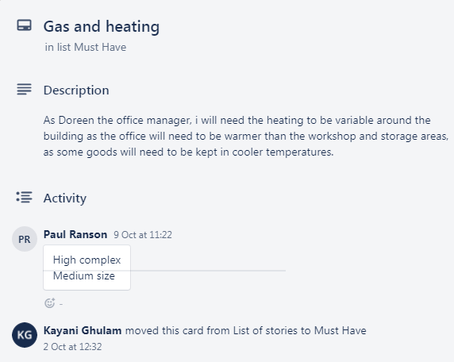
Figure 2. Vintner Family Trello ‘User Story’ Card (Trello.com, 2020).
Using Trello effectively removes the risk involved with stakeholders failing to remain in their roles and taking on the role of the experts. Each story requires the user to clearly define what the need is and why they need it. This could help to ascertain whether there is a real need or not, for instance one of the stakeholders could ask for a brand-new forklift truck and a more economical solution maybe that the existing forklift truck is serviceable. Other stakeholders can add notes and comments to the ‘User Stories’. The categories can be seen in figure 3.
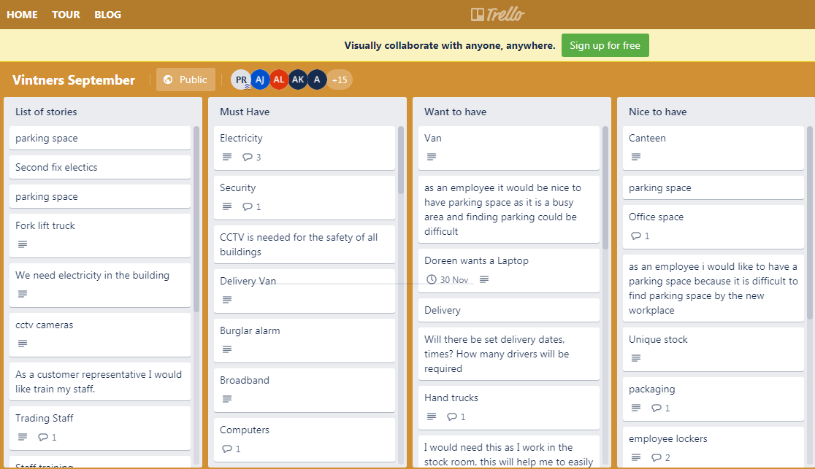
Figure 3. Vintner Family Trello Board (Trello.com, 2020).
These ‘User Stories’ cards can aid project management by, clearly defining the problem. As project manager prioritising the ‘User Stories’ into ‘Must haves’, ‘Want to haves’ and ‘Nice to haves’ categories aids the calculating of the budget and timescale. This technique is called Heaney’s Chevron Technique. It is essential that this technique is used at the beginning of the project as there is a risk that the scope can keep increasing if stakeholders are continually deciding that certain features are important as the project is developing. Using the idea of ‘the wisdom of the crowd’ we can then determine together in a meeting, how long and complex each task is. This technique will aid estimation of the timescale of the project.
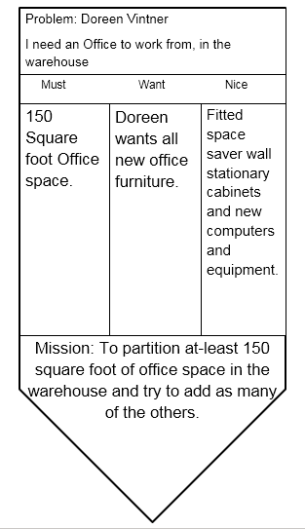Figure 4. Heagney’s Chevron Technique (Heagney, 2011)

A solution can now be created for each of the ‘Must have’ problems, as these are essential for the project to be successful. After the priorities have been completed, budget permitting ‘Want to haves’ and ‘Nice to haves’ from the ‘User Stories’ may be catered for.
This prioritisation is critical as not all stakeholders are equal and keeping the scope of the project reasonable reduces the risk of an excessive scope and project failure. Another risk is that stakeholders can cause conflict if their ‘User Story’ is not classed as a ‘Must have’, as they feel undermined, therefore these decisions must be made in the initial stage by the Steering group.
This is an excellent way of reducing the risk of project failure by gathering and sorting this key information. However, stakeholder will need to be reminded that the ‘User Stories’ only requires the problems and not suggestions for solutions, the solutions are best left to the experts. The ‘User Story’ tool also combats the risk of a high volume of requests being accumulated, as each stakeholder must justify each request.
When a projects details are being decided in the initial stages, if there is a lack of effective communication with the experts carrying out the tasks, there is high risks of disappointing results which are not in line with the vision of the project steering group, over spending and overrunning the timescale of the project. This can happen as a consequence of those who are commissioning the project assuming the roles of the experts as they are financing the project, as they have a notion that they are right. Projects can then fail to be delivered on time and on budget.

Risk of Project Change
The Vintners would ideally want their project complete within the time frame and including as many of the ‘Must have’, ‘Want to have’ and ‘Nice to have’ from the ‘User Stories’. However, the customers of the project, the Vintners may change their minds about certain features during the project development. In this case the customer is the risk to the project. Plans often will change during development, however creating awareness for the customer is important as, negotiations will have to be considered for the whole project, when any element is changed. Some changes may arise due to unpredictable factors that are not in the control of project managers, such as adverse weather conditions, workmen not arriving at work due to illness. The current Covid-19 virus has shown us how critically a pandemic can affect the workforce and operations globally. A project manager should continuously monitor the progress of a project, neglect can be a risk to the project. Change control is key in project management as it helps a team modify the scope of a project by using specific controls and policies (Wang et al, 2008).

The Iron Triangle
The Iron Triangle is a framework which clearly demonstrates to the customers that if at any point during project development they reduced the costs, the scope would then the scope would reduce and/or the time increase. Similarly, if more features are added and the scope increases, the time and cost would increase too (Pollack et al, 2018).
The noted framework is an excellent tool to demonstrate the effects of a natural process, which customers often find difficult to digest at later stages of a project.
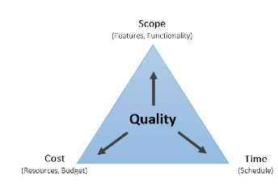
Figure 6. The Iron Triangle (Pollack et al, 2018).

Project Schedule
Using a classic tool, the Gantt Chart, as project manager I will be able to clearly demonstrate the details and time scale of the project to the Vintners. Many of the tasks which need to be carried out to complete the project, can be done by various people at the same time. Performance management is also useful to monitor any deviations from the original plan (Brandon, 2010). The Gantt Chart lists list’s tasks in a timeline. Some tasks are independent and other tasks are dependent on certain tasks being completed before they can be started. From day zero to the estimated day of project completion, is known as a ‘critical path’ (James, 2000). The Gantt Chart in figure 7, illustrates how the dependant tasks create a stepped or waterfall effect. The independent tasks will not create this effect as they do not depend on any other tasks.
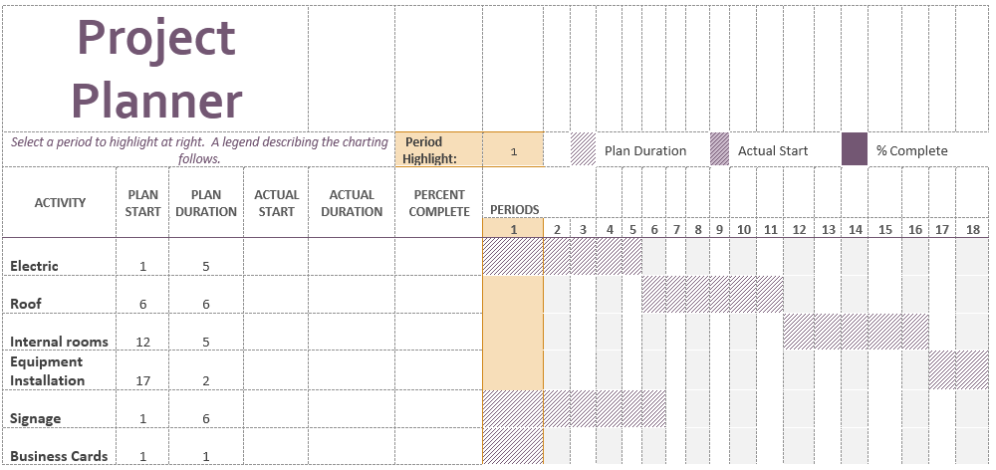Figure 7. Vintner Project Planning Schedule Gannt Chart

Communication
An efficient form of communication would be using a Gantt Chart. The tool displays the plan and the progress comprehensively. Excel has been used to create this Gannt Chart, however there are many software’s available online to create a business plan schedule, including ‘Microsoft Project Manager’. The Gannt Chart can be used in daily stand up meetings, shared virtually with the stakeholders. After the daily briefing, any updates can be added to the Gannt Chart and it can be shared virtually, so that every has the revised information. Print outs of the Gannt Charts can also be placed on notice boards and canteen areas, this ensure that updates are communicated to all the employees up and down the chain. It would be necessary for employees to be aware of the schedule and the time frame for the completion of tasks including progress feedback reports and checkpoint reports (Turner, 2007).

Personal Reflections
This report has successfully presented an appropriate project organisation structure to the board to the lecturer, following the Prince2 waterfall management approach.
Working on the Vintner Project using the waterfall project management approach has been a personal learning curve. Learning the techniques and how to use the tools to effectively manage a project has given me many insights into how to reduce risks, recognise success and failure factors and most importantly to learn from each experience.
The confidence in my abilities has grown and I am ready for new experiences, challenges and environments, working as a project manager.
I am aware, to pursue a career in project management I will need to obtain a Prince2 certification, this training is provided for £399 from The Knowledge Academy (PRINCE2 Certification Training Courses, 2020). However, to further prepare myself I will also look to complete training for Agile Project Management certification, which I can register for the price of £500 with the University of Westminster (Agile Project Management, 2020).

References
Brandon Jr, D. M. (2010). Project performance measurement. The Wiley Guide to Project Control, 9, 75.
Heagney, J., 2011. Fundamentals of Project Management. 4th ed. New York: AMACOM, p.61.
Pollack, Julien & Helm, Jane & Adler, Daniel. (2018). What is the Iron Triangle, and how has it changed?. International Journal of Managing Projects in Business. 11. 10.1108/IJMPB-09-2017-0107
Roberts, P., 2012. Strategic Project Management. London: Kogan Page.
Saladis, F. P., & Kerzner, H. R. (2011). Bringing the PMBOK guide to life: a companion for the practicing project manager. John Wiley & Sons.
Theknowledgeacademy.com. 2020. PRINCE2 Certification Training Courses. [online] Available at: <https://www.theknowledgeacademy.com [Accessed 25 November 2020].
Trello.com. 2020. [online] Available at: <https://trello.com/b/Ps5riIiP/vintners-september> [Accessed 22 November 2020
Turner, J. R. (Ed.). (2007). Gower handbook of project management. Gower Publishing, Ltd.
Wang, E. T., Ju, P. H., Jiang, J. J., & Klein, G. (2008). The effects of change control and management review on software flexibility and project performance, Information & management, 45(7), 438-443.
Westminster.ac.uk. 2020. Agilepm® – Agile Project Management™ Certification – Foundation | University Of Westminster, London. [online] Available at: <https://www.westminster.ac.uk/business-and-management (Accessed 25 November 2020).

