Report

The Future of Sustainable Aviation: Innovations, Policies, and Consumer Behaviour
Student Name: Diana Gabriela Grecu
Student ID: 2232653

Module Name and Code:
Sustainable Hospitality & Tourism Management (BMIH5006)

Submission Date: 06/03/2025

AI Acknowledgement: This report has been independently researched and written by the author, adhering to the academic integrity policies of the University.

Executive Summary 3
Introduction 4
The EnvironmentalCost of Air Travel 4
Greenhouse gas emissions andclimate change 5
Air and Noise Pollution 6
Fossil Fuel Dependency 6
Largest Roadblocks to SustainableAviation 7
Technological Barriers 7
Political and FinancialBarriers 7
SustainableWays to Travel by Air 8
Sustainable Aviation Fuels (SAFs) 8
Hydrogen and Electric Aviation 9
Policy andGovernmental Interventions 10
Sustainable ConsumerBehaviour 10
Case Studies: Airlines Putting Sustainable Solutions in Place 11
Conclusion and Recommendation 11
Reference list 13

Executive Summary
Flight is the foundation of contemporary tourism with its global connections and socioeconomic progress. Yet, its environmental footprint still holds a considerable challenge for the aviation sector, which accounts for around 2–3% of worldwide carbon dioxide (CO₂). The sector is under increasing scrutiny for its sustainability measures to counter climate change impact. Although these technological pathways, such as sustainable aviation fuels (SAFs), hydrogen-powered aircraft, and electrification, are promising, their widespread implementation is constrained by economic, infrastructure, and regulatory factors.
In this report, we look toward the skies to analyse the future of sustainable aviation through three lenses: technology, policy interventions, and changing consumer behaviour. To mitigate emissions, airlines purchase eco-friendly planes, use AI for route optimisation, or participate in carbon offset programs. This is followed by governments forcing policy directives like banning short-haul flights in France and the CORSIA framework from the ICAO. The increasing consumer interest in sustainable travel also pushes airlines to go green.
The high production costs of SAF, hydrogen-aircraft infrastructure, and the confines of the current regulatory framework all deplete pathways for a more sustainable future for the industry, and each one must be addressed. These changes cannot happen in a vacuum, so it will take heavy lifting by airlines, co-operation from policymakers, and buy-in by for change to be meaningful.

Introduction
Air travel is a basic part of the universal friendliness and tourism industry, giving cross-fringe availability, monetary improvement, and places for social trade. The science of aviation has come a long way, and many low-cost carriers have made air travel a reality for an increasing number of passengers around the world. Nevertheless, the growth is associated with substantial environmental problems, with world aviation producing global airborne carbon dioxide (CO₂) in a range of roughly 2–3% and being one of the significant drivers of climatic challenges (Batabyal, 2018).
Compared to other transport sectors, aviation is particularly exposed to kerosene fossil fuels, which makes it challenging to transition towards low-carbon alternatives. Furthermore, the warming effect of aircraft emissions at high altitudes is much greater than ground-level emissions (Jauhari, 2021). Aviation is also a source of air and noise pollution that impacts ecosystems and communities surrounding airports (Inkson & Minnaert, 2018), in addition to greenhouse gas emissions.
To combat these issues, the aviation industry looks at technological advances like sustainable aviation fuels (SAFs), hydrogen and electric planes, and fleet modernisation for fuel efficiency. In addition, governments and regulators have been taking some policy measures and developing some carbon offsetting systems to mitigate the environmental cost of air transport (Costa & Costa, 2022).

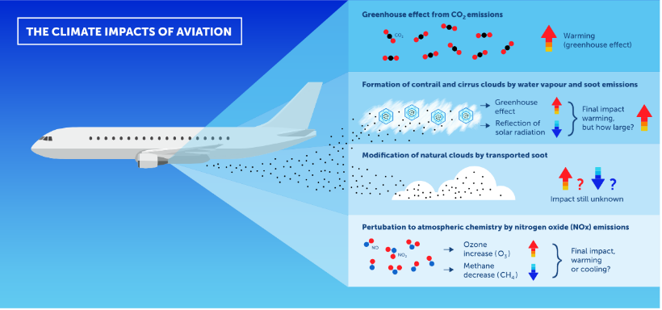
The Environmental Cost of Air Travel
Figure1: The climate impacts of aviation (Climaviation, 2022).
The aviation industry has allowed unprecedented global connectivity, stimulating economic growth, travel, and cultural exchange. But its carbon-intensive nature, pollution, and reliance on fossil fuels have raised alarms about its environmental impacts. The ever-increasing demand for air transport contributes to climate change, degraded air quality, and noise pollution, even though progress has occurred in reducing specific emissions through increased aircraft fuel efficiency (Gössling and Dolnicar, 2022).

Greenhouse gas emissions and climate change
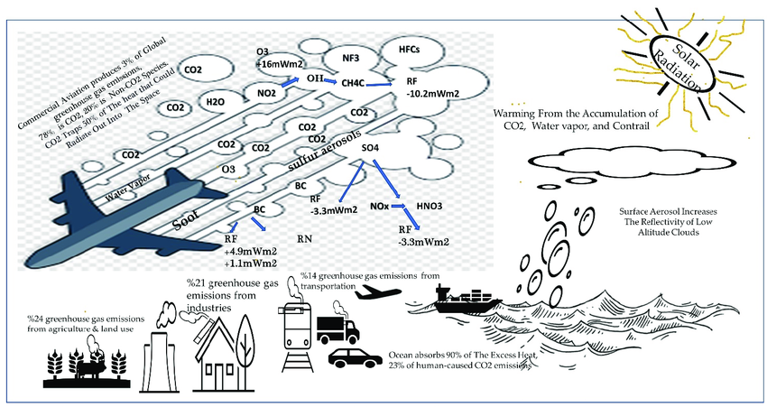
Figure2: Climate forcing caused by greenhouse gas emissions from global aviation & other sources (Modarress Fathi, Ansari and Ansari, 2023).
Aircraft are responsible for a hefty portion of global CO₂ emissions, and when this occurs at high altitudes, it can be even more detrimental to the atmosphere as greenhouse gases. In comparison, aviation transport emissions not only contribute to greenhouse gases; they have a multiplier effect as well (Ritchie, 2023). CO₂, NOx, and water vapour emissions from aircraft add directly to the atmospheric burden of greenhouse gas emissions, and due to their impact, aircraft emissions increase global warming and deplete ozone , further polluting the environment (Ritchie, 2024).
Even though aircraft designs and engine efficiencies have improved, aviation is inherently carbon-intensive, with no large-scale substitutes for fossil fuels anticipated shortly. According to studies, aviation emissions are expected to treble by the year 2050 if not prevented by measured changes, which is a significant backlash to the global climate goals (Jauhari, 2021).

Air and Noise Pollution
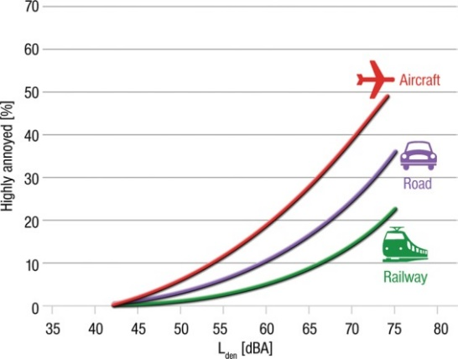
In addition to CO₂ emissions, aviation causes local air pollution, especially near airports and along highly travelled flight paths, with airborne emissions from aircraft engines, like particulate matter, volatile organic compounds, and nitrogen oxides, worsen air quality. Such pollutants have been associated with respiratory diseases, cardiovascular disease and lower life expectance, particularly in people who live near large airports (Inkson & Minnaert, 2018).
Figure3: Percentage of persons highly annoyed by aircraft, road, and rail traffic noises (Munzel et al., 2014).
Aircraft noise pollution is also a serious problem. Prior research has linked chronic exposure to high levels of aircraft noise to increased stress, sleep disturbances, and impaired cognition. According to the World Health Organization (WHO), aviation noise is a special environmental risk factor for direct exposure to urban areas with high-frequency flight operations (Cooper, 2021).
While measures such as noise abatement policies, airport curfews, and flight path changes have been implemented to reduce noise pollution, these measures are unlikely to be adequate in the face of rising international air traffic. Decarbonising aviation and addressing zero emissions from aircraft will require innovation in aircraft design, regulatory intervention, and airport planning to combat the adverse effects of air and noise pollution (Xie, Zhu and Lee, 2023).

Fossil Fuel Dependency
Aviation is still one of the most dependent industries on fossil fuels, flying exclusively on kerosene jet fuel. Contrary to the road transport sector, which is facing the switch towards electric and hydrogen-based vehicles, aviation faces few alternative fuels (Costa & Costa, 2022).
While biofuels and synthetic fuels have been investigated as alternatives to traditional jet fuel, the high production costs, supply chain restrictions, and low scalability have hindered their adoption (Sloan, Legrand, & Chen, 2022). The aviation sector faces a hard decarbonisation challenge, as fossil fuels will be hard to shift from use without serious investment in sustainable aviation fuels (SAFs) and alternative energy sources (Grimme, 2023).

Largest Roadblocks to Sustainable Aviation

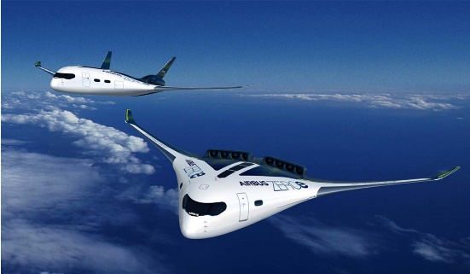
Technological Barriers
Figure4: Hydrogen powered planes (Innovation, 2021).
Although potential possibilities include hydrogen-powered aircraft, electric propulsion and other more fuel-efficient aircraft designs, many of those are still in development and have some technological hurdles to overcome. The key barriers include:
- Hydrogen storage and refuelling infrastructure limitations: Hydrogen is cryogenically stored and needs an extensive infrastructure overhaul to service hydrogen-fuelled commercial flights.
- The weight of batteries for electric aircraft: The energy density of current batteries is insufficient for long-distance flights, causing a substantial limitation for electric aircraft (Sloan, Legrand, & Chen, 2022).
- High cost of SAF production and integration: Although SAFs could reduce emissions by 80%, SAF production is still expensive, and the global supply chain is not yet fully developed (Jauhari, 2021).

Political and Financial Barriers
It emphasises the importance of government intervention in catalysing sustainable aviation but notes that regulatory frameworks still vary from place to place. Although some nations impose more rigorous carbon regulations and opportunities to promote SAF, others favour economic advancement over environmental policies (Cooper, 2021).
A CORSIA (Carbon Offsetting and Reduction Scheme for International Aviation) is a global aviation scheme that caps emissions from international flights at 2020 levels (as agreed by the International Civil Aviation Organization (ICAO)) (ICAO, 2019). Nevertheless, many nations are voluntary members of CORSIA, making it less efficacious (Costa & Costa, 2022). Combined with stronger enforcement mechanisms and binding global agreements, we will look at meaningful emissions reductions.
Economically, sustainable technology investments are capital-intensive and thus out of reach of budget airlines and smaller carriers. The deployment of low-emission aviation technologies will be sluggish without financial incentives and/or subsidies (Hasan et al., 2021).

Sustainable Ways to Travel by Air
With aviation still among the top causes of carbon footprint creation, sustainable solutions are necessary. Researchers are examining different approaches, such as sustainable aviation fuels (SAFs), hydrogen and electric-powered aircraft, government intervention, and consumer action. Some solutions may come with the challenge of short-term implementation, but all together, they hold the potential to greatly minimise the environmental consequences of aviation (Almena et al., 2024).

Sustainable Aviation Fuels (SAFs)
SAFs are a realistic near-term pathway to lower aviation emissions. SAFs, in contrast to conventional jet fuel, are produced from biomass, algae, and synthesis processes, making it possible to achieve up to 80 % net reductions in carbon emissions while maintaining compatibility within an existing aircraft infrastructure (Jauhari, 2021).
Many top carriers, such as KLM and British Airways, are already starting to add SAFs to their fleets. Despite this, their high production costs, lack of availability, and developed supply chains inhibited large-scale adoption (Sloan, Legrand, & Chen, 2022). Governments must bolster subsidies, invest in production facilities, and implement policies that will make a gradual move to SAF inevitable to inspire SAF growth (Johnson, 2019).
SAF production at scale would enable airlines to replace conventional jet fuels progressively, allowing faster decarbonisation without large-scale aircraft modifications. Maximising SAF potential will require collaboration between airlines, policymakers, and fuel producers.

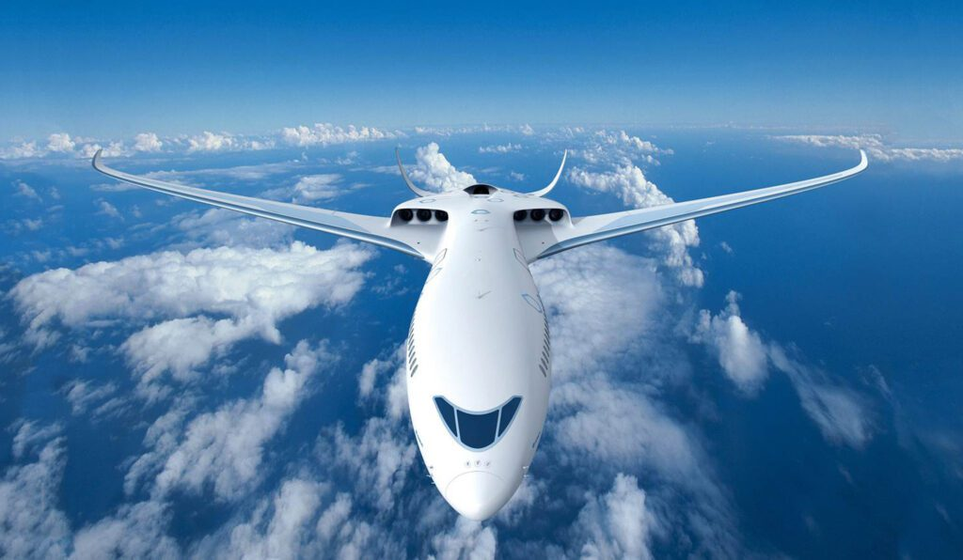
Hydrogen and Electric Aviation
Figure5: Electric Aviation (Reed, 2022)
Electric and hydrogen are long-term solutions for sustainable aviation, enabling zero-emission flights. One important initiative of this nature is Airbus's ZEROe project, which targets the achievement of hydrogen-powered commercial aircraft by 2035 and is expected to provide a major reduction in CO₂ emissions and non-CO₂ pollutants (Inkson & Minnaert, 2018).
Likewise, electric-plane makers like Rolls-Royce and Eviation are working on short-haul electric planes to prove battery-powered flight is possible. However, hydrogen and electric plane use await full development due to technological limitations, infrastructure shortages, and high design costs (Costa & Costa, 2022).
In the case of hydrogen-powered aircraft, the key hurdles relate to safe storage, transportation and refuelling infrastructure. Cryogenic hydrogen storage will be needed, and airports must be significantly redesigned to accommodate hydrogen in large volumes. Electric planes are currently constrained by the mass of the batteries needed for long-haul flights and the low power density of their batteries, limiting their feasibility far into the future.
Even with these challenges, ongoing investment in hydrogen storage, advanced batteries, and airport electrification will be necessary to drive these solutions towards market viability. Hydrogen and electric aviation could replace fossil fuel-powered flights if only a supportive regulatory framework and the joint industry effort became available.

Policy and Governmental Interventions
Government action is key to speeding up the transition of aviation to a more sustainable future. This will affect not only aviation, but many nations are enacting measures to curb emissions, reduce the usage of alternative fuels, and limit non-essential air travel. One notable instance is the French short-haul domestic flight ban, which encourages transport passengers to choose lower-emission transport where viable train alternatives exist (Cooper, 2021).
To allow meaningful change across industries, firmer international policies and frameworks for regulation will need to be taken. Governments must introduce:
- Tougher emissions standards for airlines to help spur efficient operations
- Funding for SAF and hydrogen aircraft research
- Grants for green investment for improved aviation sustainability infrastructure.
Global cooperation through institutions like ICAO and the European Union's Fit for 55 programme must ensure that sustainability does not stop at national borders. For long-term viability, the aviation sector needs to be regulated through economic incentives and stringent environmental standards (ICAO, 2019).

Sustainable Consumer Behaviour
The average traveller is now more aware than ever of their carbon footprint, and as such, consumer behaviour shapes aviation's sustainability priorities. Many passengers are seeking eco-friendly travel alternatives, which has caused airlines to present sustainability initiatives, carbon offset programs, and emissions transparency measures (Batabyal, 2018).
There are several key trends that are driving a consumer-led wave of sustainability in aviation:
The Fly less movement: Many travellers are questioning how often they really need to fly, opting instead for high-speed rail, virtual meetings, and slow travel.
Rise in demand for sustainable airlines: Consumers are trusting more airlines to invest in SAFs, carbon neutrality in the near future, and sustainable business models.
The increasing number of sustainable travel certifications: A Certification Programme certifying airlines based on sustainability performance is impacting consumer choices (Costa & Costa, 2022).
Airlines also need to do their bit by informing travelers about the climate cost of their choices and rewarding more sustainable behaviour with lower fares. Encouraging passengers to balance their footprint by voluntarily offsetting carbon, rewarding those who pay for more sustainable options, and implementing emissions data in booking platforms will enable passengers to make sustainable choices.
The future of aviation depends not just on technological progress and governmental policy but on your engagement with travel and responsible behaviours. Achieving a low-carbon aviation future will require joint effort from airlines, policymakers, and passengers.

Case Studies: Airlines Putting Sustainable Solutions in Place
In preparation to reach net zero by 2050, British Airways partnered with LanzaTech to provide waste-based sustainable aviation fuels (SAFs) (Jauhari, 2021). Under the "Fly Responsibly" initiative, KLM asks passengers to consider an alternative mode of transport and financially supports SAF production via SkyNRG, striving to achieve a cut in per passenger CO₂ emissions of 50% by 2030 (Inkson & Minnaert, 2018).
On the other hand, Norwegian Air is partnering with Rolls-Royce for hybrid-electric powered regional routes and investigating hydrogen fuel cell technology, as the airline hopes to roll out hybrid-electric commercial flights by 2030 and electric short-haul flights by 2040 (Costa & Costa, 2022).
These airlines are leading the charge in new sustainable innovations, showcasing how the technologies of today and the policies of tomorrow can help lead aviation towards a low carbon future.

Conclusion and Recommendation
Even if the aviation industry serves an important function in connecting the world and being part of economic improvement, the environmental impact of flying is not a sustainable path that this industry can take. With continued rapid demand for air travel, this sector is under intense pressure to decarbonise, rely less on fossil fuels, and lessen pollution. Sustainable aviation fuels (SAFs) and hydrogen-fueled and electric aircraft are the key technologies for decarbonising air travel. Still, the high costs of SAF production and a lack of infrastructure and inconsistent regulatory support hinder their widespread use (Batabyal, 2018). Increased adoption and growth in sustainable aviation technologies are urgently needed, and therefore, strong policy interventions are also required as they act as cornerstones of the transition.
Prioritise a few strategies to achieve this goal. More SAF production and hydrogen infrastructure will be needed to make alternative fuels more widely available and cheaper. Governments must impose more robust international emission reduction regimes using schemes like ICAO's CORSIA to incentivise airlines to utilise low-emission technologies (Cooper, 2021). Improving consumer education on sustainable travel options is vital to help travellers make better decisions. In addition to carbon offsetting, a sustainable airline certification or even alternative transport means options contribute to tackling aviation's environmental effects (Costa & Costa, 2022).
Creating a sustainable aviation sector will require the cooperation of airlines, regulatory agencies, and customers to strike a balance between financial advancement and environmental accountability. Innovative techniques, policy implementation, and customer awareness could drive aviation to a greener future.

Reference list
Almena, A., Siu, R., Chong, K., Thornley, P. and Röder, M. (2024). Reducing the environmental impact of international aviation through sustainable aviation fuel with integrated carbon capture and storage. Energy Conversion and Management, 303, p.118186. doi:https://doi.org/10.1016/j.enconman.2024.118186.
Batabyal, D. (2018). Managing sustainable tourism resources. Business Science Reference.
Climaviation (2022). CO₂, NOx, water vapour and aerosols: how to properly account for all the climate effects of aviation – Climaviation. [online] Climaviation.fr. Available at: https://climaviation.fr/en/2022/12/07/co%E2%82%82-nox-water-vapour-and-aerosols-how-to-properly-account-for-all-the-climate-effects-of-aviation/ [Accessed 14 Feb. 2025].
Cooper, C. (2021). Essentials of tourism. 3rd ed. SAGE.
Costa, V. and Costa, C. eds., (2022). Sustainability and competitiveness in the hospitality industry. Advances in Hospitality, Tourism, and the Services Industry. IGI Global. doi:https://doi.org/10.4018/978-1-7998-9285-4.
Gössling, S. and Dolnicar, S. (2022). A review of air travel behavior and climate change. WIREs Climate Change, 14(1). doi:https://doi.org/10.1002/wcc.802.
Grimme, W. (2023). The Introduction of Sustainable Aviation Fuels—A Discussion of Challenges, Options and Alternatives. Aerospace, [online] 10(3), p.218. doi:https://doi.org/10.3390/aerospace10030218.
Hasan, M.A., Mamun, A.A., Rahman, S.M., Malik, K., Al Amran, Md.I.U., Khondaker, A.N., Reshi, O., Tiwari, S.P. and Alismail, F.S. (2021). Climate Change Mitigation Pathways for the Aviation Sector. Sustainability, 13(7). doi:https://doi.org/10.3390/su13073656.
ICAO (2019). Carbon Offsetting and Reduction Scheme for International Aviation (CORSIA). [online] ICAO. Available at: https://www.icao.int/environmental-protection/CORSIA/Pages/default.aspx [Accessed 14 Feb. 2025].
Inkson, C. and Minnaert, L. (2018). Tourism management. SAGE.
Innovation (2021). Hydrogen powered planes. [online] ENGIE Research & Innovation. Available at: https://innovation.engie.com/en/news/interview/new-energies/hydrogen-powered-planes/26592 [Accessed 14 Feb. 2025].
Jauhari, V. (2021). Managing sustainability in the hospitality and tourism industry: paradigms and directions for the future. Apple Academic Press.
Johnson, K.C. (2019). Policy Perspective: A Strategy for Accelerated Decarbonization and Fuel Security in the Air-Transport Industry. SSRN Electronic Journal. doi:https://doi.org/10.2139/ssrn.3470249.
Modarress Fathi, B., Ansari, A. and Ansari, A. (2023). Green Commercial Aviation Supply Chain—A European Path to Environmental Sustainability. Sustainability, 15(8), p.6574. doi:https://doi.org/10.3390/su15086574.
Munzel, T., Gori, T., Babisch, W. and Basner, M. (2014). Cardiovascular effects of environmental noise exposure. European Heart Journal, 35(13), pp.829–836. doi:https://doi.org/10.1093/eurheartj/ehu030.
Reed, J. (2022). Challenges and Opportunities for Electric Aviation. [online] Avionics International. Available at: https://www.aviationtoday.com/2022/12/30/challenges-opportunities-electric-aviation/ [Accessed 14 Feb. 2025].
Ritchie, H. (2023). How much does aviation contribute to climate change? How will this change in the future? [online] www.sustainabilitybynumbers.com. Available at: https://www.sustainabilitybynumbers.com/p/aviation-climate-part-one [Accessed 14 Feb. 2025].
Ritchie, H. (2024). What share of global CO₂ emissions come from aviation?. Our World in Data. [online] Available at: https://ourworldindata.org/global-aviation-emissions [Accessed 14 Feb. 2025].
Sloan, P., Legrand, W. and Chen, J.S. (2022). Sustainability in the hospitality industry. Sustainability in the Hospitality Industry. doi:https://doi.org/10.4324/9781003081128.
Xie, J., Zhu, L. and Lee, H.M. (2023). Aircraft Noise Reduction Strategies and Analysis of the Effects. International Journal of Environmental Research and Public Health, [online] 20(2), p.1352. doi:https://doi.org/10.3390/ijerph20021352.

