

Student Name: Krunal Ashokbhai Sorathiya

Student ID: 2430614

Module Name: Dissertation

Module Code: LCMB7035

Supervisor’s Name: Nishi Ramsurrun Sharma

The Impact of Work-Life Balance Practices on Employee Job Satisfaction: A Case Study of Tesco Supermarkets in the UK

AI use Acknowledgement

Table of Contents
AI use Acknowledgement 3
1. Introduction 6
1.1 Background of the Study 6
1.2 Problem Statement / Research Gap 7
1.3 Research Aim 8
1.4 Research Objectives 8
1.5 Research Questions / Hypotheses 8
Hypothesis 9
1.6 Significance of the Study 9
2. Literature Review 9
2.1 Work-Life Balance Practices 9
2.2 Employee Job Satisfaction 10
2.3 Tesco Supermarkets in the UK 11
2.4 Relationship between Work-Life Balance Practices and Employee Job Satisfaction 12
2.5 Theoretical Framework 12
2.6 Empirical Studies 13
2.7 Research Gap 13
2.8. Conceptual Framework 14
3. Methodology 14
3.1 Research Philosophy 14
3.2 Research Approach 15
3.3 Research Strategy 15
3.4 Research Design 15
3.5 Data Collection Method 16
3.6 Target Population 16
3.7 Sampling Method 16
3.8 Sample Size 16
3.9 Data Analysis Techniques 17
3.10 Reliability and Validity 17
3.11 Ethical Considerations 17
4. Expected Findings 18
5. Limitations 18
6. Timeframe 18
7. Conclusion 19
8. References 19

1. Introduction

1.1 Background of the Study
Employees are more motivated to seek a harmonious balance between professional commitment and personal commitment, which includes responsibility to family, social commitments and individual wellbeing. In response, organizations are increasingly implementing work life balance initiatives including flexible working hours, well thought out leave policies, remote working options, and comprehensive employee support programmes, which all focus on improving employee wellbeing and job satisfaction (Hariri et al., 2024).
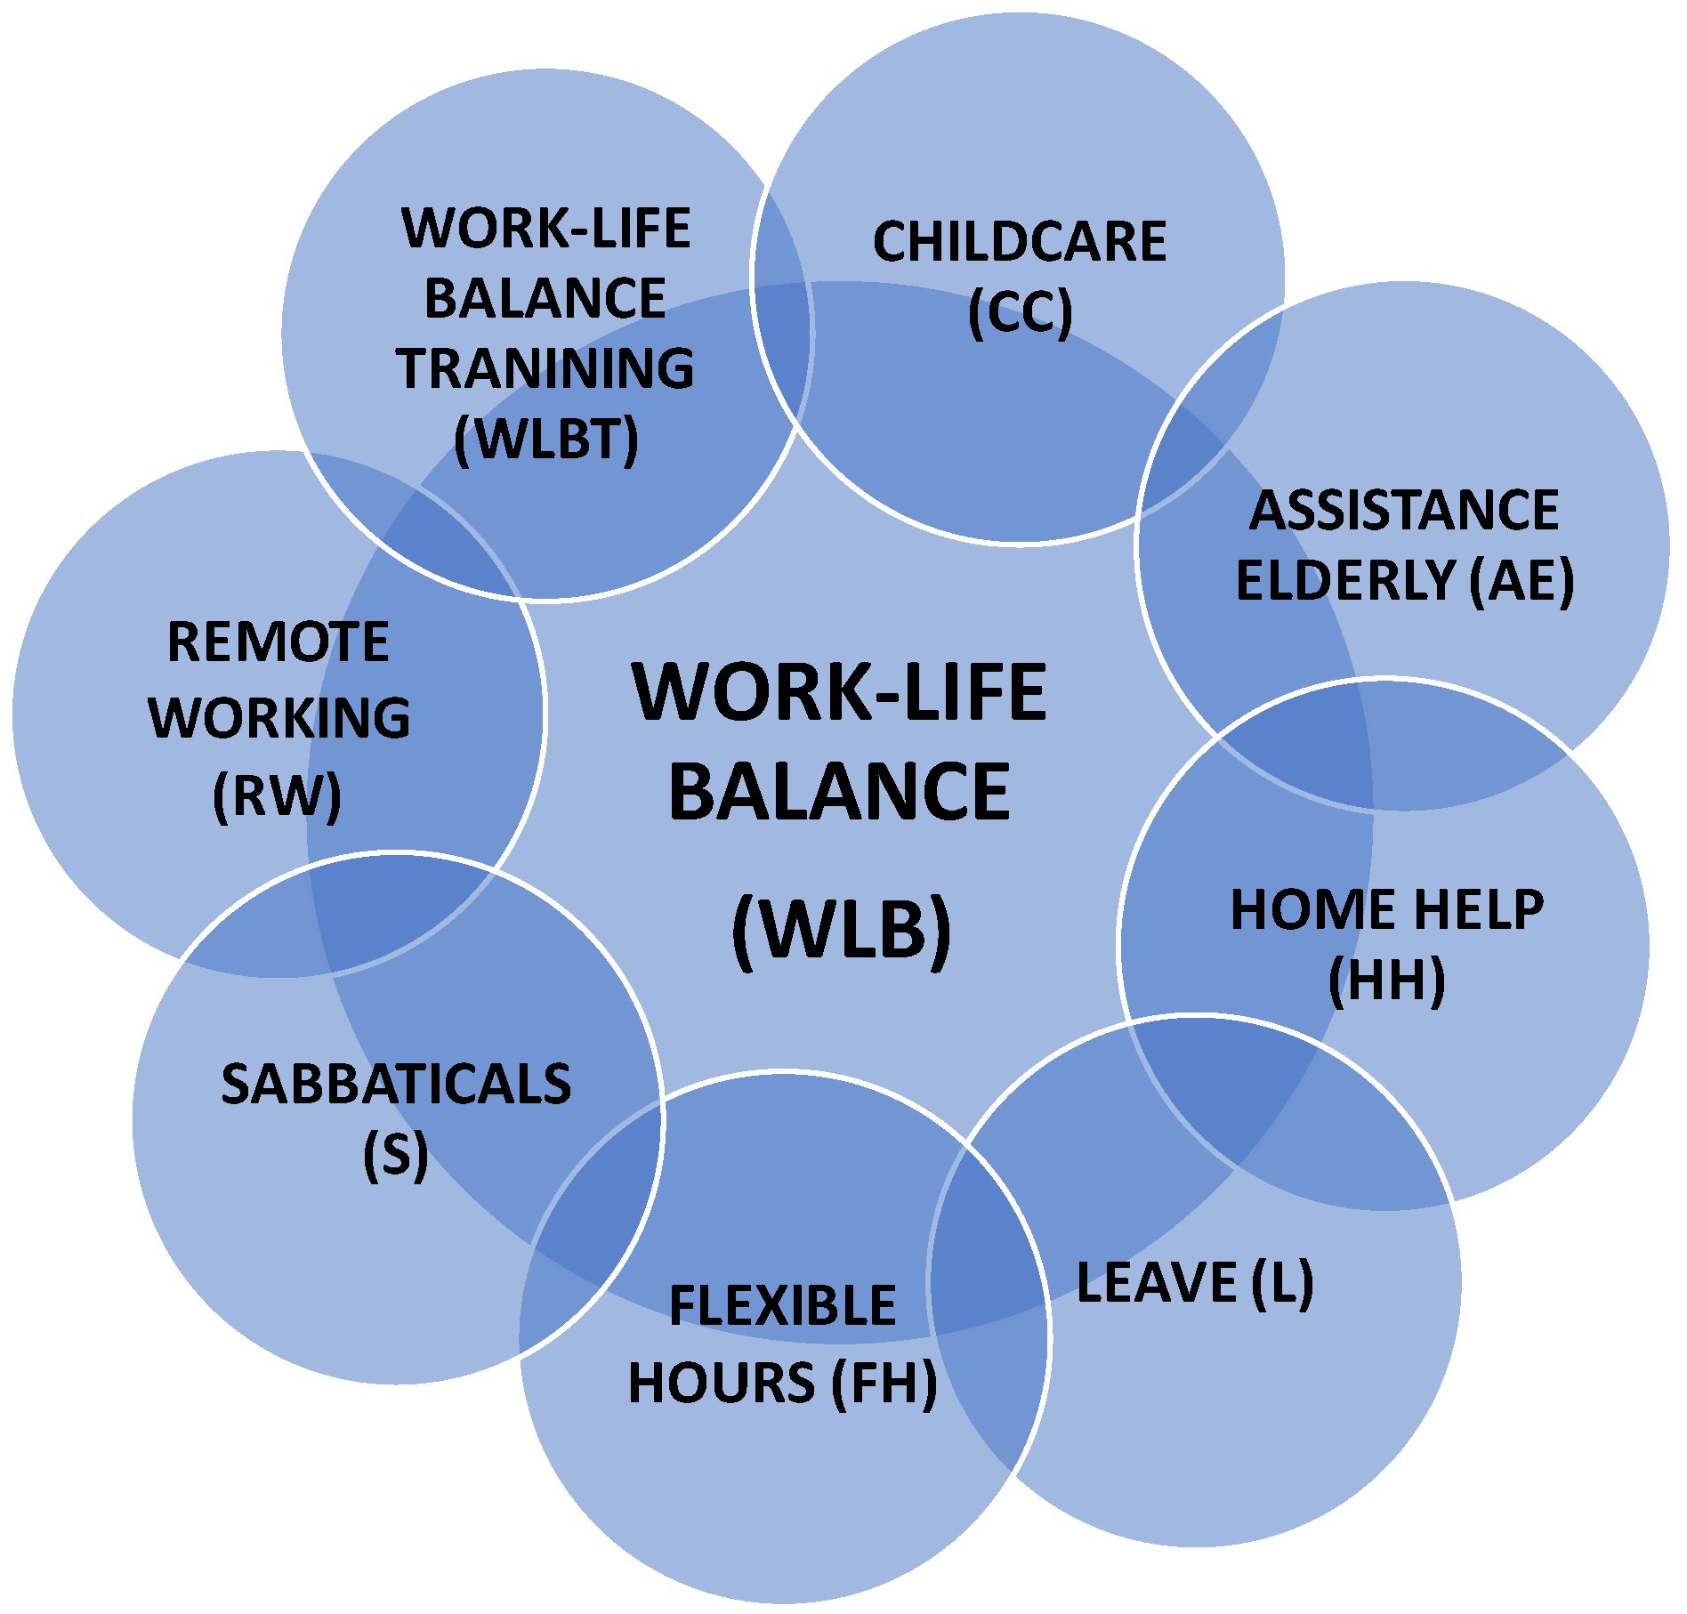
Figure 1:Work-Life Balance
(Source: Author, 2026)
Work-life balance practices are considered vital because employees who have a healthy balance between their professional demands and personal life are shown to have greater motivation, engagement, and job satisfaction. Empirical research shows that such employees show improvement in performance, lower stress levels and higher organizational commitment (Nugroho, 2025). Moreover, organizations that make active effort in terms of work-life balance practices stoke and retain talented personnel, and this in turn strengthens the organization in terms of productivity and longevity (Al- Kazem et al., 2025).
The retail sector is an area where the issue of work-life balance acquires a certain topicality. Employees who are practicing retail are often faced with the issue of long working hours, irregular shifts, and distribution, particularly during the weekends or in the public holidays which can call upon their personal lives and on the overall wellbeing (Malaki, 2024). As one of the largest chains of shop desks in the United Kingdom, Tesco consists of many employees who work in many stores and their working levels. Major challenges that Tesco employees would face maintaining a sufficient work-life balance are predetermined by the inherent demands of the activities of the retail company (Malaki, 2024).

1.2 Problem Statement / Research Gap
Although work-life balance interventions have become widely accepted by organizations as the necessity, workers who work in the retail sector still have a lot of barriers they face to strike a proper balance of work and life commitments. Retail employees are periodically exposed to the working schedules and extended working hours, work pressures, and these factors may negatively influence their job satisfaction levels and well-being (Malaki, 2024).
Enough literature has studied the connection between work life balance and the performance or productivity of employees. Empirical research is consistent in showing that work-life balance behaviour has a positive impact on employee productivity and well-being at the workplace (Cahyanuzul et al., 2025). In the same spirit, systematic reviews have affirmed that work-life balance strategies helpful in reducing stress and improving job satisfaction and organizational commitment (Gaur et al., 2025). Nonetheless, these studies concentrate on the general organization or industry but not on the actual setting of the retail supermarket industry.
Moreover, there is a small number of studies that have mainly focused on the relationship between work-life balance and workers' performance rather than studying the impact of specific work-life balance practices on workers' job satisfaction (Cahyanuzul et al., 2025).
Additionally, empirical research that examines this relationship in supermarkets (the same of Tesco in the United Kingdom) is limited. Consequently, a knowledge deficit exists regarding the effects of work/life balance practices for employee job satisfaction in large Retail Supermarket entities using the example of Tesco.

1.3 Research Aim
The aim of this study is to examine the impact of work-life balance practices on employee job satisfaction at Tesco supermarkets in the United Kingdom.

1.4 Research Objectives
- To identify work-life balance practices implemented at Tesco supermarkets in the UK.
- To analyse the impact of work-life balance practices on employee job satisfaction.
- To analyse the level of employee job satisfaction among Tesco supermarket employees.

1.5 Research Questions / Hypotheses
- What work-life balance practices are implemented at Tesco supermarkets in the UK?
- How do work-life balance practices influence employee job satisfaction?
- What is the level of job satisfaction among Tesco employees?

Hypothesis
H1: Flexible working hours have a significant positive impact on employee job satisfaction among Tesco supermarket employees in the UK.
H2: Paid leave and holiday policies have a significant positive impact on employee job satisfaction among Tesco supermarket employees in the UK.
H3: Family support has a significant positive impact on employee job satisfaction among Tesco supermarket employees in the UK.
H4: Support from colleagues has a significant positive impact on employee job satisfaction among Tesco supermarket employees in the UK.

1.6 Significance of the Study
The research contributes to the academic understanding regarding the topic of work-life balance because it examines its role in influencing job satisfaction among employees in the retail industry in a systematic manner. Despite the studies that have been conducted previously on work-life balance in various industries, there is a lack of empirical studies that specifically target the supermarket organizations in the United Kingdom. Secondly, the studies provide practical results to retail organizations such as large chains of supermarkets such as Tesco. Thirdly, the results are supportive of the initiatives aimed at improving employee wellbeing and organisational productivity (Cahyanuzul et al. 2025).

2. Literature Review

2.1 Work-Life Balance Practices
The work-life balance refers to the ability of the staff to balance work and personal and family-related duties at the same time. It is a driver of crucial factor of employee health and organizational effectiveness. The list of work-life balance practices includes flexible working schedules, working from home, parental leave policies, workload management, and favourable organizational policies (Hariri et al., 2024).
Institutionalisation of work-life balance practices in organisations is with the aim of enhancing employee satisfaction and productivity. The empirical studies have found that good work-life balance practices help to reduce the stress at work and boost the morale of workers (Al‑Kassem et al., 2025). Further, work-life balance practices are imperative in maintaining mental health and well-being of the workers in general. Stress, burnout, and low motivation are among the complications that the employees face when there is a mismatch between occupational and personal requirements (Vhutali, 2025).
The work-life balance practices gain special importance in the retail sector since employees regularly have to face irregular working hours and long shifts. Flexible scheduling and the willingness of the workplace policies make it easier to maintain the balance between occupational and personal life roles of the employees of the retail (Malaki, 2024).

2.2 Employee Job Satisfaction
Employee job satisfaction refers to the relative degree of satisfaction or personal fulfilment in work experience that the employees perceive in their occupational roles. It is influenced by various precursors, including organisational pay, workplace atmosphere, inter-personal relationships with co-employees, job security and institutional support. Job satisfaction has generally been a critical factor in determining employee motivation and organisational performance (Machova et al., 2022).
The people with higher levels of job satisfaction are more likely to display higher levels of commitment, productivity, and engagement in their occupational duties. Empirical evidence shows that job satisfaction has a significant impact on employee performance and the overall success of the organisation (Panda, 2025).
Moreover, job satisfaction has a strong relationship with employee well - being as well as psychological health. Workmen that have job satisfaction are more likely to have a sense of loyalty towards their institutions and contribute positively towards the organisational goals (Masuku et al., 2025). In case of retail enterprises, the antecedents of job satisfaction are working conditions, managerial practises, and work-life balance. Employees in retail cuttings who get enough support from the organisation are likely to show high levels of job satisfaction and job engagement (Dilmika et al., 2024).

2.3 Tesco Supermarkets in the UK
Tesco can be considered as one of the leading retail supermarket chains in the United Kingdom with thousands of stores in the network and with a significant working force. The organization has a strategic position in the UK in the retail sector as a job creator of jobs in a range of operations and management opportunities (Hermawati, 2025).
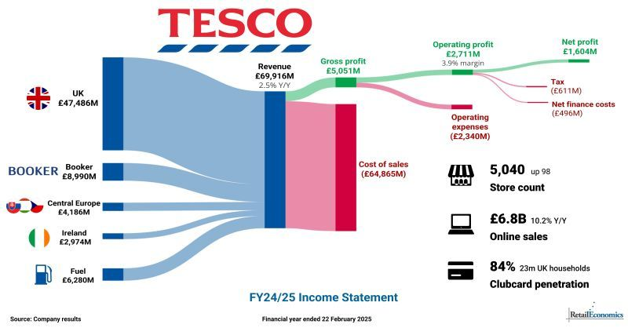
Figure 2: Tesco financial details 2025
(Source: Tesco, 2025)
This dynamic and challenging work environment is due to the inherent nature of retail operations of the Tesco employees. The retail business requires long operating hours, weekend working, and the possibility of working on shifts and neither allows workers to have a proper work-life balance (Hermawati, 2025). As a result, the best way to guarantee employee satisfaction and well-being in Tesco supermarkets is the adoption of effective work-life balance practices (Hermawati, 2025).

2.4 Relationship between Work-Life Balance Practices and Employee Job Satisfaction
Numerous studies have found a strong correlation between practices for work-life balance and job satisfaction. Work-life balance allows employees to balance work-related responsibilities without compromising their personal lives which will promote good psychological well-being and job satisfaction (Cahyanuzul et al. 2025). Effective work-lifelong policies are also known to reduce work-related stresses and burnout, thus improving performance and satisfaction of employees (Darwin et al., 2025).
A systematic review of empirical research suggests that work-wife balance practices are positively related to an array of positive employee outcomes, such as increased job satisfaction, increased well-being, and lower employee turnover (Gaur et al., 2025). Similarly, empirical investigations show that employees who receive organizational support in dealing with work-life balance are evidence of greater engagement and productivity (Lukman, 2025).

2.5 Theoretical Framework
The theoretical basis in this research is based on the Work-Life Balance Theory and the Social Exchange Theory. Work-Life Balance Theory is based on the idea that employees need to have harmony between their professional roles and personal lives in order to feel well, productive, and have a sense of job satisfaction (Hariri et al., 2024). Once employees enjoy this kind of balance, they will be more inclined to develop an increased level of motivation and dedication to their professional position (Nugroho, 2025). The Social Exchange Theory is based on the notion that employees are responsive to organisations who provide them with conducive working conditions making them develop greater satisfaction with their jobs and organisational loyalty (Lukman, 2025).

2.6 Empirical Studies
Cahyanuzul et al. (2025) stated that work - life balance has positive impact on employee productivity and job satisfactory within organization context. These results highlight the important role of experiencing flexibility in work and supporting human resources policies.
In a similar vein, Nugroho (2025) stated that work positive employees have better job performance and high job satisfaction. The importance of work-life balance practices is mentioned in the study as indispensable in maintaining employee wellbeing and motivation. A systematic review by Ragazza et al (2026) has established that work-life balance practices have a significant impact on the performance and satisfaction of employees in various industries. Their findings show that organizations that have implemented an effective work-life balance strategy achieve better employee outcomes.

2.7 Research Gap
The studies conducted in the past point at the relevance of work-life balance interventions to improving both employee well-being and organisational performance; nevertheless, research studies that focus on the role of work-life balance interventions on employee job satisfaction in the context of the UK retail supermarket industry are limited (Gaur et al., 2025). The available literature is largely dedicated to general organisational situations instead of the giant retail-friendly corporations like Tesco (Malaki, 2024). The proposed study will, therefore, fill this gap by exploring how the work-life balance practises influence job satisfaction among the Tesco supermarket employees in the United Kingdom (Nugroho, 2025).

2.8. Conceptual Framework
Dependent variable
Independent variable (Work-Life Balance Practices)

Flexible Working Hours

Paid Leave and Holiday Policies
Employee Job Satisfaction

Family Support

Support from Colleagues

Figure 3: Conceptual Framework

3. Methodology

3.1 Research Philosophy
This study utilizes the positivist research philosophy which is concerned with the objective measuring of things and statistical analysis of observable forms of data. Positivism believes that reality can be measured via empirical evidence and statistics and is commonly used in the field of business and management research because it allows researchers to investigate their hypothesis and determine the relationships between variables, based on statistical methods (Saunders et al., 2019).

3.2 Research Approach
The study will be deductive in nature. Starting with the existing theoretical models, this approach formulates assumptions, which are then examined empirically, agreeableness to Saunders and co-authors (2019). The hypotheses development in the current study will be supported by such seminal theories as the Work-Life Balance Theory and Social Exchange Theory, which have contributed to the relationship between work-life balance practices and job satisfaction of employees. The empirical information gathered among the workers of Tesco supermarkets will undergo stringent statistical tests to determine the relevance of the hypotheses proposed, as outlined by Creswell (2018).

3.3 Research Strategy
The research design that the study will adopt is the survey research design to gather the empirical data of employees. One of the reasons why the use of surveys is broadly used in business scholarship is the ability to organize and effectively gather facts on a vast group of respondents (Bryman et al., 2015).

3.4 Research Design
The research design that will be used in the study is a quantitative cross-sectional research design. Quantitative research presupposes the organized gathering of number data, which later can be examined using the statistical approach (Creswell, 2018). A cross-sectional design involves collecting data of individuals at one specific point in time, unlike a longitudinal design, which addresses the matter over a long period (Saunders et al., 2019).

3.5 Data Collection Method
The study will use the data collection methodologies of secondary data and use of questionnaires for employees. Secondary data refers to Human resource statistical data of the company, performance review of employees and retention rate (Bryman et al., 2015). Data will be analysed from different sources such as books, journals and company inventory system.

3.6 Target Population
The population of the current research will consist of the employees working at the Tesco stores in the United Kingdom. This group will be the centre of the research about perceptions on work-life balance interventions and work satisfaction.

3.7 Sampling Method
The sampling strategy that will be used in the investigation will be simple random sampling. Simple random sampling gives a member of the population an equal chance at being selected and, thus, reduces selection bias and increases the representativeness of the resulting sample (Saunders et al., 2019).

3.8 Sample Size
This investigation will aim to get responses from employees that work at a supermarket (Tesco) cohort of 50 employees. A sample of 50 participants is sufficient to use for quantitative research to allow the researcher to perform statistical analysis such as correlation and regression with a reasonable degree of precision (Hair et al., 2019).

3.9 Data Analysis Techniques
The data will be subject to statistical analysis using software’s such as statistical package for social sciences (SPSS). To begin with, descriptive statistics will be conducted to give a summary of the demographic attributes as well as the distribution of the responses from the respondents. Subsequently, a correlation analysis will be carried out to explore the relationship of work-life balance practises to job satisfaction of employees. Finally, a multiple regression analysis will be taken to calculate the effects of the independent variables on the dependent variable.

3.10 Reliability and Validity
To ensure research instrument with methodological rigour, systematic reliability as well as validity measurements will be conducted. The alpha of Cronbach will be used as an indicator of assessing the internal consistency of the items on the questionnaire. The alpha coefficient, which will be higher than 0.7, will be seen as reflecting a sufficient level of reliability, in accordance with the recommendations of Hair et al. (2019). Besides, a pilot test with a small group of respondents will be conducted before the actual survey to ensure that the items are clear, understandable, and correctly formulated.

3.11 Ethical Considerations
Ethical considerations would be rigorously followed in the research process. Participation in the survey will be voluntary, and respondents will be informed about the purpose of the study before responding to the questionnaire. The anonymity and confidentiality of respondents shall be ensured, and personal information shall not be revealed to any third parties. The collected data shall only be used for academic purposes, and the respondents shall retain the right to withdraw from the study at any time (Saunders et al., 2019).

4. Expected Findings
It is hoped that the current research will indicate a positive association between work-life balance practices and job satisfaction of employees in Tesco supermarkets. Flexible work hours, workload that is manageable, and supervisors who are supportive are expected to increase employee satisfaction and motivation; all these results may further lead to employee performance and organizational commitment (Greenhaus et al., 2011; Deery et al., 2015).

5. Limitations
The research will only be done on a small group of 50 employees at Tesco which could limit the generalizability of the subsequent findings. Besides, the use of a questionnaire tool can cause biases in the responses because the respondents might willingly provide answers that are socially acceptable rather than honest (Saunders et al., 2019).

6. Timeframe
Table 1: Gantt chart

7. Conclusion
In sum, this work would examine the impact of work life balance practices on employee’s job satisfaction in Tesco supermarket in United Kingdom. The quantitative methodology and survey method chosen is expected to find relationships between key variables and provide insights that are useful to improve the wellbeing of the employees and improved organisation performance (Saunders et al., 2019).

8. References
Adams, J.L. (2025) The effect of employee engagement and job satisfaction on job performance: The role of perceived organizational support. Journal of Management Development, 44(5), pp.700–710. https://www.researchgate.net/publication/396649125_The_effect_of_employee_engagement_and_job_satisfaction_on_job_performance_the_role_of_perceived_organizational_support
Al-Askari, A.A. and Tamim, K. (2025) Work-life balance and its impact on employee productivity at HSA Group. MBA Thesis. https://www.researchgate.net/publication/393149765_WORK-LIFE_BALANCE_AND_ITS_IMPACT_ON_EMPLOYEE_PRODUCTIVITY_AT_HSA_GROUP_ANAS_ALI_AL-ASKARI_2025
Al-Kassem, A.H., Momani, H.R. and Alzghoul, A.M. (2025) Work-life balance and its impact on employee performance: HR strategies for success. International Journal of Innovative Research and Scientific Studies, 8(5), pp.646–657. https://www.researchgate.net/publication/394039318_Work-life_balance_and_its_impact_on_employee_performance_HR_strategies_for_success
Bryman, A. and Bell, E. (2015) Business research methods. 4th edn. Oxford: Oxford University Press. Available at: https://global.oup.com/academic/product/business-research-methods-9780199668645
Cahyanuzul, P.A., Handayani, S. and Afriyani, F. (2025) The impact of work-life balance and job satisfaction on employee productivity. Golden Ratio of Human Resource Management, 5(2), pp.350–359. https://www.researchgate.net/publication/393150073_The_Impact_of_Work-Life_Balance_and_Job_Satisfaction_on_Employee_Productivity
Creswell, J.W. (2018) Research design: Qualitative, quantitative, and mixed methods approaches. 5th edn. Thousand Oaks, CA: Sage Publications. Available at: https://us.sagepub.com/en-us/nam/research-design/book255675
Darwin, D., Aryana, S. and Parasuraman, B. (2025) The influence of work-life balance, job stress, job satisfaction and burnout on job performance. Jurnal Organisasi dan Manajemen, 21(1), pp.83–99. https://www.researchgate.net/publication/391198281_The_Influence_of_Work-Life_Balance_Job_Stress_Job_Satisfaction_and_Burnout_on_Job_Performance
Dilmika, S., Wijethunga, K.L.S., Chamuddika, K.G.L. and Harshana, H.A.C. (2024) Factors influencing job satisfaction of operational level employees, with special reference to supermarkets in Colombo, Sri Lanka. International Research Conference, Open University of Sri Lanka. https://www.researchgate.net/publication/388440942_FACTORS_INFLUENCING_JOB_SATISFACTION_OF_OPERATIONAL_LEVEL_EMPLOYEES_WITH_SPECIAL_REFERENCE_TO_SUPERMARKETS_IN_COLOMBO_SRI_LANKA
Emexidis, C., Gkonis, P. and Liapakis, A. (2025) Analyzing employee job satisfaction through sentiment analysis for enhanced workplace improvement and business success. Theoretical and Applied Ergonomics, 1(2), p.10. https://doi.org/10.3390/tae1020010
Gaur, J. and Tarkar, P. (2025) Relationship between work life balance with job satisfaction in organization: A systematic review of the empirical research. Management, 29(1). https://www.management-poland.com/pdf-207992-127271?filename=Relationship-Between-Work.pdf
Hair, J.F., Black, W.C., Babin, B.J. and Anderson, R.E. (2019) Multivariate data analysis. 8th edn. Hampshire: Cengage Learning. Available at: https://www.cengage.com/c/multivariate-data-analysis-8e-hair
Hariri, N.I.M., Othman, W.N.W., Anuar, S.B.A., Lin, T.Y. and Zainudin, Z.N. (2024) Effect of work-life balance on employees’ well-being. Open Journal of Social Sciences, 12, pp.705–718. https://doi.org/10.4236/jss.2024.1212044
Hermawati, W. (2025) Employee well-being in retail operations: Conceptual model and theoretical propositions for organizational performance. Journal of Resource Management Economics and Business, 4(2), pp.48–66. https://www.researchgate.net/publication/396395582_Employee_Well-being_in_Retail_Operations_Conceptual_Model_and_Theoretical_Propositions_for_Organizational_Performance
International Journal of Business Ecosystem & Strategy (2025) The impact of work-life balance on job satisfaction and organisational commitment in higher education in KwaZulu-Natal. 7(3), pp.155–166. https://doi.org/10.36096/ijbes.v7i3.839
Limniou, M., Keane, N. and Godfrey, A. (2025) Exploring job satisfaction, team communication behaviours, and personality traits for UK remote and non-remote working. Cogent Psychology, 12(1). https://www.tandfonline.com/doi/full/10.1080/23311908.2025.2518632
Machova, R., Zsigmond, T., Zsigmondova, A. and Seben, Z. (2022) Employee satisfaction and motivation of retail store employees. Marketing and Management of Innovations, 1(1), pp.67–83. https://www.researchgate.net/publication/360549870_Employee_satisfaction_and_motivation_of_retail_store_employees
Malaki, X. (2024) Work-life balance and job performance among employees of retail supermarkets in Davao City. https://www.researchgate.net/publication/381296406_WORK-LIFE_BALANCE_AND_JOB_PERFORMANCE_AMONG_EMPLOYEES_OF_RETAIL_SUPERMARKETS_IN_DAVAO_CITY
Masuku, N.G., Esterhuyzen, E. and Ramajoe, M.G. (2025) Determinants of employee engagement and job satisfaction in a local municipality. SA Journal of Human Resource Management, 23, a2988. https://doi.org/10.4102/sajhrm.v23i0.2988
Nugroho, D.A. (2025) The impact of work-life balance on employee performance and satisfaction in start-up companies. International Journal of Islamic Education Research and Multiculturalism, 7(1), pp.206–219. https://www.researchgate.net/publication/392740993_The_Impact_of_Work-Life_Balance_on_Employee_Performance_and_Satisfaction_in_Start-Up_Companies
Panda, R.K. (2025) Exploring the relationship between job satisfaction and employee performance: A meta-analysis. Journal of Information Systems Engineering & Management, 10(3), pp.1439–1451. https://www.researchgate.net/publication/391435865_Exploring_The_Relationship_Between_Job_Satisfaction_And_Employee_Performance_A_Meta-Analysis
Ragazza, O.N.B. and Irmansyah, E. (2026) The impact of work–life balance on employee performance: A systematic review. Multidisciplinary Indonesian Center Journal, 3(1), pp.897–907. https://www.researchgate.net/publication/399877885_THE_IMPACT_OF_WORK-LIFE_BALANCE_ON_EMPLOYEE_PERFORMANCE_A_SYSTEMATIC_REVIEW
Saunders, M., Lewis, P. and Thornhill, A. (2019) Research methods for business students. 8th edn. Harlow: Pearson Education Limited. Available at: https://www.pearson.com/en-gb/subject-catalog/p/research-methods-for-business-students/P200000003490
Vhutali, M. (2025) The impact of work-life balance and mental health well-being on women’s performance in the workplace. International Journal of Applied Research in Business and Management, 6(3). https://doi.org/10.51137/wrp.ijarbm.416

