LEVEL 7 ASSESSMENT SPECIFICATION

Student name: | MOHAMMOD EMAD UDDIN | Student ID number: | 2503788
Programme: | MBA
Module: | Managing Marketing Change
Module code: | BMMB7026 | Contribution to Overall Module Assessment (%): | 75%
Lecturer: | Gwyneth Jones | Internal Verifier: | Marie Pitson
Assignment Title: | Future Developments in the  Field of Marketing  (Individual Report) | Word count (or equivalent): | 3,750 words  (+/- 10%)
Submission deadline: | Wednesday 7th January 2026 | Return date of provisional marks &  written feedback: | Wednesday 4th  February 2026

Executive Summary
The report presents a critical analysis of the marketing approach of Unilever UK. It explores how Unilever UK, a well-established leader in the FMCG market, is manoeuvring through a complex UK market with value-oriented customers, strict regulations, and economic constraints. To evaluate the effectiveness of Unilever moving towards Unmissable Brand Superiority and focused Power Brand portfolio, the analysis applies the existing models such as PESTLE, Internal Environment, STP, Marketing Mix and IMC. The results show that this sophisticated approach has fueled short-term sales and financial discipline, but at the cost of placing the company at great risk in the long term. These consist of excessive dependence on a small range of brands that inhibits innovation, and a gap in credibility between its purpose-led marketing rhetoric and quantifiable sustainability proof that raises regulatory and consumer scepticism. Therefore, the report concludes that the present strategy of Unilever UK can erode resilience and trust. It suggests a change in strategy towards Credible and Inclusive Superiority. The most important recommendations are the independent sustainability communications, innovation in mid-tier brands and rebalancing the marketing strategies to regain consumer confidence and capture long-term competitiveness.
Table of Contents
Executive Summary 2
1. Introduction 5
2. Task 1: Critical Evaluation of Unilever UK’s Marketing 6
2.1. Importance of Marketing in Unilever UK 6
2.2. External Environment Analysis 7
2.3. Microenvironment Analysis 9
2.4. Segmentation, Targeting, and Positioning Analysis 10
2.5. Marketing Mix Analysis 12
2.6. Integrated Marketing Communication Analysis 13
2.7. Marketing Evaluation 16
3. Task 2: Conclusions on Shortcomings of Marketing Strategy 17
4. Task 3: Recommendations 18
4.1. SOSTAC Framework 18
4.1.1. Situation Analysis 18
4.1.2. Objectives 18
4.1.3. Strategy 19
4.1.4. Tactics 19
4.1.5. Action Plan 19
4.1.6. Control Mechanisms 19
4.2. Feasibility Assessment 20
5. References 21

List of Figures
Figure 1: Unilever UK Headquarter (Merced, 2020) 5
Figure 2: PESTLE Analysis Summary (Author) 9
Figure 3: Unilever STP Analysis (Author) 12
Figure 4: Wall using WinDOOH Technology (Mindshare Media, 2024) 14
Figure 5: Dove "Cost of Beauty" (Clio Awards, 2025) 15
Figure 6: Unilever UK IMC Strategies Summary (Author) 16

1. Introduction
Unilever was founded in 1929 as a result of the merger of the Lever Brothers and Margarine Unie (BBC, 2017). It continues to dominate the international fast-moving consumer goods market, having a turnover of €60.8 billion in 2024 (Smith, 2025). Over time, the company has become more concerned with the purpose-driven brand equity rather than just the functional products. The Port Sunley project by William Lever in the late 1800s aimed to make hygiene cheap and widespread to assist in the establishment of mass demand for soap (Devine, 2024). Unilever UK today employs emotional differentiation as a strategy to compete in saturated markets. An example is the Dove Real Beauty campaign that questioned traditional concepts of beauty to develop a stronger consumer base loyalty (Dove, 2024). On the same note, the Love It or Hate It marketing approach by Marmite transformed polarising taste into a strong brand (Epale, 2023). In 2010, the adoption of a Sustainable Living Plan was a strategic measure to reduce the threat to the environment as well as to entice ethically conscious shoppers (Khairunisa and Kusuma, 2021). Currently, Unilever UK focuses on the development of its 30 potential brands as part of the Growth Action Plan 2030. This proves that sustainability and strong brand storeys are necessary compromises to long-term financial viability. Unilever has a purpose and performance blend at the centre of its relevancy in a UK market where purchasing decisions are increasingly influenced by consumer values.
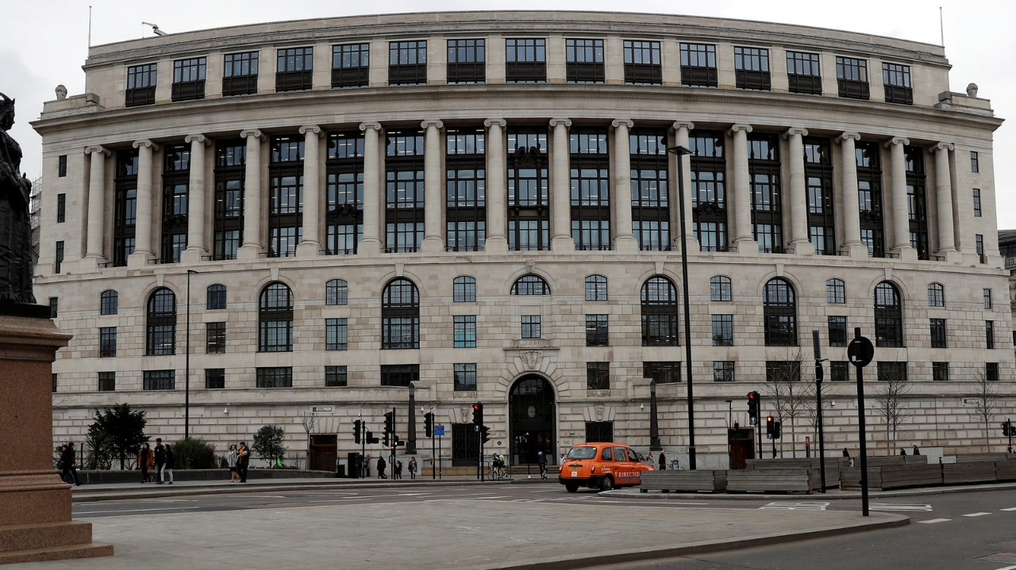
Figure 1: Unilever UK Headquarter (Merced, 2020)
This report critically analyses the marketing of Unilever UK based on PESTLE, Microenvironment, STP, Marketing Mix and IMC analysis. It assesses the success of the approach, identifies the shortcomings of innovation and credibility, and concludes with actionable suggestions of a more robust, reliable marketing plan through the establishment of trust.

2. Task 1: Critical Evaluation of Unilever UK’s Marketing

2.1. Importance of Marketing in Unilever UK
Unilever has experienced a major change in its marketing strategy in recent times. Earlier on, the company strongly marketed the idea of brand purpose, claiming that brand purpose increased more rapidly (Williams, 2023). Nonetheless, this method was severely criticised. Analysts claimed it diverted management out of fundamental business concerns, especially in products such as Hellmann's mayonnaise (Benstead, 2023). Unilever has now shifted towards what it refers to as unmissable superiority. There is evidence of this change. In 2024, the percentage of turnover spent on Brand and Marketing Investment was 15.5% (WARC, 2025). This is the largest in a decade (Unilever, 2025). This kind of expenditure reflects a new focus on marketing as the main driver of growth. But it also indicates a turn from general ideology to more rigorous commercial interest. The concentration of this investment has greatly increased. Unilever concentrates on only 30 of its Power Brands, such as Dove and Magnum. In 2024, these brands brought in three-quarters of the entire turnover (Robinson, 2025). They also achieved high underlying sales growth of 8.6% in 2023 (Bolton, 2024). This is a focused strategy as opposed to the previous one of imposing social purpose on all brands irrespective of the fit. The company currently no longer considers ESG goals as part of brand marketing unless presented with a clear commercial rationale. This indicates that Unilever acknowledges the importance of marketing in value creation. But it insists that this should be carried out with uniqueness and economic restraint. Profitability is no longer a secondary consideration to broad ideological missions. The outcome of this shift is ambivalent. There are positive short-term outcomes. Investing in products that have demonstrated success has increased sales volume and market share. It also addresses previous critiques regarding a lack of focus in its strategy. However, there are still long-term risks. Excess dependence on a narrow brand base might hamper innovation.

2.2. External Environment Analysis
PESTLE analysis assesses the macroenvironment based on political, economic, social, technological, legal and environmental factors. It finds opportunities and threats of strategies that are used to define the industry competition and profitability (Hill, Jones, and Schiling, 2020).
Category | Detail Analysis
Political | The UK-EU exports were recorded to have declined by 27% in the period between 2021 and 2023 due to political factors caused by the presence of customs barriers post-Brexit, which had an impact on supply chains and the consistency of the marketing (Du et al., 2024). HFSS advertising ban in October 2025 imposes the costly option of reformulation or a diminished presence (ADPH London, 2025). At the same time, R&D tax credits require innovation based in the UK, which may be out-of-step with international cycles. This patchwork of regulation requires a lot of operational adjustment and investment to stay in the market.
Economic | The long-running food inflation and the deeply rooted presence of discounters in the market lead to a bifurcated market. Although there has been a late-2025 recovery of 6.1% in branded goods sales (Modaes, 2025), the shares of the private labels are still high. Commodity volatility, such as recent spikes in cocoa (Eastlake, 2025), has inhibited pricing elasticity because consumers are no longer willing to see their prices rise. Premium segments that need reassurance and value segments that are motivated by price alone now severely diverge in marketing strategies, making portfolio messaging and managing margins more difficult.
Social | There is a significant social conflict. Although 80–85% of buyers say they are sustainability conscious (PWC, 2024), price can be the determinant of what is purchased. Ethics-focused campaigns will push potential customers away since they are price-sensitive. At the same time, an ageing population shows unexploited potential in functional nutrition, but marketing is disproportionately targeted at young people. Home demands remain strong on the formats of work at home, and pack size and message changes are necessary. Nevertheless, statistics about 87% of consumers in the world habit adjusting to sustainability (Market-Xcel, 2025), and a 23% premium willingness with Gen Z (Market-Xcel, 2025) indicate an enormous potential in case Unilever can bridge this value-behaviour gap successfully.
Technological | The widespread adoption of AI is the reason that 67% of the marketing processes are based on generative AI so far in order to use personalisation (Japesh, 2025). This allows efficient targeting at the expense of breakthrough innovation that would be required to differentiate in the long term. First-party data is currently mainly collected through direct-to-consumer channels to optimise retail partnerships and advertising, not to make significant independent sales. This transition is in favour of purpose-led positioning, which fosters emotional attachment and sustainable competitive advantage (Balmer, 2012), yet needs resource distribution.
Legal | The strong Green Claims Code of CMA, supported by the 2024 Consumer Act, fines 10% of the global turnover for unproven claims (Stone, 2025). This requires intensive and expensive verification of any sustainability messages, delaying the initiation of campaigns. At the same time, the CMA review on pricing practises restricts such promotional strategies during inflation. Failure to meet net-zero regulations could attract more than €10bn in fines (The Corporate Governance Institute, 2024), and legal compliance is a primary commercial requirement, rather than compliance.
Environmental | April 2025 Plastic Packaging Tax rise, £223.69/ tonne (GOV.UK, 2025), puts a cost penalty on sustainable packaging because of food-grade rPET shortages. Marketing departments find it difficult to defend high-pricing when eco-plastic materials are more expensive than virgin plastic. Moreover, the Scope 3 emissions that constitute more than 97% of Unilever's footprint (Unilever, 2024) rely on agricultural suppliers who are at risk due to climate. Environmental pressures have a direct effect on brand reputation and operational resilience, with 90% of agricultural supply chains now at risk, and sustainable brands now taking more than 40% of portfolio revenue (Unilever, 2024a). The financial risk involved is significant enough to be captured urgently as the average cost to the FMCG sector of supply chain disruption is already estimated at $5.2bn ( Expert Market Research, 2024).

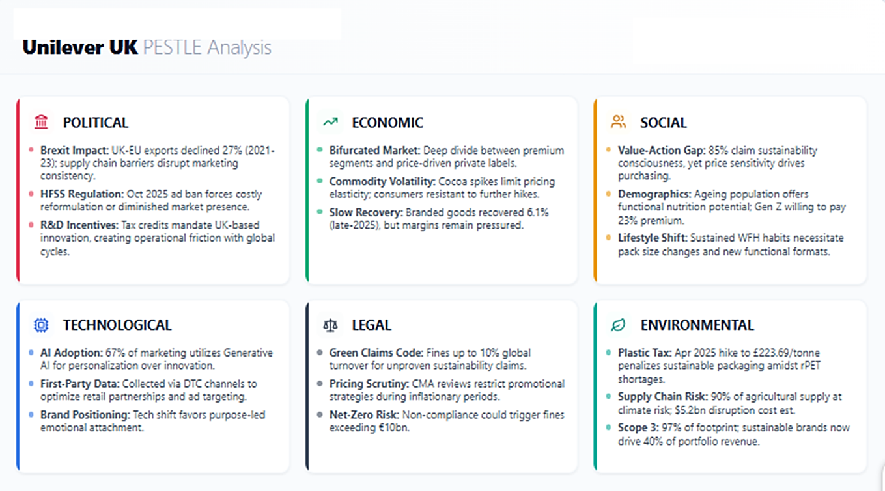
Figure 2: PESTLE Analysis Summary (Author)

2.3. Microenvironment Analysis
The microenvironment is a set of actors that are in the immediate environment of a company and that directly affect how well a company can serve its customers (Kotler and Armstrong, 2018). It consists of the company, suppliers, marketing intermediaries, competitors, publics, and customers.
Company: Unilever UK has incorporated sustainability into its fundamental operations. Its sustainable living brands are evidenced to generate more than 40% of net revenue. These brands develop 69% more rapidly than others (Unilever, 2025a). This shows that sustainability not only creates a good image but also real growth.
Suppliers and Intermediaries: Supply chains are seriously under pressure due to climatic pressures. Unilever claims that 90% of its agricultural inputs are climate-exposed (Unilever, 2024a). Recent global impacts on the sector amounted to £4.1bn (Expert Market Research, 2024). This volatility makes Unilever sell supply chain transparency to consumers. The integrity of sourcing is an apparent value proposition. The approach reduces the risk but adds complexity and cost to intermediaries.
Customers: Shopper behaviour has moved strongly towards sustainability. 87% of UK consumers have changed behaviour now to include environmental reasons, 56% of consumers changing brands (Market-Xcel, 2025). Gen Z consumers are willing to pay 23% more for sustainable products. The most progressive brands in ESG are 2.6 times more likely to be loyal (Grant, 2021). This illustrates evident commercial value in ethical positioning. To ensure such loyalty, Unilever must continuously demonstrate its sustainability claims.
Publics: Regulation is strict on the requirements of sustainability. The now obligatory provision is the net-zero compliance by the year 2040 to receive access to the market within the EU. The risk of non-compliance is over €10bn in fines (The Corporate Governance Institute, 2024). Media and activism groups look into corporate claims. Regulatory and social pressure have rendered sustainability compliance to be a requirement. It essentially guides the operational and marketing strategies of Unilever. A failure in this case jeopardises its position on the UK market.

2.4. Segmentation, Targeting, and Positioning Analysis
STP analysis entails segmenting markets, choosing targeted audiences and occupying distinctive mindshare (Kotler, Keller and Chernev, 2022).
Segmentation
Unilever UK uses integrated data to apply accurate segmentation. They have a portfolio that cuts across income levels, including Persil to high-end Dermalogica. Psychographically, they appeal to conscious consumers. According to Aziz (2019), these purpose-oriented brands increased two times faster than others. High usage is recognised by behavioural segmentation, which is supported by 3.4 billion daily global users that allow mapping of need states in detail (Unilever, 2024c). They are more localised geographically such as reformulation of Pot Noodle to suit the British. This fact evidences a strategic change of specific digital targeting rather than mass marketing. As a result, their yearly sale of EUR9.4bn provides personalised messaging, but this required the steady data optimisation to stay efficient (Guest, 2025).
Targeting
The strategic approach of targeting slightly changed under the 2024 Growth Action Plan. This is a move away to differentiated marketing and a focus on 30 Power Brands. This reinvigorates previous resource dilution. The sale of ice-cream brands such as Magnum is an example of this reduced scope, focusing on high-growth segments such as Beauty and Wellbeing, which have increased by 6.5% in the previous year (Unilever, 2024). This focuses the investment in profitable scalable segments. It strengthens core brand building by sacrificing share in niche segments, and compromises the interests of sustainable growth.
Positioning
Unilever has positioned itself as a purpose-driven leader, unlike other companies such as P&G, which focus on functional benefits. Their Unmissable Brand Superiority positioning strategy incorporates their efficacy and ethics framework. This positioning serves as a protective mechanism against the presence of private labels, owning an almost 54% share of UK grocery (Selwood, 2023). But present high inflation increases price sensitivity. Aldi and other discounters put pressure on the sustainability premium.
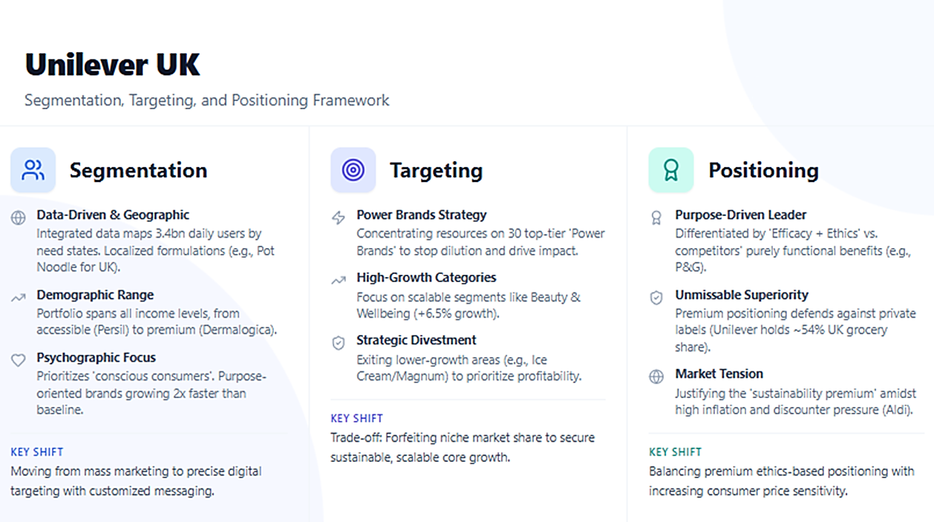
Figure 3: Unilever STP Analysis (Author)

2.5. Marketing Mix Analysis
The Marketing Mix is the product, price, distribution, and communication elements converged together to create an appeal. It enhances strategy by supplying the actionable instruments to achieve customer demands and target market objectives (Kotler and Armstrong, 2018).
Element | Analysis
Product | The product strategy of Unilever UK is focused, but has issues with trust. It can be seen that testify to a lean portfolio through 30 Power Brands that produced over 75% of turnover and 5.3% underlying sales development in 2024 (Unilever, 2025a), with disposals such as Elida Beauty and acquisitions such as K18 (Tofalli, 2024; Morosini, 2023). This is a clear strategic investment in high-end segments, such as premium Beauty and premium Health and Wellbeing, rather than sluggish mass-market segments. Nevertheless, an inquiry by the CMA into the questionable environmental statement on packaging, such as Cif and Dove in 2023, led to the compulsory revision of claims, although no actual violation of the law was identified (Gruet, 2023). Unilever is still doing well commercially, but its sustainability communications are not credible enough to the regulator.
Price | Pricing strategy effectively rectified course in 2024. Following several years of excessive dependence on excessive price growth of 6.8% in 2023 (Unilever, 2025a), which curtailed volumes to a meagre 0.2%, the company realised a healthier volume growth of 2.9% coupled with a more moderate price growth of 1.3% (Financial Times, 2024; Bolton, 2025). This rebalancing indicates that Unilever was aware of the risk of losing cost-conscious shoppers in the cost-of-living crisis. To reinforce this, gross margins increased tremendously to 45% (Unilever, 2025b). The recovery seems to be strong, but ongoing premiumisation may continue to disenfranchise budget-sensitive households.
Place | The distribution is becoming more balanced in terms of physical and digital channels. Online retail sales in the UK were at a record £127.41 bn in 2024, an increase of 3.4% compared to 2023 (Wright, 2025). This is indicative of the attempts to diminish reliance on retailers such as Tesco with direct-to-consumer principles and data-driven marketing. However, most volume is still obtained through physical stores. The UK supply chain is being improved by digitised B2B platforms, adapted to the emerging markets. This mixed strategy helps to safeguard Unilever against pure online disruption.
Promotion | Increased investment in promotion reached a ten-year high of 15.5% of turnover in 2024 in order to facilitate brand resistance against private-label building (WARC, 2025). This spend, however, is compromised by the intervention of the CMA in baseless green imagery. Although marketing infuses reviving volume, regulatory scepticism demonstrates an underlying weakness of emotive sustainability storeys that lacks the evidence to support. To prevent greenwashing allegations, future campaigns should strictly support environmental claims in Unilever UK, requiring stricter marketing controls.

2.6. Integrated Marketing Communication Analysis
Integrated Marketing Communications (IMC) is the coordination of all marketing communications channels to convey a consistent message and produce a greater synergistic effect. (Belch and Belch, 2021). The existing IMC approach in Unilever UK is very relevant to the Growth Action Plan 2030. The objective is to turn mental availability to sales. This strategy was much supported in 2024. Marketing expenditure had reached a 10-year high of 15.5% of the turnover (Unilever, 2025).
Cognitive Stage: Unilever lays emphasis on mass awareness with high-impact campaigns. Wall had allocated £10 million on its summer 2024 multimedia campaign. It introduced Wallie using new WinDOOH technology (Marketing Communication News, 2024). This virtual reality was not phone-based, which reduced entry barriers. That year, the group volume growth stood at 2.9% (Unilever, 2025). This demonstrates how the campaign penetrates advertising noise. Nevertheless, the excessive reliance on paid media is risky. Loud advertising does not necessarily attract more shoppers in the long run. The returns can fall in case voice share does not transform into market share.
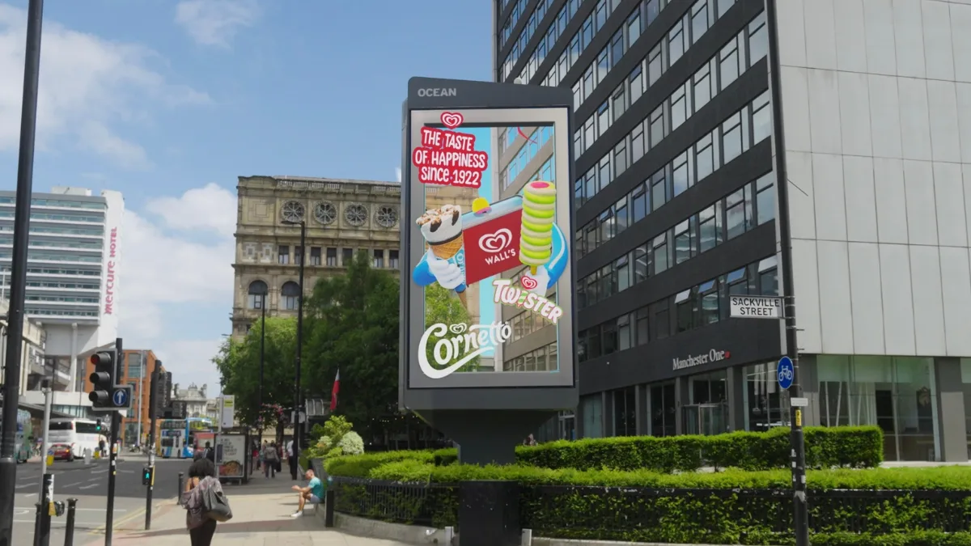
Figure 4: Wall using WinDOOH Technology (Mindshare Media, 2024)
Affective Stage: Unilever creates preference through purpose-driven PR and emotive content. The campaign by Dove’s "Cost of Beauty" was against harmful online beauty standards (Albrizio, 2025). It was able to connect brand values with social wellbeing. In this regard, the SASSY framework uses AI applications, such as "Sketch Pro" (Unilever UK, 2025). This produces highly relatable social media content. Personalisation ensures emotional bonds are stronger. Nevertheless, it has one significant threat. Possibly, there will be allegations of purpose-washing. This is likely to succeed after the operational sustainability lags behind the communications. The vulnerability is actual regarding the value-action gap.
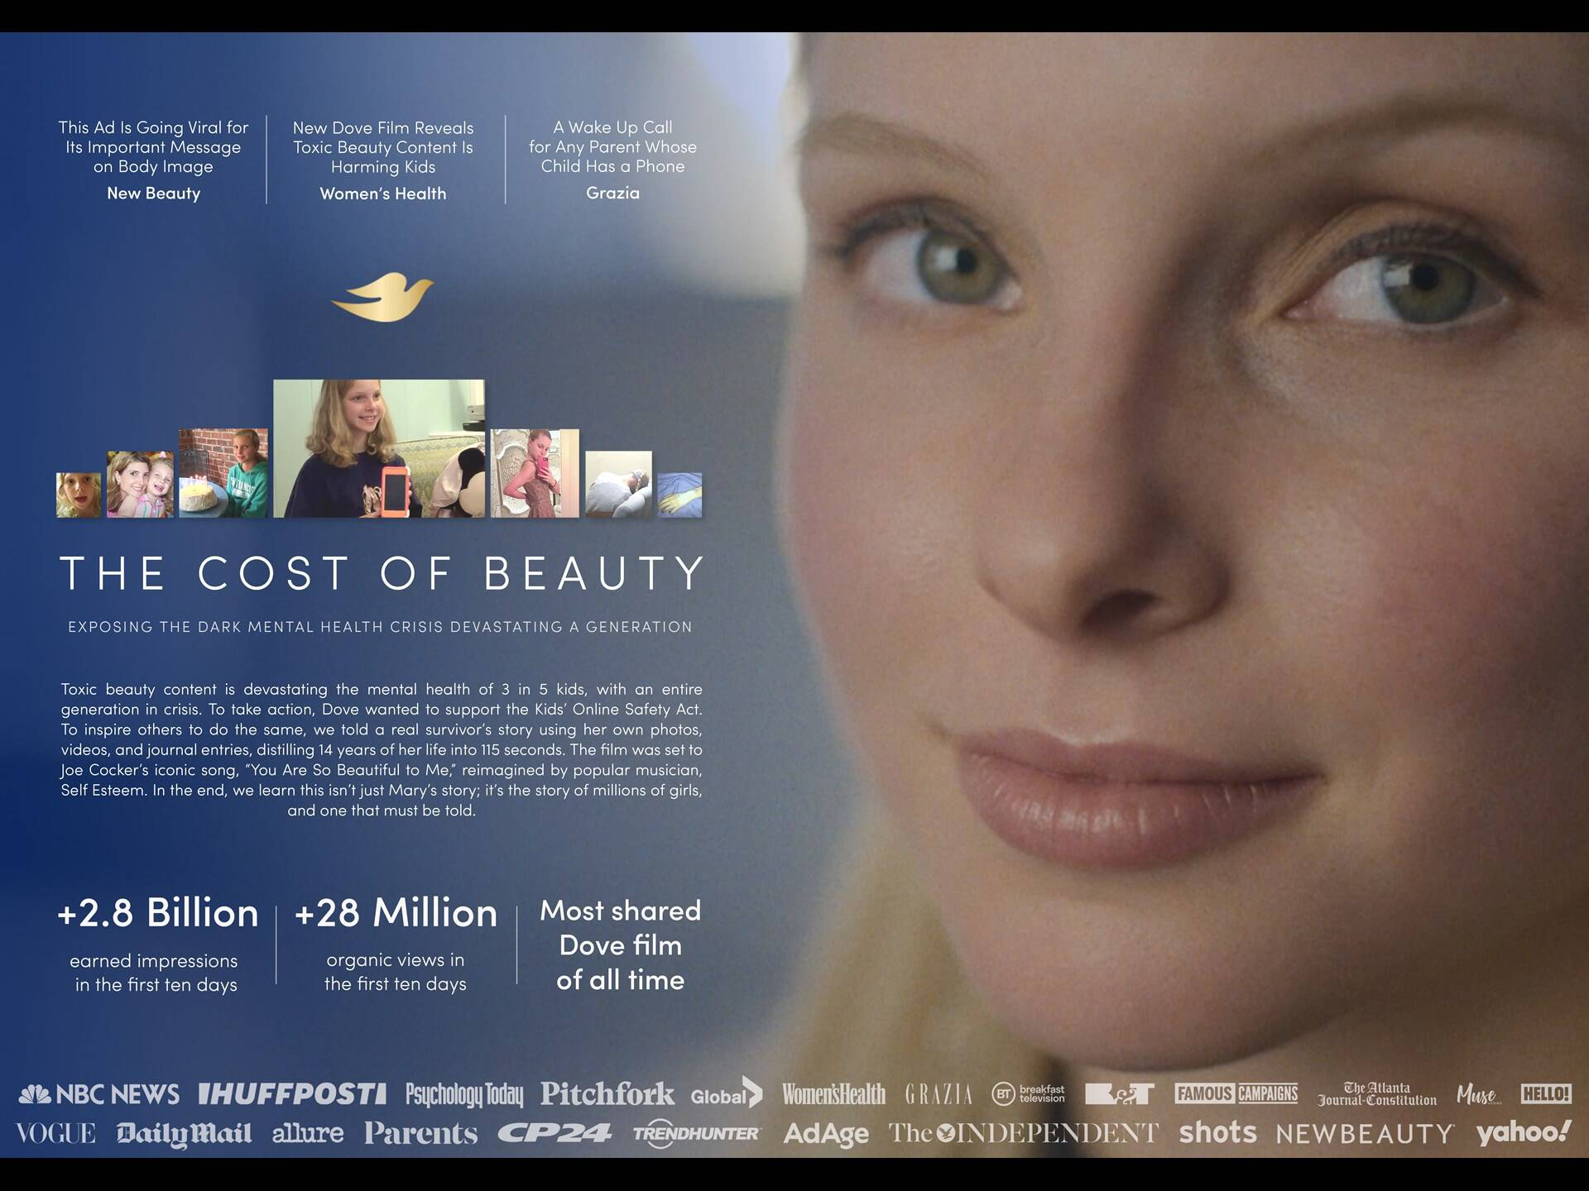
Figure 5: Dove "Cost of Beauty" (Clio Awards, 2025)
Conative Stage: Unilever motivates end-of-purchase through integrated shoppable media. It integrates purchasing opportunities into entertainment content (Bracey, 2025). This reduces the consumer decision path significantly. The success of 2024 justifies this strategy. Sales increased by 4.2%, but gross margins increased rapidly (Unilever, 2025). The no-friction method evidently works. However, overreliance on third-party platforms is a problem. Meta or TikTok changing the algorithm might hurt the purchase funnel during the night. This reveals a strategic weakness in their conversion strategy.
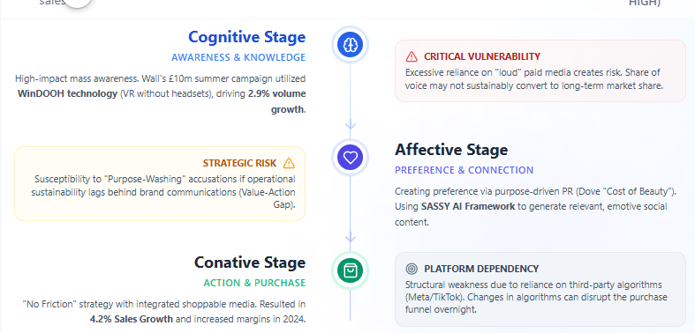
Figure 6: Unilever UK IMC Strategies Summary (Author)
The IMC strategy of Unilever UK efficiently progresses the consumers but is critically vulnerable to structural weaknesses in media dependency and operational authenticity.

2.7. Marketing Evaluation
Unilever UK applies the Unmissable Brand Superiority to measure the effectiveness of its marketing. The tool is part of its Growth Action Plan 2030. It evaluates brands on six levers, which include Product, Proposition, Packaging, Place, Promotion and Price. Instead of volume, it puts emphasis on tangible brand strength evidence (Hindustan Unilever, 2024). In 2024, the company raised Brand and Marketing Investment to 15.5% of turnover as underlying sales growth was 4.2% and a volume growth of 2.9% (WARC, 2025). Power Brands grew by 5.3% and it means that this matrix is efficient in capitalising capital on the assets that bring high returns (Unilever, 2025b). Gross margins also increased 280 basis points to 43.4% (Investing.com, 2024) which indicates a shift of strategy of premiumisation being employed instead of price warfare.
However, there are severe dangers in the approach. The emphasis on Power Brands of the matrix may constrain investment in lesser or chance brands that lack immediate measures of superiority, which may hamper long-term innovation. In addition, the brand position of being a premium is vulnerable to the current economic environment in the UK. With inflation continuing and households having limited budgets in 2025, the excessive focus on superiority rather than value might drive away budget-conscious consumers. Mintel (2025) monitors this exposure, which indicates growing infiltration of own-label in FMCG both categories. The strategy that allows it to grow as of recently though the underlying factor is financial discipline is the matrix but it lacks flexibility to adopt strategic options. At Unilever UK, a trade-off would be required to implement either high-performance or an accessible brand building to ensure effectiveness among various consumer groups.

3. Task 2: Conclusions on Shortcomings of Marketing Strategy
Unilever UK has achieved good short-term performance through its emphasis on unmissable superiority and its limited portfolio of thirty Power Brands. These power brands today contribute 75% of the company's turnover and recorded a 5.3% underlying sales growth in 2024 (Unilever, 2025). This shows efficient capital investment in existing assets. In 2024, the highest level in a decade was recorded as the marketing investment stood at 15.5% of turnover (WARC, 2025). This investment worked well to reverse loss in volume and to support premium pricing strategies, and it was useful to offset the appeal of the personal label brand (Bolton, 2025).
However, it has some severe structural weaknesses threatening this approach. Relying on a limited brand base is not innovative and reduces market responsiveness. This weakness has been compounded by recent reorganisation of operations and brand divestment. Moreover, the premium, purpose-based positioning of Unilever is vulnerable to severe belief problems. The Competition and Markets Authority stepped in on unproven environmental assertions on brands such as Cif and Dove (Stone, 2025). This reveals a harmful disconnect between the marketing rhetoric and evidence that can be proven, and it may result in not only a tarnished image but also legal fines (Gruet, 2023).
These issues are escalated in the fragmented consumer market of the UK. Shoppers are becoming extremely price-sensitive despite the declared sustainability values because of the constant cost-of-living pressure (PwC, 2024). A lot of people wonder about paying the green premium in a period of economic recession (Selwood, 2023). As a result, Unilever is not long-term resilient, even though the strategy is financially disciplined. The high initial investment in established brands will lead to immediate sales, but it will not create a plausible sustainability narrative. These stories have to survive additional regulatory scrutiny and appeal to families with tight budgets (Robinson, 2025).

4. Task 3: Recommendations
Unilever UK needs to shift more than just its current short-term focus on Power Brands and Unmissable Superiority. The company can develop resilience by investing in credibility in sustainability communications, increasing innovation in mid-tier brands, and regaining consumer trust. Wijaya, Rahayu, and Hendrayati (2024) assert that when a business conduct is aligned with sustainability, and open communication facilitates this alignment, long-term competitiveness is improved.

4.1. SOSTAC Framework
SOSTAC is a 6-step planning model that constructs a marketing plan by offering a logical framework, ensuring that goals are established, strategies are selected, implementation is described, and results are measured to enhance continuous improvement (Chaffey, Hemphill and Edmundson-Bird, 2019).

4.1.1. Situation Analysis
Unilever UK operates in a FMCG market that is fragmented, with consumer intentions that are ethical, and purchases are acquisition-based on affordability. Over 44% of consumers do not believe in sustainability statements by large corporations (Arif et al., 2025). The Competition and Markets Authority is also paying more and more regulatory attention. Chua (2025) stresses that the incorporation of sustainable innovation with the help of valid information and verification by a third party establishes a sense of resilience and trust amongst the stakeholders. Therefore, Unilever UK should restore trust by integrating verifiable sustainability in all marketing communications and increasing product innovation beyond luxury levels.

4.1.2. Objectives
The objectives that respond to the current challenges include:
- Grow consumer confidence in the sustainability of Unilever UK by 25% in a year.
- Increase the sales of mid-tier products by 10% in two years to spread the revenue lines.
- Enhance long-term brand differentiation through the use of evidence-based sustainability communications in all key product lines by 2027.

4.1.3. Strategy
Unilever UK needs to move on a Credible and Inclusive Superiority strategy through building trust by showing actual sustainability and broader innovations to lower-cost segments. Park and Minton (2025) describe credibility of sustainability communication as part of achieving trust when realism of the circumstances surrounding the product and brand is controlled. Similarly, Nshah and Deshmukh (2024) have determined that certified environmental claims do lead to high levels of consumer willingness to pay. Consequently, Unilever needs to close the gap between emotional and data-supported authenticity.

4.1.4. Tactics
- Product: To deal with consumer scepticism, the company must roll out an EcoProof verification system on packaging and supply chains to demonstrate consumer confidence, that 38% of consumers found no credibility in sustainability claims made without evidence (Singh, 2025).
- Price: Unilever should introduce value-based pricing levels backed by authenticated environmental credentials, according to evidence presented by Thabit (2025), which shows strategic pricing remains profitable in price-sensitive FMCG markets.
- Place: The company should enhance direct-to-consumer channels to obtain finer consumer data and reduce its reliance on retail algorithms to enable more precise sustainability communications.
- Promotion: Unilever must conduct Proof over promise campaigns, where validation is carried out by third parties, and verifiable evidence are used to restore trust as Jain (2025) pointed out that where green claims are transparently reported, consumers trust is increased.

4.1.5. Action Plan
Unilever UK must set up a specific Trust and Innovation Taskforce, which includes marketing, R&D, and legal teams. Such a group will initiate a single proven sustainable pilot under a mid-tier brand, partner with the UK universities to scientifically verify the claims, and repurpose 5% of the marketing budget to digital insight platforms to measure the trust in real-time.

4.1.6. Control Mechanisms
Four measures will be used to monitor performance:
- Adherence to confirmed sustainability assertions.
- Brand trust index.
- Mid-tier sales growth.
- Conversion rates of digital engagement.
The frequent independent audits will ensure CMA compliance and further improvement of the credibility.

4.2. Feasibility Assessment
This is an operationally viable and cost-neutral proposal whereby the current marketing budget will be redirected into verification. Vuong, Lam, and Bui (2024) confirm the boost of consumer loyalty and alignment to Sustainable Development Goal (SDG)-driven business models by authentic green positioning. Effective sustainability practises will therefore yield the elimination of regulatory exposures of Unilever UK and enforce resilience in the long term.

5. References
ADPH London (2025) New Restrictions on Promotions of Unhealthy Food and Drink Introduced in England - ADPH London, ADPH London. Available at: https://www.adph.org.uk/networks/london/2025/10/01/new-restrictions-on-promotions-of-unhealthy-food-and-drink-introduced-in-england/.
Albrizio, L. (2025) Dove Releases the Pursuit of Perfect in New Self-Esteem Project for Women, Happi. Available at: https://www.happi.com/breaking-news/dove-releases-the-pursuit-of-perfect-in-new-self-esteem-project-for-women/ (Accessed: 30 December 2025).
Arif, U. et al. (2025) ‘The Role of Green Digital Marketing in Driving Consumer Engagement and Brand Loyalty: a Study on Sustainable Product Adoption’, Social Science Review Archives, 3(1), pp. 2730–2743. Available at: https://doi.org/10.70670/sra.v3i1.582.
Aziz, A. (2019) The Power of Purpose: Kantar Purpose 2020 Study Shows How Purposeful Brands Grow Twice as Fast as Their Competition, Forbes. Available at: https://www.forbes.com/sites/afdhelaziz/2019/11/11/the-power-of-purpose-kantar-purpose-2020-study-shows-how-purposeful-brands-grow-twice-as-fast-as-their-competition/ (Accessed: 30 December 2025).
Balmer, J.M.T. (2012) ‘Corporate Brand Management Imperatives: Custodianship, Credibility, and Calibration’, California Management Review, 54(3), pp. 6–33. Available at: https://doi.org/10.1525/cmr.2012.54.3.6.
BBC (2017) ‘Unilever: Profile of a consumer giant’, BBC News, 17 February. Available at: https://www.bbc.com/news/business-39009072 (Accessed: 31 December 2025).
Belch, G.E. and Belch, M.A. (2021) Advertising and promotion: an Integrated Marketing Communications Perspective. Boston Mass: Mcgraw-Hill/Irwin.
Benstead, S. (2023) ‘Investment star Terry Smith attacks Unilever for “ludicrous” focus on social and green issues’, The Telegraph, 31 August. Available at: https://www.telegraph.co.uk/money/investing/funds/investment-star-terry-smith-attacks-unilever-ludicrous-focus/ (Accessed: 29 December 2025).
Bolton, T. (2024) Unilever plc 2023 Full Year Results February 8, 2024, James Sharp & Co. Available at: https://www.jamessharp.co.uk/market-news/unilever-plc-2023-full-year-results/ (Accessed: 29 December 2025).
Bolton, T. (2025) Unilever plc 2024 Final Results February 13, 2025, James Sharp & Co. Available at: https://www.jamessharp.co.uk/market-news/unilever-plc-2024-final-results/ (Accessed: 30 December 2025).
Bracey, E.E. (2025) How Unilever’s Marketing Is Connecting Social to Sales at Speed, Unilever. Unilever PLC. Available at: https://www.unilever.com/news/news-search/2025/how-unilevers-marketing-is-connecting-social-to-sales-at-speed/ (Accessed: 30 December 2025).
Carroll, N. (2022) What the Popularity of Private Labels Means for Brands, Marketing Week. Available at: https://www.marketingweek.com/fmcg-brands-private-label-goods/ (Accessed: 29 December 2025).
Chaffey, D., Hemphill, T. and Edmundson-Bird, D. (2019) Digital Business and e-commerce Management : strategy, Implementation and Practice. 7th edn. Harlow, England ; New York: Pearson. Available at: https://ebookcentral.proquest.com/lib/herts/detail.action?docID=5785532.
Chua, K.P. (2025) ‘Integrating Sustainable Innovation into Corporate Strategy’, International Journal of Public Administration Management and Economic Development, 9(2). Available at: https://doi.org/10.60026/ijpamed.v9i2.203.
Clio Awards (2025) Dove: Cost of Beauty • Ads of the WorldTM | Part of the Clio Network, Ads of the WorldTM. Available at: https://www.adsoftheworld.com/campaigns/cost-of-beauty.
Devine, J. (2024) History & Heritage | Port Sunlight Village, Portsunlightvillage.com. Available at: https://portsunlightvillage.com/history/ (Accessed: 31 December 2025).
Dove (2024) Real Beauty Pledge, Dove. Dove Campaigns - Dove. Available at: https://www.dove.com/uk/stories/campaigns/real-beauty-pledge.html (Accessed: 31 December 2025).
Du, J. et al. (2024) Unbound: UK Trade post-Brexit - the Productivity Institute, The Productivity Institute. Available at: https://www.productivity.ac.uk/research/unbound-uk-trade-post-brexit/ (Accessed: 29 December 2025).
Eastlake, D. (2025) Cocoa Prices Plunge following Record Highs, FoodNavigator.com. Available at: https://www.foodnavigator.com/Article/2025/06/11/cocoa-prices-fall-following-record-highs/ (Accessed: 2 January 2026).
Epale, K. (2023) The Marmite case: Branding Icon - Bootcamp - Medium, Medium. Bootcamp. Available at: https://medium.com/design-bootcamp/the-marmite-case-branding-icon-8d3c6a43c504 (Accessed: 31 December 2025).
Expert Market Research (2025) FMCG Market Size, Share and Growth Analysis Report | 2034, Claight Corporation (Expert Market Research). Available at: https://www.expertmarketresearch.com/reports/fmcg-market (Accessed: 29 December 2025).
Financial Times (2024) Final Results – Company Announcement - FT.com, markets.ft.com. Available at: https://markets.ft.com/data/announce/detail?dockey=1323-16323187-5SCJPCN55VILA2THIU8EQ9L1NK (Accessed: 29 December 2025).
GOV.UK (2025) Plastic Packaging Tax (PPT) Statistics Background and References, GOV.UK. Available at: https://www.gov.uk/government/statistics/plastic-packaging-tax-ppt-statistics/plastic-packaging-tax-ppt-statistics-background-and-references (Accessed: 29 December 2025).
Grant, R.M. (2021) Contemporary Strategy Analysis. 11th edn. S.L.: John Wiley.
Gruet, S. (2023) ‘Dove and Marmite Maker Unilever Faces Investigation over Green Claims’, www.bbc.com, 12 December. Available at: https://www.bbc.com/news/business-67658043 (Accessed: 30 December 2025).
Guest, H. (2025) Unilever marketing spend reached ten-year high - Marketing Beat, Marketing Beat. Available at: https://www.marketing-beat.co.uk/2025/02/14/unilever-marketing-spend/ (Accessed: 29 December 2025).
Hill, C.W.L., Jones, G.R. and Schilling, M.A. (2020) Strategic Management : an Integrated Approach : Theory and Cases. 13th edn. Boston, Ma Cengage Learning.
Hindustan Unilever (2024) Know about the 6 Ps of unmissable brand superiority, Hindustan Unilever. Unilever PLC. Available at: https://www.hul.co.in/news/2024/know-about-the-6-ps-of-unmissable-brand-superiority/ (Accessed: 30 December 2025).
Investing.com (2024) Earnings call: Unilever reports robust H1 growth, plans to reshape Ice Cream unit, Investing.com. Available at: https://www.investing.com/news/stock-market-news/earnings-call-unilever-reports-robust-h1-growth-plans-to-reshape-ice-cream-unit-93CH-3539656 (Accessed: 30 December 2025).
Jain, S. (2025) ‘Consumer Perception of Green Marketing for Eco-Friendly Fast Moving Consumer Goods: a Conceptual Framework’, International Journal of Innovative Research in Engineering and Management, 12(3), pp. 85–89. Available at: https://doi.org/10.55524/ijirem.2025.12.3.11.
Japesh, A. (2025) 2025 AI Marketing Trends: How Generative AI Is Revolutionizing Content Creation and Personalization - SuperAGI, SuperAGI. Available at: https://superagi.com/2025-ai-marketing-trends-how-generative-ai-is-revolutionizing-content-creation-and-personalization/ (Accessed: 29 December 2025).
Khairunisa, M. and Kusuma, N. (2021) How Unilever Transforms Its Business with Unilever Sustainable Living Plan, Green Network Asia. Available at: https://greennetwork.asia/gna-knowledge-hub/how-unilever-transforms-its-business-with-unilever-sustainable-living-plan/ (Accessed: 31 December 2025).
Kotler, P. and Armstrong, G. (2018) Principles of Marketing. 17th edn. Harlow: Pearson Education Limited.
Kotler, P., Kartajaya, H. and Setiawan, I. (2021) Marketing 5.0: Technology for Humanity. Wiley.
Kotler, P., Keller, K.L. and Chernev, A. (2022) Marketing Management, Global Edition. 16th edn. S.L.: Pearson Education Limited.
Market-Xcel (2025) 10 Major Shifts in Consumer Behaviour to Expect in 2025, Market-xcel.com. Available at: https://www.market-xcel.com/blogs/10-major-shifts-in-consumer-behaviour-to-expect-in-2025 (Accessed: 1 January 2026).
Marketing Communication News (2024) Wall’s Ice Cream Unleashes Happiness with Its Latest Masterbrand Campaign, Marcommnews.com. Available at: https://marcommnews.com/walls-ice-cream-unleashes-happiness-with-its-latest-masterbrand-campaign/ (Accessed: 30 December 2025).
Merced, M.J. de la (2020) ‘Unilever Decides One Headquarters Is Better than Two’, The New York Times, 11 June. Available at: https://www.nytimes.com/2020/06/11/business/unilever-headquarters.html (Accessed: 1 January 2026).
Mindshare Media (2024) Wall’s uses groundbreaking AR OOH in new campaign, Mindshareworld.com. Available at: https://www.mindshareworld.com/uk/news/walls-uses-groundbreaking-ar-ooh-in-new-campaign (Accessed: 1 January 2026).
Mintel (2025) UK Private Label BPC Consumer 2025 | Mintel Store, Mintel Store. Available at: https://store.mintel.com/report/uk-private-label-bpc-consumer-market-report (Accessed: 30 December 2025).
Modaes (2025) August Boom: UK Fashion Sales Hit Record 6% Increase - Modaes Global, @. Modaes Global. Available at: https://www.modaes.com/global/markets/uk-fashion-sales-post-record-6-rise-in-august (Accessed: 29 December 2025).
Morosini, D. (2023) Unilever to Acquire K18 Haircare, The Business of Fashion. Available at: https://www.businessoffashion.com/articles/beauty/k18-acquired-by-unilever/ (Accessed: 30 December 2025).
PWC (2024) Consumers Willing to Pay 9.7% Sustainability premium, Even as cost-of-living and Inflationary Concerns weigh: PwC 2024 Voice of the Consumer Survey, PwC. Available at: https://www.pwc.com/gx/en/news-room/press-releases/2024/pwc-2024-voice-of-consumer-survey.html (Accessed: 29 December 2025).
Robinson, N. (2025) Unilever food volumes sluggish, but ice cream shines ahead, FoodNavigator.com. Available at: https://www.foodnavigator.com/Article/2025/02/13/unilever-full-year-2024-financial-results-strong-but-food-sluggish/ (Accessed: 29 December 2025).
Selwood, D. (2023) The facts and figures behind own-label grocery’s incredible growth, The Grocer. Available at: https://www.thegrocer.co.uk/analysis-and-features/the-facts-and-figures-behind-own-label-grocerys-incredible-growth/679128.article (Accessed: 30 December 2025).
Smith, S. (2025) Unilever annual sales rise with ‘strong’ growth across beauty and wellbeing - TheIndustry.beauty, TheIndustry.beauty. Available at: https://theindustry.beauty/unilever-annual-sales-rise-with-strong-growth-across-beauty-and-wellbeing/ (Accessed: 30 December 2025).
Stone, S. (2025) Greenwashing: CMA granted power to fine companies up to 10 per cent of global turnover, Business Green. Incisive Business Media Limited. Available at: https://www.businessgreen.com/news/4411916/reenwashing-cma-granted-power-fine-companies-cent-global-turnover (Accessed: 30 December 2025).
Thabit, A.Prof.Dr.A.Sameer.N.A. - (2025) ‘The Role of Strategic Pricing and Financial Sustainability in Iraq’s Fast-Moving Consumer Goods (FMCG) Market: a Case Study of PepsiCo Iraq’s Market Strategies’, International Journal of Transformations in Business Management, 15(3), pp. 127–137. Available at: https://doi.org/10.37648/ijtbm.v15i03.009.
The Corporate Governance Institute (2024) Case Study -Unilever Company. Available at: https://www.thecorporategovernanceinstitute.com/wp-content/uploads/2024/10/Case-Study-Unilever.pdf (Accessed: 1 January 2026).
Tofalli, C. (2024) Yellow Wood Partners Completes Acquisition of Elida Beauty from Unilever, Prnewswire.com. Cision PR Newswire. Available at: https://www.prnewswire.com/news-releases/yellow-wood-partners-completes-acquisition-of-elida-beauty-from-unilever-302166127.html (Accessed: 30 December 2025).
Unilever (2024a) Climate Transition Action Plan: Updated 2024, Unilever. London, United Kingdom: Unilever PLC. Available at: https://www.unilever.com/files/ctap.pdf (Accessed: 29 December 2025).
Unilever (2024b) Innovation and R&D at Unilever, unilever. Available at: https://www.unilever.com/our-company/innovation-and-rd-at-unilever/ (Accessed: 29 December 2025).
Unilever (2025a) 2024 Full Year Results, Unilever. Unilever PLC. Available at: https://www.unilever.com/files/ir-q4-2024-full-announcement.pdf (Accessed: 29 December 2025).
Unilever (2025b) Improved Performance Led by Volume Growth and Gross Margin Expansion, Unilever. Available at: https://www.unilever.com/news/press-and-media/press-releases/2025/improved-performance-led-by-volume-growth-and-gross-margin-expansion/ (Accessed: 30 December 2025).
Unilever (2025c) Our Climate Transition Action Plan, Unilever. Available at: https://www.unilever.com/sustainability/climate/our-climate-transition-action-plan/ (Accessed: 29 December 2025).
Unilever PLC (2024a) Full Year 2023 Results Overview, Unilever. Unilever PLC. Available at: https://www.unilever.com/investors/results-events/results-events-webcasts/overview-full-year-2023/ (Accessed: 30 December 2025).
Unilever PLC (2024b) What’s behind Unilever’s First Half results?, Unilever. Unilever PLC. Available at: https://www.unilever.com/news/news-search/2024/whats-behind-unilevers-first-half-results/ (Accessed: 29 December 2025).
Unilever PLC (2025) First Half Performance Supports Full Year Confidence, Unilever. Unilever PLC. Available at: https://www.unilever.com/news/press-and-media/press-releases/2025/first-half-performance-supports-full-year-confidence/ (Accessed: 29 December 2025).
Unilever UK (2025) How AI is helping drive Desire at Scale across Unilever, Unilever UK. Unilever PLC. Available at: https://www.unilever.co.uk/news/2025/how-ai-is-helping-drive-desire-at-scale-across-unilever/.
Vuong, T.K., Lam, T.N. and Bui, H.M. (2024) ‘Sustainable Consumer Behaviour in the Fast‐Moving Consumer Goods Sector: Moderating Role of Competitive Intensity in Green Marketing’, Business Strategy & Development, 7(4). Available at: https://doi.org/10.1002/bsd2.70047.
WARC (2025) Unilever invests in fewer brands for bigger impact | WARC | The Feed, Warc.com. Available at: https://www.warc.com/content/feed/unilever-invests-in-fewer-brands-for-bigger-impact/en-GB/10312 (Accessed: 29 December 2025).
Wijaya, F., Rahayu, A. and Hendrayati, H. (2024) ‘Brand Management Strategies for Sustainability: Insights from a Systematic Review’, Journal of Business Management Education (JBME), 9(3), pp. 341–358. Available at: https://doi.org/10.17509/jbme.v9i3.76042.
Williams, E. (2023) The evolution of brand purpose, Creative Review. Available at: https://www.creativereview.co.uk/brand-purpose-2023/ (Accessed: 29 December 2025).
Wright, G. (2025) Data: UK online retail sales hit record £127bn in 2024, Retail Gazette. Available at: https://www.retailgazette.co.uk/blog/2025/02/online-retail-sales/ (Accessed: 30 December 2025).

