Programme: BA (Hons) Leadership and Management Skills for the Workplace
Assignment Title: Component 2 - Individual
written report

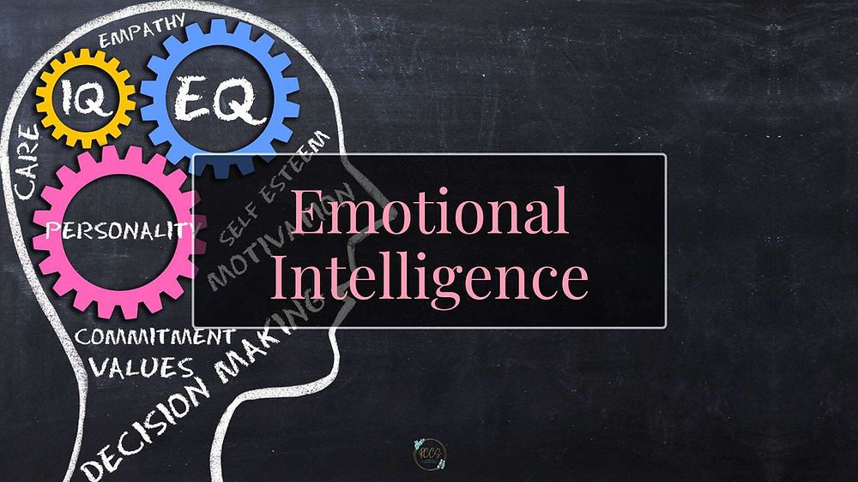

Assessing Emotional Intelligence and Mindfulness in Zara Context.

Student name: Aldmira da Mota
Student ID number: 2322676
Module: Developing Emotional Intelligence Skills
Module code: LCLM5006
Lecturer: Sujeewa Herath Mudyanselage

Table of Contents
Critically evaluate how employees in the workplace may use emotional intelligence? 4
Emotional Intelligence 4
1. Self-awareness 4
2. Self-regulation 4
3. Motivation 4
4. Empathy 4
5. Social skills 4
Applying of EI Models at Zara workplace 5
• Goleman’s Five Components at Zara 5
• Mayer & Salovey’s Four-Branch Model in Zara 5
• Bar-On’s Emotional-Social Intelligence Model in Zara 5
Integrating Mindfulness and Emotional Intelligence 6
Identify unique characteristics relating to emotional intelligence that managers may need to consider in recruiting new employees from different generations such as Generation X, Y and Z. 7
Generation X 7
Generation Y ( 7
Generation Z 7
EI Key Characteristics in Zara Recruitment 8
Self-Awareness and Self-Regulation 8
Empathy and Social Skills 8
Motivation and Adaptability 8
Mindfulness and Stress Management 8
Generation X 9
Generation Y 9
Generation Z: 9
Integration of Emotional Intelligence in Leadership 9
Inclusion of EI Assessments in Recruitment 9
Promotion of Mindfulness Practices 9
Adaptation to Generational Diversity: 9
Evaluation of EI Initiatives: 9
Conclusion 10
Reference 11

Introduction
This report offers a critical assessment of how employees at Zara utilise emotional intelligence, referencing three prominent theoretical frameworks: Goleman’s five-component model, Mayer and Salovey’s four-branch model, and Bar-On’s emotional-social intelligence model. Each framework presents unique insights into the cognitive, behavioural, and affective dimensions of emotional intelligence (EI), thereby enabling a thorough analysis of both employee performance and organisational dynamics.
In addition, this report addresses generational differences among Generations X, Y, and Z, examining their potential impact on emotional intelligence within recruitment and management processes. Identifying EI characteristics associated with each generation can significantly inform the development of human resource policies and practices.
Emotional intelligence and mindfulness are identified as critical competencies necessary for organisational success in contemporary work environments. Emotional intelligence is generally defined as the capacity to perceive, interpret, regulate, and influence emotions in oneself and others (Mayer, Salovey, & Caruso, 2008). Mindfulness, which is closely linked to self-awareness, refers to the sustained attention to present experiences without evaluative judgment; this approach may support stress management and enhance decision-making under pressure (Kabat-Zinn, 2003). These competencies are particularly relevant for roles involving interpersonal interactions and leadership, especially in sectors such as fashion retail.
As a leading global fashion retailer operating in an evolving and highly competitive industry, Zara places strategic emphasis on operational efficiency and innovation within its supply chain, while also recognising the importance of developing employees’ emotional and social skills. Staff members are regularly involved in cross-functional teamwork, customer service activities, and complex problem-solving that all require strong emotional intelligence and mindfulness. Therefore, it is advisable for Zara’s leadership to implement targeted initiatives aimed at cultivating EI, with the goal of enhancing collaboration, reducing conflict, and maintaining a positive organisational climate.

Critically evaluate how employees in the workplace may use emotional intelligence?

Emotional Intelligence - Emotional intelligence is the ability to understand, use, and manage emotions in oneself and others (Mayer & Salovey, 1997). This idea has become important in organisational behaviour because it affects leadership, teamwork, and employee motivation (Goleman, 1998). Emotional intelligence includes self-awareness, self-regulation, motivation, empathy, and social skills (Goleman, 1998).
- Self-awareness means knowing your own emotions, what causes them, and how you might react. For example, A store manager feels stress during busy weekends while customer traffic is high.

- Self-regulation is being able to control your emotions and stay calm during stressful times. For Example, the employee addresses issues calmly with the manager and offers solutions like reorganising inventory or assisting customers with alternatives.

- Motivation helps people keep working towards goals even when things get tough.
For Example, their motivation leads to proactive customer interactions, effective upselling, and helpful styling suggestions, while also supporting team commitment.

- Empathy allows understanding others' feelings, which helps with working together and handling conflicts. For example, a manager observes that a new employee appears anxious when serving many customers. By responding appropriately, the manager provides guidance and temporarily adjusts the employee's workload. This approach helps reduce stress, supports performance, and builds trust among staff members.

- Social skills are about building good relationships, persuading others, and working well in teams. For example, A floor supervisor works with the visual merchandising team, sales staff, and stockroom employees to organise product displays effectively. This contributes to maintaining a functional store environment and can impact both employee morale and customer satisfaction.
Mayer & Salovey’s (1997) model adds that emotional intelligence includes recognising emotions, using emotions in thought, understanding emotional trends, and managing emotions. Bar-On’s model (1997) also considers social skills, stress management, and adaptability as part of emotional intelligence, especially in the workplace.

Applying of EI Models at Zara workplace

Goleman’s Five Components at Zara
Zara employees require customer service abilities, operational efficiency, and collaboration skills. Managers and staff can use self-awareness to identify stressors and address them more effectively during busy periods (Goleman, 1998). For example, a sales team member who experiences frustration after receiving complaints may respond in a professional manner.
Self-regulation enables leaders to balance work demands with staff wellbeing. Managers who demonstrate emotional control can serve as role models and contribute to constructive problem-solving (Goleman, 1998).
Motivation aligns with Zara’s emphasis on quick adaptation and innovation, as motivated employees address challenges and pursue set objectives. Empathy supports both customer relations and internal communication, while social skills facilitate cooperation among employees in various roles.

Mayer & Salovey’s Four-Branch Model in Zara
According to Mayer and Salovey (1997), emotional intelligence supports better decision-making and enhances collaboration. In the context of Zara, being aware of and managing emotions helps employees understand customers, work well in teams, resolve conflicts, and remain effective when working under pressure.

Bar-On’s Emotional-Social Intelligence Model in Zara
Bar-On’s (1997) conceptual framework underscores the significance of stress management, adaptability, and social competencies. Employees possessing these attributes are better equipped to respond effectively to dynamic market trends. In a decision-making context, social competence facilitates the motivation of teams and fosters emotional awareness, thereby allowing informed decision-making and the effective resolution of organisational challenges, such as coordinating responses between retail outlets and distribution centres during shipment delays.

Integrating Mindfulness and Emotional Intelligence

Mindfulness refers to maintaining awareness of the present moment without immediately reacting emotionally (Kabat-Zinn, 2003). Zara implements mindfulness training to help employees recognise stress, maintain focus, and respond thoughtfully in challenging situations. Studies indicate that combining mindfulness with emotional intelligence can support self-control and empathy, which may contribute to improved teamwork and resilience (Glomb et al., 2011). Store managers who practise mindfulness could exhibit increased patience and have a positive effect on team morale.
Enhancing emotional intelligence at Zara is associated with long-term success in the fast-fashion sector and may help improve employee retention (Goleman, 1998; Bar-On, 1997). This approach offers several advantages for the company: Customer Service: Staff with greater empathy and social skills can meet diverse customer needs more effectively. Leadership: Managers with high emotional intelligence can motivate employees and lower turnover rates. Teamwork: Emotional awareness helps reduce conflict and encourages collaboration among team members. Stress Management: Mindfulness and self-regulation skills support reduced burnout and maintain performance during stressful situations.

Identify unique characteristics relating to emotional intelligence that managers may need to consider in recruiting new employees from different generations such as Generation X, Y and Z.

Zara's recruitment strategies must carefully consider the distinct emotional intelligence attributes associated with Generation X (1965–1980), Generation Y/Millennials (1981–1996), and Generation Z (1997–2012) (McCrindle, 2014). Recognising these differences is essential to effectively manage a multigenerational workforce and to enhance organisational cohesion.
Generation X tends to prioritise independence and stability within their professional roles. Successfully integrating members of this cohort requires an emphasis on fostering self-regulation and stress tolerance, as these individuals are often motivated by autonomy and long-term security. Recruitment approaches should therefore assess candidates’ capacity for independent decision-making and resilience under pressure.
Generation Y (Millennials) is generally characterised by their proficiency with technology and heightened social awareness. Engaging these demographic hinges on the organisation’s ability to cultivate empathy and strong social skills, as Millennials typically value inclusive workplace cultures and are drawn to employers with clear ethical commitments. Consequently, recruitment processes should evaluate interpersonal competencies and alignment with corporate social responsibility initiatives.
Generation Z is notable for its adaptability and mindfulness, shaped in part by growing up in a rapidly changing digital environment. To manage their expectations effectively, particularly in the retail sector, it is important to focus on self-awareness and flexibility. Recruitment practices should thus identify applicants who demonstrate readiness to embrace change and possess reflective abilities that allow them to navigate dynamic workplace demands.

EI Key Characteristics in Zara Recruitment

Self-Awareness and Self-Regulation - Zara’s recruitment process considers self-awareness and self-regulation as important qualities. These traits involve understanding one’s own emotions, strengths, and weaknesses, and controlling emotional reactions, especially under stress. Emotional intelligence theory (Goleman, 1995) supports this approach. Managers use situational judgment tests and behavioural interviews to assess how candidates handle tasks like customer complaints or operational problems. People with strong self-regulation are seen as capable of maintaining professionalism and resolving conflict in busy retail environments.
Empathy and Social Skills - Empathy, or understanding and sharing another person’s feelings, is necessary for customer service and teamwork at Zara. When looking for Millennials and Generation Z employees, Zara values candidates who respect various viewpoints and can work well with others. Social skills are measured by group exercises, such as role-play, which show how well applicants communicate and interact. These methods follow accepted human resource practices and help support a cooperative and inclusive workplace.
Motivation and Adaptability - The fashion retail industry changes quickly, so Zara looks for employees who are motivated from within and can adapt easily. Motivation means having personal reasons for working hard, while adaptability refers to changing behaviour when needed. Candidates who show initiative and flexibility contribute to Zara’s innovative culture and ability to keep up with consumer trends. Generation Z candidates often bring strong digital skills, which are useful for managing inventory and online sales—areas that are growing more important in retail.
Mindfulness and Stress Management

Recently, Zara has started to include mindfulness and stress management in its recruitment criteria, recognizing their benefits for employee mental health. Mindfulness means focusing on the present and staying objective, which research suggests improves resilience and reduces burnout. During hiring, Zara may ask about how candidates deal with workplace stress or their experience with mindfulness. This ensures new employees have good coping strategies for handling stress, which helps maintain performance and teamwork, supporting Zara's overall talent management goals.
Zara’s recruitment strategies should align with generational characteristics and include emotional intelligence (EI) assessment:
Generation X: Value stability, analytical ability, and leadership; support a balance between work and personal life.
Generation Y: Emphasise meaningful work, social responsibility, and teamwork; consider candidates' empathy and people skills.
Generation Z: Highlight flexibility, creativity, and ongoing learning; evaluate adaptability and awareness.
By integrating EI into recruitment, Zara can improve teamwork, uphold service standards, and adapt well to organisational change (McCrindle, 2014; Goleman, 1998).
Integration of Emotional Intelligence in Leadership: Zara should implement structured EI training for managerial staff via coaching and mentoring programs. These initiatives can improve leaders' self-awareness, empathy, and interpersonal competence, ultimately benefiting organisational culture and performance.
Inclusion of EI Assessments in Recruitment: Using behavioural interviews and role-play exercises during recruitment enables more accurate evaluation of candidates’ emotional intelligence. This ensures new hires possess necessary interpersonal and self-regulation skills, alongside technical qualifications, for collaborative work environments.
Promotion of Mindfulness Practices: Providing workshops or digital mindfulness programs supports employees in managing stress and enhancing concentration. Such interventions promote psychological well-being and workplace productivity.
Adaptation to Generational Diversity: HR practices should be tailored to the distinct strengths and preferences of Generation X, Y, and Z, facilitating effective collaboration and engagement within diverse teams. Customising approaches optimises team dynamics.
Evaluation of EI Initiatives: Ongoing assessment of emotional intelligence programs through surveys, feedback, and systematic reviews is essential. Continuous evaluation enables refinement of EI strategies, maintaining their relevance and efficacy.

Conclusion

Emotional intelligence and mindfulness are essential factors influencing the performance of both individuals and organizations at Zara. Utilizing the models proposed by Goleman, Mayer & Salovey, and Bar-On illustrates how components such as self-awareness, self-regulation, empathy, motivation, social abilities, and flexibility contribute to productive behaviours in the workplace. Employees who assimilate these skills are better equipped to manage stress, work collaboratively, and proactively address challenges, thereby improving customer satisfaction and internal team dynamics.
Generational variances further emphasize the significance of emotional intelligence in recruitment practices. By comprehending the distinctive emotional and social traits of Generations X, Y, and Z, Zara can customize its recruitment, onboarding, and developmental strategies to cultivate high-performing, cohesive, and resilient teams.
Additionally, mindfulness serves to enhance these results by promoting awareness of the present moment, facilitating emotional regulation, and fostering overall well-being. The integration of emotional intelligence and mindfulness into Zara's organizational culture fortifies its capability for innovation, operational excellence, and retention of employees.

Reference
Bar-On, R. (1997) Bar-On Emotional Quotient Inventory (EQ-I): Technical manual. Toronto: Multi-Health Systems.
Goleman, D. (1998) Working with emotional intelligence. New York: Bantam Books.
Glomb, T.M., Duffy, M.K., Bono, J.E. and Yang, T. (2011) ‘Mindfulness at work’, Research in Personnel and Human Resources Management, 30, pp. 115–157.
Kabat-Zinn, J. (2003) Mindfulness-based interventions in context: Past, present, and future. Clinical Psychology: Science and Practice, 10(2), pp. 144–156.
Mayer, J.D., Salovey, P. and Caruso, D.R. (2008) ‘Emotional intelligence: New ability or eclectic traits?’, American Psychologist, 63(6), pp. 503–517.
McCrindle, M. (2014) The ABC of XYZ: Understanding the global generations. Sydney: McCrindle Research.

