

Student name : Saloni pravinkumar patel
Student ID number :2408227
Course name: marketing management
Lecturer name: Laila Maazouz
Term: February 2025
Word count: 2553
Submission Deadline: 28 April 2025
Table of Contents
Introduction 3
Brief overview of the chosen company 3
Purpose of the report 3
Brand Extension 4
Description of the proposed new brand extension (Reebok Earth) 4
Way it aligns with the existing brand values and market position 4
Way it adds value to the brand, fills a market gap, or meets an emerging need 5
STP for the New Brand Extension 5
Segmentation: demographic, geographic, psychographic, behavioural. Explain why these are suitable for the brand extension 5
Targeting: Which segment(s) will be targeted and why. Targeting strategy used 6
Positioning: Clear positioning statement. How the brand extension will be perceived vs. competitors 7
Customer Personal Profile 7
Marketing Mix Strategy 9
Product 9
Price 9
Promotion 9
Place 10
Process 10
People 11
Physical Evidence 11
Conclusion 12
Closing thoughts 12
Recommendations 12
References 13

Introduction

Brief overview of the chosen company
Industry:
Fitness and everyday clothing from Reebok includes shoes, shirts, and accessories. Health and fitness awareness and demand for performance-fashion lifestyle items have propelled sportswear growth.
Key Products/Services:
Reebok sells sportswear and accessories. Running, training, walking, and casual shoes are their specialization. Reebok makes sports bras, T-shirts, leggings, and outerwear. The company sells yoga mats, resistance bands, and water bottles. Reebok products are for athletes and fitness enthusiasts who appreciate style, comfort, and performance.
Brand Identity:
Reebok encourages fitness and challenge. Fitness and sports company innovates athletically. Professional athletes and health-conscious clients use Reebok's performance, sustainability, and diversity products. “Be More Human” promotes better fitness, resilience, and mental strength.

Purpose of the report
This study proposes brand extension using eco-friendly Reebok Earth athletic wear. This extension meets consumer demand for eco-friendly products while keeping Reebok's innovation, performance, and active living ideals. Reebok may benefit from the shift toward recycled, biodegradable, and ethically sourced items as consumers, especially younger, eco-conscious ones, value sustainability. This new range may increase the brand's fitness and environmental sustainability. It will also evaluate how the new extension may meet a market need for high-performance, sustainable athletic gear, placing Reebok as a leader in sports, fitness, and sustainable innovation. The study will assess market segmentation, targeting, and positioning to ensure Reebok Earth satisfies audience demands and grows the brand. The study will promote Reebok Earth using a marketing mix plan that includes product development, price, promotions, and distribution. The report targets the sustainable market to help Reebok grow its market and brand.

Brand Extension

Description of the proposed new brand extension (Reebok Earth)
Reebok Earth, a sustainable sportswear line, will combine performance with sustainability. This new collection will use organic cotton, recycled polyester, biodegradable fibers, and revolutionary plant-based alternatives. As fashion and sportswear grow increasingly eco-friendly, Reebok Earth aims to create high-performance, sustainable athletic clothing without losing quality or functionality. The worldwide sustainable apparel sector will reach $9.81 billion by 2025, growing 10.8% annually, giving Reebok a great potential to engage eco-conscious consumers (Abdulhasan et al., 2024). 66% of worldwide consumers will pay more for sustainable items and 73% of Millennials and Generation Z consider sustainability while buying. Reebok Earth may capitalize on younger consumers' environmental awareness and sustainable buying habits by becoming a sportswear and environmental sustainability leader. Eco-friendly Reebok Earth sportswear will meet consumer demand for ethically made, low-waste, and carbon-neutral sportswear. New and existing Reebok customers that prioritize fitness and sustainability will be targeted. Reebok Earth will boost the brand's ethics and innovation. Reebok's high-performance products and the fast-growing population of ecologically conscious consumers who want more will drive brand growth.
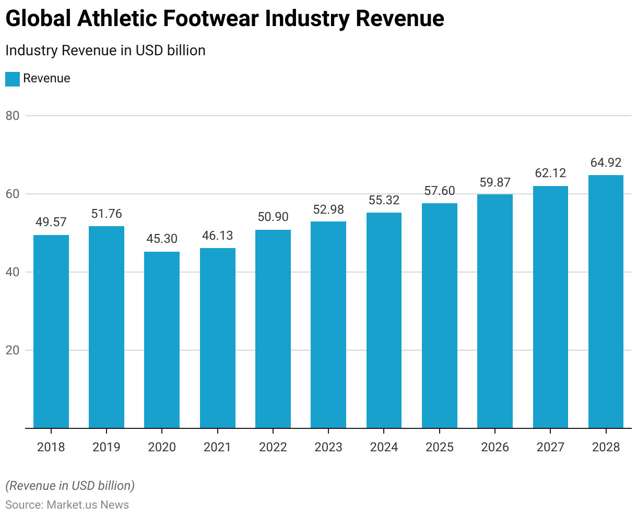
Fig 1: Global Athletic Industry
Source: (Abdulhasan et al., 2024)

Way it aligns with the existing brand values and market position
Reebok Earth effortlessly incorporates innovation, performance, an active lifestyle, and environmental responsibility into its brand values and market position. Elite athletes and fitness fanatics wear Reebok high-quality athletic wear. The sportswear company leads in utility, comfort, and technology. Sustainability meets style and performance with Reebok Earth. Innovation from Reebok powers this extension. Company sustainability initiatives include their “Cotton + Corn” shoe series and Global Sustainability Report (Alagarsamy et al., 2024). Reebok Earth should be innovative and green. This expansion shows Reebok's dedication to performance, responsible manufacturing, low environmental effect, and ethics. Reebok Earth encourages fitness. Reebok's eco-friendly “Be More Human” collection emphasizes fitness and social responsibility. People that care about carbon footprint and ethical business buy it because it matches their values. Millennials and Gen Z value sustainability, thus this extension can draw them to Reebok. Reebok Earth balances performance, innovation, and diversity with sustainability. Reebok satisfies consumer demand for sustainable products and strengthens its position as a forward-thinking, responsible, and customer-centric sportswear brand by developing high-performance, eco-friendly athletic clothing.

Way it adds value to the brand, fills a market gap, or meets an emerging need
Reebok Earth meets the growing demand for eco-friendly, high-performance sportswear. Reebok Earth meets the growing need for sustainable sportswear without losing performance or style as consumers, especially younger generations, prioritize environmental responsibility (Alkhizar and Vidani, 2024). This extension positions Reebok as an innovator and sustainability leader and attracts eco-conscious consumers, boosting its market reach and social responsibility.

STP for the New Brand Extension

Segmentation: demographic, geographic, psychographic, behavioural. Explain why these are suitable for the brand extension
Segmentation Type | Description | Suitability for the Brand Extension
Demographic | Reebok Earth targets £30,000–£60,000-earning 18–35-year-old men and women. Students, young professionals, and fitness enthusiasts are typical. | Because they value sustainability, Millennials and Gen Z like sustainable items. People with goal-range disposable money buy premium sustainable products (Mischler and Pichot, 2024).
Geographic | First, focus on sustainable urban markets in North America and Europe. Rising eco-conscious demand in Asian emerging economies may drive growth. | Urban consumers, especially developed ones, are more eco- and fitness-conscious. Reebok Earth suits these regions because they follow sustainable fashion trends.
Psychographic | Fitness, health, and sustainability aficionados will be targeted. Environmental sustainability and ethical brands are important to them (Ramaditya and Yasa, 2024). | Because customers in this sector actively seek products that meet their principles, the psychographic profile matches Reebok Earth. These folks demand health and environmental protection.
Behavioral | Target clients are active runners, yoga practitioners, and gym-goers. They like long-lasting, sustainable things. | Fitness enthusiasts value clothing performance and sustainability. Reebok Earth products are for buyers who value durability, quality, and sustainability (Sarwar, 2024).
Table 1: STP Analysis

Targeting: Which segment(s) will be targeted and why. Targeting strategy used
Demographic Segment
Reebok Earth targets 18–35-year-old men and women. Fitness and eco-friendly shopping are more popular. This age group includes students, young professionals, and fitness fanatics who can afford sustainable luxury. 73% of millennials and Gen Z value sustainability and buy brands that reflect that (Byun, 2024). Reebok Earth benefits from this demographic.
Psychographic Segment
Reebok Earth targets health-conscious, sustainable consumers psychographically. Fitness aficionados also seek to reduce their environmental impact. They seek and pay extra for ethical companies. Reebok Earth's fitness and environmental responsibility appeal to this growing consumer base, making it vital.
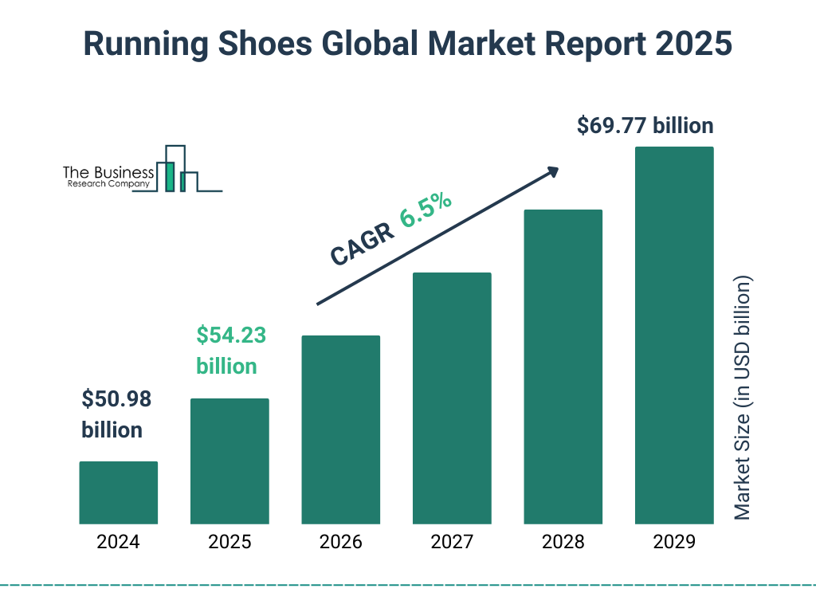
Fig 2: Running Shoes Global Market
Source: (Byun, 2024)
Targeting Strategy
Reebok Earth's "differentiated marketing strategy" targets young fitness fanatics and eco-conscious sustainability supporters. This strategy is perfect since Reebok can target these overlapping groups with its messaging and offers. Sustainable and high-quality sportswear buyers may choose Reebok Earth for performance and environmental benefits (Cacciola, 2024). Reebok's unique approach makes them a performance and environmental responsibility leader in the competitive sports wear business while appealing to these groups.

Positioning: Clear positioning statement. How the brand extension will be perceived vs. competitors
Reebok Earth will meet the demand for eco-friendly, high-performance sportswear by combining cutting-edge performance and sustainability. Fitness enthusiasts who care about health and the environment will like it (Chakraborty, 2024). Reebok Earth, a leader in athletic performance and environmental responsibility, will help athletes and active people perform better and safeguard the environment.
Perception vs. Competitors
Performance and environmental focus will make Reebok Earth the sustainable athletic wear industry leader. Nike and Adidas' "Move to Zero" and "Parley" collections have increased sustainability, but Reebok Earth will offer waste-reducing, biodegradable, ethical items (Soto-Cruz, 2024). Reebok Earth will be more niche and purposeful than rivals. Environmentally conscious buyers seeking stylish, high-performance sportswear will be targeted. From marketing to packaging to customer journey, the organization will successfully communicate its eco-friendly message to help buyers understand their purchase's environmental benefits (Chetty, 2024). Reebok Earth will stand out in the congested sportswear market by appealing to environmentally concerned and performance-driven consumers due to its transparency about sustainability and Reebok's reputation for high-performance products.

Customer Personal Profile
Customer Personal Profile | Description
Demographic
Age | Reebok Earth targets 18–35-year-old Millennials and Gen Z. These generations are tech-savvy, socially conscious, and green. Health and fitness matter to them, whether they exercise regularly or not.
Gender | Reebok Earth targets men and women since sportswear sustainability is genderless. Men and women pick various styles and functionalities, yet both care about the environment while buying active lifestyle products. Gendered and sustainable designs will be offered.
Income | For premium sustainable products, Reebok Earth targets middle- to upper-middle-class customers with £30,000–£60,000 salaries. These consumers like durable sportswear that meets their environmental and performance aims.
Occupation | Young professionals, students, and fitness lovers are targeted. Young professionals work in entry-level or mid-level business, health, IT, and creative fields. These educated folks enjoy exercise. Fitness enthusiasts—part-time workers or athletes—are good candidates because they seek performance boosters that match their values.
Education | College graduates in business, health, sports, and environmental sciences will be most customers. They are aware of global sustainability trends and likely to acquire products that demonstrate their environmental commitment. They prioritize ethical, sustainable brands.
Psychographic
Values | Healthy, sustainable, and socially responsible consumers are Reebok Earth's aim. These people care about food and company sustainability. Fitness and wellness are important to these clients.
Attitudes | Target consumers practice sustainability and eco-consciousness to reduce environmental impact. They buy to reduce climate change and resource depletion.
Lifestyle | Running, cycling, yoga, gym activities, and team sports are popular with target consumers. Personal health and environmental sustainability matter to them.
Buying Behaviour | Reebok Earth customers research products before buying. They may look for certifications, sourcing transparency, and materials to evaluate the products' environmental impact. Quality, durability, and sustainability impact their selections, but price is critical.
Aspirations | Reebok Earth clients crave fitness and sustainability. Their goal is to join a rising movement to minimize waste, carbon footprints, and support ethical enterprises. These consumers seek to look self-aware and ecologically conscientious while making a good social and environmental effect.
Table 2: Consumer Profile

Marketing Mix Strategy

Product
Reebok Earth clients crave fitness and sustainability. Their goal is to join a rising movement to minimize waste, carbon footprints, and support ethical enterprises. These consumers seek to look self-aware and ecologically conscientious while making a good social and environmental effect (Firdaus and Ramli, 2025). They choose reputable companies that share these values.

Price
Premium pricing will establish Reebok Earth as a high-quality, eco-friendly, durable brand. Luxury sportswear prices are competitive despite the higher cost of sustainable materials and ethical manufacturing. Shoe prices are £90-£150, clothes £40-£80, and accessories £20-£50. Despite being more expensive than regular Reebok products, the products will demonstrate their longevity (Gurrieri et al., 2024). Reebok Earth will justify its premium prices with eco-consciousness, performance, and quality by selling durable, performant products created from sustainable resources. The company will retain clients using loyalty programs, bundle discounts, and limited-time promotions.

Promotion
Reebok Earth's marketing will emphasize its sustainability and performance. The marketing efforts will use digital media, influencer collaborations, and social responsibility content. Key promotions will include:
Social Media Campaigns: On Instagram, TikTok, and Twitter, Reebok Earth will encourage eco-conscious influencers and athletes (Holubenko, 2024). Influencers will share their sustainability stories and promote the product line's eco-friendliness to young, socially concerned audiences.
Sustainability-Focused Storytelling: Reebok Earth's sustainable materials, ethical production, and environmental impact will be explained in videos, blogs, and other digital content. This will emotionally engage the audience.
Collaborations and Partnerships: The company will encourage sustainability with environmental and fitness groups. Cleanup and fitness tasks might promote Reebok and associate it with customer issues.
In-Store and Online Campaigns: Reebok Earth's eco-friendly materials and carbon reduction pledge will be advertised in-store and online (Hossain et al., 2024).
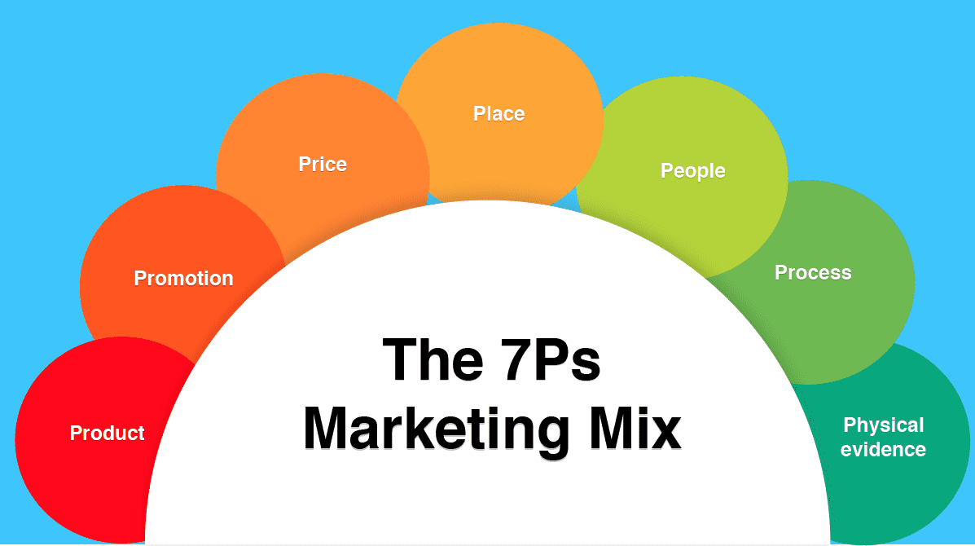
Fig 3: 7Ps Marketing Mix
Source: (Hossain et al., 2024)

Place
For wide distribution, Reebok Earth will be sold online and offline. Availability will be through:
Reebok’s Official Website: The Reebok Earth part of the main online sales platform will include product descriptions, sustainability data, and user reviews.
Premium Retail Stores: Reebok Earth will be sold in iconic Reebok stores throughout Europe and North America, where sustainability is important. These stores will enable customers touch and view the products and have knowledgeable staff discuss their sustainability.
E-commerce Platforms: Reebok will sell on Amazon and eco-friendly fashion sites to increase sales (Khammat and Atiyah, 2024).
Pop-Up Shops: Pop-up stores and events in major cities will help Reebok Earth sell special products to eco-conscious buyers (Iravaninezhad et al., 2024).

Process
Online and in-store purchasing will be easy for Reebok Earth. Credit cards, PayPal, and cryptocurrencies will be accepted on the simple website. Detailed product descriptions and size guidelines reassure clients. Shoppers can also learn about their purchases' environmental impact from clear sustainability labeling. Store workers will learn to explain eco-friendly production and products. Return and exchange policies ensure consumer satisfaction.

People
The marketing mix's "People" component lets Reebok Earth deliver sustainability and performance at every consumer touchpoint. This includes brand advocates, customers, employees, and partners who deliver brand experience. Reebok must promote sustainability internally and among stakeholders to support this eco-friendly goal (Maheshwari et al., 2025). Reebok Earth needs in-store and online customer service experts in product sustainability and performance. Recycled polyester and biodegradable footwear salespeople must highlight their environmental benefits. Engaging consumers in meaningful sustainability talks demands substantial product and customer service training. Employees should be empowered to make consumer-values-based recommendations to improve brand loyalty and purchasing confidence. Fitness and environmental influencers are carefully selected by Reebok Earth. Conservationists will inspire brand customers (Mak et al., 2024). Their sustainability and carbon reduction efforts will make them Reebok Earth ambassadors. Eco-conscious shoppers would like an athlete or fitness celebrity who supports zero-waste living or eco-friendly fitness. Reebok will reach its target audience by hiring mission-driven personnel in a market where buyers distrust “greenwashing” or hollow sustainability promises (Vidani and Singh, 2024).

Physical Evidence
Reebok Earth requires sustainability and eco-friendliness proof. To gain consumer trust, packaging must be 100% recyclable or biodegradable and eco-certified. Reebok locations will use interactive digital displays, recycled wood storage, and energy-efficient lighting to explain product sustainability (Manivel, 2024). Labels will clearly display sustainable materials like “100% Organic Cotton” or “Recycled Materials,” with QR codes for product details. Immersive pop-up stores and events will connect consumers to Reebok's environmental efforts. Reebok Earth will leverage packaging, in-store design, product labeling, and experiential marketing to build brand confidence and loyalty in its environmental commitment (Mejia and Koehler, 2024).

Conclusion

Closing thoughts
Finally, Reebok Earth's introduction combines sustainability and high-performance sportswear, a milestone. The new brand extension shows Reebok's creativity and matches consumer desire for eco-friendly products. Sustainable materials, ethical production, and performance help Reebok Earth lead the sustainable sportswear market and delight eco-conscious athletes. The Reebok Earth marketing mix attracts customers with product innovation, premium price, targeted advertising, and successful distribution. Every consumer touchpoint will show the brand's sustainability through eco-friendly packaging, in-store experiences, and straightforward language. Reebok Earth's premium price and focus on long-term value may address a need for high-performance, eco-friendly athletic clothing. The company's transparency and ethics will boost brand loyalty as consumers become more mindful of their purchases.

Recommendations
Reebok Earth can be executed successfully and sustainably with numerous proposals. Reebok should spend in R&D to find environmentally friendly materials and manufacturing methods to stay ahead of sustainable innovation. Second, the corporation should work with eco-friendly celebrities and athletes to authenticate its promotion. Europe, North America, and emerging countries with increased sustainability consciousness should be Reebok's priority for sustainable products. Finally, in a greenwashing-prone business, honest brand sustainability communication builds and maintains consumer trust. These principles can help Reebok Earth's market position and the sportswear industry's sustainability transformation.

References
Abdulhasan, M.M., Safi, H., Ali, A.T.H., Othman, N.A. and Mahmoud, M.I., 2024, December. Strategic Management of Advertising Using National Broadband IoT and Machine Learning. In 2024 International Conference on Emerging Research in Computational Science (ICERCS) (pp. 1-6). IEEE.
Alagarsamy, S., Mehrolia, S. and Paul, J., 2024. Masstige scale: An alternative to measure brand equity. International Journal of Consumer Studies, 48(1), p.e12873.
Alkhizar, M. and Vidani, J., 2024. Exploring the factors influencing consumer buying behavior of LG products: A comprehensive study. Journal of Advanced Research in Economics and Business Management, 6(2).
Byun, K.W., 2024. A Study on the Perception and Context of Sportswear Brand Collaboration through Big Data Analysis. International Journal of Internet, Broadcasting and Communication, 16(4), pp.321-329.
Cacciola, S., 2024. Reebok Isn’ta ‘Hobby’for Shaquille O’Neal. The New York Times (Digital Edition), pp.NA-NA.
Chakraborty, U., 2024. Brand Awareness: A case study of students of Mrs. KMPM vocational college Jamshedpur. GLS KALP: Journal of Multidisciplinary Studies, 4(2), pp.9-15.
Chetty, L., 2024. Marketing Analysis for a Footwear Company–Part 1. British Journal of Multidisciplinary and Advanced Studies, 5(2), pp.114-120.
Firdaus, C. and Ramli, Y., 2025. The Influence of Brand Image, Green Marketing, and Environmental Awareness against the Green Purchasing Decisions of Adidas Sport Shoes. Business, Economics, Law, Communication, and Social Sciences, 1(1), pp.1-16.
Gurrieri, L., Drenten, J. and Abidin, C. eds., 2024. Influencer Marketing: Interdisciplinary and Socio-Cultural Perspectives. Taylor & Francis.
Holubenko, M.А., 2024. The of marketing research organization mechanism at the enterprise entering the international market (Master's thesis, Sumy State University).
Hossain, M.S., Babu, M.A. and Yusuf, K.M., 2024. Exploring emotional dynamics: Word count effects in Facebook posts by sports shoe brands. Heliyon, 10(21).
Iravaninezhad, N., Sajjadi, S.N., Mahdipour, A.G. and Aghdam, A.R., 2024. Exploring the relationships between brain wave and customer-perceived value after watching sports products commercials. International Journal of Applied Management Science, 16(4), pp.397-413.
Khammat, S.K. and Atiyah, A.G., 2024, June. Maximizing the Marketing Capabilities and Digital Sustainability of B2B & B2C Platforms Using Artificial Intelligence. In International Conference on Explainable Artificial Intelligence in the Digital Sustainability (pp. 365-374). Cham: Springer Nature Switzerland.
Maheshwari, N., Mishra, D. and Sinha, P., 2025. Nike in India: Navigating Challenges, Innovating Consumer Engagement.
Mak, J., Pifer, N.D., Gulavani, S.S. and Henry, T.E., 2024. The influences of country and gender on adolescent soccer players' brand perceptions and purchase intentions. International Journal of Sport Management and Marketing, 24(3-4), pp.179-198.
Manivel, R., 2024. Decoding Customer Engagement in the Sports Shoe Industry: A Focus on Brand Loyalty and Customer Satisfaction. Available at SSRN 4824003.
Mejia, R.A. and Koehler, A., 2024. American Needle Inc. v. National Football League: An Exploration of an Industry-Changing Case.
Mischler, S. and Pichot, L., 2024. The impact of brand attribution for an innovative sports product introduced on the fitness market in France. International Journal of Sports Marketing and Sponsorship, 25(1), pp.109-124.
Ramaditya, I.M.B.M. and Yasa, N.N.K., 2024. The Role of Brand Image in Mediating the Influence of Social Media Marketing on Purchase Intention. International Journal of Management Research and Economics, 2(4), pp.189-206.
Sarwar, M.S., 2024. Challenges of Style Textile Pvt. Ltd and Its Solutions Organization: Style Textile Pvt. Ltd (Doctoral dissertation, CUI Lahore).
Soto-Cruz, F., 2024. Branding and Viewership: Does a Uniform Presentation Change Public Interest? (Doctoral dissertation, University of Oregon).
Vidani, J. and Singh, P.K., 2024. To Study the Consumer Perception on Purchase Behaviour Towards Reliance Trends in Rajkot City. Available at SSRN 4848154.

