
Master of Business Administration
Programme: Master of Business Administration
Module: Marketing Management
Module code: LCMB7024
Assignment Title: Assessment component 2
Marketing Portfolio (Xiaomi)
New Brand Concept: Xiaomi Smart Life+ — an AI- powered smart home and lifestyle service ecosystem
Framework: 7Ps (Service-based)
Lecturer: Dian Mayasari (Birmingham)
Student name: Bhargav Jagdishbhai Khunt
Student ID number: 2435433
Word count: 2418
Submission date: 19th of November 2025 by 2pm

Table of Content
1. STDP Analysis for Xiaomi SmartLife+ 2
1.1. Xiaomi and the New Brand Concept 2
1.2. Segmentation Analysis 3
1.3. Targeting Strategy 5
1.4. Differentiation Strategy 5
1.5. Positioning Strategy 7
2. Marketing Mix (7Ps) 7
3: Marketing Strategy Pitch 14
4: Reflection 16

1. STDP Analysis for Xiaomi SmartLife+

1.1. Xiaomi and the New Brand Concept
Xiaomi Corporation is one of the fastest-growing technology companies in the world, and this company was established in 2010 in Beijing, it specialises in smartphones, smart devices and the Internet of Things (IoT). Having established its philosophy of innovation to everyone, Xiaomi has succeeded in creating a brand image of a high-quality technology at a low cost. Nevertheless, with the evolving lifestyles of consumers around the world focusing in connected living, sustainability, wellness, Xiaomi has a challenge of having to differentiate itself in a world that is becoming overcrowded in the smart technology sector.
To solve this, the new brand, Xiaomi SmartLife+ proposes a high-end AI-based smart home and lifestyle system, which would bring together Xiaomi smart products and services and connect it to a single platform. The brand provides its users with personalised home automation, health monitoring and cost-effective solutions through subscription. This brand will showcase Xiaomi as not just a low-priced brand, but a high-end, technology oriented, lifestyle brand that appeals to those consumers who are interested in intelligent living arrangements.
Figure 1: Conceptual overview of Xiaomi SmartLife+ ecosystem – showing connected devices, AI assistant, and user interaction via smartphone app.

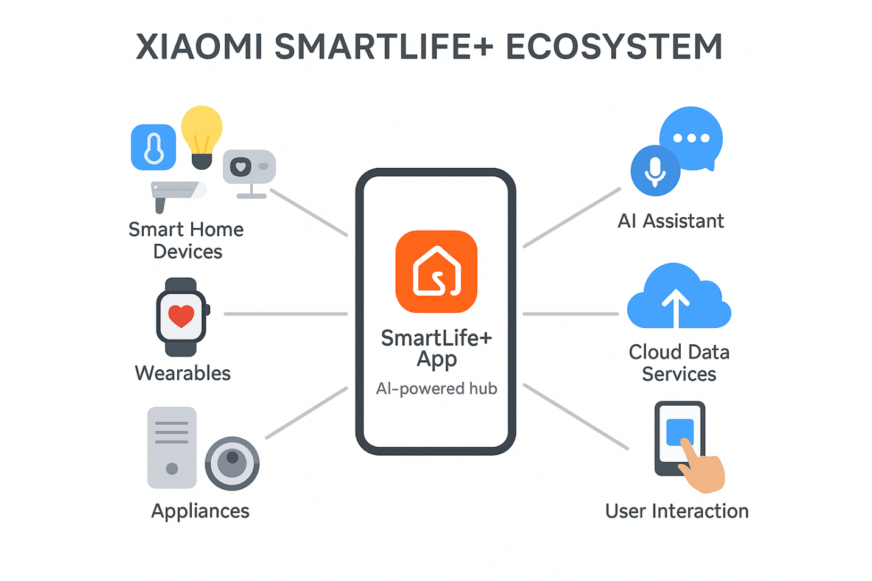1.2. Segmentation Analysis
Xiaomi SmartLife+ uses a multi-dimensional segmentation strategy, with the choice of demographic, psychographic, behavioural and geographic variables (Kotler and Keller, 2022).
- Demographic segmentation: It focuses on middle to upper-middle-income groups between 25 and 45 years old that are tech-savvy professionals and early technology adopters.
- Psychographic segmentation: Is aimed at customers who appreciate convenience, sustainability, and online lifestyles. These people are interested in automating their everyday life with the help of AI and seeking the solutions.
- Behavioural segmentation: Reach users that already have smart devices or are using AI assistants (e.g. Alexa, Google Home) but need integrated systems to get a more efficient and energy-saving experience.
- Geographic: Segmentation focuses on Asian and European markets that are urban and suburban markets and whose infrastructure is highly developed and smart home adoption rates are growing
Table 1: Segmentation Criteria for Xiaomi SmartLife+
Segmentation Type | Basis | Target Characteristics
Demographic | Age 25–45, middle–upper income | Tech-savvy professionals
Psychographic | Lifestyle | Values innovation, sustainability, convenience
Behavioural | Usage rate & brand loyalty | Users of AI/IoT ecosystems
Geographic | Region | Urban/suburban markets in Asia & Europe

1.3. Targeting Strategy
According to the segmentation, the targeting of the Xiaomi SmartLife+ will be differentiated and target two key consumer segments, which are:
- Young professionals (25-35 years) are those who want to experience a gradual introduction of technology into their daily routine and want to increase productivity with the help of automation.
- Technology-oriented families (30-45 years) are concerned with security, energy conservation, and automated home control to enjoy a better lifestyle.
This positioning is in line with the recent trends in the global systems of AI integration and wellness economy where Xiaomi SmartLife+ is seen both as a lifestyle and efficiency facilitator.

1.4. Differentiation Strategy
The brand’s differentiation will rely on three core pillars:
- Technological Accompaniment: In contrast to other existing competitors like Amazon Alexa or Google Home, SmartLife+ provides a single adaptive AI platform that supports all Xiaomi devices (phones, appliances, wearables) and can understand user habits and preferences.
- Value under Premium Experience: Xiaomi will achieve affordability and at the same time have a new subscription level that is featured with exclusive services like energy monitoring, smart health analytics, and integration of home security.
- Sustainability: Xiaomi SmartLife+ will be environmentally friendly by incorporating energy-saving functionality and sustainable devices, which will attract environmentally conscious buyers, which is a growing factor in purchase decisions (Euromonitor, 2024).
Figure 2: Differentiation Map comparing Xiaomi SmartLife+ with competitors in terms of affordability and integration.
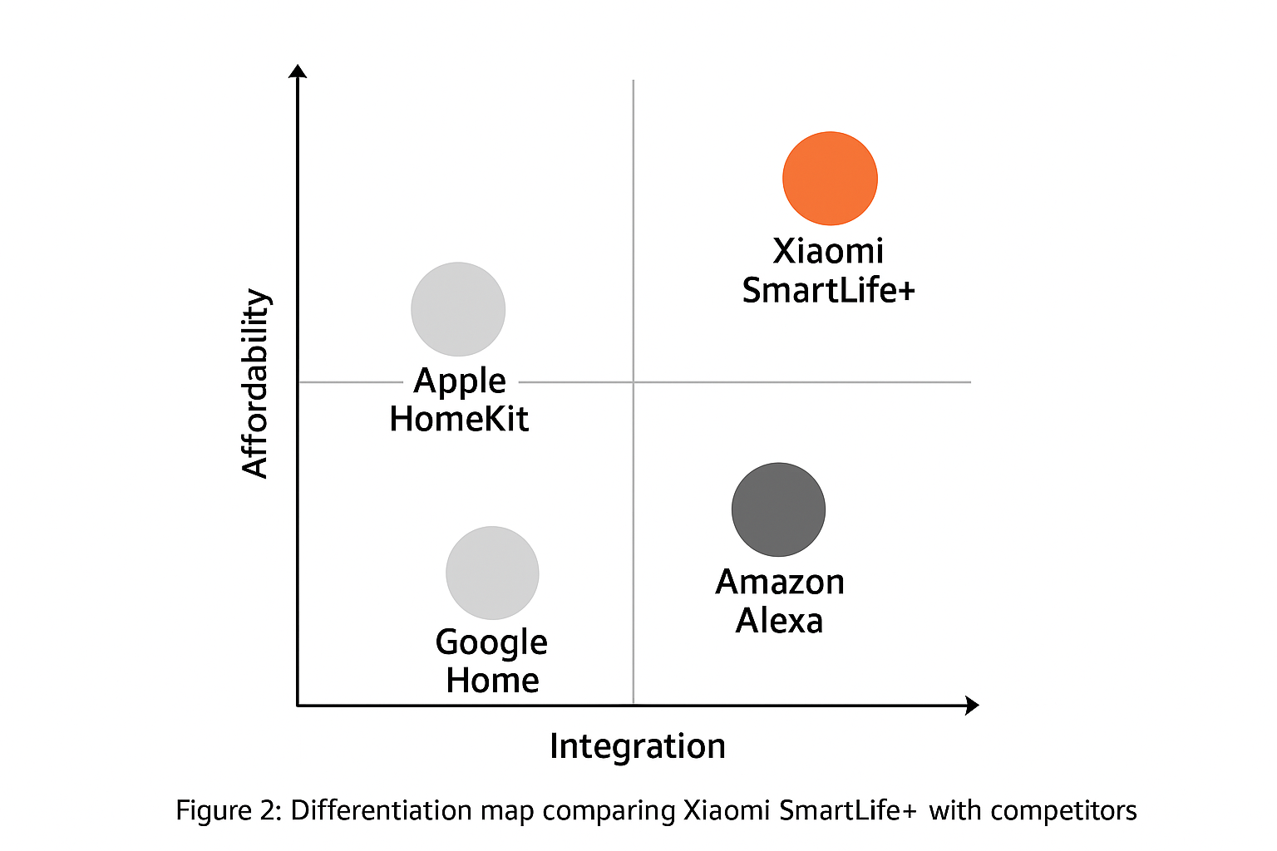

1.5. Positioning Strategy
The brand is going to position it as your smart companion towards a sustainable lifestyle. This is a positioning statement with focus on innovation, personalisation and environmental responsibility. The message will dwell upon how SmartLife+ makes the contemporary life easier due to the intelligent automation without making it unattainable. A perceptual positioning map (Figure 3) can be used to visualise Xiaomi SmartLife+ relative to key competitors:

2. Marketing Mix (7Ps)
The marketing mix is a collection of tactical arrangements which guarantee that a new brand offering meets client expectations while responding to corporate needs. As for the Xiaomi SmartLife+, the 7Ps: Product, Price, Place, Promotion, People, Process, and Physical Evidence, offer a comprehensive strategy to secure a primary position in the competitive smart home industry. Each component affects the trademark positioning statement, “Live Smart. Live Better.” Which embodies the core values of accessibility, intelligence, and sustainability towards daily living.
Product
Xiaomi SmartLife+ is designed as an innovative, subscription-based digital ecosystem integrating Xiaomi’s extensive range of Internet of Things (IoT) devices, the Mi Home app, and the Xiaomi AI assistant into a single, user-friendly platform. The product’s value proposition lies in enhancing users’ lifestyles through intelligent automation, personalized health tracking, and seamless connectivity.
The key features of SmartLife+ include:
- Smart Home Automation: Users can customize daily routines such as lighting adjustments, room temperature control, appliance scheduling, and home security monitoring.
- Health and Wellness Monitoring: Through synchronization with Xiaomi wearables, users can access insights into sleep quality, heart rate, and air quality, thereby promoting overall well-being.
- Energy Management: An AI-powered analytics dashboard streamlining reports on energy use in real-time. This helps customers waste less energy and save on electricity costs.
- Data Privacy: End-to-end data encryption and user-defined data permissions reinforce trust in consumers, which is a key differentiator in sensitive-data markets.
SmartLife+ is structured around the three product levels as shown in Table 2.

Table 2: Product Levels for Xiaomi SmartLife+
Level | Description
Core Product | Intelligent, connected lifestyle that enhances convenience and sustainability.
Actual Product | SmartLife+ digital application integrated with Xiaomi IoT devices and AI assistant.
Augmented Product | Cloud-based data storage, continuous software updates, premium customer support, and compatibility with third-party devices.
Therefore, SmartLife+ is designed as more than a service but rather an ecosystem experience that integrates second and third smart devices with digital intelligence. This comprehensive approach to the product builds customer loyalty and provides the opportunity to scale and expand into international markets.
Pricing
Pricing strategy maintains the alignment of brand outlook and the market perception of Xiaomi as a provider of high-end technology within reach. SmartLife+ service is designed with a freemium and tiered pricing model. This model is used to balance the offer to meet the needs of the low-end and high-end market.
By incorporating a freemium model, users will be able to use basic smart home features without any cost, promoting early adoption and engagement within the ecosystem. Users wanting advanced features, such as automation with predictions, AI analytics, and collaborative family sharing, may choose to subscribe to premium tiers. Proposed pricing tiers include:
- Individual Plan: $9.99 per month – includes AI automation, energy analytics, and personalized health tracking.
- Family Plan: $14.99 per month – includes multiple device integrations, shared access controls, and family health analytics.
This model incorporates principles of value-based pricing, focusing on innovativeness and long-term value, while ensuring perceived affordability. Psychological pricing - a tactic where the price ends with 9 - increases purchase intent and positions SmartLife+ as a product that is both aspirational and attainable.
To aid in customer retention and cross-selling of Xiaomi’s other products, long-term strategies will include strategic discounts on bundled purchases with devices such as new Xiaomi smart devices.
Place (Distribution)
The SmartLife+ distribution strategy harnesses Xiaomi's effective digital-first distribution strategy within an omnichannel ecosystem. Chase will focus on online distribution, consolidating the offering with selective offline experiences.
Key distribution channels include:
- Xiaomi Mi Home App and Official Website: Users can subscribe directly through the app or Xiaomi’s e-commerce site.
- Device Integration: SmartLife+ will be pre-installed or prompted during the setup of Xiaomi smart devices, encouraging seamless adoption.
- Retail and Telecom Partnerships: Collaborations with major retailers, smart home installers, and telecom providers will allow SmartLife+ to be bundled with devices or home internet services.
- Service Experience Centres: Dedicated Xiaomi Smart Hubs will be established in major cities, allowing customers to experience the SmartLife+ ecosystem through interactive demos and guided installations.
Such a multi-channel strategy strengthens accessibility and reinforces Xiaomi’s brand reputation as a technology organization that values inclusivity for all consumers—from the highly digital shoppers to those who prefer more traditional shopping methods.
Promotion
Xiaomi has primarily focused digital engagement, community promotion, and narrative experience in the promotion of SmartLife+. The aim is to emphasize the role of SmartLife+ in improving lifestyles rather than solely for fulfilling a utility service.
Promotional activities will include:
- Social Media Campaigns: Interactive posts and Instagram, TikTok, and Twitter stories using the campaign tagline “Live Smart. Live Better,” encouraging user participation through challenges.
- Influencer Partnerships: Collaboration with tech influencers, lifestyle vloggers, and eco-friendly lifestyle advocates to share real-life demonstrations of the benefits of using SmartLife+.
- Experiential Marketing: Engaging in international technology expos and smart living fairs where users will experience the SmartLife+ ecosystem.
- Content Marketing: Creating and posting tutorials, blogs, and videos on Xiaomi’s YouTube channel and Mi Community to showcase product setup, user tips, and AI features.
Figure 3: Promotion Mix Diagram for Xiaomi SmartLife+ (to be recreated) could illustrate how the digital, experiential, and influencer channels integrate into an omnichannel communication plan. Together, these initiatives strengthen brand awareness, foster trust, and communicate SmartLife+’s value proposition as a smart, affordable, and sustainable lifestyle choice.
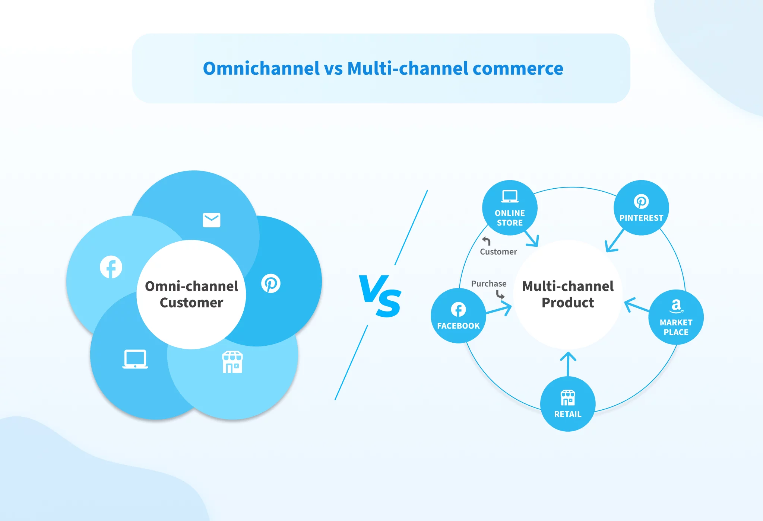People
As a service-oriented offering, people play a crucial role in shaping user experience. Xiaomi will as it is a service; the engagement of people is central towards the experience. To facilitate seamless interactions and ensure technological know-how, Xiaomi will actively focus on the professional development of its employees.
Staff interacting with customers, whether remotely, such as online support personnel, or in physical stores will be educated on the empathy dimension of customer interactions, and the cross-application of AI tools, as well as on the fundamentals of data protection. As part of Xiaomi’s multilingual support system, the following will be available:
- AI-driven customer service systems support 24/7 chat and voice interaction.
- Engaged community forums and Xiaomi ambassadors pre-registered to address customer concerns.
The retention of empowered employees and boosted service standards will foster customer satisfaction and loyalty, two essential components in subscription services.
Process
The SmartLife+ service process emphasizes simplicity, automation, and personalization. Users will experience a streamlined onboarding journey beginning with account creation and device linkage via a single QR scan. The app will then use AI algorithms to analyse user behavior, adjust automation, and device synchronization accordingly.
Key process features include:
- Guided setup tutorials to simplify first-time use.
- Real-time notifications and recommendations based on user patterns.
- Automatic software updates ensuring continuous feature enhancement.
- Feedback loops that collect customer data (with consent) to improve future updates.
This efficient and adaptive process fosters convenience, strengthens engagement, and supports Xiaomi’s brand identity as a leader in intelligent simplicity.
Physical Evidence
Even though SmartLife+ is primarily a digital service, tangible elements play a vital role in enhancing credibility and brand recognition. Physical evidence will be reflected through:
- Branded Packaging: Xiaomi devices compatible with SmartLife+ will display co-branding and QR setup guides.
- User Interface Design: The SmartLife+ dashboard will feature minimalist visuals, intuitive icons, and Xiaomi’s signature orange and white palette, symbolizing warmth and innovation.
- In-Store Demo Zones: Selected Mi Stores will showcase SmartLife+ home setups, offering live demonstrations to potential subscribers.
These elements serve as physical manifestations of the brand’s promise — connecting the intangible service experience with visible brand consistency.
Conclusion of Marketing Mix
All things considered, Xiaomi SmartLife+ does innovate and put focus and effort to both affordability and the user experience. Xiaomi enhances its position in the smart living market as an accessible and innovative company through the smart living ecosystem’s freemium model, the self-service omnichannel approach, and the tech-enhanced service. The 7Ps not only strengthen Xiaomi’s competitive edge but solidify the company’s market position as the provider of intelligent and interconnected living solutions.

3: Marketing Strategy Pitch
Pitch Title: Xiaomi SmartLife+: Your Intelligent Partner for a Sustainable Lifestyle
SmartLife+ is an AI subscription service that integrates Xiaomi smart devices, such as smartphones, wearables, and intelligent home appliances, into one interconnected intelligent ecosystem, offering an exceptional user experience through automated device interactivity. Our ideal customers are urban career individuals and technology-savvy families interested in innovation, convenience, and eco-friendly solutions.
Competitive advantages of SmartLife+ include pricing, eco-smart AI, and eco-efficient solutions. Starting from $9.99 per month, users receive individualized energy-efficient automations, health insights from smart devices, and persona-driven frameworks.
The campaign “Live Smart”. Live Better.” enables users to experience the difference SmartLife+ and help investors realize growth opportunities in the sale of recurable digital subscriptions and in the cross-selling of Xiaomi devices through influencer activations, digital story-telling, and SmartLife+ activations.
Poster Layout – SmartLife+ logo, slogan, AI ecosystem visual, key benefits, pricing tiers, QR code for trial sign-up.
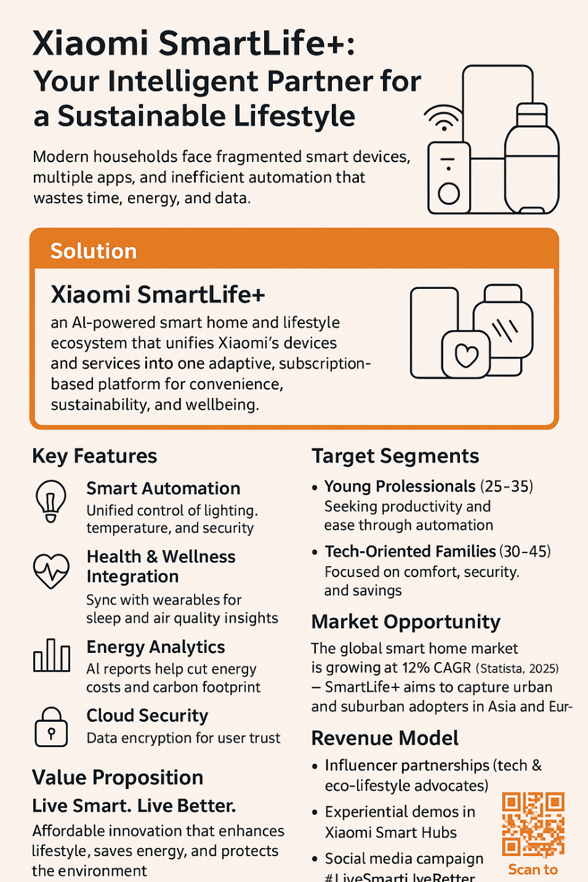

4: Reflection
Completing this branch of Xiaomi SmartLife+ sparked integrating practical experiences and acquiring new knowledge around theoretical frameworks of marketing. Constructing STDP analysis expanded understanding on how the brand breaks the market and the importance of psychographic factors in forecasting demand within the smart technology industry. It was brought to attention that marketing in today’s world needs to utilize rational approaches together with emotional tactics in building brand image.
Focusing on 7Ps of marketing in particular was eye-opening. It showed that attention to product and pricing is important, but the rest of the elements, especially process and people, are gaining increased importance in the marketing of services. Developing a service brand made me realize the importance of customer journey, brand continuity, and service ecosystem beyond the physical brand elements.
The marketing strategy preparation increased my ability in presentation and argumentation. Isolating and simplifying core marketing practices to establish a visual story on a slide deck for a heterogeneic audience honed my strategic thinking ability.
I understood the role of storytelling in marketing — people and companies are attracted to the story behind the brand more than the practical advantages derived from it.
If more of my consumer insights and AI driven market analytics were deployed in my future projects, I would refine the segmentation and targeting more. I would also involve the customers in the very early stage of brand development to co-create the offering so that it addresses the users more accurately. All in all, this assignment has demonstrated the ease and confidence with which I can apply advanced marketing concepts to novel, technology-rich environments, which has greatly prepared me for strategic marketing roles in fast-changing industries.
References:
- Aaker, D.A. (2021) Building Strong Brands. New York: Free Press.
- Baines, P., Fill, C. and Rosengren, S. (2019) Marketing. 6th edn. Oxford: Oxford University Press.
- Bhatnagar, N. and Gopalaswamy, A.K. (2021) ‘Consumer perception towards smart home devices and IoT-based products: An empirical study’, Journal of Retailing and Consumer Services, 61, 102558.
- Brown, S. (2020) ‘Evolving strategies in the smart home ecosystem’, International Journal of Market Research, 62(4), pp. 479–495.
- Chaffey, D. and Ellis-Chadwick, F. (2022) Digital Marketing: Strategy, Implementation and Practice. 8th edn. Harlow: Pearson Education.
- Chen, L. and Zhang, Y. (2020) ‘Adoption and diffusion of AI-integrated smart home products in emerging markets’, Technological Forecasting & Social Change, 160, 120231.
- Czinkota, M.R. and Ronkainen, I.A. (2020) International Marketing. 11th edn. Boston: Cengage Learning.
- Grant, R. (2019) ‘Positioning strategies in competitive markets’, Strategic Direction, 35(10), pp. 7–10.
- Kotler, P. and Keller, K.L. (2022) Marketing Management. 16th edn. Harlow: Pearson Education.
- Kumar, V. and Reinartz, W. (2021) Customer Relationship Management: Concept, Strategy, and Tools. 3rd edn. Springer.
- Mintel (2024) Smart Home Market Trends – Global Overview. Available at: https://www.mintel.com/ (Accessed: 21 October 2025).
- Statista (2024) Smart Home Industry – Global Revenue Forecast 2020–2028. Available at: https://www.statista.com/ (Accessed: 21 October 2025).
- Xiaomi Corporation (2024) Annual Report 2024. Available at: https://www.mi.com/global/about/investor/ (Accessed: 21 October 2025).
- Zhao, H. and Li, W. (2022) ‘Consumer trust and privacy concerns in IoT ecosystems’, Journal of Business Research, 145, pp. 634–642.
- Pinto, G.P., et al. (2024) “A systematic review on privacy-aware IoT personal data stores”, Sensors, 24(7), article 2197. Available at: https://www.mdpi.com/1424-8220/24/7/2197 MDPI
- Rachakonda, L.P. (2024) “A comprehensive study on IoT privacy and security”, ScienceDirect. Available at: https://www.sciencedirect.com/science/article/pii/S2667295224000230 sciencedirect.com
- “The Rise of Smart Home Technology: Opportunities for the Future of Living” (2025) Mintel Insights. Available at: https://www.mintel.com/insights/technology/the-rise-of-smart-home-technology/ Mintel
- “Smart Home Market Trends 2025: AI & IoT-Driven Personalization” (2025) Accio Business article. Available at: https://www.accio.com/business/smart_home_technology_trends accio.com
- Alzaidi, M.S. (2022) “The role of trust and privacy concerns…”, PMC (Public Health/Medical Context). Available at: https://pmc.ncbi.nlm.nih.gov/articles/PMC9197404/

