Effective team working part 1 report

VICTORIA HOLCOMBE
2028207
BMSW4002
S. Herath

Table of Contents
Summary 3
Introduction 3
Overview of Team working 4
Groups 5
Teams 5
How students can develop an effective team 5
Models of team development 5
Tuckman Model 6
Please explain each of these stages 6
GRPI model: Goals, Roles, Processes, Interpersonal Relationships 6
*The Katzenbach and Smith Model 7
*The T7 Model 7
Roles required to create an effective team. 7
Discussion 9
Conclusion and recommendations 10
The Katzenbach and Smith Model by Katzenbach and Smith (1993) 11

Summary
For this exercise, students could work together appointing each student with a role that lets them use their previously acquired skills for example students could appoint someone who is good at PowerPoint presentations to prepare slides for the team. They could get someone who has previously spoken done a bit of public speaking to present for them they could get a member who is good at notetaking to prepare the script. And a member who is good at planning to constantly plan the group's next move to progression working together using a diverse set of skills will help the group get further having a strong leader who listens to others will be a strong asset to the group.
Individuals who work in teams and groups learn to co-ordinate with each other they increase the *chances of solving shared problems and meeting a personal need (Quinn Johnson and Johnson 1995).
The difference between a team and a group

Introduction
This report summarises what it is to create an effective team. It answers 4 basic questions.
How students can develop an effective team
The impact effective teamworking can have on for team success
Barriers to effective teamwork
The types of roles that are needed to create a cohesive and effective team. This report is written based on a case study to work on that gets us to outline theory is related to group dynamics for students forming a team.



Overview of Team working

Groups
- “Groups are usually defined as three or more people sharing something in common. Their goals are often set by others, and they work independently to achieve goals set out by the group's leader or co-ordinator” (Morgan, 2017, page 204)
A group is defined by its structure; they work within boundaries it will be led and usually has a strong leader. Unless all members are equal for example in a music band, members share resources with each other the group individuals gather and usually share common interest's member share information and resources with each other group members all individuals gathered have common interests. some will support the leader some will be against for example in a vote for politics. people in groups interact sharing values principles and standards. they tend to be aware they are part of a group and will meet often at pre-determined times.

Teams
- “Teams tend to outperform groups as they use teamwork. The team is several individuals working together to achieve a shared goal mutual commitment” (Morgan, 2017, page 204)
it is several people working and standing up together in work when they do an activity they coordinate tasks focused on a goal they share. The secret that makes a Group a team is that it has a common goal. Team spirit and the ability to go beyond personal differences high-performance teams take proactive action produce solutions and innovative training and investment may be beneficial in achieving what the team hopes to achieve overall.

How students can develop an effective team

*Wheelan's model the chart she devised outlines stages. Stage one dependency and inclusion, stage 2 counter dependency and fight, stage three trust and structure, stage four work, and productivity. Groups that have a distinct ending point experience a fifth stage impending. She summarised groups achieved maturely as they continue to work together. She highlights how effective teams’ function and how individuals can be more effective team members. This model is very well suited for our students undertaking the task.
Students in the university can develop an effective team using several different methods and based their structure. On one of several models or alternatively take parts of each model and form the team. Successful teams grow and develop but ineffective collaboration can bring down any team, you need to show shared commitment to the goal no matter what your personal beliefs are.
Listening to other people's points of view and letting them bring their experiences to the table can get the team further. The team must have ground rules. When it comes to studying, extra help can be more effective than attempting to tackle this task alone. Using everyone's best set of skills can be an advantage. Every new project comes with a new challenge, so it is important to make sure that the team is working well together. Training can be an excellent way to boost the team's chances of success.

Models of team development

Tuckman Model

*One of the most famous models for forming an effective team is the Tuckman model 09/06/2015 (FNSP) which stands for forming norming storming and performing. In 1977, he added a further stage along with Mary Ann Jenson. This was adjourning. 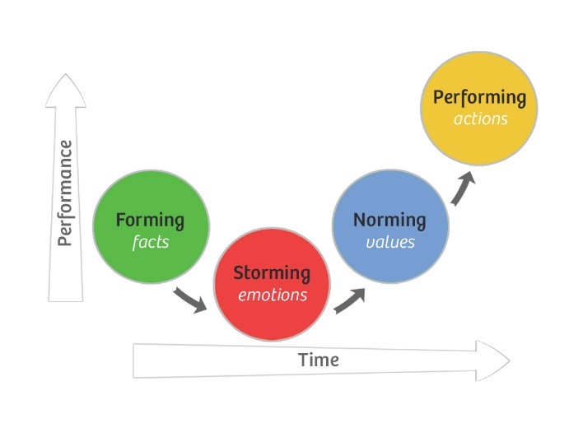
This model suggests that these five stages are necessary for teams to work at the highest possible levels of effectiveness and growth.

This model suggests that these five stages are necessary for teams to work at the highest possible levels of effectiveness and growth. There are 5 stages:
Forming… were the group members join an existing team or organisation.
Storming …people push against the boundaries conflict and friction can arise at this stage.
Norming …. people resolve differences appreciate each other and respect the leader.
Performing…. the team is now formed and performing efficiently
You can use this model to identify the stage your team is at then use the tips to move your team through the appropriate stages.

GRPI model: Goals, Roles, Processes, Interpersonal Relationships

*Rubin, Plovnick and Fry published this team effectiveness model back in 1977. GRPI model is commonly used in the team formation process, and in solving problems in teamworking. This may not be a perfect model for students, as it is static not monitoring how the team may change and evolve. It also looks at teams as rational structured entities this may not be the case in the situation of students trying to fulfil a group task. If the group, choose to use this model, they may have to take parts of other models to keep up with changes to the groups progress. 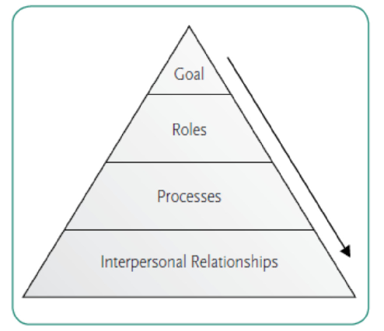

*The Katzenbach and Smith Model

This model was put together by Katzenbach and Smith in 1993 and described in their book “The Wisdom of Teams” The sides of the triangle are the three main factors contributing to the achievement of the goals.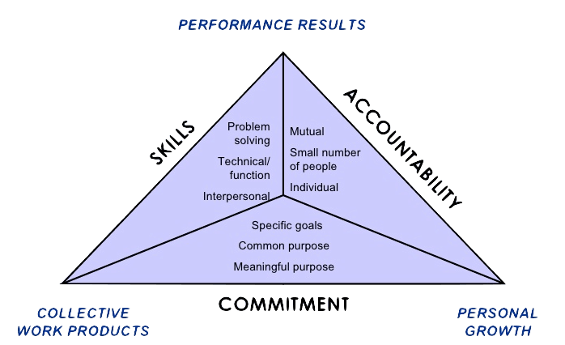

*The T7 Model
research on team effectiveness was done by Michael Lombardo and Robert Eichinger in 1995. Thrust a common team goal Trust confidence in teammates. Talent's teammates' talent required skills and experience. Teaming Skills effective teamwork teamworking skills teamworking skills —the ability to execute tasks.

Roles required to create an effective team.

*Teams share and rotate leadership roles at times. Belbin's theory was published in his book (management teams 1991.) Belbin summarised the structure a successful team need be effective here are the 9 rolls Belben summarised in successful teams' plant creative imaginative or problem solver. resource investigators outgoing communitive networkers.' shaper dynamic task focus and direct. monitor or evaluator impartial logical and weighs up options. coordinator clarify goals delegates identifies talents. team worker caring supportive listener implementer practical organised follows procedures completer has an eye for detail focuses on quality and aims for perfection
specialist expert knowledge and knowhow.

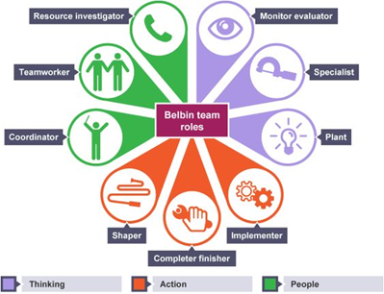

For a small group you need to have at least covered the five basic roles leaders, encourages challengers' challenges, and relist.

“It is important to consider team roles when recruiting because it is searching for candidates for employment to stimulate them to apply for roles in the organisation” (Edwin B Flippo).
It is providing quality people for the role advertised fulfil the organisations need for getting the right people for the job. They should be knowledgeable and skilful candidates that can benefit the organisation with their skills they bring to the role. As each member of a team plays a valuable part it is important to make sure the team will potentially work well together.

Discussion

The advantages of effective teamworking. Team working improves productivity it brings together cooperation in the group, thus increasing motivation to achieve the goal or outcome required. It helps individual team member flex their talents as they come from a diverse set of backgrounds this enhances flexibility this is a strength for any team as they can then rise to any new challenges the group will constantly be able to gain fresh perspective building trust not only in the team but from clients. The group can share the workload and support each other.
*Individually, we are a drop together were an ocean Ryunosuke Satoro Brainy Quote.com. Retrieved October 17, 2021
*Teamwork is a very desirable practice, yet it is not immune to error. Because of this, and not to be a surprise to you, look at some of the benefits and disadvantages of teamwork at companies. Ahemed shaman Ansary December 17, 2009.
on the other hand, the impact to the team's outcome can be affected by ineffective teamworking
Can be detrimental to the goal. Some members may come from a different background or be more dominant than others some may not be as trained as others in a particular field or management may be unwilling to work with the team on certain subjects some team members may dig their heels in when the group suggest things this can create a lack of trust and lengthily time delays and lack of competence. This can all create higher costs for the team. There is no I in teamwork remembering this will get the team a lot further
Other groups may find they are bound by politics and legislation or may be having to clear aspects of the work with a trade union.

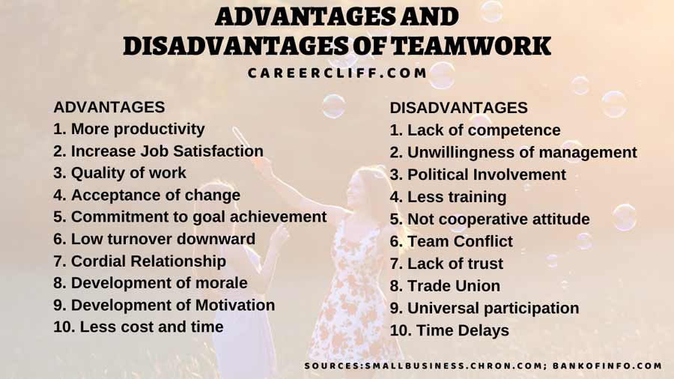

Example:
My parents ran a very lucrative business called Cara-care services limited down in Sesley west Sussex they had 40 staff working with them all was well at first as they took on exceptionally reliable staff. the contract was to clean caravans transport them do the laundry paint the A-frames fix ariels load the infantry. They encountered several problems first the site failed to communicate with them until the last-minute vans needed cleaning. Then staff became unreliable. Then they decided to appoint family members into senior roles. This created problems as they then decided not to pull their weight. Then when challenged thought they could try well we are a family you can discipline or sack me. this caused problems between my parents, then my parents got divorced. The contract was in both of their names so sadly the site was not willing to renew the contract in just person's name so they both lost the business sadly the assets were tied up in the business, so they lost the house as well. This happened due to number of reasons related to ineffective teams such as lack of communication, lack of reliability, unnecessary family influences, etc.

Conclusion and recommendations

The main points in this assignment were to illiterate what it is to create an effective team how to make sure the team keeps up with changes to the targets and how to keep the team running effectively. The different models of creating an effective team such as the Belbin on how to structure the team in the first place. The Tuckman models another way to explain the stages a team goes through. There are advantages and disadvantages to teamwork shown and an example of poor teamwork that ended a business. what it is to create an effective team. This report answers 4 basic questions How students can develop an effective team The impact effective teamwork can have on for team success Barriers to effective teamwork The types of roles that are needed to create a cohesive and effective team.

Reference list
(Quinn Johnson and Johnson 1995).
(Morgan 2017) page 204)
Wheelan's model (9/06/2015)
Tuckman model 09/06/2015
. GRPI model Rubin, Plovnick and Fry (1977)

The Katzenbach and Smith Model by Katzenbach and Smith (1993)
The T7 Model Michael Lombardo and Robert Eichinger in 1995
It is important to consider team roles when recruiting (Edwin l Flippo 1995)
Individually, we are a drop together were an ocean Ryunosuke Satoro Brainy Quote.com. Retrieved October 17, 2021
Look at some of the benefits and disadvantages of teamwork at companies. Ahemed shaman Ansary (17/12/09)

