The school is based in the Swansea area. The school is made up of a nursery, foundation phase and key stage 2. There are around 400 pupils in the school and 50 members of staff. The school is above average for free school meals with 33.6% of the children receiving them. The average for English Additional Language (EAL) in Wales is 6.1%, so the school is well over the average with 15.2%. There is also a high number of ethnic minority children in the school with 22.1% coming from a different background to White British. The school is just below the Welsh average for attendance with 94.6%. (My Local School, 2018) The school was last inspected back in 2014 and the result they got was adequate and they were considered to need monitoring. This monitoring took place in 2015 and the outcome of this was that the school had made progress and was removed from the list of school that Estyn thought needed monitoring. (Estyn, 2018) For the purpose of this essay all names of the school visited, teachers and pupils have been kept anomalous in accordance to BERA (2018) guidelines. For example, the school has been referred to as school A, the teacher as the teacher and any pupils as child A, B, C etc.

Observation
During my time observing at a Primary school I have seen for myself how the theories taught to me have been put into practice, what works well and what needs to be improvedd. From these observations in both phases of the school I have chosen a particular area of theory to concentrate on. I have looked at research to come to my own conclusion whether or not this theory works effectively and what differences I would make so this would work for myself in the classroom.
The purpose of me going to the school and observing for myself is that I can get first-hand experience of how things are being taught in the classroom and it also it allows me to see the different ways in which different schools go about teaching. (Kolb, 1984)
The event in which I observed and decided to use for the purpose of this assignment is praise and rewards given to children in the classroom. This predominantly took place in the foundation phase and so this is the phase that I will concentrate on. I saw many different ways in which children were praised and rewarded during my time observing. These included verbal praise in both English and Welsh, written praise in their books, stickers given out to children and also the class dojo’s system. The area in which I have decided to focus on is the giving of class dojos for positive behaviour which relates to the theories I have learnt about behaviourism during my studies. (Pritchard, 2014) The class dojos can be given out to individual children within a class or to a whole class if they have performed well collectively. There are some suggested ideas for teachers on what they can give dojos out for but these can be personalised which means that the teacher can make it relevant to their classroom and alongside the behaviour policies that have been put into place by the school. Some popular examples for giving dojos are for working well in a team, being on task, helping others, completing and bringing back homework and also showing good progress throughout school.
With the Welsh Government pushing for one million Welsh speakers by 2050 (Welsh Government, 2017). Some schools have already taken steps by giving dojo points to students who are using Welsh in everyday language even if it is in simple commands like bore da when you see another member of staff.
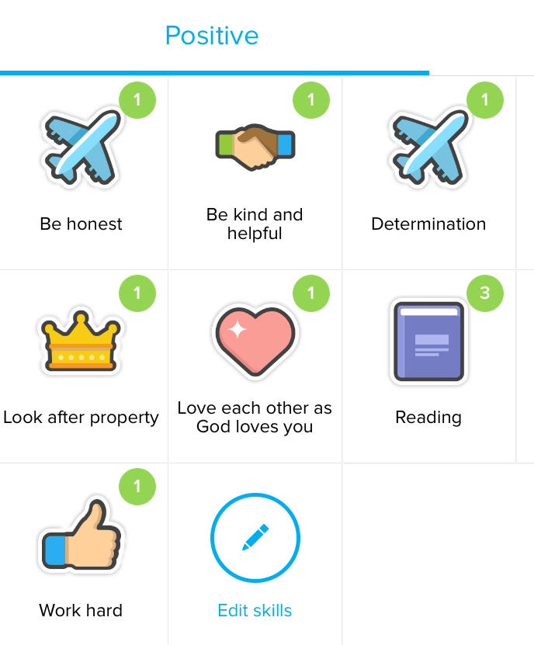
Figure 1 – Different ways in which children can earn dojo points. (Aspire Federation, 2018)
Giving children praise and rewards is beneficial as it results in children behaving better within the classroom but if you over reward children then these rewards will become insignificant and have no value. (Kohn, 1993)
During my observation I witnessed dojo points being given to pupils throughout the day. One example of when the children received these Dojo’s was when they brought their reading books back in from home. They had a chart on the wall where every child’s face was and there were two columns. All children began in the column which was labelled ‘Book at Home and when the child returned back to school the following day with their book then they would move their face into the column ‘Book at School. Once the register had been completed then the teacher looked at the chart and for every child who had returned their book then they were awarded a dojo point. This was done as a class activity as each child’s name would be called out who had returned their book and the class would clap for the child as well. Once every child who had returned their books the teacher announced that if the other children brought their books back tomorrow then they would also receive a dojo point. This is encouraging children to bring their books back in as they want to receive a dojo point and also the praise from the teacher and the rest of the class. The teacher also made an announcement to the class about how many dojo points children had received. So, the teacher called out child’s A name and announced they had 4 dojos, child B had 4 dojos but then announced “look at Child C, how many dojo points do they have”. The children responded to the teacher with 11 dojos and the teacher replies with “if you work as hard as child C then you can have as many dojos. Well done child C keep up the great work”. I could see from the reaction of child C that they were proud of having this many dojo points but also, they were happy that the teacher had noticed how well they were doing. This was also a good motivator for the rest of the children in the class to work as hard so that they could receive more dojo points. Some may say what’s the point in having these dojo points as some children will not get anything out of these rewards as everything is stored on the computer. But the teacher reminded the children in the class that there are certain levels and when they reach a certain number of dojo points then they will receive a prize which they will be able to pick out of the box themselves.
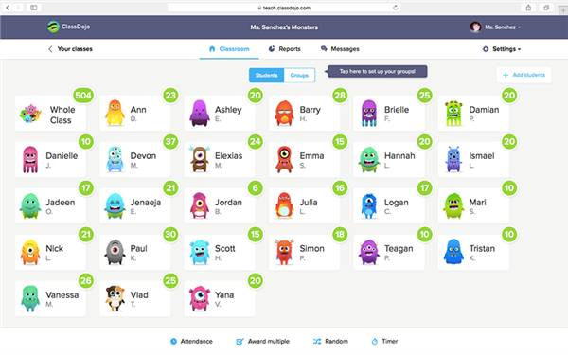
Figure 2 – Class Dojo showing how many dojos each child has and a total for the whole class. (Cusd200.org, 2018)
(All names have been blacked out for safety and ethical reasons)
Observations should be carried out for a purpose and not just because you have some time you need to fill. There are two different types of observations that can be used and within these observations there are different techniques that can be used. The two types are participant and non-participant observations.
The participant observation is the daily routine that teachers do when they make notes about a child as they are working with them or they make notes in their books later and the child addresses these problems at a later date. With this type of observation is does not take any planning as the notes are made at the time and it is what the observer thinks is relevant at the time. The problem with this type of observation is that the observer needs to remember what has happened and the notes made may not be exactly what happened and also the observer may be biased. The non-participant observation requires the observer to sit away from the activity and make notes from there. These observations require planning as there needs to be space for the observer to sit away from the activity so they don’t disrupt it but the observer needs to be able to see and hear what is going on. They will also have to make sure that they activity they want to observe is going to be taken place that day. There are normally some objectives set that the observer can then go back to later and make sure that they have all been met. (Riddall-Leech, 2005)
Some of the observation techniqoes that I could have used while in the classroom include writing written records, event stamp, target a particular child, use digital media for photographs and video, use tick charts or use a PMI (Positive, Minus, Interesting) grid. (Palaiologou, 2012)
The most accurate technique to use for my observation would have been to record the children while the dojo points were being given out. This is because I would have been able to play back the recording at a later date and pick out all the relevant information that I required and also, I may have picked up some new information in which I would have missed the first time around. It is very important to make sure that you have been given consent by the school to take photos and videos of the children and this permission was granted and I have included the consent form. Unfortunately for myself I did not have a video recording device with me at the time and so I decided the next best technique to use would be a written record of the event that took place. By writing a record of the event that took place it meant I was able to sit aback from the event and observe from a distance. This meant that I was still able to hear and see what was going on but I was not close enough to the children to cause a change in behaviour which would have not given me accurate observation on how these dojo points are normally given out. With the written record I am able to go back to the at a later date and use the information appropriately. The problem with using a written record is that if you make the notes brief then you may not be able to understand what you were saying a later date and also it doesn’t allow you to pick up more information if you had missed anything as the time will have passed. The observation is based on your opinion on what happened and it could be said to be biased as there is no evidence or another observer at the same time backing up what you have said.

Theory
There are many theorists that have spoken about praise and rewards within education. This is referred to as behaviourism. Some of these behaviour theorists include Pavlov, Skinner, Thorndike and Watson. (Pritchard, 2014) There are some very close relations between some these theorists but there are also a number of differences. I will look at some of their theories and relate these to my observations that I witnessed during my time at school.
There are a number of different elements that make up behaviourism. A lot of the early work involved looking at how animals’ behaviour changes over time with different stimuluses’ and if these stimuluses are removed, what behaviour does the animal then show. This early work was conducted by Pavlov and he done his experiments on dogs. The experiment is split into 3 sections, these are before conditioning, during conditioning and after conditioning. At the start the dog was shown a bone and the dog starts to salivate. A bell is then rung for the dog and this creates no response from the dog. (Gray and MacBlain, 2012) This is carried out over a course of time and they recorded whether or not there was a change in the way the behaves. The dog’s behaviour has not yet changed as they have not been taught anything new. Children will behave this way when they first come into your classroom as they will not know not any of your rules or how you like your classroom to be run.
During conditioning the dog is then shown the bone and the bell together and the dog starts to salivate. Here the dog is starting to associate the ringing of the bell with the smell of the bone. Within the classroom this would be when the children start learning what your rules and routines are. The last stage of this experiment was after all the conditioning had taken place on the dog. This time there was no bone present just the ringing of the bell and this caused the dog to salivate. This had proven that the dog has been conditioned and whenever it hears the bell it starts to salivate as it associates the ringing of the bell as food. (Pound, 2011)
In this experiment there was a neutral stimulate that would normally cause no response in behaviour from the dog. This is the ringing of the bell. This is then paired with the potent stimulus and this is what creates the reaction from the dog. The dog will now associate the neutral stimulus with the potent stimulus causing the dog to salivate when it hears the bell even when there is no bone present.
This theory is used widely within the classroom environment. An example of this which I witnessed during my observation was when the bell rung at the end of playtime then they knew that they had to line up in line ready to go back into class. They also knew they had to take off their coats and place them on their peg and to go to their classroom and to sit in their spot. The children have been conditionally trained to do these tasks whenever they hear the sound of the bell at the end of play.
Skinner took Pavlov theory on behaviourism and took it one step further. He looked at what actions would occur after reinforcement and he came up with reflexive actions in which he called them classic conditioning and learnt responses which he called operant conditioning. He then split these into four different categories and these were positive reinforcement, negative reinforcement, positive punishment and negative punishment. (Bates, 2016)
These could all be used in the classroom environment. Positive reinforcement is where children are encouraged to show good behaviour and this will lead them to receive praise and also rewards whereas negative reinforcement is where the child is displaying bad behaviour and this will lead them to experience a negative effect and also losing the right to praise and rewards.
During my observation I witnessed this theory being put into place. Positive reinforcement was given to the children who had brought their books back into school and so they were rewarded with dojo points and negative reinforcement was shown during play time where a child was caught climbing on the outside house and they were made to sit on a chair for 2 minutes. The impact of their bad behaviour of climbing on things which knew they were not meant to do led to them losing some of their play where they had to sit on the chair. These bad behaviours were also noted in a book and multiple occurrences of the bad behaviour led to the child losing more time during play and also, they were told they would lose some dojo’s which they had received for good behaviour and work. This does not just have a negative impact on the child as they lose points but as a class as the class have a target and when they reach that target they all get a reward.
There are many different types of rewards that a teacher can give out to a pupil.
Name of Reward | Example of the reward
Intrinsic | This reward is the reward that a child looks forward to getting. This is the positive feeling that they get when they have completed or even taken part in an activity.
Experience of success or making progress | This is when the child is praised or gets a reward for completing part of the bigger task and making steps to completing and getting nearer to the end goal or target.
Other people’s praise or approval | This could be praise or reward from another member of staff or even a nonverbal reward like a smile or thumbs up.
Preferred activities | If the child has taken part in an activity that they are not fond on then you could reward the child with some time doing an activity they enjoy. For example, for completing the maths work they don’t like then they can go and play in the construction area for 10 minutes after completing the work.
Token rewards | These could include if your school has a set of houses then points could be given to the house the child belongs to. But it can be giving out stars and stickers to the children. They has no value on their own but over time these tokens could lead to a bigger prize.
Tangible rewards | These could include giving the children sweets, toys or a voucher which has monetary value
(Based on McPhillimy, 1996)
Giving out rewards can be difficult for teachers as when should they give out a reward. The language the teacher uses to give out praise and rewards is important as in some cases it can sound like you are bribing the children with the reward. (Rogers, 2015) If you give rewards out just for good behaviour then it can lead to some children getting becoming even more distributive in the class as they see it as you’ll never pick them for a reward so why should I bother. (Rogers, 2015) During the observation the teacher made the children aware that when they hit a certain target individually they would get their own little treat but also when the class hit a target then the whole class would get a treat. This encourages all the children to work together as a team so that they get their class reward.
Canter says that the difference between a successful and unsuccessful classroom is how they manage the way they give out the praise to students and also how frequently this happens. (Canter, 1992) Some schools and teaching are able to respond to positive behaviour more affectively as they have made a record of what good behaviour has gone on within in the classroom and school not just the negative behaviour which is commonly recorded. (McNamara, 1999) Since the early 1990’s teachers have become more alert to positive behaviour not just negative. This has resulted in more praise being given out to pupils in school. (Rogers, 1990) (Cowley, 2001)
The problems that teachers face is what is too much praise and reward. It has been stated that overpraising children makes them demotivated as if the teacher is praising them in a task that they see as easy then they think that the teacher does not have much confidence in their ability. But some children will spend less time or even stop partaking in tasks if there is no praise or rewards being given out. Another problem the teacher may is that a child may be striving for success in a particular task because they want the praise and reward not solely because they are enjoying the task that they are taking part in. (Persaud, 2004)
Consistency within a school can be important when giving out praise and rewards. The system needs to be ‘fair and purposeful’ for everyone otherwise you will get children who will think there’s no point in me working hard this week as our teacher doesn’t reward us and give us praise. There is also the chance that the children will not have the same teacher every year and when they move to a new class the following year, they will not get any praise or rewards from the new teacher as they have previously been over praised and rewarded or the new teacher will not praise and reward for the same thing the previous teacher has. This will lead to negative effect on their effort to work and lead to bad behaviour. (Shreeve and Boddington, 2002) This is why its important for schools to have a policy on how praise rewards are given out so all children fell included and when they move through the school then they don’t see any differences in how the rewards are given out.

Ideal learning Environment
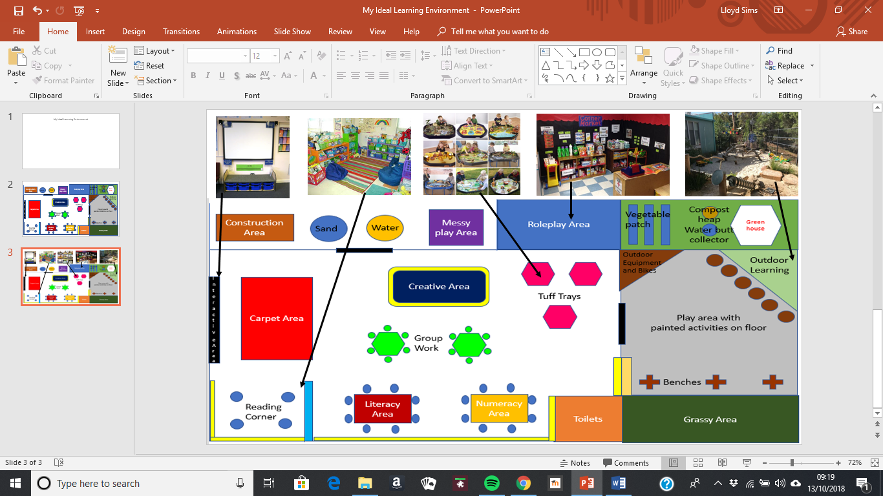
Ideal learning environment commentary
Having the correct setup in your learning environment says a lot about the kind of teacher you are. From your classroom people will be able to see if you are organised and how creative you are. The correct setup is also very important to the children as if it’s under resourced then they will find it difficult to learn but over cluttering your classroom can cause too many distractions for children. (Jackson, 1993)
An important area which I have included in my environment are the use of tuff trays. These can be moved around the classroom and also if the weather is suitable then these can be moved to the outside for messy activities that the children can take part in. The trays can be used for an individual task or as part of continuous provision for a previous activity that has taken part in the classroom. These enable the children to learn independently, for example the children could be learning about different materials and what different objects are made from. These trays could then be filled up with different items made from these materials and they can go and sort these out and continue to expand their learning independently. These areas can include instructions on different tasks that you want the children to complete or the items could be left so that the children interpret their own ideas in why these items have been included in the classroom. These can easily be changed depending on what the chosen topic is for this week or even term. These areas can be used as treats for the children if they finish their work or have shown good behaviour during a particular session. You can tell the children that once they finish their work then they can go to the tuff trays to play and the children will see this as a reward and they are going to play but whereas the teacher has set these areas up so that the children can continue to learn. (ADD REFERENCES)
Interactivity and ICT is very important within the education now with the introduction of the digital competency framework. (Welsh Government, 2018) Within the classroom there are many things that can be included to incorporate this. In my learning environment I have decided to include an interactive area where the children will sit on the carpet and be able to see the interactive whiteboard. From this whiteboard the teacher will call out the register and also the dinner register and the children will be able to see this on the screen. The teacher can also use this area to introduce lessons as the whiteboard can be used so the children can come up and interact with the lesson or a PowerPoint can be shown to explain a new topic and what is going to be going on during that lesson. This interactive can be used with a small group without the assistance of a teacher as they can work with another group. (Morgan, 2009) This enables the teacher to set the whiteboard up at the start of the lesson with a video or presentation which the group can watch or interact with themselves and the teacher can be confident that the children will complete the tasks and they are unable to go onto different applications as the current application will be locked. (Gage, 2005) Within the interactive area in my learning environment there will be 5 iPads that the children will be able to use. These can be used for group work, record tasks and work by both video and photos, children can play games on them as a treat and also there is a large number of books available as interactive books now so the children can use them to read books and some can also read to them. A problem that can arise with having quite a few iPads is that who is going to be responsible for making sure they are always charged. I would give this role to the two helpwr heddiw’s of the week and at the end of the day I would have them to check that all the iPads were on charge ready for use the following day. This role could be given to a child who is not behaving very good at the moment or a child that is not very involved as this would give them something to focus on and also giving jobs to children can help boost their confidence and make them feel included improving behaviour. (Smidt, 2015)
The outdoors is a great place for children to learn. Being outdoors does not mean that a child will not be learning as the outdoors can be associated with playing. There are some things that children cannot learn while indoors and so they will have to go outdoors to be able to see for themselves. A big mistake made by some teachers when teaching outdoors is that they simply take an indoor task and take all the resources outdoors and teach it exactly the same as they would indoors. This is not outdoor learning. (Tovey, 2007)
On another observation at a different school I witnessed a lesson being taught outdoors. The children had been learning about autumn and about different animals that hibernate during the winter. So once the teacher had given the children a brief introduction to hedgehogs to the children in class the class then went outside and they made some hedgehog huts. The children would have been able to see what a hedgehog hut looked like in a book or on a screen but they would not have been able to do it for themselves inside using the materials in the school grounds. In the next few weeks they were also going to check to see if any hedgehogs had used the huts they had built.
Learning outdoors does not just have its educational advantages but it also means that the children are moving around and keeping fit and this is big at the moment with the ever-growing problem of obesity. (Callaway, 2005) The outdoors also enables children to have freedom, time to explore for themselves and not be told do this and that all the time and with budgets being cut constantly the outdoors enables the children to have an unlimited amount of natural resources.
Children need to be able to express themselves and sometimes if a teacher is on their backs then they may not confident enough to do this or they may be scared that the teacher is going to tell them that they are great. A great for children to express themselves within a classroom is in a role play area. The advantages of a role play area are that they are able to build on skills that they already have and relate them to real life situations and the children are able to play with each other but also learn at the same from each other. (Leimanis-Wyatt, 2010)
One example of a roleplay area could be a shop. The children will already have some basic knowledge of how shops work as they would have all been to a shop. This means that the children will be able to communicate with each other and normally you will see one child taking the role of the shopkeeper and another will come in and buy things. They will not have been taught what to say to each other but they will know from going to shops the basic language used between the shopkeeper and the person buying the items. The role play area can be used as continuous provision as the topic of the area can change depending on what topic the children are learning about at that particular.
With Wales trying to promote the Welsh language and culture with the Curriculum Cymreig a role play area would help with this as you can incorporate the Welsh language. (Welsh Assembly Government, 2005) This will encourage the children to speak as much Welsh as possible and lead them to become bilingual as early as possible. (Smidt, 2015) For example the role play area is set up as a shop and the children have been learning about the different types of fruit in Welsh and how to ask for them. The teacher could have the fruit labelled in both Welsh and English so the children will be able to make the link between the two languages and also for one day a week when in the shop the children have to ask for the different types of fruit in Welsh, encouraging them to use Welsh in conversation. Over the weeks there would be more Welsh added until come the end of the topic the children will able to speak in Welsh for possibly 2 out of the 3 days they use the role play area.
To also encourage the use of Welsh throughout the classroom there will be Welsh labels on resources as well as English and the displays will try and incorporate as much Welsh without them becoming to confusing for the children. At the start of the day the 2 helpwr heddiw’s will ask questions like how are you feeling today and what is the weather to encourage them to speak Welsh. The children will pick sticks from a pot with everyone’s name on so that it is fair who is going to answer the questions.

