A Case Study Focusing On:

The Sustainability of a New Development

Prepared for:

I. Brown

Created by:

J. Hughes

Date Completed:

January 7th, 2024

Table Of Contents
Page Number
1.0 Introduction 3
2.0 Existing Frameworks for Sustainable Construction 3
3.0 Assessing the Developments Sustainability 4
4.0 Critique and Recommendations 9
5.0 Conclusion 10
6.0 References 11

  - Introduction
Sustainable development has become a necessity for the construction industry and will continue to be a prominent factor in future project designs. The construction industry contributes significantly to the environmental impact caused by human activities, with UN Environment Programme stating that “the buildings and construction sector is by far the largest emitter of greenhouse gases, accounting for a staggering 37% of global emissions” (UN Environment Programme, 2023). The growing attempts to develop sustainable projects will help to reduce this figure as much as possible.

Whilst being a large contributor to the negative environmental impact, the industry can provide sustainable variations on the existing methods used. This study will examine the sustainability of ‘The Ferndale’ type of home included in Phase 1 of the ‘Saint Sannans Field’ development using existing frameworks. The home type will be assessed and conclusions of the assessment will be provided, complete with recommendations to improve the sustainability and justification to support the proposed improvements.

Existing Frameworks for Sustainable Construction

2.1 BREEAM
Building Research Establishment Environmental Assessment Methodology (BREEAM) is used to measure the sustainability performance of buildings, aiming to ensure that buildings meet sustainability requirements throughout the project phase and will continue to do so throughout their lifecycle. McPartland discusses the measurements undertaken using BREEAM, indicating that it “evaluates the procurement, design, construction and operation of a development against a range of targets based on performance benchmarks”. (Richard McPartland, 2016)

BREEAM focuses on the sustainable value of different elements involved in the construction and usage of buildings, such as energy use, water efficiency, waste management and many others. It prioritises the most impactful factors, such as low impact design and adaptability to climate change. When the BREEAM assessment is complete, projects are scored and provided with a percentage which places the project in a category between unclassified and outstanding, creating a good benchmark for architects and designers to work towards. A good BREEAM score is also attractive to buyers of homes as it ensures that the property is a safe environment now and will be in the future.

2.2 Passive House / Passivehaus
Passive Houses aim to get the most efficient use of all heat sources and methods of recovery, resulting in standard heating systems no longer being required. Passive Houses are described as a home that can “adjust to the different seasons, all on its own accord” (Stephen Marcus, 2021) resulting in a lower requirement for man-made heating or cooling solutions.

There are further costs to consider when building passive houses in comparison to standard homes due to the high-quality materials and extensive design co-ordination required. The common features include triple glazed windows and a much higher insulation quality than a standard home (Energy Saving Trust, 2022). The reliance on mechanical ventilation means the design is of high specification resulting in many builders and buyers opting for alternatives.

2.3 One Planet Development (OPD)
The One Planet Development policy was introduced in 2012 to improve the possibility of achieving planning permission in locations that would normally not be given the permission. The system aims to produce low environmental impact homes, with the property sustaining the low environmental impact throughout the lifecycle of the home, whilst still being productive. The policy requires proof that the developer and inhabitants are able produce their own foods and generate their own power for the property. (Paul Jennings, 2020)
OPD presents an opportunity to live sustainably, using environmentally friendly materials, while optimising the surrounding environment to produce energy. The efficient use of natural resources results in lower carbon emissions and reduces the waste produced from daily activities.

Assessing the Developments Sustainability

3.1 Introduction
Llanmoor Homes’ Saint Sannans Field project includes the construction of 67 new homes. Llanmoor Homes have shared several methods used to minimise the environmental impact of the new sector, like using air-source heat pumps, the re-use of materials for structural aspects and the optimisation of the existing local public transport. This study will further analyse the project against a range of criteria, focusing on the ‘Ferndale’ style home.

3.2 Water
The Llanmoor Homes website does not explicitly mention any methods to harvest or store water for the Saint Sannans Field project. (Llanmoor Homes, ND) To increase the BREEAM score and overall sustainability of the home, the implementation of rooftop rainwater harvesting to the project is recommended. In standard systems the stored water can serve as a source for essentials such as flushing the toilet, and can even be used for watering vegetation when there has been a period without rain.

Mygate suggests that the installation of rooftop rainwater harvesting can reduce water consumption by up to 40%. (mygate, ND). While the project’s location presents a low risk of flooding, the implementation of this system will help significantly to further reduce the risk. Additionally, if the home owner utilises their garden space for growing crops or food, the system will minimise soil erosion.

Llanmoor Homes emphasise their inclusion of Sustainable urban Drainage Systems (SuDS) on the Saint Sannans Field project, stating that the system will be “Integrating ecological mitigation and biodiversity enhancement measures” (Llanmoor Homes, ND). SuDS assist with the management of flood risk, making a safer environment to live in. While minimising flood risk, they also prevent water pollution and damage to plants and wildlife (GeoSmart, 2018).

3.3 Energy
The Llanmoor Homes website highlights the use of “energy-efficient technologies, including Air source heat pumps for heating and hot water” (Llanmoor Homes, ND). This system allows a more sustainable source of heat for homes, as standard heating systems using gas or oil are heated using fossil fuels. The heat source pumps use electricity eliminating the requirement for the less environmentally friendly burning of fossil fuels.

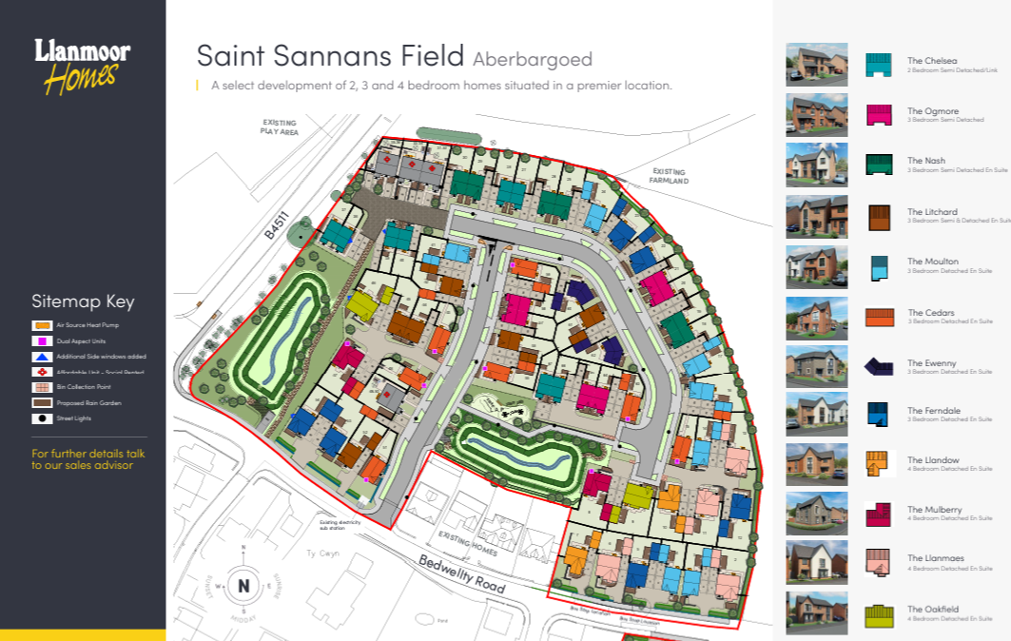
Figure 1 is an image of the Site Plan of the Saint Sannans Field project from the Llanmoor Homes website. (Llanmoor Homes, ND)
The site plan references the inclusion of “additional site windows added”, which is a feature of several of ‘The Ferndale’ style homes. The additional windows create an increase in natural lighting and ventilation for the homes, ensuring the project is working towards meeting Passive House standards. There is no reference to the specification of the windows, but a requirement for higher specification windows can be expected to ensure heat retention during the winter months.

Llanmoor Homes have not outlined any further measures undertaken to generate sustainable energy, despite there being opportunities to implement more. Due to the location of the project, the homes will be unable to utilise energy sources such as wind turbines and hydropower. Therefore, it is recommended that the homes maximise solar energy utilisation by installing photovoltaic (PV) solar panels. This is because solar energy is the least impactful energy source to the environment. (GreenMatch, 2024) Solar panels produce no pollution and require minimal water for their maintenance. One of the main benefits of solar panels is the silent operation, as they cause no disturbance to residents and the surrounding environment. Solar panels play a significant role in achieving high BREEAM scores as they reduce the reliance of non-renewable energy sources.

3.4 Transport
Llanmoor Homes emphasise the “benefits from frequent bus services and access to Bargoed railway station, offering sustainable travel options” (Llanmoor Homes, ND). Reducing car dependency is a key factor in achieving One Planet Development (OPD) and helps to lower the carbon emissions produced by the home owners. If all residents utilise the public transportation available, they will substantially contribute to generating a more sustainable local environment.

Despite a number of potentially viable options being available, there are no further measures mentioned by Llanmoor Homes to increase transport sustainability. The homes could advance towards the achievement of One Planet Development (OPD) by installing electric vehicle infrastructure. Electric cars have zero exhaust emissions, meaning they do not produce any harmful gases that may affect the environment (Pod Point, 2024). Road transport is a major contributor to the production of carbon emissions. If all residents of Saint Sannans Field transition to electric vehicles, there would be a large reduction in emissions.

3.5 Land Use and Ecology
The Llanmoor Homes website talks about the preservation of existing landscape and ecological features, (Llanmoor Homes, ND) which is highly beneficial as the project replaces existing grassland. Although stated that there will be preservation of existing landscape and ecological features, there is no clear evidence or specific detail to support this claim.
Figure 1 shows that there are large grassland areas within the Saint Sannans Field complex, which could be utilised by the residents to plant and grow crops whilst also preserving a habitat for the existing local wildlife. The site offers a range of opportunities to install birdhouses, bat boxes and other habitats to support the local wildlife. The Ferndale homes provide fairly large garden spaces that can also be used for planting crops and creating artificial wildlife habitats. The use of the gardens and green space will help the community work towards One Plant Development (OPD).

3.6 Pollution
While it is likely that Llanmoor Homes will look to minimise their pollution during the construction phase, their plans do not address this. Their “on site” activity has potential to cause a lot of pollution to the local environment, but there are a range of methods to limit their impact. One of the methods that could be implemented is ensuring that deliveries to and from site are well covered when carrying any harmful materials or waste. The contractors on site should also be using up to date machinery, as older equipment can cause pollution and contributes largely to the overall site emissions (Emsol, 2021).

3.7 Materials
Llanmoor Homes state that the stone walling currently at the site is being reused for landscape features, (Llanmoor Homes, ND) but lack further clarity on the specific locations of the landscaping. Additionally, there is no mention of further effort to source materials sustainably on the plans on their website, despite various opportunities to do so. However, the images of the Ferndale homes on the plans appear to use PVC windows which are highly recyclable for reuse and reduce carbon emissions in comparison to other materials.

A variety of materials could be used to replace those in the current plans, resulting in a more sustainable project. All external walls in the Ferndale plans are made from brickwork which is not directly recyclable. If a local building had been recently demolished, the undamaged bricks would be viable to be reused, but Llanmoor Homes did not mention this option. Therefore, it must be assumed that the bricks were not sourced locally, suggesting that they may not be the most sustainable material available for this project.

The brickwork not being reused, recyclable or locally sourced means that there are a range of materials that could be used for the external finishes. Locally sourced timber or PVC cladding would be ideal for this project. The timber is a renewable material, and the PVC cladding is highly recyclable, with both resulting in achieving a higher BREEAM score. Both materials are more sustainable options than brickwork, with the cladding also providing better internal insulation for the homes.

3.8 Waste
Waste produced during construction projects attribute largely to global waste production. Although not stated by Llanmoor Homes, it is assumed that they will undertake the necessary measures to reduce their impact. The most beneficial way to reduce waste is by reusing and recycling every material where possible.

Waste materials can be managed by implementing a waste management plan that ensures complete segregation of all materials. Effective segregation of waste materials optimises landfill space and ensures that every recyclable material is preserved (Wheelie Bin Solutions, 2024). With the materials being separated it ensures that no recyclable or reusable material ends up going to waste.

Critique and Recommendations

4.1 Critique
Llanmoor Homes presented various measures that will be employed to ensure the sustainability of the Saint Sannans Field project. However, not enough detail has been given at this stage to understand the true sustainability of the project. Although there are potentially sustainable materials being used, the plans provide no detail on the benefits of their choices in comparison to alternatives. In addition, the lack of a construction plan has made it unclear how Llanmoor Homes will minimise their environmental impact.

4.2 Recommendations
The Saint Sannans Field project has been thoroughly analysed against a range of criteria, providing detailed insights and actionable recommendations. The recommendations aim to minimise the environmental impact, ensuring the long term sustainability of the site.

There should be an inclusion of photovoltaic (PV) solar panels, as they will create a source of renewable energy, reducing the usage of fossil fuels. Fossil fuels are a non-renewable source of energy, so it is important that society aims to move away from their use as much as possible. Each home should have access to an electric charge point to assist with this also. If the electric points are installed it will encourage the use of electric cars in the community.

The project should aim to use locally sourced construction materials where possible. This approach will support the local economy and help to reduce the environmental impact associated with the transportation of materials over long distances. If Llanmoor Homes decide to implement the recommended use of timber cladding, they will be able to source the materials from local builders merchants, emphasising their aim to create project sustainability.

Llanmoor Homes should further encourage One Planet Development (OPD) by creating further opportunities for the residents to plant their own crops and food. The removal of the shipping requirement is largely beneficial to the environment (Vegepod, 2020). There could also be an inclusion for the residents to store and separate their waste, to continue with the reduction of materials being displaced.

5.1 Conclusion
Llanmoor Homes have demonstrated a range of methods in which they are working towards meeting existing sustainability framework criteria. The guidance of BREEAM, Passive House and OPD have ensured that the Saint Sannans Field project is more sustainable than projects of the past. While progress is being made towards sustainability, several actionable recommendations have been provided to further advance towards sustainable goals. By integrating the recommendations the project can align more closely with complete sustainability while setting a benchmark for future developments.

6.0 References
Emsol (2021). 5 ways that construction sites can reduce pollution. Available from: https://emsol.io/5-ways-that-construction-sites-can-reduce-pollution/ [Accessed on 30/12/2024]
Energy Saving Trust (2022). What is Passivhaus? The gold standard in energy efficiency. Available from: https://energysavingtrust.org.uk/passivhaus-what-you-need-know/ [Accessed on 29/12/2024]
GeoSmart (2018). How do Sustainable Drainage Systems (SuDS) work? Available from: https://geosmartinfo.co.uk/2018/07/how-do-sustainable-drainage-systems-suds-work-2/ [Accessed on 30/12/2024]
GreenMatch (2024). 7 Benefits of Using Solar Energy. Available from: https://www.greenmatch.co.uk/blog/2014/09/7-benefits-of-using-solar-energy [Accessed on 30/12/2024]
Jennings, P (2020). One Planet Development and access to land: Paul Jennings, OPD smallholder and self-builder. Available from: https://www.lowimpact.org/posts/one-planet-development-paul-jennings-part-1/ [Accessed on 29/12/2024]
Llanmoor Homes (ND). Saint Sannans Field. Available from: https://www.llanmoor-homes.com/development/saint-sannans-field/ [Accessed on 20/12/2024]
Llanmoor Homes (ND). Saint Sannans Field Site Plan. Available from: chrome-extension://efaidnbmnnnibpcajpcglclefindmkaj/https://www.llanmoor-homes.com/wp-content/uploads/2023/09/Saint-Sannans-Field-Site-Plan-August-2024.pdf [Accessed on 28/12/2024]
Llanmoor Homes (ND). The Ferndale. Available from: https://www.llanmoor-homes.com/house-type/the-ferndale-2024/?development=34142 [Accessed on 28/12/2024]
Marcus, S (2021). A guide to Passive Houses: designs, costs and savings. Available from: https://www.ovoenergy.com/guides/energy-guides/passive-house [Accessed on 29/12/2024]
McPartland, R (2016). What is BREEAM? Available from: https://www.thenbs.com/knowledge/what-is-breeam [Accessed on 27/12/2024]
Mygate (ND). All You Need to Know About Rooftop Rainwater Harvesting. Available from: https://mygate.com/blog/housing-society/rainwater-harvesting/ [Accessed on 29/12/2024]
Pod Point (2024). The Benefits of Driving Electric Cars. Available from: https://pod-point.com/guides/driver/benefits-of-electric-cars?srsltid=AfmBOoq-QbRfZc56KQfbvZ6bI5yZGoopyMwzObkmhbdBqxv_U3vIBPgz [Accessed on 30/12/2024]
UN Environment Programme (2023). Building Materials And The Climate: Constructing A New Future. Available from: https://www.unep.org/resources/report/building-materials-and-climate-constructing-new-future#:~:text=The%20buildings%20and%20construction%20sector,have%20a%20significant%20carbon%20footprint. [Accessed on 28/12/2024]
Vegepod (2020. 5 Reasons To Grow Your Own Food. Available from: https://vegepod.co.uk/blogs/news/5-reasons-to-grow-your-own-food?srsltid=AfmBOop07dpivV37tB_cxLOn-3RPrfvHlrKDPqE-uxuNZUQppIg8UM7e [Accessed on 02/01/2025]
Wheelie Bin Solutions (2024). All you need to know about waste segregation. Available from: https://wheeliebinsolutions.co.uk/blogs/recycling/all-you-need-to-know-about-waste-segregation?srsltid=AfmBOoptToiQV8K-tNnFbgTcDJoTMz8KpS5QnfaXZR6ykQ_jV1op-u4o [Accessed on 02/01/2025]

