Entrepreneurial Education
Amy Webb-Erwin
P141917
Word Count: 3,821 words
Assignment 2: Portfolio
Produce a written document with appropriate sub sections for a self-selected and creatively critical entrepreneurial education opportunity.

Content Page

Introduction ______________________________________ Page 2
Rationale _________________________________________Page 3
Target Group ______________________________________Page 5
Entrepreneurial Education Opportunity Brief ____________ Page 6
Aims and Objectives ________________________________Page 7
Links to the Curriculum ______________________________Page 8
Development of Skills _______________________________Page 10
Attitude______________________________________Page 10
Creativity ____________________________________Page 10
Relationships _________________________________Page 11
Organisation _________________________________Page 11
Content _________________________________________ Page 13
Resources and Funding _____________________________Page 14
Assessment of Skills _______________________________ Page 15
References ______________________________________ Page 16
Appendices ______________________________________Page 19

Introduction

According to Isak (2015) the word ‘Entrepreneurship’ is derived from the French word ‘entreprende’, which simply means to use your bare hands to do something. This suggests that every person is able to become an entrepreneur and build something from the ground up. The European Commission (2018) agree with this statement and claim that entrepreneurship is a skill that can and should be learnt. The mind set and skills which a person has is the most important component in order to become an entrepreneur. Skills such as resilience, self- reflection, motivation, creativity and communication are vital to an entrepreneur, according to Forbes (2013). These skills are what prepare young people in order to become responsible entrepreneurs, thus explains why we are able to see this theme throughout entrepreneurial education across Europe.
Entrepreneurial education aims to develop young people’s skills, knowledge and attitudes in order to ensure that these people are able to take what they have learnt with them through life and apply it to their future employment, as according to the European Commission (2018) these attributes ensures people are more employable in later life. The attributes and skills learnt in entrepreneurship education are transferrable and are not just relevant to owning a business, but to develop a set of attributes which are relevant to all areas of employability (European Commission, 2014).
This portfolio has been produced in order to exhibit the chosen entrepreneurial education opportunity, which is named ‘Close to home’. The portfolio will highlight the wide range of skills which will be developed and enhanced from the project, which include creativity and critical thinking skills.

Rationale

‘Close to home’ will be implemented in Wales, and will have many links to a wide range of initiatives and government policies, such as Successful Futures, Curriculum Cwmreig and Big Ideas Wales strategies YES plan and the ACRO model. These will be seen as a set of ethos’s in order to ensure the successfulness of ‘Close to home’.
According to the Institue for Emerging Issues (2018) the need for entrepreneurial education is becoming more readily seen in today’s system, as the skills it helps to develop are considered vital to employability. Skills such as problem-solving and creativity are becoming increasingly important as can be seen in the Donaldson Report (2015). This report suggests that as the new curriculum comes into action entrepreneurial aspects will be seen across the board, and the aim is to produce ‘enterprising, creative contributors who are able to connect and apply their knowledge and skills to create ideas and products, as well as think creatively to reframe and solve problems’ (Donaldson, 2015. P 29). This is one reason why ‘Close to home’ recognises the importance of entrepreneurial education, and offers the opportunity for students to gain these skills by communicating with others, being creative, using initiative and problem solving.
Additionally, as ‘Close to home’ will be focussed on different areas in Wales, it is important to consider the main aims of Curriculum Cwmreig and how this is incorporated into the learning process of the project. It is stated that Curriculum Cwmreig aims to encourage students to celebrate the unique qualities which Wales has to offer to people living and being educated in Wales in the 21st Century, as well as producing a sense of pride and belonging in Welsh communities (Welsh Government, 2003). This plays a very important part in ‘Close to home’ as it offers the opportunity for the students to take advantage of where they live and learn in order to produce a business.
Another initiative which will be considered throughout ‘Close to home’ will be the Youth Enterprise Strategy (YES) (See appendix 2), the vision of this strategy is to produce and nurture young people in an entrepreneurial way in order for them to have the ability to be instrumental in the success of Wales’s economic and social prosperity. This vision will be met by engaging, empowering and equipping young people with the skills and opportunities to support them on their entrepreneurial journeys (Big ideas Wales, 2015).
Lastly, another feature of Big Ideas Wales which will also be focussed on throughout the project is the ACRO model (See Appendix 1). ACRO is an acronym which represents each area of the model, these areas focus on specific skills which can be developed in each section. The areas are Attitude, Creativity, Relationships and Organisation, and were introduced in order to highlight the skills and attributes needed in order to meet entrepreneurial needs in the 21st century (Big Ideas Wales, 2018). These four key areas will work as a guideline throughout ‘Close to home’ in order to ensure the students are developing in all areas and these lifelong skills are being enhanced.

Target Group
‘Close to home’ will focus on young people aged 10-11 years and are in Year 6 of their Primary school education. This was an important age range to consider when looking into who this project will be suited for as it is stated by Young Entrepreneurs (2018) that children are born with and innate ability to be creative and imaginative, as well as having a lack of fear to take risks. This needed to be focussed upon, as these skills are just some of many which help to make an entrepreneur. However, the spirit of enterprise slowly declines as the person gets older and according to Young Entrepreneurs (2018) it has almost disappeared completely by the time they leave comprehensive school.
The project will also be offered to students of all genders, the argument for this relies on the theory that men have more chance of succeeding as an entrepreneur than women, and as a result of this we see less women entering this field (Kleinrichert, 2013). Despite of this, ‘Close to home’ wants to give each young person the opportunity and tools to succeed. As previously stated, this project will strive to meet the aims of the YES plan, which involve Engaging, Empowering and Equipping young people, by opening our project up to all genders we aim to do this, whilst giving every student a fair chance.
‘Close to home’ will offer opportunities to students of all backgrounds, races, religions, ability and monetary status. This means that the project will not be run in specific areas, which means we be able to see ‘Close to home’ operating in all areas of Wales, as each area has a unique quality which will hopefully inspire the students and the community.

Entrepreneurial Education Opportunity brief
‘Close to home’ will run over a 6 week period which will involve one supervised session per week, although the project encourages teachers to allow their students to work on their ideas throughout their free time, such as during ‘Golden Time’ or if other set work is finished by pupils early then the project can be worked on in this time. This allows for the students to take initiative and use their time management skills to ensure that the project is being discussed and ideas are being created. The sessions will run in school hours, in the students classrooms in order for the young people to feel a sense of comfort in their surroundings.
The project will offer students an opportunity to gain knowledge on entrepreneurial education and recognise the skills that can be obtained from working on ‘Close to home’, as well as discovering how these skills can be helpful throughout their lives.
As the project is focussed upon enabling the students to take pride in their area, as well as use it to their advantage in order to make a unique product which will hopefully make a profit. In order for them to have a concept of what makes the area they live and learn in unique, the students will be encouraged to speak to members of the community and ask questions on their thoughts and beliefs (See Appendix 3). This aims to encourage children to feel confident and comfortable when talking to others, and also aims to enhance communication and listening skills.
‘The students will be encouraged to use the skills learnt so far as well as their pupil voice to brainstorm ideas, design and make their product. Allowing the students to have a voice in this project is incredibly important to the success of ‘Close to home’ and to the student’s engagement and enjoyment. Salim (2015) states that allowing children to have an active input in their tasks encourages engagement, as well as allowing them to display their unique perspectives.

Aims and Objectives

The aims and objectives of ‘Close to home’ have been set out in order to aid in the structure of the project. These aims and objectives are important to consider when looking at how the entrepreneurial education opportunity is set out and run. They also play a large role in the Scheme of Work (See Appendix 4) and the Lesson Plans (See Appendix 5).

Aims
The aims for ‘Close to home’ focus on the intentions of the opportunity, and the outcome desired. These are:
- Student to be able to have a knowledge on their area.
- Have the opportunity to research and investigate their findings.
- To develop skills in a wide range of areas which they are able to take with them throughout life.
- Design, implement and sell their chosen product in order to potentially make a profit.

Objectives
The objectives for this opportunity offer a more specific goal for ‘Close to home’, as well as focussing on the steps that are in place in order to achieve it. These are:
- To develop communication skills by conversing with members of their area’s community as well as local business owners, in order to assess what makes their area unique and special.
- To enhance digital literacy and 21st century learning skills by expanding on their primary research and investigate using computers and ipads.
- To ensure that the students creativity and organisation skills, as well as attitude and relationships are being enhanced in an entrepreneurial way by using they ACRO model as a guide throughout.
- To encourage entrepreneurial skills whilst designing, implementing and selling their product.
Links to the Curriculum

As previously stated in the ‘Rationale’ section of this portfolio, ‘Close to home’ provides aspects which link directly to the future curriculum ‘Successful Futures’. Although all schools in Wales should be working towards implementing this new curriculum, currently we still have a national curriculum in Wales. ‘Close to home’ links well with both curriculums in a range of areas. These will now be discussed.

Throughout ‘Close to home’, young people are able to:

Art and Design
- Use their creativity and imagination to design and produce a product.
- Make practical decisions on how their idea will be implemented.
- Use a wide range of materials and processes to complete their product.
- Explore their imagination through a variety of visual and sensory aspects.
(Welsh Government, 2008)
Design and Technology
- Design and make product.
- Become aware of manmade achievements in design, such as landmarks or buildings.
- Given opportunities to use 21st century technology to enhance their knowledge.
(Welsh Government, 2008)
English
- Express their ideas, using examples.
- Ask questions and listen and understand responses when working in a group.
- Contribute in a purposeful way to group discussions.
(Welsh Government, 2016)

History
- Develop a curious attitude on the past and have the ability to distinguish different time periods when looking at landmarks and building in the area.
- Gain knowledge on key events, developments and other important issues in their area.
(Welsh Government, 2008)
Mathematics
- Use knowledge from set work and lessons and apply it to real life situations.
- Work on what price is best value for money when buying resources.
- Having an understanding on profit and loss whilst selling their product.
- Opportunity to handle money and understand costs.
(Welsh Government, 2016)
Personal and Social
- Receive opportunity to promote their independence by allowing them to take initiative on their project, and take responsibilities for their actions.
- Opportunity to develop effective relationships with other members of the class whilst working in groups.
(Welsh Government, 2008)

The points mentioned are just some of many to show evidence of how ‘Close to home’ is linked to the current national curriculum in a variety of areas. However, the project also has links to other aspects of the curriculum such as ‘Education for Sustainable Development and Global Citizenship’, ‘Essential Skills Wales’ and ‘Curriculum Cwmreig’. How these are embedded into ‘Close to home’ will be shown throughout the provided Scheme of Work (See Appendix 4).

Development of Skills

Developing a wide range of entrepreneurial skills is an essential aspect when looking at education and employment, this is due to the fact that the world is constantly changing, in areas such as technology, economy and employment, according to Macmillan (2016). In order for students to keep up with the everchanging environment around them, skills are needed in order to meet the needs of the demanding world of work (Macmillan, 2016). The ACRO model sets out four areas in which a person is able to develop in order to prepare them for business in the 21st century (Big Ideas Wales, 2018). This model has worked as a guide throughout ‘Close to home’ in order to ensure that the skills of the students are being developed and enhanced. How the project develops these skills will now be considered.

Attitude
Big Ideas Wales (2018) state that having the right attitude is vital, not just when taking part in entrepreneurial experiences but also in all aspect of life. The model sets out a number of skills which ‘Close to home’ aim to develop throughout the opportunity. Firstly, having ‘Self-knowledge, belief and confidence’, this skill is developed through the project by ensuring students are equipped with the opportunity and guidance to feel a sense of belief when taking part. Throughout the experience, students are encouraged to have their say and praised for doing so by members of the ‘Close to home’ team, teachers and other students. This enables the child to feel valued, Arthur (2010) argues that a child having supportive peers and adults around them offers opportunity for confidence building and higher achievement in school.
‘Motivation, Determination and Competitiveness’ are also skills which are developed in this area of the ACRO model, and are enhanced through ‘Close to home’ by having an active role in their own learning. Park (2003) believes that students who are offered the opportunity to be engaged in their learning have a better understanding of the topic, as well as being more willing to complete the task. This is important when looking at the motivation and determination aspect of these skills.

Creativity
It is stated by Big Ideas Wales (2018) that the creative area of the ACRO model does not involve a student being academically correct, but the focus is on using imagination and creativity skills in order to produce new ideas and solve problems. In order for the students to develop their ‘problem solving’ skills, ‘Close to home’ offers opportunities for students to discuss possible issues that may arise with their group. If this is not helpful, groups are encouraged to complete a ‘Problem Solving Plan’ (See Appendix 6) in order to assess the problem and create solutions to solve it in a way that is comfortable to an individual and their group, which aids in developing lateral thinking skills. This also helps to develop independence as it allows space for the child to construct a solution, rather than immediately asking an adult for guidance.

Relationships
This section of the ACRO model revolves around human interaction and communication skills (Big Ideas Wales, 2018). How a person is able to work with others and value other’s opinions is a vital entrepreneurial skill which is met through ‘Close to home’ by setting the project out in order for students to work in groups. This means that in order for the product to be a success, students have to be able to communicate and present their ideas confidently to other members of the group, as well as listen to others and respect other students right to a voice in their education. Students are also able to use their non-verbal communication skills, as well as negotiation skills in order to sell their product. Non-verbal communication plays a big role in how someone views you, as York (2013) explains that 83% of communication is non-verbal. This suggests that components of non-verbal communication skills such as body language and eye contact are important ways of making others feel at ease in your presence, for example when the students are selling their product if they are unable to look the person in the eye, and look physically uncomfortable in this situation, this may suggest that the seller cannot be trusted or that there is an issue with the product.

Organisation
Big Ideas Wales (2018) believe that this section is focussed upon the skill set obtainable by planning and managing all areas of the business in order to be fully prepared to make informed decisions and complete objectives set. The skills in this section are met through ‘Close to home’ by introducing specific time set aside to planning their product. This is done in Week 3 of the programme and will involve the students brainstorming ideas and planning how to produce and implement these ideas. Students will also be able to set goals for themselves throughout the project in order to ensure that they are managing their time and resources correctly, this will be done in Week 1, 3 and 4 of their project. The opportunity for students to research and investigate the chosen idea will also be included in the project as they are able to search for secondary research on their area using Ipads/computers, which will also help them to develop their digital literacy skills.

All of the skills mentioned in this section are useful to obtain as CWLLN (2016) suggest that they are of an equal importance as qualifications when it comes to employability. This is due to the fact that the world of work is in need of highly entrepreneurial skilled young people in order to have a greater impact on the economy. Also, these skills are transferrable and can be used in a wide range of real life situations and job roles. This is important to consider, especially when looking at AAT (2017) comment on how 65% of today’s primary school children will find themselves in a role which has not yet been created. This suggests that the employment world is constantly changing, and we should ensure young people have the transferrable skills to meet the needs of a variety of jobs.

Content
‘Close to home’ will be set out over 6 lessons, which will see the final lesson involve the students selling their product and groups being judged by local business owners. The lesson aims and objectives for each lesson can be seen in the individual Lesson Plans and Scheme of Work (See Appendices 4 & 5).
The start of the project will focus on educating the students about entrepreneurial skills and the importance of them to ensure they have an understanding of what is to come from this project. At this time, students will also be given a sum of money which needs to last them throughout the duration of this time. They must plan how they will budget the money in order to be able to afford everything they need.
After this, students will be play an active role in going out and speaking to members of the public and local business people in their area to discover what others believe make their area unique, valuable and interesting. Students will do this in order to have an understanding of their area and see what is important to people of different generations.
From this primary research, students are encouraged to investigate and explore the internet using school Ipads/computers in order to find out background information and history on their town and the landmarks, building or natural environments that the people they have spoken to have highlighted. This is to ensure the digital literacy of pupils, and to get them to explore their area of knowledge.
Then, students will brainstorm ideas on how they would be able to make these important landmarks come to life on their chosen gift. Students are offered a wide range of resources and materials which they will need to purchase with the money which was given to them at the start of the project. Students will also be able to see examples of others ideas and designs to help them with their own (See Appendix 7). After this, students will need to plan an implementation strategy in order to be prepared for the next session.
After this, students will be given the opportunity to use their ideas and plans to create the product which represents their area. When the students have made at least 10 of the product, they are able to sell to the people around them, including teachers, parents, friends and visitors to the school. This will be done without formal supervision from ‘Close to home’ staff in the week prior to the final lesson. This when students are able to put on a final event to sell the product and the judges can assess which group they feel has worked the best together, worked best on their skills, and sold the most products.

Resources and Funding
All costs mentioned below are per school, based on an average 30 students per class.

Resources
Product before design (E.g mug, mouse mat, tea towel) £300
Materials (E.g paint, pencils, chalk) £400
Printing costs (Not necessary for all groups) £200
Overall: £900
Other Fees
Student group allowance £10 per child
Staff wages £25 per hour
Overall per school: £425 (estimate)

All costs will be funded through ‘The National Lottery’ People & Places (See Appendix 8) which ‘Close to home’ is eligible for as the focus is on young people in Wales, and preparing them for the world of employment.

Assessment of Skills
In order to assess how well the skills are being developed by the students throughout the project, formative and summative assessment techniques will be used. Schleicher (2015) suggests that assessment is a crucial part of any topic in education, including entrepreneurial education. This is due to the fact that it aids in students improving their own learning with the use of skills such as independence, determination and problem solving.

Summative Assessment
This type of assessment will be seen towards the end of the project, in particular at the mini competition event in the final session. As the groups will be judged on a range of factors, by local business people this gives the students the opportunity to receive verbal feedback on how they have developed their entrepreneurial skills.

Formative Assessment
This will be ‘Close to home’s main technique in order to assess the development of the student’s skills. Quizzes will take place after the 1st and 3rd session in order to distinguish what skills have been developed in the lessons, as well as what has been learnt (See Appendix 9). Secondly, a 5 minute group discussions will occur at the end of each session. This will be done to ensure that the class has understood what has been expected of them, if they have met deadlines of the session, as well as enhancing communication skills with peers and adults. Lastly, students will be asked to complete tasks in their spare time. This will again ensure understanding, but also to evaluate whether the students is able to work independently without guidance, and use their initiative.

References
AAT (2017) Why transferrable skills are more important than ever. https://www.aatcomment.org.uk/why-transferable-skills-are-more-important-than-ever/ Date Accessed: 20th March 2018
Arthur, L (2010) The importance of children feeling valued for who they are. https://learning21c.wordpress.com/2010/06/28/the-importance-of-children-feeling-valued-for-who-they-are/ Date Accessed: 20th March 2018
Big Ideas Wales (2015) Youth Enterprise Strategy. https://businesswales.gov.wales/bigideas/youth-entrepreneurship-strategy Date Accessed: 18th March
Big Ideas Wales (2018) Understanding Entrepreneurship: The ACRO model. https://businesswales.gov.wales/bigideas/understanding-entrepreneurship-acro-model Date Accessed: 18th March 2018
CWLLN (2016) Enterprise, Entrepreneurship and Employability skills. https://curve.coventry.ac.uk/open/file/590998d1-0b42-f321-aca3-06e63956f2b3/1/final.zip/cwlln/resources/WorkPackage3/ee.html Date Accessed: 20th March 2018
Donaldson, G (2015) Successful Futures. file:///C:/Users/Owner/AppData/Local/Packages/Microsoft.MicrosoftEdge_8wekyb3d8bbwe/TempState/Downloads/Donaldson%20Report%20-%20Successful%20Futures%20-%20Independent%20Review%20of%20Curriculum%20and%20Assessment%20Arrangements%20in%20Wales.pdf Date Accessed: 18th March 2018
European Commission (2018) Entrepreneurship Education. https://ec.europa.eu/growth/smes/promoting-entrepreneurship/support/education_en Date Accessed: 18th March 2018
Forbes (2013) The top skills every entrepreneur needs. https://www.forbes.com/sites/aileron/2013/11/26/the-top-skills-every-entrepreneur-needs/#52e2308d76e3 Date Accessed: 18th March 2018
Institute for Emerging Issues (2018) Entrepreneurial Education. https://iei.ncsu.edu/emerging-issues/ongoing-programs/generation-z/taking-action/entrepreneurial-education/ Date Accessed: 18th March 2018
Isak, W (2015) Entrepreneurship education and training. https://www.intechopen.com/books/entrepreneurship-education-and-training/the-spirit-of-entrepreneurial-education-in-namibia-an-exploratory-study Date Accessed: 18th March 2018
Kleinrichert, D (2013) ‘Gender issues in entrepreneurship’, Handbook of the Philosophical Foundations of Business Ethics. P 1155-1176
Macmillan (2016) Why are life skills important? http://www.macmillanenglish.com/life-skills/why-are-life-skills-important/ Date Accessed: 20th March 2018
Park, C (2003) ‘Engaging pupils in the learning process’, Journal of Geography in higher education. Vol 27. PP 183-199
Salim (2015) The importance of giving students a voice. https://tribune.com/958685/the-importance-of-giving-students-a-voice/ Date Accessed: 19th March 2018
Schleicher, A (2015) Effective assessment is crucial in supporting students to improve their learning. https://www.gl-assessment.co.uk/news-items/2015/the-importance-of-assessment-in-education-by-sir-william-atkinson/ Date Accessed: 21st March 2018
The National Lottery (no date) People and Places https://www.lotterygoodcauses.org.uk/funding/people-and-places Date accessed: 20th March 2018
Welsh Government (2003) Developing the Curriculum Cwmreig. http://learning.gov.wales/docs/learningwales/publications/130424-developing-the-curriculum-cymreig-en.pdf Date Accessed: 18th March 2018
Welsh Government (2008) Art and Design. http://learning.gov.wales/docs/learningwales/publications/130424-art-and-design-in-the-national-curriculum-en-v2.pdf Date Accessed: 20th March 2018
Welsh Government (2008) Design and Technology. http://learning.gov.wales/docs/learningwales/publications/130424-design-and-technology-in-the-national-curriculum-en-v2.pdf Date Accessed: 20th March 2018
Welsh Government (2008) History. http://learning.gov.wales/docs/learningwales/publications/130424-history-in-the-national-curriculum-for-wales-en-v2.pdf Date Accessed: 20th March 2018
Welsh Government (2008) Personal and Social Education Framework. http://learning.gov.wales/docs/learningwales/publications/130425-personal-and-social-education-framework-en.pdf Date Accessed: 20th March 2018
Welsh Government (2016) Programme of study for English. http://learning.gov.wales/docs/learningwales/publications/150717-nc-english-en-v3.pdf Date Accessed: 20th March 2018
Welsh Government (2016) Programme of study for Mathematics. http://learning.gov.wales/docs/learningwales/publications/150717-nc-maths-en-v2.pdf Date Accessed: 20th March 2018
York, D (2013) Five keys to great non-verbal communication. https://www.entrepreneur.com/article/230136 Date Accessed: 20th March 2018
Young Entrepreneurs (2018) Why should we teach our kids entrepreneurship from a young age? https://www.younge.co.za/2015/11/02/why-should-we-teach-our-kids-entrepreneurship-from-an-early-age/ Date Accessed: 19th March 2018

Appendices
Appendix 1- ACRO Model
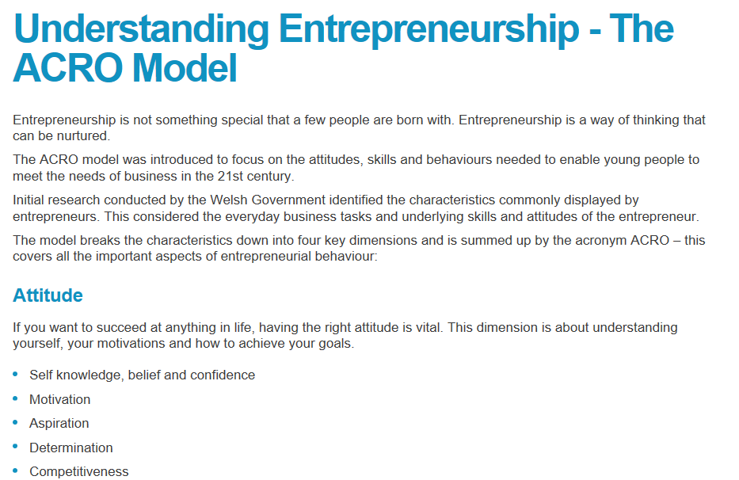
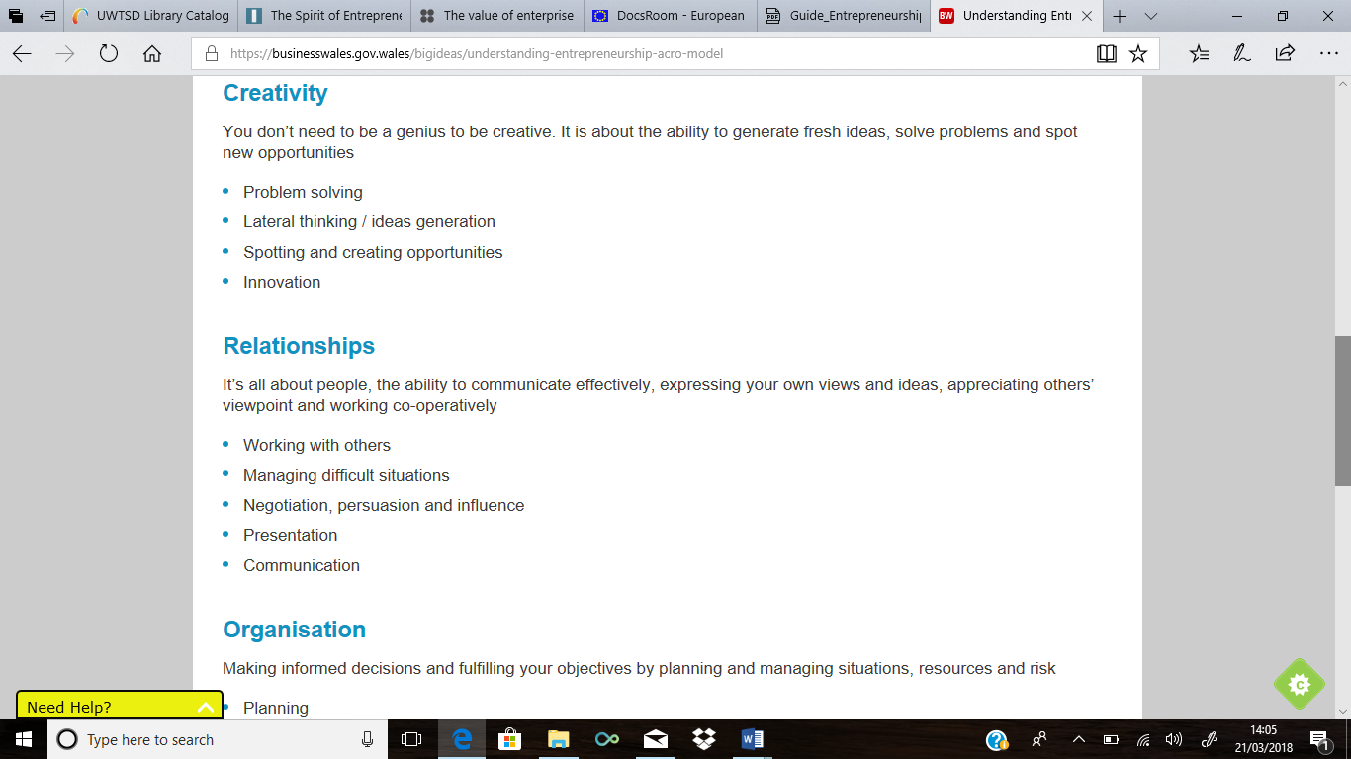

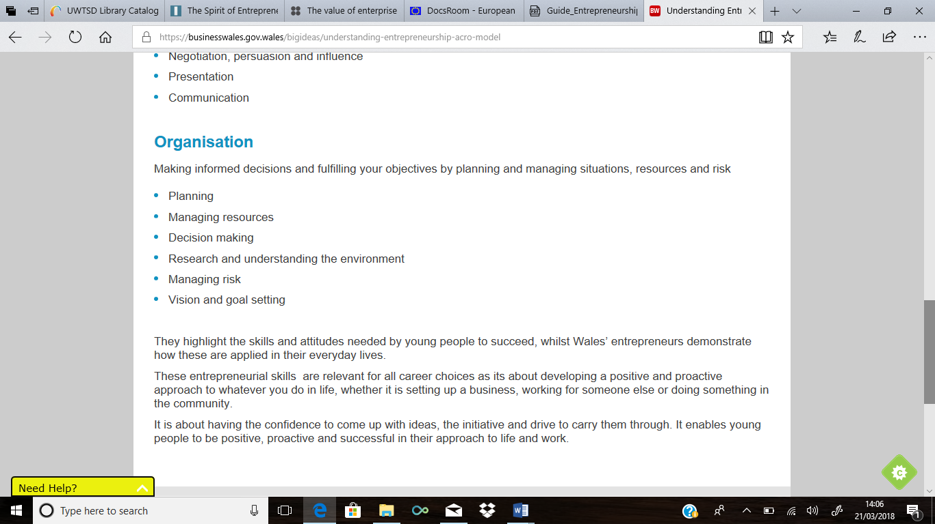

Welsh Government (2018) Understanding Entrepreneurship: The ACRO model. https://businesswales.gov.wales/bigideas/understanding-entrepreneurship-acro-model Date Accessed: 18th March 2018
Appendix 2

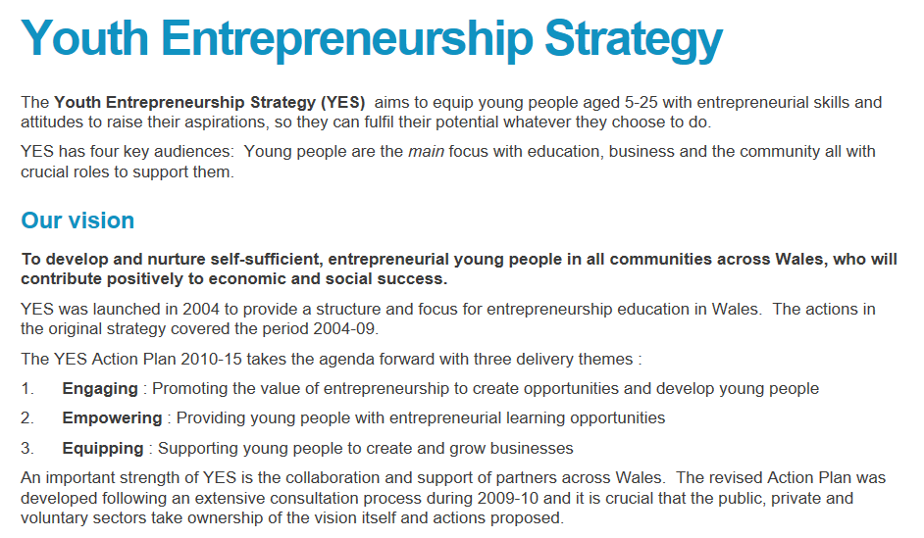
Big Ideas Wales (2015) Youth Enterprise Strategy. https://businesswales.gov.wales/bigideas/youth-entrepreneurship-strategy Date Accessed: 18th March

Appendix 3- Questions to ask members of the public

- Do you live in this area?

_____________________________________________________________________

- Do you work in this area?

_____________________________________________________________________

- What do you believe makes our area unique and special?

_____________________________________________________________________

- Are there any specific landmarks or buildings which you think are a good representation of our area?

_____________________________________________________________________

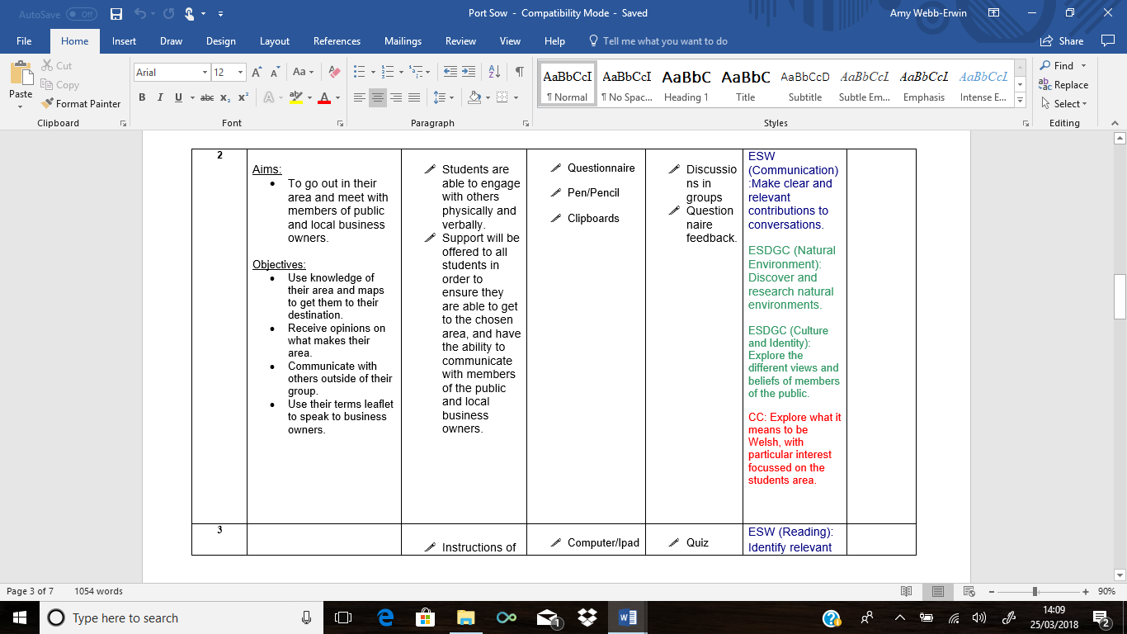
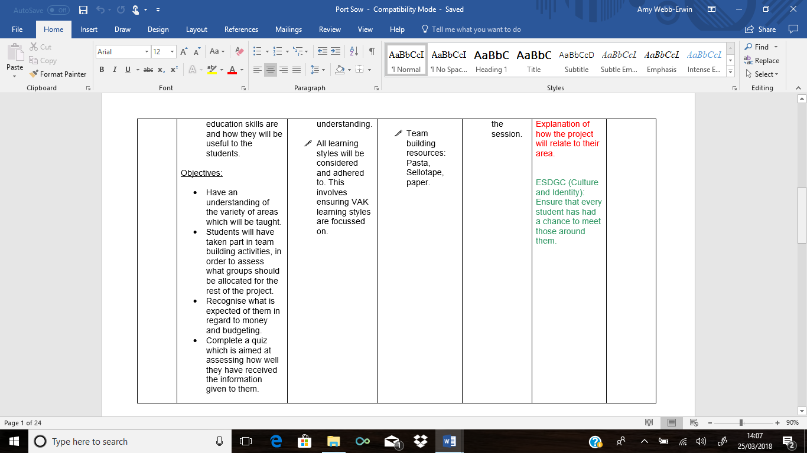
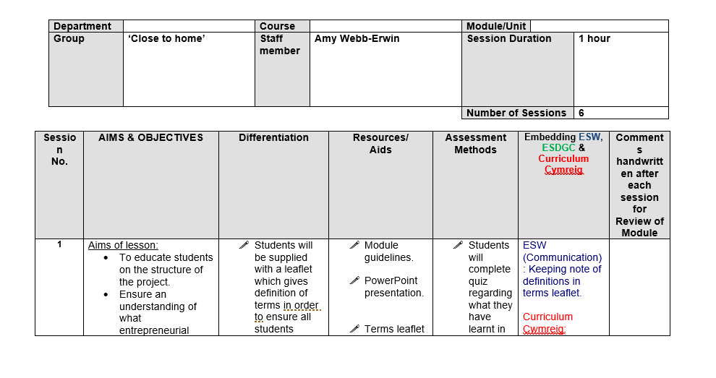
Appendix 4- Scheme of Work

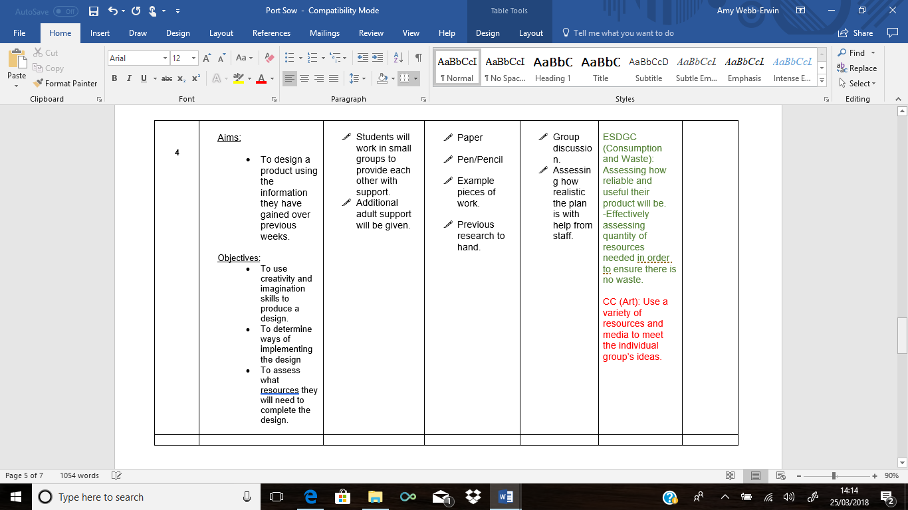
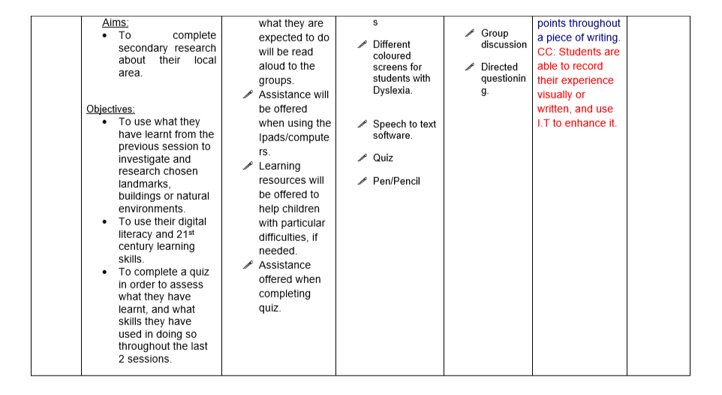

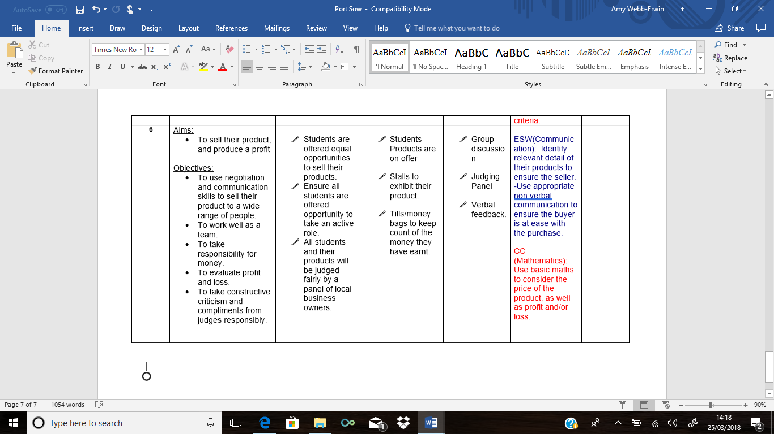
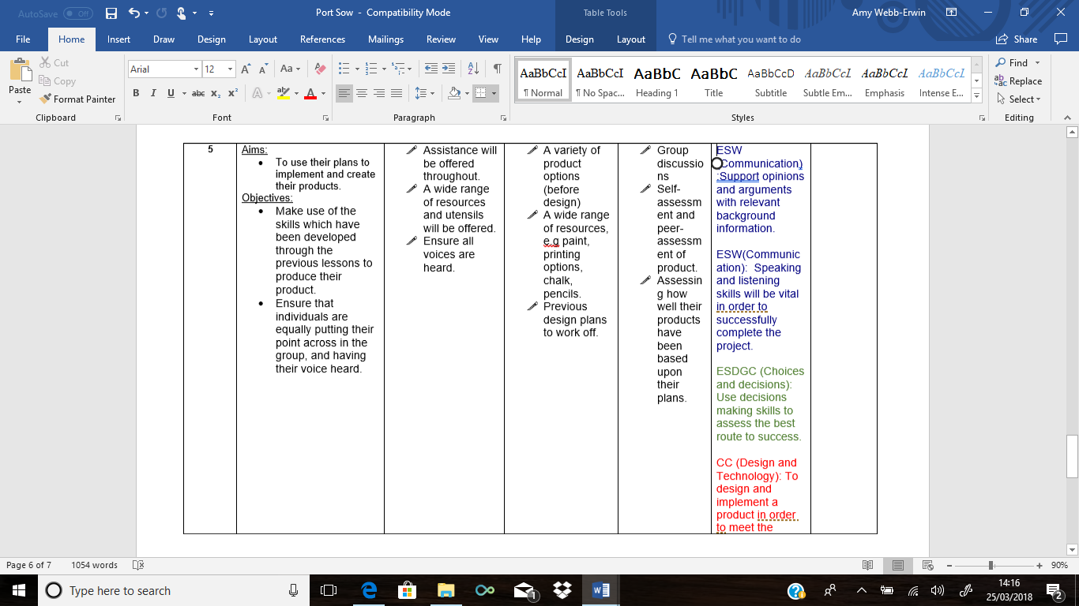

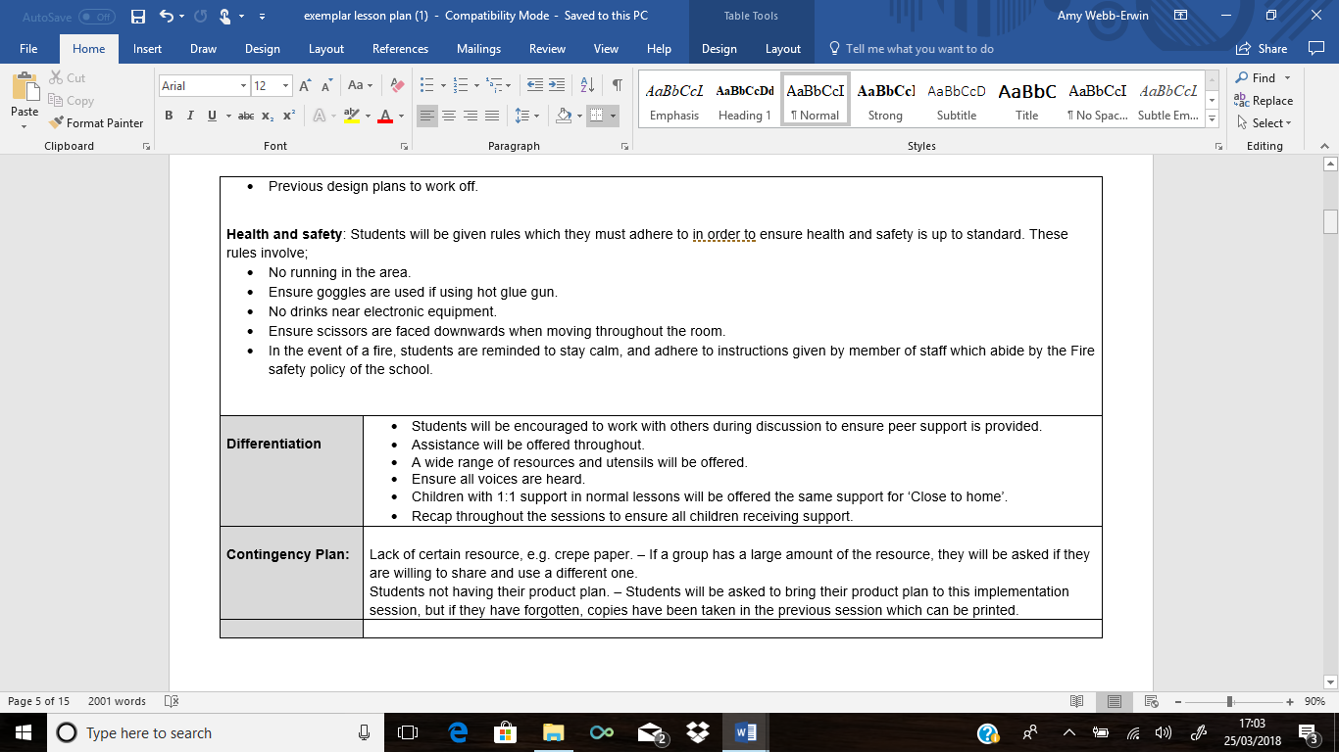
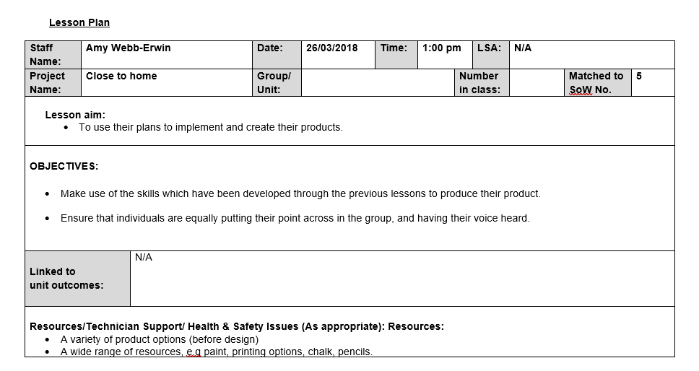
Appendix 5- Lesson Plan

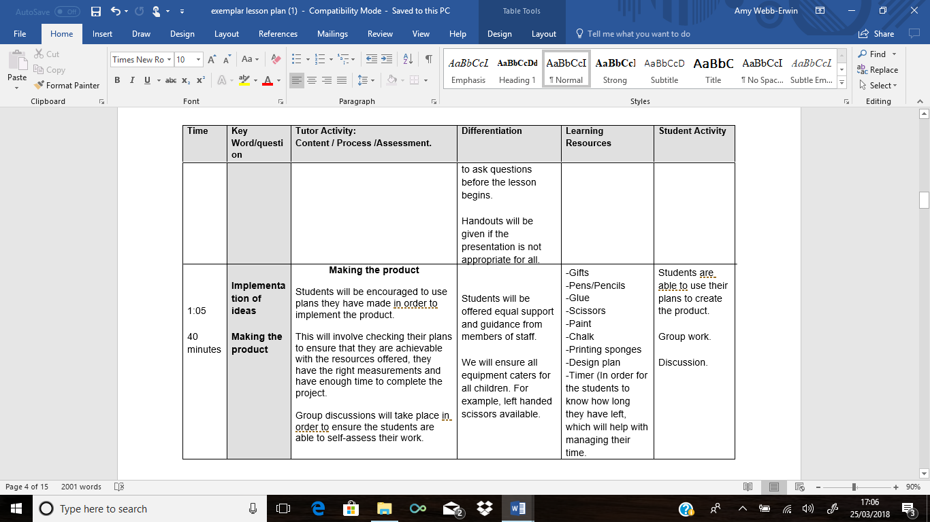
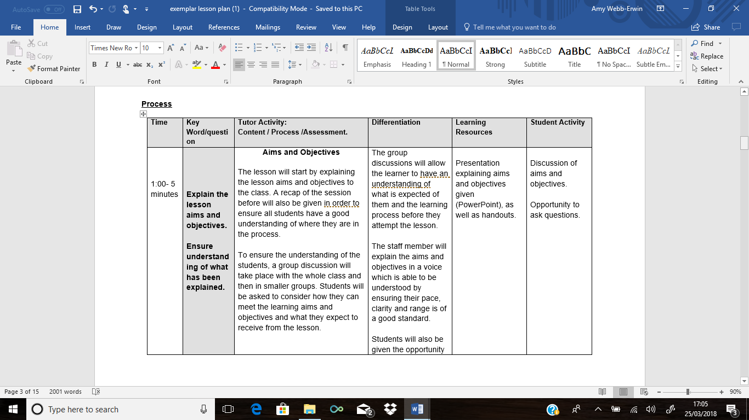

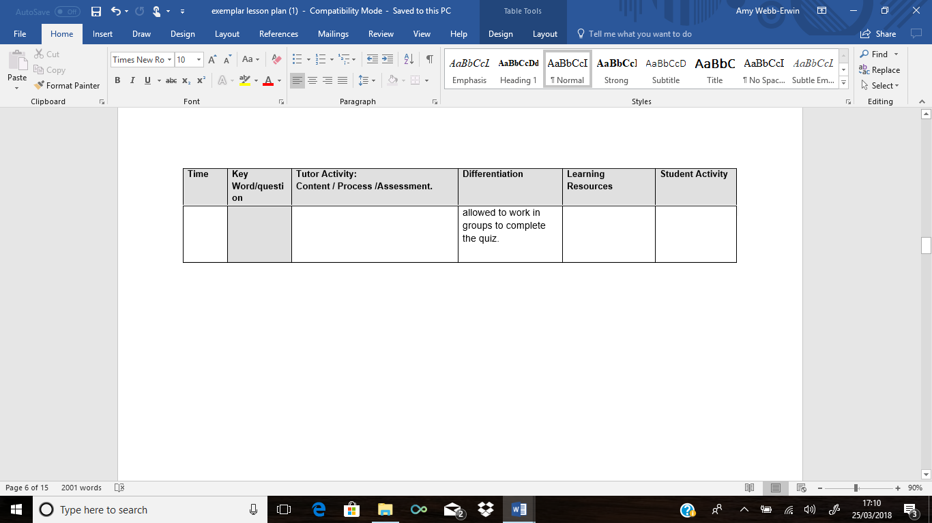
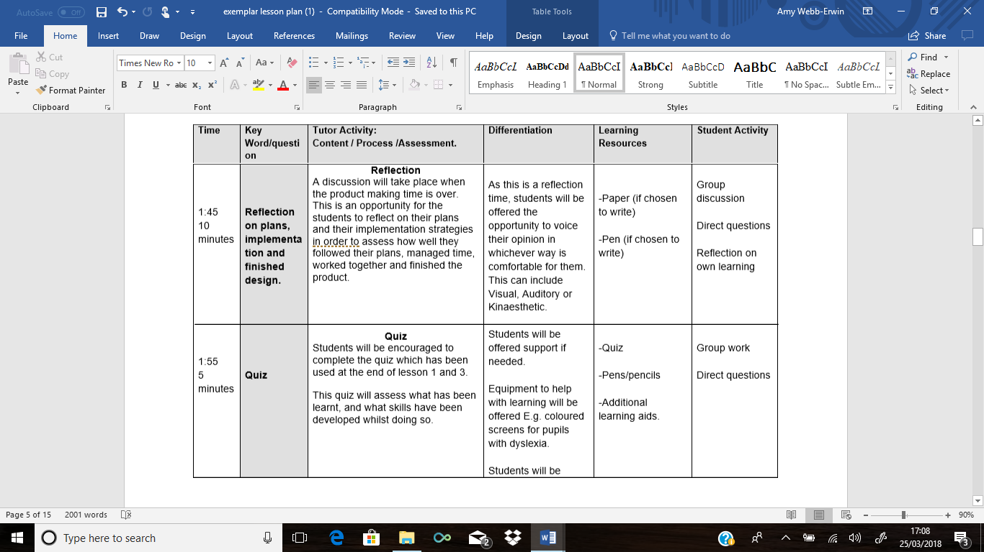

Appendix 6- Problem solving plan

What is the problem?
__________________________________________________________________________________________________________________________________________

Who does the problem affect?
__________________________________________________________________________________________________________________________________________

How did the problem arise?
__________________________________________________________________________________________________________________________________________

Solutions to fix the problem. (Please use a technique which is comfortable for you. For Example: bullet points, mind maps, diagrams, etc.)

Appendix 7- Example design on a tea towel
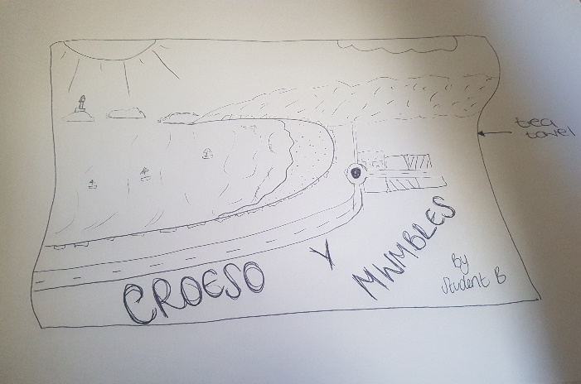

Appendix 8- Funding

The National Lottery (no date) People and Places https://www.lotterygoodcauses.org.uk/funding/people-and-places Date accessed: 20th March

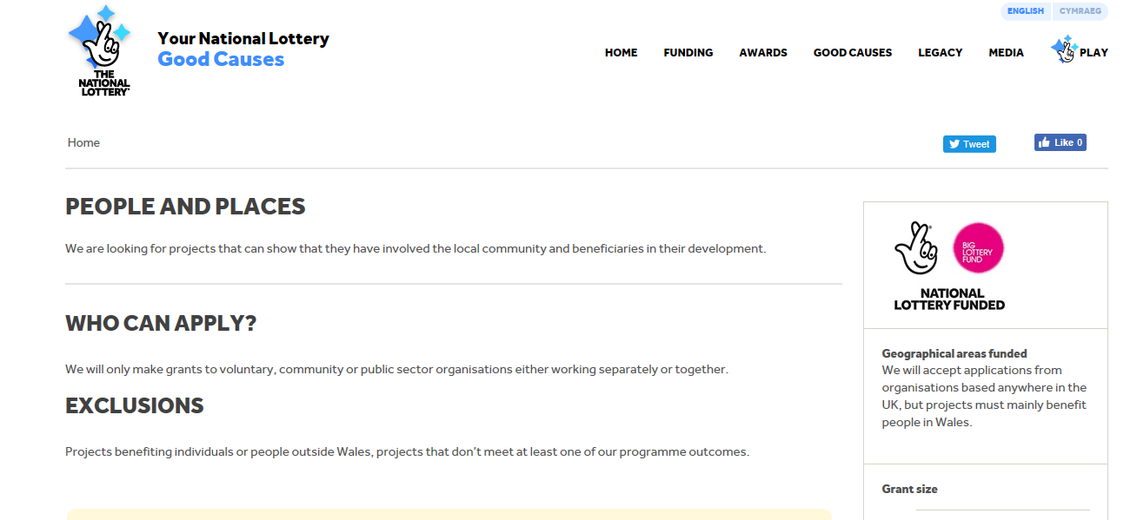

Appendix 9- Quiz for Formative Assessment
What have you learnt from today’s lesson?
____________________________________________________________________________________________________________________________________________________________________
What skills have you developed throughout today’s lesson?
____________________________________________________________________________________________________________________________________________________________________
How will these skills help you throughout the remainder of the project?
____________________________________________________________________________________________________________________________________________________________________
Are there any skills which you wish you could have tried harder at developing in today’s lesson?
____________________________________________________________________________________________________________________________________________________________________
Why?
____________________________________________________________________________________________________________________________________________________________________

