Independent Project

Name: Dylan Hopkins
Student number: 1702950
Course: 3D Animation
Module: Independent Project
Work count: 3801
Lecturer: Phillip Organ

Introduction
In this report I will write an in-depth analytical study of the work that I have created for the independent project module. I will write about all the entire process of taking the work that was created in the previous module, Major Project Stage 1 and how I have applied it, into the creation of the final artifact for the independent project module. I will start with a recap, which will include that the project is about, story wise with Jade and CD-8 which was established in the Major Project module, to splitting up the scenes as this was a group effort between Karol and I, I will state how we divided the scenes, how we helped each other to heighten the final artifact to best it can possibly be etc. I will then write about the research that I underwent for this project, YouTube videos that I watched in order to get a better understanding of animation, books I have read, online forums, where I got help, fixing a problem etc.
I will then write about how I went about rigging and weight painting the main character Jade as it was a long process, that contained a lot of tinkering in order to get correct, I will then lead into the animation and camera setup and lighting for the scenes, how I went about animating Jade and the robot companion CD-8, about the camera positions that I used and why I thought they I used them was beneficial to the scenes and how the lighting was created to get the desired effect.
I will then write about how I rendered the scenes, what setting I used and how I compiled the rendered scenes into a final Adobe Premiere file with audio and sound effects,
Then to finish off I will write about the various issues I had when it came to creating the artifact and finish with a conclusion, about how I felt about the project and how I would change it, if I were to do it again.

Recap
The independent project is the continuation of the major project stage 1 from the previous module, to which we were tasked with developing an artifact that would be approximately 1 to 2 minutes that encompasses the resource and materials learned during our time here at the university.
We could either have worked on our own for this 2 part project or we could instead work together as a team to deliver a final artifact and split the workload, in the end we had decided to work together, the people within my group where of course myself and Karol Schwarz.
In the previous module, we had developed a script, that a proposed story, models that would be used for the next module (this one) and sets that were created so that we would have a start for independent project.
the story Decimation is about a female survivor named Jade and her robot companion CD-8, in which they live in a bunker alone, protected from the harsh environment outside, they endure as they must to survive, however they are in dire need of power, as the fuel cells are running low, now jade has to adventure outside to go back to one of the places she would rather not a ship that crashed not too far from there base.

Splitting the scenes
As this was a group effort between Karol and I, we needed to decide how we would be splitting the scenes, we thankfully has created and animatic in the previous module, to which we could base out timing on, so we split the animatic into their base scenes of which there were 10, so we would both end up doing 5 scenes each, we decided from the beginning that I would do the creature based scenes and Karol would do the majority of the CD-8 scenes, which left us with about 4 scenes left to split, I took the top 2 and Karol took the other 2, we also shared all of our assets with each other, in order to retain a sense of continuity and consistency, as well as in one of the scenes I was animating directly after one of his scenes and thus used the end keyframes and placed them at the beginning and continued to animate.
We each had a maximum of 1 minute of total animation time, otherwise we would have ended up running pasted the maximum time allowed for the short.

Rigging
When it came to rigging the main character Jade, I used an already exiting guide skeleton, that I created some time ago, in order to get the sculpting proportions, correct in Zbrush, I reused the file to rig the character the only new thing I added to the skeleton was and addition bone to witch, once properly weight painted would allow the mouth to open and close.
Rigging the mouth was one of 2 options I had available, one being and actual bone rig, to which I can deform the model at any time, like with the arms and legs, or I could have created a series of facial expressions and created what are called blend shapes. Blend shaped allow me to blend between different facial expressions, from smiling to frowning or utilising both at the same time I can make expressions, that I did not originally create any blend shapes for, for example, making half the face smile and the other half frown, I can make a smirk, that wasn’t initially created for a blend shape.
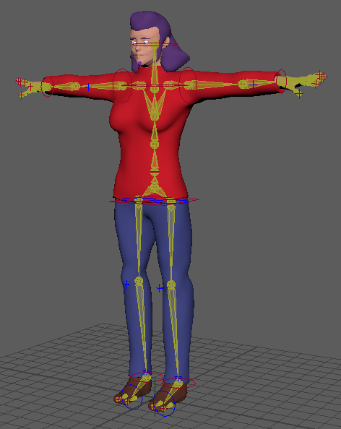
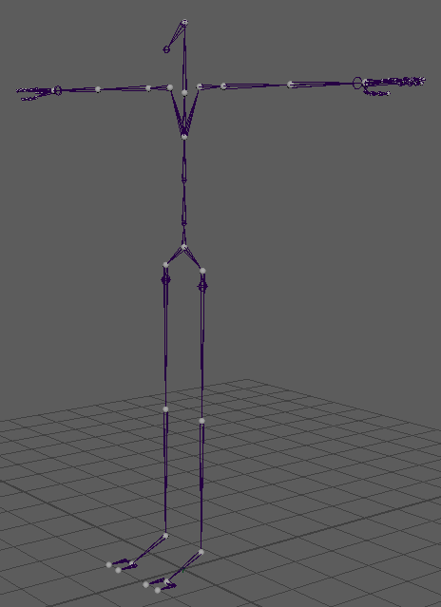
However in the end I decided to make the mouth move as a rig, in order to make things easier on myself and on Karol who would also have to use the rig, who at the time, wasn’t fully aware on how to use blend shapes, thus this would speed up the process it would take to animate the character.

weight painting
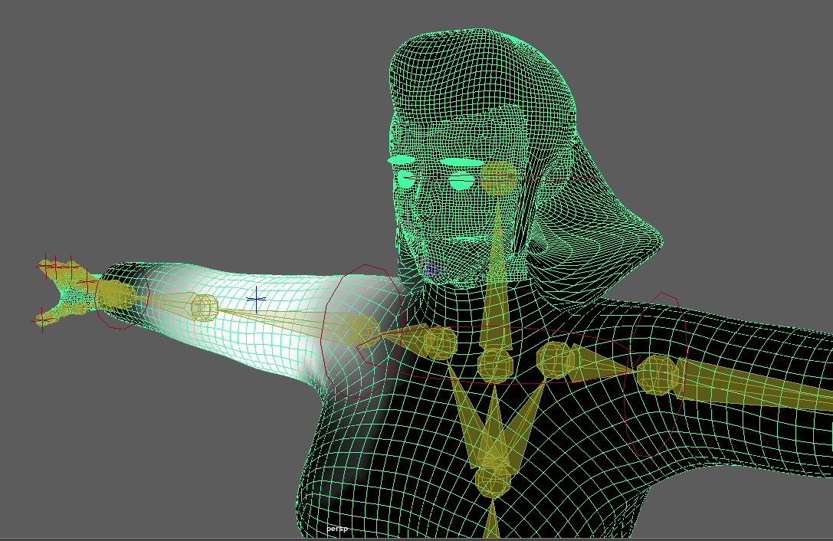
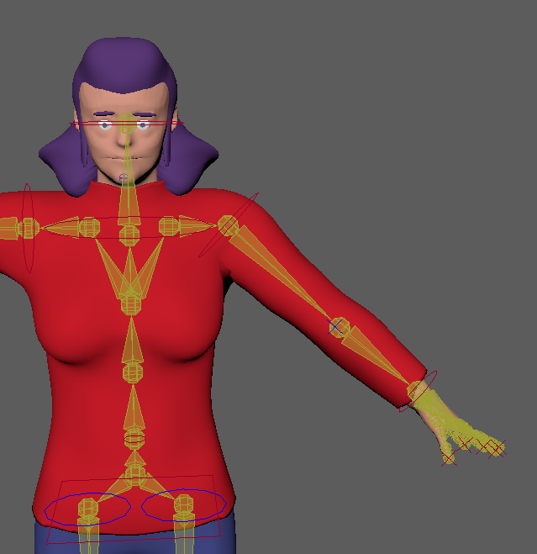
when it came to weight painting the main character Jade, there was a lot of new things that I was forced to learn, after all this was the first time, I had given any of my character sculpts a mouth cavity, to which they would be able to open to create lip movements to which we can then time to the audio that we will import into Autodesk Maya to lip sync the character to the audio. Working with the new mouth joint was a bit of a pain as I had to separate influence from the top and bottom lip and when you select once it will typically select the other as well.

Animating
When it came to animating the scenes we already knew how long they were going to be, this time however unlike one of the previous module we were prepared to deal with the difference in animation frame rate and playback frame rate, to summarise, in our previous module unrelated to this one or the major project we would animate in 24fps as this is the norm, and we’d have for example 4 seconds of animation which at 24 fps is 96 frames, however when it came time to render the clip the media player would only give us about 2 to 3 seconds of animation, the full animation would play, however it plays a bit too fast, now one or two scenes is not that bad, however this can and will pile up with the more scenes you do, which almost brought to be under the needed total time for the module.

This time however we are animating at 30fps as this is seemingly what the media player is playing back at. In doing so it solved the difference in time and is one less issue that we have to deal with I the future.

As we had already split the scenes up, we knew already how long everything would be, for example, my first scene was around 6 seconds and the next scene which followed from it was 15 seconds, which gave me a total time for scene 1 and 2 as 21 seconds of current total animation, 30 frames being 1 whole second of animation, and since we knew how long a scene would be, we could use a calculator to determine how many frames a scene should be, 15 for 15 second times, 30 for the amount of fps we use gave us 450, so scene 2 will contain a file that uses 30 fps for 450 frames which equates to 15 second of total animation time.
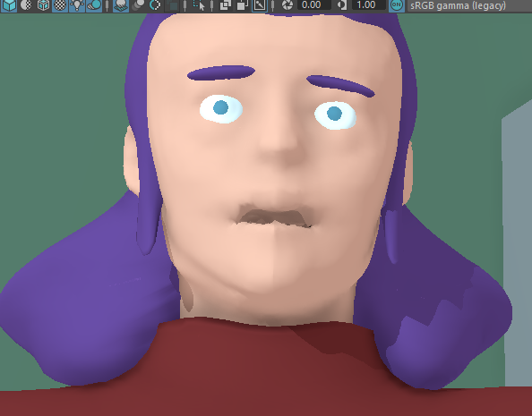
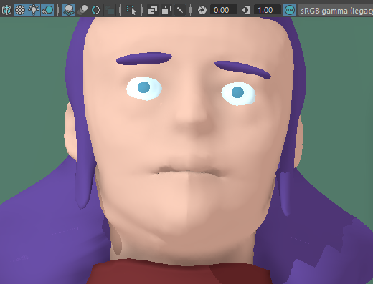
When it came to lip syncing, we had a fairly easy time with it, we could have used a dope sheet, to align the words to a time sheet, however we found a far more simpler solution, as the audio recording was already completed from the previous module, we technically already had the final audio, thus we went on to Adobe Premiere, clipped the video, into the separate scenes, and deleted the video, we then exported the audio as a .WAV file and imported each scene, scene 1, scene 2 etc into the Maya files, we then made audio wavelength appear at the bottom of the timeline, to see the peaks more easily, and lip sync the mouth to the audio, this was the workaround that we developed when animating the mouth as it was the first time either of us animated a scene with any sort of audio.

Cameras
We ensured that there would be many cameras, within each scene, as both Karol and I have worked extensively, with the cameras within Autodesk Maya, thus we are able to get a good position on the cameras fairly easily and quickly, doing so, I believe heightens the animation quality, as we can show many different angles of the same object, and/or character, it allows for us to directly choose where we want the viewer/user to look, when we switch between characters, when they begin and stop talking.
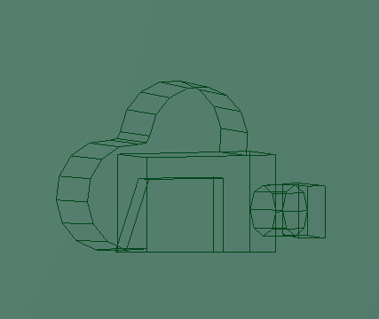

Sequencer (ubercam)
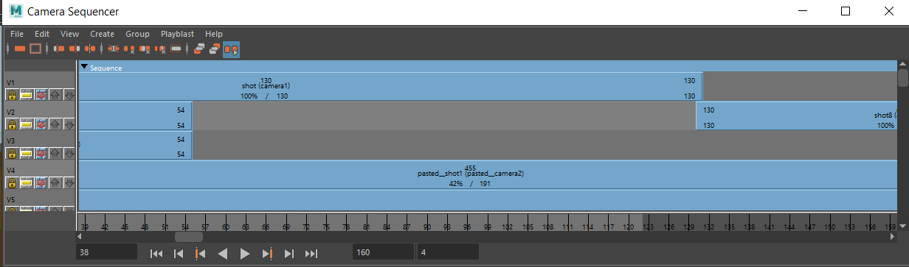
Using the sequencer for this animation was very crucial, as it allows us to use Autodesk Maya similarly to Adobe premiere, in which we can select out cameras into the timeline and choose when one camera end and where another camera begins, instead of having to render the same scene 3 or 4 times and snip then together after the fact, we can instead do such a thing withing Autodesk Maya itself and render an Uber cam, which is the camera sequencer edited to a new camera.
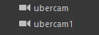

Lighting
The majority of the lighting was created by Karol when he first setup the main scene, as we are both working on the same scene as the majority of the scenes take place in the same location, it was important for us both to be working with the exact same settings, thus a base file was created, which included the building itself as well as the 2 characters Jade and CD-8 doing so ensures we both have the same lighting and locations, as we needed to ensure that we had the same consistency between the scenes, as we are both animating on different, scenarios but on the same set location.
However when it came time for the ship and creature scene, I had to create a new lighting scene, as this was not the same location, thus didn’t need to be held to the shelter interior lighting, however I did keep the three light sources that Karol had made, however I changed the values to make the interior of the ship much much darker, not pitch black to where you can’t see anything, but darker, to where you can feel a difference between the warm lighting of the shelter and the now darker interior of the abandoned ship.
The lighting was also created to be, very cartoony, originally it was meant to be very realistic, however as this project evolved, and issues, began to spring and new ideas began to flow, we had decided to change and go with a more cartoony route, as seen with the brighter lighting, and blue tinted effects, which I believe fits the animation style more than It would have should we have gone with a more realistic lighting.
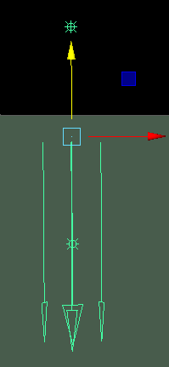
There are three types of lighting attached to each scene, there is the main lighting, that just illuminates the scene, one that adds the shadows to the scene and a dynamic light for effects.

Rendering
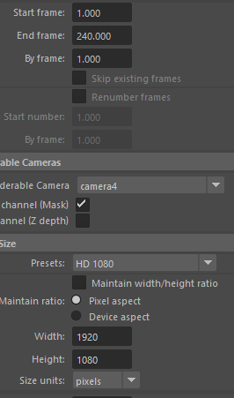
When it came to rendering, we rendered in AVI 1080p 30fps as this is the standard for video on web, as this would likely be the format that most will be viewing this on, due to the current pandemic, the rendered files would then be directly uploaded to YouTube in order to format the files from the AVI as Adobe Premiere cannot open AVI files and convert them into H.264 to then be downloaded and imported into Adobe Premiere, which allowed up to keep the file sizes small and allow the timeline scrubbing to be smooth.

Compiling in premiere
Now that all of the scenes have been animated, rendered and formatted for use in Adobe Premiere, it was time to compile the formatted scenes together, in order to create one final video, that contains the collective work that both Karol and I have created of the course of this module. Karol stitched the files together within Adobe Premiere and attacked the original audio that was created from the Major Project stage 1 module, we however had since animated more scenes that were not originally drawn in for the storyboard, these additional scenes created however are in the original and final script, thus they were planned, however they do not as of time of completing and rendering the animation scenes, been recorded, thus there were 2 additional objectives to complete, record the missing dialogue for the scenes that have none and add in the sound effects as none as of yet had been made.


Issues
In this section of the report, I will go in details the various issues/problems I encountered from the beginning to end of this project, of which I can assure you were where many, issues encountered. I will also write in how I managed to solve or work around these problems in great detail.
Throughout the process of animating the Decimation short I encountered 10 major issues, that completely halted my progress on this project, that resulted in loss of data or time wasted.
One of the issues that I had encountered, was the need for a mouth for the main character Jade, as I had never created a character with a mouth before, after all, Dynameshing and ZRemeshing merges the model together and deleted any information inside the model. This I needed to find a way to create a mouth cavity in Zbrush to create the mouth rig within Autodesk Maya, the way that I solved this issue was to create a layer within Zbrush, after watching a video on YouTube I learned you can create layers and blend between then, so I created a mask around Jade’s jaw and stretched it open, and sculpted out a cavity here the mouth would be, I then set the lay back to one, so that the mouth was closed, but still contained a cavity behind the mouth, I baked the model back down and retextured, and exported into Autodesk Maya.
The next issue I had was the textures, whilst I managed to get the textures exported out of Zbrush I could never actually apply then on the character, or to be more precise the model seemingly didn’t have any vertices that I could manipulate in order to move then across the texture, this isn’t something I manage to fix in the end, thus my solution was to apply new textures from the HyperShade tool.
The next issue that I encountered was the rig that I was using, as stated previously within this document, I stated I had already created a skeleton rig for the character from the major project module, this is correct, however when I overlayed the bones where they needed to be, arms, hand, fingers etc. and saved the file and exit, once the file was open again, the skeleton would revert back to its original condition, which was not ideas, as it meant I had to reposition the rig, however binding the rig to the model solved this issue.
The second issue with the rig was that I for some reason could not mirror the rig, usually I position the left or right hand then I would use the mirror option in the settings to mirror the newly positioned rig, which meant every time Autodesk Maya broke on me and the skeleton would reset, I would have to reposition the entire skeleton again from scratch on both sides.
The next issue I had was the weight painting of the character Jade, as it was one of the worst experience I had ever gone through, for some reason a bug that occurred within Autodesk Maya 2017 still persists to this day with Autodesk Maya 2021, in which once you remove influence from for example, an arm, the influence wouldn’t disappear it would go somewhere else or just return back to that arm, thus it was a back and forth back and forth game with the tool, to remove the influence, this took me 3 days to get the rig into an optimal way that I found acceptable. Another issue which I did not know how to solve in the end we were forced to use the rig with it, was the rig was very laggy and slow to work with, you could blame this on the 300,000 polygons used, however up until the very last weight paint the model actually worked very fast, it was an odd thing, that in end I didn’t have the time to solve.
The next issue was with the rendering, for some reason I could not set start frame and end frame in the render settings, this was an easy fix as a restart fixed the issue.
Another issue was Adobe premiere, could not use AVI files, no matter what we tried, thus the solution was to upload the video to YouTube and let them convert the video then download it later and compile it in Adobe Premiere.
And the final issue that I had which pertains even to this day is that my PC would randomly without warning or warrant, would freeze and I would have to manually turn the pc off to get it working again, this was very frustrating as it meant I couldn’t save an work and whatever work that wasn’t saved I lost forever, there wouldn’t even be any auto saves as the pc would freeze before this could happen, it could freeze in 5 minutes or in an hour it was completely random.
Another issue I had was the cache being used too quickly which crashed Maya, the fix was adding another stick of RAM to my PC.
In total I lost about 5 days’ worth of work, both in work that was actually lost and in work that could have been done if not for all the faults, lags, and freezes.
This is the reason as to why the creature was never actually seen in the final animation, I was forced to make a decision, either to be late on the animation or cut some lesser content out and give the insinuation that the creature is there.

Conclusion
To finalise my thoughts on this project, I will now write my conclusion. I felt that the animation that was created for this independent project after sorting out the issues, when smoothly, as I had learned a lot more this year in the creation of this animation project that I had in ant of the 2 years that I had before, I believe this is due to, getting into the mindset of an animator, being able to retain more information for longer unlike in year 1 where it would take longer to retain the information and would require multiple lessons to learn different things, now however I can learn multiple things in a single session and retain them for longer to recall at a later date than I use to be able to.
There are however aspects of the animation that I believe could have used some more work, such as the rigging of one of the main characters jade in which I could have added more bones onto the mouth area of the character in order for the animator to create more complex mouth movements such as, A, I, O, U, EI, EW etc. the eyes is another area in which I could have added bones, in order to make the character blink, however lack of understand of how I would have accomplished this prevented me from implementing the feature.
The weight painting is another point of failure for this project, as Autodesk Maya is very finicky in how weight painting is done and it still contains the bug from 2017 in which you remove influence in one area, that influence just moves to another area and most of the time will end up re-influencing the area that was removed.
I do believe however the animation of the arms and the quality and setup of the lighting that was created for this project, more than made up for all of the oddities that were either encountered or created, such as out of proportioned limbs that Jade and CD-8 have and the basic lighting that was used after deciding a more realistic way wouldn’t work. I believe this, because when it was decided for a new cartoony look instead of the proposed realism route, the movement of the arms and the lighting setup that was created made the renders look purposefully cartoony, which was the new direction that we were heading in, thus I believe we did a good job in that regard.
However, should I ever have the opportunity to do this project from scratch again, for whatever reason, be it, more practice on a short that was already created, so that I can focus purely on the graphics side of things and not have to create a script again, or polishing the animations for a showreel, which I may do once I leave the University, I would approach the characters in a different way, hopefully incorporating retopology in my workflow, apply a more realistic texture to the character and iron out the weight painting issues, with this animating Jade would then be a much easier job, as the PC wont chug and the model will be able to deform in a more efficient way without clipping or deforming in a way it should not.

Bibliography
Maya: Painting Skin Weights : https://www.youtube.com/watch?v=cuaXDkbg4QA&ab_channel=Uhr (accessed 28/04/19)
Quick rigging and skinning a character for beginners : https://www.youtube.com/watch?v=c538zkwxgTQ&ab_channel=MayaLearningChannel (accessed 28/04/19)
Introduction to the camera sequencer in maya : https://www.youtube.com/watch?v=_MFNIkg_Yj8&ab_channel=JasonKennedy (accessed 29/04/19)
The animator’s Survival Kit : https://www.amazon.co.uk/Animators-Survival-Kit-Richard-Williams/dp/0571238343/ref=sr_1_1?dchild=1&keywords=animators+survival+guide&qid=1620082414&sr=8-1 (accessed 29/05/19)
Zbrush – creature mouth / next step after dynamesh : https://www.youtube.com/watch?v=pSsEfdzieRk&ab_channel=Arrimus3D (accessed 01/05/21)
Export Polypaint from Zbrush : https://www.youtube.com/watch?v=0SCxp2Y0HUA&ab_channel=Dr.DMediaPhoenixIncep (Accessed 01/05/19)

