Saba Parveen- 2014411
Children, young people and families
Module code- BMHP5004_BIRM
Dr Muhammad Hossain
Essay- Covid 19 Pandemic- current challenges that children, young people and families are facing in the UK

Contents
Introduction 3
Covid 19 Pandemic 3
Impact on children and young people and families mental health and wellbeing 3
Impact on the NHS and healthcare workers 5
Poverty 7
Safeguarding concerns for children and families during COVID 19 8
Policies and legislation 9
Conclusion 9
References 10

Introduction
During this essay I will discuss current challenges that children, young people and families are facing in the UK. A current challenge that most people are facing is the COVID 19 pandemic. It has impacted the lives of many across the world. I will go through each aspect of the pandemic, what it is, how it has impacted children, young people and families. I will focus on the mental health and wellbeing of children, young people and families and how it has affected their lives. I will also discuss the impact it has on the NHS and Poverty in the UK.

Covid 19 Pandemic
The COVID-19 Pandemic is a global pandemic of a virus that spread across the world. COVID-19 is a disease affected by a virus known as coronavirus. This disease is an infectious disease which attacks the respiratory system. This virus was first identified in the city of Wuhan, Hubei, China. “Since December 2019, the Novel Coronavirus (COVID-19) has reached a pandemic status, with over 2 million individuals worldwide being infected, which has resulted in over 100,000 deaths” (Alsafi et al., 2020, p1). The virus started spreading in the beginning of 2020 which was mainly due to the fact of people travelling around Europe. By March 2020, health measures and restrictions were introduced due to the occurrence of the virus spreading rapidly. During this period, this was one of the world’s largest outbreaks.

Impact on children and young people and families mental health and wellbeing
There virus spread rapidly in March 2020, resulting in a national lockdown. The governments use of measures such as school closures and social distancing to combat the spread of COVID-19 has impacted millions of children and their families around the world (Morgül, Kallitsoglou and Essau, 2020). This meant schools closing and children were having to stay at home for months. Children missed out on months of education in schools and relied on online learning which may have seen children and young people experiencing a sense of seclusion and isolation by the lack of physical contact and activities they would normally take part in. Children and young people who would normally go to the park or community centres such a swimming and many other clubs had no choice but to stay home. The risks of physical well-being of children through reduced nutrition and physical activity for fitness put their physical well-being at risk. Although a majority of children stayed well, those that were diagnosed with special needs are most likely have suffered the most as these changes were not their normality. COVID-19 has had an effect on all levels of education and delivery, but children with special needs have been more severely impacted than other children because of it (Hoofman and Secord, 2021).
Research from the COVID-19 pandemic reveals that there are various elements influencing children and young people’s mental health and well-being. Worries about their education, missing school, all the changes and uncertainties about the future particularly among young adults (Millar, 2020).
Secondary school children and college students had even more pressure as some were in the middle of taking exams or preparing for exams. They were also told to stay at home and continue with online education. This had a big impact on their mental health which caused them concern about passing exams, not being able to go in and see their teachers in person, the uncertainty of what will happen. This can have detriment effect on their health and wellbeing. This may have caused worry and anxiety and for many resulted in stress. “Adolescents reported higher rates of depression and anxiety associated with the pandemic, and in 1 study 14.4% of teenagers report post-traumatic stress disorder, whereas 40.4% report having depression and anxiety” (Hoofman and Secord, 2021, p4).
Many families had been forced to stay together indoors due to lockdowns and restrictions which has resulted them in spending increased time together. Although this can benefit families by bonding and closeness, there is still that fear of uncertainty and how their health could be a threat by trying to avoid becoming infected. The impact of being in lockdown meant that people couldn’t visit their families and for some who lost family members due to contracting the virus. Losing someone close can affect your mental health and state of mind. The coronavirus disease is expected to have long term repercussions on the population’s mental health and well-being (O’Connor et al., 2020). Whilst parents were made to work from home many other parents had lost their jobs resulting in no income to support their families. Many families were forced to rely on local foodbanks to make sure their families were provided food. For many, who did not want this support meant they ended up in financial difficulties and going without food
Personal connections, organizations and support from trustworthy adults and peers were missing in the lives of children and families. Families were under immense stress from tension and worry of crisis. Conflicts and tense relationships were on the rise, while relief for children and parents was decreasing.

The diagram down below shows the possible mental health impacts of COVID 19 in the future
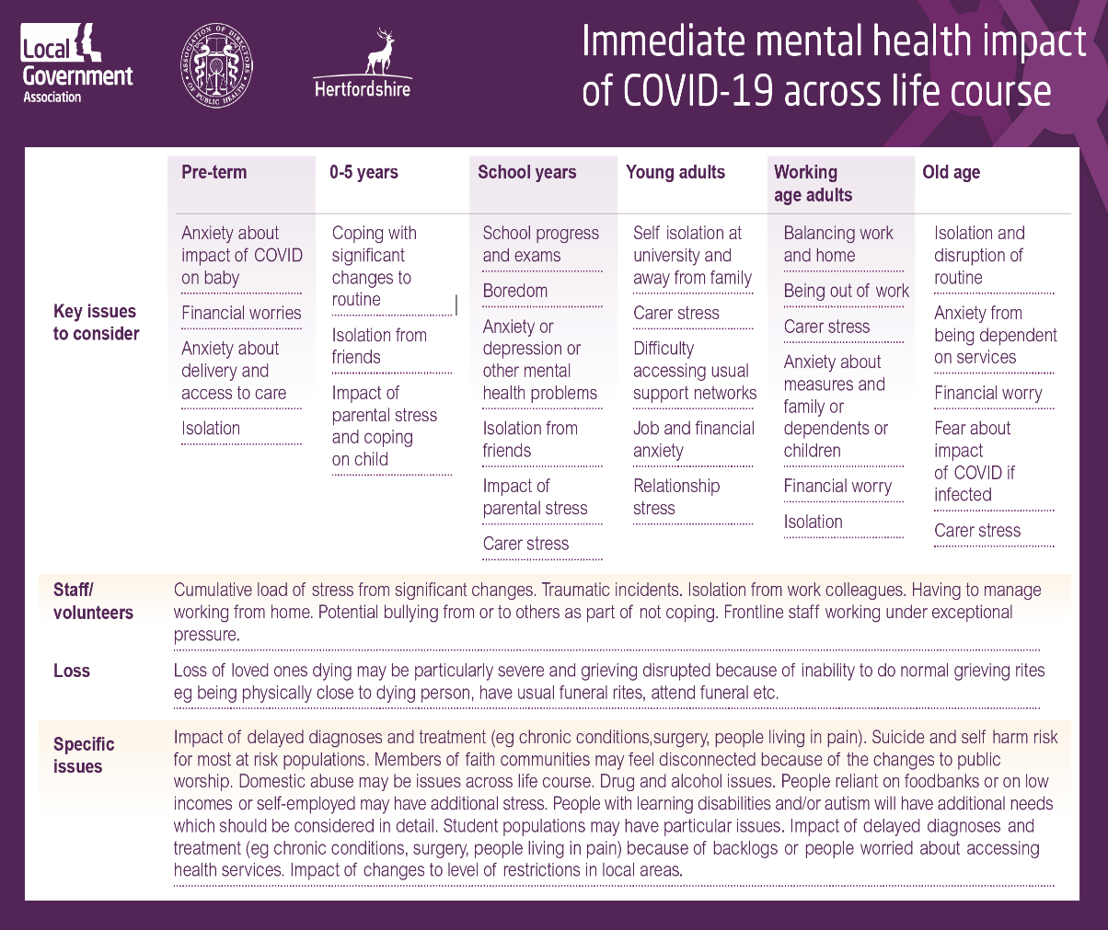
Source: Hertfordshire County Council,2022

Impact on the NHS and healthcare workers
The pandemic has put a substantial amount of pressure on the UK’s national health service (NHS). This has resulted in the instant implementation of digital technology and substantial changes in the approach of services. Remote working enabled hospitals to free up space due to the high number of cases and the amount of people who were admitted. Primary and secondary care services were forced to carry out remote services for their patients to reduce the risk of transmitting infection. Healthcare workers encouraged patients to comply with online consultations.
“In March 2020, guidance was issued to primary care providers, stating that all patients should be triaged before an appointment, ideally through an online consultation, and that remote appointment options should be used where clinically appropriate to reduce the risk of infection from Covid-19” (Hutchings, n.d, p3). Because there were too many cases of COVID and people being admitted, hospitals had to cancel people’s appointments with other health conditions as COVID was made priority. This meant that patients with other health conditions who had appointments were pushed back resulting in cancellations.
Healthcare workers have been affected significantly by this Pandemic. There were many staff shortages through this pandemic which resulted in other staff working overtime. When the government placed the country in lockdown, health workers have been on the frontline and had to continue with their jobs in providing care, which resulted in personal isolation away from family and having to travel away from home for a long period of time. This meant risking their own lives to save the lives of other. Many people died in hospitals and care homes with COVID, health care professionals were required to care for unwell colleagues, console dying patients, console patients’ family members remotely (Mehta et al., 2021). All these factors must have a huge impact on the mental health of health care workers having to witness the loss of patients in front of their own eyes.
While most people were afraid of the uncertainties whether that was the fear of getting infected or their general health and well-being, or financial difficulties, healthcare workers may have also had these fears despite continuing to do their job. Health-care workers are already under a lot of stress at work and are at risk of poor mental health. During a pandemic, their work will be even more intense, which could lead to burnout, lower quality care for others, and other mental health problems (Gilleen et al., 2021).
Furthermore, by the Law making (PPE) personal, protective equipment compulsory during COVID along with testing patients and themselves, health workers had to adjust to this new system. Routinely making sure hands were sanitised and the patients. Ensuring patients also wear the face masks. This was a new system for everyone to adjust to.

Poverty
Poverty can be defined as a lack of funds to cover basic requirements such as food, clothing and shelter. It is a state of not having enough money or other resources to support one’s daily needs. Hunger and malnutrition as well as inadequate access to education and other essential services are some of the indications.
Disadvantaged families have fallen deeper into poverty as a direct result of the COVID 19 pandemic. Even before COVID 19 Pandemic, alarming health indicators were beginning to emerge in England. As a result of the exceptional surge in infant morality caused by increasing levels of child poverty, food poverty and homelessness (Whitehead, Taylor-Robinson and Barr, 2021).
This crisis has made life even harder for thousands around the world. Many people have been made redundant and now must contend with increasing living expenses. “Over three quarters of families have said they are finding it “tough” or “extremely difficult” to manage their finances (Edwards et al., 2020). Successful businesses had to shut down and rely on furlough schemes whilst many other small businesses had to rely on universal credit.
“Anti-poverty experts welcomed a £20 weekly increase in payments for those claiming universal credit” (Westwater, 2021). There was a £20 increase in universal credit in the lockdown for people on benefits and the public believes that benefits are not high enough. They want the government to keep up with changes that were made due to the pandemic like the changes in universal credit.
Recent research highlighted the additional expenses associated with keeping children at home for longer period of times during Lockdown’s without access to important free services, necessitating more spending on food, heating and keeping youngsters occupied indoors. During 2020, more over a third of low-income households with children raised their spending, while 40% of high-income families without children decreased theirs. This proves that people who live in low-income families with young children have been hit hard by lockdown measures (Whitehead, Taylor-Robinson and Barr, 2021).
The pandemic has caused a lot of problems in the in the social and economic world. This has shown how fragile the system of giving food to people in need is. It is hard to get food to people who need it quickly, so people have been stockpiling (Power et al., 2020).
While many have been stockpiling, there have been many who have gone without food and drink for their families and have been relying on food banks and charities to feed their families. People that have made new claims for universal credit have had to wait upto 6 weeks for their face payment and then wait every 4 weeks to receive their regular payment in order to live and pay their bills. Many have ended up in arrears and debts due to this.

Safeguarding concerns for children and families during COVID 19
There are many concerns for children and family’s health and well-being especially during COVID where children and families were isolated from everyone. Many children suffered abuse and neglect whether that was by a parent or another family member who’s care they were in. Child maltreatment and neglect are more likely when families cannot provide essential requirements for their children. COVID-19’s outbreak has increased the danger of poverty for families who are unable to work or have been forced to live in isolation, making it difficult for them to follow government health guidance.
Due to the ongoing uncertainty, it is especially critical to protect children who may be at greater risk of abuse. However, it is equally crucial to protect families, especially as families are under considerable pressure to continue to protect and promote the welfare of their children despite these pressures (Social Care Institute for Excellence (SCIE), 2022).
According to the working together to safeguard children act, efforts should be made to identify developing issues and unmet requirements of children and families. Local governments should engage with organisations to establish coordinated early help services based on local requirements. Healthcare professionals, those in universal services must understand their responsibility in identifying potential problems and sharing information with other healthcare professionals.

Policies and legislation
The UK Public General Act amends the legislation to better protect vulnerable children, regulate childcare for children with special educational needs and assist parents in balancing work life and family life.
Working together to protect children law states that safeguarding is protecting children from abuse and making sure that children grow up in safe and effective care. It also means taking steps to make sure that all children have the best chance of having a good life (Johnson, 2019). Children and Families Act 2014, UNCRC, Human Rights Act 2010 and the Equality Act 2010 also protects children’s health and well-being.

Conclusion
COVID 19 has impacted all around the world. Children and families have all been affected in many ways which has had a significant impact on their emotional well-being and mental health, especially for those that have faced isolation and seclusion and have previously experienced traumatic events that have worsened by the pandemic. Children and families have had to come to terms with major changes like many things becoming inaccessible and children who had to adjust to learning from home. As for the NHS, they have been put under immense stress with numbers of infected patients rising and shortage of staff, seeing patients rapidly die from this disease and being isolated from their families caused distress. Also adjusting to the new system of PPE and wearing face masks can become overwhelming. Poverty is on the rise due to this pandemic with many people struggling to feed their families and others who have ended up in debt. For most, this will be a new way of living, adjusting to systematic rules and living with the uncertainty in the hope that there will be an end to this deadly disease.

References

- Alsafi, Z., Abbas, A.-R., Hassan, A. and Ali, M.A. (2020). The coronavirus (COVID-19) pandemic: Adaptations in medical education. International Journal of Surgery, 78, pp.64–65.

- Coronavirus (COVID-19) - Health and Safety at Work | Health and Safety Executive Northern Ireland (hseni.gov.uk)

- Edwards, Z., Howes, S., Reedy, J. and Sefton, T. (2020). Poverty in the pandemic: An update on the impact of coronavirus on low-income families and children Written and researched. [online] Available at: https://cpag.org.uk/sites/default/files/files/policypost/Poverty-in-the-pandemic_update.pdf.

- Gilleen, J., Santaolalla, A., Valdearenas, L., Salice, C. and Fusté, M. (2021). Impact of the COVID-19 pandemic on the mental health and well-being of UK healthcare workers. BJPsych Open, [online] 7(3). Available at: https://www.cambridge.org/core/journals/bjpsych-open/article/impact-of-the-covid19-pandemic-on-the-mental-health-and-wellbeing-of-uk-healthcare-workers/D7E2EA268395EC63205017929CD720D2.

- Hoofman, J. and Secord, E. (2021). The Effect of COVID-19 on Education. Pediatric Clinics of North America.

- Hutchings, R. (n.d.). Key points The impact of Covid-19 on the use of digital technology in the NHS. [online] Available at: https://www.actasanitaria.com/uploads/s1/15/56/06/9/the-impact-of-covid-19-on-the-use-of-digital-technology-in-the-nhs-web-2.pdf.

- Johnson, E. (2019). Safeguarding Children | Legislations and Policies surrounding safeguarding. [online] CPD Online College. Available at: https://cpdonline.co.uk/knowledge-base/safeguarding/legislation-safeguarding-children/.

- Whitehead, M., Taylor-Robinson, D. and Barr, B. (2021). Poverty, health, and covid-19. BMJ, [online] 372(376). Available at: https://www.bmj.com/content/372/bmj.n376.

- www.local.gov.uk. (n.d.). Public mental health and wellbeing and COVID-19 | Local Government Association. [online] Available at: https://www.local.gov.uk/public-mental-health-and-wellbeing-and-covid-19.

- Mehta, S., Machado, F., Kwizera, A., Papazian, L., Moss, M., Azoulay, É. and Herridge, M. (2021). COVID-19: a heavy toll on health-care workers. The Lancet Respiratory Medicine, [online] 9(3), pp.226–228. Available at: https://www.thelancet.com/journals/lanres/article/PIIS2213-2600(21)00068-0/fulltext.

- Morgül, E., Kallitsoglou, A. and Essau, C.A.E. (2020). Psychological effects of the COVID-19 lockdown on children and families in the UK. Revista de Psicología Clínica con Niños y Adolescentes, [online] 7(3), pp.42–48. Available at: https://dialnet.unirioja.es/servlet/articulo?codigo=7649331.

- O’Connor, R.C., Wetherall, K., Cleare, S., McClelland, H., Melson, A.J., Niedzwiedz, C.L., O’Carroll, R.E., O’Connor, D.B., Platt, S., Scowcroft, E., Watson, B., Zortea, T., Ferguson, E. and Robb, K.A. (2020). Mental health and wellbeing during the COVID-19 pandemic: longitudinal analyses of adults in the UK COVID-19 Mental Health & Wellbeing study. The British Journal of Psychiatry, [online] 218(6), pp.1–17. Available at: https://www.cambridge.org/core/journals/the-british-journal-of-psychiatry/article/mental-health-and-wellbeing-during-the-covid19-pandemic-longitudinal-analyses-of-adults-in-the-uk-covid19-mental-health-wellbeing-study/F7321CBF45C749C788256CFE6964B00C.

- Power, M., Doherty, B., Pybus, K. and Pickett, K. (2020). How COVID-19 has exposed inequalities in the UK food system: The case of UK food and poverty. Emerald Open Research, [online] 2(2), p.11. Available at: https://emeraldopenresearch.com/articles/2-11/v2.

- Social Care Institute for Excellence (SCIE). (n.d.). Safeguarding children and families during the COVID-19 crisis. [online] Available at: https://www.scie.org.uk/care-providers/coronavirus-covid-19/safeguarding/children?utm_sfid=0036f00003fnm7uaab&utm_role=manager&dm_i=4o5 [Accessed 29 Mar. 2022].

- Westwater, H. (2021). Universal credit: What is it and why does the £20 increase matter? [online] The Big Issue. Available at: https://www.bigissue.com/news/social-justice/universal-credit-what-is-it-and-why-does-the-20-increase-matter/.

