Foreign Languages & Cultural Awareness BMIH5003

Foreign Languages & Cultural Awareness BMIH5003
Lecturer: Antoinette Milne
Moryom Qureshi
ID:2238616

Table of Contents
Introduction: 2
Key differences and concepts of cultural dimensions: 2
Religion: 2
Civilisation: 2
Nation: 2
Gender: 2
Race: 2
Class 2
Cultural & Leadership Comparison: 2
Power Distance: 3
Uncertainty Avoidance: 3
Collectivism vs. Individualism 3
Gender Egalitarianism 3
Assertiveness 3
Future Orientation 3
Performance Orientation 3
Humane Orientation 3
Challenges of Intercultural Leadership 4
Potential areas of conflict 4
Formality in Workplace Interactions: 4
Work-Life Balance: 4
Example: 4
Conclusion: 4
Recommendations: 5
References 5

Introduction:
The report will reveal the GLOBE Project’s culture and leadership, which can help shed light on culturally related issues that may emerge in organisations. A hotel is hiring employees from France starting from July 2024 at this Hotel in London; estimating these peculiarities is essential for employing people to affect the whole team positively. GLOBE study defines aspects of cultural understanding like power distance, uncertainty avoidance, and collectivism, which may differ between the United Kingdom and France. When such issues are understood and addressed, the hotel can cater to its diverse staff, providing a conducive environment (Cloutier, et al., 2015).

Key differences and concepts of cultural dimensions:
The report will highlight some key differences between the employees of the UK and France for the Hotel.

Religion:
The religious profiles of both countries differ substantially. The United Kingdom harbours various religious beliefs. France adheres to the "laïcité" principle, which does not allow religion to play any role in public space.

Civilisation:
Both countries have cultural backdrops as a part of their diverse heritage. The UK has a colonial background and a solid link to sea trading, while France has had significant revolutionary experiences and outstanding contributions to art/philosophy and cuisine (Ferreira & Ferreira, 2018).

Nation:
Patriotism is valued in both countries. The United Kingdom follows traditions of monarchism, while in France, the desire for nationalism is associated with revolutionism and republican tendencies.

Gender:
France has followed a path that provides gender equality with progressive laws and policies. At the same time, the UK has relatively more traditional liberal or conservative gender roles and power, though there has been an increase in gender equality initiatives recently.

Race:
The UK is more racially diverse, and this is where the social and cultural differences between the UK and France lie. According to the study, France is also diverse but has a more or less integration policy.

Class
Both countries experience class division; however, the British class system is more defined and can promote or limit particular roles in the workplace.
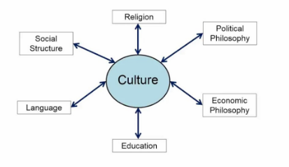
Figure 1: Elements of culture
Cultural & Leadership Comparison:
The following comparative analysis uses the information obtained from the GLOBE Project to determine the differences and similarities between the UK and France in more detail (Hampden-Turner & Trompenaars, 2020).

Power Distance:
The UK's power distance is lower, reflecting the equal distribution of power and authority and people’s willingness to approach leadership, which is beneficial at the Hotel. On the other hand, France has a relatively low power distance, so the hierarchical approach to decision-making is appropriate, and people obey the authorities.

Uncertainty Avoidance:
Globe’s analysis also shows that French society has relatively high figures on the uncertainty avoidance index, indicating that French people are more comfortable with well-defined guidelines at the Hotel. The UK's preference for risk is lower in scores, and they are more willing to accept uncertain and ambiguous situations.FF

Collectivism vs. Individualism
France is simultaneously less collectivistic than the UK. Employees in the UK are more inclined to be focused on their success and personal freedom. France is more individualistic than other countries but holds slightly more collectivistic tendencies, as observed under the subcategories, particularly about group support.

Gender Egalitarianism
France practices low protection of women’s rights but values them at a medium rate. However, the study observes a focus on the leading female and male roles more typical of a tradition-orientated society in the UK.

Assertiveness
French culture is a medium practice for assertiveness. It prefers to make decisions but relies more on senior management (Houldsworth & Jirasinghe, 2006). The British see themselves as a blend of directness in expression and politeness that rejects boorish behaviour, as stated by Houldsworth Jirasinghe (2006).

Future Orientation
The UK's practice of better future orientation is medium compared to France's, which focuses on long-term horizons and investing. French culture has a low practice of future orientation, encompassing present and past circumstances.

Performance Orientation
The UK prioritises meritocracy and performance and values it highly. Compared to the French, their practice score is medium as they prioritise competence.

Humane Orientation

These variations can be evidenced by British scores demonstrating a higher humane orientation. France also values humane practices highly, though not in the individualist manner of looking at social welfare.
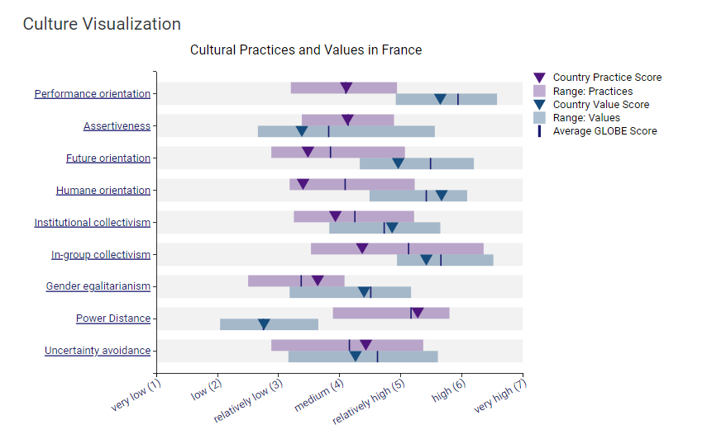
Figure-2: Culture Visualisation

Challenges of Intercultural Leadership
Intercultural leadership between UK and French employees also has challenges (Huang, et al., 2004). This is particularly the case of the difference between the British and French approaches that are necessary to understand the Hotel. This leads to hard feelings and crossed signals at the workplace. Additionally, attitudes towards hierarchy differ: UK employees may de-emphasise their professional roles in favour of equality and informality. At the same time, French employees may follow a more rigid, strict reporting-line structure with a corresponding formal demeanour. Decision-making procedures might also differ: while the UK teams may prefer brainstorming and sound collaboration, the French may anticipate much more autocratic decision-making.
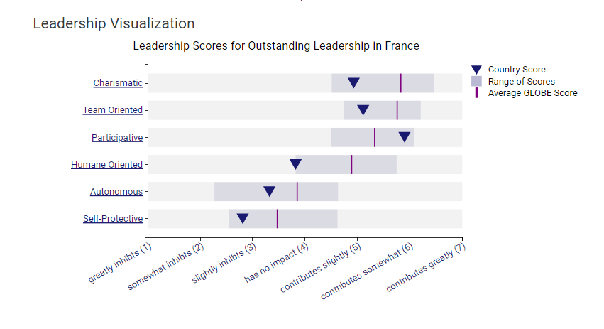
Figure-3: Leadership Visualisation

Potential areas of conflict

Formality in Workplace Interactions:
In formal communication, it is common to call UK employees using their first name to address other employees and their seniors. French may consider it unimpressive and unprofessional as they are more likely to start addressing their business partners with great formality and use more formal language during negotiations.

Work-Life Balance:
In the UK, people might be willing to compromise and work longer hours, stay until late at night, or use email even outside working hours at the Hotel. Contrary to some countries, french workers remain conscious about limiting their working hours and do not expect to be called even during the evenings.

Example:
A British worker at the hotel provided constructive comments, in which polite remarks create a barrier of praise before and after the negative observations. Some French consider this approach insincere or misleading since they tend to get to the point quickly (LaJuan, 2021).

Conclusion:
Managing interculturally between employees from the UK and France involves communication and interaction, power distance/ hierarchy, politeness, punctuality, working hours/ norms, evaluation, and constructive criticism. If these differences are not pondered, they could cause a communication breakdown, and employee frustration to a certain extent at this Hotel..

Recommendations:
- The Hotel should employ intercultural training and development initiatives to improve employees' understanding of cultural differences.
- The Hotel’s adoption of a balanced strategy may tap into the two cultures’ inclination toward collaborative processes.
- Clear expectations for working hours and expectations of bearing and addressing multiple responsibilities and professional decorum may be established (Satria & Dhanin, 2022).

References
Cloutier, O., Felusiak, L., Hill, C. & Pemberton-Jones, E. J., 2015. The Importance of Developing Strategies for Employee Retention. Journal of Leadership, Accountability and Ethics, pp. 119-129.
Ferreira, J. & Ferreira, C., 2018. Challenges and opportunities of new retail horizons in emerging markets: The case of a rising coffee culture in China. Bus. Horiz, p. 783–796.
Hampden-Turner, C. & Trompenaars, F., 2020. Riding the Waves of Culture. London: John Murray Press.
Houldsworth, E. & Jirasinghe, D., 2006. Managing & measuring employee performance. London: Kogan Page.
Huang, J.-H., Yang, C., B.-H, J. & Chiu, H., 2004. I am measuring satisfaction with business-to employee systems. Computers in Human Behavior, pp. 17-35.
LaJuan, P. F., 2021. Foundational Leadership Theory: An Ethical Leadership Approach to Developing Positive Employee Work Engagement. Open Journal of Business and Management.
Satria, N. & Dhanin, 2022. Analysis Of Leadership Style Application And Motivation By Managers In Improving Housekeeping Employees Performance At Bumi Senyiur Hotel Samarinda. Jurnal Syntax Fusion 2, p. 520–28.

