Student Name : Nadia Jabeen
ID : 2234783

CHAPTER 4: FINDINGS AND DISCUSSION

4.1 Introduction
This chapter introduces and critically evaluates the results of thematic analysis of the chosen literature on the topic of the occupational therapy (OT) role in assisting children with Autism Spectrum Disorder (ASD) in the UK school system. The chapter recaps findings of peer-reviewed studies, policy frameworks in the UK, and guidance by the professions, found in Chapter Three. The systematic coding of the literature produced three themes, namely: (1) Occupational Therapy Interventions that aid functional and Sensory Participation, (2) Multidisciplinary Collaboration and Inclusive Practice, and (3) Barriers and Inequalities in Service Delivery. Individual themes are discussed based on the research aim and objectives with empirical evidence and policy context, and critically evaluated to find out implications to practice and future development.
4.2 Thematic Analysis
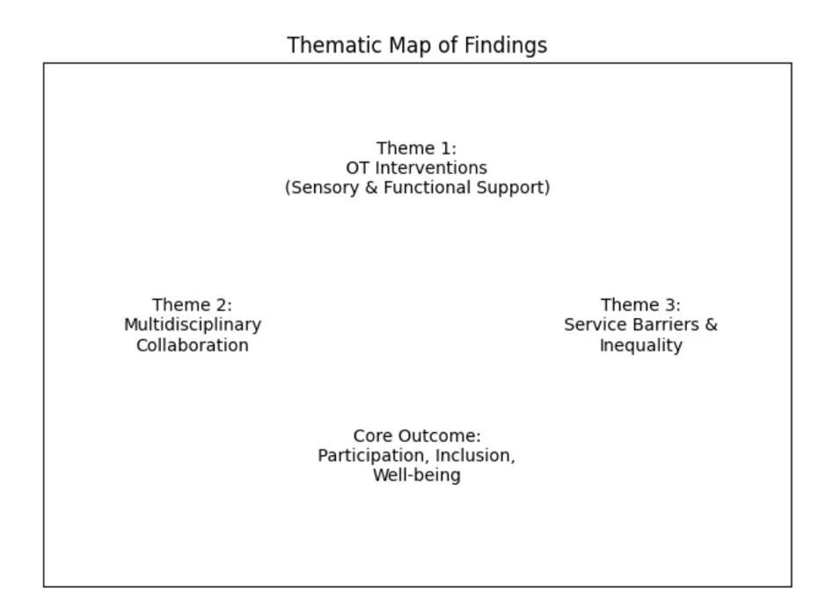
Thematic analysis is a qualitative approach that is employed to discover, examine and interpret patterns (themes) in data (Braun and Clarke, 2006). Within the scope of this secondary study, thematic analysis allowed the orderly analysis of the common concepts in academic literature, policy publications, and professional advice as per occupational therapy and ASD in UK schools.

The literature that was selected was read multiple times following the six-phase model by Braun and Clarke (2006) to facilitate familiarisation. The first codes came into being on the basis of recurring concepts which included sensory integration, functional participation, inclusive education, multidisciplinary working, policy frameworks and service inequalities. The results table was arranged with coloured results (visible in Chapter 3 and Appendix), and the patterns could be manifested across sources using these codes. There were three broad themes that were identified:
1. Occupational Therapy Interventions Supporting Functional and Sensory Participation
2. The Multidisciplinary Collaboration and Inclusive Practice in Schools.
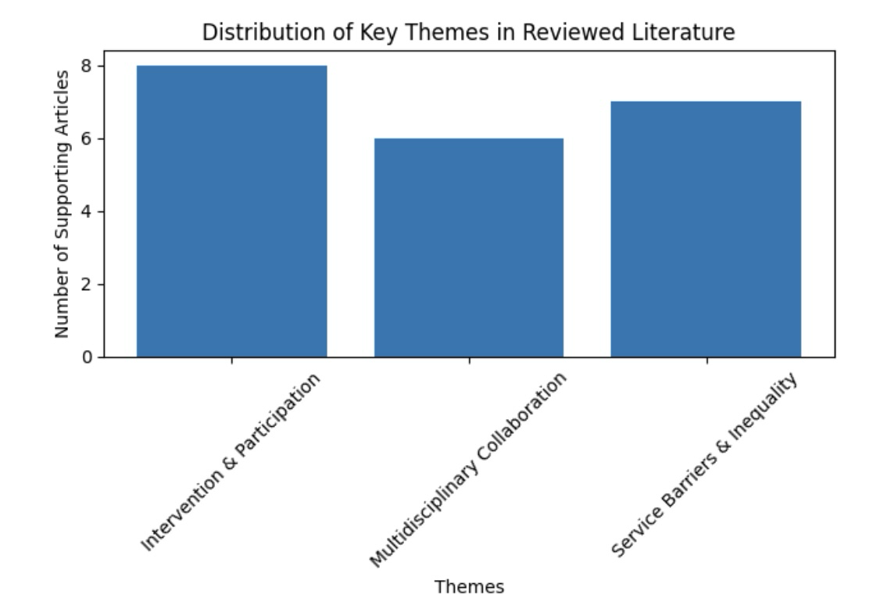
3. Ethnicity and Disparities in the Service Provisions of Occupational Therapy.

These themes directly tackle the study objectives: the analysis of the OT standards and interventions, their effects on participation, and the policy and service implementation in the context of the UK. Each of the themes is discussed below.

4.3 Theme 1: Occupational Therapy Interventions to Promote Participation in Functions and Senses
Definition
This theme discusses the application of occupational therapy to overcome sensory processing deficits, motor skill deficits, and functional participation barriers that children with ASD face at school. Functional participation is the capability of a child to participate constructively in academic, social and self-care activities in the classroom (World Federation of Occupational Therapists, 2016).
The school-based occupational therapy is intended to improve participation and not to simply treat the impairment. This is in line with the Person-Environment-Occupation (PEO) model (Kielhofner, 2008), which puts a special focus on the interaction between the person, the surroundings, and the kind of tasks that he/she is supposed to do.
Background and Context
ASD children often have sensory processing anomalies, motor coordination impairments, and executive dysfunction (Robertson and Baron-Cohen, 2017). These are issues that have a strong influence on classroom interaction. An example is that hypersensitivity to noise or touching may cause distress or withdrawal behaviour, which diminishes lessons (Dunn, 2007)
The UK inclusive education framework is one area that has been witnessing a rise in the number of children with ASD being trained in standard schools through the SEND Code of Practice (Department for Education, 2015). Nevertheless, the barriers to participation can still be observed, especially in those settings that are not geared towards sensory or functional requirements (Lamb et al., 2019).
Occupational therapists are in a special position to fill this gap by adjusting tasks, altering environments, and assisting in the development of skills in order to access the curriculum.

Religious Relevance to the Research Question
The key purpose of this dissertation is to explore the importance of occupational therapy in the promotion of children with ASD within the UK schools. This theme directly relates to that purpose by considering the way OT interventions can be improved:
• Academic engagement
• Social participation
• Functional independence
• Emotional regulation
Children with ASD might not be able to receive education equally without focused OT interventions. Thus, the discovery of intervention efficacy is crucial in concluding the worth of OT in the school system.
Sensory Integration Interventions
One of the most popular occupational therapy methods to work with children with ASD is the so-called sensory integration (SI) therapy. SI theory was initially created by Ayres (2005), and according to it, neuro-processing of sensory input influences behaviour and learning.
In their systematic review, Case-Smith et al. (2015) established moderate evidence that occupational therapy interventions built on the use of sensory can positively influence goal attainment and functional participation among children with ASD. On the same note, Pfeiffer et al. (2018) found that with fidelity, structured sensory integration interventions led to improvements in social responsiveness and sensory processing.
As Schaaf et al. (2014) showed, sensory integration interventions with the implementation of the established protocols showed significant improvement in the results of participation in comparison with regular care. This observation is especially applicable since it implies that effectiveness requires organised and evidence-based realisation instead of unstructured strategies guided by sensory.
Nevertheless, controversial details are also manifested in the literature. Other scholars state that the use of outcome measures is inconsistent (Camden et al., 2015), and there are widely different implementations in schools in the UK. This means that SI interventions may be effective, but they have to be impactful on the basis of training, consistency and contextual application.
Handwriting and Motor Skills Interventions
Children with ASD face difficulties with fine motor aspects, which have a direct impact on handwriting, the use of tools in the classroom, as well as student achievement (Feder and Majnemer, 2007). To enhance the speed and legibility of handwriting, structured handwriting programmes and strategies of motor skill development are offered by occupational therapists.
In primary school, handwriting skills are particularly important. Unless they are intervened in, children can get frustrated with their schoolwork and lose self-esteem. Feder and Majnemer (2007) note that motor interventions led by OTs guarantee significant performance and classroom involvement.
In the context of the UK, Lamb et al. (2019) insist on the fact that the occupational therapists who are employed in mainstream schools tend to consider the challenges with fine motor and coordination issues as the central aspect of the service delivery. This justifies the argument that OT directly enhances access to education.
Environmental Adaptation and Participation
Occupational therapists modify the classroom environment and develop their skills individually. This may include:
- Changing seating pattern.
- Breaking movement- Breaking movement can be introduced.
- Reducing sensory overload
- Providing visual supports
Environmental modification is one of the mechanisms that are favoured by the PEE model (Kielhofner, 2008) to enhance participation. OT does not only look at the deficiencies of the child; instead, it looks at the child as a disconnect between the child and their environment.
This strategy is closely connected to the inclusive education policy in the UK (Department for Education, 2015), which suggests eliminating obstacles to learning instead of making the child fit into a strict framework.

Implications (Positive and Negative)
Positive Implications:
- Better classroom interaction.
- Greater emotional control.
- Greater independence
- Higher teacher sensory awareness.
- Physical promotion: Inclusive practice should be encouraged.
Negative/Challenging Implications:
- Non-uniformity in implementation in schools.
- Miscellaneous- Limited supply of therapists.
- Variability in training
- Issues over the strength of sensory evidence.
Fidelity, collaboration and contextual adaptation seem to be closely associated with the effectiveness of OT interventions. OT is a great facilitator of participation when put in place correctly. Sustainability is, however, lowered by limited resources.
Connections to Other Themes
This theme is related to Theme 2 (Multidisciplinary Collaboration). Most of the OT interventions involve teacher application and parent reinforcement. The lack of collaborative working means that the application of sensory or motor strategies may not be regular.
It is also connected to Theme 3 (Service Inequalities) since the possibility of high-quality interventions is based on the commissioning structures and the workforce capacity.
Comparison of Important Articles
Case-Smith et al. (2015) applied a systematic review to investigate the sensory processing intervention of children with ASD. According to their findings, there is moderate evidence that they provide that can support the use of sensory-based occupational therapy in enhancing individualised goals and functional performance. Notably, the review focuses on specifically aimed and structured interventions instead of unspecifically oriented sensory diets. This difference makes the point of argument that OT interventions can be effective when they are integrated into quantifiable results.
Equally, Schaaf et al. (2014) have shown good results in Ayres Sensory Integration 12 provided with fidelity. The analysis demonstrated that there was a great improvement in participation objectives over control groups. This offers empirical justification for sensory integration delivered through a systematic approach by trained professionals.
Nonetheless, Camden et al. (2015) found a lack of consistency in the intervention strategies and outcome measures used in ASD intervention studies. This inconsistency complicates generalisation since it is hard to predict the findings and the quality of implementation in real-life school environments. Whereas well-designed research protocols demonstrate some positive results, the everyday practice of school life might not help to recreate such controlled conditions.
Pfeiffer et al. (2018) also confirm the possible sensory integration potential because they state the enhancement of social responsiveness and sensory behaviours. Nevertheless, their paper was defined as a pilot study, which implies a reduced sample and may impose a restriction on generalisability.
In general, the chosen articles are mostly consistent in the assumption that occupational therapy interventions could enhance participation and behavioural outcomes among children with ASD. They, however, vary in evidence strength and emphasise inconsistency in methodology. This supports the argument that there should be regular outcome measures in the UK school environments.
Greater Discussion in the Century of UK Schools
Occupational therapy is frequently incorporated in the education system of the UK in the form of Education, Health and Care Plans (EHCPs) under the SEND Code of Practice (Department for Education, 2015). The levels of the frequency of sensory and motor interventions are determined by the local commissioning arrangements (Lamb et al., 2019).
Practically, there are those occupational therapists who engage in direct intervention sessions and others who use the consultative approaches. According to the literature, consultative strategies can facilitate broader inclusion in the classroom, yet can compromise the severity of direct therapy.
The results thus show that occupational therapy interventions are effective in principle but are greatly affected by structural and contextual factors. This fact is directly related to the research goal of examining the effect of OT procedures on academic and social participation.
4.4 Theme 2 Multidisciplinary Collaboration and Inclusive Practice in Schools
Definition
Multidisciplinary collaboration is the process of the joint work of different professionals in order to address the educational and developmental needs of a child. Regarding ASD, these are usually occupational therapists, teachers, teaching assistants, speech and language therapists, educational psychologists and parents.
Inclusive practice is defined as an educative practice in which children with additional needs get to contribute meaningfully as their peers.

Background and Context
The UK policy frameworks focus on integrated work on health, education, and social care. A person-centred and coordinated approach is encouraged in the SEND Code of Practice (Department for Education, 2015). The Education, Health and Care Plans (EHCPs) are created so as to enable planning together.
It has been indicated that teamwork enhances uniformity and performance. According to Cameron et al. (2012), joint working was associated with shared goals, effective communication, and role definition. They also identified the obstacles, namely, time issues and professional boundaries.
This is the situation with children with ASD, whose home and school environments require consistent support. There are sensory strategies, behavioural strategies and environmental strategies that need to be reinforced outside the therapy sessions.
Applicability to the Research Question
The dissertation will have the objective of not only reviewing the OT interventions but also determining the impact of multidisciplinary teamworking in facilitating inclusion and well-being. This is the main theme upon which the role of occupational therapy in the broader education system can be understood.
Collaborative implementation can make even the evidence-based interventions ineffective. Therefore, the success of the work of occupational therapy is connected to the quality of the work-related relationships and school culture.
The Literature provides evidence
Lindsay et al. (2014) discussed the views of educators and employers on the topic of supporting students with disabilities. They discovered that partnership improved the knowledge of student needs and better adaptation strategies. The teachers appreciated specialist input but claimed that they needed more direction and training.
The model of Partnering for Change (P4C) that Missiuna et al. (2012) proposed is a school-based occupational therapy service delivery model; it involves collaboration and capacity-building. Even though the model was carried out in Canada, it offers pertinent information. It focuses on coaching teachers, needs early identification, and entrenching strategies in the normal classroom routines.
Such a model of collaboration is congruent with the principles of inclusive education and makes the process less dependent on the individual pull-out sessions. Rather, occupational therapists develop teacher competence, which can improve sustainability.
In their study in the UK, Lamb et al. (2019) noted that role clarity is vital in mainstream schools. There was a general misconception in the scope of occupational therapy to the extent that some teachers viewed it as purely medical and not as an educational task. This misconception may restrict the ability to cooperate.
Policy and Legislative Environment
It is legally mandated by the Children and Families Act 2014 and the SEND Code of Practice (Department for Education, 2015) that education and health services should jointly commission. Nonetheless, the way it is implemented differs among local authorities.
The NICE (2021) autism guideline is based on multidisciplinary assessment and treatment. Even though NICE appreciates the role of occupational therapy, it does not recommend particular models of service. This adaptability gives room to adaptation as well as results in inconsistency.
Hence, even though policy indicates collaborative working strongly, it is based on local systems and resource allocation to be applied practically.

Positive and Negative Implications
Positive Implications of Collaboration:
- Increased inter-setting consistency.
- Increased teacher self-confidence.
- Comprehensive knowledge of child needs.
- Improved inclusion
Counterproductive or Stressful Implications:
- Role ambiguity
- Time constraints on holding joint meetings.
- Communication breakdown
- Resource constraints
According to Cameron et al. (2012), there must be structural support in terms of integrated working. Collaboration can not be superficial without a leader and common systems.
Critical Evaluation
Most of the literature accepts the fact that children with Autism Spectrum Disorder have better outcomes when multidisciplinary collaboration is used. Nonetheless, there is a lack of empirical evidence that measures the effect of collaboration directly on academic performance.
Although Missiuna et al. (2012) offer a systematic collaborative model, additional research in the UK context is needed to assess similar models in the NHS and the local authority system.
Connections to Other Themes
This theme is highly related to Theme 1. Teacher reinforcement is needed in sensory integration strategies. Adaptation of motor skills should be incorporated in class activities. As a result, collaboration mediates intervention effectiveness.
4.5 Theme 3: Obstacles and Inequalities in the Service Delivery of Occupational Therapy
Definition
The theme deals with structural, systematic and professional obstacles that affect availability, uniformity and efficiency of occupational therapy (OT) services among children with Autism Spectrum Disorder (ASD) in UK schools. Barriers are organisational, financial, workforce, and policy-based barriers that suppress equitable service delivery. Inequalities can be defined as differences in access to OT support in regions, schools, and local authorities.
Background and Context
Despite the fact that UK legislation underlines inclusive education and multidisciplinary assistance, studies show that there is a considerable variation in the provision of occupational therapy services among the local authorities. Children with known needs can get support under an Education, Health and Care Plan (EHCP) as stipulated in the Children and Families Act 2014 and the SEND Code of Practice (Department for Education, 2015). Nevertheless, local commissioning, allocation of funds and capacity of a workforce usually define access to occupational therapy.
Lamb et al. (2019) report OT variation in the UK among mainstream schools. In certain regions, therapists are integrated into the school systems, whereas in others, the role of therapists is confined to assessments. This introduces geographical inequalities, i.e. children having similar needs might get very different levels of intervention based on the location.
Sensitivity to the Research Question
This dissertation is meant to analyse the role of occupational therapy in assisting children with ASD within the UK school system. Barriers would give insight into whether OT is accomplishing what it should be accomplishing.
Although it may have been proven that OT interventions are effective (Theme 1) and collaboration supplements inclusion (Theme 2), children may not be able to enjoy these advantages due to systemic barriers. Thus, this theme will directly answer the research problem of examining accessibility and making recommendations.
Staffing and Resource Limitation
The literature has indicated a significant obstacle to workforce limitation. According to Rens and Joosten (2014), there are also high caseload demands on OT services in schools, which leads to little time to work directly. Statutory assessment of EHCPs is often given priority by therapists compared to continuous therapy sessions.
Lamb et al. (2019) also emphasise that not all occupational therapists can work on a full-time basis because of the lack of time. Although consultation has the power to empower teachers, it could decrease the intensity of child-centred intervention.
This change in direct intervention to advisory roles can undermine the quantifiable effect on the results of participation. It also imposes a further burden on the teachers who might not be specifically trained on sensory processing or the development of motor skills.
These workforce problems are worsened by the financial strains in the NHS and local authority systems. The rise in ASD diagnoses (NICE, 2021) has led to a growth in the demand for services without a corresponding growth in resources.
Role Ambiguity and Professional Identity
Role ambiguity is another obstacle identified in the literature. Both Missiuna et al. (2012) and Lamb et al. (2019) remark that teachers do not always understand the extended role of occupational therapy. OT can be viewed as a medical service rather than an educational partner. The consequence of this misunderstanding can be:
- Limited referrals
- The underexploitation of expertise.
- Less inclusion in planning in the classroom.
- It has an uneven application of strategies.
Professional identity is also influenced by role ambiguity. Occupational therapists in education settings might have difficulty in their ability to communicate their value in curriculum-based settings.

Evidence Gaps and Limitations to Research
As mentioned by Camden et al. (2015), there is inconsistency in the reporting of interventions and outcome measurement among studies of ASD interventions. This makes it difficult to develop sound evidence-based guidelines for school-based OT.
In addition, most of the good sensory integration studies are not based in the UK. Although theoretically transferable, variations in service organisation, funding model and education systems might restrict direct applicability.
Long-term education and social outcomes also cannot be understood due to the absence of longitudinal studies. Camden et al. (2015) state that most of the studies involve the short-term outcomes but not the long-term engagement.
Policy–Practice Gap
Person-centred planning and collaborative commissioning of education and health is encouraged in the SEND Code of Practice (Department for Education, 2015). Implementation, however, is very different. Although NICE (2021) lays stress on multidisciplinary approaches, it does not impose definite service delivery models. This flexibility can promote local innovation, though it leads to disparity.
Literature indicates that there is a disjuncture between rhetoric and resource allocation on inclusive policy. Inclusion demands the investment in the specialised personnel, training and coordinated service models.
Good Progressions and Opportunities
As it is established by Missiuna et al. (2012) collaborative models of building capacity may help raise sustainability and minimise the use of individual therapy sessions. The integration of occupational therapy plans into the whole-school models can be the most effective way of reaching the maximum number of people.
Universal design and early intervention models also have their opportunities for preventative support. Instead of responding to the specific crisis, occupational therapists can make a contribution to the inclusive classroom design that will benefit several students.
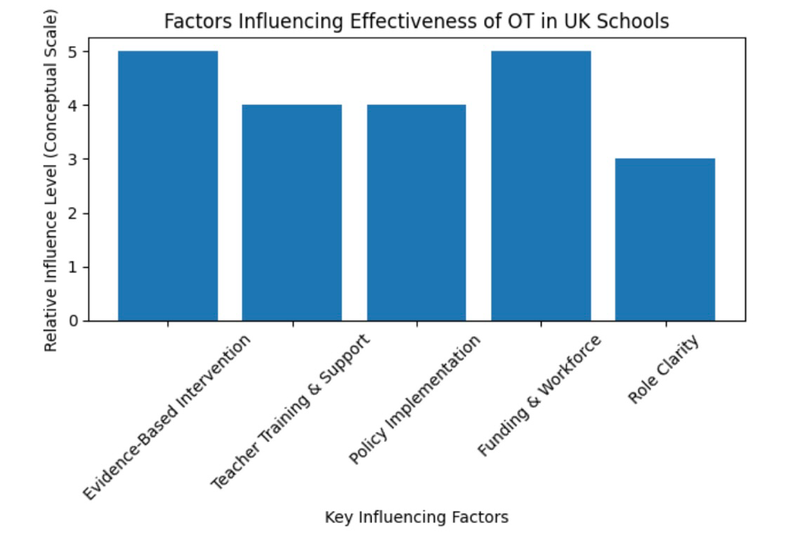
Teacher knowledge about sensory and motor needs could also be improved with the help of digital training materials and professional development programmes.

Implications for Practice
The consequences of this theme are great:
Negative Implications:
- The unfair access to OT services.
- Delays in intervention
- Decreased severity of therapy.
- The burden on teachers has increased.
- Poor implementation.
Positive Opportunities:
- Capacity-building models
- Whole-school approaches
- Clearer role definition
- Enhanced accountability of policy.
- Standardised outcome measurement.
These barriers have to be overcome for occupational therapy to realise its potential in the context of inclusive education.
Connections to Other Themes
This theme is closely related to Theme 1 and Theme 2
Sensory integration and motor skill interventions (Theme 1) cannot be provided consistently without sufficient capacity of the working force. In the absence of structural support, the multidisciplinary collaboration (Theme 2) can be superficial.
Therefore, a systemic barrier affects the outcomes of intervention and collaboration. Such results underscore the fact that the role of an occupational therapist is not only influenced by professional skills but also by institutional frameworks.
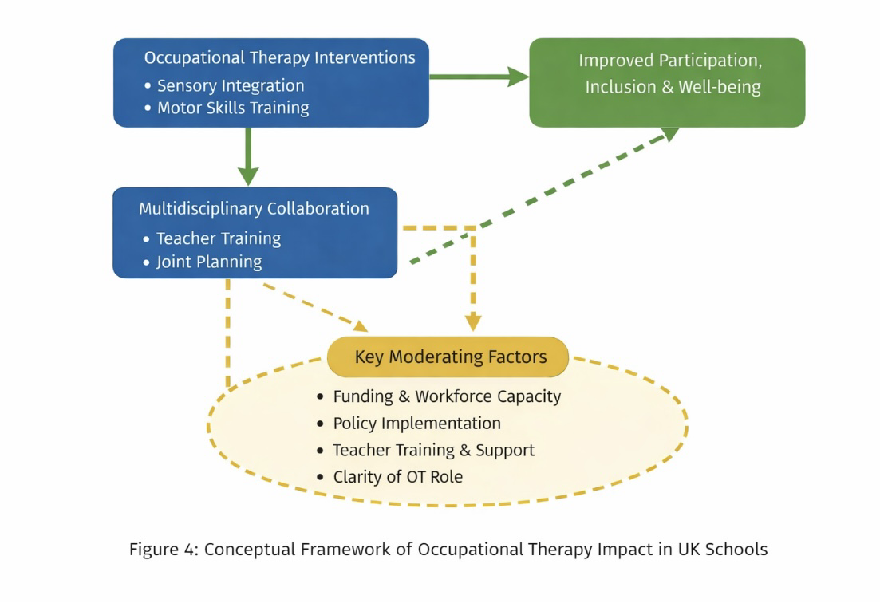
4.6 Conceptual Framework

4.7 Chapter Conclusion
The chapter has also introduced and critically analysed the results of thematic analysis on the topic to investigate the role of occupational therapy in facilitating children with Autism Spectrum Disorder in the UK school system.
Three important themes were determined, including occupational therapy interventions to facilitate functional and sensory engagement; interdisciplinary teamwork and inclusive practice; and barriers and disparities to service delivery. The results indicate that occupational therapy is an important intervention in enhancing classroom involvement, emotional regulation, motor, and inclusive involvement. Sensory integration and motor-based interventions have evidence in their support, provided that they are provided in a systematic and collaborative manner.
The next chapter will critically review these findings in connection with the existing literature and policy, and will give suggestions on how to enhance the practice of occupational therapies, accessibility, and long-term support in the UK school system.

CHAPTER 5: CONCLUSION AND RECOMMENDATIONS

5.1 Overall Conclusion
This dissertation has discussed how occupational therapy (OT) can facilitate children with Autism Spectrum Disorder (ASD) in the UK school system. The purpose of the research was to assess the efficacy of the occupational therapy interventions in providing improvement in functional, social, and educational performance, and to determine the effect of multidisciplinary collaboration and policy frameworks on inclusion and well-being.
In Chapter One, the background of ASD in the education sector was presented, and the justification of the study into the role of occupational therapy in the UK context was found. Chapter Two critically examined the available literature, pointing out the effects of sensory processing variations, motor difficulties and barriers to participation as they influence school engagement. It further discussed theory bases like sensory integration theory and occupation-based models, and UK policy frameworks like the SEND Code of Practice. Chapter Three described the second type of qualitative methodology and thematic analysis, which was employed to compile relatable research and policy documents.
Chapter Four has been able to distinguish three main themes, namely: (1) occupational therapy interventions that allow functional and sensory involvement; (2) multidisciplinary teamwork and inclusive practice; and (3) obstacles and disparities in service delivery. The results proved that occupational therapy may play a significant role in promoting participation, emotional regulation, and access to academic activities when provided effectively. Nevertheless, the provision is hampered by workforce issues, financial pressures, and geographical discrepancies.
The aim and objectives of the research have been achieved. The research has helped to elaborate the existing OT practices in UK schools, assess sensory and motor interventions, critique policy frameworks, and recommend the need to improve accessibility and collaboration. In general, the dissertation has found that occupational therapy can contribute significantly to the inclusion and well-being of children with ASD. Still, structural changes are required to make the most of it.
5.2 Recommendations
Following the results of this study, three main recommendations are formulated that can help to improve the Occupational therapy practice and accessibility in the UK school system.
5.2.1. Recommendation 1: Create and adopt a Whole-School Occupational Therapy Model
Recommendation:
A whole-school occupational therapy model where OT principles are implemented into normal classroom work should be embraced by local authorities and schools instead of focusing mainly on person-centred intervention based on assessment.
The results of Chapter Four revealed that though direct sensory integration and interventions in motor can enhance participation, there is a constraint on the availability of therapists that tends to decrease the intensity of support. The whole-school model would entail the occupational therapists offering systematic training, consultation, and involved planning with teachers. This practice would encourage universal learning design and preventive approaches to benefit children with ASD as well as other students with special needs.
Through the integration of sensory-friendly classroom modifications, movement breaks, and inclusive environmental modifications into a routine, the role of occupational therapy can be maintained and will not be reliant on an individual session. This also corresponds with the principles of inclusive education as provided by the SEND Code of Practice.
Barriers:
- Insufficient financial support for therapist time.
- Antipathy to systems change.
- Workload pressures of the teachers.

Overcoming Barriers:
- Slow innovation using pilot programmes.
- Incorporation of OT training in the current professional development.
- Determined evidence of cost-effectiveness in the long term through crisis referral reduction.
This recommendation is a response to the theme of service inequality as it moves away from the reactive intervention to the proactive, embedded support.
5.2.2. Recommendation 2: Enhance Multidisciplinary Cooperation with the help of Organised Communication Channels.
Recommendation:
Formalisation of structured multidisciplinary communication channels should be done in schools and local authorities through frequent joint meetings, joint goal setting and well-defined professional roles.
The study determined that collaboration was one of the key factors that affect the effectiveness of occupational therapy. Although there is a policy in promoting joint working, there is still a lack of consistent implementation. Collaboration would be formalised so that the occupational therapists, the teachers, parents and other professionals would be working in common goals of participation. This could include:
- Periodic review meetings (scheduled on a term basis).
- Common electronic communication platforms.
- Intelligent documentation of OT strategies in the EHCP plans.
- Clarified the roles of implementation.
Organised cooperation would enhance the regularity of sensorial plans and classroom adjustments, decreasing the support fragmentation.

Barriers:
- Time constraints
- Role ambiguity
- Communication breakdown
Overcoming Barriers:
- Digital communication facilitates communication.
- Effective role definitions in school policies.
- School management leadership.
Increasing the collaboration would increase the implementation fidelity of occupational therapy interventions and would lead to better child outcomes.
5.2.3 Recommendation 3: Standardise the Outcome Measurement and Enhance Evidence-based Practice in the UK Schools
Recommendation:
They should come up with national guidelines or regional outcomes that would facilitate the standardisation of outcome measures of school-based occupational therapy intervention to provide an equal evaluation of participation and inclusion outcomes.
Variation in intervention reporting and inconsistent outcome measures were identified as among the most important limitations in Chapter Four. Although studies prove the effectiveness of the sensory integration and motor interventions, inconsistency obstructs comparability and hinders policy advocacy. Standardised participation-oriented outcome tools would:
- Improve accountability
- Enhance the argument on commissioning decisions.
- Support Evidence-based practice.
- Improve the evaluation of educational performance over the long term.
These tools ought to be those that emphasise functional involvement, inclusion and well-being and not separated skill execution.
Barriers:
- Diversity between local authorities.
- Resource constraints to training.
- Opposition to more documentation demands.
- Overcoming Barriers:
- National direction associated with SEND structures.
- Training of the occupational therapists.
- Incorporation of outcome tools in existing EHCP documentation.
This recommendation deals with service inequality as well as gaps in evidence found in the results. With more powerful data collection, the occupational therapy services will be able to prove their impact more efficiently and request fair funding.
Final Reflection
This dissertation has brought to light the fact that occupational therapy is an important and changing field in assisting children with Autism Spectrum Disorder in the school system in the UK. Participation, environmental adaptation, and collaboration are the key features of the profession that are quite compatible with the principles of inclusive education. Nevertheless, in order to maximise the potential of occupational therapy, systemic changes are needed.
The processes of making the occupational therapy services more equitable, sustainable, and impactful can be achieved by applying the whole-school models, reinforcing the multidisciplinary collaboration, and standardising the measurement of outcomes. The recommendations are feasible and can be implemented in the existing policy frameworks, as long as the leadership, funding, and professional advocacy are in harmony.
Finally, the improvement of occupational therapy services is not a professional problem only, but an educational equity and a child welfare problem. Making sure that children with ASD are able to make a beneficial contribution to school life is not only a guarantee of academic achievement but also the successful integration into society in the long term.

