Physiological Case Study – Football Winger
Football is a dynamic, high-intensity sport that places significant physical demands on players, particularly those in wide positions such as wingers. The winger’s role is multifaceted, involving frequent sprints, rapid changes in direction, and continuous involvement in both attacking and defensive phases of play. Due to these demands, wingers require a highly developed physiological profile that combines aerobic endurance, anaerobic power, acceleration and deceleration capability, and high-speed running capacity.
During a typical match, professional footballers cover between 9 to 14 kilometres, with wide midfielders and wingers among the players covering the longest distances due to their continuous movement up and down the pitch (Modric et al., 2020). Importantly, it is not only the total distance that matters but also the intensity of movement. Wingers perform a high volume of high-intensity running and sprinting actions, which often exceed 600 to 1200 meters of sprinting per game, depending on tactical style and level of play (Oliva-Lozano et al., 2020). These actions are critical in offensive transitions and defensive recoveries, requiring rapid acceleration and deceleration throughout the 90 minutes.
According to recent tracking data, wingers and wide midfielders exhibit the highest numbers of explosive movements, including over 500 high-speed efforts involving changes in velocity (Oliva-Lozano et al., 2020). These explosive movements demand not only neuromuscular power but also muscular resilience to tolerate the eccentric loading associated with deceleration. This makes lower body strength and power essential for both performance and injury prevention.
The cardiovascular demand placed on wingers is also substantial. Match play consistently elevates heart rate to 85–90% of maximum, with wingers often spending prolonged periods above 90% HRmax during intense phases of the game (Krustrup et al., 2021). This highlights the importance of a strong aerobic foundation to support sustained activity, aid in recovery between efforts, and maintain performance across the match duration. VO2max values in elite players commonly exceed 60 ml·kg⁻¹·min⁻¹, indicating the need for excellent aerobic conditioning (Buchheit & Simpson, 2017).
In addition, repeated sprint ability is critical for wingers. These players are often required to execute maximal or near-maximal sprints with short recovery intervals. The physiological capacity to recover and reproduce sprint performance relies on both anaerobic energy systems and metabolic recovery efficiency. Players must also possess excellent agility and motor coordination, as successful wingers frequently engage in one-on-one situations that require rapid footwork and directional changes under pressure.
In summary, the physical and physiological demands of the winger position in football are among the highest on the field. Wingers must demonstrate a unique combination of aerobic endurance, anaerobic power, high-speed running ability, and muscular strength. These attributes enable them to perform explosive actions, recover quickly between efforts, and maintain performance throughout the game. A well-developed physical profile is essential not only for enhancing on-pitch performance but also for minimizing the risk of injury in such a demanding role.

Method
VO2 max test
The participant performed a VO₂max test using a cycle ergometer protocol with progressive intensity increases until volitional exhaustion. Equipment included a Wattbike cycle ergometer, mouthpiece and valve, nose clip, breathing tube, Douglas bag, Servomex gas analyser, dry gas meter and vacuum, heart rate monitor, stopwatch, and Borg RPE scale. Following a 4-minute low-intensity warm-up at a resistance lower than the initial test workload, adjustments to the ergometer setup were completed. The test commenced at a low power output and progressively increased based on the participant's age, gender, and activity history. The test concluded when the participant reached volitional fatigue, or their cadence dropped more than 10 rpm below their self-selected cadence. During the final 30–60 seconds of peak workload, expired air was collected using the Douglas bag system. Post-test, the external load was reduced to below warm-up intensity, and the participant completed a 5-minute active recovery phase to ensure a safe physiological cooldown.

Agility T-test
Participant completed an agility shuttle test designed to assess multidirectional speed and change-of-direction ability. The testing area was set up using a tape measure and four marking cones (A, B, C, D), spaced at standardized distances to form a lateral and linear movement pattern. Electronic timing gates were positioned at cone A to record total completion time. The participant began at cone A. On the tester’s command, the participant sprinted forward to cone B and touched its base with the right hand. They then turned left and shuffled laterally to cone C, touching its base with the left hand, followed by a shuffle to the right to cone D, touching with the right hand. They then returned to cone B (touching with the left hand) and ran backward to cone A. Time was recorded as the participant passed back through the timing gates at cone A.

10m sprint
A 20-metre linear sprint test was conducted to assess maximal sprint speed using electronic timing gates (Brower Timing Systems, Draper, UT, USA) and two cones for positioning (cones A and B). The participant began in a standing split-stance position, 0.3 metres behind the first timing gate at cone A, to ensure consistent and reliable measurement. The participant was instructed to maintain the same starting stance for each trial. On the verbal countdown “3 – 2 – 1 – GO,” the participant sprinted maximally toward the finish line, where the second set of timing gates was positioned at cone B. The timing gates automatically recorded the sprint time from gate entry to gate exit. A minimum of three sprints were completed to ensure result reliability, with 2–3 minutes of passive recovery between each trial. Only valid trials with clean, uninterrupted gate triggers were considered for analysis.

Keiser leg press

Results

Figure 1 – VO2max test
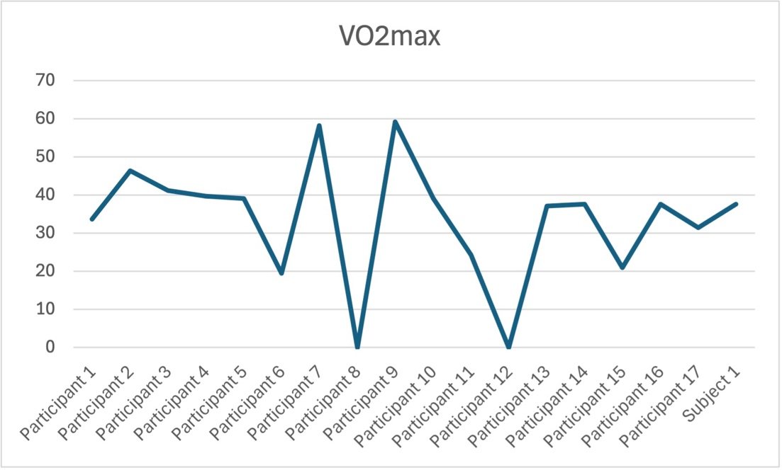

The VO2max data presented in the graph illustrates the aerobic capacity of 18 individuals, including Subject 1. VO2max, measured in ml·kg⁻¹·min⁻¹, is a key indicator of cardiovascular fitness and endurance performance. The values across the participants show considerable variability, with the highest VO2max scores observed in Participant 7 and Participant 9 (approximately 60 ml·kg⁻¹·min⁻¹), indicating superior aerobic fitness. In contrast, Participant 8 and Participant 12 recorded the lowest values, close to zero, which may indicate testing anomalies or very low aerobic capacity. Subject 1 recorded a VO2max value of approximately 40 ml·kg⁻¹·min⁻¹, placing them within the mid-range of the group. This suggests that Subject 1 possesses an average level of aerobic fitness relative to the cohort. While they are not among the highest-performing individuals, they demonstrate a considerably better capacity than the lowest-performing participants. This result may be reflective of moderate training status or general physical activity levels.

Figure 2 – 10m sprint

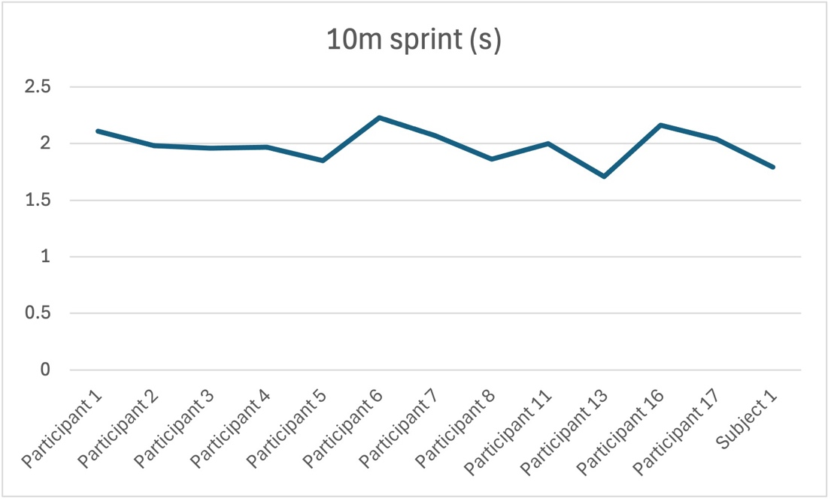
The graph displays the sprint performance times (in seconds) for 14 participants and Subject 1 over a 10-metre distance. The data highlights small variations in sprint times across individuals, with most participants recording times between 1.8 and 2.2 seconds, indicating relatively similar short-distance acceleration abilities. The slowest time is recorded by Participant 6, approximately 2.3 seconds, while the fastest appears to be Participant 5, with a time just under 1.8 seconds. Subject 1 recorded a sprint time of around 1.85 seconds, placing them among the faster performers in the group. This suggests that Subject 1 has a higher-than-average acceleration capability over short distances when compared to the rest of the cohort. Their performance is notably better than several participants, including Participants 6 and 16, indicating effective neuromuscular efficiency and lower-body power output essential for rapid sprint initiation.
Figure 3 – Agility T-test

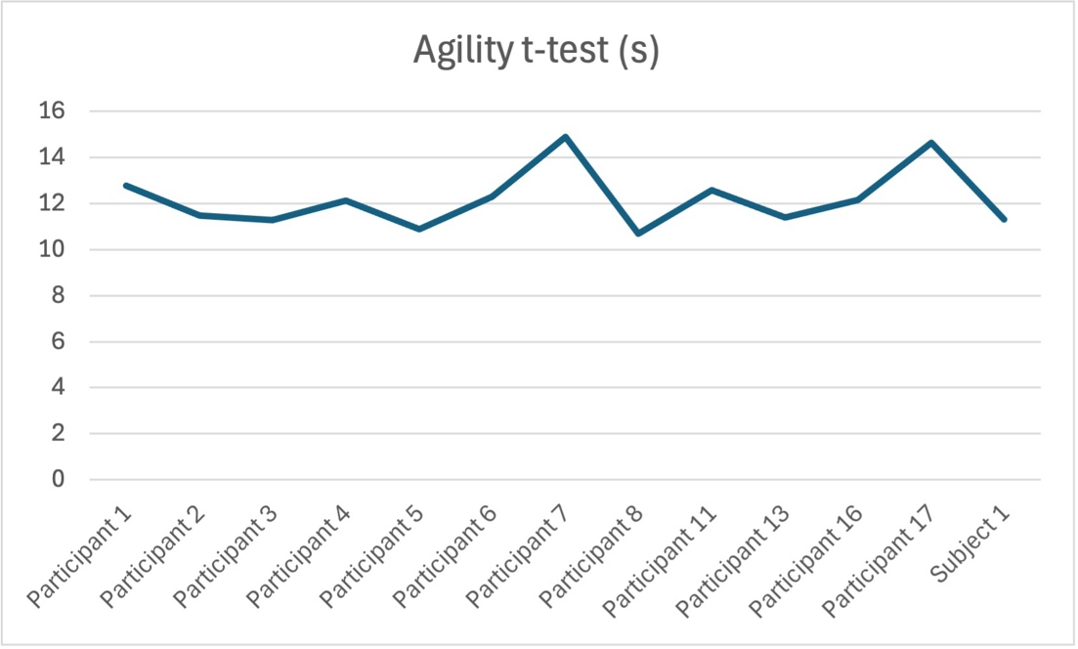
The graph displays the performance times of 14 participants and Subject 1 on the agility T-test, a measure of multidirectional speed and change-of-direction ability. Times across the group range from approximately 11 to 15 seconds, showing moderate variability in agility performance. The slowest time is recorded by Participant 7, at just under 15 seconds, while the fastest appears to be Participant 5, who completed the test in just above 11 seconds. Subject 1 recorded a time of approximately 12 seconds, placing them among the top-performing individuals in the group. Their agility score is notably quicker than several others, including Participants 7, 16, and 17, suggesting efficient movement mechanics and a well-developed ability to accelerate, decelerate, and change direction rapidly. This result indicates that Subject 1 possesses above-average agility relative to the rest of the group, an important quality in sports requiring quick directional changes such as football or basketball.

Figure 4 – Keiser Leg Press

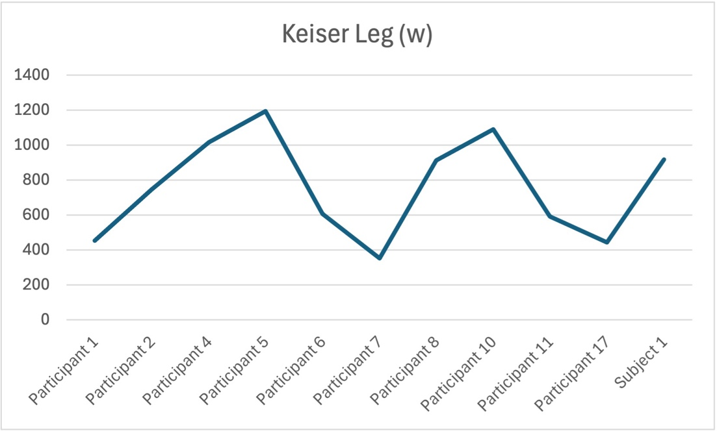

Discussion
This discussion critically evaluates the physiological performance of Subject 1, a football winger, using their results from three key fitness assessments: VO2max, 10-metre sprint, and the agility T-test. These tests provide insight into their aerobic endurance, acceleration, and multidirectional movement, physical attributes crucial for high-level performance in football, particularly in wide positions.
Wingers are among the most physically active players on the pitch, often required to cover large distances at varying intensities, interspersed with frequent accelerations, decelerations, and changes in direction (Teixeira et al., 2021). As such, understanding a winger’s physiological profile helps inform training needs and match preparation strategies.
Subject 1’s VO2max value was approximately 40 ml·kg⁻¹·min⁻¹, placing them in the mid-range of the cohort. While this level reflects moderate aerobic capacity, it falls below the benchmark typically associated with elite wingers, which ranges from 55 to 65 ml·kg⁻¹·min⁻¹ (Buchheit & Laursen, 2020). VO2max represents the maximal rate of oxygen uptake and utilisation during exhaustive exercise, and it is a primary indicator of cardiovascular endurance. For a winger, strong aerobic conditioning is vital for sustaining high intensity running efforts throughout a match and for promoting faster recovery during breaks in play (Alonso-Callejo et a., 2022). Although Subject 1 is not poorly conditioned, their aerobic performance suggests room for improvement to meet the physical demands of elite competition. Aerobic adaptations can be effectively developed through high-intensity interval training (HIIT), which has been shown to elicit superior gains in VO2max compared to traditional endurance training (Laursen & Buchheit, 2020).
In contrast, Subject 1’s 10-metre sprint time of approximately 1.85 seconds reflects an excellent level of short-distance acceleration and ranks them among the fastest performers in the group. Acceleration over short distances is especially important for wingers, who often need to break away from defenders, close down space, or make quick runs behind the backline. Research has identified short sprints (under 20 metres) as highly relevant to football performance, with acceleration over 5–10 metres being particularly decisive in goal-scoring opportunities and defensive duels (Sweeting, 2017). Given that wide players frequently engage in these types of efforts, Subject 1’s sprint performance is indicative of a physical strength aligned with their positional role. Continued development through resisted sprint drills and plyometrics could further enhance explosiveness.
Agility, defined as the ability to rapidly change direction while maintaining balance and control, is another key requirement for wingers. Subject 1’s agility T-test time of around 12 seconds places them within the upper range of performance, showing they possess strong movement coordination and reactive quickness. This result suggests that Subject 1 is well-equipped for one-on-one attacking situations and defensive recovery movements, which are prevalent for players operating along the flanks. According to Calderón-Pellegrino et al., (2022), elite wingers demonstrate superior agility scores compared to central players due to the nature of their tactical responsibilities, which involve frequent lateral and backward movements. Effective agility performance is often linked with neuromuscular coordination, core stability, and lower-limb strength—all of which appear to be strengths for Subject 1. To maintain this advantage, drills incorporating multidirectional sprints and perceptual training (e.g., reaction to visual or auditory cues) can be beneficial (Teixeira et al. 2021).
Taken together, Subject 1 exhibits a well-rounded physiological profile that aligns closely with the demands of the winger position. Their short-distance speed and agility are clear performance strengths, supporting their ability to perform explosive, multidirectional movements in match scenarios. However, their aerobic capacity is relatively average when compared to elite benchmarks. While this may not limit short-term contributions in matches, it may reduce overall work-rate, recovery between efforts, and second-half performance. Therefore, increasing VO2max should be a priority in training. Strategies such as repeated sprint interval training, or small-sided games have shown effectiveness in developing both aerobic and anaerobic qualities simultaneously in footballers (Thapa et al. 2021).
In conclusion, Subject 1 possesses many of the explosive physical attributes needed to perform effectively as a winger, including high acceleration and strong agility. These traits are crucial for beating opponents, supporting transitions, and responding to the dynamic nature of football. However, improving aerobic endurance would enhance their ability to sustain high-intensity performance and recover more efficiently throughout the match. With targeted training interventions, Subject 1 could significantly elevate their physiological profile to match the demands of elite-level play.

References
Alonso-Callejo, A. et al. (2022) ‘Effect of playing position and microcycle days on the acceleration speed profile of elite football players’, Scientific Reports, 12(1). doi:10.1038/s41598-022-23790-w.
Buchheit, M. and Laursen, P.B. (2020) ‘High-intensity interval training, solutions to the programming puzzle’, Sports Medicine, 43(5), pp. 313–338. doi:10.1007/s40279-013-0029-x.
Buchheit, M. and Simpson, B.M. (2017) ‘Player-tracking technology: Half-full or half-empty glass?’, International Journal of Sports Physiology and Performance, 12(s2). doi:10.1123/ijspp.2016-0499.
Calderón-Pellegrino, G. et al. (2022) ‘Physical demands during the game and compensatory training session (MD + 1) in elite football players using Global Positioning System device’, Sensors, 22(10), p. 3872. doi:10.3390/s22103872.
Harper, D.J., Carling, C. and Kiely, J. (2019) ‘High-intensity acceleration and deceleration demands in Elite Team Sports Competitive Match Play: A systematic review and meta-analysis of observational studies’, Sports Medicine, 49(12), pp. 1923–1947. doi:10.1007/s40279-019-01170-1.
KRUSTRUP, P. et al. (2005) ‘Physical demands during an elite female soccer game: Importance of training status’, Medicine &amp; Science in Sports &amp; Exercise, 37(7), pp. 1242–1248. doi:10.1249/01.mss.0000170062.73981.94.
Modric, T., Versic, S. and Sekulic, D. (2020) ‘Position specific running performances in professional football (soccer): Influence of different tactical formations’, Sports, 8(12), p. 161. doi:10.3390/sports8120161.
Modric, T., Versic, S. and Sekulic, D. (2021) ‘Does aerobic performance define match running performance among professional soccer players? A position-specific analysis’, Research in Sports Medicine, 29(4), pp. 336–348. doi:10.1080/15438627.2021.1888107.
Oliva-Lozano, J.M. et al. (2020) ‘Acceleration and sprint profiles of professional male football players in relation to playing position’, PLOS ONE, 15(8). doi:10.1371/journal.pone.0236959.
Sweeting, A.J. et al. (2017) ‘When is a sprint a Sprint? A review of the analysis of Team-Sport Athlete Activity Profile’, Frontiers in Physiology, 8. doi:10.3389/fphys.2017.00432.
Teixeira, J.E. et al. (2021) ‘Effects of match location, quality of opposition and match outcome on match running performance in a Portuguese professional football team’, Entropy, 23(8), p. 973. doi:10.3390/e23080973.
Thapa, R.K. et al. (2021) ‘Effects of complex training on Sprint, jump, and change of direction ability of soccer players: A systematic review and meta-analysis’, Frontiers in Psychology, 11. doi:10.3389/fpsyg.2020.627869.

