

LOCATION: Swansea | LLEOLIAD: abertawe
LEVEL 4 | LEFEL 4
EXAMINATION PERIOD | CYFNOD ARHOLIADAU
may 2018 | mai 2018

MODULE CODE: acda4002
Electrical and Electronic Principles
TIME: 2 HOURS
answer all questions

Equipment or materials required – Calculator
Adnoddau neu ddefnyddiau sydd eu hangen - Dim

ANSWER ALL QUESTIONS

- For the circuit shown below assume V_{s} = 50V

- Calculate the total circuit resistance ( R_{T} ).
[2 marks]
- Calculate the supply current ( I_{s})
[1 mark]
- Calculate the total power dissipated.
[2 marks]
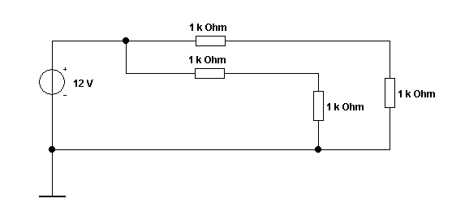

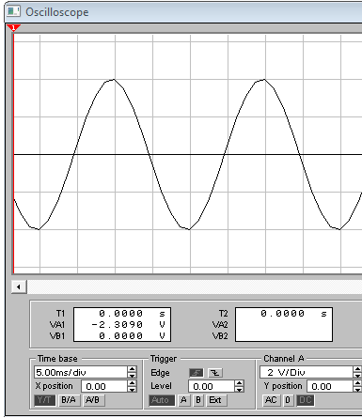
Oscilloscope settings:
2V/div
10ms/div

An oscilloscope display shows the above voltage waveform. The oscilloscope settings are shown in the box next to the waveform.

- Estimate the period of the waveform.
[1 mark]
- From the estimated period, determine its frequency.
[1 mark]
- Determine its peak-peak amplitude
[1 mark]
- Determine the r.m.s. value of the waveform.
[2 marks]

- For a series RLC circuit where R=250Ω, L= 100mH, and C=100µF supplied from a 120V 60Hz supply,
  - calculate the voltage across:

    - The resistor
[2 Marks]
    - The capacitor
[2 Marks]
    - The inductor
[2 Marks]
  - Calculate the resonant frequency of the circuit
[2 Marks]
  - At the resonant frequency, calculate the circuit current
[2 Marks]

- Using any appropriate method, determine the current flowing in the 20Ω resistor in the circuit shown below.
[5 Marks]

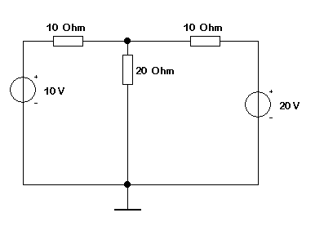
- A 230 V step-down mains transformer has a 20W lamp connected to its secondary winding. The turns ratio of the transformer is 1/20.
- Sketch the circuit
[1 Mark]
- Calculate the secondary current supplied to the load
[2 Marks]
- The primary current taken from the supply.
[2 Marks]

Diwedd/End

