Qualification: CIPD Diploma in Applied Human Resources

Module Name:
Contributing to Improving Organisational Performance 5AIOP

Word Count: 2934

Student Name: Isabelle Solomon
Student Number: 1919798
CIPD Membership Number: 56660407

By signing below, I confirm that the work/evidence presented is my own, unaided work. I understand the regulations pertaining to candidate malpractice and the action that may be taken as a result.

Signed: Isabelle Solomon
Date: 12th September 2021

Contents:
Page number:
- Title Page
- Contents
- Evidence matrix
- Evidence matrix
- Answer 1.1 and 1.2
- Answer 1.3 to 2.2
- Answer 2.2 to 3.2
- Answer 3.3
- References
- EV1
- EV1
- EV2
- EV2
- EV3
- EV3
- EV4
- EV5
- EV6
- EV7
- EV7
- EV8
- EV9

Candidate name: Isabelle Solomon |  |  |  |  | CIPD Membership/registration No.:  56660407
Qualification title: CIPD Diploma in applied Human Resources |  |  |  |  | Unique Learner No. (ULN): 1919798
Unit code | Unit title |  | Assessment criteria no. | Evidence description | Evidence reference number |  | Assessor  initials | I/V initials if sampled
5AIOP | Contributing to improving organisational performance |  |  | Staff handbook | EV 1
 |  |  |  | Appraisal | EV 2
 |  |  |  | Taco report | EV 3
 |  |  |  | Health & Safety Act 1974 | EV 4
 |  |  |  | ACAS | EV 5
 |  |  |  | Redkite advice | EV 6
 |  |  |  | Managers record of conversation | EV 7
 |  |  |  | Exit interview | EV 8
 |  |  |  | Reminder sheet | EV 9
Candidate declaration:
- I confirm that the work/evidence presented for assessment is my own unaided work.
- I have read the assessment regulations and understand that if I am found to have ‘copied’ from published work without acknowledgement, or from other candidate’s work, this may be regarded as plagiarism which is an offence against the assessment regulations and leads to failure in the relevant unit and formal disciplinary action.
- I agree to this work being subjected to scrutiny by textual analysis software if required.
- I understand that my work may be used for future academic/quality assurance purposes in accordance with the provisions of the Data Protection Act 1998.
- I understand that the work/evidence submitted for assessment may not be returned to me and that I have retained a copy for my records.
- I understand that until such time as the assessment grade has been ratified through internal and external quality assurance processes it is not final.
Signature: |  | Isabelle Solomon |  |  |  | Date: | 09/09/2021

Notes on candidate evidence matrices

Candidates should be encouraged to develop a matrix indicating how their evidence relates to each unit/module and learning outcomes/assessment criteria. This helps advisors and assessors to support candidates to draw links between units and encourage cross-referencing and the possible multi-use of evidence.

Evidence matrices can be developed using the unit/module and learning outcomes/assessment criteria, giving candidates an opportunity to link their evidence to each outcome.

Another approach is to have a more generic form where candidates list evidence and tick relevant boxes to show coverage.

Whatever approach is employed candidates should be encouraged to complete these forms themselves and not expect assessors to do this for them.

Contributing to Improving Organisational Performance

1.1
The organisation I work for is a small firm of 11 employed people and 3 self-employed. Due to the small size, the overall HR is controlled by an outsourced solicitor firm. In house we do the appraisals, reviews and manage daily performance. If a disciplinary is needed then we call our HR specialists for advice and they talk us through the situation, give us the possible avenues we can go down and provide us with a template document for the meeting.
The employee handbook outlines the expected behaviour of employees and the policies and procedures regarding daily working life, from booking holidays, sickness, absences, misconduct etc (EV1).
Staff appraisals are carried out yearly by a director (EV2). Targets are set to improve performance and training needs and career paths are discussed.
Targets are set by the Director and Finance manager at the end of the financial year, which is the 31^{st of} July. Targets relate to uplift on sales and before the pandemic was set at 20% increase on LFL sales. Our targets are set then because we are heading into a new heating season, when we sell most of our products, as we supply biomass which is a heating fuel. Before the pandemic we managed to beat that target of 20% uplift, by achieving 28%. All employees, even self-employed were rewarded with vouchers for achieving this. We are all one team, and even if not directly involved in sales, we all play a part to achieve this, from the Transport manager who keeps the lorry wheel turning, to the engineers who keep people’s boilers running.
Appraisals are yearly and are where personal development plans are made and discussed. Our company is very good at giving employees a chance to move into a relevant role within the company, or train for a role we can incorporate by not outsourcing it anymore. Succession planning also comes into this, as if an employee knows someone is leaving, through retirement etc, then they can discuss if they would like to develop into that role or suggest others for the position.
Recognition for good work and feedback received from customers is communicated via the company WhatsApp so everyone can recognise and congratulate that employee on their excellent performance.
Manager’s performance is constantly discussed and feedback is on the spot. The directors are involved daily with the operation and are very hands on, so touch base with all managers a couple of days a week at least. Feedback usually takes an informal approach if both positive, constructive or negative. If a negative behaviour or even is being addressed, an informal conversation takes place, followed by a record of conversation if the behaviour or event continues.

1.2
All employees go through a 13-week probationary period where they are given an employee handbook along with their contract of employment. They are paired up with an experienced colleague who will take them through the ropes. They are given time with all staff members to enable them to see how everyone’s job impacts another and how all the jobs connect to make the company work. With an understanding of everyone’s roles, they understand how they are interlinked. This small time spent with everyone means they can put a face to a name and cements us as a team. During the 13 weeks their performance is accessed by their line manager with issues or further training needs discussed with the Directors, along with praise if they have surpassed expectations. Communication is given via staff meetings and emails. Information is also communicated via line managers.
Regarding some job roles, there are legislative rules which apply to them. HGV drivers, the Transport manager, Health and Safety Manager and Quality Manager all have legislation that controls aspects of their job role. HGV drivers must have a valid license, along with the relevant CPC training undertaken every year. The Transport manager must keep up to date records for the Traffic commissioner and ensure lorries are maintained to Government standards (EV3). The health and safety manager must comply with legislation regarding health and safety (EV4) and maintain the relevant documentation. The Quality manager must comply with the Enplus and BSL standards and keep the relevant paperwork and practices up to date and in place. If there is a breach in these practises and policies there is serious consequences, depending on the level of the breach. Some consequences could result in immediate dismissal, legal action, and the loss of our operating license, meaning we could not continue to trade.
The ACAS website (EV5) is used to guidance when dealing with poor performance along with seeking advice on the specifics of individual situations from the outsourced HR specialists (EV6).

1.3
I have supported a director through the process of a record of conversation recently regarding a managers conduct and performance. The Director had an informal conversation with the manager and thought the issue was resolved however the behaviour continued and needed to be readdressed. A record of conversation was carried out due to the continuation of the behaviour, which was signed and dated (EV7) and all issues were aired, and a way forward was sort. Now this seems to of worked, but we have set a timescale of three months to review the situation again.

2.1
Line managers communicate and work alongside their employees daily. They are the first to raise issues or give praise when it occurs. Occasionally informal communication between a line manager and a member of staff needs to be escalated. This usually happens when there is a performance or behavioural issue. When this occurs, the line manager will talk the issue over with myself, as HR assistant and I will then discuss this issue with a director. I will advise the Director as to my thoughts on the issue and how I would proceed. Being new to the role and still learning, the Director will seek advice from our external HR specialists along with referring to ACAS website. Usually, their advice and my thoughts are aligned, and we will proceed with the course of action necessary. Sometimes the line manager can get in the way of the proper HR process. I find this is because we are a family firm and all one team, so the line manager and employee are usually ‘friends’ which makes it difficult for them to manage the employee through a formal process, or they have strong feelings towards the employee negatively so can be bias towards them.

2.2
A situation occurred in January 2021, when the Transport manager accused an HGV driver of stealing company time by falsifying his time sheets. At the same time, this HGV driver verbally communicated that he wanted to make a complaint of bullying regarding his treatment received by his line manager, the Transport manager. I told HGV driver to write down his complaint to formalise the process and bring evidence or a statement regarding why he thought he was being bullied and the situations which made up the bullying. He came back a few days later and said he did not want to take it any further. I told the transport manager I would review the locations of this HGV driver’s lorry, his timings as all the lorries are tracked and the hours he was putting on his time sheets. I said I would review this over a 2-week period and see if there were any discrepancies. This was not accepted by the Transport manager who thought I was ignoring the issue and trying to ‘sweep it under the carpet’ and not do anything about it. I did explain to him, on more than one occasion, that there is a process we must follow and the reasons why we follow a process. He would not accept this and thought I was not supporting him in his position as line manager. Within the two weeks the HGV driver submitted his notice and left the company, I carried out an exit interview with him, where he stated 80% of his reason for leaving was due to the breakdown in his relationship with his line manager (EV8). After his departure it was discussed with the Transport manager, and it was reiterated that there are processes which must be followed and applies to all. Behaviour by the Transport manager even after the employee’s departure, was unacceptable and an informal conversation took place to rectify the behaviour. Further training in HR processes was given and further conversations took place to ensure he understood the seriousness of his behaviour.
Due to the family ethos of our organisation and the close team, line managers do find it hard to manage an employee’s poor performance. This means a lot of the time; the Directors need to get involved. This involvement usually takes the form of an informal conversation with the employee, so they know that what the line manager was asking or addressing, is a serious issue that needs addressing or implementing. This does tie up the Directors time, but it also means they are fully aware of any performance or behavioural issues that are occurring within their company.
The company we outsource our HR to run HR training days (pre-covid). When these are on, we send line managers who need training in that particular area. We sent one line manager to a ‘harassment and bullying in the workplace’ session, another to a ‘managing your team’ day. They all have different needs and need to be supported in many ways from training to hands on support and advice.
I have tried to guideline management through the performance management process by talking them through the process and giving them simple remind sheets to follow (EV9).

3.1
Appraisals only happening yearly means that performance activities are forgotten from the first half of the year. Targets are laid out in the review, but how to achieve those targets are not. They are just expected to be reached. Career development is discussed, but if nothing is offered by the employee, then the employee is just left to coast along in their position. This does work for some; however others are found to be bored and tend to then waste time in their position and do not achieve high-performance working because there is a lack of motivation. I find this with the higher paid positions, who are not challenged in their day to day working. They know they won’t achieve the salary anywhere else, and don't need to do any more to achieve it within the company, so why push themselves? They do not understand that their performance does slowly start to go downhill as they get more and more complacent about their role. This has occurred within the company a lot and in the end the employee leaves because when their performance does start to lack, because they have not kept up with developments within their role or within the company, they do not have the motivation or the know how to achieve again. This causes frustration and friction, and enviably they leave as the company storms ahead and they are left behind. I personally think the company offers too high a salary to start off. The company thinks by offering a high salary to begin with they will attract the right people and those people will feel valued and stay. However, I feel that if the company was to offer an average salary for the position and add tailored bonuses and performance related pay, then employees would not get de-motivated, would not stay stagnant and indeed trapped by the salary. They might know they lack the performance and motivation to continue in the role, but unfortunately, they now need that high salary to pay their bills, so the frustration and resentment towards the Directors then begins to literally poison the team as they air their frustrations to anyone and everyone else, causing the team morale to turn negative.

Performance management does take time within our organisation. Poor performance is informally dealt with by the line management, but then they lack the knowledge and confidence to see it through, then waiting on the Directors. The Director will seek advice from me but then wait for clarification from our outsourced HR specialist, which again can take time. The Directors are not HR trained and have no formal people management training, which leads to a lack of confidence on their part also and a tendency to shy away from issues, hoping they will correct themselves. This is incredibly frustrating to members of the team and can cause bigger issues by not being addressed swiftly and correctly.

3.2
The performance management processes within the organisation do not support high performance working or lead to sustained organisational performance. High performance work systems involve having a bundle of clearly defined human resource policies and practices in place which are all enforced and followed (Taylor and Woodhams, 2016). Our company does have some policies and practices in place, but they are poorly implemented and vaguely followed where suits. High performance working has a sophisticated and robust recruitment and selection process, along with high levels of investment in training and development (Taylor and Woodhams, 2016). Employees in organisations that have adopted high performance working systems are high paid, but payment is related to performance (Taylor and Woodhams, 2016).
Pfeffer (1994, 1998), researched the relationship between organisational performance and high-performance work systems and found organisations with better results had a ‘best practice bundle’ of human resource practices and policies (Taylor and Woodhams, 2016). John Purcell’s research found that when an organisation has this bundle of progressive and high performance in place, employees performed positively, with higher levels of input. Also, he found the organisations most successful had a ‘big idea’ they all worked towards and brought to life, along with line managers and HR working together to implement the bundle of policies and practices successfully to all (Taylor and Woodhams, 2016). All this leads to improved organisational performance, with lower staff turnover, discretionary effort and job satisfaction.
3.3
I would suggest that unless it is a disciplinary hearing or an appeal, that the Directors do not get involved in the managing of employee performance, unless it is a senior manager. I think that the line managers should be trained more in people management and they should address the issues themselves within their own teams. I suggest that I spend time with every line manager and offer a training day and ongoing coaching and mentoring in people management as I have experience of managing teams throughout my career elsewhere and have the academic achievements. I can be the support they need to implement performance management techniques etc, saving the director’s time by not getting involved and deal with issues immediately as they arise. I have suggested this to the Directors, as I return from maternity on the 4^{th of} October, I can hit the ground running before our busy season starts.
I recommend that the organisation adopts the AMO model (Ability, Motivation and incentive, Opportunity) to manage performance and improve its outcomes. Boxell and Purcell identified the link between HRM and performance. The model provides guidance on the human resource management practices that need to be in place to develop a high-performance work system (Armstrong and Brown, 2019). Organisational performance is affected by the lack of performance management. It is affected by employees knowing that if the company hits its target of uplift, even if their performance was lacking, but another employee picked up their slack, they will still receive a bonus. This causes resentment amongst the team. HGV drivers who push ahead and can get more drops off in a day consistently than a fellow driver, feel they should be rewarded by their workloads achieved, not just shared between everyone.
There is not a process in place to encourage high performance working. There is instant recognition for good performance and good customer reviews but there is no financial or other incentive to promote high performance. I do feel to motivate and encourage high performance working there needs to be incentives in place. Either financial, by way of a bonus or performance related pay, or the chance to achieve an extra day’s holiday a year etc.
High performance working needs to start at the recruitment stage. We need to ensure we have an accurate person specification and job description advertised. This will then make it easier when selecting who to put forward for interviews and will ensure we have gained applications from the right sort of people with the right skills for our organisation. Interviews need to follow a template, need to be completed by the line manager, along with myself for support and ensure attention to detail. Sometimes when a person interviews on their own they tend to hire friends, or likeminded people, but who lack the actual skills required to perform the role. They make the role fit the person, rather than the person fit the role. This then needs to be followed by a robust probationary period where issues and training needs are addressed immediately, not left until the final week. Line managers need to appraise at least every 6 months, setting realistic but achievable goals and carving out a path for how to achieve them and providing the support to do so. Targets should be discussed continually, not just at the next appraisal meeting (Lee, 2015). This would all have a positive effect on employees and organisational performance. Time should be given to planning and implementing high performance working systems, being proactive rather than a reactive organisation.

Word count: 2934

References:

Armstrong, M. and Brown, D. (2019). Strategic Human Resource Management: Back to the future? A literature review in partnership with. [online] . Available at: https://www.employment-studies.co.uk/system/files/resources/files/517_Strategic-Human-Resource-Management-Back-to-the-future-IES-CIPD-2019.pdf.

Lee, S. (2015). Big Data, Social Media and HPWS for the Intelligent Office Big data, social media and HPWS for the intelligent office. [online] . Available at: https://www.cipd.co.uk/Images/big-data-social-media-hpws_2015_tcm18-15586.pdf.

Taylor, S. and Woodhams, C. (2016). Human resource management : people and organisations. 2nd ed. London: Chartered Institute Of Personnel And Development.

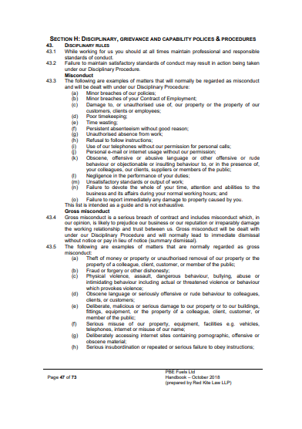
EV1
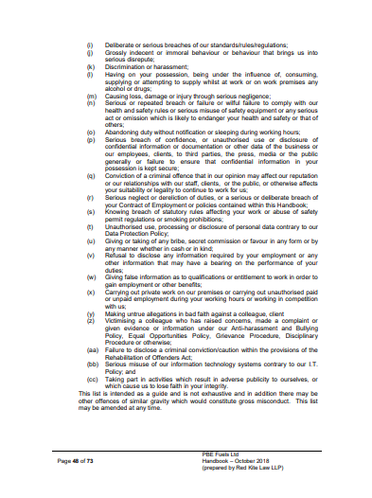
EV 2 Record of conversation template

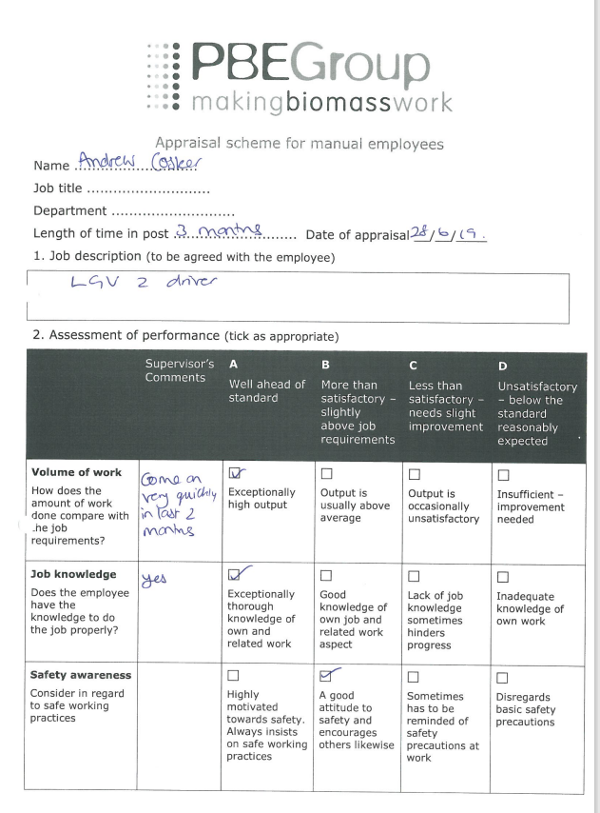

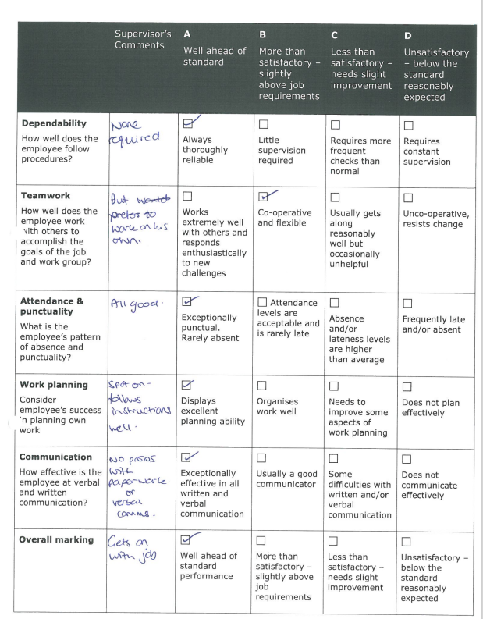

EV3 TACO REPORT

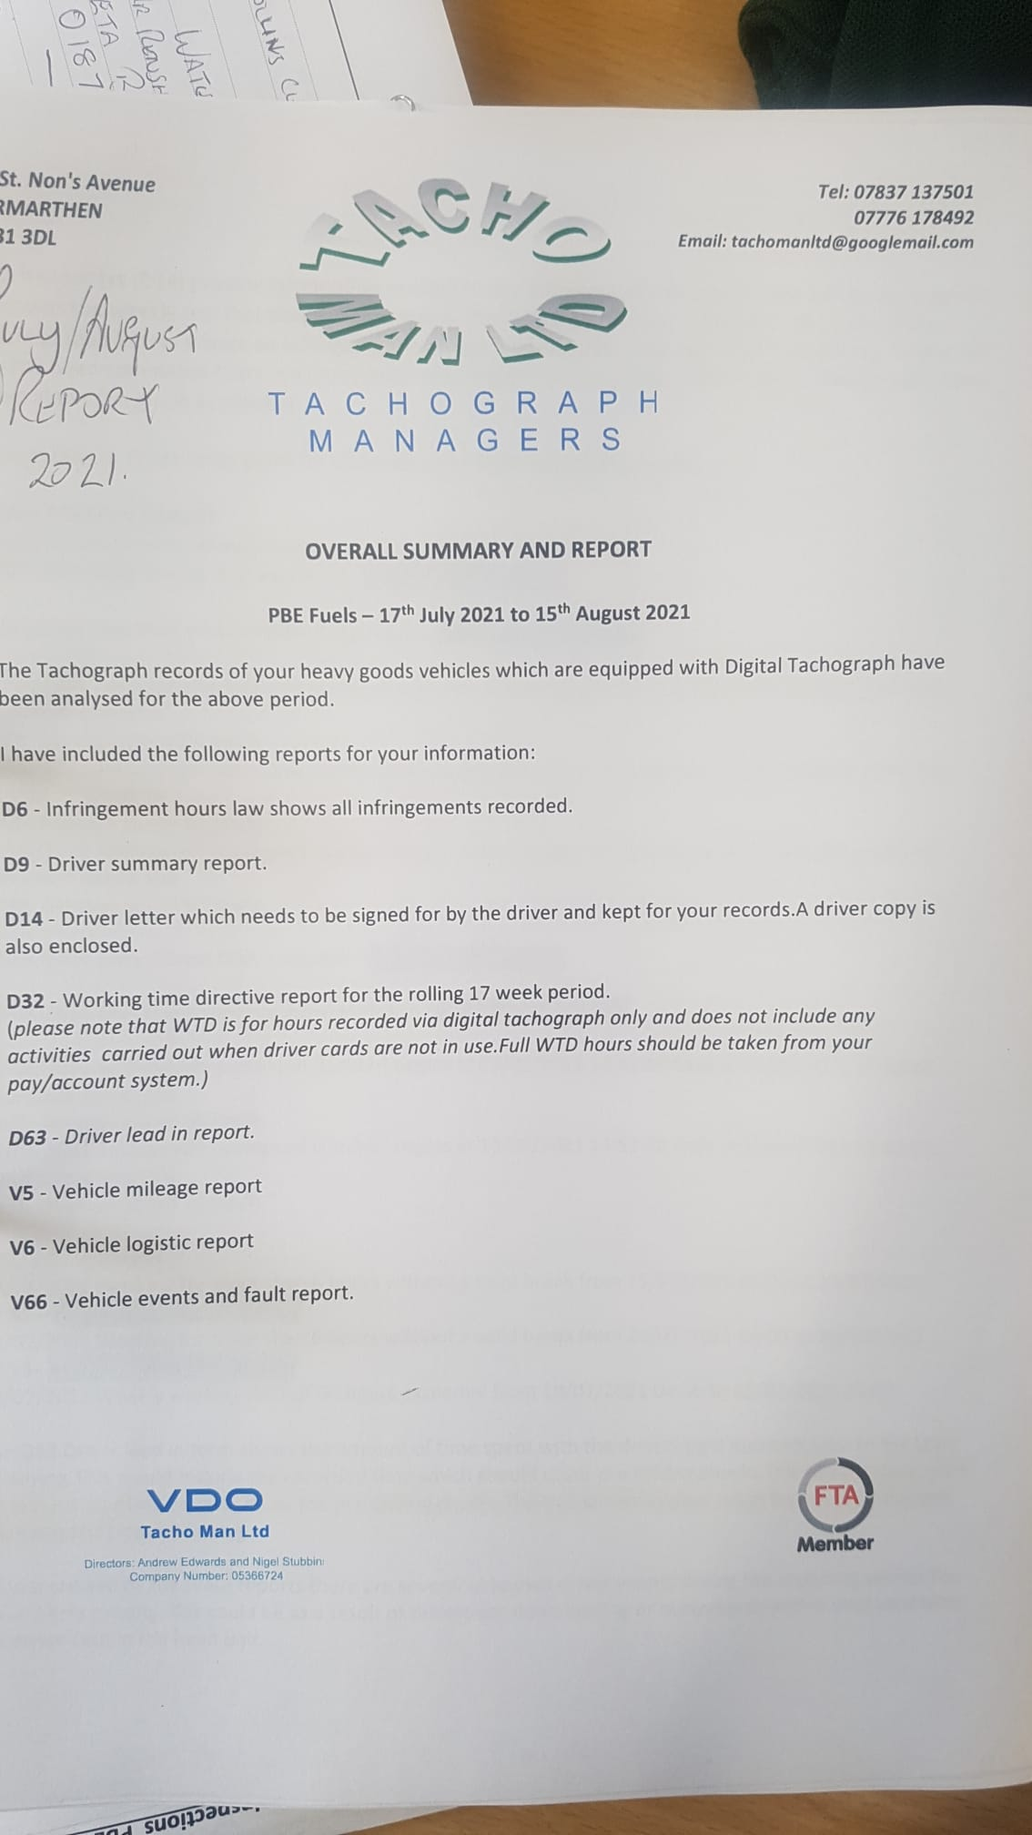

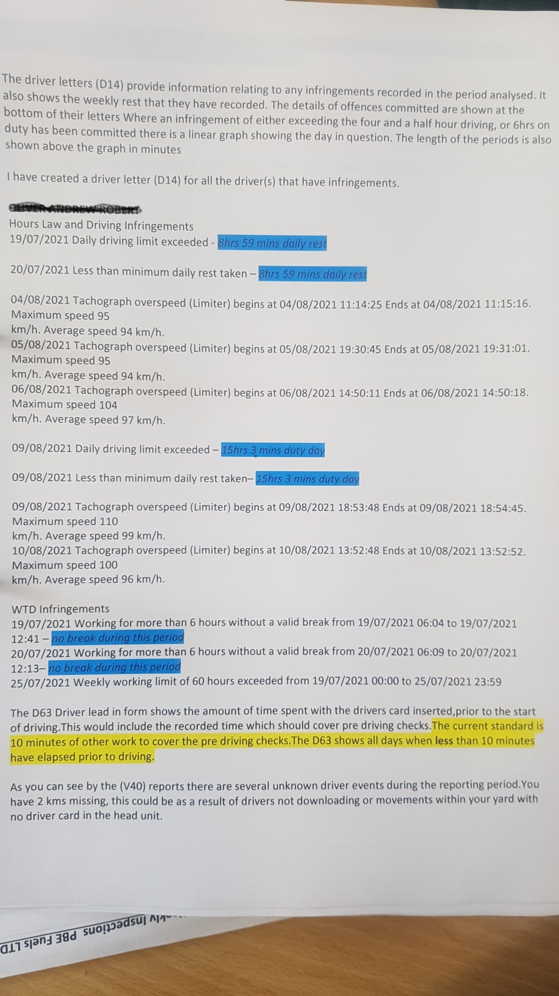

EV4

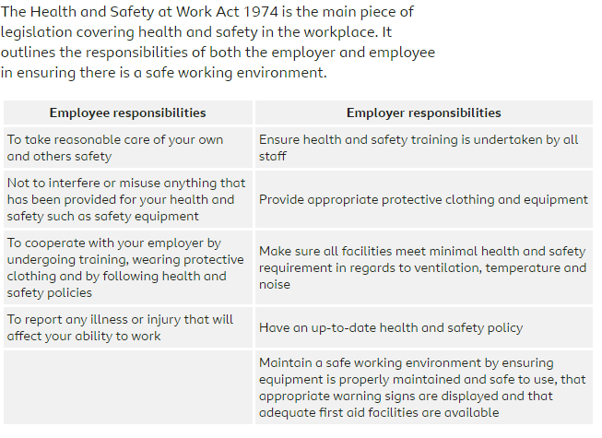

EV5

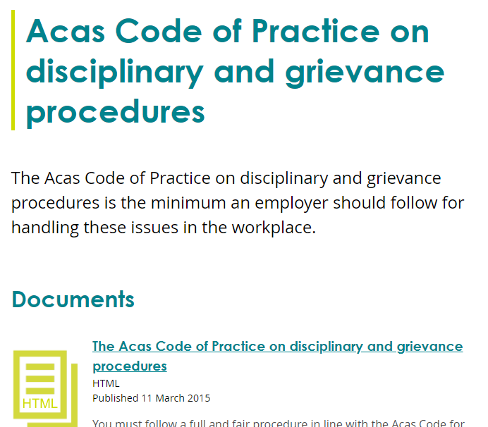

EV6 REDKITE ADVICE

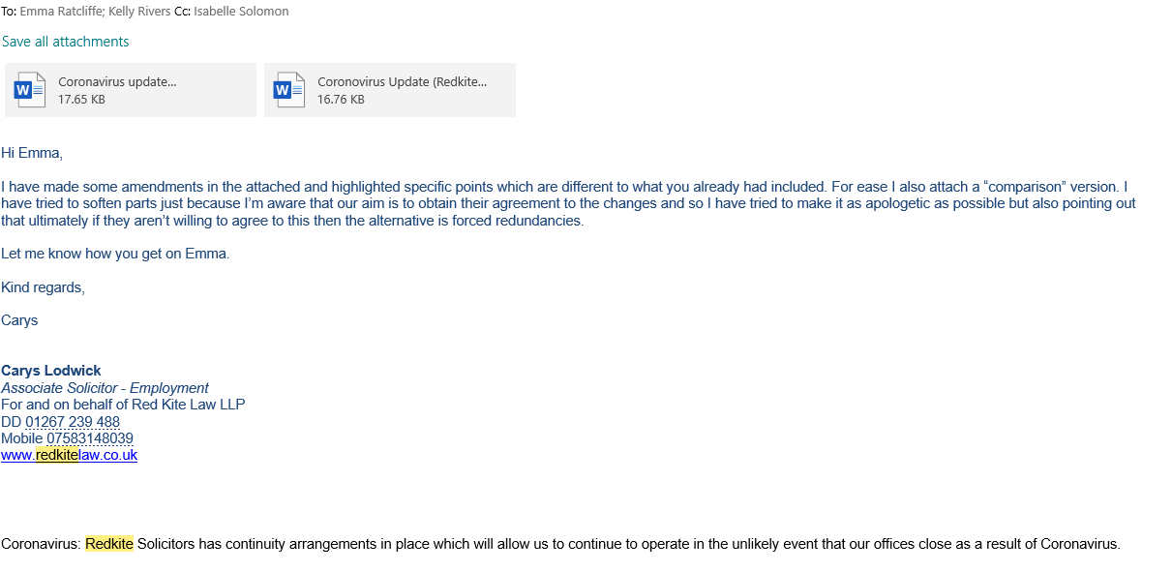

EV7 Record of conversation with Transport manager
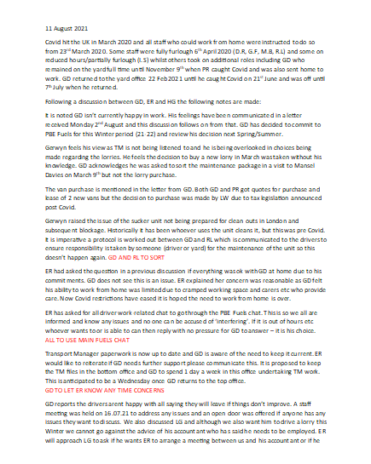

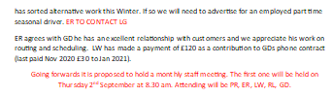

EV8

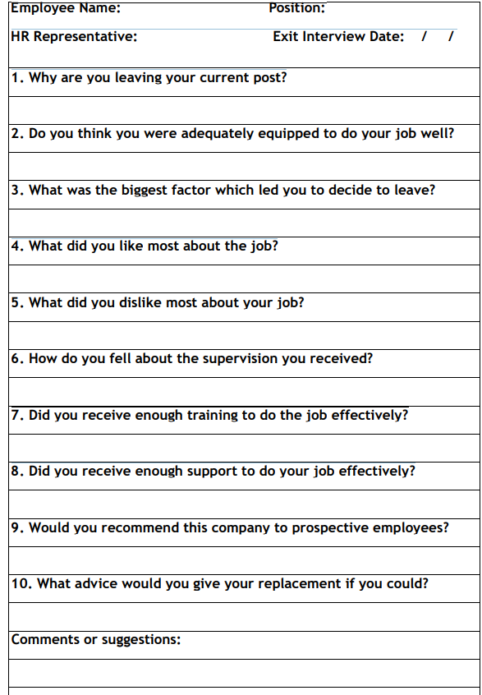
EV9


