Module Code: BMSW5104
Module: Managing Projects in the Workplace
Lecturer: Sujeewa Herath
Assignment Title: Project Management Plan
Student Name: Saeed Ahmad
Student Id:2027769

Table of Contents
Introduction 3
Scope of the project 4
Stakeholders Analysis 5
PESTLE Analysis 6
Quad Chart 11
Work Breakdown Structure 13
Gantt Chart 14
Risk Assessment 16
Conclusion 18
References 19
Table of Figures
Figure 1: Stakeholder Analysis 4
Figure 2: PESTLE Analysis 6
Figure 3: Quad Chart 10
Figure 4: Work Breakdown Structure 12
Figure 5: Gantt Chart 14

Introduction
Every project or initiative has to go through some set of constraints to reach its ultimate goal. To be successful in reaching its goal, every project requires proper planning and management. Project management is the systematic way of handling the activities related to a particular project to reach its ultimate goal by overcoming all the hurdles and constraints related to it. For leading a successful project, it is required to build as well as execute a solid project management plan which includes all the necessary project management tools for the execution. Some major project management tools include strategic planning, QUAD Chart, work breakdown structure, Gantt chart, internal and external environment analysis tool as well as benchmarking. Each of these tools is used to overcome specific constraints. These are mainly scope, time, and budget. In the following report, an adequate project management plan will be depicted for a nursery project including the mentioned tools.

Scope of the project
At present, the government of the United Kingdom has decided to remove the work-from-home condition for its citizens and immigrants. This is an opportunity for opening a nursery school. The scope of the project is as follows:
- The busy life of the employees working in various industries.
- The need for care and primary education among growing children.
- The need for a reliable organization to handle the children during the absence of parents.

Stakeholders Analysis
A stakeholder is a very common term used in the language of business. Stakeholders can be defined or depicted as a party that has any particular interest in a business or can be affected by its activities (Altarawneh, 2022). Stakeholders of a business can be both internal and external. The degree of power and authority each stakeholder holds or possesses can also be different. The stakeholders of a business can be the management authority as well as its direct customers or target market and even the employees working for it. Besides these direct stakeholders, there are also plenty of indirect or external stakeholders, the existence of which depends on the nature and type of the business.
As required, it is needed to provide the stakeholder analysis for a nursery business based in the United Kingdom. The stakeholder analysis process includes two steps. These are:
- Planning the stakeholder analysis process
- Using the results of stakeholder analysis

Figure 1: Stakeholder Analysis
Source: (Ponnappa, 2019)
Step 1: Planning the stakeholder analysis process
The first step of the stakeholder analysis process is planning the whole course of actions regarding the analysis. At first, it is required to identify who are the actual and potential stakeholders of the business. After identifying the stakeholders, it is required to gather knowledge about the position of various stakeholders with the use of observation (Ponnappa, 2019). As the project is a nursery business, it is required to identify the stakeholders of a nursery business in the United Kingdom as well as observe the power of these stakeholders. Major stakeholders of nursery business in the United Kingdom include administrators, children and their families, adequate teachers as well as trained staff. The families of the employees and staff working for the nursery can also be termed as the indirect stakeholders of the business.
Step 2: Using the results of stakeholder analysis
After planning the process and identifying the major stakeholders related to the nursery business, it is required to utilise the information regarding the stakeholders for further process. In this step, it is required to analyse which stakeholder is the most influential party and which one holes the least power or authority (Altarawneh, 2022). It will analyse which stakeholder can ensure maximum involvement in the process and which one will be more supportive. The stakeholders can be categorized using the following strategies:
- High power, highly interested people: There are specific stakeholders in a business who have higher authority and power compared to other stakeholders and they also have tremendous interest in the project (Ponnappa, 2019). In the case of the nursery project, the highly interested people who have high power include the administrators, employees, and staff as well as the clients or children. It is required to ensure the full engagement of these stakeholders for the projects to be relevant and successful.
- High power, less interested people: The stakeholders who have high power but are not very much interested in the project include the investors as well as guardians of The children who are sent to the nursery (Anderson and Merna, 2019). It is required to keep the investors and guardians satisfied but not involve them in the daily activities and processes.

PESTLE Analysis
Before starting any project, it is important to analyse both internal as well as external environment of the business (Akman, 2020). The internal environment consists of the elements which are inside the company or directly relate to it. Whereas, the external environment consists of some elements and situations which can affect the industry as a whole. The impact of the external environment is tough to measure. Various tools are used for analysing the external environment. One of these tools is PESTLE Analysis (Rose, 2019).
The PESTLE Analysis of the nursery project is provided below:
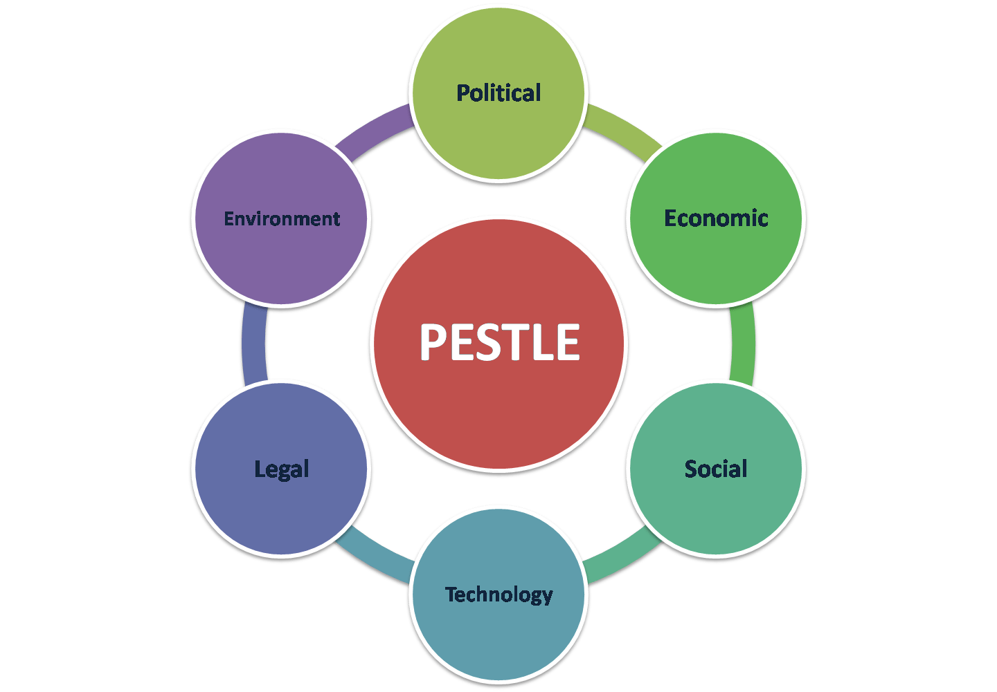
Figure 2: PESTLE Analysis
Source: (Simonsen, 2019)
Political:
The political factors include the major policies as well as decisions of the government which directly impact the activities of a business. The elements of the political factor that impact the activities of a nursing business are explained below:
Government Policies and Guidance: At present, the government of the United Kingdom has issued a policy to reduce as well as remove the work-from-home condition due to which most families with both working parents need daycare services (Anderson and Merna, 2019). It can be observed that, after the issuance of the new policy by the UK government, the demand for daycare services has increased by 21.4%.
Changes to curriculum: Currently, the national curriculum of the United Kingdom includes the preschool curriculum (Woodward, 2016). According to the preschool curriculum, children up to the age of 5 years have to attend nursery School as a prime part of their pre-primary education.
Economic:
The economic factor of the PESTLE Analysis indicates the financial elements in a government as well as the country the business is operating in and its impact on the activities of the business (Akman, 2020). The economic environment consists of the common financial elements including the income level of common people as well as spending patterns, inflation, increasing prices of commodities as well as the purchasing power of the citizens of the country. The elements of the economic environment which impact the activities of a nursing business are explained below:
Living Standard of Guardians: It is believed that the standard of living of the people in the United Kingdom is better and higher than that of most people living in other countries around the world. It is also calculated that, around the age of 13 to 64, almost 75% population of the United Kingdom is employed (Bigras, Lemay and Brunson, 2021). Therefore, it can be committed that the standard of living and the income structure of the people living in the United Kingdom support the cost of daycare services and nursery Schools.
Cost of commodities: At present, one of the major constraints from the economic environment that can cause limitations in the activities of the nursery business is the rising cost of commodities which is caused due to inflation (Rose, 2019). As inflation has increased in the United Kingdom, it has limited the purchasing power of the common people to a certain extent.
Social:
The social factor of the external environment indicates the major societal norms as well as cultural practices of the country in which the business is operating and how it affects the activities of the business. It includes the lifestyle attitude, behaviour patterns as well as traditional practices of the population. The elements of the social environment which impact the activities of a nursing business are explained below:
Lifestyle Trends:
One of the major elements of the social factor influencing the activities of nursery business is the lifestyle trends followed by the people living in the United Kingdom. In the United Kingdom, the lifestyle of people is more formalized (Simonsen, 2019). The number of working people has also increased. People living in the United Kingdom prefer leading an organised as well as systematic lifestyle. Due to this, it is easier for a nursery business or daycare service business to flourish.
Parental Preference: Cultural influence plays an important role when parental preference is concerned. Parental preference is mainly the preferences or opinions of the guardians of the kids who are to be admitted to nursery schools. The age range of the children who are admitted to the nursery school is very delicate. It is believed that a child learns most of the etiquette, manners as well as other basic knowledge within the age of 5. For this reason, the preference of parents varies with the organisational principles or norms at times.
Technological:
The technological aspect of the external environment is one of the major aspects considering the new age of learning. The technological aspect mainly represents the importance as well as the impact of various technological tools as well as the system which have the potential to influence the activities of a business. The elements of the technological environment which impact the activities of a nursing business are explained below:
Access to broadband: The first and foremost element of the technological environment which can highly impact the activities of the nursery business is the availability of broadband. If there is only partial access to broadband in the location of the nursery, it can be quite difficult for the management team to plan the operations for further development of the business.
Affordability of ICT Resources: Affordability of ICT Resources refers to the ability of the business to afford as well as utilise various technology equipment which is necessary for providing a better learning experience to the children. The kids who are admitted to a daycare centre or a nursery are very vulnerable as well as delicate to handle. As they grow up, it is required to provide them with the best learning experience possible and for this, it will be required to afford and utilise the latest digital resources (Bigras, Lemay and Brunson, 2021). Considering the growth of the education sector as well as the daycare sector of the United Kingdom, it can be assured that it is possible to afford such digital resources.
Legal:
The legal factor consists of various laws, Legal practices, policies as well as allowances which can affect the profitability as well as regular activities of a business (Simonsen, 2019). The elements of the legal environment which impact the activities of a nursing business are explained below:
Local Authority: As discussed before, the national curriculum of the United Kingdom includes the pre-primary stage which is also known as a nursery school and is supported by the local government of the country.
Health and Safety Law and guidance: The overall sector of the nursery business is highly impacted by the health and safety law and guidance because children up to the age limit of 5 years are admitted into nursery schools and daycare centres (Woodward, 2016). Therefore, it is mandatory to ensure the full safety of the children in a nursery school.
Environmental:
The environment aspect of the external environment impacts the nursery businesses or any other business both positively and negatively. The impact of the environmental aspect depends on the use of natural resources by a business (Turner, 2020). The elements of the environmental aspect that impact the activities of a nursing business are explained below:
Waste disposal: As a nursery school deals with children up to the age of 5 years, waste management, waste reduction as well as disposal of waste play an important role in the business.
Use of papers: It is recommended for nursery businesses to reduce the use of papers as much as possible as it can increase environmental pollution which will turn the environmental expectations against the activities of the business.

Quad Chart
A Quad chart is mostly defined as technical documentation that depicts the purpose, customers, desired result as well as measures of success of a project (Kaufman, 2021). Based on the above discussion over stakeholder analysis as well as PESTLE Analysis, the Quad Chart of a nursery project is depicted as well as explained below:

Figure 3: Quad Chart
Source: (Kaufman, 2021)
Purpose:
The purposes of opening a nursery school are as follows:
- To offer and provide early education to children between the age gap of 3 to 5 years.
- To provide services regarding taking care of the children of working parents living in the UK.
- To earn profit by providing day care services.
Customers:
The major customers, as well as stakeholders of the business, are defined below:
The nursery project will be planned and operated for children up to the age of 5 years. As preschool education is a part of the national curriculum of the United Kingdom, it is necessary for children under the age of 5 years.
The nursery project will benefit the working parents of children up to the age of 5 years. As the work-from-home culture is being removed by the UK government, it will become tough for working parents to take care of their children (Turner, 2020). Therefore, nearby Day Care services would be beneficial for them.
The nursery project will include teachers as well as trained staff to look after the children. In this way, employment will also be created through this project.
Desired result:
The desired result of the nursery project are as follows:
- To ensure a safe and caring environment for the children.
- To develop confidence among the children to be eager learners.
- To develop the cognitive and emotional skills of the children.
Measures of Success:
The measures of success of the nursery project are as follows:
- Satisfaction of the working parents.
- Satisfaction of the employees working on the project.
- Rate of profitability of the project.

Work Breakdown Structure

Figure 4: Work Breakdown Structure
Source:
From the above figure, it can be observed that the Work Breakdown Structure of the nursery project is divided into four parts (Ward and Chapman, 2020). These are initiation, preparation, execution, and follow-up.
The Initiation period includes the following steps:
- Choosing a location: The prime location of operation is to be chosen.
- Cost Estimation: The total cost of operations is to be estimated.
- Fund Collection: For starting the project, the fund is to be collected from both internal and external sources.
The Preparation period includes the following steps:
- Develop Promotional Plan: A strategic plan for the promotion and advertisement of the nursery is to be developed.
- Recruit Staff: Adequate staff is to be hired according to the need of operations.
- Train Staff: After successful recruitment, it is required to train the hired staff.
The Execution period includes the following steps:
- Admit Children: After recruiting and training the staff, it is required to admit the children to the nursery.
- Divide the admitted children into sections: After admitting the children, it is required to divide them into various sections based on their age (Ward and Chapman, 2020).
- Provide daycare services and education: After dividing the children into age groups, it is required to provide daycare services.
The Follow-up period includes the following steps:
- Supervise the children: It is required to closely supervise how the kids are adjusting.
- Measure the performance of employees: It is required to measure the performance of the employees using ‘performance appraisal tools.
- Frequent consultation with parents: For providing better services to the children, it is required to frequently consult with the parents (Zwikael, 2016).

Gantt Chart
Tasks | January | February | March | April | May | June | July | August | September
Choose Location
Cost Estimation
Fund Collection

Develop Promotional plan
Recruit staff
Train Staff
Admit children
Divide the admitted children into sections
Provide daycare services & education

Supervise the children
Measure the performance of employees
Frequent consultation with parents

Figure 5: Gantt Chart
Source: (Ward and Chapman, 2020)

Risk Assessment
Risk assessment is a major part of project management. Some specific risks that can affect any project. In the case of a nursery project, the major risk that can be associated is commercial risks and financial risks (Zwikael, 2016). For risk identification, a fishbone diagram will be used for the Nursery Project.
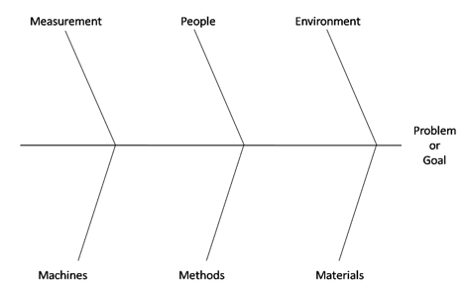
Figure 6: Fishbone Diagram
Source: (Zwikael, 2016)
According to the fishbone diagram, the main problem is the head of the diagram and the issues due to which the problem is caused are mentioned in the ribs (Altarawneh, 2022). According to the diagram, there are six major elements under which the issues are placed. These include environment, people, measurement, materials, methods, and machines.
The major risk regarding the project is the lack of enough admission.
The major causes behind the problem are:
Environment: Adverse weather and risk of Corona Virus.
People: Reluctant attitude of working parents.
Measurement: Inadequate research and wrong estimation.
Materials: Inadequate use of promotional tools.
Methods: Ineffective method of advertisement used.
Machine: Ineffective use of broadband and ICT tools.

Conclusion
Project management has a huge impact on the overall planning of a project. The success of a project depends on the efficient management of the resources related to the project. To ensure proper utilization of all the elements, it is needed to apply appropriate project management tools. In the above report, the appropriate use of project management tools has been depicted. Besides, stakeholder analysis, PESTLE Analysis, Quad Chart, Work Breakdown structure as well as Gantt Chart has been portrayed.

References
Akman, M., 2020. Defense Management and PESTLE Analysis. Ante Portas - Studia nad bezpieczeństwem, 1(14)/2020(1(14)/2020), pp.93-102.
Altarawneh, I., 2022. Toward successful project implementation: Integration between project management processes and project risk management. Problems and Perspectives in Management, 20(3), pp.258-273.
Anderson, D. and Merna, T., 2019. Project Management Strategy—project management represented as a process-based set of management domains and the consequences of project management strategy. International Journal of Project Management, 21(6), pp.387-393.
Bigras, N., Lemay, L. and Brunson, L., 2021. Parental Stress and Daycare Attendance. Does Daycare Quality and Parental Satisfaction with Daycare Moderate the Relation Between Family Income and Stress Level among Parents of Four Years Old Children? Procedia - Social and Behavioral Sciences, 55, pp.894-901.
Kaufman, G., 2021. Displaying parenthood, (un)doing gender: parental leave, daycare and working-time adjustments in Sweden and the UK. Families, Relationships and Societies, 10(2), pp.213-229.
Ponnappa, G., 2019. Project Stakeholder Management. Project Management Journal, 45(2), pp.e3-e3.
Rose, K., 2019. Book Review: Modern Project Management: Successfully Integrating Project Management Knowledge Areas and Processes. Project Management Journal, 33(1), pp.60-61.
Simonsen, M., 2019. Price of High-quality Daycare and Female Employment. Scandinavian Journal of Economics, p.no-no.
Turner, J., 2020. Towards a theory of project management: The nature of the project governance and project management. International Journal of Project Management, 24(2), pp.93-95.
Ward, S. and Chapman, C., 2020. Transforming project risk management into project uncertainty management. International Journal of Project Management, 21(2), pp.97-105.
Woodward, J., 2016. Practical Project Management—Tips, Tactics and Tools. International Journal of Project Management, 22(2), p.172.
Zwikael, O., 2016. International journal of project management special issue on “project benefits management”. International Journal of Project Management, 34(4), pp.734-735.

