PLANNING AND MANAGEMENT IN WORKPLACE
Name of Host Organisation: University of Wales Trinity Saint David
Name: Iulia Cristina Banu
Student number: 1908796
Table of Contents
INTRODUCTION 3
TASK 3
PHASE 1 3
PHASE 2 7
PHASE 3 9
PHASE 4 11
CONCLUSION 14
REFERENCES 16

INTRODUCTION
Project is a series of actions which must be performed to meeting the objectives. Therefore, project can also be known as a periodic activity which has is executed through planning all activities of all phases through which the project can be executed properly. Project management is the strategic approach of leading and guiding the work of a team through which the objective scan be accomplished and meet the desired performance project standards and meet the objectives of project (Azhar, 2017). For meeting the objectives of the report, Project of Promotion and recruitment of University courses is based on the forming a marketing material for developing skills for workplace program, promotion in local community. The report revolves around assessment of project management tool and techniques which involves project lifecycle, Quad, stakeholder analysis and will explain the implementation and execution of the project plan. Therefore, the report gathers all necessary information and data and highlights the refection of project management abilities within the project with some recommendations through which the progress can be made.

TASK

PHASE 1
Initiation Phase
A project can be defined as an activity which requires appropriate amount of time effort and resources which will be helpful in achieving the project goals in specific span of time. It can also be categorized as a task or a strategy which is pre-planned for executing and implementing in concerning scenario (Baum, 2018). The project defines the objectives which needs to be accomplished and their outcomes which are achieved after executing the project plan. To meet the project demand, it entails carrying out all activities in unique and innovative manner. The unstructured collection of resources, people, facilities and equipment which are gathered at a single location helps in meeting the objectives of the project. The project report of promotion and recruitment involves creating marketing materials, promoting local communities and recruiting applicants for the program. For meeting the demands of the project administration of University will adopt various tools and techniques which are explain underneath:
Project Life Cycle- Project life cycle is a tool which is responsible for providing direction to people that can be helpful in achieving the project goal from initial stage to the last stage of project. Project life cycle create sequence of activities and actions which needs to be performed throughout the project by focusing and clearly defining the whole project process. For the project report of Promotion and recruitment of university courses, project life cycle bring advantage by regularly tracking the project progress, simplifying the assigned work for team, ensure effective structure for delivery, deliver consistent outcomes and manage various elements which are related to the project through which better insight can be gained (Brady and et.al, 2018). The tool establishes a basic foundation of procedures and activities that must be followed regardless of the sort of work performed. There are serval limitations which has been faced in the project of Marketing Material which are related to high risk and uncertainties which will be faced while executing the planned project plan, limited feedback process at all phases of project, based on higher cost, limits creativity and innovation and create a negative and stressful scenario.
Initiation Phase- This is the initial phase which needs to be performed in a project life cycle. In this stage, the project plan is introduced, investigated, and developed. The primary motive of this phase is to determine the feasibility of the project. The initial stage supports project manager to form effective decisions regarding the needs & beneficiaries of project. In context of project of the promotional & recruitment of the University & it's specific courses, the steps who will involve forming major decisions which will define the direction with the resource needs. In the scenario a business prospective is formed a feasible study mainly organized the project charter is created all staffs along with the project office are formed & finally the review of the entire stage is executed.
Group Formation- It refers to activities taken as a result of a group of individuals working together to achieve a shared objective. Group formation is crucial for the promotion and recruiting of university courses because it begins with a knowledge of how individuals operate alone and together. The main objective of creating a group in this project is to achieve goals through work performance (Clayson, 2018). To establish a group for the project, university professionals utilize the Belbin model, which assesses each individual's devotion and participation to the creation of ideas, execution, and planning for the team in order to meet the team's objectives and contribute to the achievement of the group's goals. In relation to the project report, the project of Promotion and recruitment of university courses, there are several groups which involves various roles, such roles are described below:
GROUP ROLES | ROLES | MEANING
PEOPLE ORIENTED GOALS | COORDINATOR | These are self-assured and mature. They evaluate talent and define goals among group members within the project.
PEOPLE ORIENTED GOALS | TEAM WORKER | These people are insightful, polite, and cooperative. In the project, a team member listens and avoids conflict (Cockburn and et.al, 2016).
PEOPLE ORIENTED GOALS | RESOURCE ALLOCATOR | These are a fun; extroverted addition that help you make connections. They use their curious nature to propose suggestions to the group for the assignment.
ACTION ORIENTED ROLES | IMPLEMENTER | These are effective in turning thoughts into actions. They must create strategies and properly implement them as part of the project.
ACTION ORIENTED ROLES | COMPLETE FINISHER | These people are meticulous, perfectionists, laborious, and polishers. They polish and scrutinize processes for faults inside the project and set high standards of work (Cutts, Hooley and Yates, 2015).
ACTION ORIENTED ROLES | SHAPER | These are difficult to work with, thrive under pressure, and are dynamic in character. Shaper has the bravery to overcome hurdles in the project.
CEREBRAL ORIENTED ROLES | SPECIALIST | They are devoted, single-parenting, and self-starters. They provide unique talents, expertise, and knowledge to the project.
CEREBRAL ORIENTED ROLES | PLANT | the critical problem solvers, imaginative in nature, creative and the one who are free thinkers are included in this. They usually solve the problems in the unusual manner in the project (Engebretsen, Næss and Strand, 2018).
CEREBRAL ORIENTED ROLES | EVALUATOR | It is deliberate, thoughtful and compliment to the sober in the nature. These are involved in making the objective judgments and provide the logical eye by assessing possibilities in project.

QUAD- Successful projects do not happen by accident; they need strategic thinking, adequate resourcing, established quality control measures, active management and better management, among other things (Ferguson, B and et.al., 2018). It is a project delivery method known as QUAD, which stands for quality, use, achieve, and design, all of which are critical success factors. QUAD Chart is a useful approach for the project of University Course Promotion and Recruitment since it shows what has to be done before work begins. It covers project scope, success metrics, stakeholders, and intended objectives. The following QUAD Chart has been created in relation to the project of University Course Promotion and Recruitment:
PROJECT TITLE: PROMOTION AND RECRUITMENT OF UNIVERSITY COURSES
PURPOSE  The goal of the Promotion and Recruitment of University Courses project is to build skills for a programme and market it in local communities in order to attract individuals. | CUSTOMERS  Team VINGZ, the community, future students, the advertising standards authority, and UWTSD are all key players in the initiative of University Course Promotion and Recruitment.
DESIRED END RESULTS  The project's targeted outcomes include skill development among university students and employment for a variety of persons in the local community. | MEASURE OF SUCCESS  Benchmarking is a method of measuring performance for the Promotion and Recruitment of University Courses project, in which the project manager compares practices with those of other comparable projects and analyses the findings in order to make substantial changes in strategy.

PHASE 2
Planning Phase
The next stage in the project life cycle is planning where in plans are made in order to give direction or guide to the group or team by the execution of project and completion of it. The outcome of this stage involves procurement needs, planning of project and the estimate of cost. It is one of the crucial steps in managing the project as planning is regarded as the heart of the project life cycle provides the instructions to the stakeholders as to how activities are to be carried out. The managers of university and professionals set the plants in order to schedule and guide the team members so that the resources are managed on time and other aspects of the project can be managed such as cost, quality, risk, changes and other concerns. It defines the goals so that the deadlines are not missed and the risk are limited so that the project is improved (Hastings and MacKinnon, 2017).
Analysis of stakeholder- It is referred to as the tool which incorporates evaluation of system and the modifications because it is linked directly to the important parties. The interest and power of each stakeholder is analyzed by the project manager by using the information from this analysis. The analysis of stakeholders and the methods of communication for project of university course promotion and recruitment is discussed there under (Hertzman, Moreo, and Wiener, 2015)
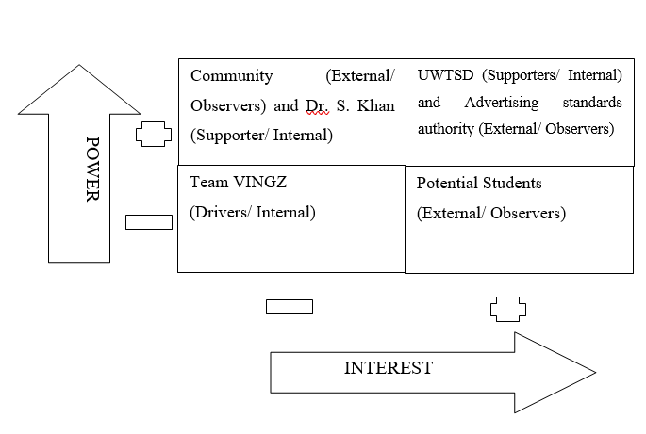
High Power and High Interest- In relation to the project report, stakeholders are categorized as people having high power along interest and are UNWTSD and Advertising Standards Authority for forming decisions related to work and activities which needs to be performed within the project. for sharing and communicating all information, verbal and non-verbal communication strategies are implemented by stakeholders in regards to their actions for offering branding facilities and meeting advertising standards.
High Power and Low Interest- As it can be seen that Community and Dr. S. Khan are stakeholders for this project (Hold and et.al, 2017). Both the stakeholders hold high power for creating decisions whereas have less/low interest in activities of the project for developing and enhancing the required skills and competencies.
Low Power and High Interest- Potential university and other educational institution students are a stakeholder with little authority in project decision-making but a strong interest in the project's responsibilities and activities (Holdstock, 2016). They are aimed to bring some fun and comedy in discourse as the communication approach so that the serious dialogues may be used with the stakeholders So that a road map is given as other things to how a project is being progressed.
Low Power and Low Interest- Team VINGZ is one of the stakeholder in project relating to recruiting and promoting the university course. They have less interest and power in the operations of project. This is entrusted with the task of collaborating with and other stakeholders so that a progressive result is delivered to them.
PHASE 3
Execution Phase
This phase involves working on the specifics of project charter so that the services are provided to the relevant stakeholders. It is considered as an essential stage in the management of project life cycle because it starts with the approval of them so that the activities are implemented. Every effort and the working of plan is drawn as per the planning stage and the execution is solely dependent on that stage. in relation to project for the promotion and recruiting of the university course, this face is mainly focused on creating such deliverables that can satisfy the stakeholders. The project manager that has authority of making the material of marketing four skill of program is interested with the work to create the papers which can guarantee that every task shall be completed within the schedule.
Work Breakdown Structure- It is a graphic depiction that divides a group's work into manageable steps. For this project report, the work breakdown structure depicts linked breakdown into smaller segments of the project (Hu, 2019). The use of this tool for the project drawing many advantages and benefits which can be done through boosting productivity, managing accountability, dealing steps of work and determining the risk through effective approach. The work breakdown structure for the project report has been outline below:

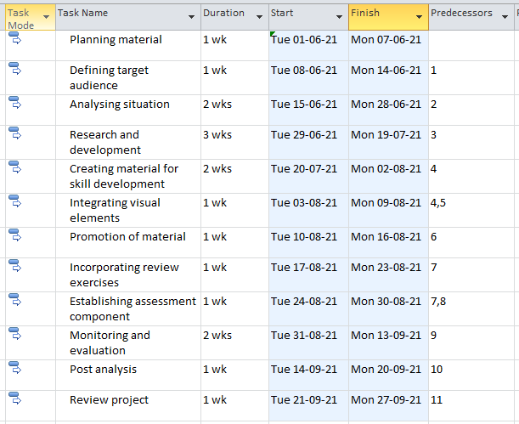
Gantt Chart- It is a form of bar chart which is used for illustration or visualization of all schedules which will be followed during the time frame of the project. in relation to the project, promotion and recruitment of university course, there are several advantages of using a Gantt chart, as it will be a helpful tool for planning and aligning all tasks and activities which needs to be performed and visualize the whole project timeline (Maksimov and Kalkis, 2018). The Gantt chart for this project report has been outlined below:

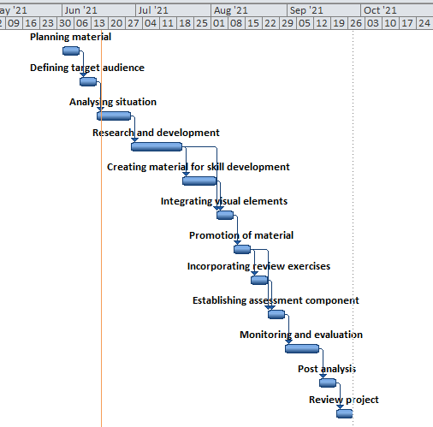
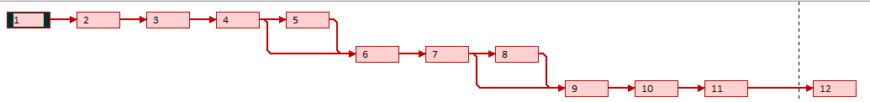
Network Diagram- This is referred to a specific chart depicting sequence of tables & arrows. In accordance to the project report, promotion and recruitment of university courses, the network diagram helped in measuring the all schedule in accordance to work sequence together with track progress at all phases of project plan (Mckeown, Wright and Mercer, 2017). The network diagram for this project has been attached underneath:

PHASE 4
Closure Phase
As per to manager project management cycle, this was helpful to deliver the specific value of the project so that all the stakeholders can satisfy effectively and maintained the final disposition & status. Project management need to communicate with the whole team members which can help can to create effective Ness of the project. With the help of promotional & recruitment activities project management team of the university can effectively launch all the courses and provide guarantee to the stakeholders to monitoring all the aspects in a effective way. Some frameworks used throughout is risk analysis by project managers are listed below for project monitoring:
Risk Analysis- It entails identifying the key difficulties & obstacles that may have a negative influence on the project's primary efforts (Perera, Hewage and Sadiq, 2020). SWOT Analysis, which is a framework for analyzing a project's strengths, weaknesses, opportunities, and threats, is one approach for analyzing risk. In relation to the project of Promotion and recruitment of university courses, SWOT analysis is discussed below:
STRENGTHS  - Time working- The time working ability is one of the strength to this project which will be helpful in making the project effectively and productively and will be able to meet the desired performance standards and project objectives effectively and efficiently. | WEAKNESS  - Incline in cost- Project management is one of the costly approach which creates he barriers and difficulties as the university have to determine the funding sources add allocate such resources through which they can function appropriately for meeting to manage all finances and operate different activities and tasks.
OPPORTUNITIES  - Digital strategy- This can be an opportunity for the university and will offer an opportunity for promoting the market material for attracting more applicants in specific and limited span of time. | THREATS  - High competition- due to rapid incline in the competition within the industry, the candidate scan easily and quickly switch their job applications to another university program which can deliver better career and growth opportunities and overall better advantages for the applicants.

Iron triangle - This triangle is also called as the project management tool which can help full to maintain all the aspects of the project with specific factors which are necessary to engage in the project task. All these triangles are cost, quality, & scope which can help full to maintain the the cost structure, overall quality of the project & create more value of the project in an effective manner. This iron triangle is beneficial in the promotional and recruitment activities of the project related to the University courses.
Scope- This is related to total aspects of work which is involved in the delivery of the project. For the project of promotion & recruitment of university courses, the scope is high as this will involve working for the purpose of planning material, forming material & promoting for improving and enhancing skills of individuals for the university program.
Cost- It can be described as the sum or amount of resources which are required for performing the daily activities and are important for delivery of work. In relation to the project, promotion and recruitment for the university courses, the most required resources re human resource, material resource, financial resource and intellectual resource.
Schedule- This denotes the time which has been forecasted and assigned for completing and delivering the project. In accordance to the project, promotion & recruitment of university courses, the project will be completed and will be delivered in the month of September and will approximately require 4 months of time period for completion of the project report.
Evaluation
It was determined that a large number of applications for participation in the university's skill development programme were received. The Promotion and Recruitment of University Courses project was a success because it improved the university's brand reputation and created a sense of belonging among group members. Various formative and summative assessments were incorporated in the initiative to promote and recruit university courses (Shen and Li, eds, 2017).
Developmental appraisals are methodologies utilized by college educators to perform measure assessments of an understudy's general scholarly accomplishment and learn necessities to improve their range of abilities for a specific program. A review is a method of social affair information from a foreordained gathering of individuals to procure data and experiences on an assortment of subjects of interest. And on the web and disconnected overview, the venture is being accomplished for the venture to decide the task's necessities for expertise advancement among understudies tried out the program.
The objective of creating advertising material for a college expertise program that arrives at an enormous number of individuals is to expand the task's adequacy, where colleagues who accept the venture have the option of successfully speaking with a particular task that most appropriate their capacities and abilities. Partners had a critical job in creating and scattering effective promoting materials that affected an enormous number of understudies to apply for college courses (Xu and et.al, 2018).
The undertaking's entire group functioned admirably in their appointed obligations and made critical commitments to the accomplishment of the task's goals. All individuals from the collaboration on the task work that has been appointed to them. Though the whole undertaking targets were isolated into particular gatherings, the general group execution was acceptable since the collaboration aided the productive utilization of accessible assets and the best yield from the allocated project objective in the errand allotted.

CONCLUSION
The exploration reasons that undertaking arranging and the executives are basic to project achievement. Task life cycle, Quad, Gathering creation, partner investigation, hazard examination, and iron triangle are key undertakings of the board procedures that guide in the powerful accomplishment of targets. The essential arrangement of plans for future work is to set up during the early phase. Partner examination is done at the arranging stage to recognize the force and interests of different partners in the undertaking. In the execution stage, WBS, network graphs, and Gantt diagrams are key instruments. Changing all documentation that is arranged into genuine exercises is important for project execution. To finish a venture on time, it is prompted that authority and time usage capacities be improved. It has been proposed that you go to online classes, connect more with individuals, figure out how to coordinate, and use rousing ways to deal with improving these abilities.

REFERENCES
Books and journals


