BA Business Management

Module: Entrepreneurship

Module code: LCBB5001

Assignment Title: Assessment 2: Business Plan

ILIYA RADICHEV

Table of Contents
BUSINESS PLAN TEMPLATE: ASSESSMENT 2 3
References 11

BUSINESS PLAN TEMPLATE: ASSESSMENT 2

BUSINESS DESCRIPTION / MARKET OPPORTUNITY

Uber Eats is an online application that has been introduced in the year 2015 for ordering the foods. The app has been launched by Uber to help the customers in ordering their favourite dishes at their doorstep effortlessly. The mission of the Uber Eats is to provide an easiest way to the customers in getting their foods.

Business Logo
Source: https://logos-world.net/
The proposed business idea is to introduce ‘Uber Eats in Bulgaria’. The business idea to open Uber Eats can achieve the desired profitability and turnover due to the rising demand of the online food delivery service across the Europe. As per the report, the food market in Bulgaria has evidenced a revenue of US$9.48bn in the year 2022 (Chai, 2021). Moreover, the report has forecasted a growth of 6.25% within the year 2025 in Bulgaria. The customers are using such services to order their food meals at their preferrable locations without standing for the long ques. Bulgaria, the online food service market is not developed and thereby Uber Eats can attain the competitive advantage. Moreover, the online food delivery market in Bulgaria will move up to US$ 66.2 billion within the year 2027 (Statista, 2022). The proposed business idea will deliver freedom and opportunities to the customers in placing the food orders at anywhere and anytime. On account of the outbreak of the COVID-19 pandemic, the people are relying on the online food delivery service for maintaining the social distancing norms. From the health-related aspect, the online food delivery service is a feasible business solution that can create long term impression in the mind of the customers by addressing their health and safety needs in the post pandemic period (Dsouza, 2021). In the terms of convenience, Uber Eats can deliver superior value proposition to the customers with their mobile apps to place their food orders at any time from the restaurants or food joints (Newswire, 2022). The fast-paced life of the millennials has increased the business opportunities in the online food delivery market. Hence, the changing lifestyle of the people, on-going shift in the taste and preferences, and steady rise in the disposable income has created a scope in the online food delivery market. In the era of digitalization, the people are aware and accustomed with the smartphone application for undertaking multiple tasks. The proliferation of the internet has also created a market opportunity for the online food delivery service providers. From the market assessment report, it has been anticipated that the online food delivery market in Europe will grow at a CAGR of 12% within the year 2025. The active smartphone users of Bulgaria have recorded around 63% in the year 2022 (Bank, 2021). In the entire Europe, the online food delivery market has evidenced a substantial growth in the platform-to-consumer services like Glovo, Uber Eat, delivery Club, Just Eat, and Deliveroo. The trend of the people in placing their food orders from the mobile app can be contemplated since lockdown implemented by the Government in the year 2020 for maintaining the social distancing protocols during the COVID-19 pandemic (Statista, 2022).
Uber Eats is a three-sided marketplace business model that will connect the restaurant, customer and delivery partner from the Uber Eats platform. The customer will explore the dishes/restaurants from the mobile app and place the orders. The orders will be processed by the selected restaurant and then the delivery partner of Uber will collect the order from the restaurant and conduct the delivery to the customer. Hence, Uber Eat will act as a unified platform that will integrate the restaurant, customer and delivery partners.
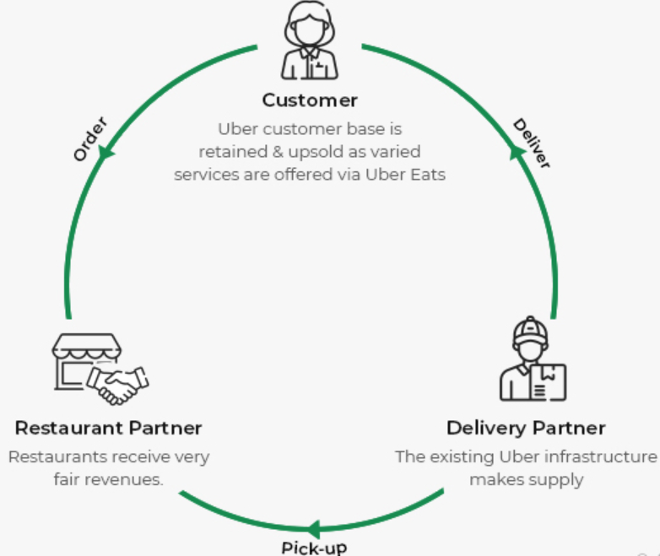
Business Model of Uber Eats
Source: https://www.foodesoft.com/
Organisation structure underlines the hierarchical arrangements that helps to maintain the line of authority, communication and work process in the organisation (Meredith, 2018). Uber Eats has the ‘formal structure’ under the leadership of CEO Uber.

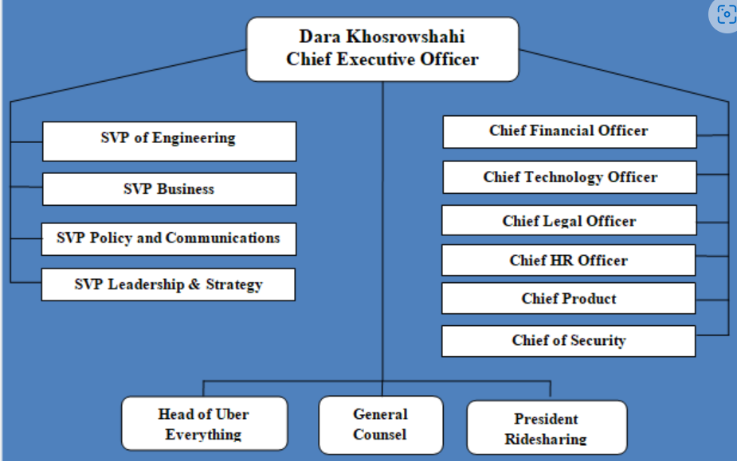
Organisation structure of Uber Eats

INDUSTRY ANALYSIS
Porter’s Five Force analysis can help to analyse the industry trends and competitive intensity for determining the strategy for the business (Parnell, 2020). The online food delivery service is growing across the European market due to the rising health concern and fast paced life of the people.
- Bargaining Power of the customers: The customers are the major revenue source of the business. Hence, the bargaining power of the customers are high. The changing lifestyle of the people, on-going shift in the taste and preferences, and steady rise in the disposable income has created a scope in the online food delivery market (Rumelt, 2019). In the era of digitalization, the people are aware and accustomed with the smartphone application for undertaking multiple tasks. Therefore, a tech friendly mobile app can support the growing needs of the people in the food delivery market.
- Bargaining Power of the Suppliers: The suppliers are the restaurants that will work as a strategic partner of Uber Eats. In Bulgaria, the online food service market is not developed and thereby Uber Eats can attain the competitive advantage. Moreover, the online food delivery market in Bulgaria will move up to US$ 66.2 billion within the year 2027 as per the market assessment report (Dsouza, 2021). Therefore, the suppliers will have low bargaining power due to the high demand in the market.
- Threats of new Entry: The threats of entry for Uber Eats in Bulgaria will be low. Uber Eats is an online application that has been introduced in the year 2015 for ordering the foods. The app has been launched by Uber to help the customers in ordering their favourite dishes at their doorstep effortlessly.
- Threats of Substitutes: The substitutes like Glovo, Delivery Club, Just Eat, and Deliveroo can have a moderate impact to the business turnover of Uber Eats in Bulgaria (Lynch, 2019).
- Competitive Rivalry:
Name of competitor | Differentiation
Just Eat | Just Eat is the market leader in the online food delivery market with 40% of the total market share in the Europe. The company has achieved a revenue of €3.4 billion in the year 2021 which is 45% increase in comparison to the previous year (Newswire, 2022). Moreover, 65 million users to access Just Eat for ordering their foods.
Deliveroo | In the online food delivery market, Deliveroo is a renowned name and it has been launched in the year 2013 in London, England. Deliveroo operate in 150 cities mainly across 120 nations in Europe with 13% of the total market share (Dealroom, 2022). Currently, Deliveroo is working with 140000 restaurants across its locations.
Takeaway | Takeaway is another online food delivery marketplace located in continental Europe that has connected the users in 14 European countries. Moreover, Takeaway has acquired 13% of the total market share in Europe.

OPERATIONS AND MANAGEMENT TEAM
OPERATIONS
The proposed business is the three-sided marketplace business operation model that will connect the restaurant, customer and delivery partner from the Uber Eats platform. The customer will explore the dishes/restaurants from the mobile app and place the orders. The orders will be processed by the selected restaurant and then the delivery partner of Uber will collect the order from the restaurant and conduct the delivery to the customer.

How would you generate revenue for your business?
Operation Management underlines the administration of the business practices in creating highest level of efficiency within the organisation. The operation management includes planning, coordinating, organizing, coordinating and controlling the resources in producing the organisations’s goods and services. Moreover, the maximum efficiency within the business can be observed with the operation management. Uber Eats will implement the operation management principle under the Total Quality Management (TQM). TQM reflects the management framework that is based on the belief in building long-term success by improving the quality and delivering ultimate customer satisfaction (Helleno, 2020). In the operational process, TQM reflects the structured approach in improving the quality through the continual improvement of the internal practices. The business has to uphold the cultural values that creates long-term success. Moreover, the TQM helps to reduce the chances of customer dissatisfaction and ensure the goodwill of the brand. The Quality Assurance team will work closely with the restaurants to fulfill the quality benchmark requirements for delivering the foods to the customers of Uber Eats. Furthermore, the Food Safety protocols will be maintained thoroughly under the Quality Culture principle to provide customer satisfaction and also to achieve the sustainable business growth. Lean production is an effective operational management methodology that can eliminate the waste and exclude the non-value-added aspect to the customers (Munns, 2017). The lean method will reduce the production time as well as response time from the suppliers. The exact matching of the customer requirements with the production quantity can be achieved with the Lean Production. Moreover, the lean production can minimize the waste and eventually reduces the operation cost of the business. Hence, the lean production maximises the productivity and helps to generate revenue from the business.

MANAGEMENT TEAM
Name | Skills | What do they bring to the firm
Andrews | Leadership skill | Transformational leadership by forming the direction of the business will help to attain the desired business goal.
John | Analytical skill | Interpreting the numbers to achieve the business outcomes with the Data Analytics can help to undertake effective business decisions.
George | Organising skill | The people management skill and administrative decisions can help to achieve the desired organisational productivity.
Enrique | Teamworking skill | The collaboration among the functional units of the business by integrating the activities can help to access the real-time information flow

MARKETING:

Product: The proposed business idea is to introduce ‘Uber Eats in Bulgaria’. The three-sided marketplace business model of Uber Eats that will connect the restaurant, customer and delivery partner from the Uber Eats platform. The customer will explore the dishes/restaurants from the mobile app and place the orders. The orders will be processed by the selected restaurant and then the delivery partner of Uber will collect the order from the restaurant and conduct the delivery to the customer.

Price: The pricing is the only element in the marketing mix that supports to generate revenue of the organisation. In the current business perspective, Uber Eats will emphasise to the ‘market penetration’ pricing objective to attract the people in the business introduction phase. Under the ‘market penetration’ pricing objective, the price of the product/service will be low for enticing the customer with the new products/services (Brassington, 2019).

Promotional Mix: The basic objective of the business promotion is to create awareness of the new service of Uber Eats in Bulgaria. Firstly, the business will select the social media platforms like Facebook and Instagram to promote their business and also to inform the people about the introduction of the service in Bulgaria. Secondly, the proposed business will utilise the ‘sales promotion’ techniques to boost the people in towards purchase consideration. The sales promotion can create hedonic effect in the mind of the customers and helps to increase the sales turnover of the business.

Place (Distribution strategy): The service of the Uber Eats can be taken only from the mobile app. The customers have to create an online account with Uber Eats for accessing the services. Uber Eats will enhance the reach and availbality of the service gradually in Bulgaria

FINANCIALS

Sources of funds: where would you be getting funds from?
With respect to Uber Eats staring its business Bulgaria, the main source of fund for the company shall be retained earnings as well as bank loan. It is important to understand that Uber Eats has been doing business for quite a few years within the UK due to which they possess significant retained earnings. Now the main purpose of retained earnings generally remains to reinvest that in the business. Hence this will be the appropriate opportunity for Uber Eats to at least use 30% of their retained earnings in starting their business in Bulgaria, making retained earnings one of the most important funding source of business. Other than this, the rest 70% amount required for setting up the business shall be sourced by taking loan from the bank, which shall be repaid in instalments as per the interest rate of the bank. Hence the main sources of funds for the business remains at bank loan and retained earnings.
Use of funds
The following part shall be showing the total amount of profit Uber Eats is expected to earn after 6 months of its operation in Bulgaria. The detailed analysis of the costs distribution and expected profit is provided below.
 | Month 1 | Month 2 | Month 3 | Month 4 | Month 5 | Month 6
A: Revenue (from your operations and marketing section) | £100 | £120 | £110 | £90 | £140 | £130
Fixed Costs  (List out your fixed costs)  - Insurance  - Advertising  - Delivery Software  - Rent  - Insulated Bags  B: Total Fixed Costs | 5  3  8  4  6  26 | 5  3  8  4  6  26 | 5  3  8  4  6  26 | 5  3  8  4  6  26 | 5  3  8  4  6  26 | 5  3  8  4  6  26
Variable Costs  (List out your variable costs)  - Packaging  - Vehicle Operation Cost  - Wages of Drivers  C: Total Variable Costs | 3  5  7  15 | 3.5  6.5  8  18 | 2.5  5  6.5  14 | 1.5  3.5  5  10 | 4  7  8  19 | 3  6  7  16
Profit [A – (B+C)] | 59 | 76 | 70 | 54 | 95 | 88

References
Bank, W., 2021. GDP growth (annual %) - Bulgaria. [Online]
Available at: https://data.worldbank.org/indicator/NY.GDP.MKTP.KD.ZG?locations=BG
[Accessed 29 07 2022].
Brassington, F. a. P. S., 2019. Principles of marketing. In: London: Prentice Hall.
Chai, L., 2021. Online food delivery services: Making food delivery the new normal. Journal of Marketing advances and Practices, 12(9), pp. 62-77.
Dealroom, 2022. Food Delivery Tech: Battle for the European Consumer. [Online]
Available at: https://dealroom.co/uploaded/2020/06/Food-Tech-Prez-FINAL.pdf
[Accessed 02 08 2022].
Dsouza, D. a. S. D., 2021. Online food delivery portals during COVID-19 times: an analysis of changing consumer behavior and expectations. International Journal of Innovation Science, 11(5), pp. 117-124.
Helleno, A. P. C. F., 2020. Integrating value stream mapping and discrete events simulation as decision making tools in operation management. The International Journal of Advanced Manufacturing Technology, 80(7), pp. 1059-1066.
Lynch, R., 2019. Strategic Management. 8th ed. London: Pearson.
Meredith, J. S. S. a. M. J. S., 2018. Project Management: A Strategic Managerial Approach. London: John Wiley & Sons.
Munns, A., 2017. The role of project management in achieving project success. International journal of project management, 14(5), pp. 81-87.
Newswire, G., 2022. Europe Online Food Delivery Market Report 2022-2027 Featuring Deliveroo, Just Eat, Delivery Hero, Uber Eats, Dominos, Doordash. [Online]
Available at: https://www.globenewswire.com/en/news-release/2022/04/01/2414632/28124/en/Europe-Online-Food-Delivery-Market-Report-2022-2027-Featuring-Deliveroo-Just-Eat-Delivery-Hero-Uber-Eats-Dominos-Doordash.html
[Accessed 29 07 2022].
Parnell, J., 2020. Strategic management. London: Sage.
Rumelt, R. S. D. a. T. D., 2019. Strategic management and economics. Strategic management journal, 12(2), pp. 5-29.
Statista, 2022. Food: Bulgaria. [Online]
Available at: https://www.statista.com/outlook/cmo/food/bulgaria#revenue
[Accessed 29 07 2022].

