DS 1 Template

My Screenshots/Photos
- Please add 4–6 screenshots or photos of your digital life.
- You can use your phone or laptop.
- For each screenshot, write one or two sentences explaining what it shows.

Screenshot/Photo 1

I use this app to order shopping for the house

Screenshot/Photo 2
[Insert Photo/Screenshot below]
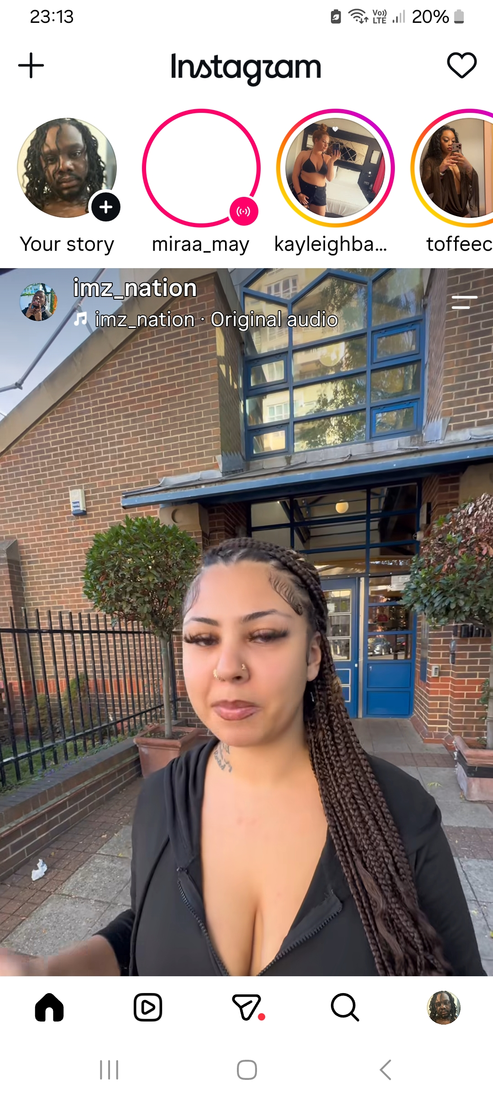
I use Instagram to search the latest stories of peoples life’s .

Screenshot/Photo 3
[Insert Photo/Screenshot below]
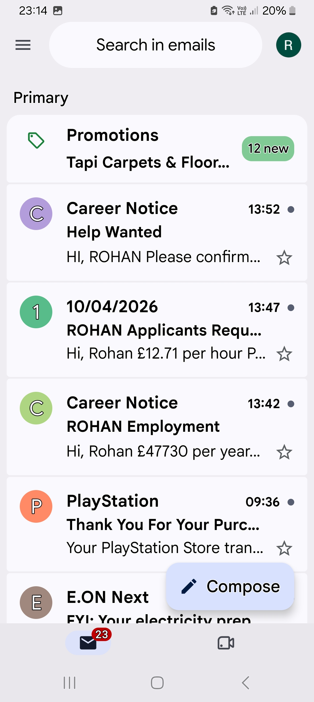 I use this to find out who has been trying to contact me using my emails

Screenshot/Photo 4
[Insert Photo/Screenshot below]
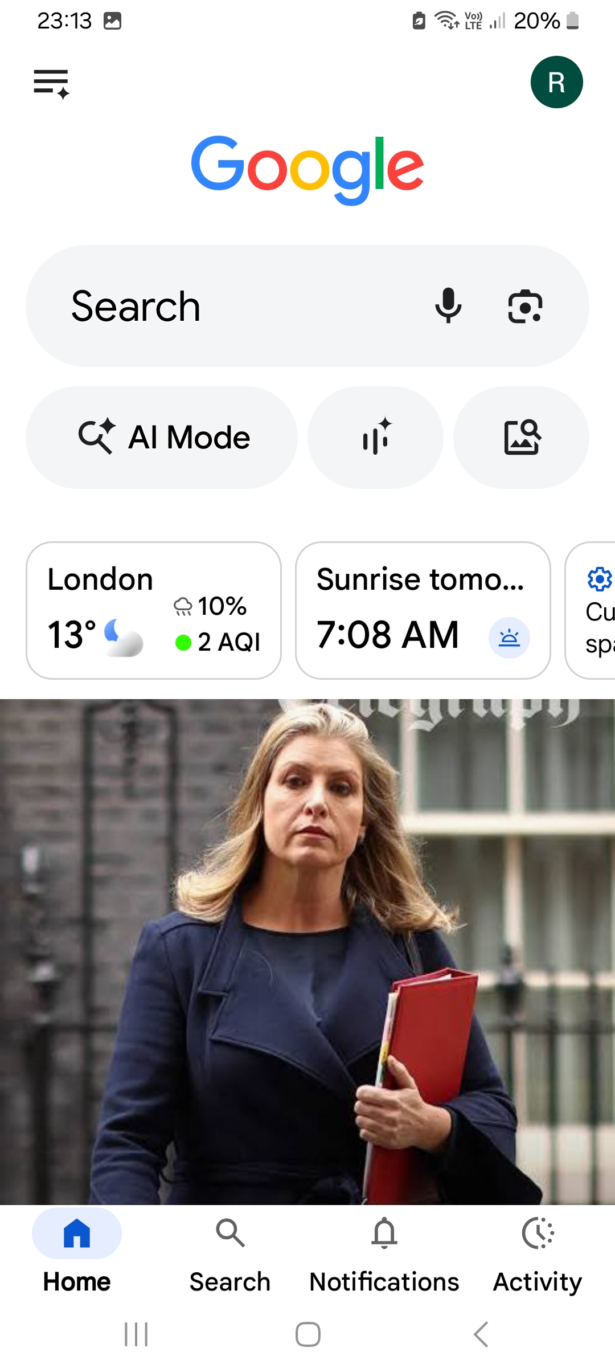
I use google to search for news around the world and other information

Screenshot/Photo 5
[Insert Photo/Screenshot below]

[Write what this shows of your digital life]

Screenshot/Photo 6
[Insert Photo/Screenshot below]
[Write what this shows of your digital life]

My Short Reflection
- Write 5–8 simple sentences about your digital life.
- You can use the sentence starters below if helpful.
- I use digital tools to make things easier to understand
- I feel confident when I find the right things um looking for
- I want to improve uploading documents
- I often use these tools when I use my phone
- I sometimes feel nervous about not understanding certain digital platforms

Sentence starters
- I use digital tools to …
- I feel confident when I …
- I want to improve …
- I often use these tools: …
- I sometimes feel nervous about …
- I hope this module will help me …
- Digital skills are important for me because …
You can write more if you want.

Submission Checklist
Before you submit, please check:
​​​ ☒ I added 4–6 screenshots
☒ I wrote short sentences for each screenshot
☒ I wrote my short reflection
☒ My work is my own
☒ My file opens correctly
​​☒ My file opens correctly

