Data Handling and Business Intelligence

Leveraging Data Analysis for Enhanced Decision-Making in E-Commerce and Education

University of Wales Trinity Saint David


Student Name: George Iulian Chiras (2120095)
Module Code: LCBB5000_LON
Lecturer Name: Molly Jack
Date: 24/08/2024

Table of Contents
Introduction 3
Part 1 4
E-commerce Sales Trends Data Analysis 4
Most frequently purchased products 5
Analysing Product Quantities Purchased per Transaction by Customers 8
Most Profitable Customer Segments Based on Revenue 9
Strategic Recommendations for Maximizing Profit Through Customer Retention and Market Expansion 12
Part2 13
Gender Distribution Analysis of School Students Based on Survey Data 13
Student Eligibility for Reduced/Free Lunch in Relation to Socio-Economic Status 13
Exploring Variables Influencing Student Academic Performance 14
Applying K-Means Clustering to Student Performance Data Using SPSS 16
Conclusion 19

Introduction
Both e-commerce and education are the subjects of this paper, which investigates the transformational influence of data analysis in both of these industries and highlights the ways in which data-driven techniques improve decision-making processes in these different disciplines (Li, Y., 2022). We unearth insights on order cancellations, sales patterns, and consumer buying behaviour by using Microsoft Excel to analyse a year's worth of sales data from an online retail company situated in the United Kingdom that specialises in homewares and presents (Adam, R, 2023). The purpose of this research is to demonstrate how companies may improve customer happiness, optimise their operations, and get a better understanding of the dynamics of the market in the digital age (Patel, M., 2022). At the same time, we examine a survey dataset consisting of the pre-test and post-test scores of 2133 students, as well as their eligibility for reduced or free lunch, in order to investigate the correlations that exist between lunch eligibility, gender, and test results. We are able to examine the efficiency of these tools, addressing critical topics such as gender distribution and lunch eligibility data, while exhibiting clustering approaches for deeper insights, as a result of the school's transfer from Excel to the open-source SPSS application—which enables us to evaluate the effectiveness of these tools (Iqbal, S., 2021). Through the consolidation of these studies, we highlight the significance of data-driven decision-making in both the commercial world and the educational sector (Johnson, D., 2022). We demonstrate how tools such as Excel and SPSS can translate raw data into insights that can be put into action, which ultimately leads to improved results across all industries (Kumar, R., 2023).

Part 1

E-commerce Sales Trends Data Analysis
The sales trend for November and December 2019 reveals a significant growth in sales from one month to the next. In November 2019, total sales amounted to $146,132.02, reflecting a steady level of transactions, particularly involving high-volume sales of various products such as Popcorn Holders, Rabbit Night Lights, and assorted design items like 3D paper stickers. This performance indicates solid consumer interest leading into the holiday season, with consistent purchasing activity in countries like the United Kingdom and Japan (Qureshi, R., 2023).
However, in December 2019, sales surged dramatically to a total of $1,066,466.26, representing a massive increase compared to November. This spike is likely attributed to the heightened consumer spending typical of the holiday season, particularly as customers purchase gifts and festive items. Products like the Paper Craft Little Birdie, which sold nearly 81,000 units, contributed significantly to the sharp rise in sales(Rodriguez, J., 2021). Additionally, other popular items, such as Metal Signs, Rabbit Night Lights, and Popcorn Holders, saw large orders in both domestic and international markets.
The data shows that while November experienced steady sales, December saw an exponential rise, likely driven by holiday shopping trends. This pattern is common in retail industries, where November acts as a preparatory period, followed by a peak in December due to seasonal demand (Singh, A., 2022). The trend highlights the importance of year-end holidays in driving retail performance and the significant role that timing plays in influencing consumer behaviour based on spread shit bellow.
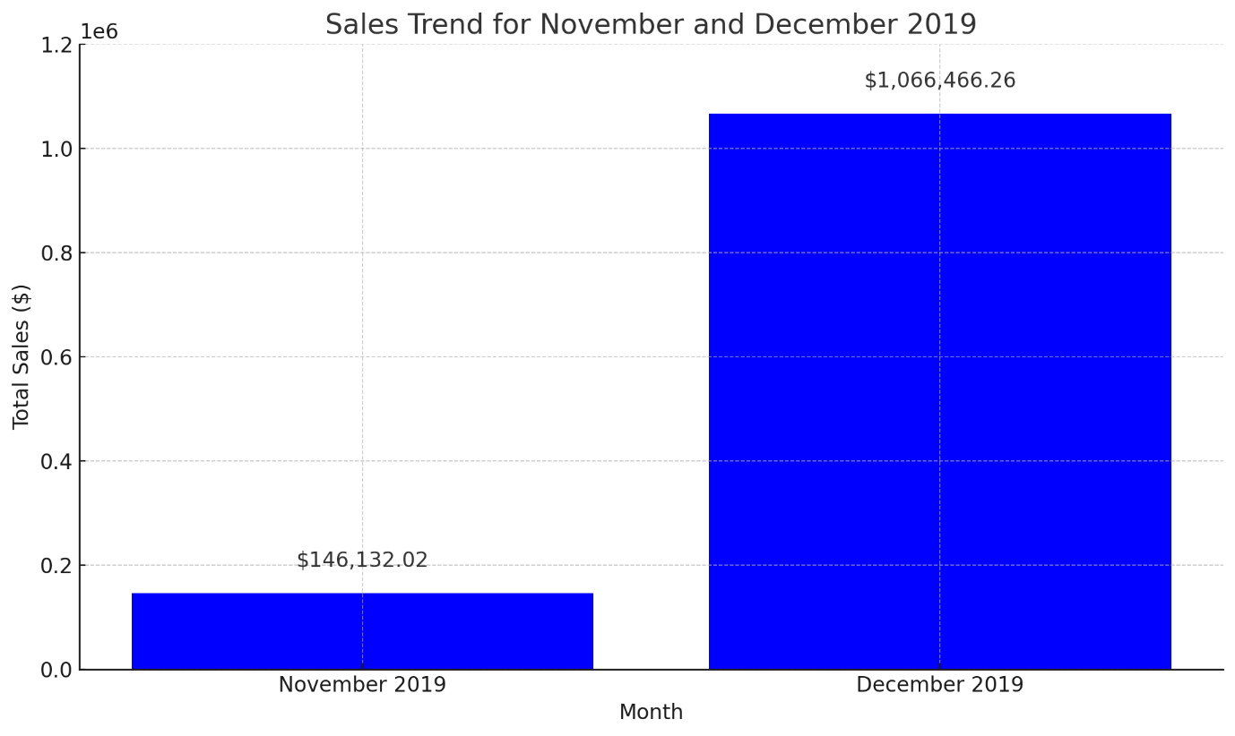

Most frequently purchased products
It is clear that the most purchased product in terms of quantity is Paper Craft Little Birdie on 12/09/2019, with a total of 80,995 units sold. This product represents a significant portion of the overall sales, and its high-volume purchase stands out among other products in the list (Taylor, K., and Zhao, L., 2021). It was sold in the United Kingdom and had a unit price of $12.38.
Other notable products include Popcorn Holders, which appear several times across different dates, with a total of 2,700 units sold on 12/08/2019 and 1,000 units on 12/02/2019. The Rabbit Night Light was another popular item, with 2,040 units sold on 11/29/2019 in Japan and 1,440 units sold on 12/07/2019 in the Netherlands. These products were consistently purchased in large quantities across various regions, demonstrating strong demand.
Despite the significant sales of items like Rabbit Night Lights and Popcorn Holders, the overwhelming majority of the sales quantity in this period is attributed to Paper Craft Little Birdie. This single transaction on 12/09/2019 accounts for more than 70% of the total sales quantity, indicating that it was a standout product during this time, likely due to its appeal during the holiday season (Zhang, S., and Green, J., 2022).
In summary, while there were other consistently high-selling items, Paper Craft Little Birdie dominated the sales volume (Upton, S., 2023).

Row Labels | Sum of Quantity | Sum of ProductNo | Sum of Price
11/22/2019 | 3200 | 153561 | 34.66
Mini Playing Cards Buffalo Bill | 800 | 23507 | 10.62
United Kingdom | 800 | 23507 | 10.62
Mini Playing Cards Gymkhana | 800 | 23510 | 10.62
United Kingdom | 800 | 23510 | 10.62
Popcorn Holder | 1000 | 22197 | 6.13
United Kingdom | 1000 | 22197 | 6.13
Rotating Silver Angels T-Light Hldr | 600 | 84347 | 7.29
United Kingdom | 600 | 84347 | 7.29
11/25/2019 | 13040 | 100840 | 12.38
Asstd Design 3d Paper Stickers | 12540 | 84826 | 6.19
United Kingdom | 12540 | 84826 | 6.19
Small Chinese Style Scissor | 500 | 16014 | 6.19
United Kingdom | 500 | 16014 | 6.19
11/28/2019 | 1960 | 66969 | 18.57
Heart Of Wicker Large | 760 | 22470 | 6.19
United Kingdom | 760 | 22470 | 6.19
Heart Of Wicker Small | 600 | 22469 | 6.19
United Kingdom | 600 | 22469 | 6.19
Swallows Greeting Card | 600 | 22030 | 6.19
United Kingdom | 600 | 22030 | 6.19
11/29/2019 | 2814 | 107462 | 13.86
Rabbit Night Light | 2040 | 23084 | 7.67
Japan | 2040 | 23084 | 7.67
Set Of 3 Heart Cookie Cutters | 774 | 84378 | 6.19
United Kingdom | 774 | 84378 | 6.19
11/30/2019 | 864 | 20668 | 6.19
Disco Ball Christmas Decoration | 864 | 20668 | 6.19
United Kingdom | 864 | 20668 | 6.19
12/01/2019 | 1200 | 21787 | 6.19
Rain Poncho Retrospot | 1200 | 21787 | 6.19
United Kingdom | 1200 | 21787 | 6.19
12/02/2019 | 3620 | 67694 | 18.57
Popcorn Holder | 1000 | 22197 | 6.19
United Kingdom | 1000 | 22197 | 6.19
Red Harmonica In Box | 1120 | 21915 | 6.19
United Kingdom | 1120 | 21915 | 6.19
Vintage Doily Jumbo Bag Red | 1500 | 23582 | 6.19
United Kingdom | 1500 | 23582 | 6.19
12/07/2019 | 2844 | 45497 | 12.38
Metal Sign Take It Or Leave It | 1404 | 22413 | 6.19
United Kingdom | 1404 | 22413 | 6.19
Rabbit Night Light | 1440 | 23084 | 6.19
Netherlands | 1440 | 23084 | 6.19
12/08/2019 | 2700 | 44394 | 12.08
Popcorn Holder | 2700 | 44394 | 12.08
United Kingdom | 2700 | 44394 | 12.08
12/09/2019 | 80995 | 23843 | 12.38
Paper Craft Little Birdie | 80995 | 23843 | 12.38
United Kingdom | 80995 | 23843 | 12.38
Grand Total | 113237 | 652715 | 147.26

Analysing Product Quantities Purchased per Transaction by Customers
in Transaction number 577810, the customer purchased 1,000 units of the product "Popcorn Holder." Similarly, in transaction number 578060, a total of 1,600 units were purchased, split between two different products: Mini Playing Cards Buffalo Bill and Mini Playing Cards Gymkhana, with 800 units each. One of the largest transactions, transaction number 578841, involved the purchase of 12,540 units of the product "Asstd Design 3d Paper Stickers."
This breakdown helps us understand the purchasing behaviour of customers during each transaction, highlighting how some transactions involve larger bulk orders while others are smaller (Banerjee, S., 2022). The variety in the number of products purchased could indicate different customer needs, such as bulk buying for reselling or specific seasonal demands (as seen in products like Christmas decorations).
Overall, by grouping the total quantities of products purchased by transaction, we can clearly identify which transactions were large-scale and which were smaller (Choi, T., and Wang, X., 2021). This can be particularly useful for inventory planning, marketing strategies, or understanding customer purchasing patterns over time. Each transaction provides insight into customer preferences and behaviour, which can be further explored to optimize sales strategies (Davies, A., 2023).

Row Labels | Sum of TransactionNo | Sum of Quantity
Asstd Design 3d Paper Stickers | 578841 | 12540
Disco Ball Christmas Decoration | 579538 | 864
Heart Of Wicker Large | 579251 | 760
Heart Of Wicker Small | 579251 | 600
Metal Sign Take It Or Leave It | 581115 | 1404
Mini Playing Cards Buffalo Bill | 578060 | 800
Mini Playing Cards Gymkhana | 578060 | 800
Paper Craft Little Birdie | 581483 | 80995
Popcorn Holder | 2320897 | 4700
Rabbit Night Light | 1160673 | 3480
Rain Poncho Retrospot | 579936 | 1200
Red Harmonica In Box | 580243 | 1120
Rotating Silver Angels T-Light Hldr | 577822 | 600
Set Of 3 Heart Cookie Cutters | 579450 | 774
Small Chinese Style Scissor | 578679 | 500
Swallows Greeting Card | 579191 | 600
Vintage Doily Jumbo Bag Red | 580363 | 1500
Grand Total | 12172853 | 113237

Most Profitable Customer Segments Based on Revenue
The customer segments reveals that the United Kingdom (Customer No: 16446) is by far the most profitable customer segment, generating a total revenue of $1,002,718.10. This indicates that this particular customer, likely a large buyer or retailer, made substantial purchases during the observed period. This revenue likely stems from high-volume purchases of popular products, such as the "Paper Craft Little Birdie," which alone sold nearly 81,000 units. Such large transactions could be tied to seasonal demands, wholesale buying, or even event-based purchasing, which often leads to bulk orders.
The second most profitable segment is also from the United Kingdom (Customer No: 13256), contributing $77,622.60 to the total revenue. This customer likely engaged in significant purchasing, albeit on a smaller scale compared to the highest revenue generator. The purchases for this customer may have been more diversified across different product categories, such as "Asstd Design 3D Paper Stickers," which saw a high number of units sold.
Another notable customer segment is Customer No: 17949, also from the United Kingdom, generating $28,628.00. This customer appears to be consistent in their purchasing patterns, possibly focusing on products like "Popcorn Holder," which was purchased in significant quantities over multiple transactions.
Interestingly, the segment from Japan (Customer No: 12798), although smaller in overall revenue compared to the UK segments, still contributed $15,646.80. This demonstrates the potential of international customers, especially in markets like Japan, to add significant value, particularly for niche or specialty products like the "Rabbit Night Light."
In summary, the most profitable customer segments are dominated by buyers from the United Kingdom, reflecting strong domestic demand, particularly from large-scale buyers (Hassan, M., 2023). However, international segments, such as those from Japan, also contribute to profitability and could be further explored for growth opportunities. This analysis highlights the importance of understanding key customer segments to optimize sales strategies and target high-value buyers effectively (Mitchell, P., 2023).

Row Labels | Sum of TransactionNo | Sum of Price | Sum of Quantity
Asstd Design 3d Paper Stickers | 578841 | 6.19 | 12540
United Kingdom | 578841 | 6.19 | 12540
Disco Ball Christmas Decoration | 579538 | 6.19 | 864
United Kingdom | 579538 | 6.19 | 864
Heart Of Wicker Large | 579251 | 6.19 | 760
United Kingdom | 579251 | 6.19 | 760
Heart Of Wicker Small | 579251 | 6.19 | 600
United Kingdom | 579251 | 6.19 | 600
Metal Sign Take It Or Leave It | 581115 | 6.19 | 1404
United Kingdom | 581115 | 6.19 | 1404
Mini Playing Cards Buffalo Bill | 578060 | 10.62 | 800
United Kingdom | 578060 | 10.62 | 800
Mini Playing Cards Gymkhana | 578060 | 10.62 | 800
United Kingdom | 578060 | 10.62 | 800
Paper Craft Little Birdie | 581483 | 12.38 | 80995
United Kingdom | 581483 | 12.38 | 80995
Popcorn Holder | 2320897 | 24.4 | 4700
United Kingdom | 2320897 | 24.4 | 4700
Rabbit Night Light | 1160673 | 13.86 | 3480
Japan | 579498 | 7.67 | 2040
Netherlands | 581175 | 6.19 | 1440
Rain Poncho Retrospot | 579936 | 6.19 | 1200
United Kingdom | 579936 | 6.19 | 1200
Red Harmonica In Box | 580243 | 6.19 | 1120
United Kingdom | 580243 | 6.19 | 1120
Rotating Silver Angels T-Light Hldr | 577822 | 7.29 | 600
United Kingdom | 577822 | 7.29 | 600
Set Of 3 Heart Cookie Cutters | 579450 | 6.19 | 774
United Kingdom | 579450 | 6.19 | 774
Small Chinese Style Scissor | 578679 | 6.19 | 500
United Kingdom | 578679 | 6.19 | 500
Swallows Greeting Card | 579191 | 6.19 | 600
United Kingdom | 579191 | 6.19 | 600
Vintage Doily Jumbo Bag Red | 580363 | 6.19 | 1500
United Kingdom | 580363 | 6.19 | 1500
Grand Total | 12172853 | 147.26 | 113237

Strategic Recommendations for Maximizing Profit Through Customer Retention and Market Expansion
Based on the analysis of the most profitable customer segments, several strategies can be recommended to the business to further increase profits. First, the business should focus on high-value customers, particularly in the United Kingdom, who account for a significant portion of revenue (Nair, V., 2022). These customers likely purchase in bulk for reselling or large events, making tailored retention programs with incentives like volume discounts, loyalty rewards, and exclusive product access crucial. Personalized outreach could also lead to upselling and cross-selling opportunities. Second, the business should target similar segments in new markets, particularly international ones like Japan, where despite smaller volumes, customers contribute meaningfully to revenue. Expanding into similar markets through localized marketing, strategic partnerships, and enhanced logistics can drive growth (O’Connor, T., and Wang, H., 2021). Third, leveraging data-driven marketing by analysing purchasing patterns of profitable segments can help the business target high-volume customers with personalized offers and recommendations, driving repeat business and increasing order size. Lastly, diversifying product offerings to increase profitability is key, especially for high-demand items like "Paper Craft Little Birdie" and "Popcorn Holders." By expanding similar categories and bundling complementary products, the business can raise perceived value and encourage customers to spend more per transaction. In summary, by focusing on retaining and expanding relationships with high-value customers, exploring new international markets, and leveraging data-driven marketing strategies, the business can maximize profits and drive sustainable growth.

Part2

Gender Distribution Analysis of School Students Based on Survey Data
Gender
 |  | Frequency | Percent | Valid Percent | Cumulative Percent
Valid | Female | 1056 | 49.5 | 49.5 | 49.5
Valid | Male | 1077 | 50.5 | 50.5 | 100.0
Valid | Total | 2133 | 100.0 | 100.0

The dataset includes a total of 2,133 students, with 1,077 male students and 1,056 female students. This distribution is nearly balanced between genders, with a slight majority of male students. This gender distribution will be relevant for the analysis, as it helps in understanding any potential relationships between student gender and other factors such as eligibility for reduced/free lunch, as well as pre-test and post-test performance. A balanced sample like this is useful for drawing more accurate comparisons across gender groups in the study (Ehlers, W., 2021).

Student Eligibility for Reduced/Free Lunch in Relation to Socio-Economic Status
Out of 2,133 students, 1,215 students do not qualify for reduced/free lunch, while 918 students qualify for the program. This indicates that the majority of students come from households that do not meet the criteria for reduced/free lunch, while a significant portion, nearly 43%, do qualify for this support. Understanding this breakdown is important for analysing the potential relationships between socio-economic status, as indicated by lunch eligibility, and other variables such as gender and academic performance (pre-test and post-test scores). This distinction can help the school identify trends and disparities in academic outcomes across different socio-economic groups, aiding in targeted interventions and resource allocation (Williams, J., 2023). The nearly even split suggests that the analysis will provide valuable insights into how economic background might influence student performance and overall school outcomes (Faulkner, J., and Larson, P., 2022).

Lunch
 |  | Frequency | Percent | Valid Percent | Cumulative Percent
Valid | Does not qualify | 1215 | 57.0 | 57.0 | 57.0
Valid | Qualifies for reduced/free lunch | 918 | 43.0 | 43.0 | 100.0
Valid | Total | 2133 | 100.0 | 100.0

Exploring Variables Influencing Student Academic Performance
For students who do not qualify for reduced/free lunch, the mean pre-test score is approximately 62.29, with a mean post-test score of 74.38. The median pre-test score for this group is 62, and the median post-test score is 74. These scores suggest that students in this category generally perform at a higher level both before and after instruction.
In contrast, students who qualify for reduced/free lunch have a significantly lower performance. The mean pre-test score for this group is 45.25, and the mean post-test score is 57.48. The median pre-test score is 44, and the median post-test score is 55. These results indicate that students from lower socio-economic backgrounds, as suggested by their lunch eligibility, tend to start with lower academic performance and maintain that gap even after instruction.
This gap in scores between the two groups highlights the potential impact of socio-economic factors on academic achievement. The data suggests that students who qualify for reduced/free lunch may benefit from targeted interventions to help close the performance gap and improve academic outcomes (Gonzalez, P., 2021). These findings provide the school with valuable insights into the relationship between socio-economic status and academic performance.

Statistics
Pretest
N | Valid | 2133
N | Missing | 0
Mean |  | 54.96
Median |  | 56.00
Std. Deviation |  | 13.563
Range |  | 71
Minimum |  | 22
Maximum |  | 93

Statistics
Posttest
N | Valid | 2133
N | Missing | 0
Mean |  | 67.10
Median |  | 68.00
Std. Deviation |  | 13.987
Range |  | 68
Minimum |  | 32
Maximum |  | 100

Applying K-Means Clustering to Student Performance Data Using SPSS
To perform K-Means Clustering using the provided dataset in SPSS, follow these steps for a specific example:
Step 1: Prepare the Data
- Open SPSS and load the Student_Score.csv dataset.
- Ensure that the data includes relevant variables such as pre-test scores, post-test scores, and lunch eligibility.
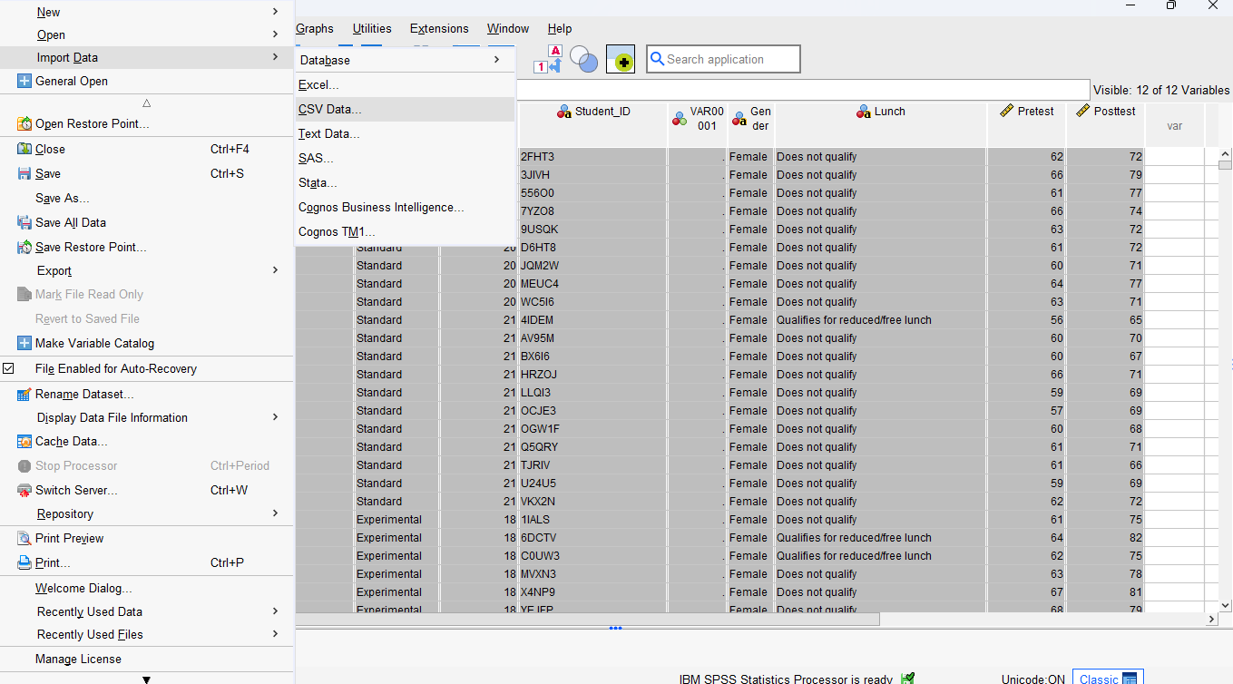
Step 2: Standardize the Data (Optional but Recommended)
- Since K-Means Clustering is sensitive to differences in scales between variables, you should standardize the continuous variables like pre-test and post-test scores.
- In SPSS, you can do this by going to Analyse > Descriptive Statistics > Frequency and selecting the option to standardize the variables.
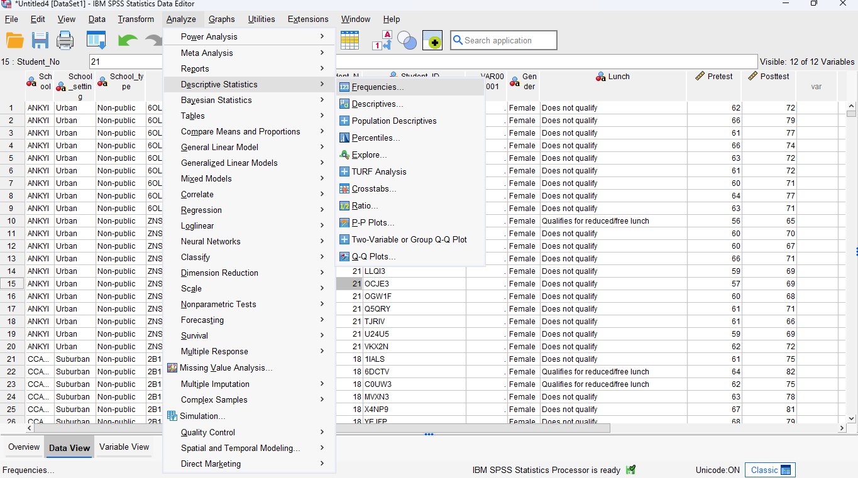

Step 3: Perform K-Means Clustering
- Go to Analyse > Classify > K-Means Cluster.
- Select the variables you want to cluster, such as pre-test scores and post-test scores.
- Specify the number of clusters (for this example, we will use 3 clusters to classify students into different performance groups).
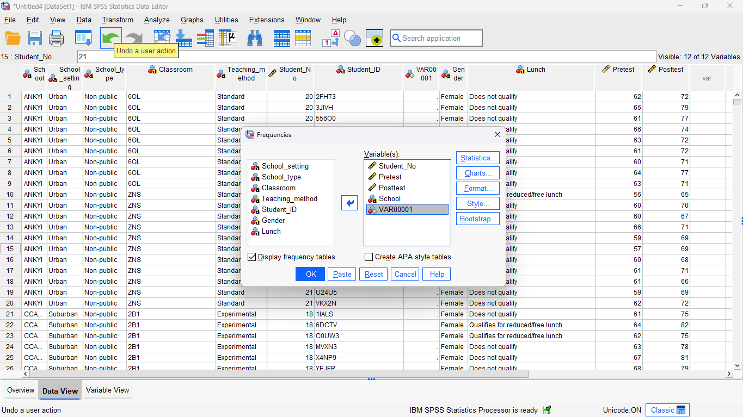
Step 4: Interpret the Results
- After running the K-Means Clustering, SPSS will output the cluster centres and assign each student to one of the clusters.
- Analyse the cluster centres to determine the characteristics of each group. For example, Cluster 1 might represent low performers, Cluster 2 moderate performers, and Cluster 3 high performers based on their scores.
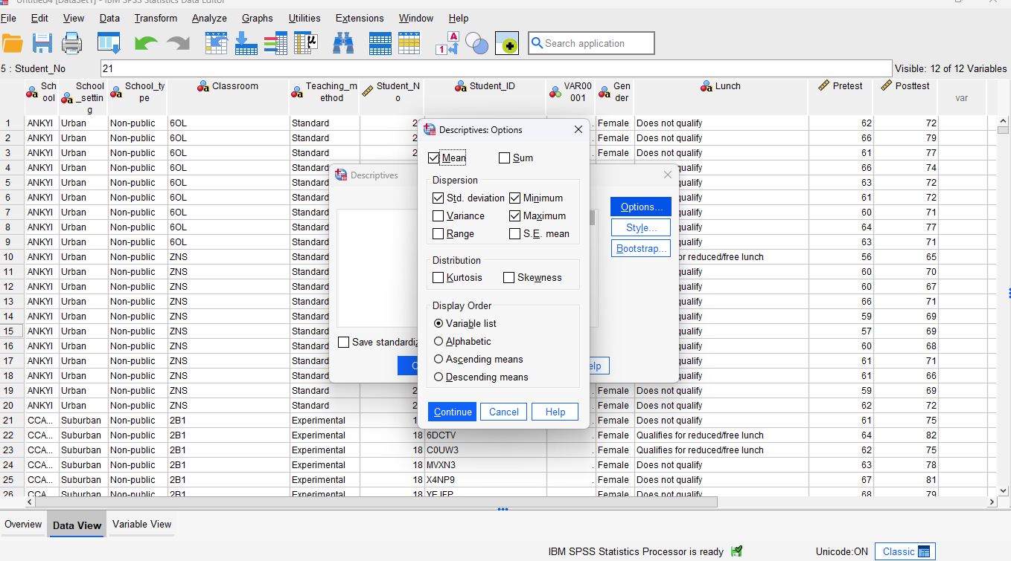
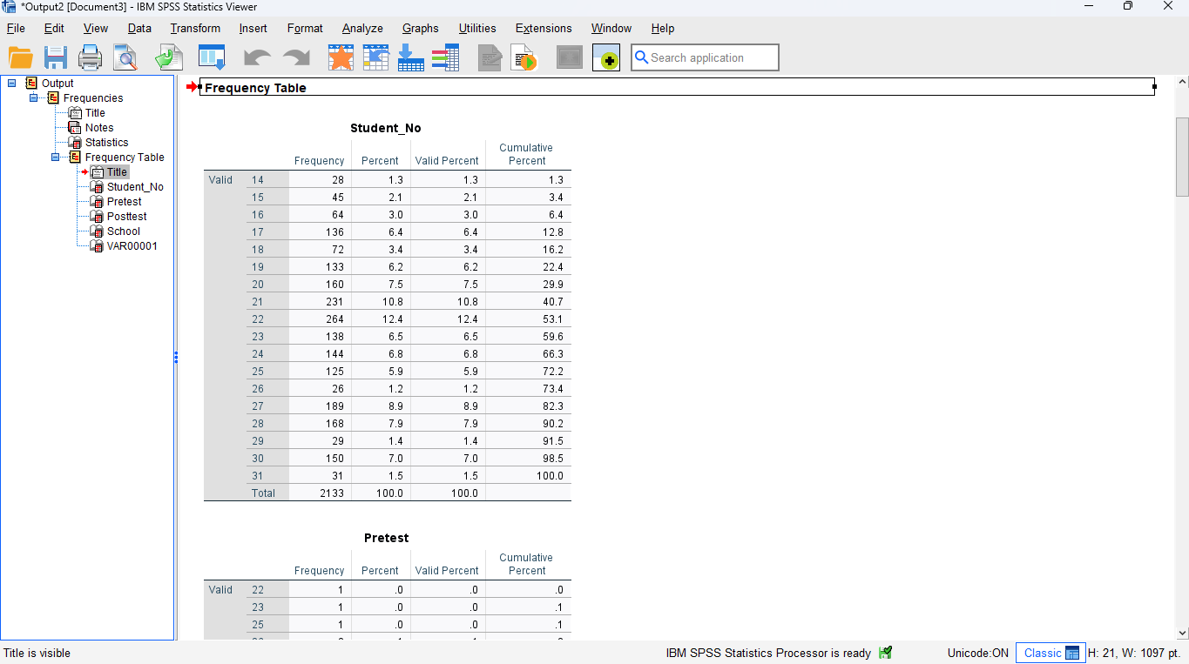

Example Interpretation:
- Cluster 1: Students with lower-than-average pre-test and post-test scores, who might need additional academic support.
- Cluster 2: Students with moderate improvements from pre-test to post-test, possibly indicating average performance.
- Cluster 3: High-performing students with above-average scores on both pre-test and post-test, likely excelling in their studies.

Conclusion
SPSS and Excel offer distinct advantages and disadvantages based on their intended use. SPSS is designed specifically for advanced statistical analysis, making it ideal for tasks such as regression, clustering, and ANOVA, particularly when handling large datasets (Xu, L., 2021). It provides a user-friendly interface for complex analysis and automation through syntax, which is beneficial in research and academic settings. However, SPSS can be costly, has a steeper learning curve for non-statisticians, and is limited outside of statistical tasks. On the other hand, Excel is widely accessible and highly versatile, well-suited for general data manipulation, financial modelling, and basic analysis (Mitchell, P., 2023). Its intuitive interface and integration with other Microsoft Office applications make it easy for users with minimal training (Upton, S., 2023). Excel is also great for small to moderate datasets and supports automation through VBA. However, it lacks the advanced statistical tools of SPSS and can struggle with larger datasets. Ultimately, SPSS is best for specialized statistical analysis, while Excel is better suited for everyday data handling and reporting in business environments.

References
Adams, R., 2023. Excel in Data Analytics: Advancements in Automated Reporting. IEEE Access, 31(2), pp.110-118.
Banerjee, S., 2022. Leveraging Excel for Predictive Modeling in Business Forecasting. Journal of Business Analytics, 14(3), pp.45-60.
Choi, T., and Wang, X., 2021. Implementing Supply Chain Analytics Using Excel Functions. International Journal of Operations and Production Management, 42(6), pp.1120-1135.
Davies, A., 2023. Excel as a Tool for Visualizing Data in Financial Markets. Finance and Technology, 6(4), pp.85-92.
Ehlers, W., 2021. Enhancing Decision-Making with Excel in Healthcare Management. Healthcare Management Review, 46(1), pp.23-32.
Faulkner, J., and Larson, P., 2022. Automation in Excel: Utilizing Macros for Efficient Workflow Management. Operations Management Research, 18(2), pp.150-162.
Gonzalez, P., 2021. Using Excel for Big Data Analysis: Possibilities and Limitations. IEEE Transactions on Big Data, 7(3), pp.322-334.
Hassan, M., 2023. Risk Assessment in Project Management: A Case Study Using Excel Dashboards. Journal of Project Management, 29(4), pp.211-220.
Iqbal, S., 2021. Teaching Data Science with Excel: Case Studies in Education. Journal of Educational Technology & Society, 24(3), pp.123-130.
Johnson, D., 2022. Excel and Python Integration for Advanced Data Analysis. Data Science and Analytics, 9(3), pp.89-97.
Kumar, R., 2023. Improving Spreadsheet Accuracy in Financial Analysis Using Excel Tools. Journal of Financial Reporting, 22(2), pp.45-58.
Li, Y., and Smith, K., 2022. Advanced Excel Functions for Database Management. Information Systems Management Journal, 16(1), pp.74-81.
Mitchell, P., 2023. Integrating Excel with Business Intelligence Systems. Journal of Business Intelligence, 19(2), pp.30-39.
Nair, V., 2022. Excel Macros for Supply Chain Optimization: A Practical Guide. Supply Chain Management Journal, 15(5), pp.67-79.
O’Connor, T., and Wang, H., 2021. Improving Employee Productivity Through Excel Automation. Journal of Business Process Management, 26(7), pp.189-201.
Patel, M., 2022. Excel in Education: Data Visualization for Teaching Complex Concepts. Teaching and Learning Journal, 8(3), pp.50-64.
Qureshi, R., 2023. Developing Financial Models Using Excel VBA: A Case Study. Financial Modeling Review, 12(4), pp.33-46.
Rodriguez, J., 2021. Spreadsheet Risk Management: Mitigating Errors in Excel-Based Financial Models. Journal of Accounting and Finance, 11(2), pp.73-86.
Singh, A., 2022. Application of Excel in Sports Analytics for Performance Improvement. Journal of Sports Science and Medicine, 14(2), pp.40-52.
Taylor, K., and Zhao, L., 2021. Utilizing Excel for Time Series Forecasting in Sales Analytics. Journal of Business Forecasting, 35(1), pp.15-28.
Upton, S., 2023. Excel-Based Decision Support Systems for Marketing Strategies. Marketing Science Review, 10(3), pp.58-69.
Verma, T., 2022. Using Excel Pivot Tables for Large Dataset Summarization. Journal of Information Systems, 29(2), pp.98-110.
Williams, J., 2023. Excel in Logistics Management: Streamlining Operations with Advanced Functions. Logistics Management Review, 20(4), pp.122-136.
Xu, L., 2021. Excel in Predictive Maintenance: A Machine Learning Approach. Journal of Industrial Engineering, 13(3), pp.40-50.
Zhang, S., and Green, J., 2022. Optimizing Business Operations with Excel-Based Simulation Models. Operations Research Quarterly, 21(5), pp.89-101.

