Law and Legal Practice LLB
Student name: Sylwia Maciejewska
Student number: 2130318
Module name: Conveyancing
Module code: BMLW6009

Task 1: Record a voicemail for a client
Good morning, Ms. Thropp, this is solicitor from Blue Light Law LLP regarding your property purchase at Kiamo Ko, Swansea West. Thank you for reaching out to us. I would like to provide you with an overview of cost involved and answer your question.
Legal fees
Based on agreed purchased price of £739,000, the applicable legal fees for our fee structure are £1800+ VAT. VAT currently is 20% so,
- Legal Fees: £1800
- VAT (20% of 1800): £360
- Total legal fees: £2160
- Since you are purchasing mortgage handing fees (excluding VAT): £200
- VAT (20% of 200) = £40
- Total Mortgage Handling fees (including VAT): £240
- Total legal fees payable: £2160+£ 240= £2,400
Additional Cost and disbursements
- Search Fees: £300 (deposit required upfront)
- Bank transfer fees: £20 + VAT= £24
- ID Verification fees: £20 + VAT= £24
Land Transaction Tax
Purchase price bands | Percentage rate | Amount | Tax due
Up to 225,000 | 0 | 225,000 | 0.00
Above 225,000 to 400,000 | 6 | 175,000 | 10,500.0
Above 400,000 to 750,000 | 7.5 | 339,000 | 25,425.00
Above 750,000 to 1,500,000 | 10 | 0 | 0.00
Above 1,500,000 | 12 | 0 | 0.00

Total estimated cost payable
Legal fees: £2,400
Search Fees: £ 300 (deposit required upfront)
Bank transfer fees: £20 + VAT= £ 24
ID Verification fees: £20 + VAT= £ 24
Land Transaction tax payable: £35925

Tax calculator
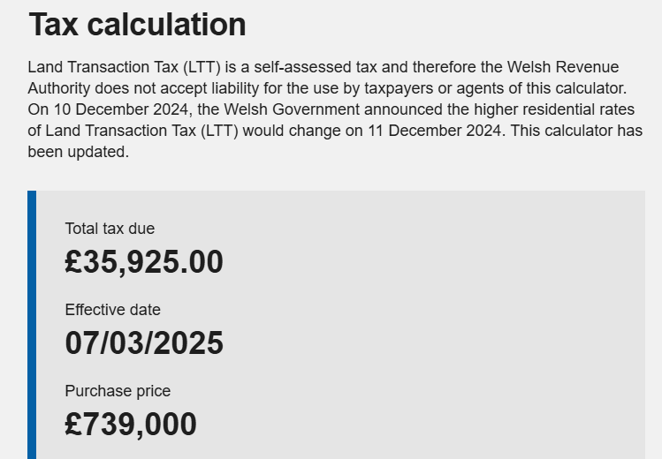
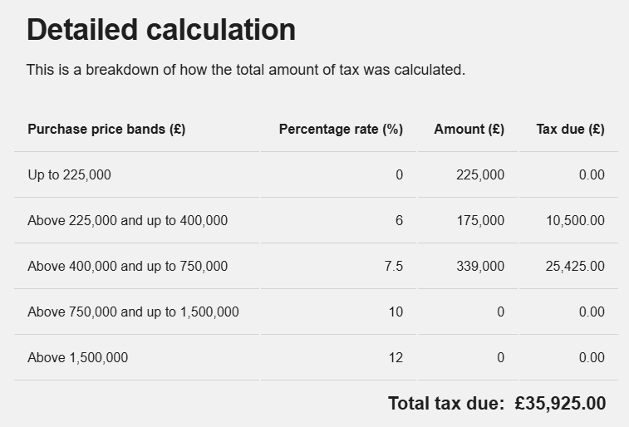
Figure 1 detailed land tax calculated.
(Source: WRA, 2025)
Timescale and commitment
The process typically takes 8 to 12 weeks, subject to mortgage approval, searches, and other factors. We will keep you informed at every stage to ensure smooth experience. Since contract have not been exchanged, you are legally committed to purchasing the property and can withdraw if necessary.
Best regards
Trainee Solicitor
Blue Light Law, LLP

Task 2: Research the law and produce a memo to your supervising solicitor
Investigation of title report: Kiamo Ko Castle
Prepared for: Ms. Elisa Thropp
File reference: VTH-10485/01
Prepared by: Trainee Solicitor

Introduction
Following your request, I reviewed the title documentation for Kiamo Ko Castle (title number WA1234) and set out below analysis of the easement and covenant affecting the property. The memo addresses whether these rights and restrictions will transfer to our client, Ms. Elisa. Thropp upon her purchase of the property.

1 Easement and reserved rights
The property subjected to following easement and write which may impact the Ms. Thropp ownership:
Party walls and fences: Clause two of the property register states that boundary walls or fences between the conveyed premises and other land remain party structure (Philips et al., 2022). Under the rule in Dyer v Terry (1881), such obligation run with the land and will transfer to the owner upon completion under Land Registration Ac 2002 (Dixon, 2023).
Right of access for Poppy Field Park: The charges register state that Poppy Field Park, a reserved land has a right of access over “The Yellow Brick Road.” The obligation to maintain this road in good condition and retain its yellow golden color will transfer to Ms. Thropp as constitute a positive covenant that binds successor in the title by indemnity Halsall v Brizell (1957) (Azizagaoglu, 2024).

2 Covenant affecting the property.
The charge register includes following restrictive and positive covenant.
Use restriction.
- In 1974 conveyance prohibits the use of the property for:
- Noisy, noxious, and offensive trades
- Accommodation of livestock
- Religious worship
Trade that involves alcohol, production, or sale: These restrictive covenants are enforceable against the successor in the title under Tulk v Mohay [1848], considered the benefit neighboring land with a radius of hundred meter as stated in the conveyance. Ms. Thropp must be advised accordingly (Bhutoria and Palep, 2024). The Law of Property Act 1925 Section 9 confirms that restrictive covenants run with land unless expressly stated otherwise (English and Atmaz Al-Sibaie, 2024).
Maintenance of Yellow Brick Road: The purchaser is obligated to maintain the Yellow Brick Road and retain its golden yellow color. This constitutes a positive covenant, which under Halsall v Brizell (1957) may bind Ms. Thropp a foible chain of covenant exits (Bevan, 2018).

Transfer of benefit burden
- Benefit: The property benefit from the right granted in the 1974 transfer, which remain enforceable by successor under Federated Homes Limited v Mill Lodge Property Limited (1980) (Lee and Abbot, 2022).
- Burden: The covenant, particularly those restricting land use, and requiring road maintenance, will transfer under the doctrine in Hallsall v Bristol (1957) as Ms. Thropp will gain reciprocal benefit (Richards, 2021).

3 Conclusion and recommend.
Ms. Thropp must be advised that:
- She is bounded by restrictive covenant, limiting business activities and land use.
- She has an obligation to maintain Yellow Brick Road, ensuring access for Poppy Field Park
- Any breach of covenant could result in legal enforcement by affected landowners, or original covenanters.
I recommend for the review of enforcement mechanism, potential indemnity, and whether insurance is advisable to protect the owner against future and breaches.
Best regards
Trainee Solicitor
Blue light law, LLP

Task 3: Produce an Investigation of title report for a client
Investigation of title report: Kiamo Ko Castle
Prepared for: Ms. Elisa Thropp
File reference: VTH-10485/01
Prepared by: Trainee Solicitor

Introduction
This report finding from our investigation of title for Kiamo Ko Castle (title number WA1234). The purpose of report is to inform the owner, Ms. Thropp about any right, restriction and obligation attached to the property. Particular attention is given to the easement and covenant that will transfer to the owner upon acquisition of the freehold estate. This report will enable her to make an informed decision on proceeding with purchase.

Title summary
Kiamo Ko Castle is a freehold estate with legal title registered under title number WA1234. The title documentation, including property registered and charges register indicate the presence of easement and covalent that may impact Ms. Thropp’s rights and obligation as per prospective owner. This report will provide an analysis of these factor.

Easement and reserved right.
The property has following types of reserve right and easement that will be affected:
Party wall and fences.
Clause two of property register specifies that boundary wall and fences between the castle and adjacent land are designed as party structure. This means that Ms. Thropp will share responsibility for maintenance, and any alteration must be agreed upon with the adjoining landowner. Establishes that such obligation run with the land, ensuring that they bind succession in title.
Right of access for Poppy Field Park
Charges, register, grant poppy field Park, neighboring property, right over “The Yellow Brick Road,” which runs through the castle. The obligation to maintain the access route in good condition and perceive, its golden yellow color will transfer to Ms. Thropp upon convenience. With positive covenant, not automatically mind successor Halsall v Brizell (1957) enforcement is possible via indemnity agreement (Azizagaoglu, 2024). The owner will obtain the burden for maintaining of the road while will be benefited by the easement of Poppy Field Park.

Covalent affecting the property.
The charges registered details, several covalent both restrictive as well as positive that upcoming owner must adhere to.
Restrictive covenant
The 1974 conveyance imposes the following types of restriction on the use of property:
- No noisy, noxious, or offensive trade permitted.
- Accommodation of livestock is prohibited.
- The property cannot be used for any religious worship.
- The sale or production of alcohol on premises is forbidden.
The restrictive covenants are enforceable against successor, entitled Tulk v Mohay [1848] provided that the benefit land with hundred meters of property, as stated in the title documentation (Bhutoria and Palep, 2024). The owner must be advised that any beat could result in legal action from benefiting landowners. The owner will acquire the burden of these covenant while benefiting neighboring landowners will retain enforcement, right. The Law of Property Act 1925 Section 9 confirms that restrictive covenants run with land unless expressly stated otherwise (English and Atmaz Al-Sibaie, 2024).
Positive covenants
The charge register imposes a positive covenant requiring the owner to maintain Yellow Brick Road and ensure that it detain its yellow color. While the positive covenant general does not run with the land the owner may become bound to indemnity agreement by the principle Hallsall v Bristol (1957), which states that a successor who is benefited from an easement must accept the associated burden (Bevan, 2018).

Transfer of benefit burden
Upcoming conveyance, the owner Ms. Thropp will assume both benefits and burden associated with properties title.
Transfer of benefit
The property benefit from right granted under 1974 transfer, will remain enforceable by successor under Hallsall v Bristol (1957). These rights include access over specific adjoining land and potential aesthetic protection benefiting the estate (Richards, 202).
Transfer of burden
The burden imposed by restrictive covenant will transfer with the land. In particular, the restriction on the use and obligation to maintain the Yellow Brick Road are enforceable against Ms. Thropp under the doctrine in Federated Homes Limited v Mill Lodge Property Limited (1980) (Lee and Abbot, 2022). Any breach could result in enforcement action from affected landowner or even previous owners (Dixon, 2023).

Potential risk and consideration
Risk of covenant breach
- If Ms. Thropp intends to use the property in a manner, contrary to restrictive covenant, she may face legal challenges.
- The obligation to maintain the Yellow Brick Road could become financially burden if significant requires are required.
Enforcement mechanism
- Benefiting landowner could enforce restrictive covenant through injunction or damage claims.
- Positive covenant may be enforced by indemnity, making it essential to review past conveyances to determine Ms. Thropp exposure to liability.
Title insurance consideration
Ms. Thropp wish to obtain title indemnity insurance to mitigate risk associated with covalent enforcement. This is particularly advisable if she intends to modify the use of property in ways that could potentially breach the covenants.

Conclusion and recommendation
Based on our investigation Ms. Thropp must be advised of following:
- She is bounded by restrictive covenant, limiting her ability to conduct certain business activities or modify properties use.
- She has an obligation to maintain Yellow Brick Road, ensuring continued access for Poppy Field Park. This obligation could lead to legal and financial implication.
- She will obtain the benefit of certain easement, such as access right under 1974 transfer, but also accept the associated burden.
- Any breach of covenant could result in enforcement action, which may include financial penalties or legal proceedings.
- Title indemnity insurance should be considered to protect against unforeseen covenant, enforcement risk.
- Further, due diligence is recommended, particularly regarding any existing indemnity agreement or potential negotiation with benefiting landowners.
Should Ms. Thropp required for the classification on any of this matter, we would be happy to assist.

Task 4: Complete a short reflection

Reflection
What?
During this assignment, I engaged in types of legal communication, including to the client, a memorandum to my supervising solicitor, and investigation of title report and reflection. Each start required a distinct style and tone. The voicemail, necessity, clear and concerns, language, ensuring client could understand legal concept without confusion. Conversely, the memorandum and investigation of title report required a formal, structured, and analytical approach, focusing on technical accuracy and legal reasoning.
So what?
The experience the significance of adapting communication style based on the audience. When addressing the client, the first-time buyer with limited legal knowledge, I had to simplify complex terminology and ensure clarity. In contrast, communicating with my supervisor, I required legal language, referencing all types of case laws, and legal principles concisely. This distinction enforced the challenge of maintaining legal accuracy while ensuring access accessibility. Drafting the investigation of title report further evaluated my ability to present legal advice in structured and logical manner. Ensuring critical issues were highlighted thoroughly.
Now, what?
Moving forward, I aim to refrain my ability to transition between legal ease and plane, English, tailoring explanation to suit different audiences. To enhance this skill, I will actively seek feedback from supervisor, study well drafted legal documents and participate in training focused on client communication. Additionally, practicing, the simplification of complex legal principles will strengthen my ability to convey information effectively. Mastering this skill will be invaluable in my future career, for clarity, efficiency, and strong client relationships.

References
Azizagaoglu, H.T., 2024. Should a third party, bringing a direct action against an insurer, be bound by dispute resolution clauses concluded between the insurer and the insured? Doctoral dissertation. University of Southampton.
Bevan, C., 2018. The doctrine of benefit and burden: reforming the law of covenants and the numerus clauses “problem.” The Cambridge Law Journal, 77(1), pp.72-96.
Bhutoria, T. and Palep, N., 2024. Clash of principles: Unraveling the Tulk v Moxhay conundrum.
Dixon, M., 2023. Modern land law. Routledge.
English, J. and Atmaz Al-Sibaie, J., 2024. Dispositions of subsisting equitable interests and section 53(1)(c) of the Law of Property Act 1925. Conveyancer and Property Lawyer, 2024(2).
Lee, M. and Abbot, C. eds., 2022. Taking English planning law scholarship seriously. UCL Press.
Philips, R.C., Calabrese, M., Keenan, R., and van Leeuwen, B., 2022. The regional occupational structure in interwar England and Wales. Historical Methods: A Journal of Quantitative and Interdisciplinary History, 55(2), pp.78-97.
Richards, M., 2021. Property Law. Oxford University Press.
WRA, 2025. Available at: https://services.wra.gov.wales/land-transaction-tax-calculator [accessed on 7th March 2025]

