

LEVEL 6

SEMESTER 1

MODULE CODE: BMOE6003
Landscape and Sustainable Recreation
aSSESSMENT TYPE: assignment
Assessment: 2

COMPONENT WEIGHTING: 50%

WORD COUNT: 2,500 WORDS

MODULE TUTOR: Anthony Burns

Reflective Fieldwork Journal
As part of this module there will be a number of virtual/physical site visits as fieldwork. As you visit each site you will need to keep detailed notes relating to the following issues:

• Landscape Character
• Landscape Quality
• Designations
• Use
• Access
• Future Potential

You should choose two sites of your choice from those visited (whether virtual or physical) and the notes you took should subsequently form the basis of a reflective and critical account of the landscape at each location, including relevant academic and policy related literature also providing suggestions for sustainable approaches to recreational development at each site. Maps, sketches and photographic evidence should be used as appropriate.

SUBMISSION DETAILS:

Submit by Turnitin on or before 22nd January Friday 2021
Feedback to be returned to student: on or before19th February 2021

School of Sport, Health & Outdoor Education

Assessment Feedback Sheet

Student No./Name:
Module:
Module Code:

Personal Evaluation – to support your academic progress please complete the section below BEFORE submitting your work.
What do you consider to be the best aspects of this work?
Which aspects do you consider could have been improved in this piece of work?
What have you found most satisfying whilst undertaking this submission?
ASSESSMENT CRITERIA | Learning  Outcomes |  | GRADE
ASSESSMENT CRITERIA |  |  | Poor  < 20% | Weak  20-29% | Unsatisfactory  30-39% |  | Satisfactory  40 – 49% | Good  50 – 59% | Very Good  60 – 69% | Excellent  70 – 84% |  | Exceptional  85– 100% | %
Your discussion of the nature of landscape within the context of the fieldwork locations | 1 |  |  |  |  |  |  |  |  |  |  |  | 20%
Your critical evaluation of external and internal influences that affect the perception, interpretation and use of landscape at the fieldwork sites. | 2 |  |  |  |  |  |  |  |  |  |  |  | 20%
Your critical discussion of the relationship between landscape and recreation and your suggestion of sustainable approaches to the interpretation and use of landscape for recreation. | 3 |  |  |  |  |  |  |  |  |  |  |  | 40%
Your identification and use of relevant academic and other material to help inform and develop your argument | 1,2,3 |  |  |  |  |  |  |  |  |  |  |  | 20%
It is expected that students will present work that is proof read, correctly referenced and adheres to the Assessment Checklist. Therefore a range of 0 – 10 marks will be deducted for non-completion of any of the points on the checklist below.
TUTOR COMMENTS:

Submission date:  via Turnitin |  | Return date:  (at least within 4 weeks) |  |  |  | Tutor: |  |  |  |  | Mark:

Assignment Checklist

- Please complete the Personal Evaluation section of the Assessment Feedback sheet, add your name and details, and paste the whole of this assignment document into the front of your assignment

- Submission is a single word file, clearly labelled with your name and module code
- Font style - Times New Roman, size -12 for text and 14 for headings
- Ink colour – black only
- Line spacing – 1.5 line spacing and 2cm- 2.5cm page margins
- Quotations more than three lines to be indented 1 line spacing
- One line space between paragraphs, paragraphs must be left aligned
- Pagination (your assignment should have page numbers)
- All tables and figures are internally referenced and have a title
- Word count checked and written at end of text (before references and any appendix)
- Assignment is within 10% of the word limit (excluding references and any appendices)
- All references in the text are included in the reference list
- Correct referencing following the Harvard style, as described in the Palgrave study skills book ‘Cite them Right’.
- Correct spelling using UK English
- Correct use of punctuation
- Grammar and syntax correct- double check anything that has a green line under it
- I have read my assignment out loud to myself and it makes sense and is easy to read
- Somebody else has read my work and it makes sense to him or her!
- I have checked and I have not plagiarised
Failure to follow these guidelines will cost you marks!

Introduction:
The following document is a reflective virtual field work journal that researches two different locations - Lundy Island and the Lower Swansea Valley. The purpose of this field work journal is to learn about the landscape, in particular the landscape character, quality, designations, use, access and future potential. There are also suggestions as to how the areas could be developed to incorporate more sustainable recreational activities.
Lundy Island
Landscape character:
Lundy Island is an island found just off the coast of North Devon where the Bristol channel meets the Atlantic Ocean, (see appendix 1a for a map of the island). There is nothing between Lundy Island and America other than a large stretch of the Atlantic Ocean (Landmark Trust, 2021). The island itself is half a mile wide and three miles long. It is a natural landscape with minimal manmade infrastructures to be seen. The island was built in 1835 with plain classical style. The minimal construction on the island is a small village with an Inn, a shop, a Victorian church and a 13th century castle. The church there was built in 1897 and is known as the church of Saint Hellen (Balmora TV, 2016). MalcomeAtGullrock (2018) states that Lundy Island is the most remote place in the West. The open space is rich with a variety of seabirds, especiallly Jenny’s Cove see (appendix 1b) which is full of seabirds such as Puffins, Kittiwakes, Razorbills, Guillemots and European Shags (Natural England, 2014). Lundy Island is surrounded by turquoise water and beneath the sea there is a jungle of kelp and various other types of corals (Balamora TV, 2016).
Landscape quality:
Within the landscape there is evidence that towards the latter half of the first millennium AD there was almost certainly a Christian community on the island. Landmark Trust (2021) underline this because there are four granite gravestones that are dated between 500 AD and 700 AD in the Beacon Hill cemetery. Landmark Trust (2021) further explain that only important people would have inscribed granite memorial stones and the fact that there are four of them suggest that the Christian community on Lundy Island was strong. Prior to this, archaeological evidence suggests that the island was inhabited for at least three thousand years, as there have been artifacts found across several parts of the island. Stone age tools have been found that suggest a developed farming community and existing structures have been discovered that link to late Bronze age and Iron age developments found elsewhere across Europe (Landmark Trust, 2021). The history of Lundy Island is remarkable, and, in my opinion, it is super interesting. The island is mostly made up of granite and there is some slate (Natural England, 2014).
Designations:
In 1969 it was suggested that Lundy Island should become a marine nature reserve. The waters surrounding the island became Britian's first voluntary marine nature reserve and soon became Britian's first statutory marine nature reserve (MNR) in 1986. Following the Marine and Coastal Access Act 2009, in 2010 the waters surrounding the island became England's first marine conservation zone (MCZ) (Journey to the sea, 2020). The island is owned by the National Trust and managed by the Landmark Trust. Due to the Island having a wide range of rare plants and wildlife, Lundy Island is one of four sites of special scientific interests (SSIs) on or near the Peninsular (Hartland Peninsular, no date). The fact that it is owned by the National Trust this gives an external factor to most individuals that the place is going to be natural and rich in wildlife. The designations on Lundy Island also promote that the landscape is protected and from my own experience this is another external factor that promotes the wildlife and nature of the landscape. I certainly have topophilia for natural areas and I know and understand that when I see similar designations on areas such as Lundy Island that I am going to be impressed with the surrounding environment because of the designations (Tuan, 1974).
Use:
Today Lundy Island is a well-known tourist destination. There are a range of different activities to participate in that the island affords such as guided walks, bird watching, fishing, hiking, climbing and abseiling, snorkel safaris, the secret Lundy letterboxes and even warden led events (Landmark Trust, 2021). There are hundreds of day visitors that visit the island each year and, in addition, there are twenty-three self-catering accommodation blocks available for hire. The landscape is undisturbed by cars although there is a land rover available for disabled individuals that may have difficulty making their way up the long steep path (Journey to the Sea, 2020).
Access:
As the character of the landscape is that of an island, the main way of accessing the location is by boat. There is also space to land aircraft along a short stretch of bumpy grass, but now the Landmark Trust collaborate with Castle Air to operate a helicopter service (Marinevisionsudios, 2015).
Future potential:
As mentioned above there are numerous sustainable recreational activities that already take place here. However, there is no mention of kayaking or canoeing. Therefore, my first suggestion for the island would be the introduction of paddle sports such as kayaking. This would be a great way to navigate around the island without causing much (if any) damage to the natural environment. The fact that there are numerous sources of information that suggest that one trip to Lundy Island is a gateway to multiple trips there in the future suggests to me that the island would be an amazing location for schools to bring children to develop their relationship with nature and the natural world. Louv (2006) underlines that over the past few decades children are losing their connection to nature due to the advances in technology. Therefore, the Island would be a special place for school children to escape the technological world and begin to redevelop their connection with the natural world. This is particularly true on Lundy Island as the power is turned off during the night (Journey to the Sea, 2020). If I had the opportunity to experience this as a child on a school trip, I certainly would not forget the unique experience. The knowledge and understanding that comes with the island is so unique and if we are to tackle problems such as climate change in the future, we must look at Lundy Island as an inspiration and incorporate this into the modern world.

Hafod and the lower Swansea valley
Landscape character:
Hafod and the lower Swansea valley is situated along the valley floor and sides of the River Towy, to the east of Swansea city centre. During the 18th century, industry arrived in Swansea due to the water, coal of South Wales and metal ores, in particular copper, were transported to South Wales. Swansea became important leaders of the metallurgical industry right the way through to the 19th century. The current city of Swansea was developed since the industry origin. There were 150 blast furnaces each smelting and refining over 40 different types of metal that came from numerous imported ores within a four-mile radius of the centre of Swansea. Nearly all the worlds zinc, ninety percent of the world's coper and 75%of the world’s tin plate were produced in Swansea (BBC Two, 2012). Swansea has had a connection with the sea for quite a while as there was a port there in 1550, However the port grew enormously during the advent of the metallurgical industry resulting in the establishment of many wharves along the riverbanks to help load and unload the ships that were full of metal ores (Swansea University, no date). The premium anthracite was an essential material in the booming local copper industry back in the early 1820s. By the peak in the middle of the 1800s, Swansea was the home to seventeen out of the eighteen copperworks located in the UK. As time passed the techniques were enhanced and the copper industry began to adapt to non-ferrous metals such as, tin, nickel, lead, silver and even gold. It is to no surprise that Swansea was the world leader in the processing and manufacture of the metallurgical industry (Swansea University, no date).
An overview of the harbour in 1852 can be seen in (appendix 2a). The last dock that was opened in 1909 is known as the ‘Kings Dock’ and today it is the only remaining dock in operation in Swansea due to the decline in the metal and coal industry (Swansea University, no date). Today there are only a few visible reminders to help visualise what happened in the past in the Lower Swansea valley (Wales Online, 2012). In 1961 the lower Swansea valley project was established to create a plan with the aim of redeveloping the area. The first problem that was faced was clearing and levelling out all the waste. The land was further treated to reduce contamination. Shortly after this, trees and various other types of vegetation were introduced to begin to try to develop the valley floor to attract a pleasant community environment. After fifty years of hard community effort, the area is now thriving with lakes and parkland, sports facilities and commercial centres. There are only two chimney stacks remaining at Harfod out of the hundreds that helped generate the wealth that remains in the area today (Franklin Cardy, 2012).
Landscape quality:
The quality of the landscape as mentioned above was poor as it was a heavily polluted area, however since 1961 when the Lower Swansea Valley project began the quality of the landscape has improved as it returns to the natural landscape that it once was. Today the Lower Swansea Valley is an urbanised area that is very close to Swansea city centre. Since the industrial period the valley has undergone large scale developments in order to facilitate the thousands of people that live there today.
Designations:
In terms of designations there is the Lower Swansea valley enterprise designation order 1981. This designation came into operation on 11th June 1981 but only lasted 10 years (Legislation.gov.uk, 1981). There is also the council owned Hafod-Morfa copperworks regeneration project which is marked out (see appendix 2b). This designation was put into place by Swansea University and the Country and City of Swansea. The heritage-led regeneration project aims to reconnect people to the heritage of the landscape (Hafod-Morfa Copperworks, 2020).
Use:
The area today is used by man to live everyday life. Business parks, retail shops and a stadium occupy the area that was once a booming industrial location (Welsh Government, 2016). The usage of the landscape is similar to the area where I grew up. There is not much natural landscape as the area has been urbanised to house the growing population across the UK. Since moving to Carmarthen to study my degree course I have changed my perception towards urbanised areas and I now have topophobia of the chaos and busyness that comes with these sorts of areas. I much prefer natural landscapes and scenery as this allows me to disconnect from daily stress (Gonzalez, 2005).
Access:
Access to Hafod and the lower Swansea valley was improved due to the large demands of the industry. In 1784 there was a canal built to carry coal three miles from Llansamlet to Foxhole called John Smith’s canal. Over the next 20 years there were further canal developments such as the Swansea canal that stretched 16 miles from Abercrave to Swansea (Wales Online, 2012). However, since the industry declined these waterways were not needed. There were also railways that helped transport the mass of materials across the landscape. Today there are numerous roads that make navigation and transportation around the area effortless. The M4 is close by which makes access available to a wide range of locations easier. There is also the railway that goes to the city centre (Welsh Government, 2016).
Future potential:
As mentioned above, the Lower Swansea Valley Project has helped transform the industrial wasteland into a pleasant, thriving area. Since then, Swansea University have partnered up with the County and City of Swansea to allow individuals to visit and reconnect with the heritage of the site. This project has had over eight thousand people attend events at the site (Hafod-Morfa Copperworks, 2020). However, in terms of recreational activities, the area has brilliant potential, but there seem to be few suggestions currently. The main recreational activity that I would incorporate into the area would be the use of paddle sports on the remaining waterways and in and around the harbour. This activity could be a wonderful way to display the heritage of the Lower valley however, it is important that with the activity there are sustainable precautions put into place to help protect and conserve the currnt landscape. The landscape has a lot of potential and I think that if there are educated instructors that understand the heritage of the area then this message could be delivered in session. Regarding the housing and architecture of the area, I think that there should be further investments put into the planning and aesthetic of the buildings. From undertaking research into the area, it is clear to see that Swansea was particularly important regarding the industrial revolution and I believe that if the right decisions are made, then the Lower Swansea Valley area could potentially be developed to be the next hotspot for recreational activities that influence other parts of the world. With the River Towy the government could easily develop hydroelectric power that could sustainably cover the costs of these developments over a long timeframe. It is critical to understand the importance of sustainability within every development of the area because as the industrial movement was a booming success it soon ended and destroyed the surrounding environment, due to the pollution.
Word count: 2300

Appendix list:

Appendix 1a) Map of Lundy Island
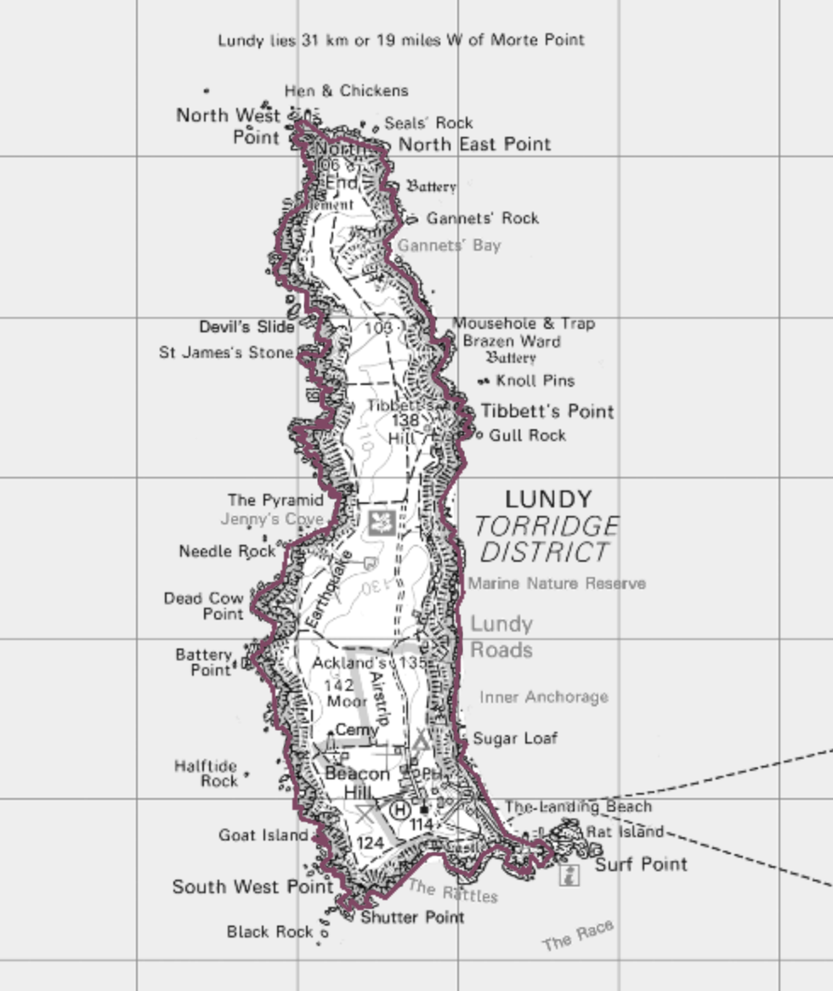

Appendix 1b) Jenny’s Cove
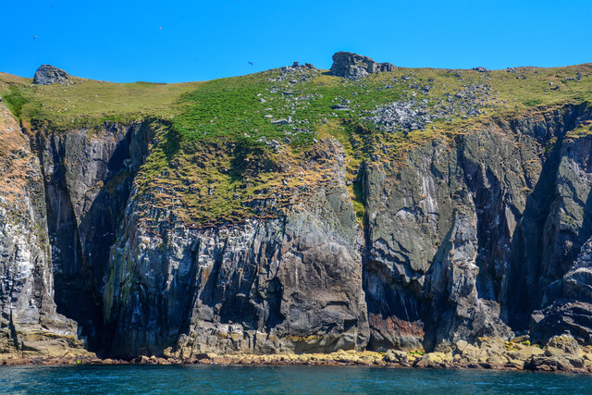

Appendix 1c) Lundy Islands marine conservation zone
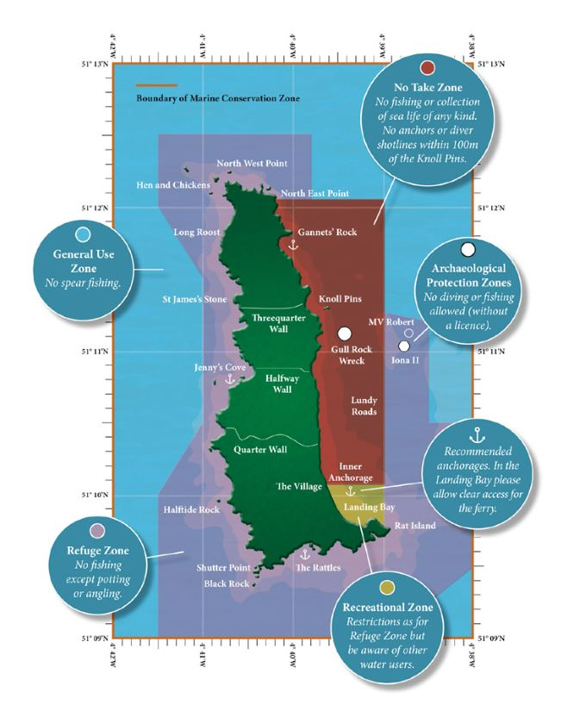

Appendix 2a) Swansea Harbour in 1852
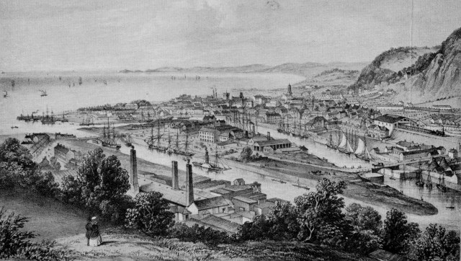

Appendix 2b) Hafod-Morfa copperworks regeneration project
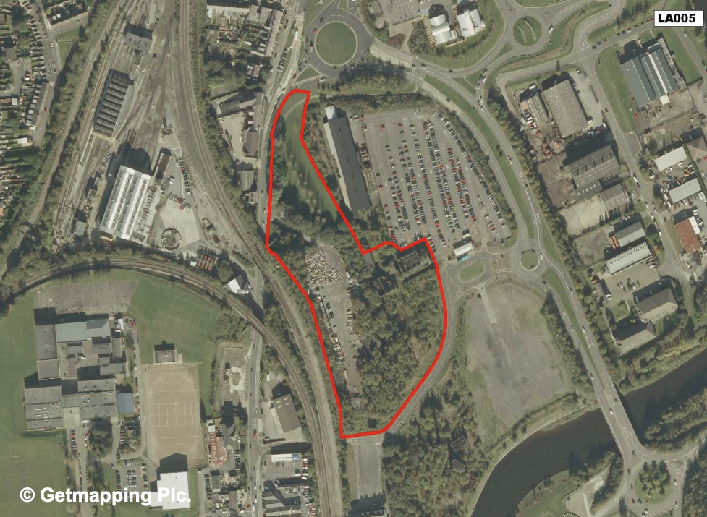

Reference List:
Balamora TV (2016) Destination Lundy Island. [video]. Available at: Destination Lundy Island (Accessed: 14th April 2021).
BBC Two (2012) Counties of Wales: Swansea during the industrial revolution. Available at: https://www.bbc.co.uk/programmes/p01280zw (Accessed: 12th April 2021).
Franklin Cardy (2012) Scenes from the Lower Swansea Valley in 1963; Where No Trees Grew. [video]. Available at: Scenes from the Lower Swansea Valley in 1963; Where No Trees Grew (Accessed: 12th April 2021).
Gonzalez, M.B. (2005) ‘Topophobia and topophilia’, the home as an evocative place contradictory emotions, Sage Publications, 8(2) pp. 193-213.
Gov.uk (2013) Marine conservation zone 2013 designation: Lundy. Available at: https://www.gov.uk/government/publications/marine-conservation-zone-2013-designation-lundy#:~:text=Situated%2019%20km%20off%20the,reserve%20(%20MNR%20)%20in%201986 (Accessed: 14th April 2021).
Hafod-Morfa copperworks (2020) A site of world importance. Available at: https://hafodmorfacopperworks.com/the-past/ (Accessed: 12th April 2021).
Hartland Peninsular (no date) Outstanding natural beauty. Available at: https://www.hartlandpeninsula.co.uk/outstanding-natural-beauty (Accessed: 14th April 2021).
Journey to the sea (2020) Episode 6: Lundy island with dean. [video]. Available at: Episode 6: Lundy island with Dean (Accessed: 14th April 2021).
Landmark Trust (2021) Accomodation. Available at: https://www.landmarktrust.org.uk/lundyisland/staying/staying-on-lundy/accommodation/ (Accessed: 14th April 2021).
Landmark Trust (2021) Activities and things to do. Available at: https://www.landmarktrust.org.uk/lundyisland/discovering-lundy/activities/ (Accessed: 14th April 2021).
Landmark Trust (2021) History of Lundy Island. Available at: https://www.landmarktrust.org.uk/lundyisland/discover-lundy-island/history-of-lundy/ (Accessed: 14th April 2021).
Landmark Trust (2021) Map. Available at: https://www.landmarktrust.org.uk/lundyisland/discovering-lundy/map/ (Accessed: 14th April 2021).
Legislation Gov (1981) The lower Swansea valley designation order 1981. Available at: https://www.legislation.gov.uk/uksi/1981/757/pdfs/uksi_19810757_en.pdf (Accessed: 12th April 2021).
Louv, R. (2006) ‘Last child in the woods : saving our children from nature-deficit disorder’, Chapel Hill, NC: Algonquin Books of Chapel Hill.
MalcomeAtGullrock (2018) BBC Inside Out Full HD – Sian's Lundy. [video]. Available at: BBC Inside Out Full HD - Siân's Lundy (Accessed: 14th April 2021).
Marinevisionstudios (2015) Heaven on Lundy (Promo Lundy film). [video]. Available at: Heaven on Lundy (Promo Lundy film) (Accessed: 14th April 2021).
Natural England (2014) Lundy Island total landscape and history document. Available at: https://moodle.uwtsd.ac.uk/pluginfile.php/412141/mod_resource/content/1/Lundy%20island%20total%20landscape%20and%20history%20document.pdf (Accessed: 14th April 2021).
Swansea University (no date) Marine tradition at Swansea. Available at: https://www.swansea.ac.uk/law/istl/llm-degrees/maritime-tradition-at-swansea/ (Accessed: 12th April 2021).
Tuan, Y (1974) Topophilia: A Study of Environmental Perception, Attitudes and Values, Prentice Hall, New Jersey.
Wales Online (2012) Welsh history month. Available at: https://www.walesonline.co.uk/news/wales-news/welsh-history-month-lower-swansea-2032065 (Accessed: 12th April 2021).
Welsh Government (2016) Hafod and the Lower Swansea valley: Understanding urban character. Available at: https://cadw.gov.wales/sites/default/files/2019-05/Hafod%20and%20the%20Lower%20Swansea%20Valley-%20Understanding%20Urban%20Character_0.pdf (Accessed: 12th April 2021).

