ACCA4025
Learning in the Digital Era

https://sites.google.com/view/sobaan-lde-eportfolio/home

Sobaan Shaja 2436564
University Of Wales Trinity Saint David LONDON CAMPUS

Table of Contents
Task 1: Essential Academic and Employment Skills for My Future Career 2
Task 1(a): Report on Essential Academic and Employment Skills 2
Introduction 2
Main Body 2
Task 1(b): Evaluation of Task 1(a) Based on the Similarity Report 4
Task 2: Collaborative Mind Map and Individual Poster 5
Task 2(a): Collaborative Mind Map. 5
Task 2(b): Professional Academic Poster 6
Task 3: Virtual Collaboration and RefWorks 7
Task 3(a): Unit 3 Topic Summary 7
Building an Effective Virtual Team 7
Task 3(b): Practical Evidence of Using RefWorks 8
1 – RefWorks Dashboard 9
2 – Adding a Reference 9
3 - All three references stored in RefWorks 10
4 - RefWorks explanation 11
Task 4(a): E-Portfolio Creation 12
https://sites.google.com/view/sobaan-lde-eportfolio/home 12
Screenshots of the Published E-Portfolio 12
References 17
Task 1 References 17
Task 2 References 17
Task 3 References 17
Task 4 References 18

Task 1: Essential Academic and Employment Skills for My Future Career

Task 1(a): Report on Essential Academic and Employment Skills

Introduction
While studying Computer Science, I have realised that technical knowledge alone is not enough. Learning programming and understanding computer systems are important, but I also need good study habits and professional skills. Time management helps me organise assignments and avoid leaving work until the last minute. Research and critical-thinking skills also help me decide whether information is trustworthy before using it in my work [1]. These skills should make me more independent and confident during my degree.

Main Body
Essential Academic and Employment Skills

Problem-solving is one of the main skills needed in Computer Science. When a program does not work correctly, I need to stay patient, examine the problem and test different solutions. Software developers also need logical thinking, attention to detail and the ability to explain technical information clearly [2].
Communication and teamwork are just as important because most computing projects involve working with other people. Team members need to share ideas, listen to feedback and complete their allocated work on time. Research shows that communication, teamwork and problem-solving remain important skills for employment [3].
Technology changes quickly, so I will also need to continue learning after graduation. ChatGPT was used to suggest adaptability and continuous learning as relevant skills [4]. However, I checked the main information against credible academic and professional sources instead of accepting every AI suggestion automatically.
Developing these skills will help me complete my studies and prepare for a future role in software development. They will allow me to solve problems, work responsibly, communicate with colleagues and adjust to new technologies throughout my career.

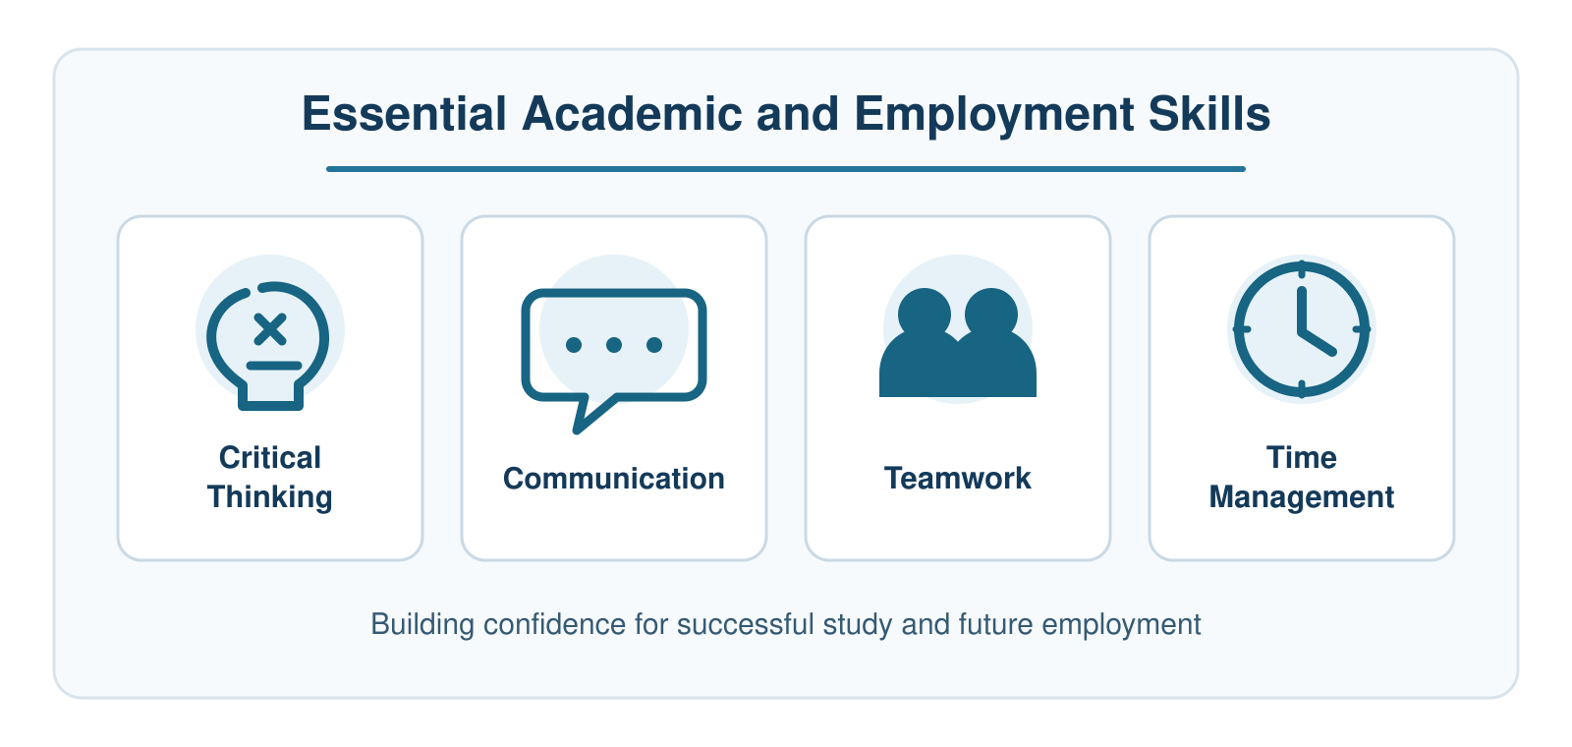
Fig. 1. Essential academic and employment skills supporting study and career success.

Task 1(b): Evaluation of Task 1(a) Based on the Similarity Report
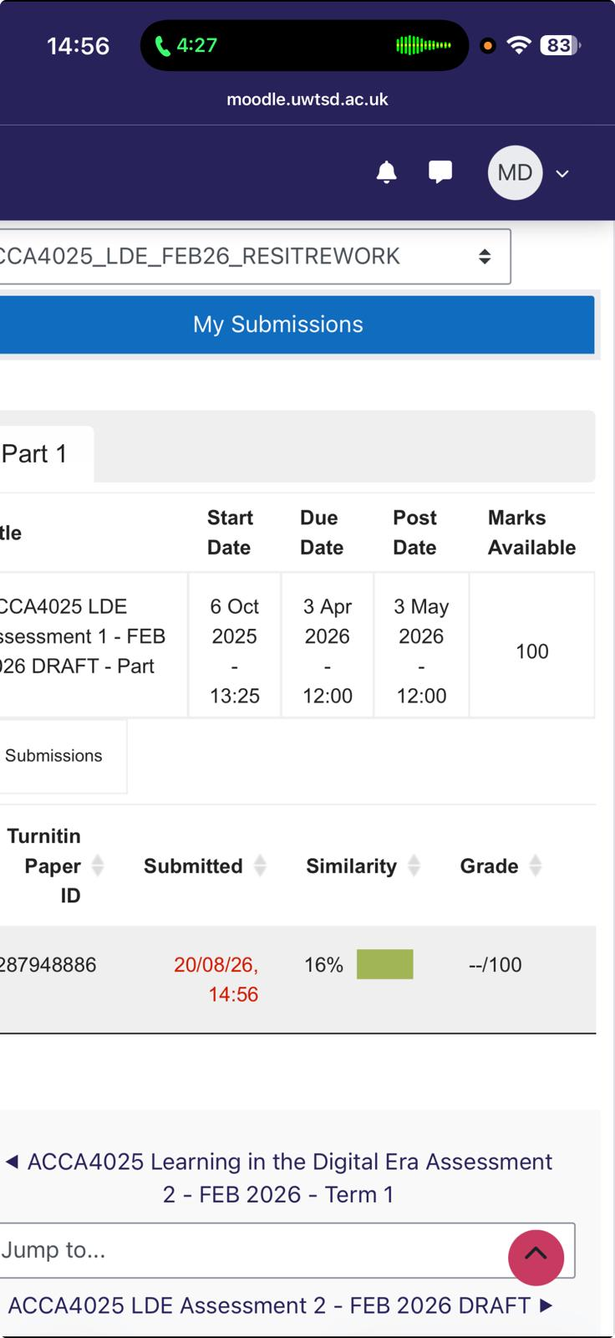
Fig:2

After submitting my work to Turnitin, I received a similarity score of 16%. I think this is a reasonable score because most of the work was written in my own words, although some matching text may have come from citations, titles and commonly used phrases. Next time, I would check the highlighted sections and rewrite any sentences that are too close to the original sources. Based on the Generic Assessment Criteria, I would award myself 78%. My work is clearly organised, relevant to Computer Science and supported by suitable sources. However, I could improve it further by adding more critical discussion and stronger personal examples.

Task 2: Collaborative Mind Map and Individual Poster

Task 2(a): Collaborative Mind Map.
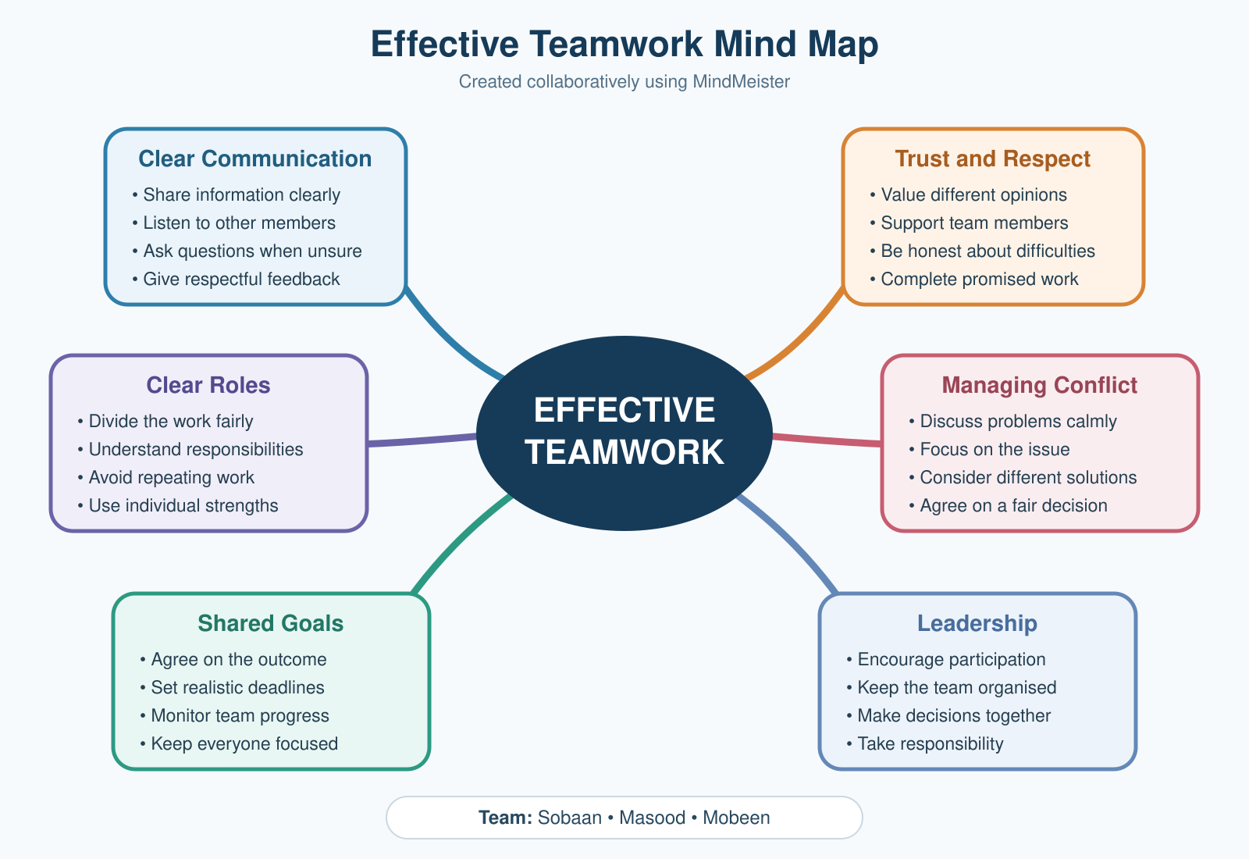

Fig:3 This mind map was created collaboratively by Sobaan, Masood and Mobeen. MindMeister was selected to organise the team’s ideas into six important areas of effective teamwork.

Task 2(b): Professional Academic Poster
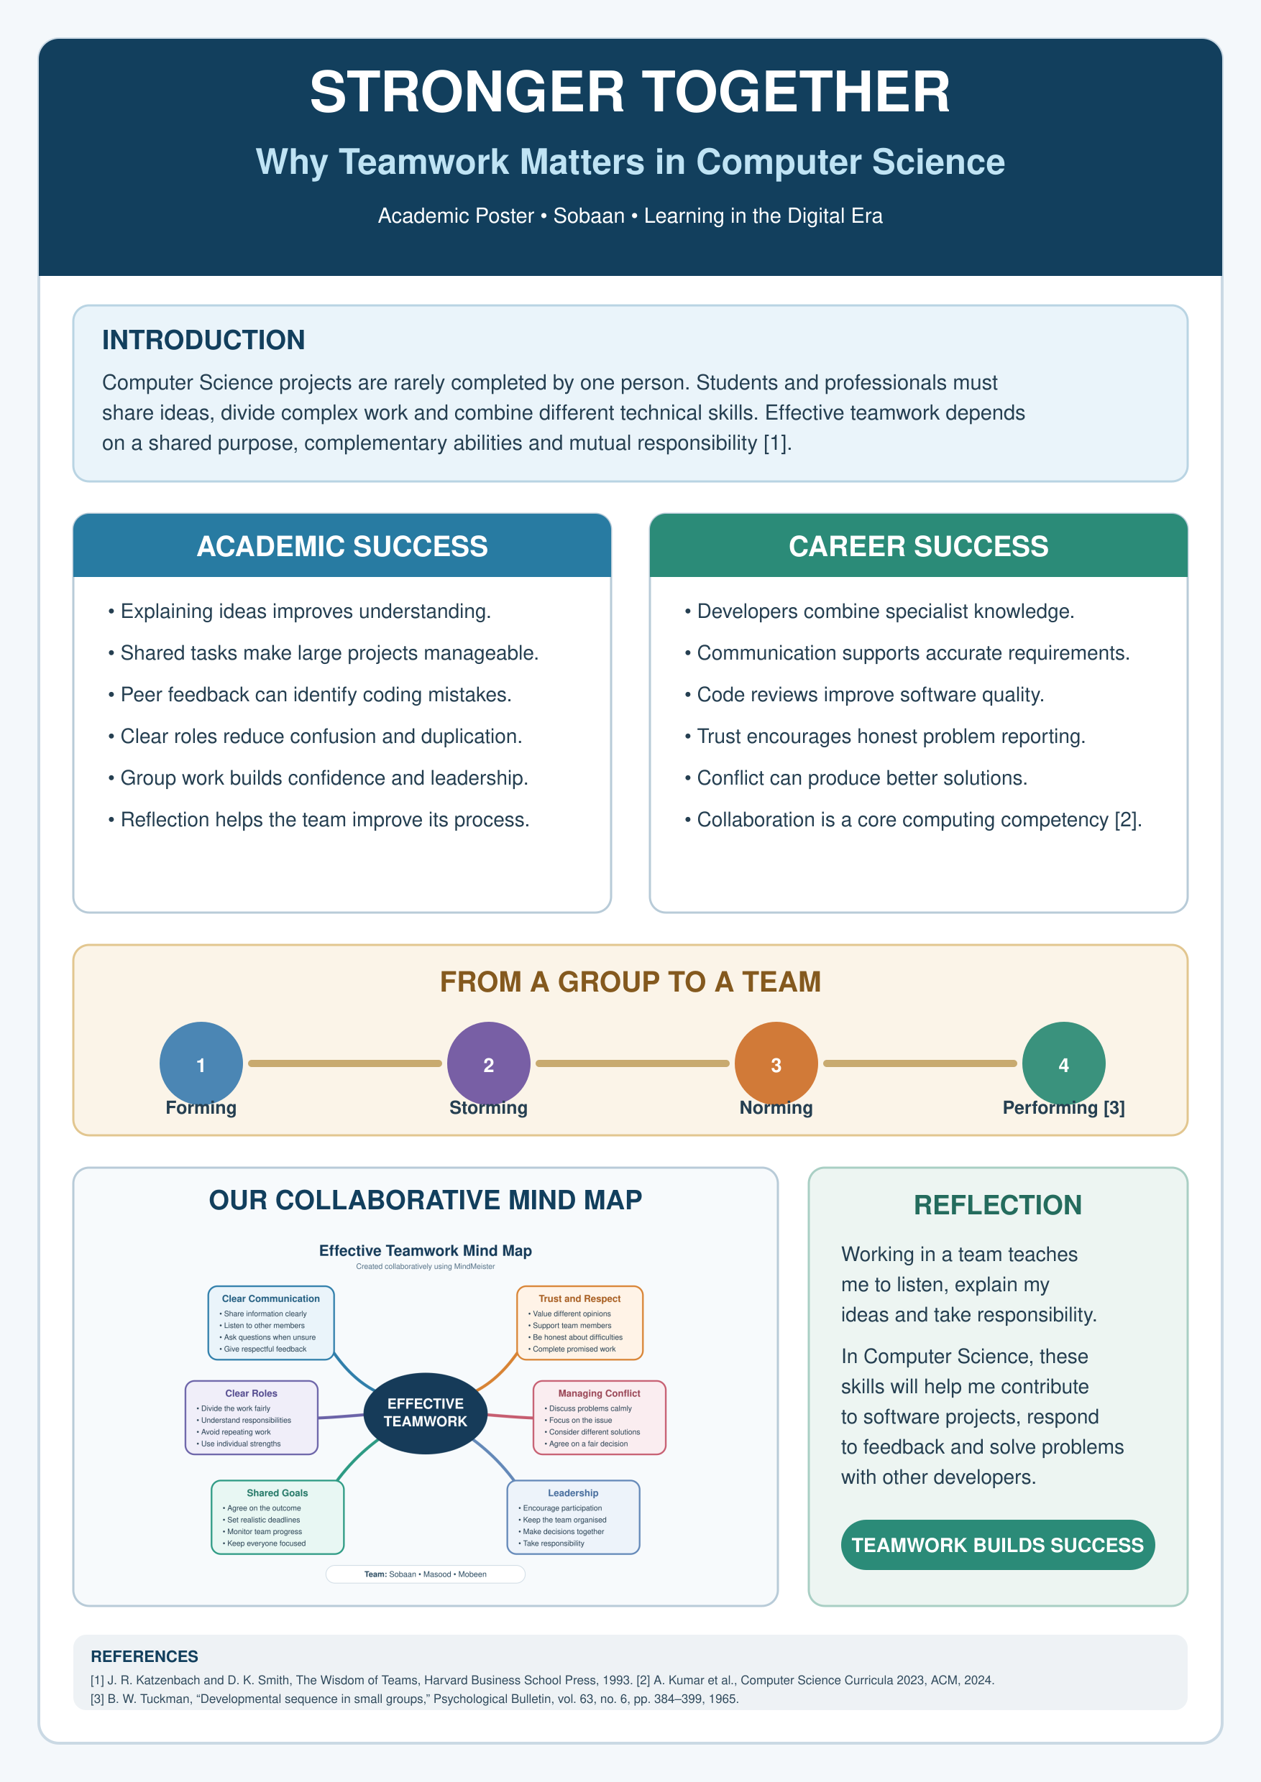
Fig. 4.

Task 3: Virtual Collaboration and RefWorks

Task 3(a): Unit 3 Topic Summary

Building an Effective Virtual Team

Virtual collaboration allows people to work together without being in the same physical location. Team members may attend online meetings, share documents and communicate through platforms such as Microsoft Teams or Zoom. This gives people more flexibility, but it can also create problems when communication and responsibilities are not managed properly.
When a virtual team begins working, members may initially feel uncertain because they do not fully understand one another’s working styles. Tuckman explains that teams usually move through forming, storming, norming and performing stages [3]. These stages can also be seen in virtual groups. During the forming stage, members introduce themselves and try to understand the task. Disagreement may occur during the storming stage, especially when messages are unclear or somebody is not completing their work. As the group establishes rules and responsibilities, it can move towards the norming and performing stages.
Communication is one of the main challenges in virtual collaboration. Written messages can sometimes be misunderstood because people cannot always see facial expressions or hear the speaker’s tone. Delayed replies may also slow down the whole group. Research has identified communication difficulties, trust and technology as common challenges affecting virtual teams [2]. Team members should therefore write clearly, respond within an agreed time and ask questions when something is uncertain.
Clear roles are also important. At the beginning of a project, the team should decide who will complete each task and when it is due. Shared documents and regular progress updates can help everyone see what has been completed. This reduces duplicated work and makes individual members more accountable.
Trust develops when people attend meetings, share progress honestly and complete their promised work. Virtual teams also perform better when members feel comfortable offering ideas and asking for support. Research on virtual teamwork suggests that leadership, technology and relationships between members can influence team performance [1].
Overall, technology provides the space for virtual collaboration, but it does not automatically create good teamwork. Successful virtual teams still depend on clear communication, trust, fair participation and shared responsibility. These skills will be useful during my Computer Science degree and in future software projects involving people working from different locations.

References
[1] Lucy L. Gilson, M. Travis Maynard, Nicole C. Jones Young, Matti Vartiainen and Marko Hakonen, "Virtual teams research: 10 years, 10 themes, and 10 opportunities," vol. 41, no. 5, pp.1313–1337, 2015, doi: 10.1177/0149206314559946.
[2] S. Morrison-Smith and J. Ruiz, "Challenges and barriers in virtual teams: A literature review," vol. 2, no. 6, pp.1096, Jun 1 2020, doi: 10.1007/s42452-020-2801-5.
[3] B. W. Tuckman, "Developmental sequence in small groups," vol. 63, no. 6, pp.384–399, 1965, doi: 10.1037/h0022100.

Task 3(b): Practical Evidence of Using RefWorks
I used RefWorks to manage the sources for my virtual collaboration summary. I first created a journal article record manually and entered the author, title, year, volume and DOI. For the other articles, I entered their DOI numbers and used the automatic search function to complete most of the publication details. I checked each record and corrected any missing or inaccurate information before saving it. I then selected all three references, chose the IEEE UWTSD style and generated the bibliography automatically. Finally, I copied the reference list into my document and checked that each numbered citation matched the correct source.

1 – RefWorks Dashboard
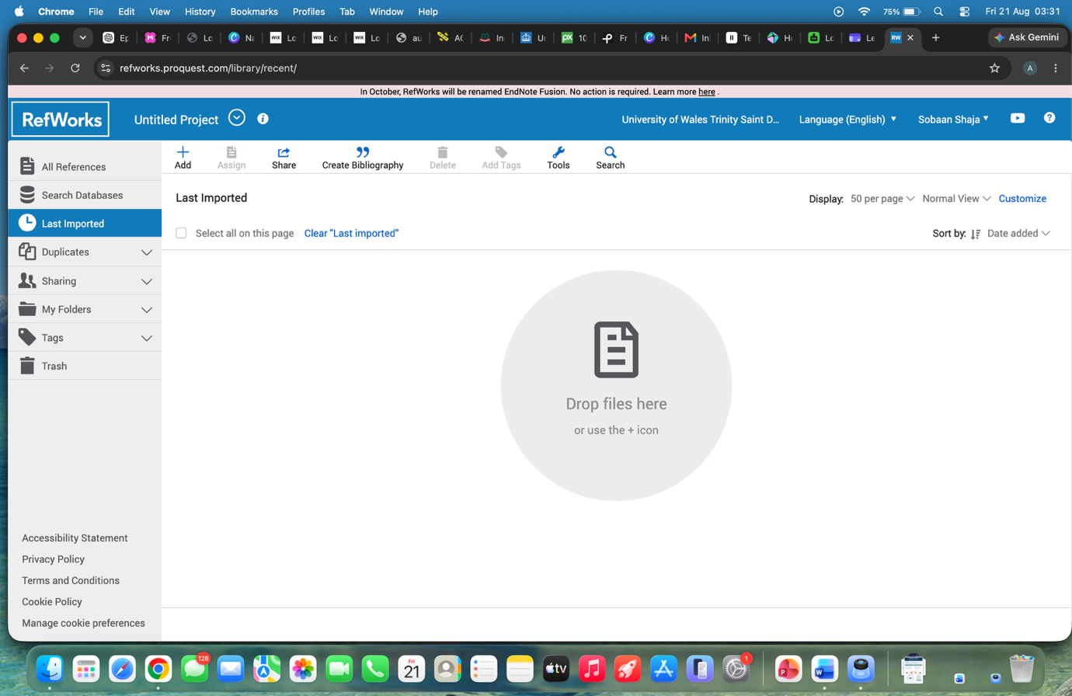
Fig. 5. RefWorks dashboard used to manage the project sources.

2 – Adding a Reference
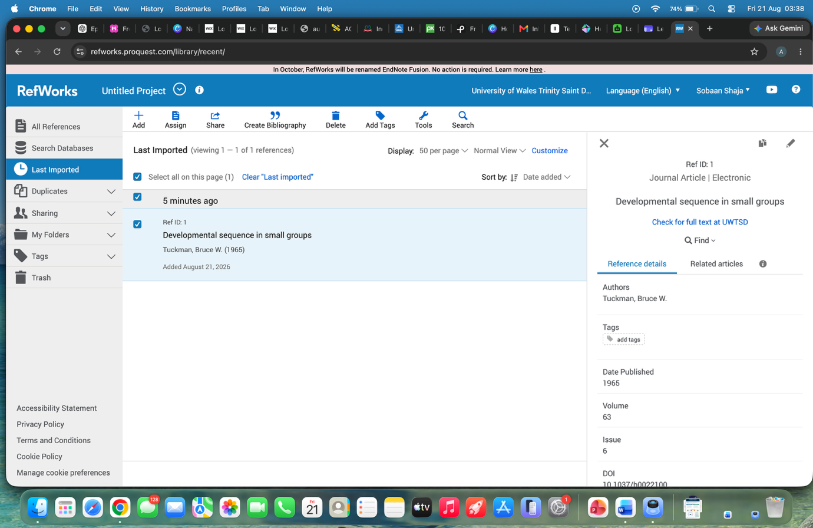
Fig. 6. Journal article details recorded in RefWorks.

3 - All three references stored in RefWorks
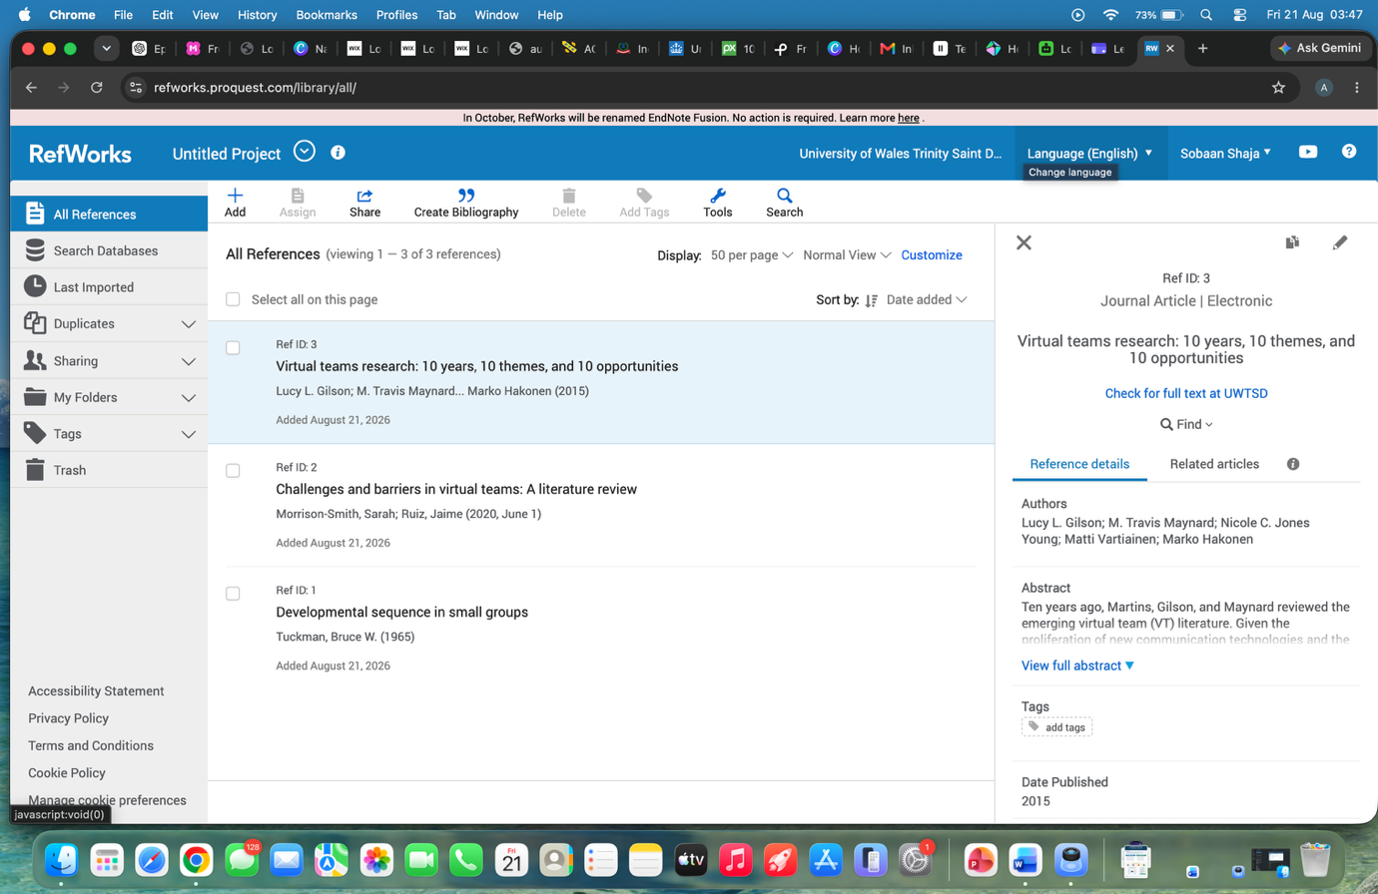
Fig. 7. Three sources stored in the RefWorks library.

4 - IEEE UWTSD bibliography generated automatically
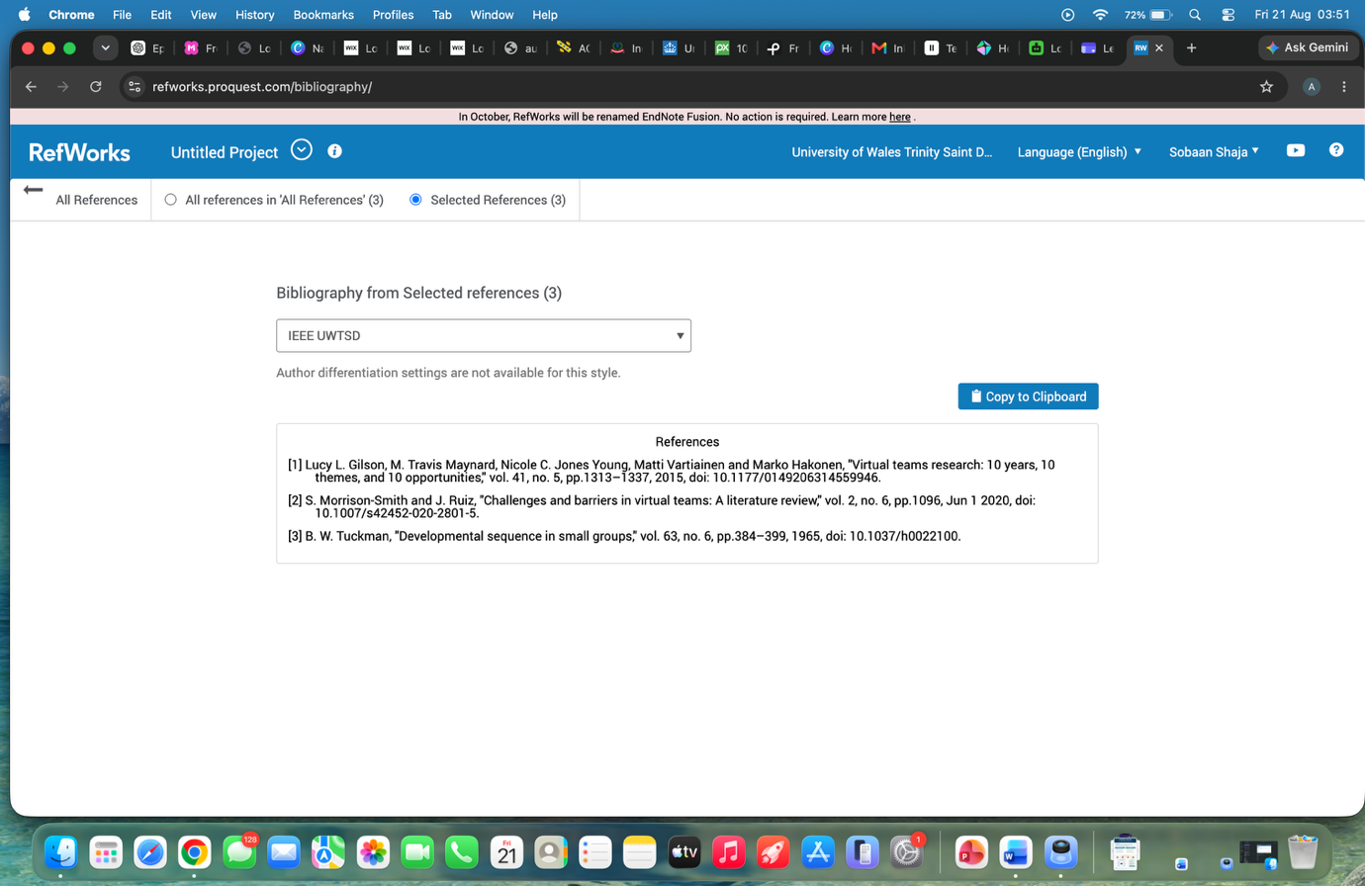
Fig. 8. Bibliography automatically generated using IEEE UWTSD style.
5 - Task 3 citations and bibliography pasted into Word
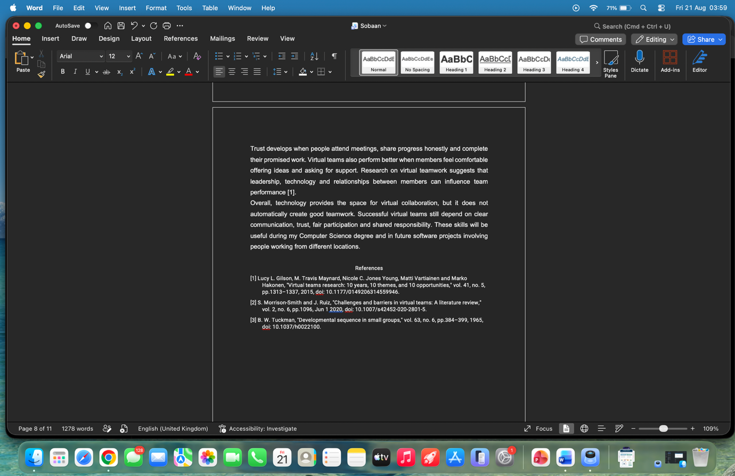
Fig. 9. IEEE citations and reference list included in Microsoft Word.

4 - RefWorks explanation
I used RefWorks to manage the sources for my virtual collaboration summary. I first created a journal article record manually and entered the author, title, year, volume and DOI. For the other articles, I entered their DOI numbers and used the automatic search function to complete most of the publication details. I checked each record and corrected any missing or inaccurate information before saving it. I then selected all three references, chose the IEEE UWTSD style and generated the bibliography automatically. Finally, I copied the reference list into my document and checked that each numbered citation matched the correct source.

Task 4(a): E-Portfolio Creation

https://sites.google.com/view/sobaan-lde-eportfolio/home

Screenshots of the Published E-Portfolio

Screenshot 1 – Home Page
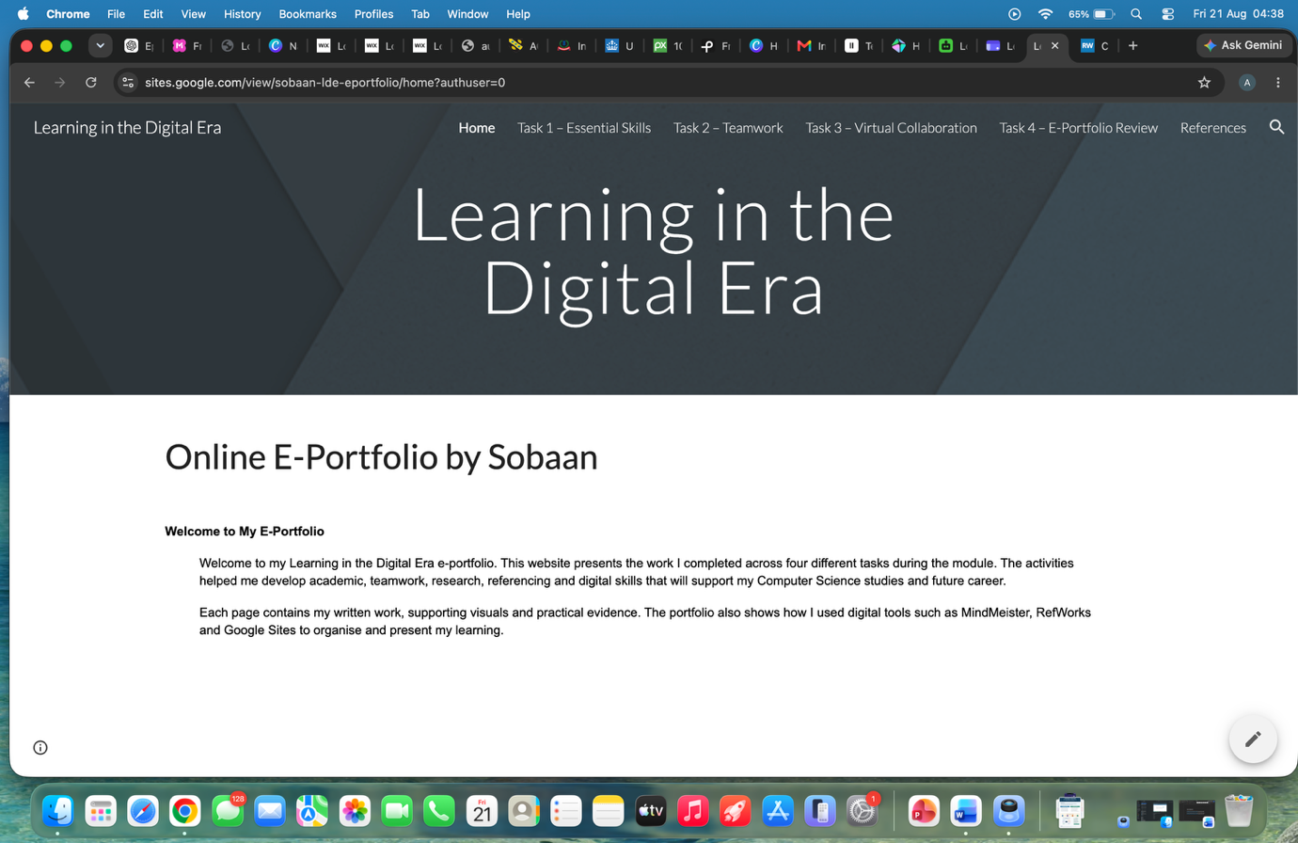
Fig. 10. Home page of the published Google Sites e-portfolio.

Screenshot 2 – Task 1: Essential Skills
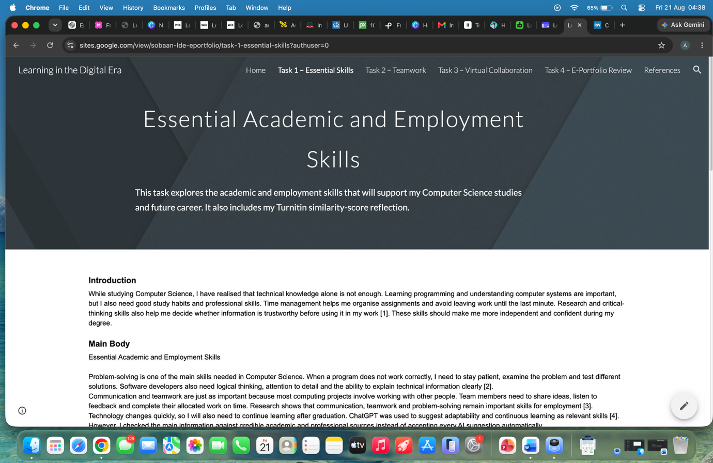
Fig. 11. Task 1 page containing the essential-skills report and reflection.

Screenshot 3 – Task 2: Teamwork
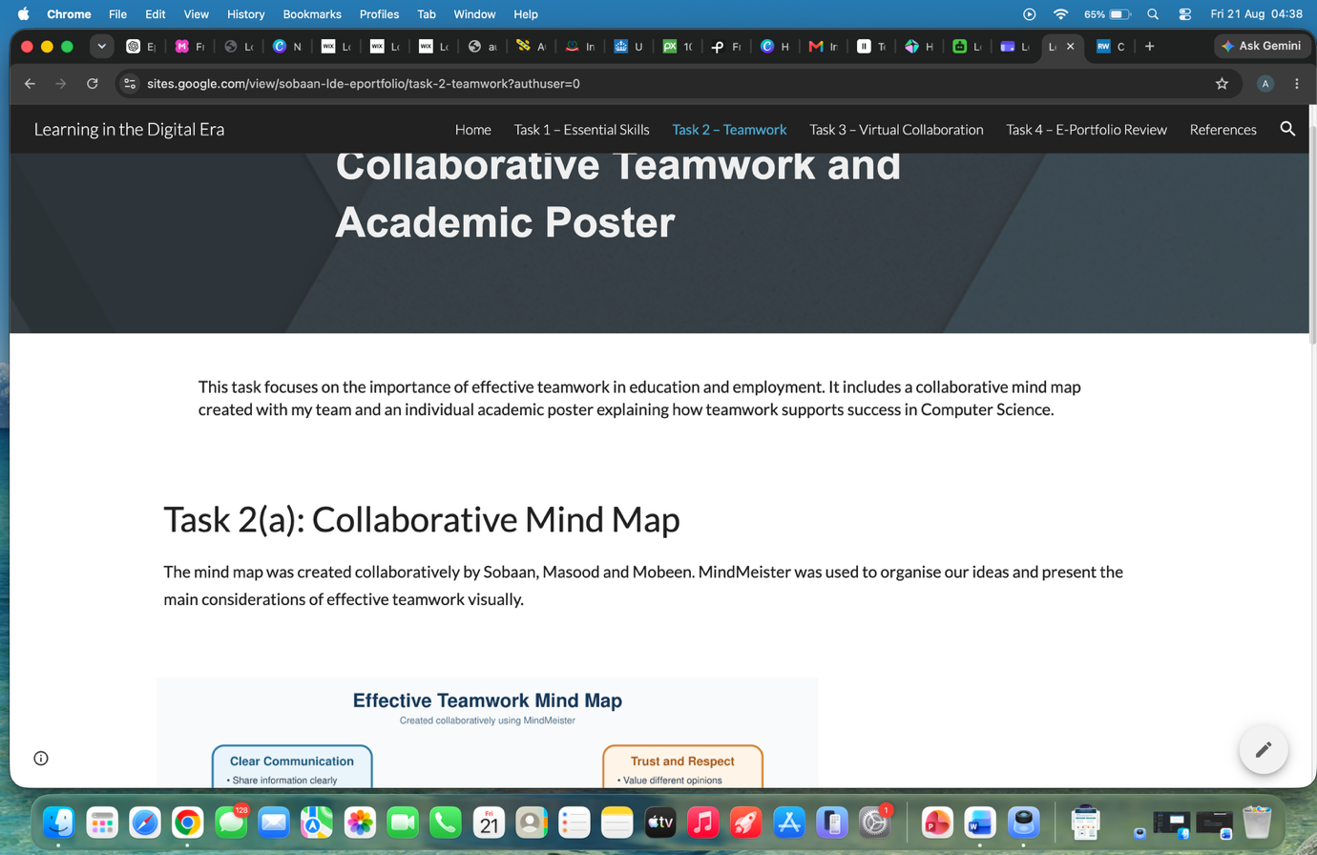
Fig. 12. Task 2 page containing the collaborative mind map and academic poster.

Screenshot 4 – Task 3: Virtual Collaboration
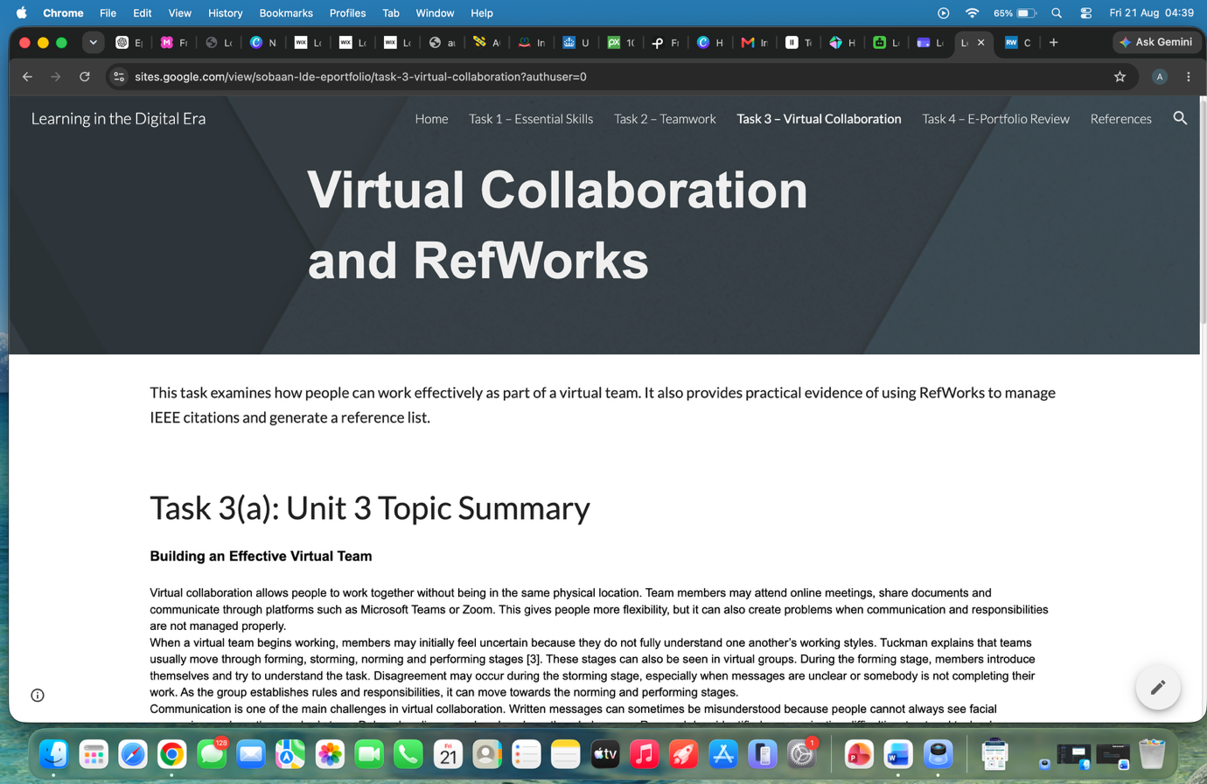
Fig. 13. Task 3 page containing the virtual-collaboration summary and RefWorks evidence.

Screenshot 5 – Task 4: E-Portfolio Review
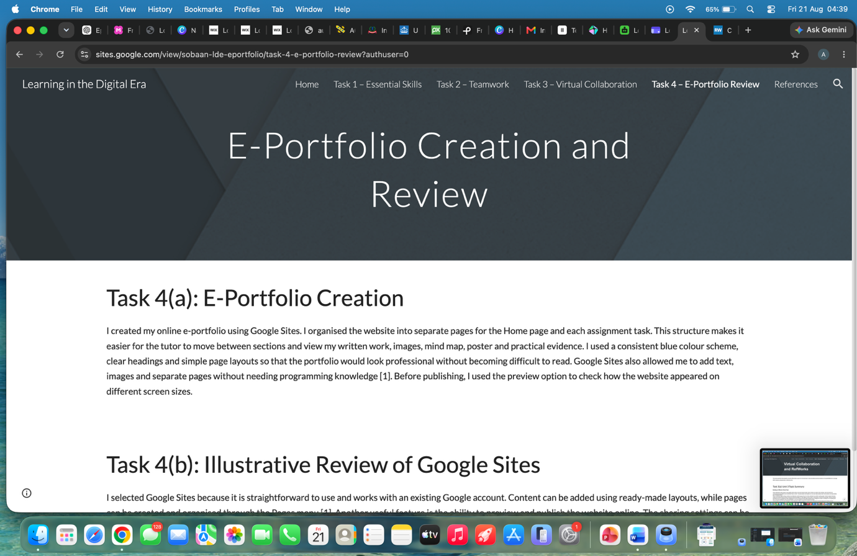
Fig. 14. Task 4 page reviewing the Google Sites platform.

Screenshot 6 – References Page
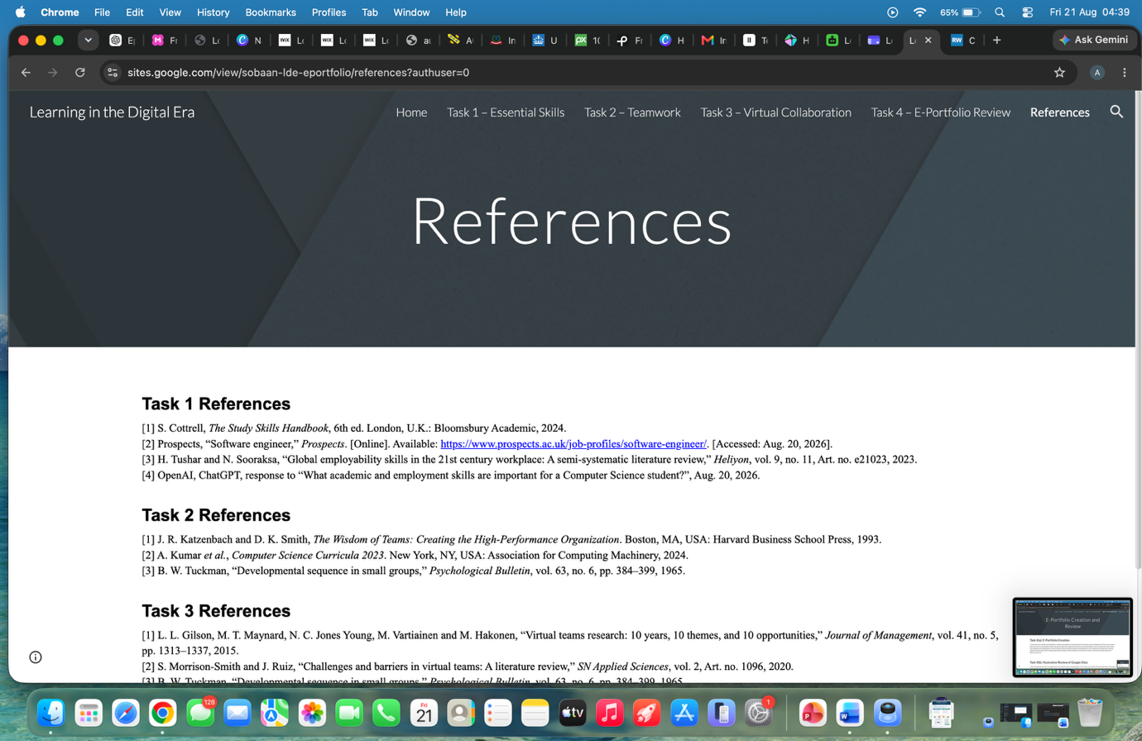
Fig. 15. IEEE reference lists used throughout the e-portfolio.

References
The following sources were used to support the written work, academic poster and reflective review presented in this e-portfolio. The references are organised by task and presented in IEEE style.

Task 1 References
[1] S. Cottrell, The Study Skills Handbook, 6th ed. London, U.K.: Bloomsbury Academic, 2024.
[2] Prospects, “Software engineer,” Prospects. [Online]. Available: https://www.prospects.ac.uk/job-profiles/software-engineer/. [Accessed: Aug. 20, 2026].
[3] H. Tushar and N. Sooraksa, “Global employability skills in the 21st century workplace: A semi-systematic literature review,” Heliyon, vol. 9, no. 11, Art. no. e21023, 2023.
[4] OpenAI, ChatGPT, response to “What academic and employment skills are important for a Computer Science student?”, Aug. 20, 2026.

Task 2 References
[1] J. R. Katzenbach and D. K. Smith, The Wisdom of Teams: Creating the High-Performance Organization. Boston, MA, USA: Harvard Business School Press, 1993.
[2] A. Kumar et al., Computer Science Curricula 2023. New York, NY, USA: Association for Computing Machinery, 2024.
[3] B. W. Tuckman, “Developmental sequence in small groups,” Psychological Bulletin, vol. 63, no. 6, pp. 384–399, 1965.

Task 3 References
[1] L. L. Gilson, M. T. Maynard, N. C. Jones Young, M. Vartiainen and M. Hakonen, “Virtual teams research: 10 years, 10 themes, and 10 opportunities,” Journal of Management, vol. 41, no. 5, pp. 1313–1337, 2015.
[2] S. Morrison-Smith and J. Ruiz, “Challenges and barriers in virtual teams: A literature review,” SN Applied Sciences, vol. 2, Art. no. 1096, 2020.
[3] B. W. Tuckman, “Developmental sequence in small groups,” Psychological Bulletin, vol. 63, no. 6, pp. 384–399, 1965.

Task 4 References
[1] Google, “How to use Google Sites,” Google Sites Help. [Online]. Available: https://support.google.com/sites/answer/6372878/. [Accessed: Aug. 20, 2026].
[2] Google, “Publish and share your site,” Google Sites Help. [Online]. Available: https://support.google.com/sites/answer/6372880/. [Accessed: Aug. 20, 2026].

