Inclusive Culinary Journeys

International Meetings Management for the Hotel Industry
BMIH6007
Christopher Wilkin

Marcin Patryk Segrecki
ID 2219780
Word Count 2625
I acknowledge the use of Grammarly and Microsoft Office 365 Editor on 26.02.2025 to check my document for grammatical and syntactical errors

- Executive Summary
Inclusive Culinary Journeys is a food festival that promotes equity, diversity, and inclusion in the food industry by highlighting the skills of chefs with disabilities and campaigning for accessible kitchen innovation. The event is divided into three phases: planning, delivery, and post-event evaluation, to ensure that everything operates effectively. The Bangkok's Queen Sirikit National Convention Centre festival includes interactive workshops, cooking demos, and storytelling sessions focusing on adaptable techniques and assistive kitchen equipment.
The Experience Economy concept encourages participation through live cooking demonstrations, sensory-friendly tastings, and networking panels, resulting in an inclusive and instructive environment. Key stakeholders, such as Bangkok Bank, Knorr, and the Asia-Pacific Development Centre on Disability, ensure financial and accessibility standards. AI-powered assistive technologies, QR-coded ticketing, and virtual access improve accessibility and operational efficiency.
The event expects to generate £117,000 in sales with a 40% profit margin, allowing it to continue its long-term accessibility initiatives. Compostable service ware, food residue recycling, and energy-efficient operations are all examples of sustainable practices. Risk management procedures enable safe, wheelchair-accessible layouts, real-time emergency response, and cybersecurity for digital systems.
Recommendation
To increase event risk management, consider strengthening emergency response systems, expanding safety protocols for guests with disabilities, and improving cybersecurity for digital tickets and payments. All participants will benefit from these efforts, making the event safer, more secure, and accessible.

- Table of Contents
- Introduction ………………………………………………………………………………5
- The Event Cycle …………………………………………………………………………5
- Event Concept and Attendee Experience …………………………………………….7
- Aim and SMART Objectives ……………………………………………………………8
- Strategic Event Management Considerations ………………………………………..9
- Marketing Strategies ……………………………………………………………………10
- Financial Analysis ………………………………………………………………………11
- Long-Term Financial Impact …………………………………………………………..13
- Industry Trends and Issues Impacting the Event …………………………………...13
- Situational and Cultural Factors (PESTEL Analysis) ……………………………….14
- Conclusion ………………………………………………………………………………16
- References ………………………………………………………………………………17
- Appendix ………………………………………………………………………………...23
- Applying the EMBOK Framework to the Event Cycle ………………………….23
- Risk Management Strategies ……………………………………………………..25
- SWOT Analysis: Evaluating the Event’s Strategic Position ……………………27
- SOAR Analysis: Strategic Growth Potential ……………………………………..28
- Service Scapes Theory and Event Experience ………………………………….29
- Cultural Sensitivity and Multiculturalism in Event Planning …………………….30
- Experience Economy and Engagement Models ………………………………...30

- Introduction
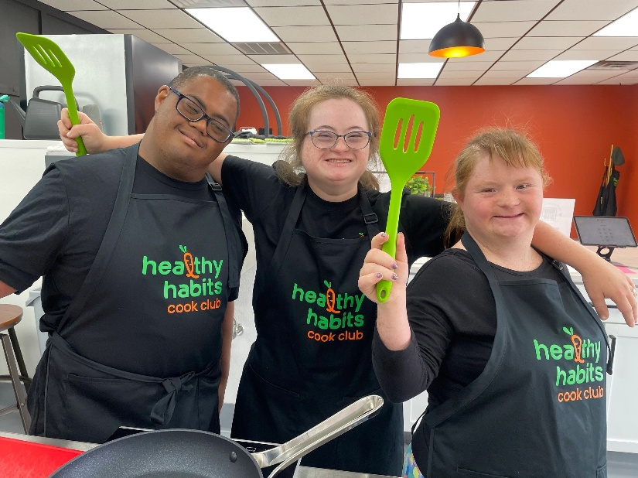
Inclusive Culinary Jours is a food festival designed to advance inclusion, diversity, and equality in the culinary arts. By highlighting the skills of chefs with disabilities and supporting accessible kitchen innovation, the event illustrates the value of diversity in cuisine. Built around the three main phases of event management (Planning, Delivery, and Post-Event Evaluation) the festival guarantees a flawless experience for guests while prioritising access. The event promotes participation and learning through interactive workshops, live cooking demonstrations, and sensory-friendly activities. Strategic alliances with sponsors and advocacy groups help the festival to fulfil its goals by guaranteeing financial sustainability and complying with accessibility standards.

- The Event Cycle
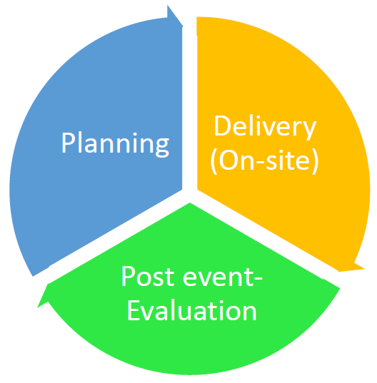
Like any well-organized event, Inclusive Culinary Journeys will follow a structured cycle to ensure the event runs efficiently and without issues. According to Getz and Page (2024), an event's life cycle consists of three key phases: Planning, Delivery, and Post-Event Evaluation. Each stage will be essential in bringing this festival to life while ensuring it remains accessible, engaging, and well-managed.
The Planning phase lays the groundwork for the festival. Choosing the right venue is a top priority, and the Queen Sirikit National Convention Centre in Bangkok has been selected for its excellent accessibility features, including wheelchair-friendly pathways and sensory-friendly spaces. Beyond logistics, crafting a meaningful program is essential. The festival’s lineup will feature cooking demonstrations, hands-on workshops, and storytelling sessions, all designed to highlight the talent of chefs with disabilities and promote inclusivity in the culinary world. Funding and partnerships will also play an important role during this phase. Sponsors like Oxo Good Grips, Knorr, and Bangkok Bank will provide financial support. At the same time, advocacy groups, including the Asia-Pacific Development Centre on Disability, will help ensure the event meets accessibility standards and legal requirements under Thailand’s Persons with Disabilities Empowerment Act (2007).
With the foundation set, the festival will move into the Delivery phase, where all the planning will be implemented. Setting up the space won’t just involve arranging tables and equipment; it will require creating an inclusive and accessible environment. Sensory-friendly zones, accessible seating, and real-time sign language interpretation will be implemented to ensure that every attendee can fully participate. Once all preparations are finalised, the event will begin. Chefs will lead cooking demonstrations, showcasing adaptive techniques, while hands-on workshops will allow guests to try out assistive kitchen tools and methods firsthand. Meanwhile, the storytelling sessions will provide a platform for chefs to share personal experiences, shedding light on the challenges and achievements of working in the culinary industry with a disability. Throughout the event, trained staff and volunteers will ensure efficient operations, assist attendees, and collect feedback.
Finally, the festival will transition into the Post-Event Evaluation phase, where organisers will assess its impact. Feedback will be gathered from guests, chefs, and partners to understand what worked well and what could be improved. This phase will also involve data evaluation, looking at attendance figures, financial outcomes, and marketing reach to measure the festival’s success. Another key focus will be sustainability. Organisers will review how well waste reduction initiatives such as compostable serviceware and recycling stations are performed. All these insights will inform future event editions, ensuring continued growth and improvement.
The festival aims to successfully balance creativity, inclusivity, and efficient management by structuring Inclusive Culinary Journeys around these three phases. More than just a food festival, it aspires to become a space where talent is celebrated, barriers are broken, and meaningful conversations about accessibility in the culinary world occur.

- Event Concept and Attendee Experience
Inclusivity is at the root of the Inclusive Culinary Journeys Food Festival. This event highlights the exceptional talents of chefs with disabilities while demonstrating how accessible culinary techniques empower professionals and home cooks. The festival aligns with the Experience Economy model (Pine and Gilmore, 1999), accentuating engaging, interactive, and transformative experiences over passive consumption (De Geus et al., 2016). By crafting an event where attendees observe and participate, the festival deepens its impact on inclusivity and accessibility in the culinary arts.
Daily Itinerary
Attendees will experience, taste, and engage with adaptive cooking:
- 10:00 AM – Opening Ceremony and Keynote Speech
  - A leading chef with a disability shares their culinary journey and challenges.
- 11:00 AM – Live Cooking Demonstrations
  - Chefs with mobility impairments showcase techniques for one-handed meal prep and assistive cutting (Harper, 2019).
- 12:30 PM – Sensory-Friendly Tasting Sessions
  - Guests explore dishes designed for individuals with sensory sensitivities.
- 2:00 PM – Interactive Workshops
  - Attendees practice using adaptive kitchen tools under expert guidance (Mossberg and Eide, 2017).
- 4:00 PM – Panel Discussions and Networking
  - Industry leaders, advocates, and chefs discuss barriers and solutions for disability inclusion.
- 6:00 PM – Cultural Food Exchange
  - Traditional dishes from different cultures are recreated with adaptive techniques.
- 8:00 PM – Closing Performance and Recognition Awards
  - Honoring chefs, advocates, and participants who push for inclusivity in culinary arts.
Promoting Active Involvement
This event adopts multi-sensory engagement, where attendees can touch, taste, listen, and interact. Rather than being passive observers, they co-create their experience by participating in adaptive cooking, networking with chefs, and engaging with inclusive culinary tools (Gregori et al., 2018).

- Aim and SMART Objectives
This event aims to promote equality, diversity, and inclusion in the culinary industry by showcasing the talents of chefs with disabilities and advocating for accessible kitchen innovation. This aligns with industry efforts to create events that are not only entertaining but also socially impactful and action-driven (Antchak et al., 2019).
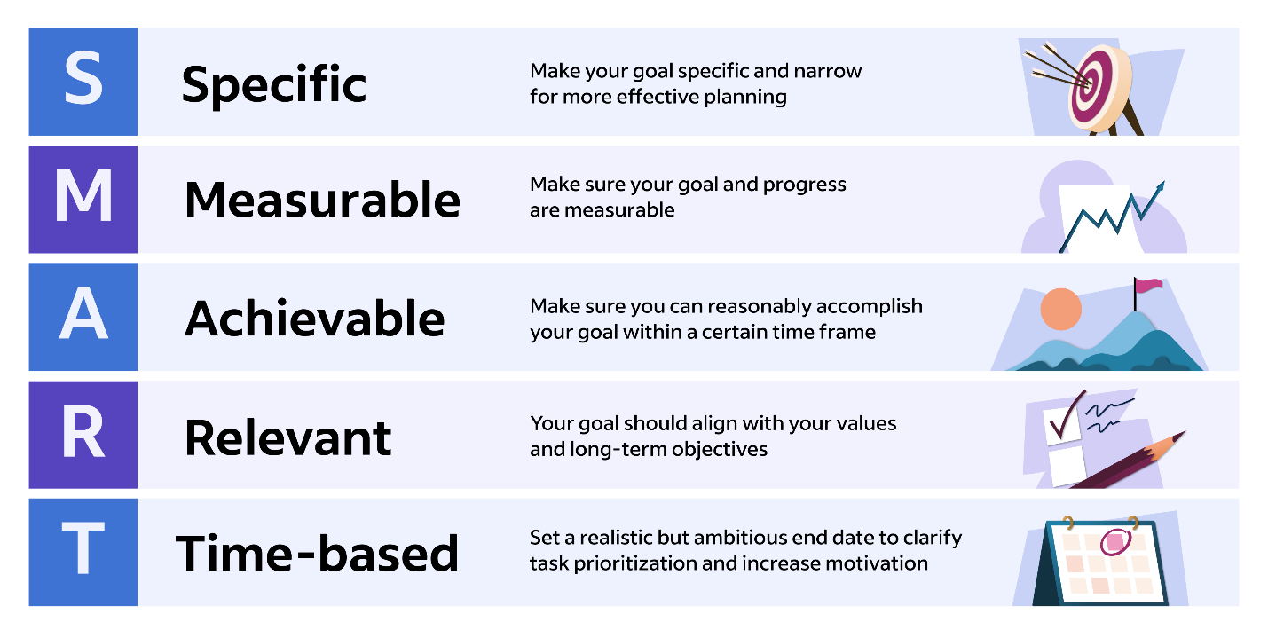
SMART Objectives
S - The festival will increase awareness of culinary accessibility, aiming for 80% of attendees to better understand inclusive cooking techniques (Dwyer et al., 2016).
M - At least three major culinary institutions will commit to promoting accessible training programs and securing partnerships with schools like Le Cordon Bleu Bangkok (Maguire and Hanrahan, 2017).
A - A 95% satisfaction rate on accessibility will be provided through feedback surveys and accessibility audits (Antón-Maraña et al., 2024).
R - These objectives align with long-term accessibility improvements in culinary education.
T - Evaluation will occur post-event, with partnership agreements secured within six months.

- Strategic Event Management Considerations
Operational and Planning Considerations
Planning an inclusive culinary event requires meticulous attention to stakeholder management, accessibility, and technology integration. These factors are essential in providing a practical event experience and meeting the festival’s core mission of equality, diversity, and inclusion (Finkel and Dashper, 2020).
- Stakeholder Management
- The event collaborates with Bangkok Bank, Knorr, and Oxo Good Grips, who provide funding and adaptive kitchen tools (Greenhalgh and Kim, 2024).
- The Asia-Pacific Development Center on Disability ensures that inclusivity measures meet industry standards (Jiang et al., 2024).
- The audience comprises food enthusiasts, industry professionals, and disability advocates, reinforcing the festival’s advocacy goals.
- Accessibility
- Wheelchair-friendly seating, step-free pathways, and accessible restrooms (Bell et al., 2022).
- Quiet zones, adjustable lighting, and Braille menus improve inclusivity for neurodivergent attendees.
- ASL interpreters and live audio descriptions ensure accessible presentations (Finkel and Dashper, 2020).
- Technology Integration
- QR-based ticketing improves entry efficiency while reducing physical touchpoints.
- Smart cooking tools, voice-activated appliances, and AI-powered recipe customisation through assistive kitchen technologies.
- Livestreaming and virtual access expand reach for attendees unable to attend in person (Stofer, 2024).

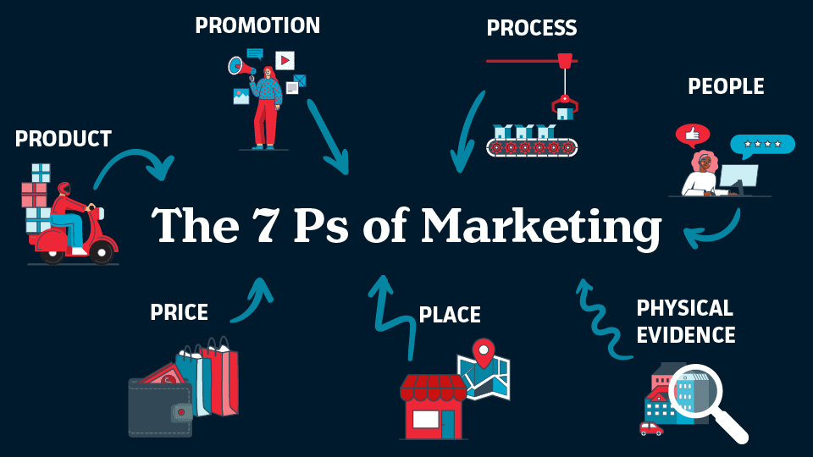
- Marketing Strategies
A well-organised marketing strategy guarantees maximum participation and supports the festival's main goal— culinary inclusiveness. The 7Ps framework (Booms and Bitner, 1981; Calitz et al., 2017) guarantees that every component of the marketing plan corresponds with the goals of the festival:
- Product - The festival promotes accessible cooking methods and adaptive culinary tools, promoting inclusivity in gastronomy.
- Price - General admission is £50; to guarantee affordability, students and disability advocates have a £20 discounted ticket.
- Place - Bangkok was chosen for its close international connections, making it easily reachable for attendees from different regions (Siriwatthanatrakarn and Kidrakarn, 2024).
- Promotion - The strategy calls for social media campaigns, influencer partnerships, and digital participation to appeal to a varied audience.
- People - The event is designed for chefs, food enthusiasts, and disability advocates, promoting an inclusive and involved community.
- Process - QR-based check-ins, real-time access help, and a user-friendly ticketing system guaranteeing efficiency and inclusiveness ( Wrathall and Steriopouls, 2022).
- Physical Evidence - The festival offers designated zones, interactive displays, and eco-friendly giveaways, strengthening its identity and commitment to sustainability.

Public Relations and Sponsorship
Public relations contribute to the festival’s visibility. Culinary institutions such as Le Cordon Bleu Bangkok support accessible culinary training (Maguire and Hanrahan, 2017), partnerships with disability organisations improve media coverage, campaigns highlight chefs with disabilities, and strengthen industry recognition (Dickson et al., 2017). Furthermore, major brand sponsorships help increase financial sustainability and exposure.

- Financial analysis
Income Sources
Income Source | Amount (£)
Sponsorships (Bangkok Bank, Knorr, Oxo Good Grips) | 30,000
Ticket Sales (1,200 attendees at an average price of £45) | 54,000
Workshop Fees (Hands-on training sessions) | 10,000
Vendor Fees (Food exhibitors and adaptive kitchen technology brands) | 3,000
Grants (Support from disability advocacy groups and cultural foundations) | 20,000
Total Projected Income | 117,000

Expenses
Expense Category | Details | Amount (£)
Venue and Setup | Rental of Queen Sirikit National Convention Center | 15,000
 | Event setup (staging, seating, accessibility modifications) | 5,000
Staffing | Event staff (registration, security, accessibility support) | 12,000
 | Volunteer coordination and training | 3,000
 | Speaker and chef accommodations and travel | 10,000
Marketing | Social media campaigns (advertisements, influencer collaborations) | 4,000
 | Printed materials (flyers, brochures, banners) | 2,000
 | Digital promotions (email campaigns, website development) | 3,000
 | PR outreach (press releases, media partnerships) | 1,000
Honorariums | Keynote speakers and panellists | 5,000
 | Chef demonstrations and workshop facilitators | 5,000
Sustainability | Waste management and compostable service | 2,000
 | Recycling stations and eco-friendly initiatives | 1,500
 | Carbon footprint reduction measures | 1,500
Total Projected Expenses |  | 70,000

Break-Even Analysis
Calculation | Value (£)
Average ticket price | 45
Variable cost per attendee | 12
Fixed costs | 60,000
Break-even attendance required | 1,818 attendees
Expected attendance | 1,200 attendees
Projected Net Revenue | 47,000

With an expected 1,200 people, the festival stays financially feasible due to grants, sponsorships, and extra income sources such as workshops. Calculated by dividing the £47,000 net income by the £117,000 total income and multiplying by 100, the profit margin of 40% is a strong indicator of profitability. This guarantees the event stays financially viable and sustainable even if the 1,818-attendee break-even objective is not reached.

- Long-Term Financial Impact
The Inclusive Culinary Journeys Food Festival is a stepping stone towards long-term inclusivity in the culinary sector rather than a one-off event. The projected £47,000 surplus will be purposefully reinvested to empower disabled chefs and increase accessibility initiatives. A part of the earnings will go towards culinary inclusion initiatives, including training grants for restaurants dedicated to accessibility and scholarships for aspiring disabled chefs.
With possible future events in Singapore, Tokyo, and Kuala Lumpur, ultimately increasing its influence in Asia's gastronomic scene, the festival also seeks to scale its impact globally. Moreover, investing in adaptive kitchen technology research would inspire creativity in assistive gadgets, facilitating cooking for people with disabilities. These financial reinvestments guarantee that the event has a long-lasting effect, promoting a more accessible, varied, and environmentally friendly gastronomic sector.

- Industry Trends and Issues Impacting the Event
- Addressing Underrepresentation in the Culinary Workforce
Individuals with disabilities continue to be under-represented in the culinary industry despite efforts to increase workplace diversity. Less than one-third of working-age individuals with disabilities are employed in food service roles, according to the National Restaurant Association (2022). This demonstrates a substantial gap in inclusion, as the industry frequently fails to provide adequate accommodations, adaptive apparatus, and training programs. Research indicates that the disparity can be bridged by improving the accessibility of culinary education and mentorship programs, which will provide aspiring disabled chefs with the requisite skills and confidence to enter the workforce (Chalegre and Almeida, 2022).
- Advancing Accessibility in Chef Education
To guarantee that chefs with disabilities receive an accessible education, training institutions must incorporate universal design principles. Digital learning tools and hands-on accessibility training have significantly improved inclusivity in vocational education, according to Guilbaud et al. (2021). The festival addresses this issue by offering adaptive cooking seminars and live demonstrations that showcase assistive technologies such as voice-assisted cooking devices and one-handed cutting tools.
- The Push for Zero-Waste Events
Sustainability has become an increasingly pressing issue as culinary festivals are gaining popularity. To comply with global sustainability objectives, the event implements compostable serviceware, recycling stations, and food waste management initiatives (Hottle et al., 2015). The festival's environmental impact is also reduced, which benefits the brand's reputation and the contentment of attendees, as eco-conscious consumers increasingly favour green initiatives in public events.
- Innovation for Accessibility and Security
In contemporary events, technology is instrumental in improving accessibility and efficacy. The festival will incorporate blockchain-based ticketing systems to guarantee efficient digital transactions and fraud prevention. Furthermore, the overall experience will be significantly improved by AI-powered accessibility tools, including real-time captioning and navigation assistance for visually impaired attendees. These developments not only improve the event's inclusivity but also create new standards for accessibility in large-scale culinary events (Zhang, 2019).

- Situational and Cultural Factors (PESTEL Analysis)
- Political
Government policies influence culinary tourist growth, with the Persons with Disabilities Empowerment Act (2007) assuring accessibility (Royal Thai Government, 2007). Thailand's sustainable tourism policies encourage environmentally responsible event planning (Buathong and Lai, 2017). Policy-backed policies improve market positioning with the sector expected to rise from USD 32.5 billion to USD 179.4 billion by 2034 (Future Market Insights, 2024). These policies promote inclusion and long-term industry sustainability.
- Economic
Thai culinary tourism is a considerable economic driver, with food festivals accounting for 29% of the culinary tourism market share in 2024. In 2024, the sector is anticipated to expand from USD 32.5 billion to USD 179.4 billion by 2034 (Future Market Insights, 2024). The opportunity to start Inclusive Culinary Journeys as a driving force for inclusive culinary tourism is presented, which will result in increased employment opportunities for disabled chefs and the attraction of a global audience (Future Market Insights, 2024).
- Social
Although Thailand has a strong hospitality culture, societal attitudes towards individuals with disabilities continue to impede full inclusion. Events that draw attention to the abilities of disabled chefs and offer interactive experiences challenge preexisting biases and encourage the normalisation of inclusion in professional culinary environments. This event could be an educational instrument to promote greater diversity in the hospitality industry and shift perceptions (Chiengkul et al., 2022).
- Technological
The culinary industry is experiencing a transformation in accessibility due to technological innovation. AI-driven assistive technology, including voice-controlled kitchen tools, innovative adaptive implements, and automated food preparation stations, could allow disabled chefs to operate more independently. The festival will present these innovations through live demonstrations, ultimately educating professionals and consumers on how technology improves accessibility (Zhang, 2019).
- Environmental
The industry increasingly accepts sustainability in culinary festivals (Hottle et al., 2015). The event incorporates zero-waste initiatives, such as sustainable ingredient sourcing, food residue recycling, and compostable service ware. These measures are designed to minimise the environmental impact and appeal to environmentally conscious attendees. Thailand's national initiative to promote sustainable event planning and green tourism is consistent with sustainability initiatives (Buathong and Lai, 2017).
- Legal
Legal compliance is indispensable for guaranteeing that the festival fulfils all accessibility standards. The Persons with Disabilities Empowerment Act (2007) mandates barrier-free access to public spaces, necessitating the implementation of accessible seating areas, braille menus, sign language interpreters, and wheelchair-friendly pathways. The event promises compliance and creates an industry standard for future culinary events in Thailand by adhering to these regulations.

Conclusion
Inclusive Culinary Journeys breaks down barriers and celebrates talent, transcending just a food festival. Including accessibility in every event element helps create a more inclusive gastronomic scene. Its long-term effects go beyond a single event and affect industry norms, culinary education, and future accessible initiatives. The financial reinvestments of the festival will help initiatives for adapted cooking education and promote creativity in assistive kitchen technologies. One important recommendation is to improve event risk management by strengthening contingency planning and boosting success. This covers implementing real-time emergency response systems, extra security measures for visitors with disabilities, and more cybersecurity protections for digital ticketing and payments. The festival will create a precedent for inclusiveness and operational quality in the worldwide culinary event sector by constantly improving its accessibility and safety measures, guaranteeing a safe, enjoyable, and powerful experience for all attendees.

Reference List
- Akman, M.K., 2019. SWOT analysis and security management. European Journal of Management and Marketing Studies. https://oapub.org/soc/index.php/EJMMS/article/download/624/1206
- Banate, R.M., Ramirez, V., Magdale, J.R.S., Tambal, C., Caones, J., Bombita, C., and Balite, A., 2024. Customer with disabilities experiences on the accessibility of selected stand-alone fast-food restaurants in Cavite: Basis for service enhancement plan. International Journal of Research in Education Humanities and Commerce, 5(1), pp.147-157. https://ijrehc.com/uploads2024/ijrehc05_12.pdf
- Banate, R.M., Ramirez, V., Magdale, J.R.S., Tambal, C., Caones, J., Bombita, C., and Balite, A., 2024. Customer with disabilities experiences on the accessibility of selected stand-alone fast-food restaurants in Cavite: Basis for service enhancement plan. International Journal of Research in Education Humanities and Commerce, 5(1), pp.147-157.https://doi.org/10.37602/IJREHC.2024.5112
- Boardroom Global, 2023. The Crown Jewel of Events in Bangkok: Introducing the Queen Sirikit National Convention Center. [online] Available at: https://boardroom.global/the-crown-jewel-of-events-in-bangkok-introducing-the-queen-sirikit-national-convention-center/.
- Bowdin, G., Allen, J. and Harris, R., 2011. Events Management. [online] Available at: https://research-ebsco-com.ezproxy.uwtsd.ac.uk/linkprocessor/plink?id=0713b2d6-c559-3133-a063-9c460741a170
- Chalegre, V. and Almeida, A., 2022. Software Requirements for Inclusive Employment: Accessibility, Usability and User Experience Contributions. AHFE International. https://doi.org/10.54941/ahfe100888.
- Choi, D.W., Lee, S. and Alcorn, M., 2020. Influence of culture on purchase decision Integrative models development of amusement park customers. International Journal of Hospitality Management, 87, p.102502. https://doi.org/10.1016/j.ijhm.2020.102502
- Culinary Ability Awards, 2020. Promoting Inclusion. [online] Available at: https://www.olympiade-der-koeche.com/en/news/culinary-ability-awards-promoting-inclusion/
- Dadwal, S.S., and Dadwal, D. (2020). Management of health and safety risks at large events: Process, procedures, and factors. In Organizational Culture and Achieving Business Excellence: Emerging Research and Opportunities (pp. 21–41). IGI Global.https://openresearch.lsbu.ac.uk/download/e7aec906542f47834d7bfb05e17aaedb84814c973a83bbeca46ab1483e4a13da/533344/Management-of-Health-and-Safety-Risks-at-Large-Events_-Process-Procedures-and-Factors.pdf
- Damsbo-Svendsen, M., Karpantschof, B., Stovgaard, M., Christensen, J. and Frøst, M., 2022. Effects on skills and knowledge of a sensory teaching program for culinary students. International Journal of Food Design. https://doi.org/10.1386/ijfd_00041_1.
- Dewata, M. and Wijaya, L., 2024. Public Relations Marketing Strategy in Building Brand Awareness Using Product Bundling. Jurnal Indonesia Sosial Sains. https://doi.org/10.59141/jiss.v5i10.1385.
- Fischer, R.J., Halibozek, E.P. and Walters, D.C., 2018. Contingency planning, emergency response, and safety. In Introduction to Security (pp. 249–268). https://doi.org/10.1016/B978-0-12-805310-2.00011-1
- Fischer, R.J., Halibozek, E.P., and Walters, D.C. (2018). Contingency planning, emergency response, and safety. In Introduction to Security (pp. 249–268). Elsevier. https://pmc.ncbi.nlm.nih.gov/articles/PMC7149346/
- Future Market Insights, 2024. Thailand Culinary Tourism Market. [online] Available at: https://www.futuremarketinsights.com/reports/thailand-culinary-tourism-market
- Getz, D. and Page, S., 2024. Event studies: theory and management for planned events. Fifth Edition. London: Routledge. [online] Available at: https://librarysearch.uwtsd.ac.uk/permalink/44WHELF_UWTSD/upgrip/alma99100647735602421
- Gillovic, B. and McIntosh, A., 2020. Accessibility and Inclusive Tourism Development: Current State and Future Agenda. Sustainability, 12, pp. 9722. https://doi.org/10.3390/su12229722.
- Greenhalgh, G. and Kim, E., 2024. Enhancing the Attendee Experience: The Power of Event Sponsorship. Event Management. https://doi-org.ezproxy.uwtsd.ac.uk/10.3727/152599524X17265263360278
- Guilbaud, T.C., Martin, F. and Newton, X., 2021. Faculty perceptions on accessibility in online learning: Knowledge, practice and professional development. Online Learning, 25(2), pp.6-35. https://files.eric.ed.gov/fulltext/EJ1301723.pdf
- Gulla, F., Ceccacci, S., Menghi, R. and Germani, M., 2016, June. An adaptive smart system to foster disabled and elderly people in kitchen-related tasks. In Proceedings of the 9th ACM International Conference on PErvasive Technologies Related to Assistive Environments (pp. 1-4). http://dx.doi.org/10.1145/2910674.2910678
- Harper, G., 2019. The culinary arts in the creative industries. https://www.tandfonline.com/doi/pdf/10.1080/17510694.2019.1570651?needAccess=true
- Harper, G., 2019. The culinary arts in the creative industries. https://doi.org/10.1080/17510694.2019.1570651
- Harrington, R. J. and Ottenbacher, M. C. (2013) ‘Managing the Culinary Innovation Process: The Case of New Product Development’, Journal of Culinary Science and Technology, 11(1), pp. 4–18. doi: 10.1080/15428052.2012.754724.
- Hottle, T., Bilec, M., Brown, N. and Landis, A., 2015. Toward zero waste: composting and recycling for sustainable venue-based events. Waste management, 38, pp. 86-94 . https://doi.org/10.1016/j.wasman.2015.01.019.
- Hottle, T., Bilec, M., Brown, N. and Landis, A., 2015. Toward zero waste: Composting and recycling for sustainable venue-based events’, Waste Management, 38, pp. 86-94. https://doi.org/10.1016/j.wasman.2015.01.019
- Janjusevic, J. and Mathur, S., 2021. Financial Planning and Budgeting of Events. . https://doi.org/10.23912/9781911635734-4769.
- Janjusevic, L. and Salama, M., 2021. Sustainability in the Context of Event Management. https://doi.org/10.23912/9781911635734-4775.
- Jiang, H., Wan, Y. and Eddy-U, M., 2024. Constraints and Facilitators, Universal Design and Event Experience: Accessibility of Facilities at a Food Festival. Event Management. https://doi.org/10.3727/152599524x17293162639423.
- Jiang, H., Wan, Y. and Eddy-U, M., 2024. Constraints and Facilitators, Universal Design and Event Experience: Accessibility of Facilities at a Food Festival. Event Management. https://doi.org/10.3727/152599524X17293162639423
- Kamkankaew, P., 2023. Current trends in strategic management: A comparative analysis of SWOT and SOAR approaches’, RMUTT Global Business Accounting and Finance https://doi.org/10.60101/gbafr.2023.269044
- Katherine, D. and Rebecca, F., 2020. Accessibility, diversity and inclusion in events. The Routledge Handbook of Events. https://librarysearch.uwtsd.ac.uk/permalink/44WHELF_UWTSD/igoone/cdi_crossref_primary_10_1080_15470148_2020_1814472
- Khavarian-Garmsir, A.R., Stavros, J.M. and Saraei, M., 2017. Strategic planning for tourism development with a focus on Muharram ceremony using SOAR framework: A case study of Yazd Province in Iran’, Event Management, 21, pp. 119-129. https://doi.org/10.3727/152599517X14809630271311
- Khir, M., 2014. Developing an event safety risk typology : a qualitative study of risk perception amongst event planners and venue managers in Malaysia. . https://doi.org/10.24377/LJMU.T.00004441.
- Khir, M., 2014. Developing an event safety risk typology: A qualitative study of risk perception amongst event planners and venue managers in Malaysia. https://doi.org/10.24377/LJMU.t.00004441
- Kou, L., wei, C., Chi, C.G. and Xu, H., 2024. Understanding sensescapes and restorative effects of nature-based destinations: a mixed-methods approach. http://dx.doi.org/10.1080/09669582.2024.2324021
- Kusuma, K.A., 2021. Development of SWOT method with additional elements of aspirations and results in the music industry’, Jomantara: Indonesian Journal of Art and Culture. https://doi.org/10.23969/jijac.v1i2.4331
- Melly, D., McLoughlin, E. and Maguire, K., 2023. Emerging Venue Considerations for Event Management: The Case of Ireland. Tourism and Hospitality. https://doi.org/10.3390/tourhosp4010011.
- Mossberg, L. and Eide, D. (2017) ‘Storytelling and meal experience concepts’, European Planning Studies, 25(7), pp. 1184–1199. doi: 10.1080/09654313.2016.1276156.
- Mossberg, L. and Eide, D., 2017. Storytelling and meal experience concepts. European Planning Studies, 25(7), pp. 1184–1199. https://doi.org/10.1080/09654313.2016.1276156
- Moyle, B., Kennelly, M., and Lamont, M. (2014). Risk management and contingency planning in events: Participants’ reactions to the cancellation of Ironman New Zealand 2012. International Journal of Event Management Research, 8(1), 94–106. https://citeseerx.ist.psu.edu/document?doi=2817eb1b745aaebc3e07b563cc2e7a72e90029b0&repid=rep1&type=pdf
- National Restaurant Association, 2022. Inclusive hiring: Welcoming workers with disabilities. [online] Available at: https://restaurant.org/education-and-resources/resource-library/inclusive-hiring-welcoming-workers-with-disabilities/
- National Restaurant Association. 2022. Inclusive hiring: Welcoming workers with disabilities. https://restaurant.org/education-and-resources/resource-library/inclusive-hiring-welcoming-workers-with-disabilities/
- Office Timeline Online, 2025. https://online.officetimeline.com/
- Pine, B.J. and Gilmore, J.H., 1999. The Experience Economy: Work is Theatre and Every Business a Stage. Harvard Business Press.
- Pir Mohammadzadeh, A., Kamyabi, S., and Zandmoghaddam, M.R., 2021. Strategic planning and sociology in improving the quality of life and sustainable development of cities in arid regions climates with emphasis on MICE tourism using meta-SWOT and SOAR techniques’, Iranian Journal of Educational Sociology. http://dx.doi.org/10.52547/ijes.4.2.224
- planning guide for federal information systems (NIST Special Publication 800-34 Rev. 1). National Institute of Standards and Technology. https://nvlpubs.nist.gov/nistpubs/legacy/sp/nistspecialpublication800-34r1.pdf
- QSNCC, 2024. At a Glance. https://www.qsncc.com/en/about/at-a-glance
- Royal Thai Government (2007) Persons with Disabilities Empowerment Act, B.E. 2550 (2007). https://www.un.org/development/desa/disabilities/wp-content/uploads/sites/15/2019/11/Thailand_The-Persons-with-Disabilities-Empowerment-Act-B.E.-2550-2007-PDEA.pdf
- Royal Thai Government, 2007. Persons with Disabilities Empowerment Act, B.E. 2550 (2007). https://www.un.org/development/desa/disabilities/wp-content/uploads/sites/15/2019/11/Thailand_The-Persons-with-Disabilities-Empowerment-Act-B.E.-2550-2007-PDEA.pdf
- Sanchez-Jofras, J.F. and Kuri-Alonso, I., 2019. Education and innovation in gastronomy: A case study of culinary art school in Tijuana, Mexico. Cultural and Creative Industries: A Path to Entrepreneurship and Innovation, pp.101-119. https://repositorio.cetys.mx/bitstream/60000/1765/1/978-3-319-99590-8.pdf#page=114
- Shibuya, M. and Chen, X., 2021. Production Planning and Management Using Gantt Charts. Journal of Mechanics Engineering and Automation. https://doi.org/10.17265/2159-5275/2021.03.002.
- Silvers, J.R., Bowdin, G.A., O'Toole, W.J. and Nelson, K.B., 2005. Towards an International Event Management Body of Knowledge (EMBOK). Event Management, 9(4), p.185. https://doi.org/10.3727/152599506776771571
- Siriwatthanatrakarn, C. and Kidrakarn, K., 2024. The Development of Integrated Marketing Communication Strategies for Organizing International Running Events. Studies in Media and Communication. https://doi.org/10.11114/smc.v12i4.7009.
- Siriwatthanatrakarn, C. and Kidrakarn, K., 2024. The Development of Integrated Marketing Communication Strategies for Organizing International Running Events. Studies in Media and Communication. https://doi.org/10.11114/smc.v12i4.7009
- Swanson, M., Bowen, P., Phillips, A.W., Gallup, D. and Lynes, D., 2010. Contingency
- Swanson, M., Bowen, P., Phillips, A.W., Gallup, D., and Lynes, D. (2010). Contingency planning guide for federal information systems (NIST Special Publication 800-34 Rev. 1). National Institute of Standards and Technology. https://nvlpubs.nist.gov/nistpubs/legacy/sp/nistspecialpublication800-34r1.pdf
- Zhang, X., 2019. Accessibility manager: Creating a profile of a new profession’, Linguistica Antverpiensia, New Series – Themes in Translation Studies, 18, pp. 73-86. https://doi.org/10.52034/lanstts.v18i0.510

Appendix
Applying the EMBOK Framework to the Event Cycle
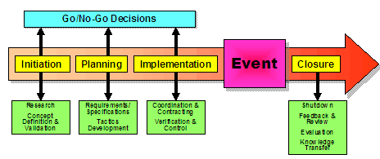
According to Getz and Page (2024), the Event Management Body of Knowledge (EMBOK) (Silvers et al., 2005) offers a structured approach to event planning, assisting organisers in the management of critical areas such as administration, design, marketing, operations, and risk management.
Each phase of the event cycle is consistent with the EMBOK elements: During the Initiation phase, stakeholder engagement and feasibility studies were conducted. Planning was concentrated on accessibility, logistics, and budgeting. Implementation guaranteed that the event was prepared for execution, including technical setup and staff training. Assuring a seamless experience for attendees necessitated real-time decision-making during event execution. Ultimately, Closure focused on sustainability reporting and post-event evaluation.
- Initiation
- Feasibility and Stakeholder Engagement
Initially, the organisers must assess the festival's financial and logistical viability. The event will be able to cover costs while still leaving space for future initiatives by evaluating revenue projections using industry benchmarks (Janjusevic and Mathur, 2021). Bangkok Bank, Knorr, and Oxo Good Grips are anticipated to serve as sponsors, providing logistical and financial support (Greenhalgh and Kim, 2024). Securing partnerships will also be a top priority.
Another significant focus will be placed on compliance. The event must adhere to the national standards imposed by Thailand's Persons with Disabilities Empowerment Act (2007), which defines legal accessibility requirements (Royal Thai Government, 2007). Venue selection will be a significant factor. The Queen Sirikit National Convention Centre has been selected for its well-established accessibility features, convenient location, and reputation (QSNCC, 2024). Venue selection will be a significant factor.
- Planning
- Budgeting, Logistics, and Marketing
Once feasibility is verified, the planning process will start in full force. A structured budgeting strategy will ensure that significant expenses, such as venue rental, staffing, marketing, and accessibility improvements, are balanced against revenue sources, including sponsorships, ticket sales, and grants. The break-even analysis provides organisers with the assurance that the festival is financially viable while also ensuring that there is a surplus for future initiatives.
A wide range of audiences, including culinary professionals, disability advocates, and the general public, will be targeted by marketing initiatives. A digital marketing strategy will incorporate influencer collaborations, social media outreach, and accessibility-focused campaigns, such as assistive technology and multilingual ads (Dewata and Wijaya, 2024).
The logistics planning process will be equally comprehensive. The organisers will ensure that the venue is mapped out with distinct, accessible pathways, sensory-friendly zones, and Braille menus. A special focus will be placed on transportation coordination to facilitate the conveyance of attendees with disabilities to the venue.
- Implementation
- Final Preparations Before the Festival
Staff and volunteers will undergo rigorous training as the festival date approaches to guarantee a welcoming and accessible atmosphere. Gillovic and McIntosh (2020) propose that sensory awareness workshops will assist attendees with various requirements, while emergency exercises will centre around evacuation protocols for guests with disabilities (Khir, 2014).
Simultaneously, sponsors will be more prominent by incorporating their brands into interactive product showcases and culinary demonstrations. The theme of inclusivity will be strengthened by the opportunity for visitors to directly experience adaptive kitchen implements.
Cybersecurity measures will be implemented to safeguard digital ticketing and contactless payment systems from a technical perspective (Swanson et al., 2010). The event will be made genuinely accessible by implementing assistive technologies, including live sign language interpretation and screen readers.
- Event Execution
- Managing the Live Experience
With months of planning behind them, the organisers will now concentrate on providing the festival experience in real-time. Live cooking demonstrations will be the primary focus, as chefs will present innovative kitchen equipment and adaptive culinary techniques (Damsbo-Svendsen et al., 2022). Panel discussions will investigate the future of accessibility in the food industry, and sensory-friendly food testing will provide attendees with a more inclusive culinary experience.
The primary objective will be to optimise operational efficacy. Dedicated crowd management teams guarantee guests can seamlessly transition between various event areas. At the same time, a QR code-based check-in system will simplify the process of entering. Medical and safety personnel will be prepared to respond in an emergency.
- Closure
- Evaluating Success and Ensuring a Lasting Impact
Evaluation and long-term impact will be the primary focus following the event's conclusion. Attendee experiences will be captured through post-event surveys, focusing on the functionality of accessibility features (Jiang et al., 2024). Sponsors and collaborators will also be invited to provide feedback on the engagement results.
We will conduct a thorough evaluation of sustainability initiatives. Organisers will evaluate the effectiveness of waste reduction initiatives, including compostable serviceware and minimal single-use plastics (Hottle et al., 2015). Eco-conscious event practices and energy-efficient illumination will be observed to facilitate future improvements.
The influence will extend beyond the festival. It is anticipated that the event will serve to advance discussions regarding accessibility in culinary education, thereby fostering long-term partnerships with culinary institutions and industry leaders and influencing policies. These initiatives are designed to guarantee that the festival's objective, to develop a more inclusive culinary industry, continues well beyond a single event.
Risk Management Strategies
A top priority for the Inclusive Culinary Journeys Festival is to ensure a safe and accessible environment. Effective risk management strategies are indispensable when dealing with a diverse audience, including the general public, food industry professionals, and individuals with disabilities. These strategies ensure a secure and consistent event experience by addressing safety concerns, population control, technical reliability, and emergency preparedness.
- Venue Safety and Accessibility
The festival guarantees that all areas of the Queen Sirikit National Convention Centre (QSNCC) are wheelchair-accessible by Thailand's Persons with Disabilities Empowerment Act (2007) (Royal Thai Government, 2007). To improve accessibility, the event layout will incorporate features such as tactile floor paths, braille menus, and sign language interpreters (Banate et al., 2024). Furthermore, seating arrangements are engineered to accommodate mobility devices without blocking pathways, reducing the risk of accidents.
- Crowd Management
To mitigate congestion, the daily attendance limit will be set at 1,200 individuals (Khir, 2014). Entry and exit points will be monitored by security personnel who have been trained to prevent bottlenecks and ensure an uninterrupted movement of people. Radio-linked security squads will be prepared to address health-related emergencies or disturbances in critical areas. Clear signage and designated waiting zones will be in the waiting areas for workshops and food vendors to prevent congestion.
- Technical Contingencies
Cybersecurity measures will be implemented to safeguard attendee data, as the event depends on digital ticketing and scheduling systems (Swanson et al., 2010). A specialised IT staff will monitor the system in real time, ensuring that the event infrastructure has backup power sources. Generator reserves and Wi-Fi redundancies will prevent interruptions in digital transactions or assistive technology displays.
- Emergency Preparedness
Implementing complete emergency protocols will guarantee a coordinated and efficient response to crises. Individuals with disabilities will receive assistance from trained personnel, who will announce evacuation routes in multiple languages and ensure they are marked (Fischer et al., 2018). Key locations will have access to an on-site medical staff with defibrillators, first aid stations, and allergen management resources. In the event of unforeseen disruptions, the Bangkok International Trade and Exhibition Centre (BITEC) will function as a secondary venue, guaranteeing the festival's continuity.
SWOT Analysis: Evaluating the Event’s Strategic Position
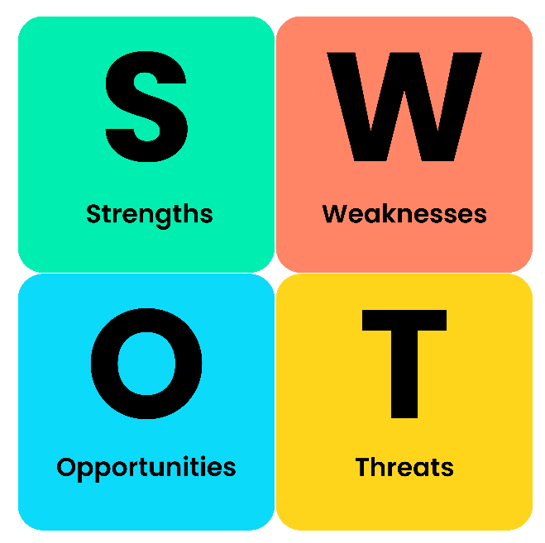
A SWOT analysis (Strengths, Weaknesses, Opportunities, and Threats) assesses the event's long-term impact and feasibility. With this framework, event planners can leverage opportunities, capitalise on strengths, resolve weaknesses, and mitigate potential threats (Kamkankaew, 2023).
- Strengths
Brands such as Knorr and Bangkok Bank provide substantial sponsorship support for the event. It also ensures legal compliance by aligning with government disability empowerment policies. Additionally, the event's distinctive concept of inclusivity in culinary arts distinguishes it from traditional food festivals, attracting the media's and the public's attention (Khavarian-Garmsir et al., 2017).
- Weaknesses
Although innovative, the event may incur increased operational expenses as a result of the necessity for adaptive culinary configurations, assistive technologies, and modifications to the venue that are more accessible. Furthermore, the public's awareness of culinary accessibility is still limited, necessitating further marketing initiatives to increase engagement (Kusuma, 2021).
- Opportunities
The gastronomic tourism industry in Thailand is experiencing significant growth, which presents a substantial opportunity for expansion. The event has the potential to establish itself as a model for inclusivity in the hospitality sector, which could result in partnerships with international culinary institutions. The event's status as a pioneer in tech-integrated inclusivity may be further strengthened by the development of AI-driven accessibility tools (Pir Mohammadzadeh et al., 2021).
- Threats
The event could face economic uncertainties, particularly if sponsors withdraw due to financial downturns. Furthermore, operational delays may result from logistical challenges associated with managing accessibility requirements that are poorly planned. Another variable is public perception, as mainstream culinary festivals currently dominate the market and may potentially overshadow the event unless strategically marketed (Akman, 2019).

SOAR Analysis: Strategic Growth Potential
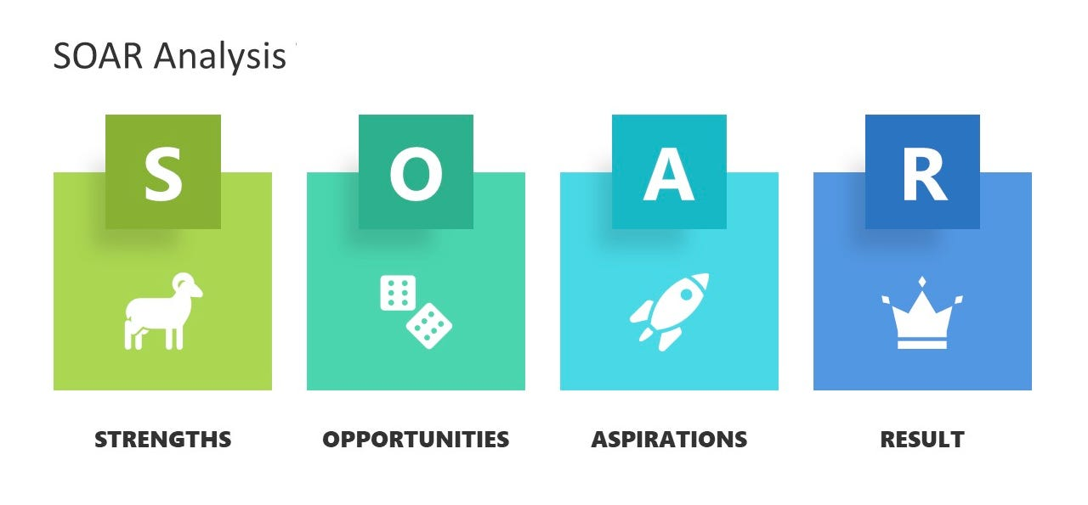In contrast to SWOT, SOAR analysis (Strengths, Opportunities, Aspirations, Results) focuses on the potential for advancement and expansion, thereby reinforcing positive strategic planning (Kamkankaew, 2023).
- Strengths
A strong foundation is built by the event's partnerships with prominent culinary brands and advocacy organisations. By merging educational workshops with live culinary experiences, the festival provides attendees with a high-value, interactive experience.
- Opportunities
The global movement towards inclusivity and accessibility in professional industries strengthens the event's long-term development potential. If executed effectively, the festival can expand to other significant culinary cities, creating a sustainable event model (Khavarian-Garmsir et al., 2017).

- Aspirations
The event's ultimate goal is positioning itself as a global standard for inclusive culinary festivals. The event team aims to ensure that culinary education undergoes industry-wide transformations by integrating accessible techniques and tools into training programs for future chefs with disabilities (Kusuma, 2021).
- Results
Success will be evaluated by adopting accessibility standards by high-end restaurants and hospitality venues, policy changes in culinary institutions, and increased employment rates for disabled chefs.

Servicescapes Theory
The Service Scapes Theory focuses on the tangible environment's impact on customers' experiences and behaviours in service environments. Initially developed by Bitner (1992), this theory claims that user perceptions and satisfaction are significantly influenced by layout, accessibility, ambience, and technology integration.
Service scapes are essential for the Inclusive Culinary Journeys festival to guarantee accessibility and inclusivity. Jiang et al. (2024) designed the event layout with distinct, spacious pathways to ensure wheelchair users can move around. The experience for visually and hearing-impaired visitors is improved by providing Braille menus, sign language interpreters, and sensory-friendly areas (Banate et al., 2024). The seamless incorporation of smart kitchen technology enables chefs with disabilities to exhibit adaptive techniques, illustrating the seamless integration of assistive tools into professional culinary settings.
Moreover, the Service Scapes Theory's focus on creating environments that influence emotions and perceptions is consistent with immersive multi-sensory experiences, including adaptive sampling stations and aroma-based food navigation for visually impaired guests (Kou et al., 2024). The festival guarantees a memorable and inclusive visitor experience by precisely selecting the venue, technology, and engagement elements.

Cultural Sensitivity and Multiculturalism
Cultural Sensitivity Theory underscores the importance of event design in reflecting and honouring the diverse cultural backgrounds of its audience (Choi et al., 2020). Cultural sensitivity is a critical factor in the organisation of the Inclusive Culinary Journeys festival, located in Thailand, a country with a diverse culinary heritage and a strong cultural identity.
The festival ensures inclusivity for international visitors while incorporating Thai culinary traditions. Adaptive cooking workshops demonstrate the potential of traditional Thai dishes to be adapted for chefs with disabilities, thereby preserving cultural authenticity and fostering accessibility. Moreover, the challenges of disability inclusion in global culinary industries will be discussed by guest speakers from various cultural origins, who will promote cross-cultural learning (Harper, 2019).
The selection of chefs and cuisines also indicates multicultural engagement, guaranteeing a diverse representation from the Americas, Europe, and Asia. To facilitate international visitors, the festival signage and digital guides are available in various languages (Siriwatthanatrakarn and Kidrakarn, 2024). The event reinforces its equality, diversity, and inclusion theme by ensuring that all attendees feel respected and included by adopting multiculturalism.

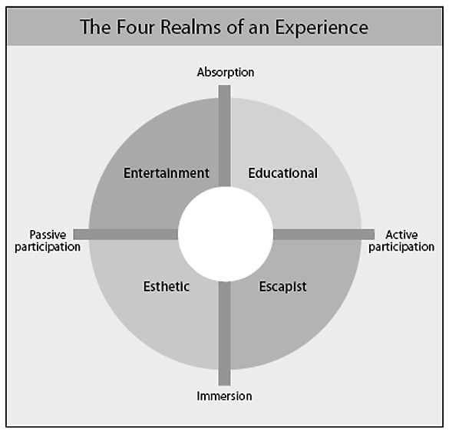
Experience Economy and Engagement Models
The Experience Economy framework (Pine and Gilmore, 1999) implies that effective events must surpass passive participation and captivate attendees through realistic, memorable experiences. As per this theory, entertainment, education, escapism, and aesthetics are all essential components of the Inclusive Culinary Journeys festival.
- Entertainment
Audiences are captivated by the personal narratives and skilful performances of chefs with disabilities during live culinary demonstrations (Mossberg and Eide, 2017).
- Education
Both industry professionals and food enthusiasts are educated on accessibility innovations in cookery through workshops on adaptive culinary techniques, which guarantees long-term knowledge retention.
- Escapism
The attendees participate in interactive activities, including sensory dining, which involves the exploration of flavours while blindfolded to gain a deeper understanding of the experiences of visually impaired individuals.
- Esthetics
The ambience is improved by eco-friendly elements, artistic culinary presentations, and branded zones, which contribute to the visually appealing design of the event.

