Script Changes: 14-Nov-2019

New Scripts Added
- IPlayerSetter: interface that will be implemented by all scripts that depend on the Player game object
- TrackTarget: new script used to check if game object (i.e. fish, etc.) is too far ahead/behind the target (player)
  - Attach to Fish Prefab
- CustomUnityEvent: script used to define a set of custom events that extend the UnityEvent class provided with Unity.

Scripts Updated

Player Script

Added RegisterSceneObjectItem method
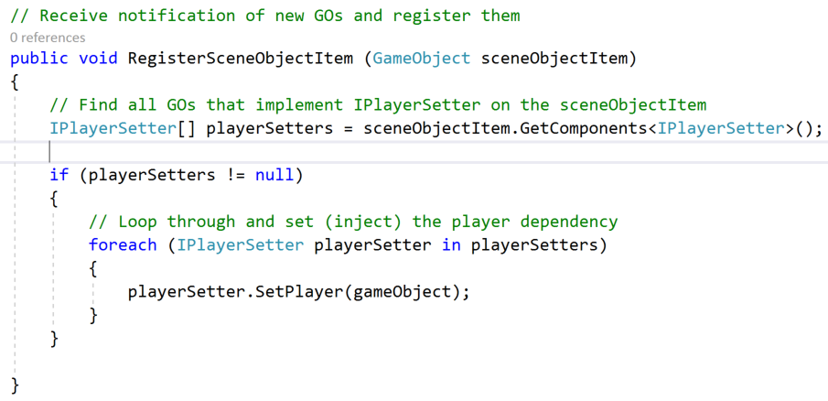

Scene Controller Script

Added a new custom ObjectItemCreated event variable
This is a variable – add to start of script class. The variable is visible in the Inspector window.

Invoke the custom ObjectItemCreated event
Send notification of event to any other game objects that have subscribed to listen for the event – that is notify game object when a new scene object item is spawned (created).
- Locate the AddSceneObjectItem method.
- Add as shown below.
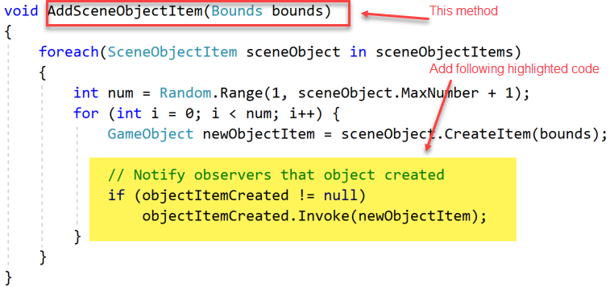

Updates in Editor
- Go back to Unity
- Select your Scene Controller game object in the hierarchy window
  - You should see the new event in the Inspector window
  - Configure as shown
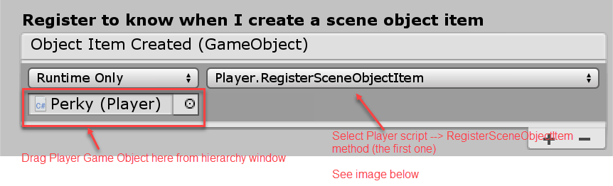
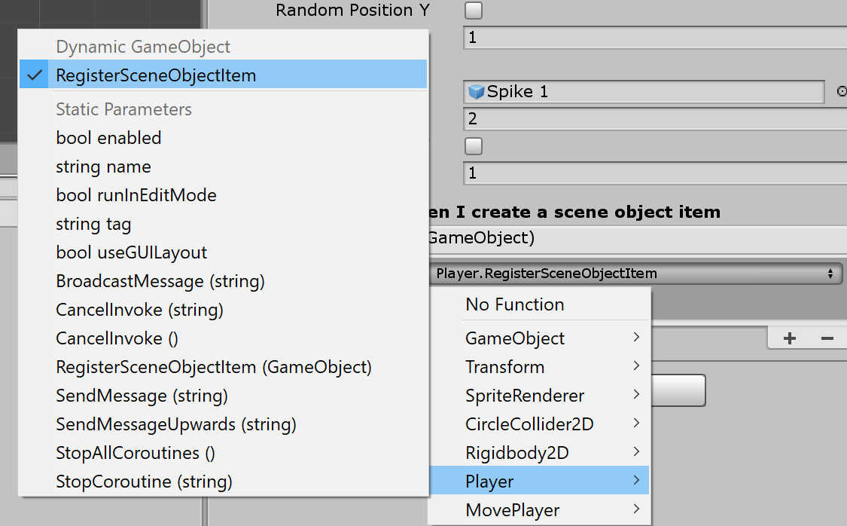

Fish Script

Add new variables for TrackTarget class and Player transform

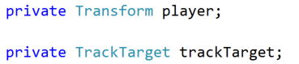

Implement IPlayerSetter interface
- Make class require TrackTarget script to be added to the game object/prefab this script is attached to
- Add interface to class definition
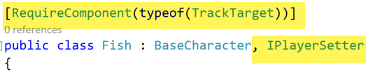

Implement the required interface method
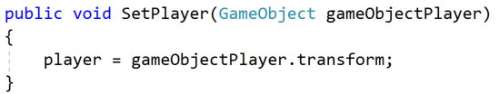

Initialise TrackTarget variable in Start
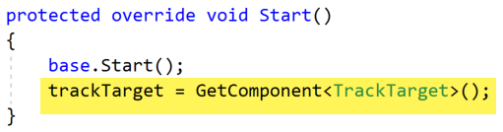

Add new method called IsTooFarAheadOrBehind
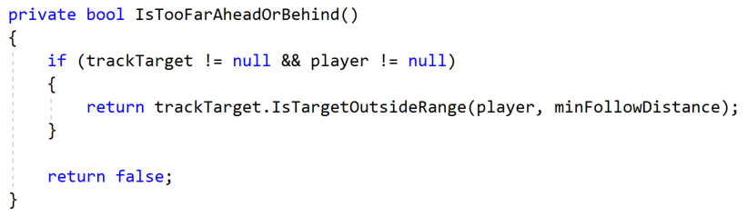

Use new method in Update method
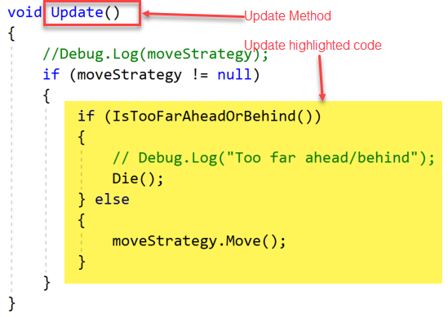

Spike Script

Add OnBecameInvisible Method


