Database Management Systems
  - Lecture 2 Lab Tutorial Exercise

Database Analysis and Design

Objectives
The aim of this lab exercise is to refresh your memory of database analysis and design techniques. You will be looking at conceptual database modelling, that is, identifying entities, attributes and relationships to model an organisation’s information needs. The exercises are based on using the following data modelling techniques:
- Entity-Relationship modelling
- Normalisation
The aim of this lab exercise is to create the relational database schema for the DreamHome case study below. You will need to identify the relations (tables), attributes (columns) and relationships of the organisation’s information. This is the case study that we will be using for the rest of the module.
Note: All solutions should be added to the class’s OneNote Notebook.

Tips
- Entities: nouns and noun phases identified during requirements gathering for the database are usually your entities.
- Attributes: Think of attributes as qualities or characteristics an entity has.
- Entity Occurrence: remember to consider how many possible occurrences of the entity will exist: zero (0), one (1), or many (*).
- Relationships: How are the different entities connected – what is the relationship between them? Think of relationships as verbs (what the entity can do or experience).

The DreamHome Case Study
The first branch office of DreamHome was opened in 1992 in a city called Glasgow in the UK. Since then, the Company has grown steadily and now has several offices in most of the main cities of the UK. However, the Company is now so large that more and more administrative staff are being employed to cope with the ever-increasing amount of paperwork. Furthermore, the communication and sharing of information between offices, even in the same city, is poor. The Director of the Company, Sally Mellweadows feels that too many mistakes are being made and that the success of the Company will be short-lived if she does not do something to remedy the situation. She knows that a database could help in part to solve the problem and requests that a database application be developed to support the running of DreamHome. The Director has provided the following brief description of how DreamHome currently operates.
DreamHome specializes in property management, by taking an intermediate role between owners who wish to rent out their furnished property and clients of DreamHome who require to rent furnished property for a fixed period. DreamHome currently has about 2000 staff working in 100 branches. When a member of staff joins the Company, the DreamHome staff registration form is used. The staff registration form for Susan Brand is shown in Figure 1.

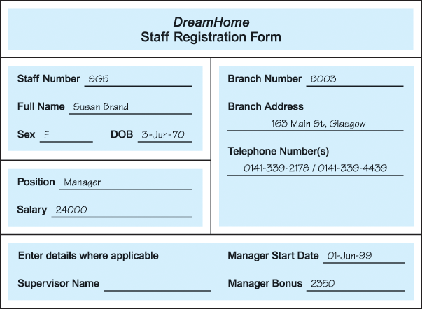
Figure 1 The DreamHome staff registration form for Susan Brand.

Each branch has an appropriate number and type of staff including a Manager, Supervisors, and Assistants. The Manager is responsible for the day-to-day running of a branch and each Supervisor is responsible for supervising a group of staff called Assistants. An example of the first page of a report listing the details of staff working at a branch office in Glasgow is shown in Figure 2.
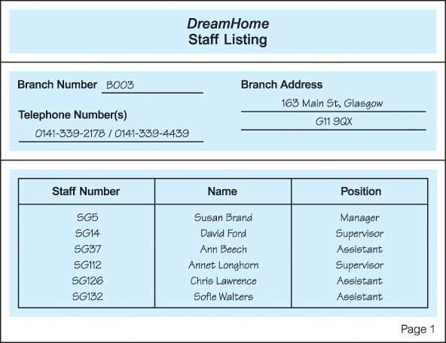
Figure 2 Example of the first page of a report listing the details of staff working at a DreamHome branch office in Glasgow.

Each branch office offers a range of properties for rent. To offer property through DreamHome, a property owner normally contacts the DreamHome branch office nearest to the property for rent. The owner provides the details of the property and agrees an appropriate rent for the property with the branch Manager. The registration form for a property in Glasgow is shown in Figure 3.
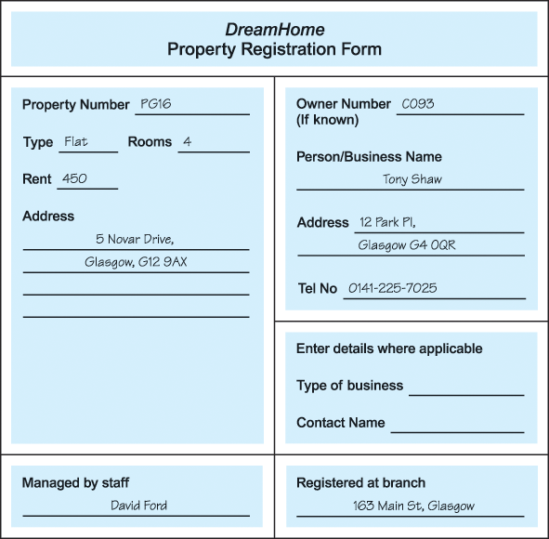
Figure 3 The DreamHome property registration form for a property in Glasgow.

Once a property is registered, DreamHome provides services to ensure that the property is rented out for maximum return for both the property owner and of course, DreamHome. These services include interviewing prospective renters (called clients), organizing viewings of the property by clients, advertising the property in the local or national newspapers (when necessary), and negotiating the lease. Once rented, DreamHome assumes responsibility for the property including the collection of rent.
Members of the public interested in renting out property must first contact their nearest DreamHome branch office to register as clients of DreamHome. However, before registration is accepted, a prospective client is normally interviewed to record personal details and preferences of the client in terms of property requirements. The registration form for a client called Mike Ritchie is shown in Figure 4.

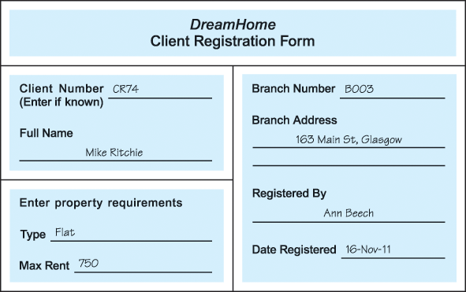
Figure 4 The DreamHome client registration form for Mike Ritchie.

Once registration is complete, clients are provided with weekly reports that list properties currently available for rent. An example of the first page of a report listing the properties available for rent at a branch office in Glasgow is shown in Figure 5.

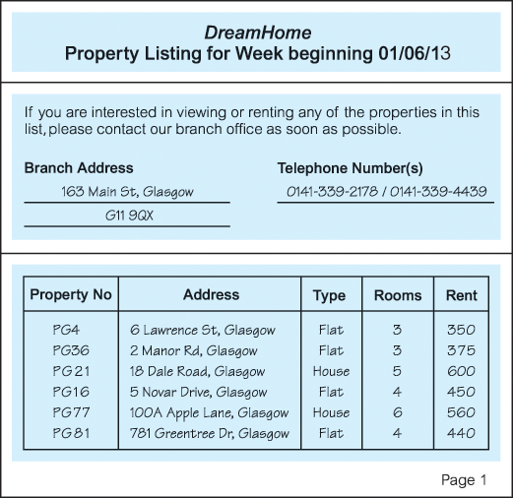
Figure 5 The first page of the DreamHome property for rent report listing property available at a branch in Glasgow.

Clients may request to view one or more properties from the list and after viewing will normally provide a comment on the suitability of the property. The first page of a report describing the comments made by clients on a property in Glasgow is shown in Figure 6. Properties that prove difficult to rent out are normally advertised in local and national newspapers.
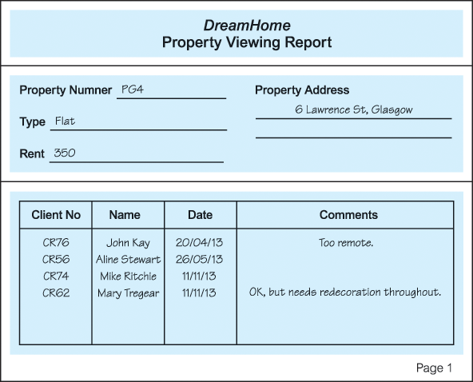
Figure 6 The first page of the DreamHome property viewing report for a property in Glasgow.

Once a client has identified a suitable property, a member of staff draws up a lease. The lease between a client called Mike Ritchie and a property in Glasgow is shown in Figure 7.
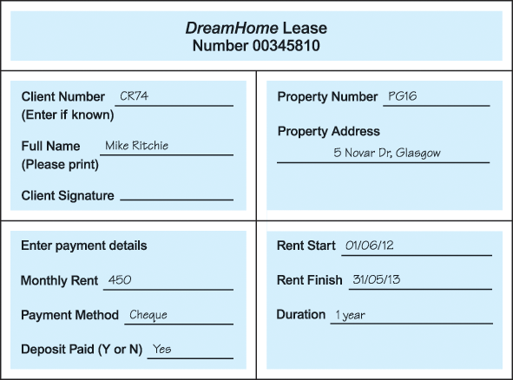
Figure 7 The DreamHome lease form for a client called Mike Ritchie renting a property in Glasgow.

At the end of a rental period a client may request that the rental be continued, however this requires that a new lease be drawn up. Alternatively, a client may request to view alternative properties for the purposes of renting.

Some Additional Notes
Below are additional data requirements for the DreamHome organisational information to give you a better understanding of some of the data requirements.

Branch
Additional data is held on each branch manager, which includes the date the Manager assumed his or her position at the current branch office, and a monthly bonus payment based upon his or her performance for rent market.

Properties for rent
A member of staff may manage a maximum of 100 properties at any one time.

Property Owners
The addition of a password field will allow owners access to parts of the DreamHome database via a Web application.

Property Viewing
The member of staff taking the client for a viewing should also be recorded.

Leases
The lease also requires storing the deposit value for the rental contract which is twice the monthly rate. The duration is also the number of months the lease is for, based on the start and end dates.

Exercise
Given the above information, what will be the relational database schema for the DreamHome case study? Produce an ER diagram using Visio to reflect your database schema, and paste on the group’s OneNote page for this exercise.
- What relations and corresponding attributes are required?
- What will be the relational keys – primary keys and foreign keys?
- What constraints do you think are needed, for example, which attributes are a must or have other restrictions?
- What will be the business requirements for each of the tables and their attributes?
  - Any restrictions on the possible values allowed for each attribute.
  - Any general constraints or business rules? E.g. quantities must not be less than zero.
You may ignore the information requirement for advertising the property in the local or national newspapers for now.
We will be discussing your solutions together before the end of the class.
Note: Your design should produce a set of well-defined 3NF tables. You can look at the notes on normalisation available on Moodle, if you have forgotten what it is.

Adapted from Database Systems: A Practical Approach to Design, Implementation and Management by Thomas Connolly & Carolyn Begg

