Contents
Introduction 1
Task 1. e-Commerce Website builders/software solutions 1
1.1 Wix 1
1.2 Shopify 1
Task 2. Mind-map of contemporary software applications 1
2.1 Describe mind mapping and explain the benefits of using mind mapping 1
2.2 Create a mind map of contemporary software applications 2
Task 3. Office Applications 2
3.1 Four office software solutions for business operations 2
Ms Word 2
Ms Excel 2
Ms PowerPoint 2
Ms Access 2
3.2 Test any two features 2
Mail Merge 2
IF Statement 3
Task 4. Communication and Collaboration applications 3
4.1 One contemporary Communication and one Online Collaboration 3
Gmail 3
Zoom 3
4.2 Test one feature of a freely available Communication (1) and one feature of a Collaboration (1) application 3
Gmail 3
Zoom 3
Conclusion 4
References 4

Introduction
Software applications are an important part of modern business and everyday life. They help individuals and organisations perform tasks more efficiently, communicate with others, manage information, and improve productivity. There are many different types of software available, each designed to meet specific needs.
This assignment explores several contemporary software applications and their uses. It examines e-commerce website builders, including Wix and Shopify, and explains their advantages and limitations. It also describes mind mapping and its benefits for organising ideas and information. In addition, the assignment discusses four Microsoft Office applications—Word, Excel, PowerPoint, and Access—and explains how they can support business operations.
The assignment also demonstrates practical features such as Mail Merge in Microsoft Word and the IF Statement in Microsoft Excel. Finally, it explores communication and collaboration applications, including Gmail and Zoom, and demonstrates how their features can support effective communication and teamwork.

Task 1. e-Commerce Website builders/software solutions

1.1 Wix
Wix is a popular website-building platform that allows individuals and businesses to create professional websites without needing advanced coding skills. It provides a simple drag-and-drop editor, making it suitable for beginners who want to design and publish a website quickly.
One of the main advantages of Wix is its ease of use. Users can choose from many templates and customize them according to their needs. Wix also offers built-in features for blogging, e-commerce, SEO, contact forms, and marketing, which means users can manage many aspects of their website in one place. Another benefit is its flexibility in design, as users have considerable control over the appearance and layout of their pages. Wix also provides hosting and security, reducing the need for users to manage technical infrastructure themselves.
However, Wix has some limitations. Free and lower-cost plans may include Wix branding and have restrictions on storage, features, or domain names. Websites can also become expensive as users add premium features or upgrade their plans. Compared with fully custom-coded websites, Wix may offer less control over advanced functionality and performance optimization. Additionally, moving a Wix website to another platform can be difficult.
Overall, Wix is a convenient and user-friendly choice for small businesses, individuals, portfolios, and simple online stores, but it may be less suitable for highly complex or fully customized websites. [1]

1.2 Shopify
Shopify is a popular e-commerce platform that allows individuals and businesses to create and manage online stores without requiring advanced technical or coding skills. It provides tools for product management, payments, shipping, marketing, and customer orders, making it a convenient solution for businesses that want to sell products online.
One of the main advantages of Shopify is its ease of use. Users can choose from a range of professional themes and customize their online store according to their brand. Shopify also supports multiple payment methods and provides useful features for inventory management, analytics, marketing, and SEO. Another advantage is its scalability, as it can support small businesses as well as larger online stores. Shopify also offers reliable hosting and security, reducing the need for businesses to manage technical infrastructure themselves.
However, Shopify has some limitations. It requires a monthly subscription, and additional costs may arise from premium themes, apps, or transaction fees depending on the payment setup. Some advanced features may require third-party apps, which can increase the overall cost and complexity of managing a store. Shopify also provides less control over the underlying website structure than a fully custom-coded e-commerce website.
Overall, Shopify is an excellent choice for businesses that want a reliable and easy-to-manage online store, but it may be less suitable for businesses requiring highly customized functionality or wanting to minimize ongoing costs. [2]

Task 2. Mind-map of contemporary software applications

2.1 Describe mind mapping and explain the benefits of using mind mapping
Mind mapping is a visual technique used to organise and present information around a central idea or topic. It usually starts with the main topic in the centre of a page, with related ideas, keywords, images, and concepts branching out from it. These branches can then be divided into smaller sub-branches to show relationships between different ideas.
Mind mapping is useful for planning, learning, brainstorming, problem-solving, and organising information. It helps people see the connection between ideas more clearly than using long paragraphs or lists.
Benefits of Mind Mapping
- Improves memory – Using keywords, colours, images, and connections can make information easier to remember.
- Encourages creativity – It allows users to generate and connect new ideas freely.
- Organises information – Complex information can be broken into smaller, easier-to-understand sections.
- Improves concentration – A visual structure can help users focus on the main topic and related points.
- Supports problem-solving – Mind maps help identify relationships, causes, and possible solutions.
- Saves time – Key information can be presented briefly instead of writing long notes.
- Useful for planning – Students and businesses can use mind maps to plan projects, presentations, essays, or tasks.
Overall, mind mapping is an effective way to organise thoughts, understand information, develop ideas, and improve learning. [3]

2.2 Create a mind map of contemporary software applications
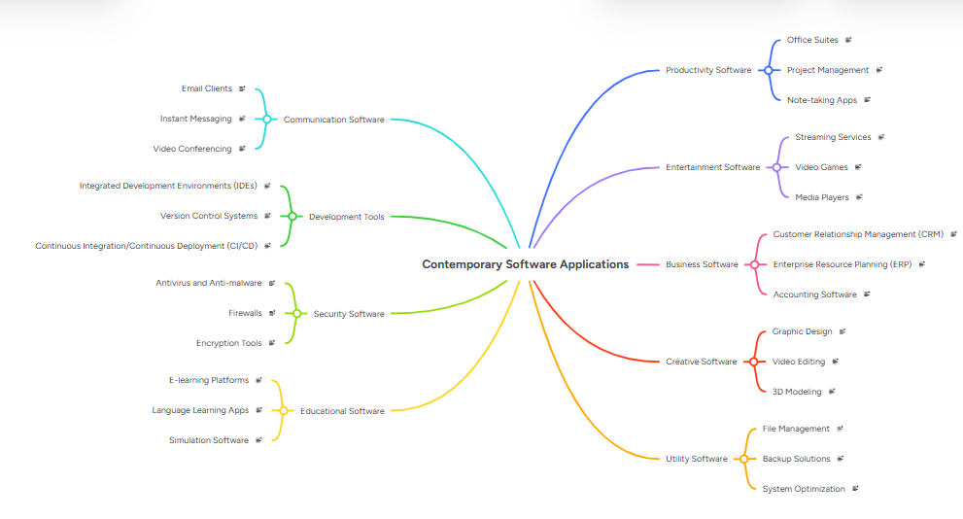

Task 3. Office Applications

3.1 Four office software solutions for business operations

Ms Word
Microsoft Word is a popular word-processing application developed by Microsoft. It is used to create, edit, format, save, and print different types of documents. It is commonly used by students, teachers, businesses, and organisations for preparing letters, reports, assignments, resumes, and other written documents.
One of the main advantages of Microsoft Word is its easy-to-use interface. Users can format text by changing fonts, sizes, colours, and styles. It also provides tools for inserting images, tables, charts, shapes, headers, and footers. Features such as spell checking, grammar checking, word counting, and templates help users create professional-looking documents. Microsoft Word also allows users to collaborate and share documents with others.
However, Microsoft Word has some limitations. The full version usually requires a paid Microsoft 365 subscription or licence. Some advanced features may be difficult for beginners to learn. Documents can also have formatting problems when opened in different versions or other word-processing programs.
Overall, Microsoft Word is a useful and powerful application for creating professional documents. Its wide range of formatting, editing, and presentation tools makes it an important software for education, business, and personal use.

Ms Excel
Microsoft Excel is a spreadsheet application developed by Microsoft. It is used to organise, calculate, analyse, and present data in rows and columns. Excel is widely used by students, businesses, accountants, and organisations for tasks such as creating budgets, managing records, calculating expenses, and analysing information.
One of the main advantages of Microsoft Excel is its powerful calculation and data analysis features. Users can perform calculations using formulas and functions such as SUM, AVERAGE, and COUNT. Excel also allows users to create tables, charts, graphs, and pivot tables to present data clearly. It can save time by automating calculations and repetitive tasks. Excel is also useful for sorting, filtering, and organising large amounts of information.
However, Excel has some limitations. Large and complex spreadsheets can become difficult to manage and understand. Incorrect formulas or data entry can lead to inaccurate results. Excel may also not be suitable for managing very large databases compared with specialised database systems. Some advanced features require knowledge and practice.
Overall, Microsoft Excel is a useful tool for data management, calculations, budgeting, analysis, and reporting. Its flexibility and powerful features make it an important application in education, business, finance, and everyday work.

Ms PowerPoint
Microsoft PowerPoint is a presentation software developed by Microsoft. It is used to create and deliver presentations using slides that can contain text, images, charts, tables, videos, audio, and animations. It is commonly used by students, teachers, businesses, and organisations for lessons, meetings, reports, and projects.
One of the main advantages of PowerPoint is its easy-to-use interface. Users can choose from different templates and themes to create attractive presentations. It allows information to be presented in a clear and organised way. PowerPoint also provides features such as transitions, animations, speaker notes, charts, and multimedia, which can make presentations more engaging. It can also help users explain complex information through visual content.
However, PowerPoint has some limitations. Creating a professional presentation can be time-consuming, especially when adding animations, images, and other visual elements. Too much text or excessive animation can also make a presentation confusing or distracting. Some advanced templates and features may require a paid Microsoft 365 subscription.
Overall, Microsoft PowerPoint is a useful tool for creating professional, visual, and engaging presentations. It is widely used in education, business, training, and public speaking.

Ms Access
Microsoft Access
Microsoft Access is a database management application developed by Microsoft. It is used to store, organise, manage, and retrieve information efficiently. It is commonly used by small businesses, schools, and organisations to manage customer records, employee information, inventory, and other types of data.
One of the main advantages of Microsoft Access is that it allows users to create databases, tables, forms, queries, and reports without requiring advanced programming skills. Forms make it easier to enter and update information, while queries can be used to search and analyse specific data. Reports help users present information in a clear and organised format. Access can also connect related tables, which helps reduce duplicate information and improve data organisation.
However, Microsoft Access has some limitations. It is less suitable for very large databases and high numbers of simultaneous users compared with enterprise database systems. Advanced database functions may also require technical knowledge. Access is mainly designed for Windows environments, and databases can become difficult to manage as they grow in size and complexity.
Overall, Microsoft Access is a useful tool for small and medium-sized database projects. Its combination of tables, forms, queries, and reports makes it suitable for managing and analysing structured information in schools, businesses, and organisations.

3.2 Test any two features

Mail Merge
Step 1
Name | Course | Date
John Smith | Business | 15 August 2026
Sarah Jones | Computing | 15 August 2026
David Brown | Marketing | 15 August 2026
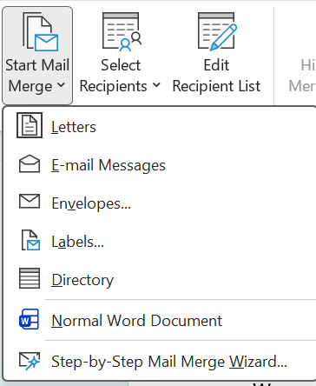

Step 3
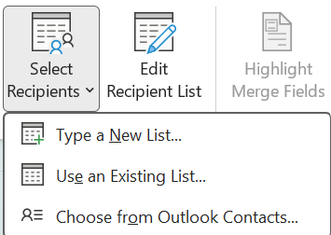
Step 4

Step 5
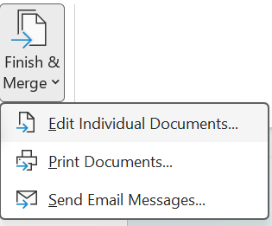
Step 6
[4]

IF Statement
Step 1

Step 2
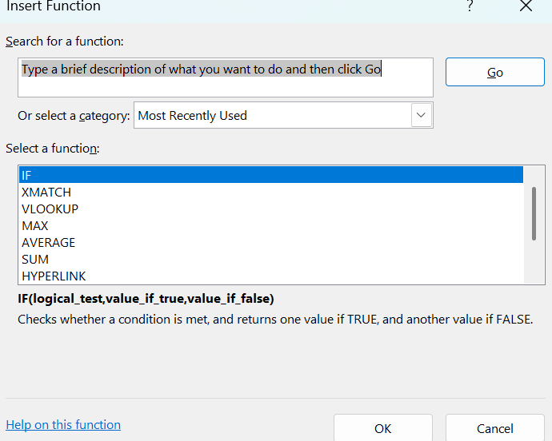

Step 3
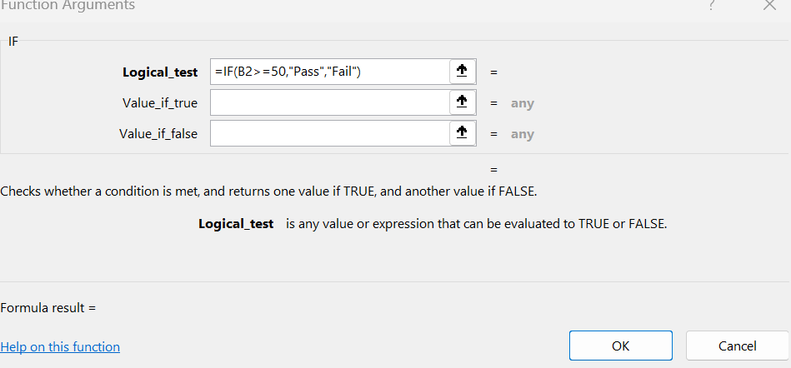
Step 4


Task 4. Communication and Collaboration applications

4.1 One contemporary Communication and one Online Collaboration

Gmail
Gmail is an email service developed by Google. It allows users to send, receive, organise, and manage emails using a computer, tablet, or smartphone. Gmail is widely used by students, businesses, teachers, and individuals for communication and sharing information.
One of the main advantages of Gmail is its easy-to-use interface. Users can send emails with attachments such as documents, images, and videos. Gmail also provides useful features such as spam protection, search, labels, filters, and email organisation. It can be connected with other Google services, including Google Drive, Google Calendar, Google Meet, and Google Docs. Gmail also provides a large amount of cloud storage through a Google account and can be accessed from different devices.
However, Gmail has some limitations. Users need an internet connection for most online features, although offline access can be enabled in some situations. Free storage is shared with other Google services, so users may eventually need to manage their storage or purchase additional space. Gmail also depends on Google's systems and policies, and users may receive unwanted promotional emails despite spam filtering.
Overall, Gmail is a reliable, convenient, and widely used email service. Its strong organisation tools, security features, and integration with other Google services make it useful for both personal and professional communication.

Zoom
Zoom is a video-conferencing and online communication platform that allows people to communicate through video calls, audio calls, online meetings, and webinars. It is widely used by students, teachers, businesses, and organisations for online classes, meetings, interviews, and presentations.
One of the main advantages of Zoom is its ease of use. Users can join meetings using a link and communicate through video and audio. Zoom also provides features such as screen sharing, chat, recording, virtual backgrounds, and breakout rooms. These features make it useful for teaching, teamwork, and remote communication. Participants can join meetings using computers, tablets, or smartphones, making Zoom convenient for people in different locations.
However, Zoom has some limitations. Many useful features are restricted or limited on the free plan, particularly for longer or larger meetings. The quality of a meeting depends heavily on the user's internet connection, device, and microphone/camera. Poor internet connections can cause delays, frozen video, or poor audio quality. Long online meetings can also cause tiredness and reduced concentration.
Overall, Zoom is a useful platform for remote communication, online learning, meetings, and collaboration. Its wide range of communication and presentation features makes it an important tool for education and modern workplaces.

4.2 Test one feature of a freely available Communication (1) and one feature of a Collaboration (1) application

Gmail
Step : 1
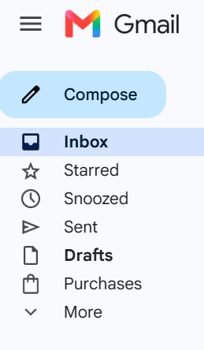
Step : 2



Step :3


Zoom
Step :1

Step :2

Step 3

Step :4

Step :5

Step :5



Conclusion
In conclusion, this assignment has explored a range of contemporary software applications and their importance in modern business and everyday activities. Website builders such as Wix and Shopify provide useful solutions for creating and managing e-commerce websites, although each has its own advantages and limitations.
The assignment also examined mind mapping as an effective method for organising ideas and information. Different Microsoft Office applications, including Word, Excel, PowerPoint, and Access, were discussed and their uses in business operations were explained. Practical features such as Mail Merge in Word and the IF Statement in Excel were also tested, demonstrating how software can save time and improve accuracy.
Finally, communication and collaboration applications such as Gmail and Zoom were explored. These applications support effective communication, online meetings, information sharing, and teamwork.
Overall, the assignment has demonstrated that modern software applications play an important role in improving productivity, communication, organisation, data management, and business operations. Choosing the right software depends on the specific needs of an individual or organisation, as each application provides different features, benefits, and limitations.

References
[1] Wix, “eCommerce features that help you sell more online,” Wix. Accessed: Aug. 10, 2026. https://www.wix.com/ecommerce/features
[2] Shopify, “Online Store,” Shopify Help Center. Accessed: Aug. 10, 2026. Shopify Help Center – Online Store
[3] T. Buzan and B. Buzan, The Mind Map Book: How to Use Radiant Thinking to Maximize Your Brain's Untapped Potential. New York, NY, USA: Plume, 1996.
[4] Microsoft, “Use mail merge for bulk email, letters, labels, and envelopes,” Microsoft Support. Accessed: Aug. 10, 2026. Microsoft Support – Mail Merge

