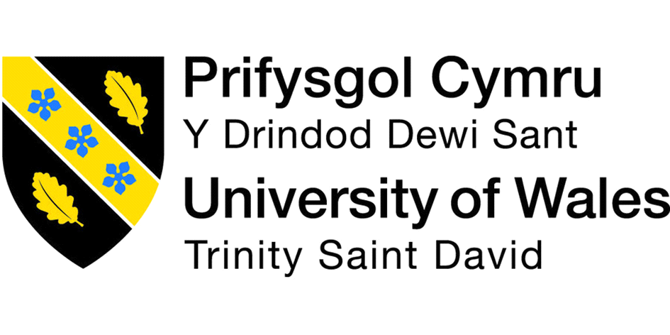

Student Name: Kitti Takacs
Student Number: 1906398
Module Title: Developing Relationship and workplace achievement Kitti Takacs 1906398

“The simple act of paying positive attention to people has a great deal to do with productivity.” - Tom Peters, American writer on business management practices

Employee development plans help address future business needs and succession planning. Employment development plan helps to improve business results and outperform the competition. Employment development has many different ways to build a workplace relationship. Good relationships in any business can help to grow and achieve more. In my assignment I will show the different development methods and plans what we are using in a day to day basic. The company I will write is my work place. The company called manor park dental practice. The company has 8 practices around London. To run a successful business and develop new plan and maintain relationship we have many different trainings. As we are a customer service-based healthcare provider company we have different sectors what we need to focus on. As all companies Manor park dental had and have problems to communicate with each other so to work together and build trust between colleagues are more difficult in this time. I will show the techniques and what kind of achievement what we are facing at the moment as we would like to rebranding the company.
“There are no secrets to success. It is the result of preparation, hard work, and learning from failure.” - Colin Powell, American statesman and army general

