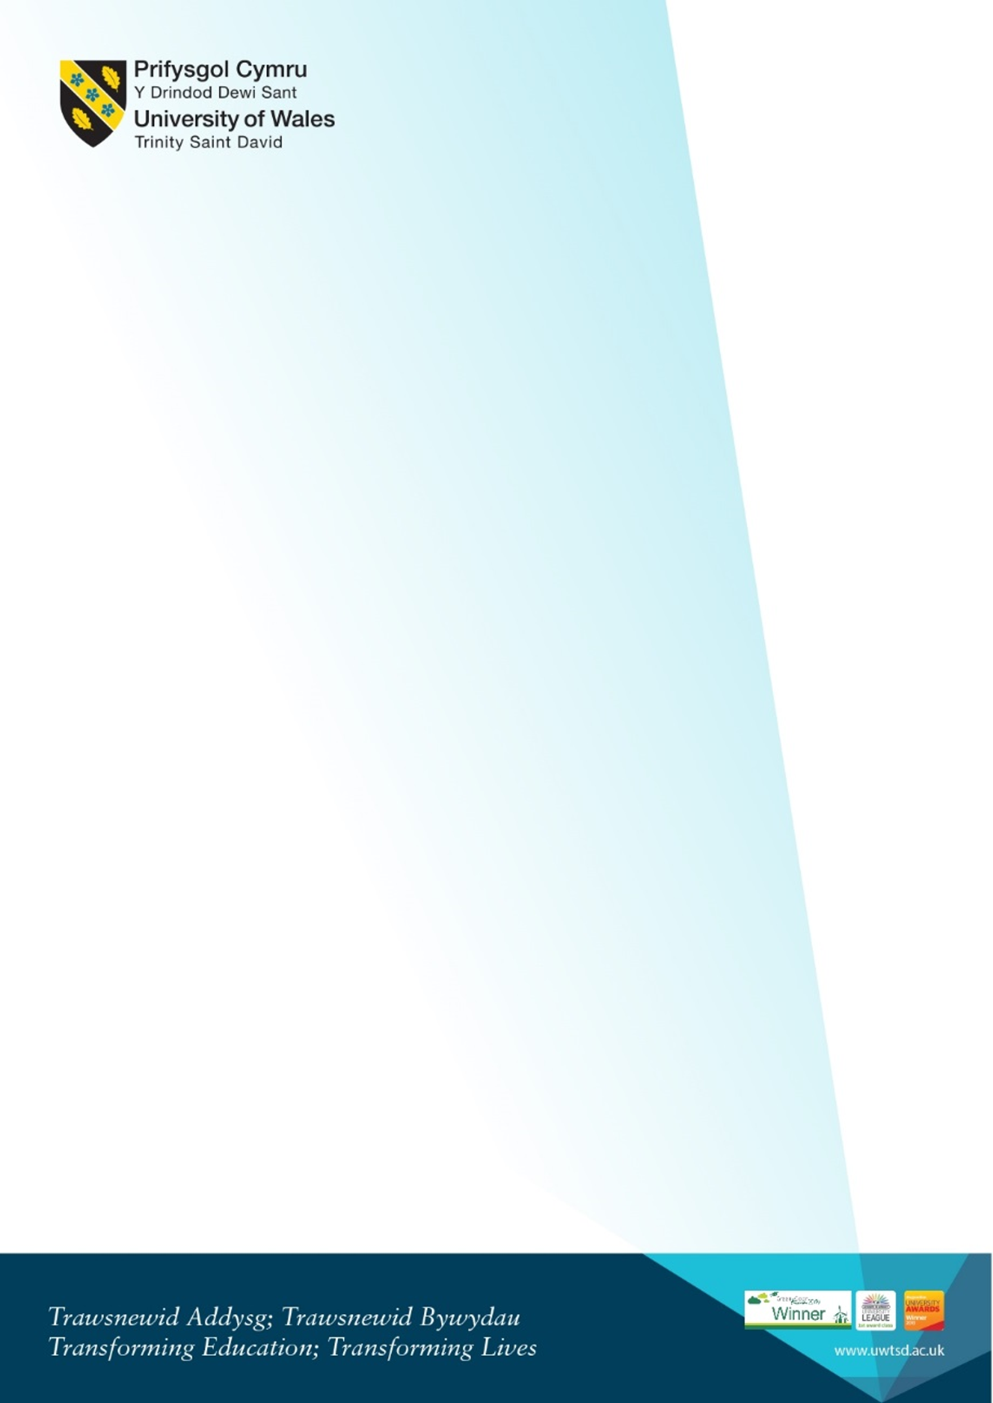
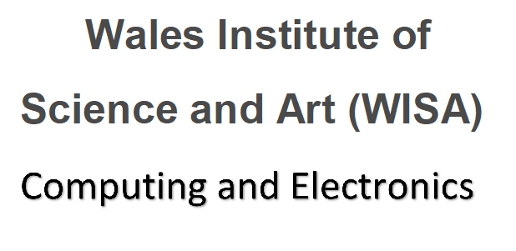
Welcome for Returning Level 5 DDA Students
Sept 2020 + Jan 2021 intake (Year 3)
Thursday 29th September 2022 2pm
IQ Building – Room IQ110 (See map on page 2 below)

2pm-2.30pm  Room IQ110 | Meeting with the team Kapilan, Gaynor and Bridget. Also Liaison Officers | - Welcome back.  - What’s changed? Staffing etc  - Updates from liaison officers, Bridget etc
2.30pm – 3.00 pm ish | Gaynor Course overview. Q and A | - Introduction to the course pathway for this academic year and overview of the modules  - Timetable/study day  - Workshop Days 2022/3  - Moodle and any changes  - Hwb what’s new  - ID Cards – what to do if you haven’t got one  - SOAC logins  - Student services and procedures to follow  - Q and A
3 - 3.30pm | Professor Ian Wells Director of the Wales Institute of Digital Information (WIDI) | Discussions on:  - Potential health related projects  - Industry and Police related projects  - Suitable topics / areas of study for Industrial Research Module and Major Project
3.30pm ish |  | - Opportunity to discuss individual circumstances  - Campus tour if required?
 | Self-guided:  Welcome videos and Campus safety presentations link.  Pre-recorded videos please see links. Please take some time to watch the videos if you have any questions please email the team. | Including  • Welcome from the VC  • Welcome from Provost  • Campus Virtual Tour  • Parking  • Enrolment  Link to resources on Hwb:  https://uwtsd.myday.cloud/pages/student/resources_welcomeandinduction

MAP:
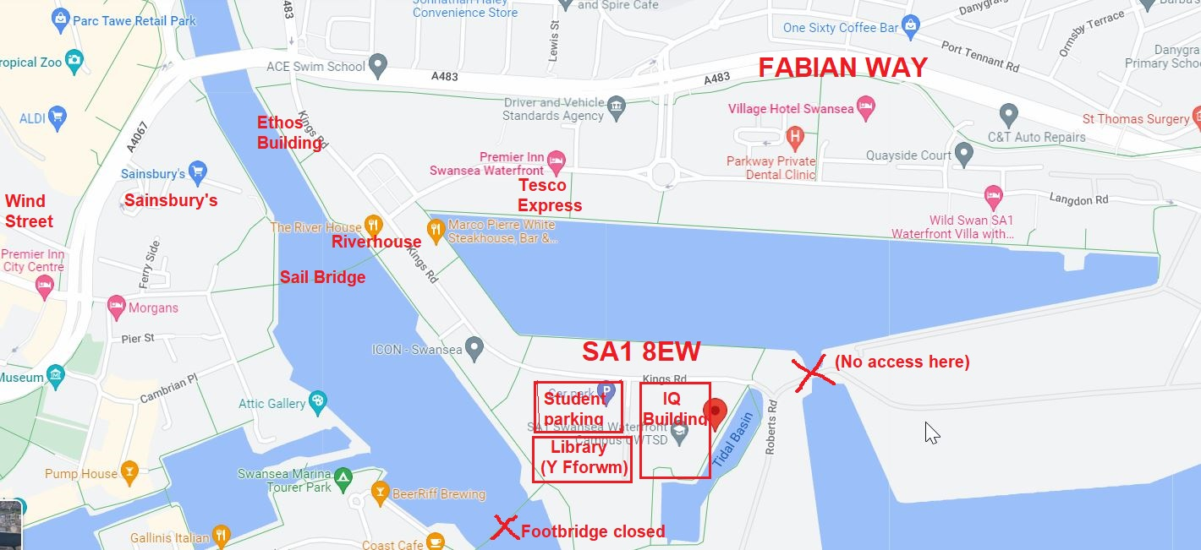
Link to Google Maps: https://www.google.com/maps/place/Swansea+SA1+8EW/@51.6186566,-3.9335031,15.5z/data=!4m5!3m4!1s0x486e8aacbcc83705:0xae10d016e8626d05!8m2!3d51.6173561!4d-3.9255004
Photo of area:


