ASSIGNMENT NO 1 FOR MANAGEMENT ECONOMICS
MODULE NUMBER LCBB5003
LECTURER JUAN CARLOS
UWTSD AUGUST 2022 BUSINESS MANAGEMENT
DANIEL ANTONESCU STUDENT NUMBER 1914798

CARLSBERG PILSNER

TABLE OF CONTENTS

Business description………………………………………………………………………3
Demand and market equilibrium…………………………………………………………..4
Factors that affect demand………………………………………………………………...5
Price of substitutes………………………………………………….……………………..5
Price of complements…………………………………………..………………………….5
Consumer income………………………………….……………………….……………..6
Consumer tastes and preferences……………………………………………….…………7
Consumer expectations of price…………………………………………………………...7
Demographics……………………………………………………………………………..9
Price elasticity of demand ……………………………………………………….….…….9
References……………………………………………………………….….……….…..12

Business description

Carlsberg is a worldwide known alcohol brand that was founded in 1847 in Denmark (Carlsberg,2020). The founder of the brand is Jacob Cristian Jacobsen who was a brewer as well as his father. After 21 years Carlsberg makes its first export to Great Britain in 1868. Between 1868-1981 Carlsberg opens breweries in Malaysia, UK, Hong Kong and, from 1990 the brand becomes more popular in Portugal, Sweden, Italy, Vietnam, China, Poland, Latvia, Croatia (Carlsberg,2020). Currently, Carlsberg has a strong market position globally with sales in Western Europe, Asia and Eastern Europe. There are more than 40,000 employees at Carlsberg around the world and their products are sold in more than 30 countries. (Carlsberg,2021)
Carlsberg’s website shows that their product portfolio includes more than 700 products. Some of the products that are found at Carlsberg are Carlsberg pilsner, Carlsberg 0.0%, Carlsberg Nordic ale, 1664 Gold, 1664 blonde, Afsana, Afsana strong, Bellman, Bosman Full, Brooklyn east IPA, Tuborg etc. According to research Carlsberg is a brand with heritage and it has been on the market for over 160 years. The brand is known and recognized for their alcoholic products especially IPA, pilsner, lager that are found in restaurants, shops, liquor stores etc.
The chosen product for this task is the original Carlsberg pilsner which is a European pale lager with 5% alcohol. Carlsberg Group (2020) describes the product as ‘’perfectly balanced Danish pilsner, crisp and refreshing, full of flavor with distinct hoppy aroma.’’ The reason why I chose this product is because the Carlsberg pilsner is the first product produced by Carlsberg and it is the most emblematic and well-known globally. When consumers think about Carlsberg they associate the brand with the picture of the pilsner in a green bottle or aluminum can with the name of the brand on it and the country where it was founded which is Denmark. Moreover, the Carlsberg pilsner can be found in more countries around the world than other products in the portfolio such as Brooklyn pilsner which is only available in USA.

Demand and market equilibrium

According to Coll (2015) the price and quantity of the products sold on the market are determined by the shape of supply and demand curves when they cross. The law of demand states that if the price is high the producers will offer more products than the demand, resulting in excess products that are not sold and, afterwards the price will drop (Coll, 2015). Lower prices correspond to an increase in demand and a decrease in supply volume resulting in a slow market stabilization. On the other hand, if the price is below the market equilibrium price there is a product shortage (Lucyna, 2022). If the quantity people plan to buy is equal to the quantity producers plan to sell then, the market equilibrium exists (Edgmand et. al, 2004). Research has suggested that fluctuations in supply and demand can be generated by changes in population income, production conditions and demand structures.
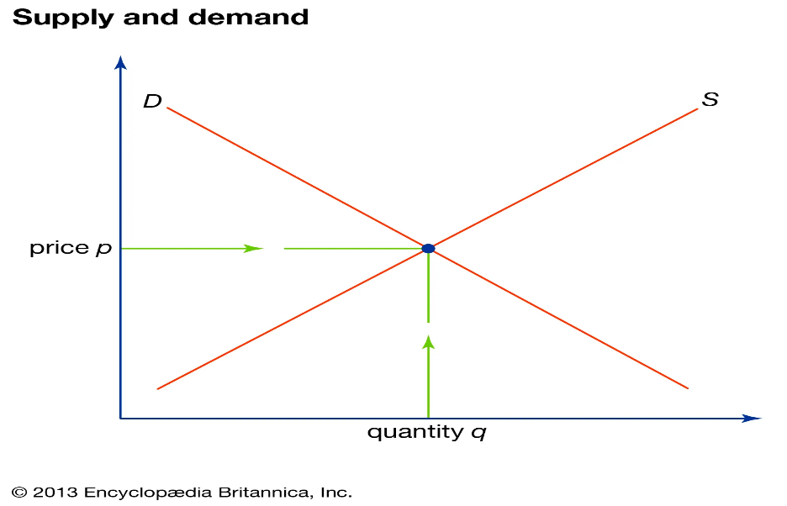
Fig. 1 Supply and demand diagram. Source Encyclopaedia Britannica (2013).
Currently with the price rises and inflation lately, Carlsberg Group (2022) declared that the sales have not been affected. Furthermore, this situation can reflect that people who choose Carlsberg might see their products as necessary rather than luxury and they choose to buy the products on a daily basis regardless of price increases. This can be defined as habitual behavior. Leventoğlu (2017) argues that people form habits for consumption and their actual satisfaction level tends to be highly associated with their past consumption level. Additionally, Becker (1992) defines habitual behavior as a positive relation between past and current consumption.

Factors that affect demand

Price of substitutes

A substitute good is an alternative good that can be used for the same purpose. Pettinger (2022) states that substitutes offer the buyer an alternative choice, if the price of one good increases the demand for the substitute increases. Thus, substitutes have a positive cross elasticity of demand. The substitutes can be perfect substitutes which means one good is the same as the other, weak substitutes where the goods are not as similar to each other and close substitutes where the goods have little differences between each other (Pettinger, 2022) For the Carlsberg pilsner a substitute can be the Heineken which is a Dutch lager with 5% alcohol, same as the Carlsberg pilsner (DrinksSaloon, 2020)
According to research, alcohol has relatively inelastic demand of around. There are few substitutes for alcohol and even with price rises, alcohol is an addictive substance (Sloman et. al., 2019) For beer, the estimate of elasticity is more elastic, there are substitutes for beer such as wine and other spirits. If the price for beer is increasing, the demand will decrease, and customers will tend to choose other alcoholic drinks.

Price of complements

Complementary goods are those goods that are consumed together like cars and petrol, bread and butter (Sloman et. al., 2019). Usually, a complementary good for beer is a snack, crisp, nachos or peanuts. A shift in the consumption of one good will impact the marginal utility of substitute and complimentary goods. According to research, Carlsberg Group does not provide complementary goods like snacks or any other quick foods that can be served with their alcoholic drinks. If the brand would offer complementary goods the sales can increase dramatically because people choose to pair alcoholic drinks with quick snacks. Two goods are complements if a growth in demand for one causes an increase in demand for the other. In particular, a price cut for one good boosts sales for the other (Samuelson, 2015) For the Carlsberg pilsner a complimentary good can be nuts, nachos or pretzels. If the price of the complimentary good increases, the consumer can chose another complimentary good to consume with the pilsner.

Consumer income

The law of demand can be defined as the relationship between price and consumption, if the price of a good increases then, the demand of the good will decrease (Sloman et. al.,2019). The law of demand states that customers will purchase more of a good if the prices are low and less of a good if the prices are high. The demand can be affected by income as well. Edgmand et. al. (2004) argues if a product is good quality, then the increase in income will show an increase in demand. On the other hand, if a good is inferior quality, then the increase in income will show a decrease in demand.
Currently, the world is affected by inflation, the war in Ukraine has affected many countries, individuals and brands altogether. Inflation is a growth in prices of the goods and services that a household buys, measured as a rate of change of those prices (RBA,2020). After the COVID-19 pandemic the income of workers is still not very stable but, for Carlsberg Group these issues did not reflect on their earnings. According to the trading statement first quarter in 2022 Carlsberg’s Group profit increased with 350million DKK (Kondrup, 2022). The company forecasted a growth of 7% to 9% of profit in 2022. As stated by Carlsberg Chief Executive Cees Hart in a phone conference the company did not suffer losses from rising inflation and, people choose to pay less on luxuries but prefer to have a beer at the end of the day (Pedersen,2022)
Consumer tastes and preferences

Brumfield et. al. (1993) argues that consumer preferences and tastes are important factors influencing consumer’s decision when making purchases. Thus, consumer preference is a concept that refers to the choices consumers make to satisfy their satisfaction. Some examples include brand loyalty, price sensitivity, product quality, purchasing power (Williams, 2022). Consumer preferences change continuously, and the brand needs to adapt to consumers preferences and trends in order to continue its activity and bring profit.
Regardless of its global presence, Carlsberg acknowledged the need to react to changing consumer trends, where standard lager was seen to be declining behind developing tastes. Carlsberg has upgraded their pilsner recipe in order to bring more customers and to adjust to customers preferences. The brand is going back to its heritage and positions the brand with the slogan ‘’Probably the best beer in the world’’.
Carlsberg customers are more risk-seeking and are likely to look for excitement thrills, whilst appreciating the slogan and daring to try the new Carlsberg (Schriere,2019). Thus, Carlsberg customers care for brand origins which makes sense for the brand to go back to its heritage. According to Carlsberg Group (2017) consumer’s preferences when choosing the Carlsberg pilsner are to replenish and refresh, reward and indulge, unwind and unplug, have a carefree time, shared treat.

Consumer expectations of price

In any country around the world, the producer tends to focus on the most important goal which is to bring profit. The producer is aware that in order to bring profit he needs to offer a good or service with lower costs than the price offered and to find the customer interested to buy the product or service (Ciuciu,2002). Price is one of the most crucial components and it is the only factors that generates revenue. According to Sloman et. al. (2019) if the price of a product rises, the demand for it will fall and, if the price of the product drops, the demand of it will increase.
Consumers frequently make purchasing decisions without complete info about a certain product. The decisions are based on expectations about the quality of the product and not about the knowledge of the product. Thus, market demand is a function of the distribution of expectations about product quality among consumers (Goering, 1985)
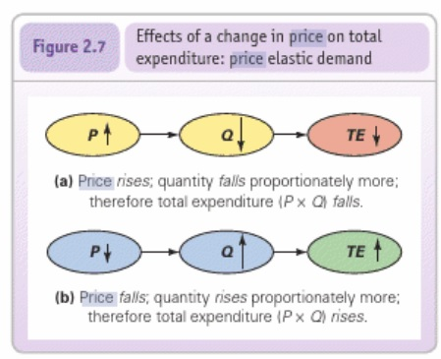
Fig 2. Effect of a change in price. Sloman et. al. (2019)
Carlsberg promotes its Pilsner as Premium and the price for the product is in balance with the quality. Customers expect a premium product, and they are prepared to pay the premium price but, compared to its closest competitor Heineken, Carlsberg prices are lower which gives the brand advantage in the eyes of the customers. Consumers expect the prices of products and services in general to increase especially during this period after the pandemic and the war. Carlsberg has strong brand loyalty and the quality offered is premium, which influences the customer’s choice to remain the same and choose Carlsberg in the future.

Demographics

Carlsberg audience has a broad and fairly mature audience while aiming on people aged 28 and above. The brand will continue to target this age group while expanding and aiming on younger generation of beer drinkers (Das,2011) Carlsberg target audience is the ‘’social drinker who enjoys like-minded company, with an explorer mindset and keen to move out the comfort zone and try something new’’.
Carlsberg Group (2017) states that ‘’Part of the group’’ is an important demand space for the brand. The brand also focuses on group of friends, social drinkers as their target audience to increase their sales while offering alcohol-free substitutes for the Carlsberg Pilsner. According to Carlsberg Group (2017) 1/3 of serves are alcohol-free resulting in increased sales while targeting the beer drinkers which prefer alcohol-free options. In 2017 Carlsberg launched new flavors and beer styles to target the non-alcohol drinkers and according to the 2021 annual report the alcohol-free brews volumes have more than doubled since 2016. Thus, the sales have increased over time. According to research, 50% of the population moderate their alcohol consumption to maintain a healthy lifestyle (Stone,2017) Carlsberg has adapted to the trend in order to increase profits.

Price elasticity of demand

The price elasticity of demand is a gauge of the responsiveness of quantity demanded to a shift in price (Sloman, 2020) The more elastic variables are, the more receptive in the market to changing circumstances. The relationship between price and consumption of a good its measured by its price elasticity as. According to IAS (2017) younger individuals decrease their drinking in response to a change in price. Nevertheless, younger people are more likely to drink beer which is less price elastic. Spirits, beer and cider are found to be more price elastic while wine tents to be more price inelastic.
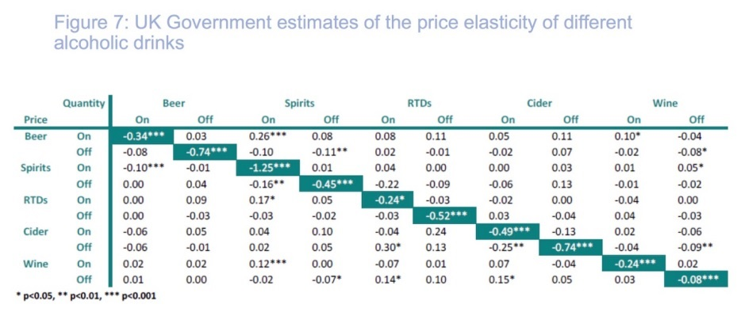
Fig. 4 UK Government estimates of the price elasticity of different alcoholic drinks. Source Sousa (2014)
The beer can be seen as a necessity for some and as a luxury by others. For instance, a consumer might not react as strongly to a price change if he/she is in the habit of consuming lager rather than beer (Euromonitor International, 2014). As Carlsberg has strong brand loyalty, the consumers may see the Carlsberg pilsner as a necessity rather than a luxury.
Generally, the purchase of Carlsberg Pilsner represents a small part of income. In United Kingdom the price of 24 bottles of 330 ml of Carlsberg Pilsner is £18 resulting in £2.28 per liter. This is a small amount in report of national living wage in United Kingdom which is £9.50 (GOV.UK,2022). Thus, Carlsberg Pilsner is an affordable lager in United Kingdom which is enjoyed at home, bars, restaurants with a group of friends. The product is classed as premium, but the price is relatively affordable for each individual. This factor indicates that the price is elastic.
Carlsberg Group support positive price/mix development in a challenging pricing environment by moving from ad-hoc/annual pricing tactics to multi-year pricing plan, developing analytics and tools to define ideal discount structure, ensure implementation feasibility and continuously follow through measure, structure and train organization and define KPIs support (Carlsberg, 2017)
In my opinion Carlsberg Group should employ value-based pricing which would base the products on what the customer believes its worth. Carlsberg Group is a beer brand with heritage and the company is seen as offering premium products which gives the advantage quality and great taste. In some cases, Carlsberg pilsner may be seen as a luxury by people who do not consume alcohol or live in less developed countries and have lower income. On the other hand, some people see the Carlsberg pilsner as a necessity if the product is bought repeatedly. As there are plenty competitors on the market which produce alcoholic drinks, lagers, beers etc. and using a different pricing policy such as competitive pricing will not work as expected. Competitive pricing is defined as setting the price lower than the competitor (Profitwell,2021). It may look like a good idea but if Carlsberg is seen as a premium lager brand, when lowering the prices, customers may question the quality and in the end they may not choose the brand over and over.
Carlsberg products have been on the market for years and the Carlsberg Pilsner is seen as emblematic for the brand. Good quality, refreshing taste, good time with friends is what the product is seen as by its consumers. The brand has been adapting to trends and consumers taste in order to bring more profits and remain in top of the consumers choices.

References:

Becker, GS, (1992) Habits, addictions and traditions. doi:10.1111/j.1467-6435.1992.tb02119.x

Brumfield. R., Adelaja, A., Lininger, K., (1993) Consumer taste, preferences and behavior in purchasing fresh tomatoes.

Carlsberg Group (2017) Capital markets day. Available at: https://www.carlsberggroup.com/media/20136/carlsberg-group-cmd_12-10-17_final.pdf (Accessed on 21/08/2022)
Carlsberg Group (2020) Carlsberg. Available at: https://www.carlsberggroup.com/products/carlsberg/carlsberg/?Ckey=1417 (Accessed on 11/08/2022)
Carlsberg Group (2020) Products. Available at: https://www.carlsberggroup.com/products/ (Accessed on 11/08/2022)
Carlsberg Group (2020) Our rich heritage. Available at: https://www.carlsberggroup.com/who-we-are/about-the-carlsberg-group/our-rich-heritage/ (Accessed on 11/08/2022)
Carlsberg Group (2021) Who we are. Available at: https://www.carlsberggroup.com/?cbgAge=1996121#who-we-are (Accessed on 11/08/2022)
Carlsberg Group (2021) Annual report 2021. Available at: https://www.carlsberggroup.com/media/48855/carlsberg-goup-annual-report-2021.pdf (Accessed on 22/08/2022)
Carlsberg Group (2022) Carlsberg says rising beer prices not hurting sales. Available at: https://www.reuters.com/business/carlsberg-q1-sales-up-27-full-year-guidance-unchanged-2022-04-28/ (Accessed on 12/08/2022)
Coll, M., (2015) Echilibrul pietei. Available at: https://www.eumed.net/ecorom/IV.%20Functionarea%20pietelor/7%20echilibrul_pietei.htm (Accessed on 11/08/2022)
Ciuciu, M., (2002) 5. Comportamentul consumatorului. Available at: https://ebooks.unibuc.ro/StiinteADM/sica/5.htm (Accessed on 13/08/2022)
Das, N., (2011) Carlsberg adopts new positioning; revamps logo and packaging. Available at: https://www.afaqs.com/news/marketing/30297_carlsberg-adopts-new-positioning-revamps-logo-and-packaging (Accessed on 22/08/2022)
DrinksSaloon (20202) Beer like Heineken: 8 similar pale brews to try. Available at: https://drinkssaloon.com/beer-like-heineken/ (Accessed on 13/08/2022)
Edgmand, M., Moomaw, R., Olson, K., (2004) Economics and contemporary issues 6th ed. chapter 3.
Euromonitor International (2014) Price elasticities in alcoholic drinks. Available at: https://www.euromonitor.com/article/price-elasticities-in-alcoholic-drinks (Accessed on 22/08/2022)
Goerig, P., (1985) Effects of product trial on consumer expectations, demand and prices. Available at: https://www.jstor.org/stable/2489382 (Accessed on 21/08/2022)
GOV.UK (2022) The national minimum wage in 2022. Available at: https://www.gov.uk/government/publications/the-national-minimum-wage-in-2022 (Accessed on 22/08/2022)
IAS (2017) The price of alcohol. Available at: https://www.ias.org.uk/uploads/pdf/Factsheets/FS%20price%20032017.pdf (Accessed on 22/08.2022)
Kondrup, P., (2022) Q1 2022 trading statement. Available at: https://www.carlsberggroup.com/newsroom/q1-2022-trading-statement/ (Accessed on 13/08/2022)

Leventoğlu, Bahar, (2017) Bargaining with habit formation. doi:10.1007/s00199-016-0994-z
Lucyna (2022) Echilibrul pietei. Available at: https://edu.trans.eu/ro/blog/post/echilibrul-pieei (Accessed on 11/08/2022)
Pedersen, J., (2022) Carlsberg says beer sales robust despite rising living costs. Available at: https://www.reuters.com/business/retail-consumer/carlsberg-q2-sales-below-expectations-higher-costs-drag-2022-08-17/ (Accessed on 22/08/2022)
Pettinger, T., (2022) Substitute goods. Available at: https://www.economicshelp.org/blog/glossary/substitute-goods/ (Accessed on 13/08/2022)
Profitwell (2021) The pricing strategy guide: choosing pricing strategies that grow (not sink) your business. Available at: https://www.profitwell.com/recur/all/pricing-strategy-guide/ (Accessed on 22/08/2022)
RBA (2020) Inflation and its measurement. Available at: https://www.rba.gov.au/education/resources/explainers/pdf/inflation-and-its-measurement.pdf?v=2022-08-13-14-12-12 (Accessed on 13/08/2022)
Samuelson, W., Marks, S., (2015) Managerial economics 8th edition.
Schiere, M., Muravina, M., (2019) The audacious new Carlsberg campaign – a case in boldness and consumer insights. Available at: https://glocalities.com/news/the-audacious-new-carlsberg-campaign-that-is-a-case-in-boldness-and-consumer-insights (Accessed on 21/08/2022)
Sousa, J., (2014) Estimations of price elasticities of demand for alcohol in the United Kingdom. Available at: https://assets.publishing.service.gov.uk/government/uploads/system/uploads/attachment_data/file/387513/HMRC_WorkingPaper_16_Alcohol_elasticities_final.pdf (Accessed on 22/08/2022)
Sloman, J., Jones, E., (2020) Essential economics for business 6th edition.
Sloman, J., Garratt, D., Guest, J., Jones, E., (2019) Economics for business 8th edition.
Stone, S., (2017) Carlsberg report breaks down millennial stereotype. Available at: https://www.morningadvertiser.co.uk/Article/2017/12/14/Carlsberg-report-breaks-down-Millennial-stereotype (Accessed on 22/08/2022)
Williams, K., (2022) What are concepts and assumptions for consumer preference? Available at: https://study.com/learn/lesson/consumer-preference-concept-assumptions.html (Accessed on 21/08/2022)

