Module: Management & Organisational Behaviour
Module code: BMIH5004
Assessment 2
Student Name: Sylvester Egbueri
Student ID: 1714548
Lecturer: Dale Clarke

Table of Contents
Introduction 1
Overview of the organisation 1
Analysis of the structure, culture and goals of the organisation 2
Organisational structure 3
Organisational culture 3
Goals of Accor 4
Evaluation of change activities and impact of those on the Company 5
Assessment of strategic direction and present business performance of the organisation 8
Strategic directions 8
Current business performances 10
Conclusion 11
References 12

Introduction
The report aims to deliver an audit case study along with relevant theories and critical evaluation of the organisation at the corporate as well as individual levels. Additionally, the Accor hotel group will be chosen here for assessing its culture, structure goals, change activities and strategic directions. The current performance of the business will be also discussed here for a better understanding of the audit of Accor Group.

Overview of the organisation
Accor is one of the leading augmented Hospitality Hotel groups that has a global portfolio of hotels, resorts and different kinds of service apartments. It has offered unique and meaningful experiences in more than 5100 hotels and around 110 countries (Group.accor, 2023). The headquarters of the hotel group is in France and it has served luxury budget to a variety of traveller tastes. It has been observed that the concerned hotel group experienced a revenue of approximately 4.22 billion euros in 2022 which has been increasing by 2.2 billion euros from the previous year.
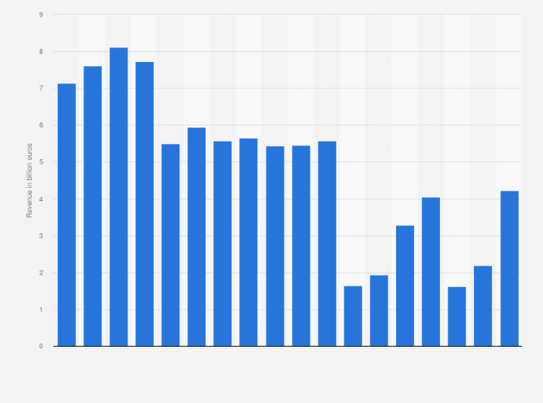
Figure 1: Revenue of Accor Group from 2005 to 2022
(Source: Statista, 2023)
The image mentioned above shows the net revenue of the organisation across the world. Additionally, the net worth of the hotel group is 8.06 billion GBP (Group.accor, 2023). It has offered the most diverse brand portfolio along with more than 40 hotel brands across all of the segments and attracts customers in large numbers.

Analysis of the structure, culture and goals of the organisation
The Accor Group of Hotel is famous for its diverse portfolio, strong and essential corporate culture, and ambitious goals. Here Accor’s structure, culture and goals have been justified.

Organisational structure
The organisational structure of the company has been characterised by its international presence and effective management of a vast area of all the hotel brands. In this context, it needs to be stated that the hotel group has followed a hierarchical structure that facilitates all the functional specialisation, various kinds of marketing operations, finance and human resources of the organisation (Bloisi, 2017). On the other hand, it operates as a hotel operator, B2B and B2C services have been offered by the organisation to make improvements in the care experience of local and non-local travellers. Additionally, the Organic theory can be implied to enhance the development of the organisation (Idem and Udosen, 2019). An organic structure is compatible with Accor’s flexibility and response to the ever-changing hospitality sector. As a result, the company can become flexible towards the brand creation and the considerable management can adapt to the shifting needs as well as tastes of the market.

Organisational culture
Accor Group promotes a diverse, creative, and innovative workplace. Open innovation has fueled the company's aggressive and agile leadership. This innovative partner provides an integrated hospitality environment (Buchanan and Huczynski, 2007). Industry-defining tools boost performance and value while stabilising growth. It aims to make visitors and staff feel welcome (Huczynski and Buchanan, 2013). This culture values respect, creativity, sustainability, and passion. Cultural theory can be used to the organisation. The cultural theory relates to social science, political economy, communication and sociology in the case of the company (Rollinson, 2008). Through implementing this Accor has become capable of understanding its environment and pushing it towards success.

Goals of Accor
The Accor group aspires to achieve several different things such as sustainable growth, brand expansion, and happiness of the guests. It has started to enhance environmental impact and make improvements in those areas where it has certain drawbacks (Robbins, 2008). Additionally, by aligning the goal-setting theory, Accor can easily adopt all the specific goals and measure those with high priority so that success can be achieved. Furthermore, one of the greatest goals of the group is achieving sustainability and that can be ensured by accessing the Goal setting theory (Locke and Latham, 2019).
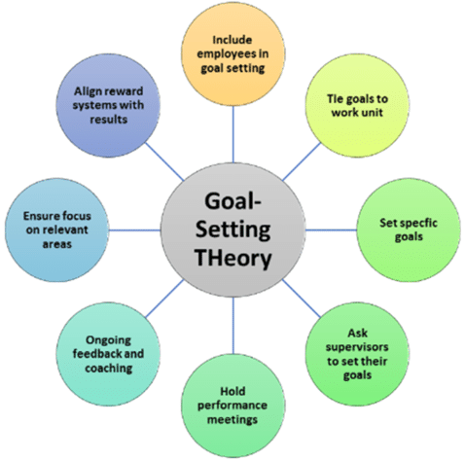
Figure 2: Model of the Goal Setting Theory
(Source: Raju et al., 2021)
The attached image shows attributes of the Goal Setting theory such as setting specific goals, asking supervisors for goal setting, ongoing feedback and coaching, and many more. This implies that with all these processes Accor can achieve all the objectives (Liang et al., 2020). All the application of organisational theories helps to make an understanding about managing operations off the Accor group and its operational efficiency as well as contribution towards the success in the global hospitality sector.

Evaluation of change activities and impact of those on the Company
The company has currently taken a lot of change initiatives along with significant effects, potential management and adaptability. Digital transformation and sustainability development are some of the change activities that the company is presently working with.
Digital transformation- Accor Hotels has embarked on a 5-year digital transformational plan that has been involved with three building blocks. Those are common mobile apps for all the hotels, strong focus on the customers and different ways for streamlining the experience of customers. Additionally, the current Cloud strategy of the hotel is to open new hotels along with the features of cloud computing and eventually migrate existing hotels to the cloud. Along with the ALL (Accor Live Limitless) app, visitors can now easily book, check-in, access their room, and request services using their cell phones (Group.accor, 2023). Through process simplification and convenience enhancement, this effort significantly enhanced the visitor experience. Additionally, it offered useful information for targeted advertising. Moreover, digital transformation helps to reduce the need for physical contact during the time of the pandemic and it has ensured the safety process (Armstrong, 2012). Accor managed all the aspects of digital transformation along with maintaining all the staff and customer's expectations. All the company needs to manage the approaches of digital transformation regarding surety to delivering training to employees (Sundaram et al., 2020). The changeover went smoothly, and the software has kept developing to adapt to shifting user demands.
Sustainability initiatives- Accor committed to environmental and social responsibility when it launched its "Planet 21" program, in keeping with worldwide sustainability trends. They established challenging targets to cut back on trash production, carbon emissions, and the use of energy and water. The team also wanted to introduce personnel and visitors to sustainable practices (Mullins and Dosser, 2013). It has been working towards designing a more sustainable way of travelling, enhancing green mobility as well and inspiring a lot of conscious exploration and greater awareness for society (Mullins, 2016). The hotel group has been aiming to achieve Net zero carbon emission by the year 2050 along the lines of the Paris Agreement that delivered the commitment to reduction in greenhouse gas emissions (Group. accor, 2023). The environment benefited from Accor's sustainability measures, which lessened their ecological footprint and supported international sustainability programs. In this context, it needs to be added that Planet 21 allows the hotel to achieve 1 of 4 levels. Those levels are Bronze, Silver, Gold and Platinum.
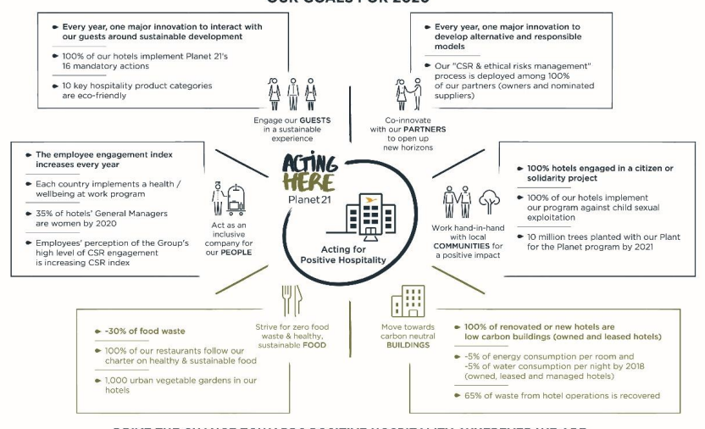
Figure 3: Goals of Accor for sustainability
(Source: Accorhotelscomms, 2022)
Alongside that, Planet 21 has also included a WATCH program that supports protests against the sexual exploitation of children in society (Accorhotelscomms, 2022). On the other hand, it needs to be noted that over the last 10 years, solidarity Accor has supported over 330 projects internationally, involved around 20000 employees and delivered advantages to 450,000 indirect as well as direct beneficiaries (Group.accor, 2023.). The way that Accor handled its sustainability projects was admirable. They made staff aware of sustainable practices, incorporated them into hotel operations, and successfully told visitors about their initiatives. The "Planet 21" initiative showed a strong dedication to corporate social responsibility.

Assessment of strategic direction and present business performance of the organisation
The Accor Group of Hotels exhibits great performance at the corporate level thanks to its wide range of brands, global presence, and strategic initiatives in corporate responsibility and sustainability. It has become one of the top hospitality firms in the world because of its efficient management of the entire brand portfolio (Brandão et al., 2020). The corporation's branding, operational know-how, and assistance are advantageous to Accor's hotels and properties at the unit level, helping them to deliver varied and excellent guest experiences. By using a dual-level strategy, Accor can continue to be a major player in the industry while making sure that every location serves the unique requirements of its community and provides outstanding customer service.

Strategic directions
Accor has taken a lot of strategies for enhancing its business performance and understanding an appropriate view regarding the development of the business. Accor's approach has prioritized brand variety to accommodate a broad spectrum of client preferences. This includes high-end labels like Fairmont and Raffles, fashion labels like SO, and budget labels like Ibis. Their objective is to increase their global footprint and acquire various market niches (Armstrong, 2012). Accor implemented a digital transformation plan, spearheaded by the Accor Live Limitless (ALL) app, after realizing the significance of technology. From reservation to check-out, the app expedites the visitor experience and offers useful information for tailored advertising, increasing client interaction. Through digital transformation, the organisation has become capable of encouraging social media learning and engagement. Through partnerships and acquisitions, the group has grown as well as broadened its portfolio of brands (Lacy-Nichols and Williams, 2021). All this has included Fairmont, raffles, SBE Entertainment Group and many more (Adair, 2009). As a result, Accor can better position itself in the luxury and lifestyle markets and attract a wider range of clients. In this way, a customer-centric approach can be gained by the company and it continually seeks to achieve guest engagement, loyalty and feedback (Boddy, 2014).
In the case of sustainability, the organisation has tried to build some sort of effective sustainable model so that environmental challenges and societal problems can be solved regularly (Mullins, 2020). It needs to achieve industry-wide sustainable transformation and place people as well as nature in the core heart of the sustainable strategy (Le et al., 2021). Additionally, it has also been taking the approach of preserving nature and necessary natural resources to contribute to the “Nature Positive” world.

Figure 4: Reinforcing Sustainable Hotel Operations of Accor
(Source: Group.Accor, 2023)
On the other hand, Accor has driven its journey regarding sustainability through ringing concrete solutions, tools as well and best practices standards., Furthermore, sustainability has been incorporated into business value so that financing strategy can be improved and developed (Group.accor., 2023). Moreover, all the changes, have been implemented in Accor through, the three best effective and operational pillars and those are reinforcing sustainable operations associated with the hotel, enhancing a sustainable food chain, and promoting the local ecosystem and ways of travelling.

Current business performances
Accor has faced a lot of trouble due to the pandemic situation and that has affected the organisation in a broad sense. Those challenges hurt the business performance of the organisation. Due to travel restrictions and lockdowns, Accor's revenue was significantly impacted by the pandemic, as occupancy rates and event reservations decreased (Elhini and Kafafy, 2021). When compared to prior years, the group's revenue decreased. Accor implemented cost-saving measures, such as staff furloughs, reevaluating capital expenditures, and streamlining operations to increase efficiency, to offset the financial impact. The business has become capable of receiving from the pandemic downfall over the period. "Management 7 franchise" revenue stood at €403 million, additionally, up 39% LFL versus H1 2022 (Group. accor, 2023). All of this business recovery led the company to the sixth position among the largest hotel chains in the world. Through digital transformation. ALL app launching, sustainability approaches business performance of Accor has improved a lot. It can able to focus and deliver on a diverse brand portfolio so that customers can be attracted significantly and appropriately. The strategic vision and current business performance help to maximise profit and revenue.

Conclusion
Based on overall analysis it can be stated that Accor is presently in a good position through following and adopting digital transformation and sustainability approaches. This provides confidence to the company to achieve a good position in the market. Through establishing organisational theories, it has become easier to understand the goals and strategic objectives of the organisation. Organisational culture and structure have been identified here to develop its brand portfolio in the market.

References
﻿Accorhotelscomms, 2022. Accor Planet 21. [Online] Available at: <https://accorhotelscomms.com/newsletter/luxe/2019/issue_02/spotlight-pdfs/Accor-Planet21.pdf>[Accessed 7th November 2023]
Adair, J. 2009 The Inspirational Leader (2nd Ed), London: Kogan Page
Armstrong, M. 2012 Armstrong’s Handbook of Management and Leadership (3rd Ed), London: Kogan Page.
Bloisi, W. et al 2007 Management and Organisational Behaviour, (2nd edition) Maidenhead: McGraw-Hill.
Boddy, D. (2014) Management: An Introduction (6th Ed), Harlow, Pearson
Brandão, A., Sousa, J.C.C. and Rodrigues, C., 2020. A dynamic approach to brand portfolio audit and brand architecture strategy. European Business Review, 32(2), pp.181-210.
Buchanan, D. And Huczynski, A. 2007 Organisational Behaviour: An Introductory Text (6th edition), Harlow: Prentice
Elhini, M.M. and Kafafy, D., 2021. The Economic Impacts of COVID-19 on the Tourism Global Value Chain. In Handbook of Research on the Impacts and Implications of COVID-19 on the Tourism Industry (pp. 92-114). IGI Global.
Group.accor, 2023. About Accor. [Online] Available at: <https://group.accor.com/en/group/who-we-are/about-us>[Accessed 7th November 2023]
Group.accor, 2023. Commitment. [Online] Available at: <https://group.accor.com/en/commitment>[Accessed 7th November 2023]
Group.accor, 2023. Sustainability Strategy. [Online] Available at: <https://group.accor.com/en/commitment/approach/sustainability-strategy>[Accessed 7th November 2023]
Group.accor., 2023. 2023 Interim Financial Report. [Online] Available at: <https://group.accor.com/-/media/Corporate/Investors/Documents-financiers/2023/07-27-H1/Interim_Financial_Report_2023_Accor_vDef.pdf>[Accessed 7th November 2023]
Huczynski, A. and Buchanan, D. 2013 Organisational Behaviour (8th Ed), Harlow: Pearson
Idem and Udosen. 2019. The Organic Theory of Corporate Management and Its Applicability under the Nigerian Company Law. 374-383. 10.21276/sb.2019.5.7.10.
Lacy-Nichols, J. and Williams, O., 2021. “Part of the solution:” food corporation strategies for regulatory capture and legitimacy. International Journal of Health Policy and Management, 10(Special Issue on Political Economy of Food Systems), pp.845-856.
Le, D., Phi, G.T. and Le, T.H., 2021. Integrating chaotic perspective and behavioral learning theory into a global pandemic crisis management framework for hotel service providers. Service Science, 13(4), pp.275-293.
Liang, J., Augustine-Shaw, D. and Sottile, J., 2020. An Exploration of New Superintendent Mentoring and Goal Setting. Journal of School Administration Research and Development, 5(1), pp.25-35.
Locke, E.A. and Latham, G.P., 2019. The development of goal setting theory: A half century retrospective. Motivation Science, 5(2), p.93.
Mullins, L 2020. Organisational Behaviour in the Workplace (12th edition) Harlow:Pearson
Mullins, L and Dosser, P. 2013. Hospitality Management and Organisational Behaviour (5th Ed) Harlow, Pearson.
Mullins, L. 2016. Management and Organisational Behaviour (11th edition) Harlow: Pearson
Raju, Valliappan and Juan, Wang and Shrestha, Sandeep and Kalathinathan, Arrunkumar and K K, Ramachandran. 2021. Role of Big Data Analytics in Belt and Road Initiative (BRI): Multivariate Analysis with Gaussian Distribution of Data. 10.3233/FAIA210245.
Robbins, S. Et al 2008 Organizational Behaviour (5th edition) Harlow: Pearson Education Limited.
Rollinson, D. et al 2008 Organisational Behaviour and Analysis (4th edition) Harlow: Addison-Wesley Longman
Statista, 2023. Revenue of Accor Group worldwide from 2005 to 2022. [Online] Available at: <https://www.statista.com/statistics/266261/revenue-of-the-accor-group/#:~:text=The%20revenue%20of%20Accor%20Group,billion%20euros%20the%20previous%20year.>[Accessed 7th November 2023]
Sundaram, R., Sharma, D.R. and Shakya, D.A., 2020. Digital transformation of business models: A systematic review of impact on revenue and supply chain. International Journal of Management, 11(5).

