STRATEGIC MANAGEMENT ASSESSMENT

COURSE CODE: SBMA 7103

NAME: AYOOLA ADEBOBAJO OLANIYI

STUDENT ID: 1710674

LECTURER: DR ALLYSON WYLDE


- Introduction
The focus of this study is to critically analyse the Afrimalt drink, its business growth strategies and the contributions of those strategies to the growth of the business. I will endeavour to review its strategic decision-making efforts of the Company. To understand situations around the business, I will in the process of this analysis examine the Macro and the Micro environment of the business. That is not all, I will also deploy strategic tools to analysing the business.
1.1 Afrimalt Company Background
Afrimalt UK Limited, the sole manufacturer of the Afrimalt drink is a private limited company. The company was incorporated on June 2nd 2009 in the United Kingdom. The registered office address is 43a High Street, Barkingside, P.O Box 2536, Ilford, Essex, IG6 2AD, The firm can be reached on telephone number +4420 8270 0915 and/or Fax number +44 20 8550 8885. The Company is also reachable on the following email address: info@afrimalt.co.uk.
The Afrimalt Company has gotten a subsidiary in Lagos, Nigerian called Afrimalt International Limited. Registered address is Mulliner Towers, 39 Alfred Rewane Road, Ikoyi. Lagos, the product offerings and product ranges are the same, the pack size is the same 500 ml, the taste is the same and the flavours are the same.
The product, Afrimalt is, unarguably, one of the most favourite non-alcoholic malt drinks in the world. It is best loved for its rich malt tastes and for the fact that it is enhanced with vitamins and minerals. Besides, it is not only delicious and nutritious; it is the perfect energy drink for lovers of malt goodness. It is worthy of note that because Afrimalt is high on nutrients and vitamins, the drink has been designed as an energy supplement.
1.2 Afrimalt’s Product Range
The Afrimalt Company product ranges include: Afrimalt Classic, Afrimalt Ginger, Afrimalt Table Water and the very low calorie Afrimalt Light. The product ranges, which are manufactured with only the finest of ingredients such as Barley, Malt extract, Caramel, Vitamins, water, Hops and minerals etc. are all in 500 ml pack sizes making the Company effectively a one pack size company. It, however, remains the desired malt drink, for goodness, energy & vitality, not only in the United Kingdom but also in Africa and across the Asian continent. Among its core consumers, the brand is described as the brand that fuels your rise every day, everywhere. For those who desire a vibrant lifestyle, Afrimalt is the brand of choice, full of life and full of uncommon nourishment.
1.3 The Aims and Objectives of the Company.
The aims and objectives of the Company are pretty straight forward. The Afrimalt Company aims to be among the leading suppliers of malt drinks in the world.
The Mission of the Company is to provide refreshment as well as completely satisfy the world with a great tasting malt drink while the vision of the organisation is to make a can of the nutritious malt drink available within arm’s reach of every customer’s desire worldwide.
1.4 The Slogan: Afrimalt………’Some things have no equal…’
Afrimalt represents a refreshing non-alcoholic beverage that has a delicious flavour. It has a very unique and distinctive taste which appeals to lovers of malt drink particularly in Africa and the United Kingdom. This is a refreshing beverage that is ideal for consumers of all classes and ages and its competitors do not come close to its rich taste, to its nourishment and to its refreshment qualities.
Afrimalt is a non-alcoholic beverage containing assorted nutrients which ensures that this delicious malt drink is vitamin-packed with natural barley malt and sugar. As a matter of fact, Afrimalt combines the super-rich taste of a nutritious malt drink with the authentic refreshment of an energising soft drink. No wonder, the slogan ‘’Some things have no equal…’’
1.5 New Addition to the Stable
On the 6th of November, 2017, Afrimalt International Limited, the Nigerian bottler of the malt drink unveiled, in Lagos, a new cola drink, called ‘Miss Cola’, into the Nigerian market. The Director of the company, Dotun Olusi, informed that the new product, which had also been recently rolled out in London, is designed to appeal to the refreshment needs of many lovers of delicious drinks all over the world. He reiterated that with the arrival of ‘Miss Cola’ into the soft drinks market, a thirst quenching solution has just been unleashed. He promised the loyal consumers of the product an experience of a life time which comes from a great refreshing taste and rich vanilla flavour.
1.6 Afrimalt is an affordable product – In United Kingdom, a case of 24 cans is offered for sale at only £24.00 VAT and delivery is included whereas in Nigeria, a case of the same great tasting product is sold at 3800 Nigerian Naira which is the equivalent of £8 thus making the product so cheap and affordable in Nigeria. It is common place to find the Nigerian brewed Afrimalt drinks on the shelves in UK.
1.7 Characteristics of the Afrimalt Drink
- Afrimalt is a drink of the highest quality made from raw material that are carefully selected and chosen with the utmost care. Afrimalt naturally contains Vitamin B complex that provides energy and stamina for all who drink it resulting in a revitalised and refreshed feeling.
- The malt component of the Afrimalt drink is refined to an extremely high grade control before the processing of the drink begins and even when consumed, the feeling of the very rich malt taste is evident and delicious.
- Made of only quality ingredients, Afrimalt is an enjoyable malt drink with a fantastic taste and without any alcoholic content.
- Afrimalt beverages are completely alcohol free and great tasting for all consumers; it contains the natural sugars, vitamins and healthy minerals that ensure the consumer have an energy filled experience whenever they drink it.
- Its brewing technique is second to none and because of its superior pasteurisation system, the products natural goodness of selected malts is preserved.
- Afrimalt has a rich natural taste; it does not contain harmful chemical preservatives that are known with other similar malt drinks and it does not go through the process of fermentation like in the case with beers.
- Afrimalt drink satisfies the intrinsic quality of a thirst quencher at every occasion and also fits in perfectly well as an easily digestible beverage when consumed with meals. As a matter of fact, Afrimalt goes well with food.
- Afrimalt drinks are very high in antioxidants, a critical nutritional factor which has the ability to protect the body against certain types of cancers, cardiovascular disease, cataracts, arthritis, diabetes and Alzheimer’s disease.
1.8 Why drink Afrimalt?
Afrimalt is a healthy malt drink for anyone who does not wish to consume alcohol but still desires to enjoy their delicious and great tasting malt drink. It tastes just as good as the alcoholic malts but it contains more health benefits and consumers who drink Afrimalt do so because they enjoy their cold refreshing and great tasting drink.
- Malt Beverages Market Trends and Market Drivers
The Malt drink is half sweet as the other normal sugar drinks and it is generally considered generally as a healthier drink than the other carbonated soft drinks (CSD) like Coca-Cola or Pepsi. The Malt drink has really grown in popularity over the last ten years worldwide. The sales and revenue from the malt segment has shown consistent growth due largely to its unique taste, availability of various flavours and the increasing health concerns of sugary beverages.
Suffice to mention that consumer preferences for malt beverages are high and is still increasing. As a result, manufacturers of the product are making variety of the product available. Consumers believe that the health benefits of malt deliver on wellbeing and indulgence.
Key drivers of the malt beverage market are diverse. They include:
• consumers’ worldwide large demand for flavoured drinks
• flavoured drinks are believed to be part of human wellbeing, and
• malt drinks not harmful when compared to alcoholic drinks.
• the extended use of malt in variety of flavoured products
• organic malt used in making flavoured drinks contribute to growth
• availability of the drinks in retail shops, supermarkets, online stores
2.1 Market Segmentation of Malt Drinks
Segmentation of the malt market can be by product type, by region, and by application. By product type, the market can be classified as flavoured and unflavoured. The flavoured malt drinks include: apple, peach, lemon, pomegranate, raspberry, strawberry and pineapple. By application, the segment can be alcoholic and non-alcoholic drinks market. By region, the malt segments can be Latin America, North America, Europe, Middle East and Africa and Asia Pacific. It is good to note that malt drinks are gaining popularity in Africa because, for religious reasons, people there are refraining from the consumption of alcoholic drinks. However, due to current growth in the sector, producers are focused on seizing the opportunity of this growth by making other variants of the drink available.
2.2 Malt Drinks Forecast For the Future
It is projected that the Malt beverage market will grow at more than 10% in the next five years. It is also expected that the sector will show a healthy CAGR in the next four to five years. It is also argued that the major drivers of the malt business will continue to be consumers’ health consciousness and the increasing consumer preferences for organic malt in the drinks. However, increasing prices of the drink in no distant future will be a critical factor expected that will limit the growth currently witnessed in the industry.
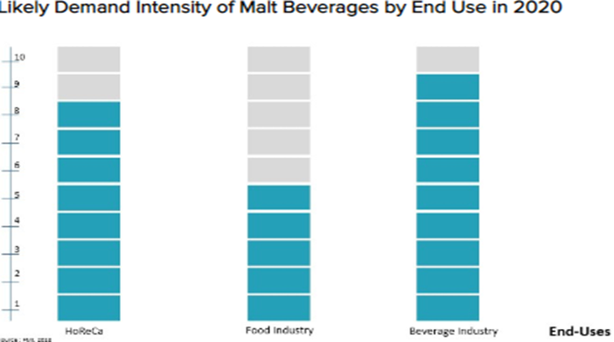
Diagram 1: Future Demand Outlook For Malt
2.3 Key Challenges Faced by the Malt Drinks Market
• young adults aged 16- 19 are mostly the target audience
• no target specific product for male and female
• consumer awareness level very low
• products are premium priced
- no product differentiation especially in ingredients

- Strategic Analysis of Afrimalt
I will attempt to do a strategic analysis of the macro environment of Afrimalt Nigeria. Afrimalt continued to do relatively very well in the market place, vis a vis, its close rivals such as Supermall, Power malt, Malta, Hi-Malt etc. However, the product is affected by challenges rocking the beverage industry today. For instance, changes in eating and drinking habits as well as in the lifestyle of an average consumer are critical challenges. Consumers are today in search of healthy drinks with little or no sugar. This is an important factor responsible for the sharp decline in the consumption of sugar drinks all over the world. Purdy, (2017) says that ‘informed consumers are turning to products like bottled water than to sodas because they fear for their health and for obesity levels that have risen to a level of great magnitude worldwide’. Sun, (2017) reiterated the same concern as Purdy that ‘because of obesity and other health related issues, consumers are concerned about what they drink and eat’.
This situation has thrown up potential opportunities and challenges for the beverage Industry, especially in the malt category. This led Kell, (2017), to say that the ‘beverage organisations are fighting this challenge with new product innovations, building new capabilities, reformulating existing products or adding new product categories in order to stay afloat’.
I will now review the macro environment of Afrimalt with a view to identifying the trends that are influencing Afrimalt’s performances with special focus on the Nigerian market. Doing this will show how one of the most successful malt drinks company in the world can engage its brand competencies to take advantage of opportunities outside of the organisation as well as simultaneously addressing any threats that could affect its progress and stability.
  - The PESTEL Analysis: This is PESTEL as it relates to Afrimalt: 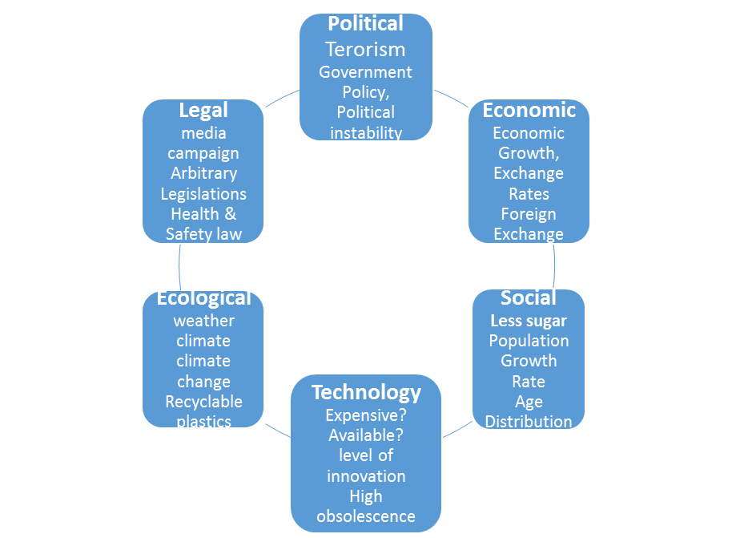
Diagram 2: PESTEL Analysis Diagram created by Ayo Olaniyi
3.1a The Political Environment of Afrimalt.
According to Kotler, P & Armstrong, G, (2010, p.108), ‘’the first factor to consider when analysing forces that influences a company seeking to get into business is politics because a firm’s operations are heavily influenced by the political environment’’ For Nigeria and the Afrimalt business, for example, this environment is highly unfavourable. In the first place, the Boko Haram insurgencies from the North affect the distribution of Afrimalt drinks nationwide. Thus, the Company resorts to opening new markets and new channels of distribution along the West coast of Togo, Benin Republic and Ghana. Also, the political environment has witnessed tough regulations that have potentially hindered business development in the country and elsewhere. Besides, arbitrary tax policy of the government limits consumption and undermines growth. In the United Kingdom, Brexit is significantly affecting efficiencies in supply chain and limiting recruitment of European Union nationals as many of them are leaving UK in droves. Besides, on the 24th of April precisely, the UK government imposed a sugar tax levy on all sugar drinks with a view to discouraging obesity (BBC News 16th March, 2016. This certainly has a significant impact on rate of consumer purchase and company revenues.
3.1b The economic Environment of Afrimalt
Khanna, T, Palepu, K.G, & Sinha, J,(2005) suggest that, ‘’in order to understand a nation’s macro-economics, it is imperative to examine the Gross Domestic Product (GDP), per capita income growth rates, composition of the nation’s population and many more’’. One of the biggest economic issues for an international company like Afrimalt is foreign exchange swings. This is absolutely unfavourable to Afrimalt because it has some major negative implication for the corporation’s revenues. In Nigeria, for instance, the currency devaluation of the Naira has made imports of production inputs more expensive thus increasing the selling price of Afrimalt. Also, in the last two years, the Nigerian economy had been hit by reduced prices of fuel as well as low interest rates. These had significant impact on the Company’s growth and market capacity. That is not all, unemployment, coupled with lack of steady incomes limit purchases and consumption of Afrimalt. In the United Kingdom, where Afrimalt is also produced, there was low economic growth following the announcement, after the referendum of 2016, that Britain will be withdrawing from the European Union following the victory of the Leave campaigners by 51.9% to 48.1% (BBC News 23rd June, 2016). Besides, announcement by financial and economic experts that there will be a likelihood of an increase in inflation in spite of wage freeze affected Afrimalt’s financial performance.
3.1c The Socio-Cultural Environment of Afrimalt
Yuksel, 2013 defined ‘’Socio-Cultural factors as those elements of a population that dictate the ways individuals or groups live within that society’’. Supporting this definition, Barney & Hesterty, (2008, p33) added further that ‘’firms should consider these forces because having a knowledge of the socio-cultural factors will help businesses decide the level of their product changes and core clients’’. It is a known fact that consumers of beverages are focusing now on less consumption of sugary drinks in favour of more healthy and sugar-free drinks. This is affecting the total gross revenue of Afrimalt especially because the Company hasn’t got much of sugar-free products except Afrimalt Table Water and Afrimalt Light. Also, the strike actions embarked upon, in the first half of 2018, by all the employees of the Petroleum industry grounded mobility and so beverage distribution vehicles could not operate. Besides, re-distributors of the product could not visit their retailer’s outlets. However, the growth of religious churches and believers who are opposed to the consumption of alcoholic drinks is fostering growth positively. That is not all; the annual growth in Nigeria’s population by 2.6% is a catalyst for malt beverage growth. The socio-cultural environment of Afrimalt in Nigeria is positive and can be said to be near favourable. In addition, the cultural belief by communities in Nigeria that large families are a source of security and wealth is fuelling growth in the beverage market and Afrimalt is benefitting from that. Besides, changes in trends and lifestyles especially for trendy malt drinks are also driving sales of the product upwards.
Hofstede’s Model: I will use the Hofstede’s Model to explain the socio-cultural environment of the Afrimalt business. This is because it will describe the effects the Nigerian culture has on the values of the people and the relationship between those values and the peoples’ behaviours.
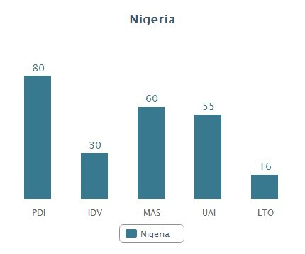
Diagram 3 showing Hofstede’s Dimensions of Culture: Nigeria
a. Power Distance Index; this describes the extent to which Afrimalt consumers can be influenced. A high score of 80 suggests that the Afrimalt consumer in Nigeria accepts that power inequality can be the norm. This has implication for the Afrimalt business because the average consumer of soft drinks believes Afrimalt is for the upper class while cheaper alternatives are for the lower class of the society. Therefore, it is usual to find Afrimalt available in prestige outlets.
b. Individualism vs. Collectivism: this underscores the fact that the society can be dependent upon its members. A score of 30 means that Nigeria can be classified as a collectivistic society meaning that there is commitment to each other i.e. close family ties. For example, the average Nigerian consumer considers his/ her family, friends and neighbours before making a buying decision. This is not only true of luxurious items but also of convenience and impulse products like the Afrimalt.
c. Masculinity vs. Feminity: A masculine society is one that is driven by competition, success and achievement while the Feminine society believes that what drives the society is strictly quality of life. With a score of 60, Nigeria is a masculine society where people live in order to work. It also means that people will work so as to live a good life. Afrimalt’s slogan is ’Some things have no equal…’ and that means that to enjoy life that is unequalled, a product that has no equal should be part of that experience.
d. Uncertainty Avoidance Index: this describes the degree to which societal members feel threatened by unknown situations, unknown future etc. As a result, members of the society will seek ways out in order to deal with their fears such as trying to save for the future time. Putting money aside to meet future uncertainties will affect buying behaviour i.e. consumers will be unwilling to spend and to consume. Meanwhile, Though, with a score of 55, Nigeria does not show a clear preference, Afrimalt has a responsibility to drive brand image and preference by using aggressive advertising and impactful promotions.
e. Short Term vs. Long Term Orientation: this answer the question are we going to focus on the future, the present or the past or should we be long term or short term in our thinking? A score of 16 suggests that the average consumer in Nigeria will less likely think long term or plan for the future when it comes to purchasing impulse products like malt drink. Therefore, the Afrimalt organisation would need to ensure arms reach availability for the product, focus on pervasive presence and drive eye level merchandising for the product at the point of purchase.
f. Indulgence Versus Restraint: this explains the extent to which people try to control their desires and impulses. If that control is weak, it is indulgence but when it is strong, it is called restraint. With a score of 84, the Nigeria culture is classified as indulgence meaning that consumers will be willing to realise their impulses, have fun and spend money on their desires. Afrimalt will benefit from this culture as the average beverage drinkers will be willing to realise their desires and enjoy their refreshing drink which they can purchase at arm’s reach and on impulse dreams.
3.1d The Technological Environment of Afrimalt
Kotler & Armstrong (2010, p.107) says ‘Technological factors are definitely worth putting into consideration because they are very imperative in making existing products obsolete’. Technology is actually the bane of businesses in Nigeria as most of the technologies required for expansion purposes are not readily available. Afrimalt International Limited today is a one package company because production capability for other packages is not available and cannot be immediately sourced. They are available overseas at exorbitant prices and the devaluation of the Nigerian currency has made such technology more expensive and almost near impossible to acquire. Even for production and selling equipment that are currently available; local fabricators are not able to fabricate durable spare parts when they become faulty. In addition, high obsolescence rates of available technology without immediate replacements available are affecting growth of Afrimalt. Today, as Afrimalt drinks in Nigeria is concerned, the technological environment is very unfavourable. However, advanced technology, if it can be sourced, presents a massive opportunity for modernized production and packaging.
3.1e The Ecological Environment of Afrimalt
According to Yuksel, 2013, ‘’ecological analysis is important so as to develop a business model that is sustainable overtime, identify potential opportunities and seek out collaboration’’. There is pressure on the beverage industry to transit to a low carbon and efficient way of doing business by demanding that they consider for future use recyclable plastics such as plant bottle packaging. Though Afrimalt is not presently packaged in plastic materials but cans, the bottler is currently researching into a more efficient way doing business. The implication of this is that marketing funds are being channelled into Research & Development purposes thus limiting funds needed in other key sectors of the business. Also, adverse weather conditions in 2017 and the first half of 2018 caused disruptions to routing as many towns and cities were rendered inaccessible by flood. The access roads were impassable and conventional routing near impossible. Largely, changing climatic conditions led to high risks for the Afrimalt business. Besides, there were government legislations made to protect the environment which in a major way added to the cost of production. All of these factors made the ecological environment of the Afrimalt business substantially unfavourable.
3.1f The Legal Environment of Afrimalt
Melling and Mann, (2012) opined that ‘’government legislations are usually stable, however, unexpected fluctuations and changes could affect a firm’s operations’’ Media campaign by government and public organisations drawing attention to the dangers of obesity and unrestrained consumption of sugar is driving consumption down and sales is nose-diving. That is not all; the Afrimalt Company in Nigeria was fined about £2.8 million Nigerian Naira or £6,087 in 2016 by a competent court for a breach of the advertising and signage law which prohibits mini shops and commercial vehicles from carrying product signage without proper authorisation. This is money that should have been added to the bottom-line. In addition, arbitrary laws imposed by government forbidding trading in certain places or along certain roads and territory are hurting the Afrimalt business. To this end, this factor is completely unfavourable to the Afrimalt business in Nigeria. In the United Kingdom, where Afrimalt is also bottled and sold, the government imposed a new sugar tax levy which is intended to cut down sugar content in drinks by 20% by the year 2020. That is a major cost added to the business operations of Afrimalt. Besides, the new legislation forbidding promoting high fat, salt and sugar drinks to children less than 16 years of age in UK also undermine growth and revenues. And what is more? The promulgation of Health and Safety law both in Nigeria and UK also keeping Afrimalt in check and conscious of operating standards.
3.2 Limitations of the PESTEL Analysis
PESTEL analysis is undertaken by organisations and businesses to examine the market environment in which they do business. It helps the firms to understand how the political, economic, social-cultural, technological, ecological and legal factors affect their operations. In addition, this analysis provides businesses an opportunity to study and measure their performance as well as improve it by critically reviewing the factors in the external environment that affect them long term. Though the PESTEL analysis is quite accurate, beneficial and effective as a management tool, there are limitations that have the ability to obscure the outcome and they need to be addressed.
- The forces in the external environment change on a consistent basis and so periodic reviewing and attention is required. The firm may need to engage R&D experts to work on this. This will not only add to costs, an analysis badly done can result in the company incurring losses.
- The work of analysing requires undiluted commitment and so supervision is very important and where this is not properly supervised, it constitutes an important limitation. Changes in the environment can potentially affect the business so a detail analysis of PESTEL is needed to avoid uncertainty.
- A simple presentation of the PESTEL analysis is inadequate to dissect the obstacles confronting an organisation because it could be erroneous, deceitful and could also present a myopic picture of the forces. Thus, there is need to properly examine the forces, especially its impact on the business otherwise the analysis may not be useful.
- Doing research and analysis need time, effort and money. The task of evaluating forces may be long and tedious depending on the complex nature of the factors, therefore, to obtain data from outside sources will definitely require time, effort, money and patience.
- In some cases, the data needed for analysis may not be readily available, therefore, a PESTEL evaluation is done using rule of thumb assumptions and predictions. This is risky as decisions and policies made based on those assumptions may be faulty.
- One other limitation of PESTEL is that it can lead to subjective results and outcome since the analysis is based on data which changes every day. If care is not taken, the company can suffer huge losses if the study is misinterpreted.
3.3 Addressing the limitations in the PESTEL Analysis:
- A PESTEL analysis should be combined with a SWOT analysis for better strategic planning results because while SWOT analysis focuses on both the internal and external factors, PESTEL only focuses on external factors.
- Companies should better do a monthly analysis as their market are growing and expanding monthly.
- Also, PESTEL analysis requires consistency for it to be effective therefore the firm require an effective and committed team.
- Besides, interpretations of results vary from one organisation to another; therefore, it is very critical that an organized team is dedicated to research.
Internal Environment of Afrimalt
It is very challenging to master some of the forces influencing the business and the degree to which they can be controlled will differ from one business to another. Below are the popularly assessed internal factors impacting the Afrimalt business:
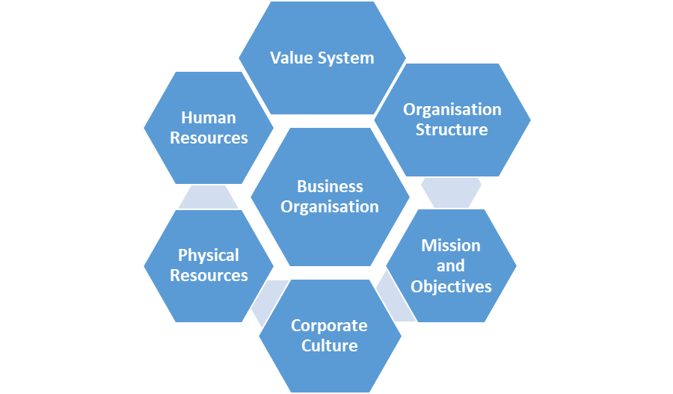
Diagram 4 showing elements of Internal Environment created by Ayo Olaniyi
- The strength of employees or Human Resources: the Afrimalt bottler has about 300 employees working either in the factory, warehouse and distribution, sales and marketing. An average employee earns about £10,000 per year and in Nigeria, that is a fairly good salary. So the average Afrimalt employee is reasonably motivated, hard-working and talented. The relationship between and within departments, particularly warehousing and sales, sales and marketing is very cordial and this has led to improvement in effectiveness and efficiency. They, undoubtedly, collaborate on ideas, processes and resolutions
- Value System: According to Kotler, P (2007), value system can be defined as ‘’a set of values adopted or evolved by a person, firm or society as a standard to guide its behaviour in all situations’’. The value systems of the Afrimalt Company include integrity and accountability. The company makes a very conscious effort to deal with its employees, customers and the larger society with the best of intentions because doing so helps the company in achieving its mission and objectives. The value system of the firm has caused it to adopt morally just and fair policies, processes and practices of doing business. This has helped to promote the interests of consumers, employees, shareholders and the society at large. For instance, because of the value system of the firm, the Afrimalt Company refused to produce or distribute liquor because it considers it morally wrong to promote the consumption of liquor.
- Mission and Objectives: The objective of every organisation is to maximize long term profits; however, the mission of the firm is quite different from the objective of profit maximization. A firm’s mission will be the overall purpose for its existence and this will largely guide and influence its business decision and economic activities. For instance, the mission of the Company is to provide refreshment as well as completely satisfy the world with a great tasting malt drink while the vision of the organisation is to make a can of the nutritious drink available within arm’s reach of every customer’s desire worldwide. The aims and objectives of the firm is to be among the leading suppliers of malt drinks in the world.
- Organisation Structure: Organisation structure basically refers to the composition of board of directors, independent directors, the professional management and shareholders. The organisation structure of a firm has a major influence over the decision making process of the firm. The Afrimalt Company currently has three active directors and four other department managers according to the latest confirmation statement of 5th March 2018. The board of directors of Afrimalt Company is the highest decision making body of the organisation. The board makes policy decisions for business growth and supervises the overall operations of the firm.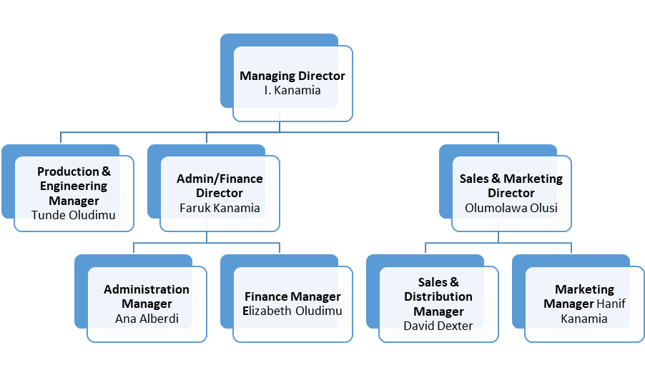Diagram 5 showing the Organisational Structure of Afrimalt Company created by Ayo Olaniyi
- Corporate Culture – The Corporate culture and style of leadership within the firm is an important factor in the internal environment of the company. Corporate culture can either be closed and threatening or open and participatory. In Afrimalt Company, the culture is open and participatory. For instance, senior managers have high level of trust and confidence in their subordinates; they also look forward to them volunteering information about the direction of the business; business decisions are taken at lower levels of management and there is free communication between top level management and lower-level managers. Also, staffs are encouraged to participate in managerial tasks.
- Labour Unions: The workers union is a factor in the internal environment of the business. They are involved in collective bargaining with top management regarding wages, working conditions of different categories of employees. The workers of Afrimalt are members of the National Union of Food, Beverage and Tobacco Employees and the union ensures smooth working of the business organisation. To ensure good relations between management and labour union, each side must implement the terms of agreement reached.
- Physical Resources and Technological Capabilities: the physical resources of an organisation such as its plant and equipment and other technical capabilities speaks to its competitive strength, its efficiency and production costs while its R&D capabilities will determine its ability to innovate. Afrimalt has a production facility in Lagos, Nigeria, which has the capability to produce only the 500 ml pack. The filler capability is for 500 ml pack only. There is, thus, a massive opportunity to expand production capacity to enable production of other pack sizes such as the 350ml for small thirst and the 1 litre for big thirst. The firm also has huge distribution capacity with capability to deliver over one million unit cases a month via a conventional routing system. This is possible because Afrimalt has over 200 trucks, each loading 400 cases per routing.
SWOT Analysis of Afrimalt
At this point, I will do a SWOT analysis for Afrimalt beverages. This analysis will examine the strengths and weaknesses of the firm as well as its opportunities and threats.

Purposes of the SWOT - The SWOT Model serves some purposes:
- First, it enables the organisation to study and understand the external and internal environment of the firm by identifying and measuring the strengths and weaknesses of the firm as well as the opportunities and threats facing it.
- Second, the SWOT also helps to find out factors that have the capacity to influence the performance of the firm thus making available to the firm useful information and data in the course of business planning.
- Third, SWOT analysis is carried out as part of the overall planning process where financial and operational goals are set for the in-coming year and strategies to achieve the goals are also created.
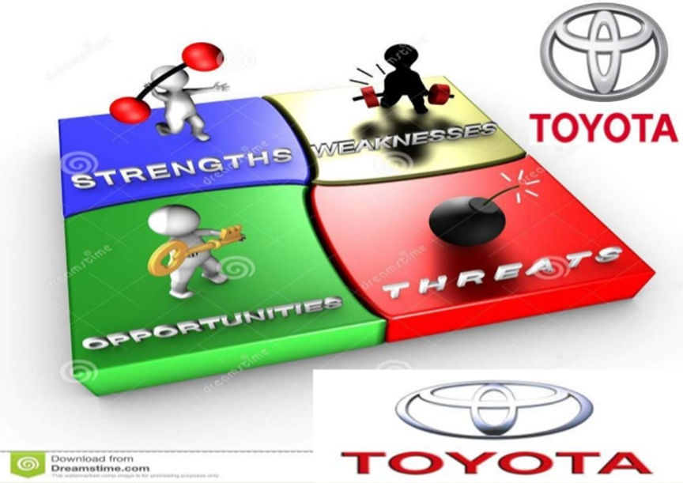
Diagram 6 showing the elements of the SWOT Model
STRENGTHS  - Strong malt taste and brand equity at £21 million in 2017 (Statista.com)  - Strong brand reputation and rapid innovation capabilities.  - Strong net revenues at £ 73 million in 2016 and £77 million in 2017 ( 2017 Balance Sheet)  - Nigeria’s best-selling malt drink brand - sales revenue topped £123 million in 2016 and £127 million in 2017.  - Brand Awareness - widely recognized logo and slogan ‘something’s have no equal’  - Robust distribution network - company - controlled distributors  - Aggressive CSR programs like green conservation, packaging recycling  - Aggressive non-price competition in the form of branding, advertising, promotion etc.  - Pervasive advertisement methods especially in supermarkets, hotels and eating places.  OPPORTUNITIES  - Opportunity to expand production and distribution capacity  - Capable and qualified employees requiring huge resources to hire and train. The use of expatriates very costly.  - Need for diversification - explore CSDs, energy drinks, Low and no sugar products  - Entry into packaged food is another way Afrimalt can expand its markets and expand revenues  - Market expansion arising from acquisition of already existing company to expand production and distribution capacity. | WEAKNESSES  - Some Afrimalt drinks contain artificial colourings which can lead to certain illnesses (Michaels, 2013).  - Many of the products/brands are relatively unknown such as Afrimalt Light, Miss Cola etc.  - Water Management and water scarcity problems leading to higher costs & capacity constraints.  - Largely undiversified portfolio compared to competition that are into beers and carbonated soft drinks (CSDs).  - Shortage of capable and qualified employees requiring huge resources to hire and train.  - Weak presence in rural markets of Nigeria due to weak purchasing power.  - Poor production capacity – only one production plant with capability for only one pack size.  - Growing administrative, selling and distribution costs (Beverage Financial data, 2017  THREATS  - Fuel shortages affecting routing and product distribution.  - Growing societal concern and media campaign health experts to eliminate high sugar foods and beverages which cause obesity, diabetes, and heart diseases.  - Indirect Competition from CSDs, Coffee, beers and energy drinks etc.
Advantages of the SWOT
- When an organisation understands what constitutes its strengths, it can better focus attention on business driving initiatives.
- Knowledge of the organisation’s weaknesses allows it to devote time to efficiency improvement measures that helps the business.
- The ability of an organisation to use the opportunities available to it properly will improve the business significantly. It is always in the best interest of the firm to take advantage of its opportunities.
- A knowledge of one's threats before helps one to take preventive measures so as to reduce the impact of the threat on th business.
Disadvantages of the SWOT
- When an organisation focuses so much attention on its strengths it can lead the organisation to ignore flaws and cause the business to nose-dive eventually.
- On the other hand, if the firm pays too much attention on its weaknesses, that can make the owners of the business to neglect the strengths that have been properly harnessed.
- If an organisation misses an opportunity that should have been taken advantaged off, that is a missed chance to possibly better the business.
- Threats are very dangerous, if an organisation does not spot them on time, they can signal the end of the business sooner or later.

Core Competencies and Capabilities
Every firm has got competencies that require to either be exploited or developed and the Afrimalt Company is not at all exception. Profs Hamel, G and Prahlad, C.K, (1990), defined Core competencies as, ‘’those capabilities which are key to a business achieving competitive advantage’’. It is important to note that the place to begin analysing core competencies is to appreciate that rivalry between businesses is a race for the mastery of competence just as much as it is for market leadership and power.

Dr Amit Mitra, FICCI agreed that ‘Core competency is a unique type of capability acquired by a firm over a period of time in form of a resource, operations facility, specially skilled manpower, knowhow, delivery of service which gives the firm sustainable competitive advantage in future in quality, design, production or distribution of a product or in cost of the product and viewed as a relative value addition by a prospective customer’’ (Economic Times, Feb 14, 2011)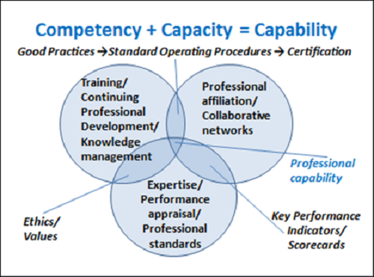
Diagram 7 showing Core Competencies and Capabilities
- The Afrimalt Beverage Company is classified as an innovative company because of the development of the unique product that has come out of its stables; a very fine, rich, refreshing and nutritious malt drink which has remained unequalled. Sliber and Kearny (2009), says that ‘’core competencies are the skills and capabilities of a firm which makes it special and gives it competitive advantage over its rivals’’
- A core competency of Afrimalt includes its attractive and innovative packaging. These have made the product appeal to a wide range of consumers (www.afrimalt.com).
- Another core competency of the Afrimalt is its solid financial position. In 2016, the company made a net revenue of £73 million and £77 million or +6% in 2017. 2018 projected net revenue id £81.5 million. Due to this, Afrimalt is able to pay its highly qualified R&D people to develop new flavours and brands. That led to the birth of Miss Cola on Nov., 6 2017.
- Surfeit to say that core competencies of Afrimalt are robust. First, it is very hard to copy and imitate the products and this gives it the edge over its competitors. Second, it has been able to respond to any changes brought in by competition. In the words of Zolo and Winter, (2002), ‘’dynamic capability is the ability of a firm to respond to address the changes taking place within and outside the business environment’’.
- Afrimalt has also embarked upon developing competencies not limited to technology. This involves customer orientation and employee training and development.
Resource and Competencies Analysis
The resources that are available to an organisation are essential and they are as essential as its ability to effectively apply and manage them. The Resource and Competencies Analysis Model is a tool of planning which put into consideration the followings:
- the resources needed to support specific strategies, and those required to gain competitive edge
- the competencies needed to adequately and effectively deploy available resources.
A resource analysis must consider how resources are managed, used and deployed. For instance, there is no sense in a firm having a good brand image or reputation if that can’t be capitalized upon properly.
Afrimalt has classified resources into Tangible and Intangible as follows:
RESOURCES AND CAPABILITIES
 | PHYYSICAL | Stores | Depots | Warehouse
TANGIBLE | FINANCIAL | Investments | Expansion Activities | Working Capital
 | HUMAN | Well Trained Staff | Bottling & Engineering Team | R&D Team
 | TECHNOLOGY | Information Tech | Cold Drink facilities | Online/Web
INTANGIBLE | ORGANISATION | Brands and Reputation | Training Programs | Afrimalt Culture
 | REATIONSHIPS | Raw Material Suppliers | Partnership – Franchise Agreement | Interaction with customers
Table 1 showing Resource and Capability Analysis Model
It is important to note that Resource capabilities are not the same as product characteristics or features. From the above table, we can deduce that:
- Afrimalt, as a company, has a strong innovation capability utilising its financial strength and its well trained staff particularly bottling and engineering to produce a well accepted and reputable brand.
- Afrimalt, as a drink, has a strong appeal and combining its unique taste with the nutritious contents and the power of its attractive packaging to deliver unequalled refreshment to the consumers.
- Afrimalt, as an institution, has a well trained staff. This added to its efficiencies in production and distribution and its customer orientated culture help to produce happy consumers &customers.
Afrimalt and the VRIO Framework
The VRIO i.e. value-rarity-imitability-organization technique (Barney, 2002) has turned out to be the most universally advocated method for assessing a specific firm’s resources. Barney, (2002), defined ‘’ the VRIO framework as a tool used to examine a firm’s internal resources and capabilities to see if they can be a source of sustained competitive advantage’’.
I will use this framework to examine Afrimalt’s internal resources and capabilities:
Applying The VRIO Framework to Afrimalt
ASSET | SCORE | VALUE | RARITY | COSTLY TO IMITATE | ORGANI  ZED TO EXPLOIT | COMP IMPL | ECON IMPL
MARKET SHARE | 2 | YES | NO | NO | NO | DISADVAN-  TAGE | BELOW NORMAL
BRAND IMAGE | 4 | YES | YES | YES | YES | SUSTAINED ADVANTAGE | ABOVE NORMAL
PRODUCT QUALITY | 4 | YES | YES | YES | YES | SUSTAINED ADVANTAGE | ABOVE NORMAL
R&D SPENDING | 1 | YES | NO | YES | YES | TEMPORARY ADVANTAGE | ABOVE NORMAL
REPUTA  TION | 4 | YES | NO | N0 | YES | PARITY | NORMAL
PROFIT MARGIN | 3 | YES | NO | NO | YES | PARITY | NORMAL
TRAINED STAFF | 4 | YES | NO | NO | YES | PARITY | NORMAL
EMPLOYEE MOTIVATION | 3 | YES | NO | NO | YES | PARITY | NORMAL
CSR PROGRAMS | 1 | YES | NO | NO | NO | DISADVAN-  TAGE | BELOW NORMAL
UNION RELATIONS | 2 | NO | NO | NO | YES | DISADVAN-  TAGE | BELOW NORMAL
PRICE COM-PETIVENESS | 4 | YES | NO | NO | YES | PARITY | NORMAL
SCORE | 2.9
Table 2 showing Afrimalt’s VRIO Framework
The Four Links Analysis Model

It is a known fact that economic benefits derived from working together and so the Afrimalt business relates with its internal, its external publics and networks. I will evaluate some of these relationships using the Four Links Analysis Model.
Diagram 8 showing The Four Links Analysis Model created by Ayo Olaniyi

Whittington, R, (2008), defines ‘’the four Link analysis model as a method of analysing data used in examining relationships that exist between an organisation and its public or its networks’’. These connections can be between people, organizations, government or even transactions.

The Afrimalt Organisation has a robust connection with its networks.
- The Government: there is a symbiosis type of relationship between Afrimalt and the Nigerian Government. For instance, the government depends on Afrimalt to pay its taxes i.e. excise, import, custom, company taxes etc. so that the government can continue to function, Afrimalt on the other hand depends to create enabling environment that allows business to continue to operate and too prosper. Afrimalt pays a company tax of 20% from its gross revenues to government yearly as well as every other tax associated with importations and clearing of raw materials while the government has legislated the ban on importation of foreign beverages to protect local industries.
- Complementors - Complementors are those whose presence either boost your value or increase demand for your business. Complementors’ help in making the market bigger. Afrimalt has a robust relationship with its Complementors such as Schools and colleges where a lot of consumption takes place, Afrimalt implements impactful sponsorship programs like Beauty contests, consumer promotions across Nigerian Universities as well as Essay writings and quiz competitions in colleges and grammar schools. There is also robust relationship with other point of sales like supermarkets, hotels, and clubs, hole-in-the wall shops etc. where consumer promotions and other contests are conducted.
- Formal Cooperative Links – the relationship between Afrimalt and its formal cooperative links is also very solid and symbiotic. For instance, suppliers are constantly delivering inputs and Afrimalt is turning those inputs into outputs and generating money with which to pay the suppliers. The Banks are also waiting for the company’s money to help them save it and also be able to generate revenue and give back loans. There is also c massive connection between Afrimalt and its agencies i.e media and advertising, vehicle repair etc.
- Informal Cooperative Links – Afrimalt also relates informally with some other organisations. For example, the use of other company’s products as prizes in consumer promotions is an example of informal cooperative links. While the promo items do not really add value to the Afrimalt drink, they however, help in driving sales up for the beverage company.
The McKinsey’s 7S Model

According to Consultants Tom Peters, Robert Waterman, Julien Philip and Richard Pascale and Anthony G. Athos McKinsey 7s model, ‘’is a tool that examines a firm’s structural design by looking at 7 key internal elements such as strategy, structure, systems, shared values, style, staff and skills so as to verify if they are positioned properly to assist the firm in to achieve its goals’’. Basically, what this model talks aboutis the culture of the company.

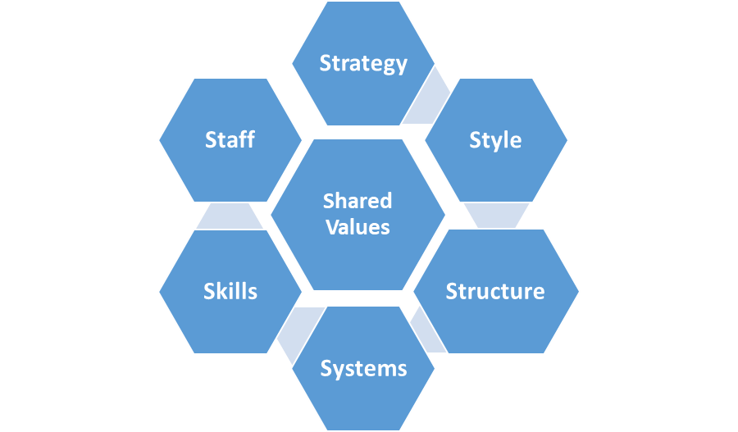
Diagram 9 showing Mckinsey’s 7S Model created by Ayo Olaniyi
Applying the Mckinsey’s 7S to Afrimalt

- Strategy: When an organisation aims to compete successfully in the market place, it develops a Strategic plan. Such a strategic plan which is usually long term and well-articulated, helps the organisation to gain competitive edge. It is how imperative that the strategy of the firm is well aligned with other elements within the firm. Afrimalt has a strategy of positioning its malt drink as one that is strong, rich and full of nutrients including vitamin C. When this strategy is juxtaposed with the culture of hard work, skills and style etc. strong results are produced.
- Structure: this represents how business is run operationally, the hierarchy, reporting structure, basically the organizational chart of the company. Afrimalt a board of directors of 8 people constituted by the nominal Chairman, the Managing Director of the firm, the three active directors of the firm and three shareholders. Even though, this is one of the most visible and easy to change elements of the framework, this element make the policy decisions that drive the operational direction of the business
- Systems: these highlights how the business is to be done nd managers are expected to focus on this area on a day to day basis. Afrimalt have gotten systems of reporting sales called Sales Record and Analysis Report; it has got systems for measuring sales activities daily called the DRAR i.e. Daily Route Activity Report; it has also got systems in place to measure in trade activities called ITMO i.e. In-Trade Marketing Opportunity report etc. There are also KBIs i.e. Key Business Indicators and KRAs (Key Results Areas) to measure business and individual performances etc. Such systems are also in place to measure production and quality efficiencies.
- Skills: these are the skills, competencies and capabilities that the employees possess. The staffs at Afrimalt are well trained and motivated. The company considers training and development as bedrock for business success. It actually prides itself as the best training provider within the beverage industry,.
- Staff: this element speaks to what type and how many employees would the company require to deliver the optimum performance. It also includes how would they be hired, trained, motivated and rewarded. Afrimalt operates a salaried system and every staff is paid monthly. However, overtime payments are made especially to employees in production and sales. There is also a bonus system for high achievers.
- Style: this refers to the management and leadership style of the organisation. How do top managers interact, what actions and steps do they take in the face of constraints and setbacks. Afrimalt management style encourages participation by the lower level employees and communication is two way.
- Shared Values: this is the core of the McKinsey 7s model. They are rules, the norms and standards that guide employee behaviour and company actions. Afrimalt has a set of ethical codes that guide the behaviour of staff and there are a set of guidelines which are contained in the employee handbook that employees are supposed to follow. Deviation from any of them attracts penalties and/or disciplinary actions.

It is important to mention here that all the seven elements must be given equal importance to achieve the best results.
The Ansoff Matrix
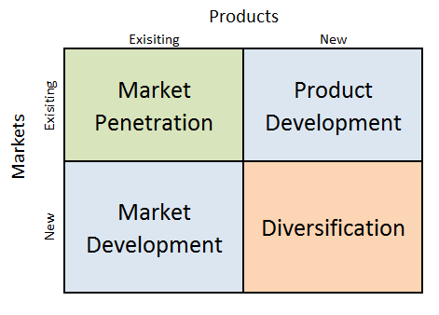
Diagram 9 showing the Ansoff Matrix Diagram
1. Market Penetration - Afrimalt Company must increase promotion for the brand. In the addition, product should be used to target more consumers especially in rural markets.
2. Product Development – Afrimalt should do line extensions for the malt drink. More variants of the drink is hereby proposed. The company should consider bottling malt in plant made plastics to, first to ensure 100% recycling of the plastic and also to differentiate the brand from its closest rivals.
3. Market Development - There is an opportunity to expand distribution into every nook and cranny in the country; first for current products in the existing market where they are. This may involve adding more VIP dealers and SSDs (Strategic Supply Depots) In addition; the company should stretch its resources a bit more by targeting new markets and entering new segments.
4. Diversification – Afrimalt should consider diversifying into CSDs i.e. carbonated soft drinks, energy drinks etc..
Recommendations
This study provides insights into the different strategies employed by Afrimalt to sell more of the drink in Nigeria. It also reviewed the different business models available to the Company. I will make some recommendations to the Company by visiting the Product Life Cycle of the product:
The Product Life Cycle

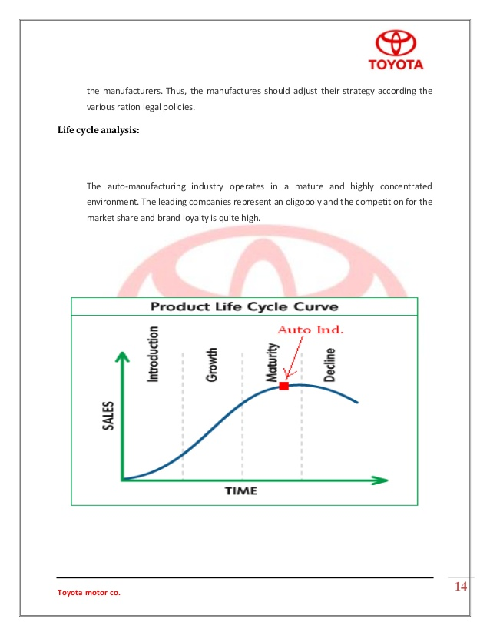

Afrimalt is in-between the growth and the maturity stages of its Product Life cycle. Also, the focus of the marketing strategy that the Company’s is using suggests the drink is in its maturity stage. The company is working hard to appeal to customers who desire more taste and freshness. Such strategies include market penetration, market development, market appeal, product development and product differentiation.
.
Conclusion
Considering the niche marketing strategies Afrimalt have used, I am of the opinion that the strategies are right and suitable for the type of niche product in this study:.
First, the strategies do not only serve the specialist and prestigious consumers at high margins, it also serves the smaller
Second, the strategy is all about getting the target customers to like and procure the product; it uses successfully cheap media for advertising thus gaining mileage for the product.
Third, the Company has also successfully achieved high sales at high prices by leveraging on the reputation of the product.

Appendix

AFRIMALT UK LIMITED
Unaudited Filleted Accounts
30 June 2017

AFRIMALT UK LIMITED
Registered number: |  |  | 06920887
Balance Sheet
as at 30 June 2017
Notes |  |  |  |  | 2017 |  |  |  |  |  |  | 2016
£ |  |  |  |  |  |  |  | £
Fixed assets
Tangible assets | 2 |  |  |  | 12,319 |  |  |  |  |  |  | 958
Current assets
Stocks |  |  | 57,159 |  |  |  |  |  | 45,570
Debtors | 3 |  | 68,234 |  |  |  |  |  | 71,426
Cash at bank and in hand |  |  | 88,723 |  |  |  |  |  | 27,505
 |  |  | 214,116 |  |  |  |  |  | 144,501
Creditors: amounts falling due within one year | 4 |  | (99,766) |  |  |  |  |  | (21,985)
Net current assets |  |  |  |  | 114,350 |  |  |  |  |  |  | 122,516
Net assets |  |  |  |  | 126,669 |  |  |  |  |  |  | 123,474
Capital and reserves
Called up share capital |  |  |  |  | 50,000 |  |  |  |  |  |  | 50,000
Profit and loss account |  |  |  |  | 76,669 |  |  |  |  |  |  | 73,474
Shareholders' funds |  |  |  |  | 126,669 |  |  |  |  |  |  | 123,474
The directors are satisfied that the company is entitled to exemption from the requirement to obtain an audit under section 477 of the Companies Act 2006.
The members have not required the company to obtain an audit in accordance with section 476 of the Act.
The directors acknowledge their responsibilities for complying with the requirements of the Companies Act 2006 with respect to accounting records and the preparation of accounts.
The accounts have been prepared and delivered in accordance with the special provisions applicable to companies subject to the small company’s regime. The profit and loss account has not been delivered to the Registrar of Companies.

IBRAHIM KANAMIA
DIRECTOR

AFRIMALT UK LIMITED
Notes to the Accounts
for the year ended 30 June 2017
1 | Accounting policies
 | Basis of preparation
 | The accounts have been prepared under the historical cost convention and in accordance with FRS 102, The Financial Reporting Standard applicable in the UK and Republic of Ireland (as applied to small entities by section 1A of the standard).
 | Turnover
 | Turnover is measured at the fair value of the consideration received or receivable, net of discounts and value added taxes. Turnover includes revenue earned from the sale of goods and from the rendering of services. Turnover from the sale of goods is recognised when the significant risks and rewards of ownership of the goods have transferred to the buyer. Turnover from the rendering of services is recognised by reference to the stage of completion of the contract. The stage of completion of a contract is measured by comparing the costs incurred for work performed to date to the total estimated contract costs.
 | Tangible fixed assets
 | Tangible fixed assets are measured at cost less accumulative depreciation and any accumulative impairment losses. Depreciation is provided on all tangible fixed assets, other than freehold land, at rates calculated to write off the cost, less estimated residual value, of each asset evenly over its expected useful life, as follows:
 | Plant and machinery |  |  | 20% straight line
 | Motor vehicles |  |  | 20% straight line
 | Stocks
 | Stocks are measured at the lower of cost and estimated selling price less costs to complete and sell. Cost is determined using the first in first out method. The carrying amount of stock sold is recognised as an expense in the period in which the related revenue is recognised.
 | Debtors
 | Short term debtors are measured at transaction price (which is usually the invoice price), less any impairment losses for bad and doubtful debts. Loans and other financial assets are initially recognised at transaction price including any transaction costs and subsequently measured at amortised cost determined using the effective interest method, less any impairment losses for bad and doubtful debts.
 | Creditors
 | Short term creditors are measured at transaction price (which is usually the invoice price). Loans and other financial liabilities are initially recognised at transaction price net of any transaction costs and subsequently measured at amortised cost determined using the effective interest method.
 | Taxation
 | A current tax liability is recognised for the tax payable on the taxable profit of the current and past periods. A current tax asset is recognised in respect of a tax loss that can be carried back to recover tax paid in a previous period. Deferred tax is recognised in respect of all timing differences between the recognition of income and expenses in the financial statements and their inclusion in tax assessments. Unrelieved tax losses and other deferred tax assets are recognised only to the extent that it is probable that they will be recovered against the reversal of deferred tax liabilities or other future taxable profits. Deferred tax is measured using the tax rates and laws that have been enacted or substantively enacted by the reporting date and that are expected to apply to the reversal of the timing difference, except for revalued land and investment property where the tax rate that applies to the sale of the asset is used. Current and deferred tax assets and liabilities are not discounted.
 | Foreign currency translation
 | Transactions in foreign currencies are initially recognised at the rate of exchange ruling at the date of the transaction. At the end of each reporting period foreign currency monetary items are translated at the closing rate of exchange. Non-monetary items that are measured at historical cost are translated at the rate ruling at the date of the transaction. All differences are charged to profit or loss.
2 | Tangible fixed assets
 |  |  |  | Plant and machinery etc |  | Motor vehicles |  | Total
£ |  |  |  |  | £ |  | £
 | Cost
 | At 1 July 2016 |  |  | 1,900 |  | 8,210 |  | 10,110
 | Additions |  |  | - |  | 13,333 |  | 13,333
 | At 30 June 2017 |  |  | 1,900 |  | 21,543 |  | 23,443
 | Depreciation
 | At 1 July 2016 |  |  | 942 |  | 8,210 |  | 9,152
 | Charge for the year |  |  | 172 |  | 1,800 |  | 1,972
 | At 30 June 2017 |  |  | 1,114 |  | 10,010 |  | 11,124
 | Net book value
 | At 30 June 2017 |  |  | 786 |  | 11,533 |  | 12,319
 | At 30 June 2016 |  |  | 958 |  | - |  | 958
3 | Debtors |  |  |  |  | 2017 |  | 2016
£ |  |  |  |  |  |  | £
 | Trade debtors |  |  |  |  | 40,903 |  | 71,426
 | Other debtors |  |  |  |  | 27,331 |  | -
 |  |  |  |  |  | 68,234 |  | 71,426
4 | Creditors: amounts falling due within one year |  |  |  |  | 2017 |  | 2016
£ |  |  |  |  |  |  | £
 | Trade creditors |  |  |  |  | 73,797 |  | 2,077
 | Corporation tax |  |  |  |  | 514 |  | 663
 | Other taxes and social security costs |  |  |  |  | 15,757 |  | 8,201
 | Other creditors |  |  |  |  | 9,698 |  | 11,044
 |  |  |  |  |  | 99,766 |  | 21,985
5 | Controlling party
 | The ultimate controlling party was Mr. Ibrahim Kanamia, who are the director and majority shareholder of the company.
6 | Other information
 | AFRIMALT UK LIMITED is a private company limited by shares and incorporated in England. Its registered office is:
 | 43-A High Street
 | Barkingside, Essex
IG6 2AD
References
- Barney, J. (2002), Gaining and Sustaining Competitive Advantage, Second Edition, Prentice Hall, NJ.
- Barney, J.B. and Hesterly, W.S. (2006), Strategic Management and Competitive Advantage: concepts and cases, Pearson Education, New Jersey.
- Core Competencies Concepts and relevance. Available from: https://www.researchgate.net/publication/235618411 _Core_Competencies_-_Concepts_and_relevance [accessed Sep 04 2018].
- https://www.gov.uk/government/publications/soft-drinks-industry-levy/soft-drinks-industry-levy
- Khanna, T, Palepu K.G, & Sinha, J, 2005, ‘Strategies that fit emerging markets’
- Kotler, P & Armstrong, G.M, (2010), ‘’Principles of Marketing’’, Prentice Hall, 2010
- Kotler, P & Keller, K.L, ‘’A Framework For Marketing Management’’. Essays and Research Papers
- Yuksel, C.C and Carles, J, (2013), ‘’ The role of geography in the success of the balearic tourism industry’’(PDF)
- Whittington, R. (1996), “Strategy as practice”, Long Range Planning Vol. 29 No. 5, pp. 731-735.
- Hamel, G. and Prahalad, C.K. (1994), Competing for the Future, Harvard Business School Press, Boston.
- Hill, W.L., Jones, G.R, Galvin, P. and Haidar. A. (2007), Strategic Management: an Integrated Approach, John Wiley and Sons, Australia.
- Whittington, R. (2008), “The crafts of Strategy: Special issue introduction”, Long Range Planning Vol. 41 (3), pp. 241-247.

