University of Wales Trinity Saint David

BENG2H-PT Ordnance, Munitions and Explosives



Design and manufacture process of a bullet using a systems engineering approach
Systems Engineering (ACDA5021)

Adam Mayo

2112088

01.05.2024

Lecturer: David Holley

Contents
Table of Figures 3
List of Tables 4
Abstract 5
1.0 Introduction 6
1.1 Aims & Objectives 6
1.2 Context 6
2.0 Sub-system breakdown 8
2.1 Functional Decomposition 8
2.2 Functions Means Analysis (FMA) 10
2.3 Pugh Diagram 11
2.4 Quality Function Development 2 (QFD 2) 12
3.0 Potential failure modes & critical design features 14
3.1 Qualitative Robustness and Critical Parameter Analysis 14
3.2 Design Failure Modes and Effects Analysis (DFMEA) 14
3.3 Additional Failure Mode and Effects Analysis (FMEA) 16
3.4 Parameter Diagram (P-Diagram) 17
3.5 What-Why Table 20
4.0 Manufacturing Process 23
4.1 Manufacturing requirements 23
4.2 Process Flow 24
4.3 Quality Function Deployment (QFD) 1 25
4.4 Process Function Means Analysis (FMA) 26
4.5 Quality Function Deployment (QFD) 2 27
4.6 Process Pugh 29
4.7 Quality Function Deployment (QFD) 3 29
4.8 P-Diagram 30
4.9 What-Why Table 32
5.0 Critical process steps 35
5.1 Quality Function Deployment (QFD) 4 35
6.0 Conclusion 38
7.0 References 40

Table of Figures
Figure 1 - V-diagram [2]. 7
Figure 2 - Functional decomposition of 7.62mm dark ignition tracer ammunition. 9
Figure 3 - Process for conducting a Function Means Analysis [3]. 11
Figure 4 - QFD 2 Component. 13
Figure 5 - QFD 2 Component results. 13
Figure 6 - Tool map [9]. 14
Figure 7 - A systems model of failure [10]. 15
Figure 8 - Application of FMEAs during development stages [10]. 16
Figure 9 - Fault tree analysis diagram [12]. 17
Figure 10 - designing the best possible solution [13]. 17
Figure 11 - tightening tolerances [13]. 18
Figure 12 - P-Diagram for dark ignition tracer composition. 20
Figure 13 - What-Why table control factors graph. 22
Figure 14 - What-Why table Noise factors graph. 22
Figure 15 - Manufacturing requirements diagram. 23
Figure 16 - Process flow for the tracer composition. 24
Figure 17 - QFD 1 Manufacturing. 25
Figure 18 - QFD 1 Process Importance Chart. 26
Figure 19 - Process FMA. 27
Figure 20 - Manufacturing QFD 2. 28
Figure 21 - QFD 2 Means Chart. 28
Figure 22 - Process Pugh. 29
Figure 23 - QFD 3. 30
Figure 24 - QFD 3 importances chart. 30
Figure 25 - Manufacturing P-Diagram. 31
Figure 26 - Manufacturing What-Why Table. 33
Figure 27 - What-Why, Key controls. 34
Figure 28 - What-Why, Key noise factors. 34
Figure 29 - QFD 4. 36
Figure 30 - QFD 4 Importances Chart. 37

List of Tables
Table 1 - Functional Decomposition Summary [1]. 8
Table 2 - FMA for 7.62mm dark ignition tracer. 11
Table 3 - DFMEA for the tracer composition. 15
Table 4 - What-Why Table for tracer composition. 21

Abstract
This report discusses the manufacturing of a 7.62mm dark ignition tracer and the various systems engineering techniques and tools to establish the important features of the sub-system. The sub-system functionality was identified, so that the means could be generated and justified why they were chosen. Progressing through the report the most important component was identified, and a large consideration was placed upon how that component is likely to fail during the whole Manufacture to Target Disposal Sequence (MTDS). The identified failures were explored so that solutions could be adopted to mitigate against these failures.

The manufacturing process of the 7.62mm ammunition was reviewed to establish the process flow. These processes were compared against the manufacturing requirements to establish critical relationships and the critical processes. With the critical processes being identified, solutions were generated and justified using the systems engineering tool set, which highlights how the toolset can be used at any stage during a systems lifecycle. The solutions were compared to the processes to check the relationships between them and to indicate which solutions had the greatest influence on the desired outcome. The component requirements and manufacturing requirements were compared to identify the critical process. From this, the associated noises and controls were communicated to the systems engineer. The control factors were compared to the process parameters to show which controls are the most important to ensure that increased focus is placed on these during the manufacturing process proposal. Throughout this report, the most critical design and manufacturing aspects were identified and discussed so that the final product has the highest probability of fulfilling the requirements with a high level of reliability.
However, future work should enhance the integration of the system engineering approach to other parts of the Ordnance, Munitions and Explosives (OME) life cycle.

Introduction

1.1 Aims & Objectives
This report focusses on the manufacturing of a sub-system of a gun system that fires 7.62mm Dark Ignition Tracer ammunition henceforth referred to as ‘tracer’. There is a rising interest in this type of ammunition, therefore this report shall consider the most critical factors and come up with reasonable solutions, to ensure a low probability of failure in its manufacturing. This will ensure that the ammunition is inherently safer, cheaper and more efficient during its complete manufacture to target disposal sequence (MTDS).

The report shall develop a solution to this sub-system using a range of accepted systems engineering tools and thinking. The use of the tools and concepts will help the systems engineers discover the architecture that makes up the tracer, which allows the whole life cycle to be scrutinised and provides traceability of any decisions made. By discovering the architecture, the most critical components should be identified, which may be routine or non-routine. In addition, sophisticated and innovative solutions can be outlined that are within the realms of reality. In addition, as systems engineering is fractal the majority of the tools and concepts can be applied at different stages to achieve a well-engineered system[1].

The solutions should be robustly engineered using systems thinking to ensure that the final product will function as intended with good reliability. This report will cover:
- needs analysis
- developing solutions
- assessing risks and constraints

1.2 Context
The systems engineering methodology has developed over the recent years producing a detailed plan of how a system should be designed and manufactured, ensuring minimal variation and unexpected or unintended outcomes. The key to the systems approach is to fully understand the problem by exploring the stakeholder’s needs and expectations, by using techniques and tools that give the engineer purpose and context [2]. Going forward, an approach would be to generate all possible solutions using divergent thinking, which can be narrowed down by searching and evaluating using convergent thinking to select the “best one” [2]. The “best” solution should be checked back through the system to confirm if it solves the whole problem for all concerned stakeholders.

All systems will have a degree of complexity, which can be broken down into further system, sub-system and component levels, the previous tier being the source of requirements for the next level down. Once the components have been designed, they can be built and integrated with the above levels, providing checkpoints ensuring that the final solution will work as per the stakeholders requirements. This view is referred to as ‘top-down’ design and “bottom-up” manufacturing which forms the V-diagram shown in Figure 1. The V-diagram illustrates that the details in the higher levels of a system are dependent on the design of the lower levels illustrating the importance of the integration and validation steps of the systems engineering tools.
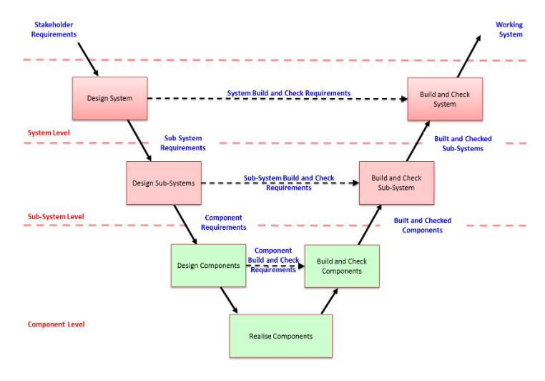
Figure 1 - V-diagram [2].
It is important to identify potential or proven system issues. Although counterintuitive, these issues must be considered allowing the system designers to mitigate against the identified issues. This will improve the overall confidence and robustness of the item being designed. It is important to also consider that any changes or design choices that could have a positive or negative effect on the system. A compromise might be necessary to achieve the intended system functionality.

2.0 Sub-system breakdown

2.1 Functional Decomposition
In order for the functionality of the bullet to be established, a functional decomposition must be completed. This will allow the functionality of the bullet to be broken down into smaller functions, that should match the requirements of the overall system. This process is normally accomplished by thoughtful analysis and team discussions [3], to incorporate a holistic view. This requires every component and feature to be identified and considered no matter how insignificant. These functions should follow a verb-noun description as well as being written as a positive function.

However, this tool has advantages and disadvantages outlined in Table 1
Table 1 - Functional Decomposition Summary [1].


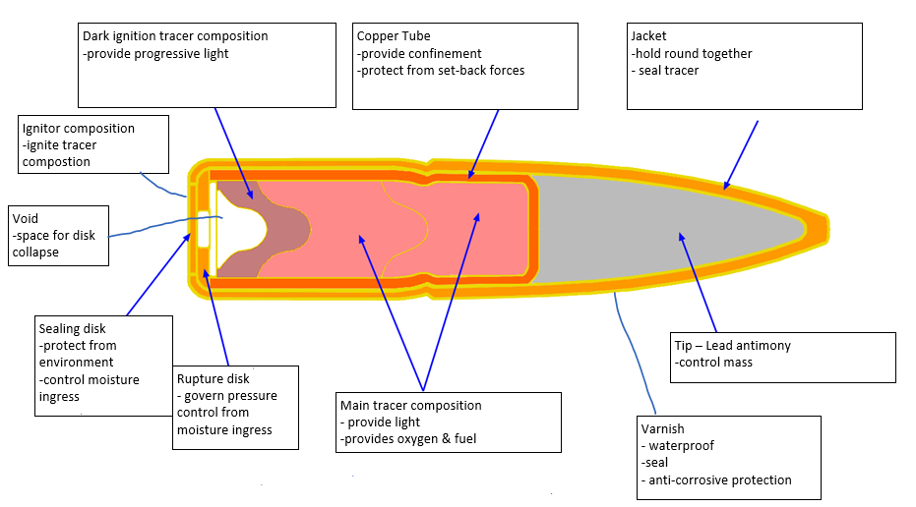
Figure 2 - Functional decomposition of 7.62mm dark ignition tracer ammunition.
Completing the functional decomposition, Figure 2, has allowed the functionality of the tracer to be broken down into an array of smaller components. This will foster a better understanding of the sub-system and all the components involved in achieving the final functionality of the system. This technique is often used on systems that need to be improved upon, or that do not necessarily have a design history that the systems engineer can call upon. In a typical design tree, a Quality Function Development (QFD) design could be used to gather the functionality of the system.

2.2 Functions Means Analysis (FMA)
A Function Means Analysis (FMA) provides a way of documenting and exploring potential system solutions, that are displayed in the solution space of the table with the incorporation of ‘divergent thinking’ which covers many possible solutions to populate the means. This is also a highly structured approach to generating and selecting system design concepts. The left-hand side of Table 2 lists the functionality of the system, derived from section 2.1 Functional Decomposition. This functionality is deemed necessary to deliver the operational requirements of the system. The central section of the table contains potential functional solutions, often referred to as a solution space for a particular system. Once the table is complete, full system solutions can be identified. This often causes some concept solutions to be de-selected as well as the possible identification of concepts that match well to several different system solutions [4]. This tool is used to negate undesirable, emergent behaviour by producing an array of solutions, that can later be down-selected [4]. Figure 3 outlines a process plan for completing an FMA. If multiple solutions are chosen, a Pugh Diagram can help identify the best solution for the system.

Table 2 - FMA for 7.62mm dark ignition tracer.
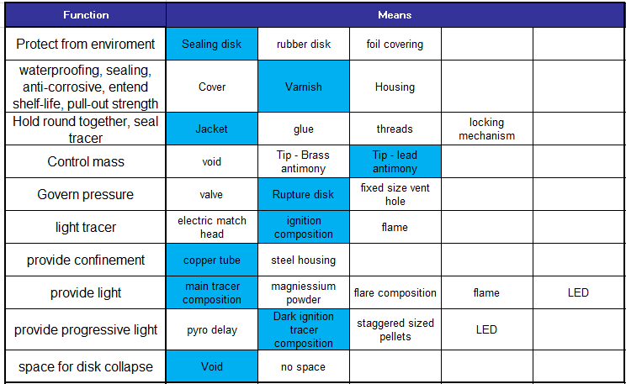
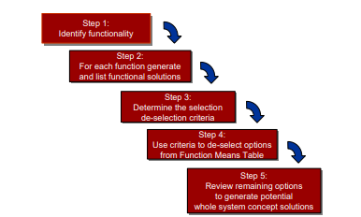
Figure 3 - Process for conducting a Function Means Analysis [3].

2.3 Pugh Diagram
A Pugh Diagram [5] is a multi-solution analysis tool that can be implemented at any stage, where there is a need to compare solutions of the system. The best approach is to establish a baseline solution that the other concepts should be compared and justified against. The resulting outcome should indicate which solution is best tailored to the system. However, a Pugh Diagram was not conducted at this stage as only one solution was derived from the FMA.

2.4 Quality Function Development 2 (QFD 2)
The QFD 2 matrix is used during the design development stage of the sub-system [6]. By utilising this tool, the user can identify the means that have the most influence on the sub-systems required functionality. The data from QFD 2 may be put directly into a Design Failure Mode and Effects Analysis (DFMEA) [6]. QFD 2 can be referred to as Component level QFD, and the key means are identified when compared to the systems required functionality with their relevant importance scores. The importance scores can be gathered from a range of experiments/tests which gather importance data, known as the Taguchi tests [7]. These involve a robust design of experiments to investigate differing design parameters to identify how they affect the processes at the relevant levels. Scoring is done by ranking them (1, 3 or 9) shown in Figure 4 and the results are shown in Figure 5. In the case of the tracer the ‘dark ignition tracer composition’ was deemed as the most important component. The following stages of this report will now consider the manufacture and the control of these processes to reduce the likelihood of the system failing to meet customer requirements.

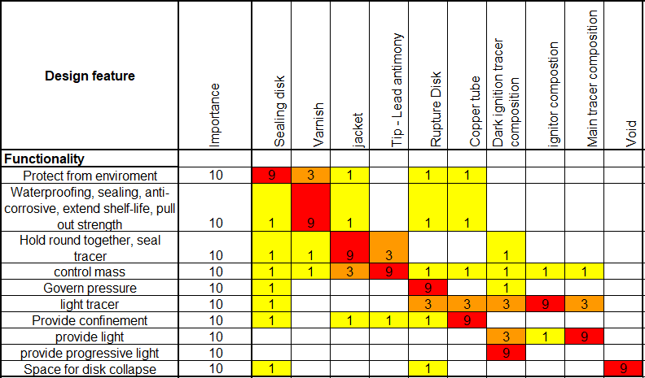
Figure 4 - QFD 2 Component.
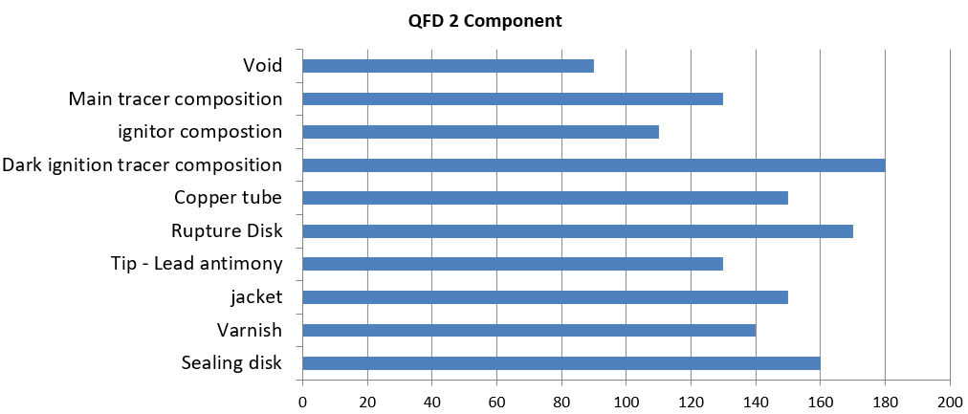
Figure 5 - QFD 2 Component results.
Gemba visits are generally defined as going to where the action is [8]. They are a teaching exercise to the designers, providing them with a clear understanding of how the end user will interact with the system that they are going to design. This in turn provides the designers with the required functionality and requirements for use in QFD 2.
Additionally, this can also provide an opportunity for the end user to give feedback to the designers outlining what they would like from a system (desired functionality).

3.0 Potential failure modes & critical design features

3.1 Qualitative Robustness and Critical Parameter Analysis
The purpose of this section is to identify the critical design parameters and the presiding sources of noise that would result in a poor design that is subjected to failure [9]. Figure 6, illustrates how each tool can be used to influence each other.
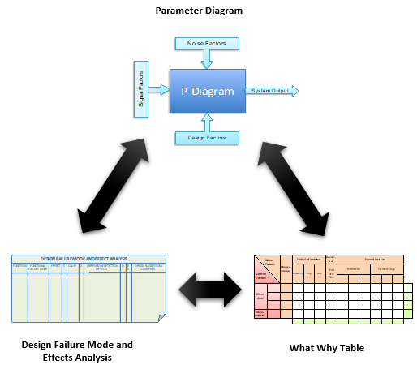
Figure 6 - Tool map [9].

3.2 Design Failure Modes and Effects Analysis (DFMEA)
A DFMEA for the tracer was performed to understand critical failure modes, effects and causes. Failure is described in five basic types in systems engineering [10]:
- Over Function
- Under Function
- No Function
- Intermittent Function
- Unintended Function
By following a systems view of failure, Figure 7 it becomes apparent how failures are defined and relate to one another providing a clear understanding of failure.
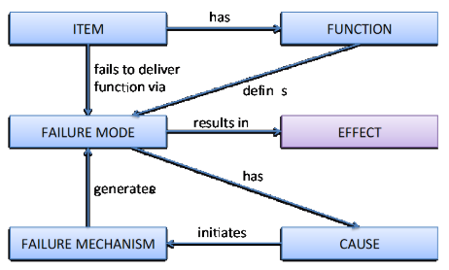
Figure 7 - A systems model of failure [10].
Table 3 - DFMEA for the tracer composition.
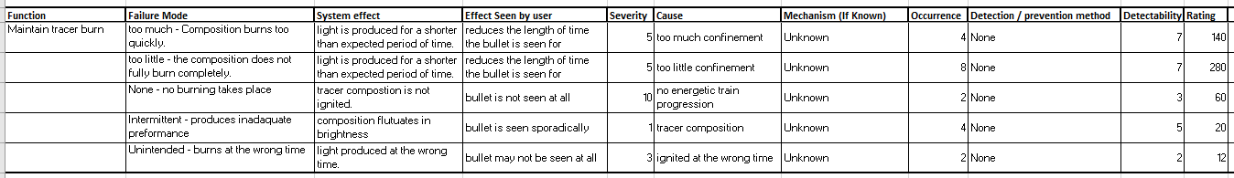
The DFMEA in this report focusses on the tracer composition, as it was identified as the most important component feature to control from QFD 2 previously discussed in section 2.4. Figure 8 shows that the most likely/ severe failure that the tracer composition would experience would be a lack of confinement. This was closely followed by over-confinement, suggesting that this aspect of the tracer composition has to be closely monitored to avoid failure.

3.3 Additional Failure Mode and Effects Analysis (FMEA)
Failure Modes and Effects Analysis (FMEA) should be completed before any design has been considered, by using the systems approach to understand the customer’s requirements fully. This can be expressed by the necessary functionality in a Function FMEA (FFMEA) and what the outcome would be should a function not be performed. Additionally, a Process FMEA (PFMEA) is used at the manufacturing stage to provide a structured, qualitative, analytical framework of how a process could fail and the effect of that failure [11]. Figure 8 represents how expensive it would be to fix failures at different stages of the system's life cycle.
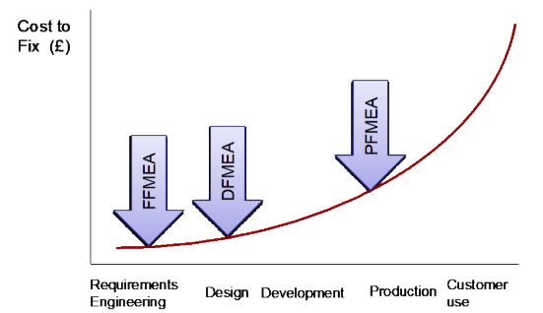
Figure 8 - Application of FMEAs during development stages [10].

An FMEA can additionally be used to start a Fault Tree Analysis (FTA), which considers top-level events and the likelihood of them occurring through the illustration of an ‘AND’/’OR’ gate symbol, Figure 9. This process continues identifying lower-level events that lead to higher-level events until the lowest level has been reached [12]. Furthermore, the FTA can provide probability/occurrence numbers that will enhance the information in a DFMEA.
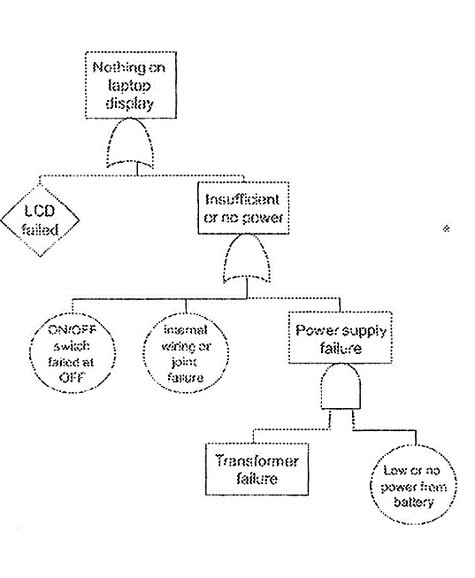
Figure 9 - Fault tree analysis diagram [12].

3.4 Parameter Diagram (P-Diagram)
A P-diagram can be used to consider the design choices that need to be controlled and the noises that are likely the performance of the component. The analysis of the design of the tracer composition assumes that everything is in optimal working conditions. However, this is all dependent if the system is more robust to noise but has lower performance or vice versa. The robustness of a system can be controlled using a set of tolerances for noise factors, but this does encounter a greater cost typically [13]. These concepts are shown in Figure 10 and Figure 11.

In addition to a regular P-Diagram, a cascading P-Diagram can be used as the side can feedback and become a source of noise to a sub-system or the side effects can interact with separate systems [9]. Figure 12, shows an example P-Diagram for the tracer composition, which was useful for identifying noises that can be controlled at later development stages.
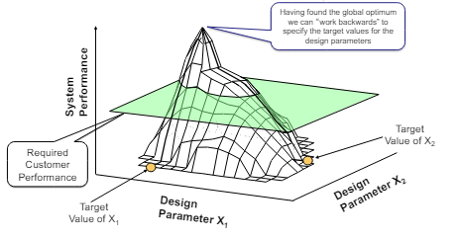
Figure 10 - designing the best possible solution [13].
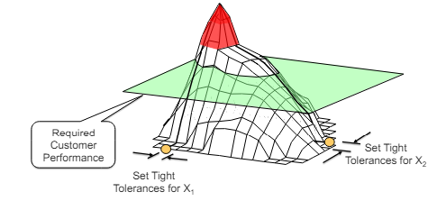
Figure 11 - tightening tolerances [13].
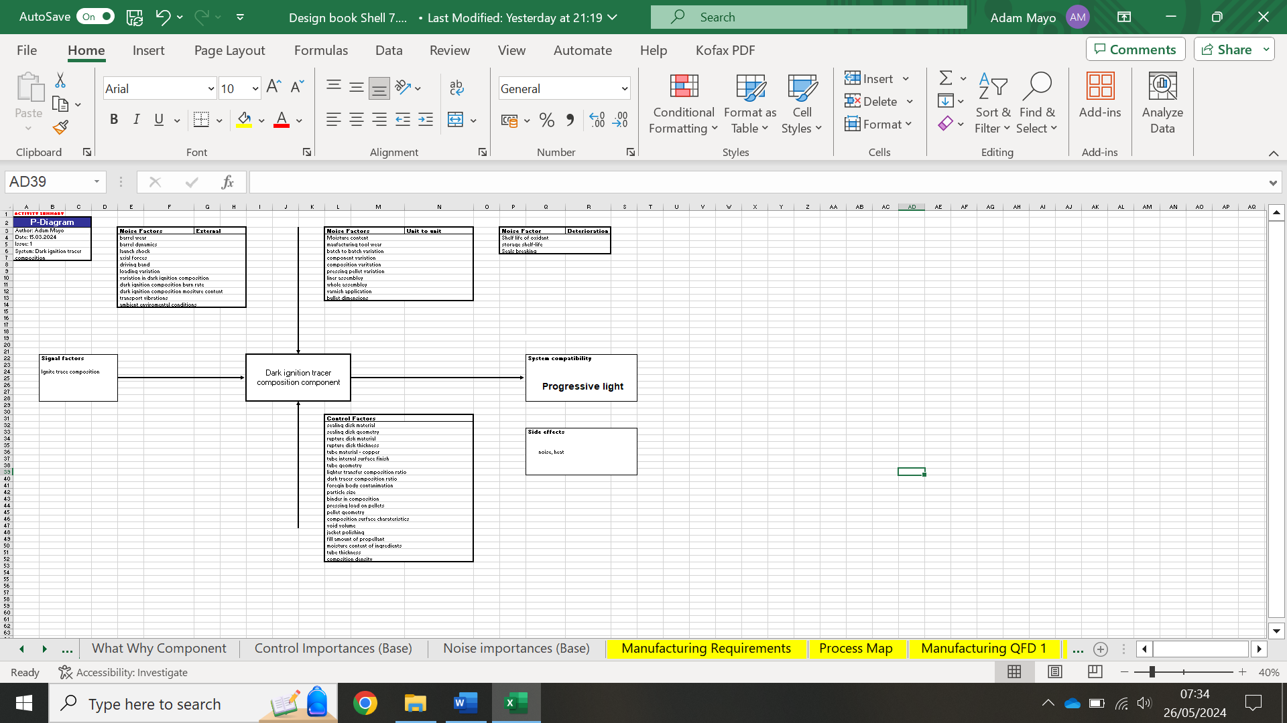
Figure 12 - P-Diagram for dark ignition tracer composition.

3.5 What-Why Table
Continuing on from a P-Diagram, a What-Why table can be used to identify control factors for external, unit-to-unit and deterioration noise factors. Important noise or control factors will emerge with a high score, guiding the systems engineers focus to the factors that pose the biggest threat to the integrity of the system. The important noise or control factors can be removed or used to mitigated against them. An example What-Why table is shown in Table 4. The graphs shown in Figure 13 and Figure 14 identify that the most important control factor is the dark tracer composition ratio, closely followed by composition density and the most important noise factor is load variation, which can be monitored closely in the manufacturing process with mitigation methods.
Table 4 - What-Why Table for tracer composition.
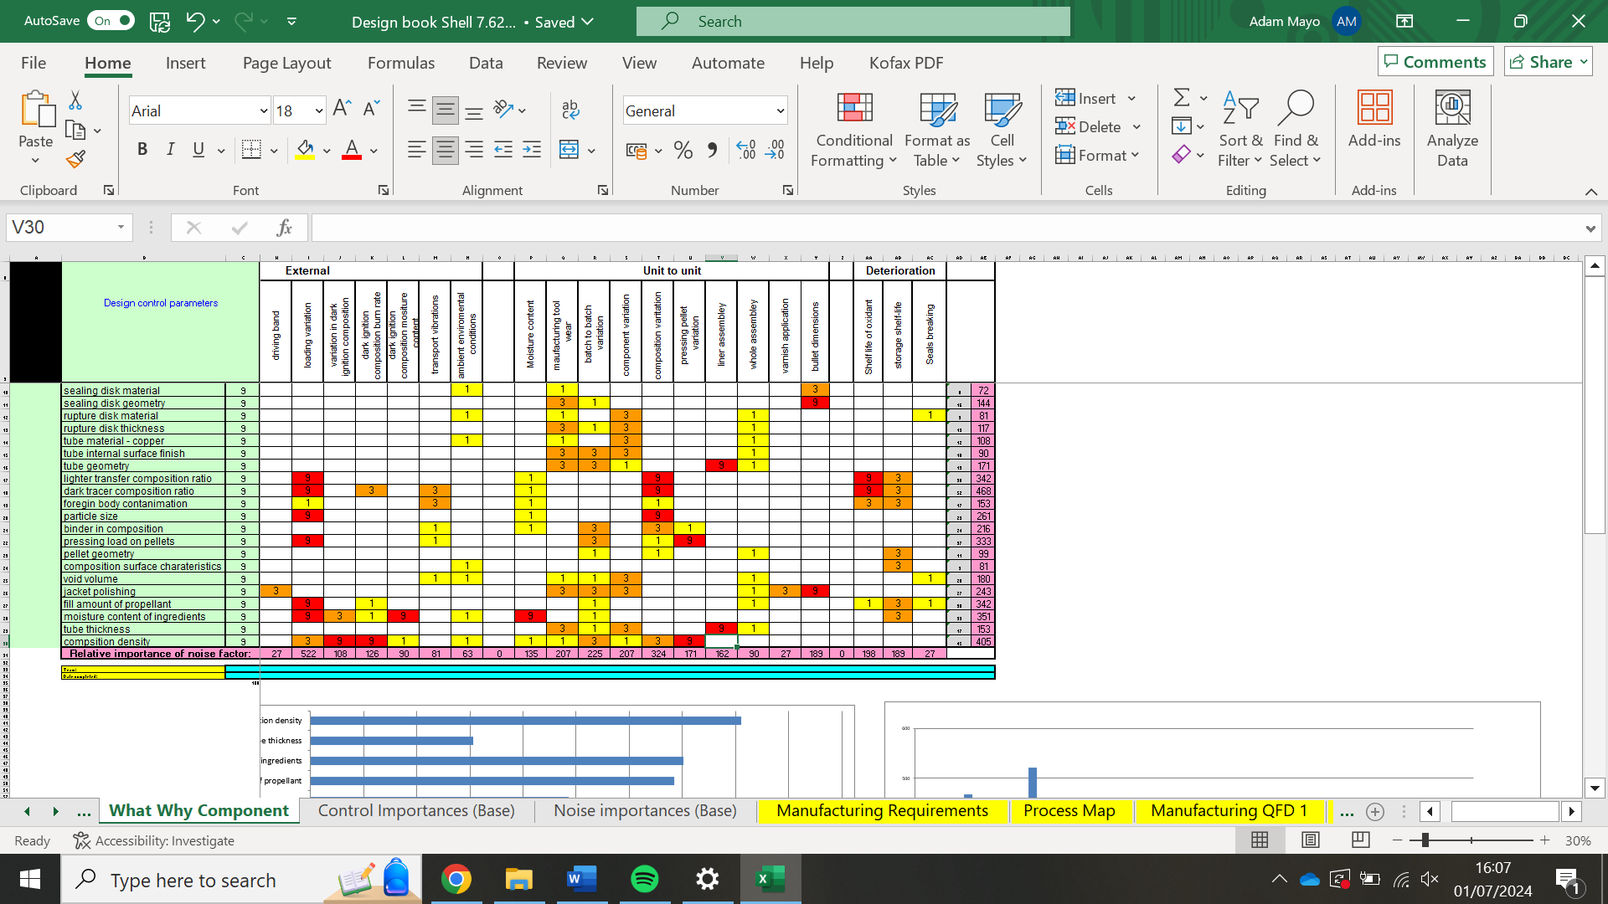

Figure 13 - What-Why table control factors graph.

Figure 14 - What-Why table Noise factors graph.

4.0 Manufacturing Process

4.1 Manufacturing requirements
Similarly to the design process, the next stage, manufacturing, requires a specific set of requirements. These requirements will often consist of:
- Reliability (High)
- Safety (High)
- Quantity (High)
- Capacity (High)
- Reject Rates (Low)
- Machine Downtime (Low)
- Cost (Low)

Figure 15 is an example of a set of manufacturing requirements. These would have values placed beside them to give a target to aim for within the manufacturing process. A pairwise comparison should be conducted at this stage on the requirements, to find the most critical manufacturing requirements.
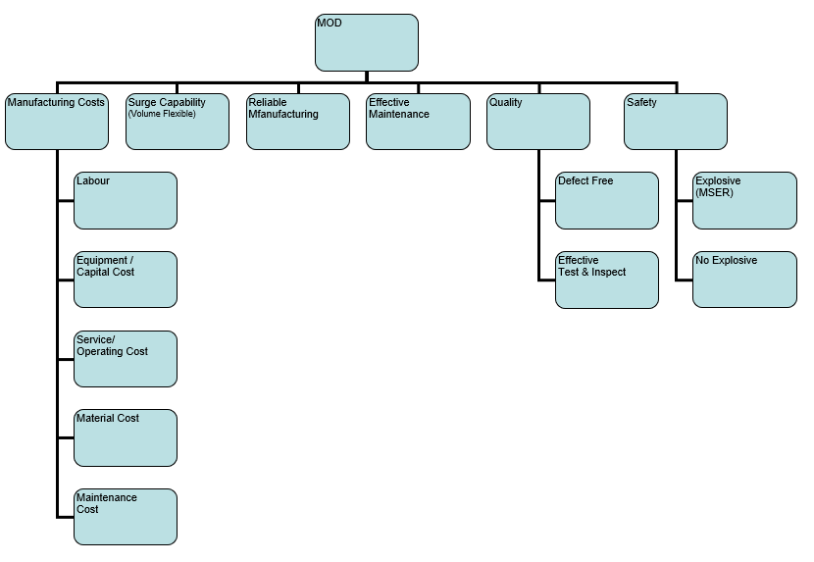
Figure 15 - Manufacturing requirements diagram.

In addition to the above tool, a stakeholder influence map should be considered for the manufacturing process. This tool identifies the people/organisations who have an interest in the manufacturing process and how they interact with other stakeholders [14]. Once a map is established it can then be used to provide a degree of focus on who the requirements must or should and could ignore [14].

4.2 Process Flow
A process flow diagram is a type of flowchart that illustrates interactions between processes [15]. It is often used at the manufacturing stage in many industries like car manufacturing and other engineering fields [16]. The benefits of this tool are that it provides a documented process and can theoretically be used to improve a process or model a new one [15]. Figure 16 shows a simplified process flow for the tracer composition. However, a typical process flow would have functions linking the process together, and the function are a choice of means of how to achieve the processes. There may also be included the inputs and ideal outputs of each process. Additionally, quality measures can be used on the outputs, which is useful on critical processes.
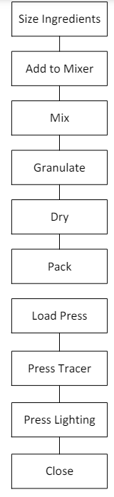
Figure 16 - Process flow for the tracer composition.

4.3 Quality Function Deployment (QFD) 1
Quality Function Deployment 1 (QFD 1) is used to confirm manufacturing system requirements and identify critical processes [17]. By utilising this tool, the relationships between the manufacturing requirements and critical processes are well documented. Overall, this allows the systems engineer to develop a good understanding of the most important manufacturing processes for this component. Figure 17 shows a completed QFD 1 for the tracer which allows a processes importance chart to be produced, Figure 18. From this processes chart, it is found that the most critical process is ‘Press tracer’ which must be closely monitored in all manufacturing tasks.
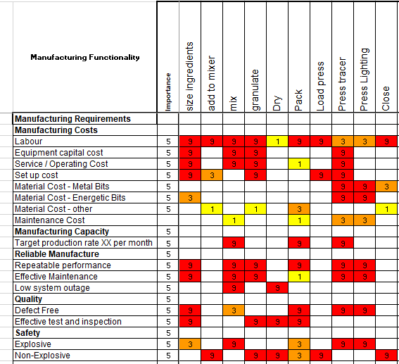
Figure 17 - QFD 1 Manufacturing.

Figure 18 - QFD 1 Process Importance Chart.

4.4 Process Function Means Analysis (FMA)
As in section 2.2, an FMA will be used to further provide solutions to the processes outlined in section 4.2. The solution space will allow for differing solutions to be selected, however, due to the time constraints of this report only one solution was selected (Figure 19) and will be further analysed. By analysing more than one solution concept the systems engineer can make more informed choices about why each solution was selected. The comparison of different concepts can be done with a Pugh Diagram, which allows for a Quantitative decision to be made [5].
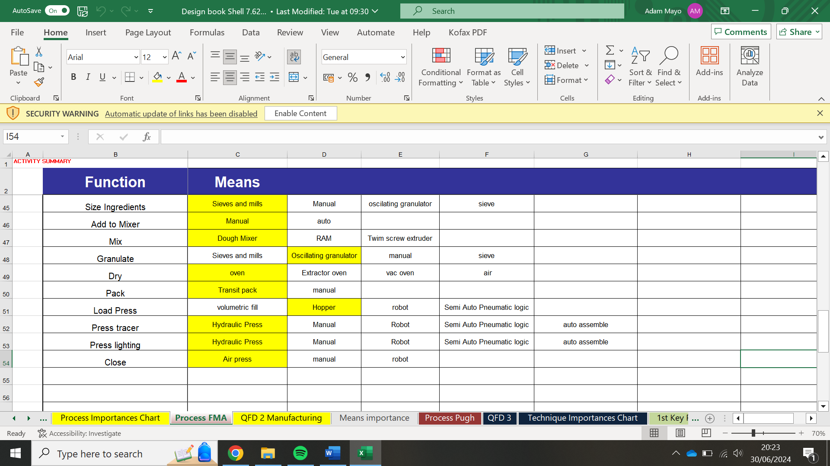
Figure 19 - Process FMA.

4.5 Quality Function Deployment (QFD) 2
QFD 2 manufacturing (Figure 20), describes the relationship between processes and the means to complete them. The interactions between them can identify where to focus efforts in the design of those means. If the limitations are not known, then they would be elicited by contacting different manufacturing teams to obtain information about each means. It was identified that ‘manual’ was the most important means as it has the most influence on the processes as shown in Figure 21.

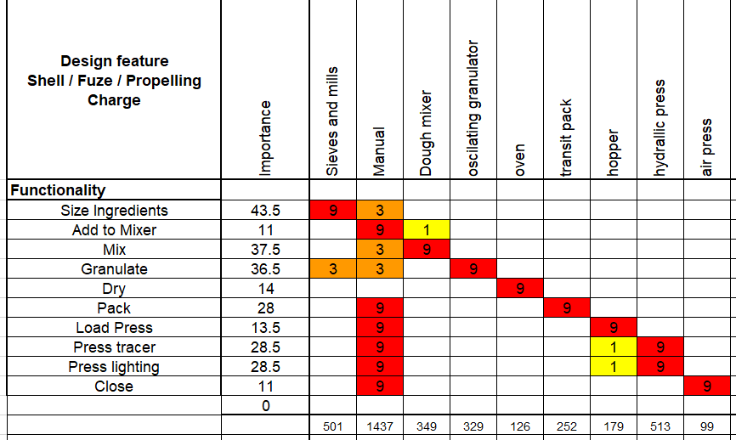
Figure 20 - Manufacturing QFD 2.

Figure 21 - QFD 2 Means Chart.

4.6 Process Pugh
The Process Pugh uses one concept as a baseline, to compare other concepts against [17]. If applicable, the previous, known processes should be included as the baseline as there should already be a well documented understanding of the performance. Figure 22 details that ‘auto pressing’ was best, whilst providing a detailed justification of why it was chosen.
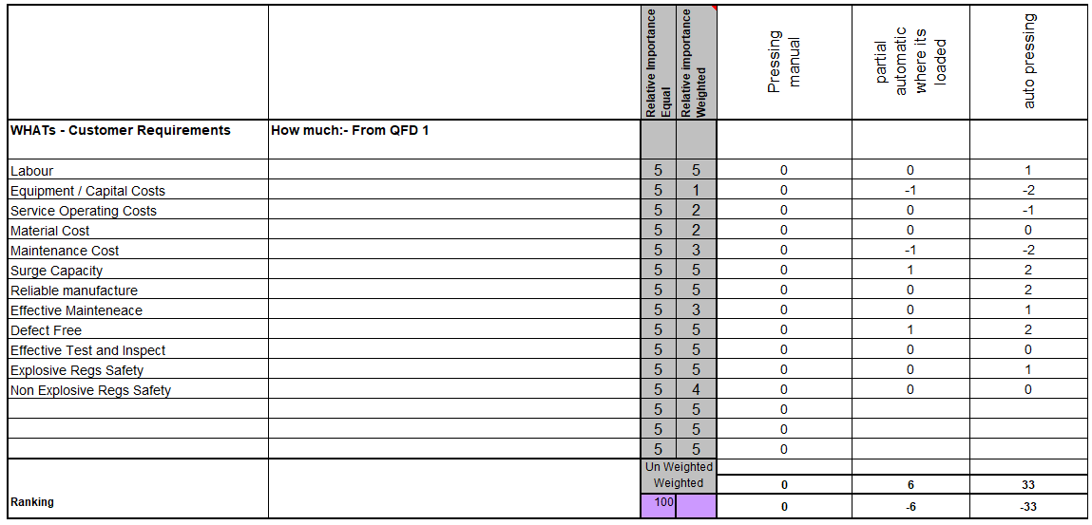
Figure 22 - Process Pugh.

4.7 Quality Function Deployment (QFD) 3
Quality Function Deployment 3 (QFD 3) is a matrix diagram that allows the assessment of the relationships between component requirements and the manufacturing process requirements, as shown in Figure 23. This assures the flow-down of requirements and the impact of the manufacturing process on the achievement of the design. Additionally, target values can be implemented for the critical product parameters in the ‘room’ on the right-hand side of the tool, which is not demonstrated in Figure 23.

When transitioning from QFD 2 to QFD 3 care must be taken to ensure the critical characteristics are transferred. These can also be identified from previous P-diagrams and What-Why Tables. The most critical manufacturing step for the case of the tracer was the ‘hydraulic press’, as shown in Figure 24.

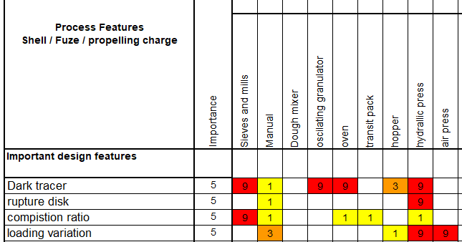
Figure 23 - QFD 3.

Figure 24 - QFD 3 importances chart.

4.8 P-Diagram
Similarly to section 3.4, the P-Diagram at this stage of the process will identify and capture the factors that influence the performance of the system output during the manufacturing process. As ‘press tracer’ is a critical process step, the systems engineer must be confident that they understand the factors that might affect it. Figure 20 shows the P-Diagram for the ‘press tracer’ process.
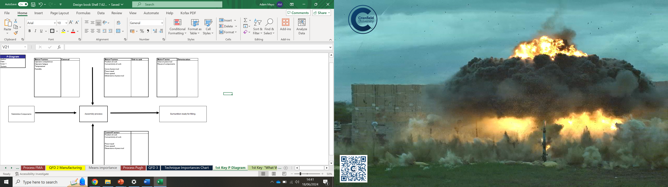
Figure 25 - Manufacturing P-Diagram.

4.9 What-Why Table
Similarly to section 3.5, a further what-why table will be used to identify the emergence of critical manufacturing parameters. In order to discover this, the control parameters were compared to noise factors within the processes. The results show the relationships between the noises and the controls (shown in Figure 26, Figure 27 and Figure 28). These figures show that the dimensions of the press need to be closely monitored, in conjunction with the wear on the press tool. By controlling these noises, mistakes later in the manufacturing lifecycle of the munition can be reduced or even eliminated, reducing redesigning costs.

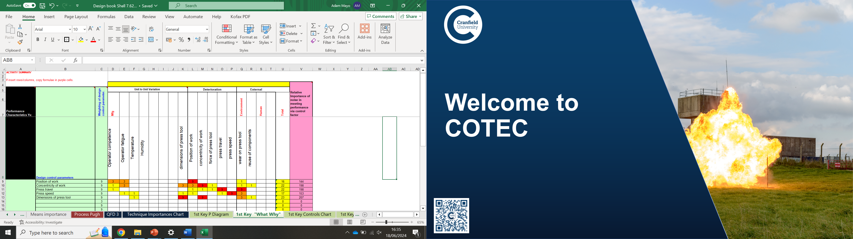
Figure 26 - Manufacturing What-Why Table.

Figure 27 - What-Why, Key controls.

Figure 28 - What-Why, Key noise factors.

5.0 Critical process steps

5.1 Quality Function Deployment (QFD) 4
The final systems engineering tool to be considered in this report is Quality Function Deployment 4 (QFD 4), which takes the manufacturing processes for critical steps and compares them to the control measures that are put in place. By conducting a Gemba visit [18], processes can be identified that are inadequate or can be improved upon, which gives quality control measures on the process. The control measures allow the systems engineer to have a higher confidence of trust in the final product so that it is manufactured to the required specification of the customer. QFD 4 for the tracer is shown in Figure 29 and Figure 30, illustrating that training is the most important control for the tracer manufacturing processes. Therefore, this control measure must be considered in the manufacturing process.

Should a particular process present a problem, then QFD 4 would be conducted again for that particular process until reasonable control measures can be implemented, highlighting the iterative nature of the systems engineering tools.

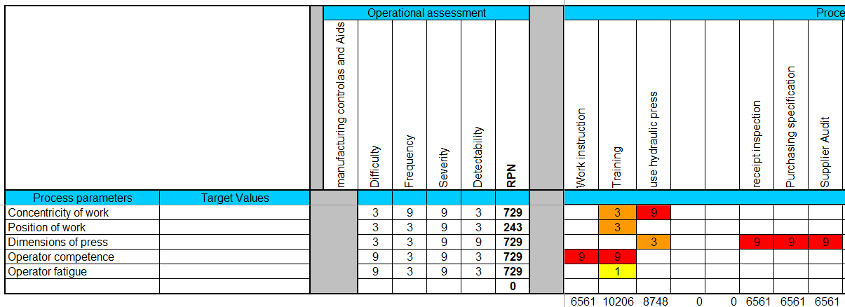
Figure 29 - QFD 4.

Figure 30 - QFD 4 Importances Chart.

6.0 Conclusion
This report set out to develop a robust manufacturing plan for 7.62mm Dark Ignition Tracer Ammunition. This was achieved by identifying the critical features of the manufacturing process and purposing relevant solutions, in the form of control measures, to limit the noise introduced to the processes. The investigation of the sub-system led the systems engineer to identify the dark ignition tracer composition as the critical component. Following on from a DFMEA of this component, the most likely and severe failure was identified to be a lack of confinement. However, other FMEA tools were discussed to provide insight into additional techniques available, which allowed the systems engineer to evaluate the most suitable tool for this report. The noises and controls for this component were identified, which were compared against each other to gain information on the most important controls and noises.

The report progressed to the manufacturing aspects of the dark ignition tracer. This involved identifying the process flow of the tracer composition. The critical process was identified as ‘manual’ using the systems engineering tools, and subsequent solutions were generated with a quantitative justification for their selection. The most important process technique was the ‘hydraulic press’ which was to be expected as this interacted with the most design components during the manufacturing process. Noises and controls for this process were identified and the critical ones clarified. Following, this manufacturing process the critical steps were compared against control measures to pinpoint the most influential control measure.

These findings suggest that in general the systems engineering mindset/ toolset can be used effectively to discover the architecture of the manufacturing process, whilst identifying key components or features that can be controlled in the process to eliminate any noises identified. This is a positive outcome of using systems engineering within the Ordnance, Munitions and Explosives (OME) industry, where safety and reliability are paramount. This suggests that the systems approach can be applied to most situations in a variety of industries, where it is vital for cost saving or safety to ensure the success and reliability of a product or service.

It is unfortunate that the study did not utilise the tools in the best way due to time restraints and the systems engineer was working as an individual and not as part of a team. Working within a team would allow for a broad range of knowledge to be sought and included with each tool. This ensures that solutions would not be subjective or prejudiced from past experience. Furthermore, the more experienced a systems engineer is the better their interpretations of results and the depth of the analysis of tools.

Systems engineering in general is a fruitful subject area that should have further investigations into the integration of the tools and mindset into a range of systems within the OME industry, where safety and performance are paramount.

7.0 References

[1] | D. Holley, 09 Subsystem Design, Swansea: University of Wales Trinity Staint David, 2023.
[2] | S. Burge, “Systems Engineering Process,” [Online]. Available: https://www.burgehugheswalsh.co.uk/systems-engineering/process.aspx. [Accessed 09 03 2024].
[3] | Purdue University, “1.20 Teacher Tool Box- Functional Decomposition,” [Online]. Available: https://engineering.purdue.edu/EPICS/k12/Teachers/Teacher-Toolbox/1.20-Teacher-Toolbox-Functional-Decomposition.pdf. [Accessed 14 03 2024].
[4] | S. Burge, “Function Means Analysis (FMA) Alias Morphological Analysis,” 2006. [Online]. Available: https://www.burgehugheswalsh.co.uk/Uploaded/1/Documents/FMA-Tool-v1-1.pdf. [Accessed 25 03 2024].
[5] | S. Burge, The Systems Engineering Tool Box - Pugh Matrix (PM), 2009.
[6] | Quality-One international, “Quality Function Deployment (QFD),” [Online]. Available: https://quality-one.com/qfd/. [Accessed 26 03 2024].
[7] | “c,” in Chemical Process and Dynamics and Controls, University of Michigan, 2024, p. 757.
[8] | M. Bremer, How to Do a Gemba Walk, vol. 2, Chicagoland Lean Enterprise Consortium , 2014, p. 136.
[9] | D. Holley, 07 Designing Systems and Specifying Subsystems, Swansea: University of Wales Trintiy Staint David, 2023.
[10] | S. Burge, “A Systems Approach to Failure Modes, Mechanisms, Effects and Causes,” January 2018.
[11] | Elsmar Cove, Process Failure Modes and Effects Analysis (PFMEA) Training, 2003.
[12] | D. Holley, 10 FTA2_SE, Swansea: University of Wales Trinity Staint David, 2024.
[13] | S. Burge, Robust Design, Burge Hughes Walsh, 2016.
[14] | S. Burge, The Systems Engineering Tool Box - Stakeholder influence Map (SIM), Burge Hughes Walsh, 2011.
[15] | LucidChart, “What is a Process Flow Diagram,” [Online]. Available: https://www.lucidchart.com/pages/process-flow-diagrams. [Accessed 26 05 2024].
[16] | T. Kolossvary, D. Feszy and D. Tibor, “Systems Engineering in Automotive Product Development: a Guide to Initiate Organisational Transformation,” p. 1, October 2023.
[17] | D. Holley, 11 Manufacturing System Design, Swansea: University Wales Trinity Staint David, 2023.
[18] | M. Bremer, The effective way to do a gemba walk, 2015.

