

Student name: Alya Toseef Javed
Student ID: 2328853
Module name: Changemakers: Building you Personal Brand for Sustainable Employment
Module code: BMHP5015_LON
Lecturer name: Caroline Salami

Table of contents

Introduction…………………………………………………………………………3
Job role overview………………………………………………………………….3
Figure 1: Job vacancy…………………………………………………………….4
Job Description…………………………………………………………………….4
Person specification………………………………………………………………5
Figure 2: Skills and values attained…………………………………………….5
Skills needed for the job………………………………………………………….7
Figure 3: Skills accomplished for future aspirations………………………. 8
Development of personal skills & resources (SWOT)………………………10
Current Experience, Qualifications and Professional Identity…………….11
Personal Brand and professional networking………………………………..12
Figure 4: Networking to build professional relationships………………….13
5-year Action Plan and Timeline………………………………………………..14
Resources Required………………………………………………………………15
Figure 5: Achieving my dream!.....................................................................15
Conclusion………………………………………………………………………….16
References………………………………………………………………………….17

Introduction
Diagnostics Radiographer is gaining significance within the UK healthcare system, with the profession evolving in response to advancements in technology and clinical requirements. Radiographers are expected to integrate specialised technical expertise with effective communication and patient care abilities. By utilising imaging modalities such as X-ray, CT, MRI and fluoroscopy, radiographers play a crucial role in ensuring precise diagnoses and efficient patient management (Society of Radiographers, 2023). Engaging in the profession also necessitates the application of scientific principles while upholding professionalism, empathy and the capacity to maintain composure in high-pressure clinical environments.
The report examines the essential employability skills required for a career in diagnostic radiography. It features a SWOT analysis to assess my existing competencies, highlights areas for professional development and outlines a structured development plan along with a five-year progression timeline to facilitate my entry into this field.
Job role overview
Diagnostics radiographers are highly skilled allied-health professionals who utilise advanced imaging technologies such as X-rays, CT, MRI and fluoroscopy to generate images that facilitate precise clinical diagnosis (Prospects, 2025). To perform this role effectively, radiographers must employ and blend of technical proficiency, communication abilities and professional judgement. Radiographers evaluate imaging requests and substantiate examinations in accordance with radiation legislation, necessitating robust decision-making skills and a comprehensive understanding of clinical governance (Find a job, 2025; Skills England, 2025). Securing informed consent and ensuring the safe positioning of patients also significantly depends on interpersonal skills, empathy and the capacity to articulate procedures clearly to individuals with diverse levels of health literacy.
In addition to capturing images, radiographers assess image quality and decide whether repeats or escalations are warranted- responsibilities that require meticulous attention to detail, problem-solving capabilities and accountability (Skills for England, 2025).
Their obligation for radiation protection under IR(ME)R underscores the necessity for professionalism, risk=awareness and compliance with legal and ethical standards (Society & College of Radiographers, 2025).
Job Description (Based on NHS Radiographer Vacancy)
Figure 1: Vacancy for Diagnostic Radiographer
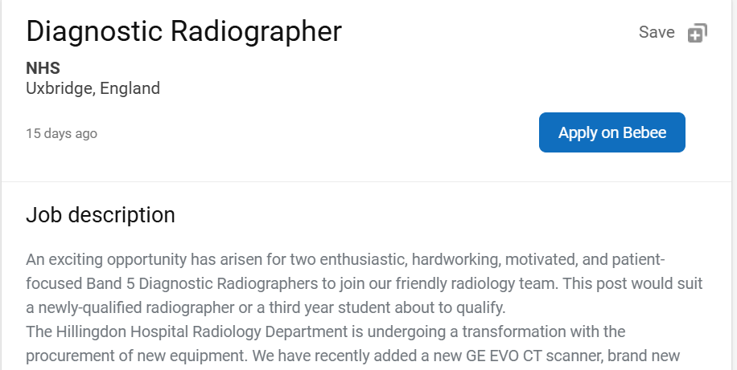

Band 5 Diagnostic Radiographer (Royal Free London NHS FT)
Job Description:
- Rotate through imaging areas (X-ray, mobiles, theatre, fluoroscopy) under supervision. This requires adaptability, time-management and the ability to learn new technical skills quickly.
- Minimise patient radiation exposure through accurate positioning and collimation. This demonstrates technical competence, precision and an understanding of safety protocols.
- Act as an IR(ME)R operator by assessing and justifying referrals. This requires critical thinking, confidence in decision-making and knowledge of regulatory frameworks.
- Monitor departmental Dose Reference Levels (DRLs) and report radiation incidents. This reflects responsibility, attention to detail and the ability to follow governance procedures.
- Escalate complex or atypical cases to senior staff when necessary. This requires professional judgment, communication skills and awareness of personal limitations.
- Maintain competencies using a departmental competency framework. This demonstrates commitment to continuous learning and professional development.
- Communicate clearly and empathetically with patients and colleagues, reflecting the Trust’s values. This highlights interpersonal skills, compassion and teamwork.
- Participate in shift work, including nights and weekends. This requires resilience, flexibility and reliability.
- Maintain confidentiality and adhere to clinical and information governance standards. This shows professionalism, ethical conduct and respect for patient privacy.
Person specification:
Qualifications:
- BSc (Hons) Diagnostic Radiography (or equivalent), registration with the Health and Care Professions Council (HCPC).
Experience & Knowledge:
- Experience in executing a broad spectrum of plain X-ray radiographic techniques.
- Robust anatomical and pathological knowledge to substantiate exams and accurately position patients.
- Awareness and comprehension of pertinent legislation (e.g., radiation protection/ IR(ME)R).

Skills & Abilities:
- Capable of functioning within a team, yet also independently when required.
- Excellent communication skills, empathy and professionalism.
- Dedicated to ongoing professional development.
Figure 2: Skills and values attained.
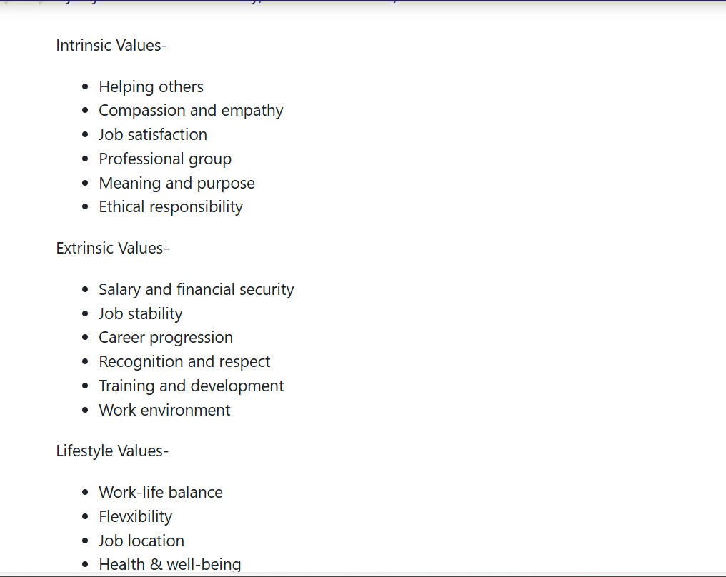

Skills needed for the job, my skills and experience
The Band 5 Diagnostic Radiographer role requires a blend of technical imaging skills, safe justification of examinations in line with IR(ME)R, effective communication, teamwork and a commitment to patient-centred care (Royal Free London NHS Foundation Trust, 2025). Radiographers must also operate within strict radiation safety legislation, such as the Ionising Radiation (Medical Exposure) Regulations (IR(ME)R, 2017), and meet the professional standards outlined by the Society & College of Radiographers (2025).
Although I have not yet begun my radiography course and do not have clinical experience, my Level 4 and 5 Health and Social Care studies, combined with experience in customer-facing and volunteer roles, have provided me with several transferable skills. These include understanding confidentiality, communications with diverse groups and providing supportive interactions, all of which align with the persons specification’s emphasis on empathy, professionalism and effective communication with anxious or vulnerable patients (Royal Free London NHS Foundation Trust, 2025).
Reflecting on my abilities allows me to recognise both strengths and areas that require development. Through personal reflection and feedback from previous managers in non-healthcare roles, I have developed insight into the skills I can build upon.
Community and interpersonal skills are currently among my strongest attributes. My educational background strengthened my understanding of safeguarding, equality and sensitive communication and my previous roles involved interacting with individuals from diverse backgrounds. One manager commented that “you explain things clearly and calmly but sometimes give more details than necessary- try to summarise more concisely.” This feedback highlights an area I must develop further, as structed and concise communication is essential when explaining procedures or giving handovers in radiographic practice (Society & College of Radiographers, 2025).
Despite these strengths, my biggest skills gap relates to radiography-specific technical competencies, such as operating imaging equipment, optimising exposures, positioning patients and evaluating diagnostic images. These are essential for producing high-quality images safely (Royal Free London Foundation Trust, 2025). At present, my knowledge of these areas is purely theoretical, and I recognise that gaining these competencies will require extensive supervised practice during training.
Another urgent area for developing is understanding and applying IR(ME)R in practice. While I have basic awareness of legal and ethical requirements from my Health and Social care studies, I have no experience justifying examinations or applying radiation safety principles in a clinical setting. This skill is fundamental, as radiographers are legally responsible for ensuring exposures are justified and safe (IR(ME)R, 2017).
Finally, image evaluation and clinical decision-making are skills I currently lack entirely. Radiographers must critically assess image quality and decide whether repeats or escalations are needed (Society & College of Radiographers, 2025), which requires knowledge I will only gain through placement experience and academic training.
To address these gaps, I plan to:
- Complete introductory e-learning on IR(ME)R and radiation safety
- Engage in shadowing and observational opportunities before placement, if available
- Practice structured communication (e.g., SBAR) to meet clinical expectations
- Take full advantage of university skills labs and supervised practice to develop technical imaging abilities
- Build an image critique portfolio during placement
- Although I am an early stage, my existing transferable skills provide a solid foundation on which to build the clinical and technical expertise required to become a competent Band 5 Diagnostic Radiographer.

Figure 3: Skill empathy., professionalism and effective communication wis accomplished for future aspirations.
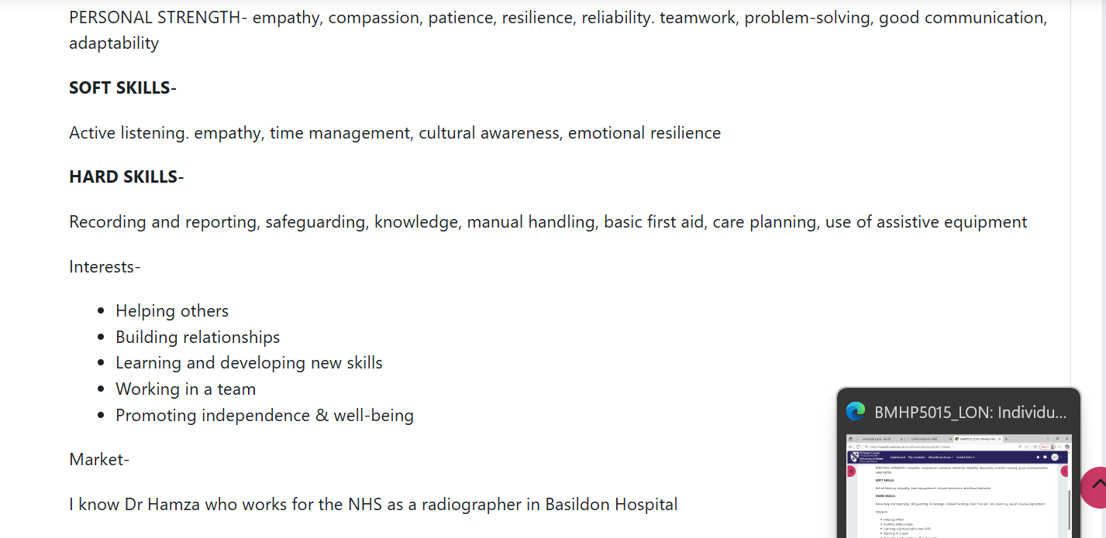

Development of personal skills and resources (SWOT)
Current Experience, Qualifications and Professional Identity
Reflecting on my suitability for a future career in Diagnostic Radiography, I have identified several personal strengths that will support my development. One of my key strengths is my ability to communicate clearly in both academic and social settings. This skill is essential in radiography, as radiographers must explain procedures, reassure anxious patients and collaborate with multidisciplinary teams. My previous volunteering in caregiving has strengthened my capacity to support vulnerable individuals with compassion, which aligns with the NHs expectation for patient-centred practice. Additionally, I manage deadlines effectively and demonstrate a reliability- qualities that are crucial in clinical environments where accuracy, punctuality and professional accountability are required.
Despite these strengths, I recognise several weaknesses that may initially restrict my readiness for radiography training. My lack of hands-on experience in imaging departments means I currently have limited familiarity with radiographic workflows, patient positioning and image-quality assessments. This gap may impact my confidence when beginning clinical placements, as radiography requires practical competence from an early stage. I also lack experience with imaging equipment, which could my ability to perform procedures safely an efficiently. Furthermore, my limited knowledge of anatomy and radiographic physics may hinder my understanding of image interpretation, radiation safety and justification under IR(ME)R regulations. These weaknesses highlight the need for structured development before entering a university programme or apprenticeship.
There are, however, several opportunities available to help address these gaps. The current national storage of radiographers creates increased availability of training places and development pathways (HEE, 2022), improving my chances of securing a university place or apprenticeship. Many NHS Trusts now offer radiography apprenticeships that combine theoretical study with paid clinical experience, which would allow me to gain practical skills while receiving supervision from qualified radiographers. University courses also include clinical placements, giving me the opportunity to develop technical competence, build confidence with imaging equipment and apply academic learning in real clinal settings.
At the same time, I am aware of the potential threats that may affect my progression. Radiography degrees often have stringent entry requirements and without strengthening my technical understanding and scientific knowledge, I may struggle to meet academic expectations. The role itself can be demanding, with high patient exposure to stressful situations, increasing the risk of burnout. Rapid technological advancements also require radiographers to continually update their skills, meaning that a lack of ongoing development could limit career progression. However, many of these threats can be mitigated through the opportunities available. Clinical placements and apprenticeships will provide the practical experience I currently lack, helping me meet entry requirements and prepare for the fast-paced nature of the role. Specialist pathways and continuing professional development opportunities also help radiographers adapt to technological change, reducing the long-term risk of falling behind in skills.
Overall completing the SWOT analysis has enabled me to critically reflect on my readiness for radiography and identify clear areas for improvement. It highlights how my communication, empathy and professionalism form a string foundation, whilst also guiding me toward targeted actions, such as gaining clinical exposure and strengthening scientific knowledge to overcome weaknesses and progress confidently towards my goal of becoming a diagnostic radiographer.
Current experience
My voluntary work with elderly and vulnerable individuals, combined with my Level 4 and 5 Health and Social Care studies, has shaped the beginning of my professional identity. These experiences strengthened my empathy, patience and understanding of confidentiality and safeguarding, which are essential values in diagnostic radiography. They also improved my confidence when communicating with people from diverse backgrounds.
What makes me stand out compared to other applicants is my strong patient-centred approach and my ability to build rapport quickly, which is especially important for anxious or vulnerable patients. However, I recognise academic gaps I must address before starting radiography, particularly in anatomy, physiology, radiographic physics and radiation protection. Improving these areas will prepare me better for university or apprenticeship training.
To build my personal brand, I have begun updating my CV and creating a professional LinkedIn profile that highlights my volunteering, coursework and commitment to radiography: I plan to develop a small digital portfolio with certificates and CPD records to demonstrate my readiness to train.
In terms of networking, I intend to join the Society of Radiographers, attend NHS careers events and connect with radiographers and admissions tutors on LinkedIn. I will measure my progress by tracking the number of new contacts, the shadowing opportunities I secure and whether these connections lead to placements or interview offers. Although all networking methods are helpful, gaining shadowing experience in imaging departments will be the most valuable because it directly addresses my lack of clinical exposure and provides evidence for applications.
Figure 4: Networking to build professional relationships.


5-year Action Plan, Timeline and Resources & Communication Strategy
Year & Goal | Actions/ Objectives | Resources needed | How I will communicate these skills to employers
Year 1 (2026-2026)  Build foundation | - Complete Level 5/6 by June 2026  - Apply for radiography degree/apprenticeship by Jan 2026  - Gain 20+ hours healthcare volunteering  - Complete 3 CPD modules in anatomy/radiography by March 2026 | - Online CPD platforms (e.g., e-LfH)  - University application portals  - Local volunteering services  - Study materials for anatomy/physics | - Add CPD certificates to LinkedIn and portfolio  - Highlight volunteering experience on CV  - Reference academic achievements in personal statements
Years 2-3 (2026-2028)  Develop technical and clinical skills | - Complete academic modules: anatomy, patient care, radiation physics  - Attend 3 clinical placements (CT, MRI, theatre)  - Build communication and positioning skills | - University learning resources  - Placement supervisors  - Clinical equipment and training logs | - Document placements in a digital portfolio  - Use reflective logs in interviews  - Gain supervisor references
Year 4 (2028-2029)  Start professional practice | - Begin Band 5 role by Oct 2028  - Undertake CT, MRI development  - Attend 2 CPD events/ conferences | - NHS Trust training programmes  - Society of Radiographers events  - CPD funding (if available) | - Update CV with Band 5 competencies  - Share CPD event participation on LinkedIn  - Include signed competency documents
Year 5 (2029-2030)  Progress & Specialise | - Explore CT specialisation pathway  - Mentor students  - Work towards Band 6 competencies and leadership skills | - Advanced modality training  - Mentorship guidance  - Leadership workshops | - Showcase mentorship in interviews and portfolio  - Provide evidence of advanced competencies  - Demonstrate leadership through CPD logs

Figure 5: Achieving my dream!


Conclusion
In conclusion this report has explored the essential competencies required for a career in diagnostic radiography, assessed my current strengths and development needs and outlined a structured five-year plan to support my progression into the profession. Radiography demands a balance of technical skills, empathy, communication and continuous learning and although I am still developing my clinical and scientific knowledge, my existing interpersonal strengths provide a strong foundation for future training.
This module has played a valuable role in shaping my emerging professional identity by helping me understand the importance of personal branding, reflective practice and proactive networking. Building a professional online presence, developing meaningful contacts and engaging with CPD activities will be crucial in demonstrating my commitment to employers and progressing confidently towards becoming a Diagnostic Radiographer.

References
Anderson, K. (2021) ‘Introduction to radiographic Imaging.’ London: CRC Press.
Department of Health (2022) ‘Diagnostic Radiography Workforce Review 2019-2029.’ (Northern Ireland). Available at: https://www.health-ni-.gov.uk/publications/diagnostics-radiographry-workforce-review-2019-2029 [Accessed: 24 November 2025].
Gibbs, G. (1988) Learning by Doing: ‘A Guide to Reflective Practice.’ Oxford: Oxford Polytechnic.
Health and Care Professional Council (2023) ‘Standards of Proficiency-Radiographers.’ London: HCPC. Available at: https://www.hcpcuk.org/standards/standards-of-proficiency/radiographers [Accessed: 24 November 2025].
Health and Care Professionals Council (2023) ‘Standards of proficiency- radiographers.’ London: HCPC. Available at: https://www.hcpcuk.org/globalassets/resources/standards/standards-of-proficiency---radiographers.pdf [Accessed: 24 November 2025].
Health Education England. (2022) ‘Diagnostic Radiographer Workforce Report.’ London: HEE.
Ionising Radiation (Medical Exposure) Regulations (IR(ME)R) (2017) ‘The Ionising Radiation (Medical Exposure) Regulations 2017. London: HMSO.
National Institute for Health and Care Excellence (NICE), (2021) ‘Patient experience in adult NHS services: improving the experience of care.’ London: NICE.
NHS careers (2024) ‘Diagnostic Radiographer Job Profile.’ NHS.
NHS Employers. (2022) ‘Person specification guidance for NHS roles.’ Available at: https://www.nhsemployers.org [Accessed: 15 November 2025].
NHS Scotland Careers (2024) ‘Diagnostic Radiographer.’ Available at: https://www.careers.nhs.scot/careers/explore-our-careers/allied-health-professions/diagnostic-radiographer [Accessed: 13 November 2025].
O’Leary, N. (2020) ‘Communication in diagnostic radiography: challenges and strategies’, Radiography, 26(£), pp. 139-146.
Paterson, A. and Price, R. (2019) Principles of radiographic Positioning and Techniques. Edinburgh: Elsevier.
Price, R., Le Masurier, S. and Smith, T. (2019) ‘Workforce transformation in diagnostic imaging’, Journal of Medical Imaging and Radiation Sciences, 50(1), pp. 17-24.
Prospect (2025) ‘Prospects position on the 2025 Pay Remit Guidance.’ London: Prospect. Available at: https://prospect.org.uk/news/prospects-position-on-the-2025-par-remit-guidance [Accessed: 13 November 2025].
Royal Free London NHS Foundation Trust, 2025. ‘Band 5 Diagnostic Radiographer-Job Description and Person Specification.’ Find a Job [online]. Available at: https://findajob.dwp.gov.uk/details/16839142 [Accessed: 21 November 2025].
Royal Free London NHS Foundation Trust, 2025. ‘Band 5 Diagnostic Radiographer-Person Specification.’ HealthJobsUK / trac.jobs [online]. Available at: https://www.healthjobsuk.com/job/UK/London/Herts/Royal_Free_London_NHS_Foundation_Trust/Diagnostic_Radiographer/Diagnostic_Radiographer-v7519524 [Accessed: 21 November 2025].
Skills England (n.d.) Diagnostic Radiographer. Occupational Maps. Available at: https://occupationalmaps.skillsengland.education.gov.uk/maps/occupation/OCC0619 [Accessed: 24 Nov 2025].
Society & College of Radiographers (2025) ‘Education and Professional Standards for the Diagnostic Radiography Workforce. London: SCoR.
Society of Radiographers (2023) ‘Continued Professional Development Guidance.’ SoR.
Society of Radiographers (2023) ‘Updated standards of proficiency of radiographers from September 2023.’ London: SoR. Available at: https://www.sor/org/news/professionalism/new-standards-of-proficiency-for-radiographers-tak [Accessed: 24 November 2025].
Society of radiographers (2025) ‘Scope of Practice.’ Available at: https://www.sor.org/getmedia [Accessed: 24 November 2025].
Society of Radiographers (SCoR). (2023) ‘Career Guide for diagnostic Radiographers.’ Available at: https://www.sor.org [Accessed: 20 November 2025].
UK Government (2025) ‘National Diagnostics Reference Level (NDRLs) for medical radiation.’ Available at: https://www.gov.uk/government/publications/diagnostic-radiology-national-diagnostic-reference-levels-ndrls/ndrl [Accessed: 24 November 2025].

