Part 1

Compile a Simple Descriptive Statistics Report
Word Count 638

Part 1 -SPSS Table and Forest Plot

Distribution of disease in Wales

Descriptive Statistics
 | N | Minimum | Maximum | Mean | Std. Deviation
bmi_overweight_or_obese | 94 | 48 | 63 | 55.81 | 3.952
diabetes | 94 | 3 | 10 | 5.94 | 1.343
health_status_poor_or_fair | 94 | 14 | 34 | 21.47 | 5.054
high_bp | 94 | 15 | 25 | 19.41 | 2.649
mental illness | 94 | 4 | 14 | 9.62 | 2.338
resp_illness | 94 | 8 | 20 | 13.76 | 2.430
smoker | 94 | 14 | 36 | 25.37 | 4.207
Valid N (list wise) | 94
Figure 1 - Descriptive Statistics

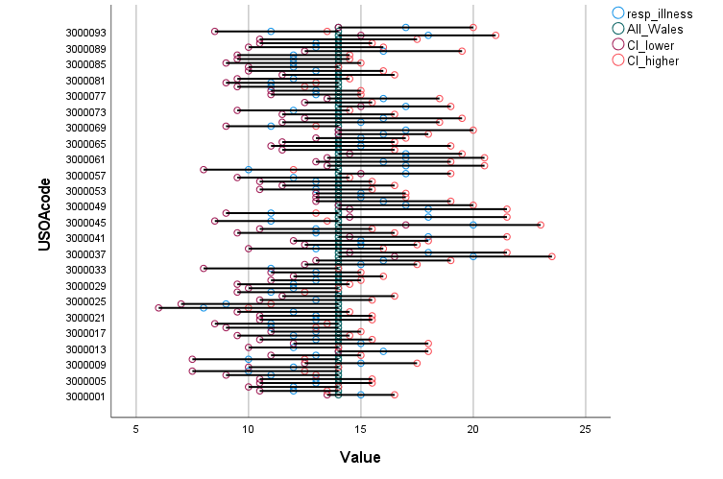
Figure 2- Forest Plot

Data Origins
The data within the descriptive statistics (table 1) and the forest plot (table 2) details the health of citizens in Wales. Tiffany (2012) describes how Welsh citizens self-completed questionnaires as part of the Welsh Health Survey, a continuous survey that began in 2003, and runs all year round. This report combines data from 2003-2009. The survey population were selected using a random sample from the post offices postcode address files, and includes individuals who live in private housing. Individuals from institutional setting such as care or nursing homes are excluded; Tiffany (2012) identifies that individuals in such settings are likely to have poorer health and that this should be considered whilst interpreting these statistics. They also identify that the survey was self-completed and represents an individual’s understanding of their condition rather than a clinical assessment of their health. Tiffany (2012) details how data has been split into USOA – super output areas which contain a similar population size, smaller than local authority sizes but large enough to allow a wide range of statistics to be produced, with an average population of 32,000.
The Descriptive Table
The descriptive table provides overall percentages of illness with a standard deviation to illustrate the spread of reporting, with some conditions having a small value for standard deviation (SD) indicating that the data is clustered nearer to the mean with a more consistent pattern of illness across Wales. Whilst some conditions have a large value SD indicating that, the data is spread away from the mean with peaks and troughs amongst USOAs.

Illustrating the variation amongst USOAs the variation in health is stark for some conditions such as ‘reported health status poor’ varying from 14% to 34%, with a large SD at 5.05 indicating a significant difference between USOAs. Similarly, smoking had a large SDs indicating a smaller but significant difference in reporting of smoking behaviour amongst USOAs. There is more of tendency to the mean and thus widespread distribution of disease in particular with Diabetes with a mean average of 5.94% and SD of 1.343. One fifth of the overall Welsh public suffering hypertension with a SD 2.65 indicating a moderate distribution of disease, although the min and max range being 15-25% and the mean being 19.41. Reporting of overweight or obese is significant with a minimum of 48% of and maximum of 63%, mean of 55.81, reporting this as an issue, there is a large SD but a figure of almost 50% at the minimum indicated a significant issue despite the spread across the USOAs.

The Forest Plot
The forest plot demonstrates respiratory illness per USOA and against an all Wales average, with 95% of the population falling between the upper and lower confidence values. Using the table from Tiffany (2012) to identify USOA codes demonstrates a higher degree of respiratory illness within the South Wales valleys compared to the rest of Wales apart from a small cluster in Anglesey. Comparing this data to smoking incidences may identify a correlation but further correlation with health status and mental illness, industry in the area, work history and indices of poverty would provide a richer picture of reasons for respiratory illness in these areas.

Reference List
Tiffany, C. (2012) Sub-local authority analysis of the Welsh Health Survey, Public Health Wales Observatory, available at http://www.publichealthWalesobservatory.Wales.nhs.uk/ (accessed on 22/03/2023)

Part 2

Outline a Data Analysis Plan
Word Count 5,478

Part 2 -Data Analysis Plan
A Nursing Perspective on the use of Digital Documentation, its Effects on Nurses Time, Their Ability to Care and Patient Outcome

Part 1 - Context and Scope
Post Coronavirus pandemic, significant challenges to nurse recruitment and retention exist, with the ICN (2023) describing the worldwide shortage of nurses as a global health emergency. It is essential that any digital system, designed for use by nursing staff, support the delivery of safe efficient patient care.

Digital nursing documentation for adult inpatients in the form of the Welsh Nursing Care Record (WNCR) was introduced in Wales in April 2021. Beadle and Rodgers (2017) identify the fundamental aims of WNCR as enabling nursing staff to better manage their patients by releasing nurses to care and facilitating clear, accurate concise and contemporaneous nursing records in compliance with Nursing and Midwifery Council (2015) nursing code of conduct. These aims were supported by the Chief Nursing Officer for Wales, White (2019) who identified the project as enabling the provision of safe and effective care, which would reduce the administrative burden of completing paper documentation, and enable nurses to spend more time on direct patient care, subsequently improving patient care and staff experience.

Braun (2023) describing the WNCR roadmap identified multiple future releases of documents, spanning the next two years, along with the release of new and improved functionality. Based on this a formative evaluation of WNCR will be undertaken, identified by the Health Foundation (2015) as an evaluation that is undertaken as the intervention is evolving. This evaluation will be in the form of a case study of a local Health Board (HB) and will aim to establish from a nursing perspective if the aims detailed by Beadle and Rodgers (2017) have been met. This will uncover new evidence relating to the use of digital nursing documentation and its effects on nurses time to care and patient outcomes.

The findings from this study will enrich the evidence base around WNCR and be transferable to any health board in Wales. The study will also add to the pragmatic understanding of EHRs and how they are perceived by the end user, and will be beneficial to anyone interested in the digitalisation of nursing documentation and other electronic health records. The review of implementation strategies, devices and staff training are outside the scope of this project but may be highlighted in feedback from WNCR users.

Part 2 – Define and Justify Project Aims
The HB within this case study were one of the first to implement WNCR in April 2021 and completed their implementation in November 2022. WNCR is used on all adult inpatient areas including two specialist ITU areas. WNCR is not used on paediatric or mental health inpatient areas.
The adapted Donabedian diagram in table 1 identifies the proposed outcomes of the introduction of WNCR. A formative evaluation on the use of WNCR in the local HB using a pragmatic case study approach will be undertaken. This will investigate if digital nursing documentation has met these outcomes from the perspective of the main service users. Preskill and Russ-Eft (2005) illustrate how the use of a case study design when evaluating is useful, allowing for understanding of the participants perspectives, where generalisation is not the goal. Cresswell et al (2020) contends that undertaking a pragmatic formative evaluation can help to understand areas for improvement in systems and identify ways to improve and streamline process and provide stakeholders with the information they need to adjust their strategy enabling faster and more effective learning.
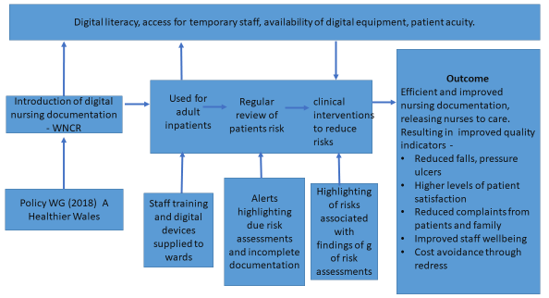
Fig 1 - Adapted Donabedian Diagram, from Lilford (2010)
Creswell and Poth (2018) suggest that a case study in qualitative research as the study of a real life contemporary bounded case which could be a wide scope such as an organisation or individual case, and utilises detailed in depth data collection from multiple sources e.g. observation interviews, documents, reports, to identify themes. Friedman (2022) describes case studies as particularity useful means of conducting an organisational level and are ideal for summarising the results of an evaluation study by combining what has been learned using different methods, thus gathering information in differing ways so the information paints an accurate picture of the situation.

Dixson (2016) identifies the task of the evaluator is understand of the impact of an intervention in the surrounding context and understand the relationship between them. Craig et al (2021,2022,2023) conducting internal post implementation evaluations documented significant time savings using WNCR, which were not reflected in the comments received from nursing staff who found the system time consuming and were concerned it took them away from their patients. Booth et al (2021) contends that nurses haven’t kept pace with technological advances and maximised the benefits that digitalisation can have on patient outcomes, referring to some nurses viewing digitalisation as an unwelcome intrusion into hands on patient care and building therapeutic relationships with patients.

Kelly et al (2010) in a literature review found that the assumption that digital documentation will lead to improved outcomes had yet to be confirmed. Whilst, McCarthy et al (2018) in a robust systematic review of digital nursing documentation concluded that there was little evidence that digital documentation improved patient outcomes, they recognised the poor quality of some of the research critiqued and the need for further research using qualitative and quantitative methods. Wiggins et al (2022) as part of a research MSc into WNCR at Bangor University found great variation with some staff suggesting WNCR took longer to complete and other stating it was quicker. This study was undertaken early into the Wales wide implementations now that the system has had time to embed in practice and staff are familiarity with the system a truer picture of its effectiveness in practice.
Friedman et al (2022) describes the difference between research and evaluation as subtle but important; both collect and analysis of data, but evaluation is shaped by questions of interest to audience who are separate from the team conduction the study, he provides a generic set of questions upon which to build an evaluation (table 1)

Post release | - Is the resource performing as intended? Why or why not?  - how can it be improved
Post release | - Did it make a difference to clinical practice? Why or why not?  - Are the differences beneficial? Why not?
Post release | - Are the observed affects those envisioned by the developers? why or why not  - Are there unexpected effects? Why?
Table 1 - Friedman (2023) Research Questions
To understand who are most affected by these questions, it is important to define all stakeholders in WNCR. It would be easy to assume that the WNCR is only used by nurses, however allied health professionals also use WNCR. Friedman et al (2022) suggests that to make the resource better it is necessary to undertake a stakeholder analysis and communicate directly with the those in the real word using the resource. A review of the local access group for WNCR identified multiple users, Table 2 crudely represents the frequency and purpose of use along with the impact and power of multiple stakeholders and as expected identifies nursing staff as the primary users of WNCR, but acknowledges that WNCR also affects the workload of other staff groups.

Table 2 also identifies that WNCR has the highest impact on nurses but they have the least power to influence future design processes. Salmen (1989) points out that those who are intended to benefit from a change either lack a voice or are not listened to by those designing activities. He suggests a beneficiary assessment can act as a bridge of understanding between those designing a project and the beneficiaries of the project, enabling the understanding of the value of an activity as the principle users perceive it. Whilst a beneficiary assessment is not being conducted, understanding from a nurse’s perspective the effects of WNCR in key areas is essential to evaluate the effectiveness of the system and to improve future design.

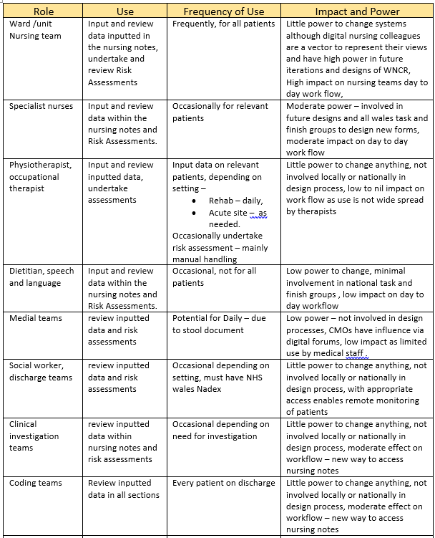
Table 2 Stakeholders, Role, Use, Impact and Power
Friedman et al (2022) pragmatic questions and study results in informatics are used to inform and improve developments of computing artefacts and provide society with a reassurance that artefacts deployed in the real work are safe and reliable. Turner et al (2016) suggests a single measure of effectiveness e.g. increased completion of admission documentation could be unduly narrow and neglect other potential benefits and unintended consequences, and also need to consider the value of something – whether it works or does not work . With this in mind, three research questions are proposed.

Compared to paper process -
- Does digital nursing documentation improve completeness of documentation?
- Does digital documentation free up nurses time to care?
- Does WNCR support improvements in patient outcomes?

Part 3 – Data collection and Analysis Plan

Tong et al (2007) highlighting the need for a robust checklist to ensuring research objectives are met, provides the ‘Consolidated Criteria for Reporting Qualitative Research’ (COREQ).The four domains from within COREQ have been used to identify data collection and analysis methods.

Domain 1: Research team, reflexivity, and Personal Characteristics
The principle researcher of this evaluation is a qualified nurse with a degree in Adult Nursing, currently studying a MSc in Digital Transformation for health and care professionals. The researcher is currently employed as an Informatics clinical nurse specialist within the Health board were the study will be conducted. She has a professional interest in the evaluation findings and their impact on future development of WNCR. She is part of the team who initially implemented WNCR and provides ongoing WNCR clinical support to ward teams, as well as being a member of the all Wales nursing forum responsible for developing future iterations of WNCR. The possibility of personal bias is recognised both in terms of the relationship with staff and as part of the WNCR project team.

Domain 2: study design
- Theoretical framework and Methodological Orientation
To answer the research questions several ontological approaches were considered. The introduction of WNCR has resulted in the generation of big data. Mertens (2018) highlights that big data can provide information on a whole population rather than just a sample group, with 54 wards live every digital interaction with WNCR is recorded and can be audited. The use of quantitative data would lend itself to a positivist approach; however, this data would only demonstrate the digital interaction and not represent the impact of the complex clinical environment that WNCR is used in.

To evaluate the impact of digital documentation on nurses’ practice it is essential to collect qualitative data, the use of a constructivists approach facilitated by undertaking an observational study on a small cohort of wards was explored. However, WNCR is used in wide range of inpatient setting, with a wide variation in the acuity of patients, the speed of patient flow, the size and layout of wards, and a variety of digital equipment in use on each site, all of which will influence staffs experience of using WNCR. Furthermore, wards are at differing levels of digital maturity, with some areas being live on WNCR for 6 months and others 2 years, and some wards using an electronic prescribing and medication administration system for more than three years, and some wards yet to go live.

All of these factors influence the users experience of WNCR and make it impossible to study one area and generalise the findings to other areas. A pragmatic approach will be used, identified by Brinkmann (2017) as facilitating the use of whichever method is most useful, enabling the triangulation of data and the development of a rich understanding of the situation. The use of mixed methods for such cases is supported by Creswell et al (2013) who suggest that mixed methods are best used when the quantitative and qualitative approaches by themselves ae inadequate to develop multiple perspectives and a complete understand of the research question, e.g. the use of qualitative data to make quantitative outcomes measures comprehensible. The movement between quantitative and qualitative research will highlight the auditable data relating to completion of nursing documentation, and the lived experience of the nurses and how WNCR affects their practise.

Johnson et al (2007) detail how Pragmatism recognises the effects of the physical, social and psychological world on individuals and how they interact day to day with their environment. They further recognise the need to constantly adapting to new situations and environments, and to improve on past understanding and ensure it fits in the world in which we live. Morgan (2007) within a pragmatic approach it’s important to ascertain what knowledge from one method in a specific setting can be applied in other circumstances. This involves a process of working back and forth between results and their more general implications.

Johnson et al (2007), pragmatism acknowledges how people's daily interactions with their surroundings are influenced by the physical, social, and psychological world, recognising the need for individuals to constantly adapt to new situations and environments. Morgan (2007) suggests that using a pragmatic approach we can assert that theirs both a single real word and those individuals have their own unique interpretation of that world. Mertens (2018) suggests that a pragmatic approach allows researchers to create research agendas based on the respondent experiences, and that by gaining a deeper understanding of organisational process and staff member behaviours, experiences, and understanding the connections between these experiences will enable the research to be of practical value through the creation of actionable knowledge.

- Participant selection and Sample Size
WNCR has a large user base; nursing staff who work in adult inpatient areas are the principle users and will be the primary target of the questionnaire. Other users of WNCR are most likely to view or input data into an area of WNCR. Future studies to understanding their experiences of WNCR would be useful but they are not the primary target group for this evaluation.

Friedman (2022) believes it is never possible to sample all users of an information resource, and that it is more practical to choose a representative sample. Based on estimate of 2500 nursing users of WNCR and a confidence level of 95% and 5% margin of error the ideal sample size of 333 was calculated using the Qualtrics (2023) sample size calculator. Permission will be sort to circulate the questionnaire and the sample group will be contacted via an email this will clearly state the aim of the questionnaire to gather information for academic purposes, a link to the questionnaire will be placed on the HB WNCR homepage. Staff will also be asked if they wish to participate in a series of focus groups and to complete a form asking for basic information on their role, preferred date of attendance and whether they wish to attend via Microsoft teams or face to face. Bowling (2023) identifies that due to the size of the staff pool there is likely to be a significant non-response rate.

Agency nurses may use WNCR in several HBs, their replies may be biased by experiences in other health boards, this bias will be recognised and agency nurses responses will be reported separately, an evaluation aimed at understand the effects of digitalisation on our temporary workforce and how restricted access to systems affects their workflow and patient safety would also be helpful but out of scope here.

Parahoo (2014) suggests that the use of volunteer sampling is the weakest form of sampling, identifying it as a sample of convenience where the researcher has little control over who is taking part and suggests those recruited may be conformist with traditional viewpoints and could bias the sample. This method will however remove the risk of selection bias by the researcher who is familiar with most staff. Creswell (2014) further identifies volunteer or convenience sampling as saving time, money and effort but at the expense of information and credibility. Gerrish and Lacey (2006) identify the use of convenience sampling as key to recruiting an accessible group of participants and the building of trustworthy relationships to facilitate qualitative research.

- Setting
The study will take place within a Welsh HB. The HB has three main hospital sites, including a large acute tertiary hospital, a medium sized sub-acute hospital and third smaller rehabilitation hospital, as well as a dedicated palliative care unit and a single warded cottage hospital. These sites deliver a variety of tertiary services including renal, cardiac, burns, trauma, neuro and elderly rehabilitation as well as containing general and specialist medical and surgical wards. All hospital sites are digitally mature using multiple digital programmes e.g. EPrescribing, electronic white boards for patient flow and handovers and electronic test requests in addition to WNCR.

- Data collection Methods
Paulus and Lester (2022) identify having a thorough understanding of what’s known and unknown about a topic as essential, and Machi and McEvoy (2016) suggest undertaking a literature review will enable a comprehensive understanding of the current state of knowledge about a topic. Paulus and Lester (2022) identify how a literature review frames a search for new evidence and creates an argument, grounded in evidence that justifies the reason for a new study. Whilst this method is generally used in a positivist ontology, it will also be beneficial in the pragmatic approach enabling the generation new knowledge and will be completed to provide a baseline of knowledge relating to digital nursing documentation.

Qualitative Data Collection
- Staff Questionnaire
The questionnaire will use Likert Scale and closed questions to attain quantitative data as well as open questions depending on the response required, parent and child questions will be used e.g.
- Do you think WNCR saves time? yes or no
- yes – Please describe how WNCR saves time
- NO – Please describe how WNCR is more time consuming

Bowling (2023) describing acquiescence response bias where responders are far more likely to endorse a statement rather than disagree with its opposite, thus questions will be screened for neutrality, she also identifies that those who respond to a survey are most likely to give positive results compared to those who are uninterested or dislike the topic being surveyed.

Bruce et al (2018) identified that long questionnaires can cause fatigue, and recommend they take no longer than 20 minutes to complete. Parahoo (2014) suggests that the length of questionnaires not only affect the response rate but also lead the respondents to take them lightly and have a negative effect on the reliability and validity of the study. To screen for such issues the questionnaire will be piloted on a small group of staff and refined following a PDSA cycle. Parahoo (2014) suggests that refining questions by piloting them can enable the detection of typographical errors and also if the questions have been written in a way which makes sense to the respondents, and if the length of the questionnaire and structure are like to affect response rates.

2. Focus Groups
Focus group members will be provided with a terms of reference and an information sheet highlight the purpose of the group, and asked to commit to two meetings with the option to attend a face to face or Microsoft teams session. The Microsoft teams sessions will be transcribed but not recorded; the ethical implications associated with teams will be discussed in section 4. The groups will be facilitated by a moderator and an observer and will have no more than fifteen participants. Staff will be allocated to sessions according to the staff group to ensure a cross section of staff in each session. Field notes will be taken particularly relating to interactions between members and how engaged members appeared to be. Certificates will be given to all staff who attend as well as a letter of thanks, both of which can be used towards the qualified nurses’ revaluation and for work appraisals

Bowling (2023) identifies the purpose of a focus group as generating new data and not to just have a group discussion, thus, the groups will discuss themes identified from the questionnaire to frame open discussions. The meetings will be time bound for one hour, and members will be asked to fill in an evaluation following the meeting. This will enable the research team to check there have been no negative effects on the staff members following the discussion. Gerrish and Lacey (2006) suggests it is seldom practical to ask focus group participants to check to validate of transcripts, thus there will be a 10 min debrief at the end of each section for moderator to summarise what they believe to be the main issues to have emerged and to allow tentative themes to be identified.

Hennink and Kaiser (2022) identify saturation is considered the cornerstone of rigor when determining sample sizes for qualitative research. Saturation is defined by Friedman (2022) as the point in a qualitative study where enough data has been gathered and nothing new is being learnt. Thus whilst participants are asked to commit to two focus group sessions, if the first round of focus groups reach saturation and are not brining any new information the second set will be cancelled.

Qualitative data will be analysed using a thematic analysis or the framework method. Gale et al(2013) describes how framework methods are not aligned to any particular epistemological approach and provide a flexible tool which can be adapted to any approach, and suggests the method is not inductive or deductive – it is the type of question which illicit this type of response. Parahoo (2014) describes how the framework method enables qualitative data to be broken down into as many part or categories as can be identified before being grouped together into manageable themes based on their similarities. Gale et al (2013) describes how the systematic approach and matrix structure facilitates the recognition of patterns in the data and provides a clear audit trail from original raw data to final themes.

- Quantitative Data Collection – Interrupted Time Series
Data related to the timing of risk assessments is available from DHCW, this is aggregated across the wards and each risk assessment, the mean and mode averages are available along with the SD. Plotting this against timings taking by the WNCR implementation pre implementation for the same assessments will provide a simple before and after study. Health foundation (2015) identify that whilst a before-and-after or time series analysis are straightforward to do, the results should be interpreted with caution as improvements may happen irrespective of the intervention and measurements may not reflect the mean. The existence of confounding variables identified by Bowling (2023) as extraneous factors not controlled for which could distort the study results e.g. extremes of patient acuity and poor staffing levels are also affect the reliability of a one off comparison. Thus ensuring multiple timings are recorded will enable a greater confidence rating; this approach is supported by Creswell (2016) who suggests that collecting data in the short, medium and long term will enable a richer understanding of the affects of a system on individuals and their workload.

Each set of data will built another layer of understanding relating to WNCR and nursing documentation enabling a rich understanding of the effects of WNCR on nursing staffs time, workflow and patient care. Comparing falls and pressure ulcers pre and post WNCR could also provide a quantitative basis to compare patient outcomes, however the COVID pandemic, rising patient acuity, poor staffing levels and multiple health board initiatives to reduce these factors will not be adequately represented in a large-scale study, thus this method of anlaysis has been excluded.

- Domain 3: Data Analysis and Reporting
Qualitative Data
Creswell and Perth (2018) suggest that using a case study model enables researchers to establish themes and patterns and then develop naturalistic generalisations of what was learned. Adu (2021) identifies four steps to coding data. Beginning with the use of the coding method tree (figure 3 ) to determine an appropriate coding strategy, from there he suggests creating an anchor code for each research question, before identifying relevant responses, and assigning a code or connecting to an existing code before categorising these codes into themes.
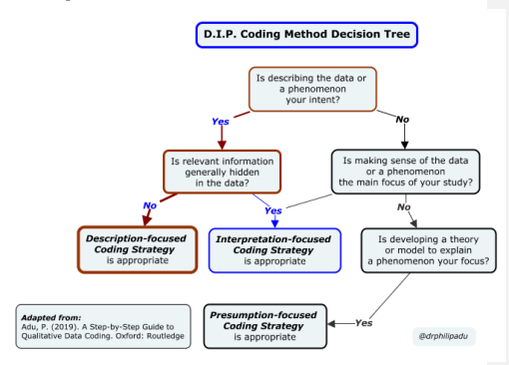
Figure 3 – Coding Tree, Adu (2021)

To facilitate the coding of the qualitative data from the focus groups, the principle researcher will use a Qualitative Data analysis software package (QDAS). Paulus and Lester (2022) identify that most major QDAS packages now support the transcription of audio and video recording. Major and minor themes will be identified and participant quotations used to illustrate these themes, the transferability of data will be discussed and consistency of findings illustrated.

Quantitative Data
The demographics of the questionnaire respondents will be summarised in a table identifying the spread of job role, areas of work and time using WNCR. Parahoo (2014) describes how descriptive statistic are used to describe and summarise the frequency central tendency and dispersion of data. Thus, a descriptive table detailing responses from the questionnaire will include the upper and lower response limits mean, mode and standard deviation.

Bruce et al (2018) describes how there are often complex interrelationships amongst variables which can be explore by the use of simple linear regression. The use of scatter plots to compare variables such as time saving with WNCR and users perceived digital literacy may illuminate such correlations, similar comparisons will be made between increased completion of paperwork and perceived patient outcomes.

Statistical significance is usually defined as a p-value of 0.05 or less, with Heston and King (2017) clarifying that the chance that the null hypothesis is not true is at most 1 in 20 time, thus the predicted chance of the findings randomly occurring is less than or equal to 1 in 20 trials. Confidence intervals of 95% will also be set. Bowling (2023) explains this means that 19 out of 20 times the results will be within the upper and lower limits. Mariani and Fernandes (2014) suggest that whilst statistical significance may not be sufficient to change practice, there is a need to understand the clinical significance of such results in practice. Sen et al (2021) suggest clinical significance or practical importance is subjective and that the decision on significance depends on the context and may vary from person to person. Thus responses from staff in the questionnaire on significance of impact of WNCR and time saved will be compared to the statistical data on time save from the timings of risk assessments.

Through the collection and analysis of data from mixed methods and a pragmatic cross comparison using induction, deduction and abduction will enable a rich understanding of the effects on nursing staff and patient outcomes.

Part 4 - Ethical or Information Governance Issues
Carrying out an evaluation brings ethical and information governance issues. Evaluation Works (2022) in their NHS evaluation toolkit advise that ethical implications are considered and a plan put in place to mitigate highlighted issues and ensure continuous review throughout the project lifecycle. The University of Wales Trinity St Davids (UWTSD) (2022) Research Ethics and Integrity Code of Practice (REICP) directs researchers to follow their professions code of conduct and ensure the principles of beneficence, non-maleficence are maintained, as well as –
- protecting participants rights
- avoid harm or potential harm through risk management
- ensure research is proportional and consider the effect on the work of others
- ensure informed consent
- avoid deception
- provide debriefing
- allow for withdrawal from the study
- ensure confidentiality
- ensure that research data is held securely and archived in a way that is accessible for future audits

UWTSD (2022) further direct researchers of health and social care to comply with the UK policy framework for health and social care. The Health Research Authority (HRA) (2023) Framework of health and social care research requires all studies, which are deemed research to undertake a formal ethics committee review. Using the HRA (2020) decision tool alongside the HRA (2022) defining research table this study was deemed a service evaluation, and does not require formal approval from an ethics committee. The principles enshrined within this framework are acknowledged and will provide guidance for good practise whilst conducting questionnaires and focus groups.

The local health board handbook stresses the importance of protecting the personal data of staff including their voice or image, with Hackett (2023) directing that staff and patient data is processed in accordance with data protection legislation. The Information Commissioners office (2022) places a number of duties under the GDPR legislation on an individual who is processing personal data. A summary of these duties is illustrated in Figure 4 and includes the safe collection, storage and disposal of study data. A review of UWTSD (2022) REICP indicates that a ‘Data Protection Impact Assessment’ may be required, and will be completed following guidance from academic supervisors.

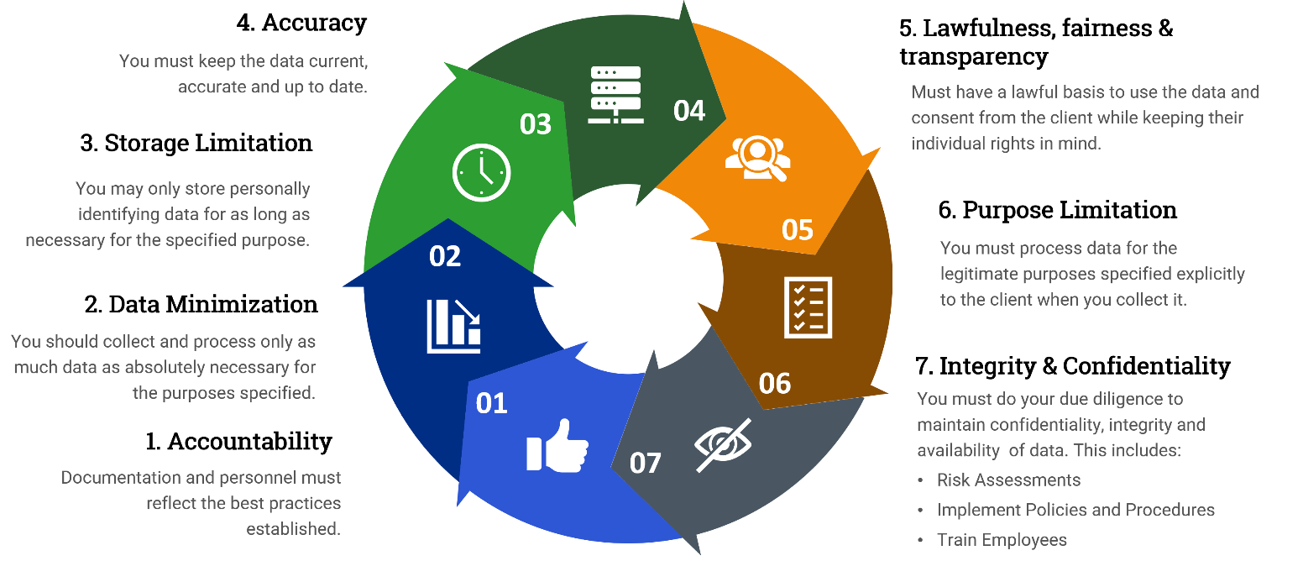
Figure 4 Cybercompass (2023)
This evaluation is being conducted for scholarly purposes. UWTSD (2022) expect that research conducted in and by the university is in accordance with the core aspects of research integrity as detailed in table 2. They direct that research must be considered for ethical approval if it involves others or has the capacity to interfere with or make a difference to their lives, and requires students to ensure that all research is subject to active and appropriate ethical consideration and complies with ethical, legal and professional frameworks and standards. Thus a ‘UWTSD Application for Ethical Approval’ will be submitted, a draft copy of which is available in the Appendix.
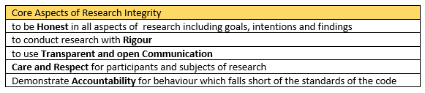
Table 2 Core Aspects of Research Integrity, UWTSD (2022)

Applying these principles data collection and processing
- Questionnaire
The use of Microsoft forms to complete the questionnaire will enable the anonymity of participants, for analysis purposes it will be important to understand what areas participants work in and their job roles but individual names or specific ward areas will not be collected. Once an individual response has been received for the questionnaire, it would not be possible to withdraw it, as it will not be possible to identify individual responses. The completion of the staff questionnaire should not cause direct harm to staff, other than taking up some of their time. An accompanying information sheet will provide full disclosure on the purpose and use of the data collected within the questionnaire.
- Timings of risk assessments
The WNCR implementation team collected baseline timings prior to each implementation; this information has subsequently been anonymised. Friedman (2022) suggests that the digital sphere within which evaluations are undertaken poses many unanswered questions about intellectual property and data ownership; to overcome this permission will be sought from the local health board and the data provider to reuse this data. The data will be compared with subsequent timings of digital documents. The data provider averages these timings thus no data relating to individual patients or staff is collected. The data is not in the public domain. Informa UK (2023) identify the need for a data availability statement in such cases to describe where the data associated with the paper can be found and under what conditions it can be accessed.

- Focus group

Hammersley and Trianou (2012) identifying the rise and use of digital tools in research as presenting new ethical quandaries, some of which can be overcome with the provision of an information sheet to each group member.
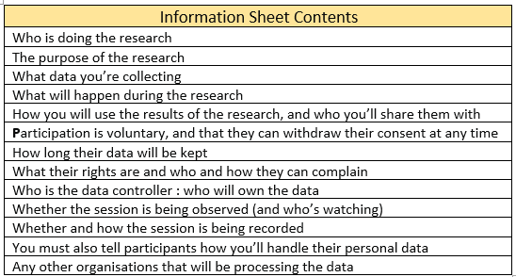
Table 3 – Information sheet Contents, User Research Community (2016)
User Research Community (2016) provide a list of information that should be included in an information sheet (table 3), this ensures participants understand the purpose of the sessions and that the research is ethical and abides by data protection and information governance regulations. The User Research Community (2016) also include directions in the use of plain English and suggest that the information is delivered in a format that participants can access e.g. email, post or read aloud.
The information sheet will advise participants that the session will not be recorded and that the transcription function will be used to assist with recall. Immediately post meeting the transcription will be reviewed and with the use of UK Data Service (2023) Text Anonymisation Helper Tool all personal data will be reviewed and anonymised. Staff who attend focus groups may be subject to opposing or conflicting conversations, these may be uncomfortable for some group members, and to control these clear rules of the group will be set out at the beginning of each sessions. Mirroring the values of the local HB, staff will be asked to respect each other and value each other’s contributions.
The avoidance of deception and inappropriate bias is also considered. Creswell and Porth (2018) highlight there is a risk of the qualitative researcher siding with participants and shaping findings towards their viewpoint, they stress the need to report honestly presenting multiple perspectives. Friedman (2022) reports that it’s common for inexperienced research team members to blend descriptions of observations with their own interpretation, making it difficult to understand what is fact and what is interpretation, to avoid this a second researcher or academic supervisor will review the evidence.

Appendix – University of Wales Trinity Saint Davids, Ethical Approval Form 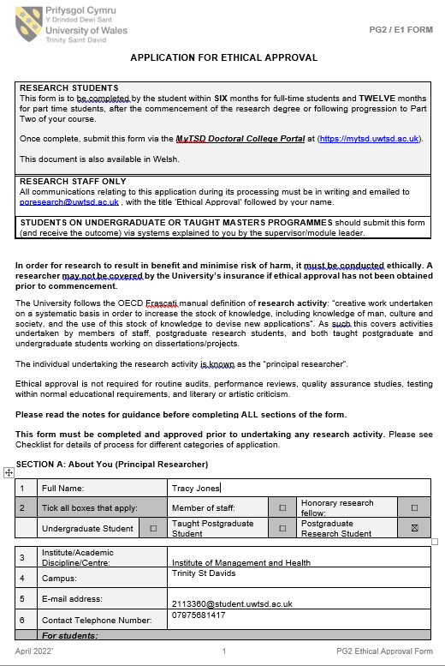
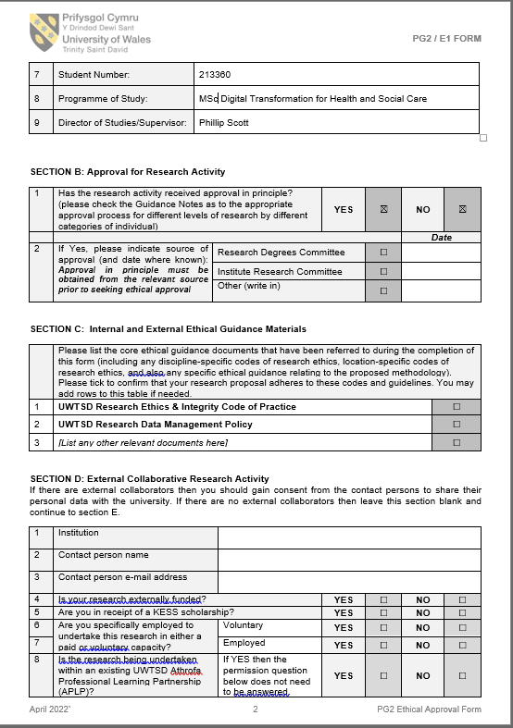
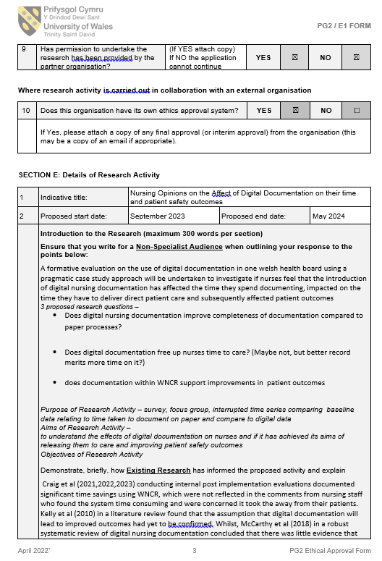
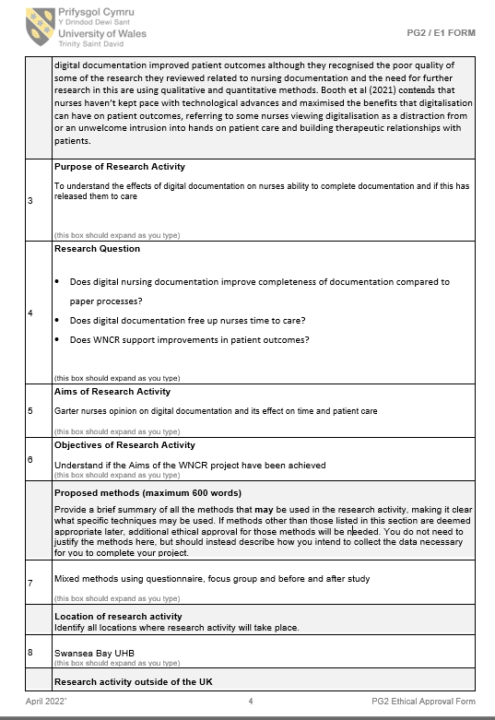
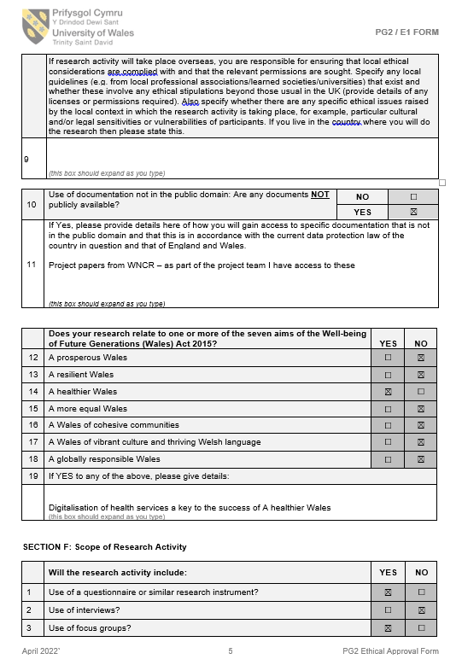

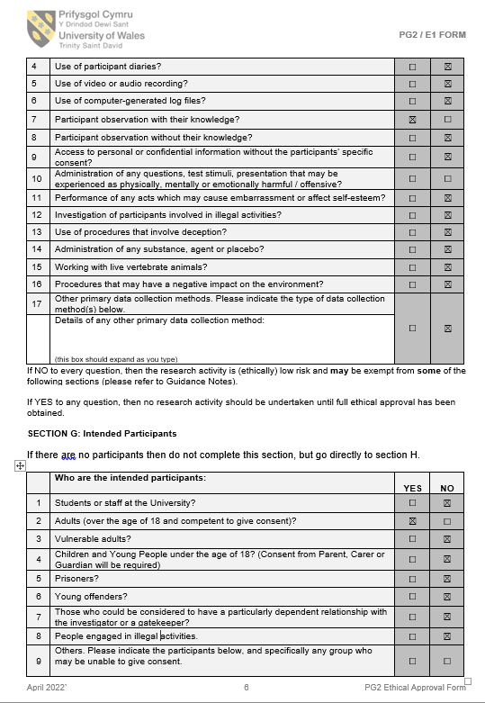
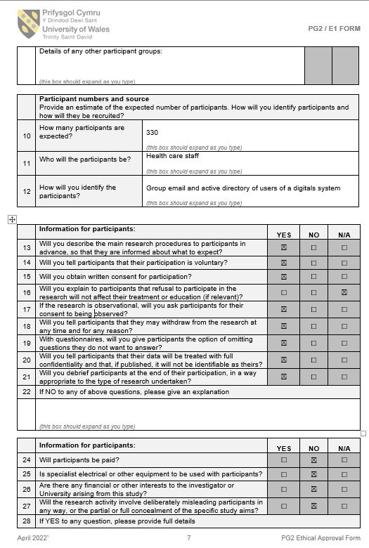
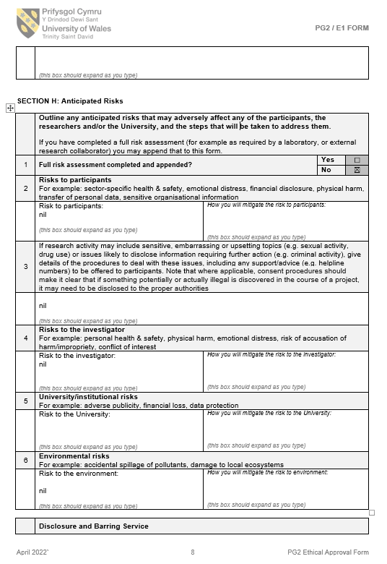
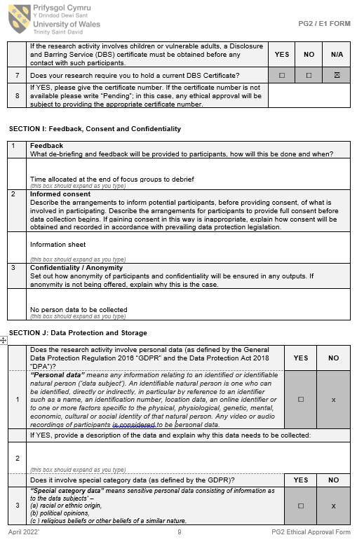
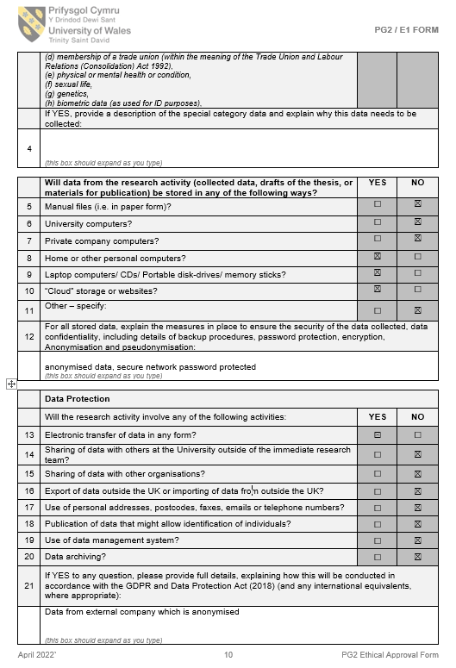
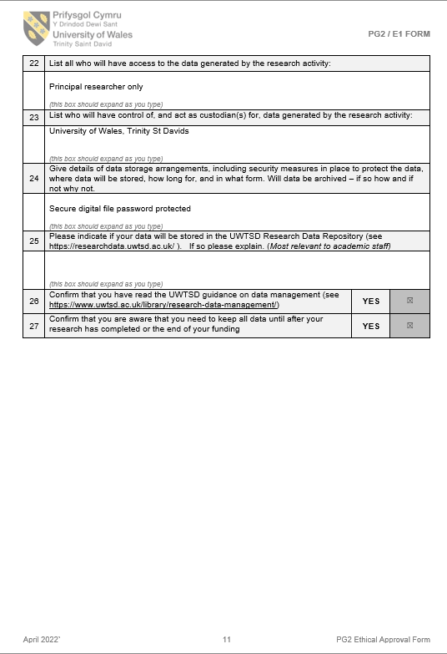
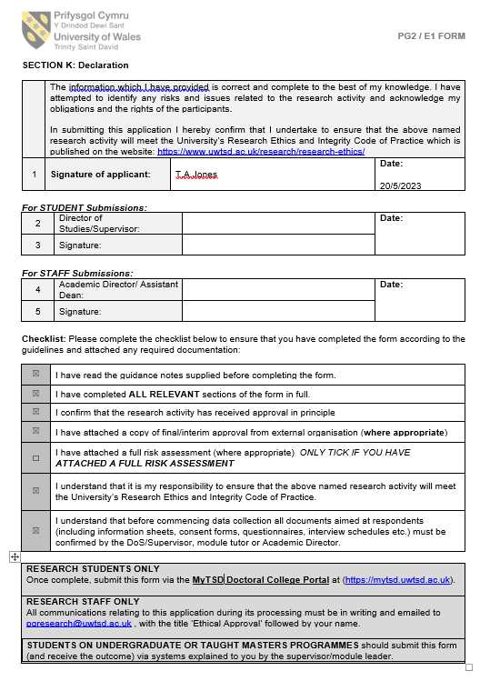
Reference List

- Adu, P (2021) ‘Qualitative data coding’, V111th International Eurasian Educational Research Congress, (EJERs’21) Turkey, 21July 2021. Available at: https://www.researchgate.net /publication /353174130_Qualitative_Data_Coding (Accessed on 10/05/2023)

- Beadle, F. and Rodgers, S. 2017, The future of nursing E-documents in NHS Wales. Digital Health Care Wales. Unpublished.

- Booth, R. et al (2021) 'How the nursing profession should adapt for a digital future', BMJ, 1190. Available at: doi: http://dx.doi.org/10.1136/bmj.n1190. (Accessed on 15/03/2023)

- Bowling, A. (2023) Research methods in health. 5th edn. Maidenhead: Open University Press.

- Braun, J. (2023) WNCR Roadmap, Digital Health Care Wales. Unpublished.

- Brinkmann, S. (2017) 'Philosophies of qualitative research'. Available at: https://library.biblioboard.com/viewer/074615ed-5af7-4bf7-b483-fb28ee214d9e. (Accessed on 12/01/2023)

- Bruce, N. et al (2018) ‘Quantitative methods for health research’. 2nd edn. New Jersey: Wiley.

- Craig, K. et al (2021) Project evaluation Welsh Nursing Care Record (WNCR) Neath Port Talbot Hospital Evaluation SBUHB. Unpublished.

- Craig, K. et al (2022) Project evaluation Welsh Nursing Care Record (WNCR)
Singleton Hospital Evaluation. SBUHB. Unpublished.

- Craig, K. et al (2023) Project evaluation Welsh Nursing Care Record (WNCR) Morriston Hospital Evaluation. SBUHB. Unpublished.

- Cresswell, K. (2016) 'Evaluation of implementation of health IT', Studies in Health Technology and Informatics, 222, pp. 206-219. Available at: doi: 10.3233/978-1-61499-635-4-206 https://www.ncbi.nlm.nih.gov/pubmed/27198104. (Accessed on 17/03/2023)

- Cresswell, K. et al (2020) 'Developing and applying a formative evaluation framework for health information technology implementations: qualitative investigation', Journal of Medical Internet Research, 22(6), pp. e15068. Available at: https://www.ncbi.nlm.nih.gov/pubmed/32519968. (Accessed on 23/04/2023)

- Creswell, J. and Poth, C (2018) Qualitative inquiry & research design: choosing among five approaches, 4th ed. Glasgow: Sage.

- Creswell, K. et al (2013) Best practices for mixed methods research in the health sciences, National institutes of health , Available at: http://obssr.od.nih.ogv/mixed_method_research (Accessed on 23/04/2023)

- Creswell, K (2014) Research design: qualitative, quantitative and mixed methods, approaches, 4th edition, Thousand Oaks: Sage

- Cybercompass (2023) Who falls under GDPR Regulations? Available at: https://cybercompass .io/gdpr/ (Accessed on 15/05/2023)

- Dixon, J. (2016) ‘Foreword’ in Raine, R. et al Challenges, solutions and future directions in the evaluation of service innovations in health care and public health, Health services and delivery research, 4(16), pp. 1-136. Available at : https://www.ncbi.nlm.nih.gov/ books/NBK361262/ (Accessed on 17/04/2023)

- Evaluation Works. (2022). Evaluation Works Toolkit. Available at : http://nhsevaluationtoolkit.net/ (Accessed on 15/04/2023)

- Friedman, C.P. et al (2022) Evaluation methods in biomedical and health informatics. 3rd edn. Switzerland: Springer International Publishing.

- Gale, N.K. et al (2013) 'Using the framework method for the analysis of qualitative data in multi-disciplinary health research', BMC Medical Research Methodology, 13(1), pp. 117. Available at: https://www.ncbi.nlm.nih.gov/ pubmed/24047204. (Accessed on 23/04/2023)

- Gerrish, K. and Lacey, A. (2006) The Research Process in Nursing, Somerset: John Wiley & Sons, Incorporated.

- Hackett, M. (2023) 'SBUHB Staff Handbook’. Available at: https://nhswales365. sharepoint.com/tes/SBU_LearningAndOrganisationalDevelopment/SiteAssets/Forms/AllItems.aspx?id=%2Fsites%2FSBU%5FLearningAndOrganisationalDevelopment%2FSiteAssets%2FSitePages%2FValues%2DBased%2DVirtual%2DInduction%2FStaff%2DHandbook%2Epdf&parent=%2Fsites%2FSBU%5FLearningAndOrganisationalDevelopment%2FSiteAssets%2FSitePages%2FValues%2DBased%2DVirtual%2DInduction. (Accessed on 14/04/2023)

- Hammersley, M. and Traianou, A. (2012) Ethics in Qualitative Research. Los Angeles: Sage.

- Health Research Authority (2020) Is my study research tool, Available at: https://www.hra-decisiontools.org.uk/research/index.html. (Accessed on 14/04/2023)

- Health Research Authority (2022) Defining research table, Available at: https://www.hra-decisiontools.org.uk/research/docs/Defining ResearchTable_Oct 2022.pdf. (Accessed on 14/04/2023)

- Health Research Authority (2023) UK policy framework for health and
social care research, Available at: https://www.hra.nhs.uk/planning-and-improving-research/policies-standards-legislation/uk-policy-framework-health-social-care-research/uk-policy-framework-health-and-social-care-research. (Accessed on 14/04/2023)

- Hennink, M. and Kaiser, B. (2022) 'Sample sizes for saturation in qualitative research: A systematic review of empirical tests', Social Science & Medicine (1982), 292, pp. 114523. Available at: https://dx.doi.org/10.1016/j.socscimed.2021.114523. (Accessed on 12/03/2023)

- Heston, T. and King, J. (2017) ‘Predictive power of statistical significance’. World Journal of Methodology, 7(4), 112–116. Available at: https://doi.org/10.5662/ wjm.v7.i4.112 (Accessed on 16/05/2023)

- ICN (2023) ‘ICN Report says shortage of nurses is a global health emergency’, 20th March, [Press Release], Available at: https://www.icn.ch/ sites/default/files/inlinefiles/PR_10_Recove r%20to%20Rebuild%20Final%20PFC%20-%20PC%20edits%20-%20HC%20edits%20-%204.pdf, (Accessed on 28/03/2023)

- Informa Uk (2023) Writing a data availability statement, Available at: https://authorservices.taylorandfrancis.com/data-sharing/share-your-data/data-availability-statements/ (Accessed on 17/04/2023)

- Information Commissioners Office (2022) Guide to the General Data Protection Regulation (GDPR), Available at: https://ico.org.uk/media/for-organisations/guide-to-data-protection/guide-to-the-general-data-protection-regulation-gdpr-1-1.pdf (Accessed on 17/04/2023)

- Johnson, R. et al (2007) 'Toward a Definition of Mixed Methods Research', Journal of Mixed Methods Research, 1(2), pp. 112-133. Available at: https://journals.sagepub.com/ doi/full/10.1177/1558689806298224. (Accessed on 15/04/2023)

- Kelly, M. et al (2018) ' The search for understanding: the role of paradigms', Nurse Researcher, 25(4), pp. 9-13. Available at: http://dx.doi.org/10.7748/nr.2018.e1499. (Accessed on 23/04/2023)

- Lilford, R.J. et al (2010) 'Evaluating policy and service interventions: framework to guide selection and interpretation of study end points', BMJ, 341(7775), pp. 715-720 Available at : http://dx.doi.org/10.1136/bmj.c4413. (Accessed on 25/04/2023)

- Machi, L.A. and McEvoy, B.T. (2016) The Literature Review Thousand Oaks: Corwin Press.

- Mariani, A. and Pêgo-Fernandes, P. (2014). ‘Statistical significance and clinical significance’. Sao Paulo Medical Journal, 132(2), 71–72. Available at: https://doi.org/10.1590/1516-3180.2014.1322817. (Accessed on 15/5/023)

- McCarthy, B. et al (2019) 'Electronic nursing documentation interventions to promote or improve patient safety and quality care: A systematic review', Journal of Nursing Management, 27(3), pp. 491-501. Available at : https://doi.org/10.1111/jonm.12727, (Accessed on 03/05/2023)

- Mertens, D.M. (2018) Mixed methods design in evaluation, London: Sage.

- Morgan, D.L. (2007) 'Paradigms lost and pragmatism', Journal of Mixed Methods Research, 1(1), pp. 48-76, Available at: https://journals.sagepub.com /doi/full/10.1177/2345678906292462. (Accessed on 15/04/2023)

- Nursing and Midwifery Council (2015) The Code, Professional standards of practice an behaviour for nurses, midwives and nursing associates, Available at: https://www.nmc.org.uk/ globalassets/sitedocuments/nmc-publications/nmc-code.pdf, (Accessed on 15/02/2023)

- Parahoo, K. (2014) Nursing research, Basingstoke: Bloomsbury Publishing.

- Paulus, T. and Lester, J. (2020) Doing qualitative research in a digital world, London: Sage.

- Preskill, H. and Russ-Eft, D. (2005) Building evaluation capacity, Thousand Oaks: SAGE.

- Qualtrics (2023) Sample Size Calculator, Available at: https://www.qualtrics.com /blog/calculating-sample-size/, (Accessed on 28/04/2023)

- Salmen, L.F. (1989) 'Beneficiary assessment', Evaluation Review, 13(3), pp. 273-291. Available at: https://journals.sagepub.com/doi/full/10.1177/0193841X8901300306. (Accessed on 08/05/2023)

- Sen, A. et al. (2021) ‘Statistical significance versus practical importance in information systems research,’ Journal of Information Technology, 37(3), 288–300. Available at: https://doi.org/10.1177/02683962211062236 (Accessed on 25/04/2023)

- The Health Foundation (2015) Evaluation: What to Consider, Available at: https://www.health.org.uk/publications/evaluation-what-to-consider, (Accessed on 12/03/2023)

- Tong, A. et al (2007) 'Consolidated criteria for reporting qualitative research (COREQ): a 32-item checklist for interviews and focus groups', International Journal for Quality in Health Care, 19(6), pp. 349-357. Available at: doi: 10.1093/ intqhc/mzm042. (Accessed on 12/05/2023)

- Turner, S. et al (2016) ‘Major System change: a management and organisational research perspective’ in Raine, R. et al (2016) Challenges, solutions and future directions in the evaluation of service innovations in health care and public health, Health Services and Delivery Research, 4(16), pp. 1-136. Available at: https://www.ncbi.nlm.nih.gov/ books/NBK361261/ (Accessed on 17/04/2023)

- UK Data Service (2023) Text Anonymisation Helper Tool all, available at: https://ukdataservice. ac.uk/learning-hub/research-data-management/ anonymisation/anonymising-qualitative-data/ (Accessed on 15/05/2023)

- University of Wales Trinity St Davids, (2022) Research Ethics & Integrity Code of Practice, Available at: https://moodle.uwtsd.ac.uk/course/view.php?id=1148, (Accessed on 23/04/2023)

- User Research Community (2016) Getting Informed Consent, UK government, Available at: https://www.gov.uk/service-manual/user-research/getting-users-consent-for-research#getting-informed-consent (Available at 26/04/2023)

- White, J. (2019) Welsh Health Circular. WHC (2019) 026, Introduction of Nationally Standardised Core Risk Assessments. Cardiff. Welsh Government.

- Wiggins, L. (2022) An Evaluation of the Initial Implementation, Integration, and Impact of the Welsh Nursing Record (WNCR). Bangor University: Unpublished

