The module title:
Marketing Essentials BMIH 4005 -Ass-2
Student name:
Mihaela Calin
Student ID number:
2226828
Lecturer’s Name:
Luciana Suardi
Word Count:
1307

Table of Contents

Introduction 3
"Situation Analysis” 4
"Objectives” 6
"Strategy” 6
"Tactics” 7
"Action” 7
"Control” 9
Conclusion 10
References 11
Appendices 12

Introduction
The main purpose of initiating the marketing plan is to articulate the strategy for promoting the brand more effectively in different business markets. The report will be focused on knowing the marketing strategy of Premier Inn. Initiating marketing helps Premier Inn to generate opportunities to boost sales and retain more valuable customers in the firm. The main focus of the report is to aim at the business market of Premier Inn in the United Kingdom and create more opportunities to boost the marketing revenues. The SOSTAC model will be used in the report to analyse the marketing plan for Premier Inn.

“Situation Analysis”
“5 'C's”
“SWOT analysis (Micro analysis) of Premier Inn”

Strength | Weakness
- Strong brand presence in the UK.  - located near the airports.  - the higher occupancy rate of 76.3% | - less presence in the global market.  - more issues related to the cancellation of the refund.  - the firm is related closely to hygienic issues.
Opportunities | Threats
- Premier Inn may explore new business markets.  - Decorating new infrastructure can help the firm retain more customers.  - Rapid growth in Germany may boost revenues and brand images. | - more competitors like IBIS and Easy hotel are present in the business market.  - hygienic issues related to the firm may threaten the business.  - Outbursting of the Pandemic also affected the revenues of the firm
Table no.01: Swot analysis of Premier Inn
Source: (Created by the learner)

“Customers: Segmentation and Targeting/ Customer profiles”
The marketing model may help the management of Premier Inn to segment the market and target the customers available in the market (Huang and Rust, 2021). The marketing model has three stages and they are,
Segmentation: it is an important business function for the management of premier Inns to analyse the customers in different business marketing (Fahy and Jobber, 2019). Knowing the preferences, age, gender and age of the customers the management will be able to offer the services and create the packages which may help to retain more customers in the firm.
Targeting: The customers evaluated in the segmentation process will be targeted in this stage. The targeting stage helps the management to make communication closer between the customers segmented in the targeted process (Huang and Rust, 2021).
Positioning: This process helps the management of Premier Inn to access the attributes which also offer more to grow the business.
Competitors: “Perceptual positioning map”
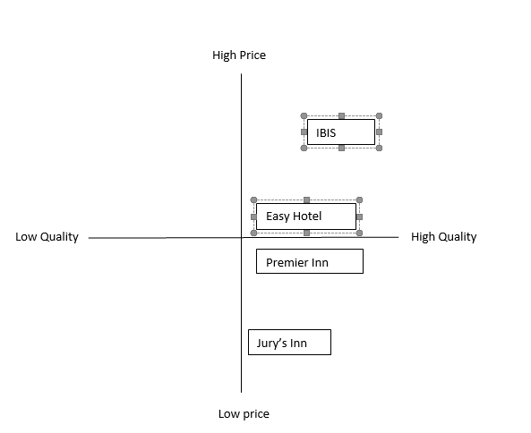
Fig no.01: Perceptual mapping of Premier inn
Source: (Created by the learner)
The figure disclosed above shows that Premier Inn is offering services at an average cost as compared to strong competitors like IBIS and Easy hotel.
Bowman's strategy clock: It is a model which can be used by the management of Premier inn to compete in the different business markets with the string competitors by analysing the strategy (Ferell et al., 2021). The comparison of the price rates will be analysed among the competitors by using the strategies such as cost differentiation strategy by the management of Premier Inn.

“Collaborators: Demonstrate an awareness of your organisation's B2B Relationships, Partnerships, and Franchises”
B2B relationships are more useful for the management of Premier Inn to function the business for more future days and help more to achieve long-term development by procuring the targets. partners are also more important for the Premier Inn to function the business because it also helps the management by generating more clues and ideas (Sumarwan, 2019). The franchise may help the management to retain more revenues in the firm and generate more brand awareness in the firm.

-Climate: “PESTLE (Macro analysis)”

Factors | Impacts | positive/negative
Political | frequent changes in the UK government. | negative
Economic | Out bursting of Covid-19 | negative
Social | Tastes and preferences of the young generations. | positive
Technological | good connectivity of internet speed. | positive
Legal | Equality Act 2010 | positive
Environmental | carbon neutralisation by 2030 | positive
Table No.02: Pestle analysis of Premier Inn
Source: (created by the learner)

“Objectives”
-SMART target: The marketing plan such as creating of cost differentiation strategy and cost leadership strategy can be focussed more effectively by the management of the Premier Inn (Beirman, 2020). These strategies can be focussed more effectively by the management to gain market share and generate profit more effectively (Quensenberry, 2020). The current market share of Premier Inn is 11.64% which may be increased by the management of Premier Inn by analysing the strategies more efficiently. the management will be benefited more from forfeiting the packages and retaining more customers in the firm (Fuertes et al., 2020). Market planning strategies may help the management to focus on boosting production.

“Strategy”
Discuss and explain your organisation's value proposition.
The value proposition is the concise statement which may be more beneficial for the management of Premier Inn to deliver the services to the customers in the organisation. The value proposition of the Premier Inn is to deliver premium services at an affordable cost (Desai and Vidyapeeth, 2019). The value proposition helps the management to understand the needs and satisfy the customers by delivering the services. implementing the value proposition strategies by the management of Premier inn may be helped more to understand the ease of the customer's procedures and focus on the services which can be offered to the customers (Lee and Kotler, 2019). The value proposition can be delivered through the services of the management of Premier Inn. The implementation of the value proposition helps management to retain valuable customers in the firm and generate more revenues as well as delivering the value proposition also helps the management to boost the brand image of the firm.

“Tactics”
Marketing mix: it is a model or approach which can be used by the management of Premier Inn to know the outcome of the services developed by the management (Tarsakoo and Charoensukmongkol, 2020). It also helps the management to focus on the growth of the business by following the procedures developed in the marketing mix elements.
Product - the services such as accommodation of the guest are the main offerings developed by the management of premier Inn to boost revenues and gain a positive brand image (Hanlon, 2021). It also helps the management to develop unique products which are more unique from the other rivals present in the different business markets. product or the services which are being developed by the management can be more helpful for the firm to generate positive brand images.
“Place (Distribution)”- it is more important for the management of the Premier Inn to locate the business in a good environment which may help the customers to refresh more (Paley, 2021). The location of the firm also plays an important role in functioning the business more effectively by retaining valuable guests in the firm. The guest must be helped more to relieve the stress of visiting the firm.
-Price – the price of the services is a more important business function for the management of Premier inn. Maintaining the balancing price of the services also helps the management to retain more valuable customers in the firm. the package prices such as suite and junior room costing 265.57 pounds per night will be more affordable for the customers (Jin et al., 2019). Looking at the economic status of the citizens the package prices must be created more effectively by the management of Premier Inn to boost revenues and retain customers.
-Promotion – it is also a more important business function for the management of Premier inn to boost the business and gain positive market share in the business market (Morgan et al., 2019). The services which have been initiated by the management must be promoted well by the management to retain the customers in the firm. By letting the people know more about the services and offerings made by the Premier Inn, the management will be helped more to retain valuable customers in the firm.

“Action”
Work Breakdown Structure:

“Activities” | “Start date” | “End Date” | “Duration (Days)”
“Market research” | 05- 03-2023 | 10-03-2023 | 6
“Hiring of Employees” | 11-03-2023 | 17-03-2023 | 7
“Generation of Strategy” | 18-03-2023 | 27-03-2023 | 10
“Implementation of Strategy” | 28-03-2023 | 31-03-2023 | 4
“Monitoring and Improvement” | 01-04-2023 | 15-04-2023 | 15
Table No.03: WBS of Premier Inn
Source: (created by the learner)

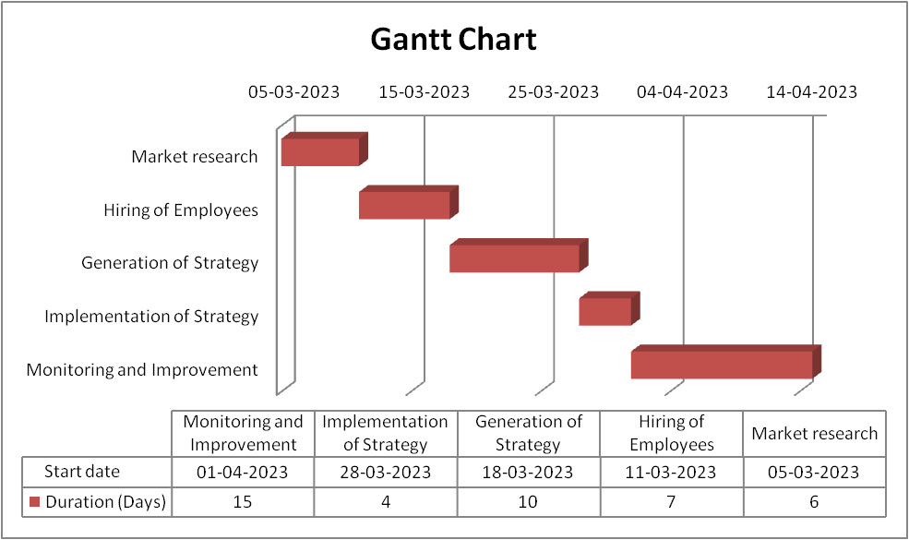
Image No. 02: Gantt Chart
(Source: created by the learner)
On analysing the marketing panning by making a Gantt chart and Work Breakdown Structure, the management of Premier Inn requires more changes in the marketing plan which may help management to function more effectively in the different business markets.

“Control”
The implementation of the marketing plan is more important for the management of the Premier Inn to boost revenues by retaining customers in the firm. The measures which can be made by the organisation can be used by the management of Premier Inn as a strategy. It is also more important for the management of Premier Inn to generate new customers in the firm by promoting the services through various sites. Retention of new customers in the firm also helps the management to create more changes in the organisational structure. The changes which are required for the firm can be made more effectively by analysing the marketing plan.

Conclusion
As discussed above, a marketing plan is more important for the management of Premier Inn to analyse the market share. A marketing plan helps the firm to boost its revenues and productivity in the firm. the marketing plan such as 4Ps, STP and 5Cs has been analysed in the report above which helps the management of Premier Inn to focus more on researching the market. The report has been analysed more briefly on knowing the marketing strategy of the Premier Inn which helps the firm to make more changes in the services which are being developed in the firm.

References
1.AlAwadhi, S. and Al-Daihani, S.M., 2019. Marketing academic library information services using social media. Library Management, 40(3/4), pp.228-239.
2.Beirman, D., 2020. Restoring tourism destinations in crisis: A strategic marketing approach. Routledge.
3.Desai, V. and Vidyapeeth, B., 2019. Digital marketing: A review. International Journal of Trend in Scientific Research and Development, 5(5), pp.196-200.
4.Fahy, J. and Jobber, D., 2019. EBOOK: Foundations of Marketing, 6e. McGraw Hill.
5.Ferrell, O.C., Hartline, M. and Hochstein, B.W., 2021. Marketing strategy. Cengage Learning.
6.Fuertes, G., Alfaro, M., Vargas, M., Gutierrez, S., Ternero, R. and Sabattin, J., 2020. Conceptual framework for the strategic management: a literature review—descriptive. Journal of Engineering, 2020, pp.1-21.
7.Hanlon, A., 2021. Digital marketing: strategic planning & integration. Digital Marketing, pp.1-100.
8.Huang, M.H. and Rust, R.T., 2021. A strategic framework for artificial intelligence in marketing. Journal of the Academy of Marketing Science, 49, pp.30-50.
9.Jin, S.V., Muqaddam, A. and Ryu, E., 2019. Instafamous and social media influencer marketing. Marketing Intelligence & Planning, 37(5), pp.567-579.
10.Lee, N.R. and Kotler, P., 2019. Social marketing: Behavior change for social good. Sage Publications.
11.Morgan, N.A., Whitler, K.A., Feng, H. and Chari, S., 2019. Research in marketing strategy. Journal of the Academy of Marketing Science, 47, pp.4-29.
12.Morrison, A.M., 2022. Hospitality and travel marketing. Taylor & Francis.
13.Paley, N., 2021. The manager's guide to competitive marketing strategies. Routledge.
14.Quesenberry, K.A., 2020. Social media strategy: Marketing, advertising, and public relations in the consumer revolution. Rowman & Littlefield Publishers.
15.Sumarwan, U., 2019. Pemasaran Strategik: Perspektif perilaku konsumen dan Marketing plan. PT Penerbit IPB Press.
16.Tarsakoo, P. and Charoensukmongkol, P., 2020. Dimensions of social media marketing capabilities and their contribution to business performance of firms in Thailand. Journal of Asia Business Studies, 14(4), pp.441-461.

Appendices


